Class 4 Recap – RPL

In this class, we integrated the calculator into our website. We used the **<script>** tag to signify JS code within HTML and copy and pasted our created calculator code into there.

We use document.getElementByID in order to get the value of the textbox we made (using the **<input>** tag) and set the calculator answer response in order to give back the correct number.

If you want to check out the finished code, go to #class4 and download the **latest** ansel.html file I uploaded in the channel.

We also covered an upgrade on our calculator to handle multi-digit inputs by identifying the position of the operator and declaring that any positions less than the position of the operator is the firstNumber while any position greater than position of the operator would be the secondNumber.

**Publishing our code to a URL (part 1)**

In order to publish your code to a URL and get it up and working you must do the following:

Step1: Make a GitHub account

Step2: Make a new repository by clicking **Repository** and clicking **New** (green button)

Step3: Under repository name, you **must** follow the format *username.*github.io. For example, if my GitHub username is ansel, then my github repository would be ansel.github.io. Also make sure your repository is **public** and **NOT private.**

Step4: Click **Create Repository**

Step5: Download Git Bash on your local computer. You need Git Bash to run local commands. <https://git-scm.com/downloads>

Step6: Go back to Github and click at your new repository.

Step7: Click the clipboard icon on the right hand side to copy the repository URL.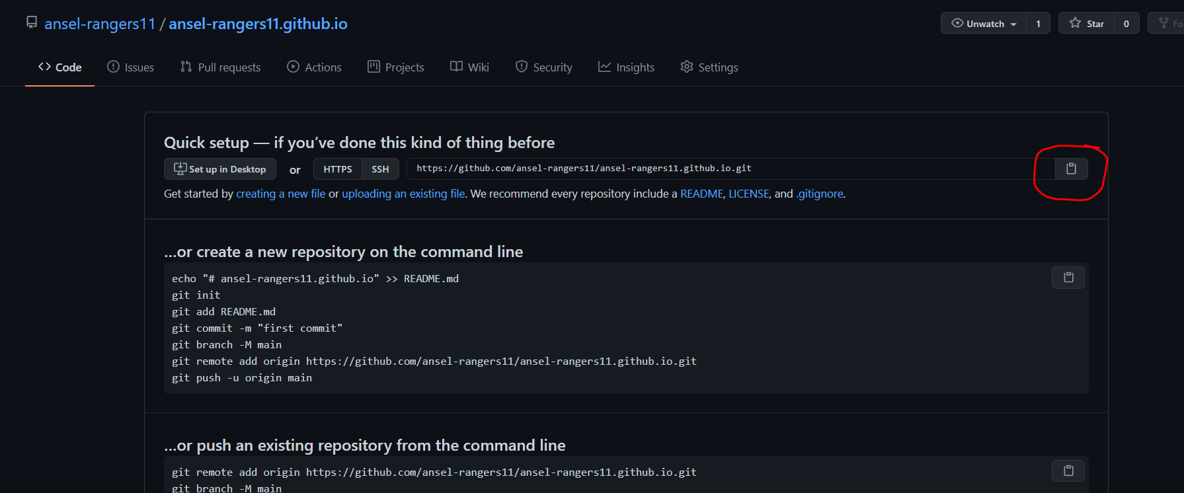

Step8: Open Git Bash and go to the folder you want your github repository to live in your computer. **NOTE: Watch this video first to understand how to navigate with command line (**[**https://www.youtube.com/watch?v=xp6oHaStwww&ab_channel=OneMonth**](https://www.youtube.com/watch?v=xp6oHaStwww&ab_channel=OneMonth)**)**

Step9: Once in the right directory, type in **git clone (repository URL you just copied)** See example below for reference. If successful, you should receive some warning that says “You appear to have cloned an empty repository

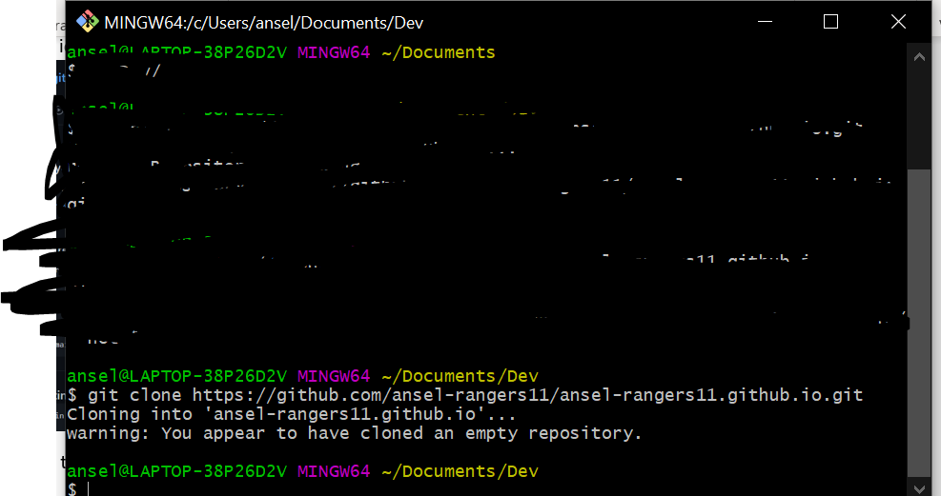

Step10: Copy and paste **all** the files you used in this course into the new repository you just made.

Step11: You are done for now and please wait for next class for further instructions on how to get your website up and running on a URL.