Class 5 Recap: Binary

We learned about the binary number system, and how the digits are in **multiples of 2** (1, 2, 4, 8, 16, 32, etc).

Binary is a base-2 number system that's made up of only two numbers or digits: 0 (zero) and 1 (one). This numbering system is the basis for all binary code, which is used to write digital data such as the computer processor instructions used every day in your laptops, phones, computers etc. It is a simple and elegant design. Binary's 0 and 1 method is quick to detect an electrical signal's off (0) or on (1) state.

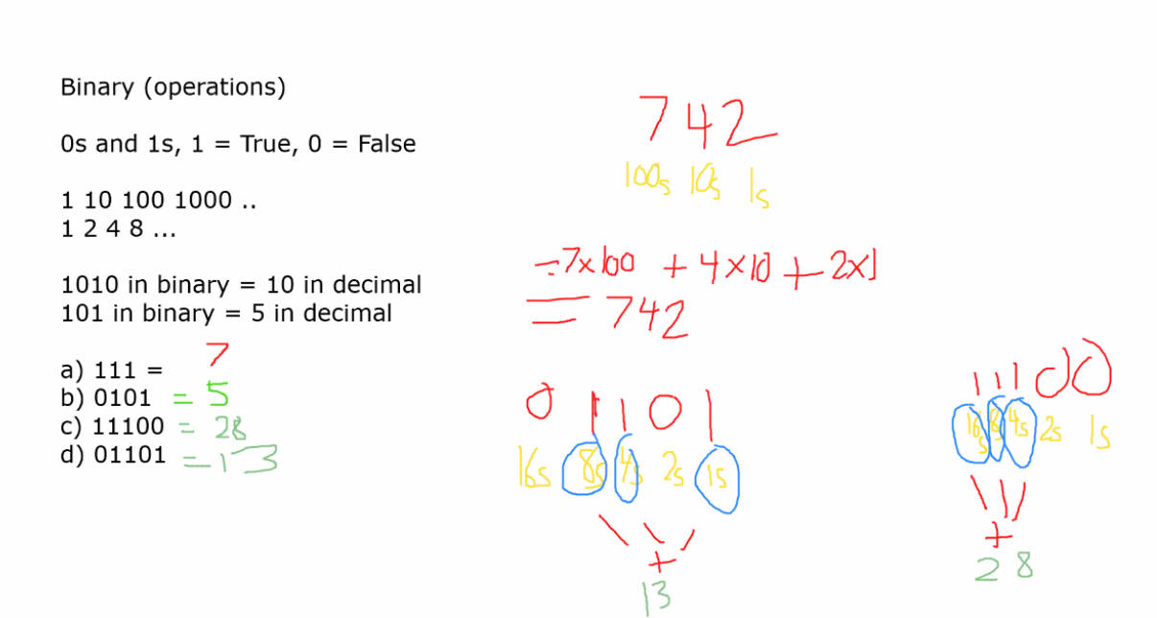

We can see in above example how we can visualize the digits of a binary number, we read it from right to left with the multiples getting larger as you go to the left.

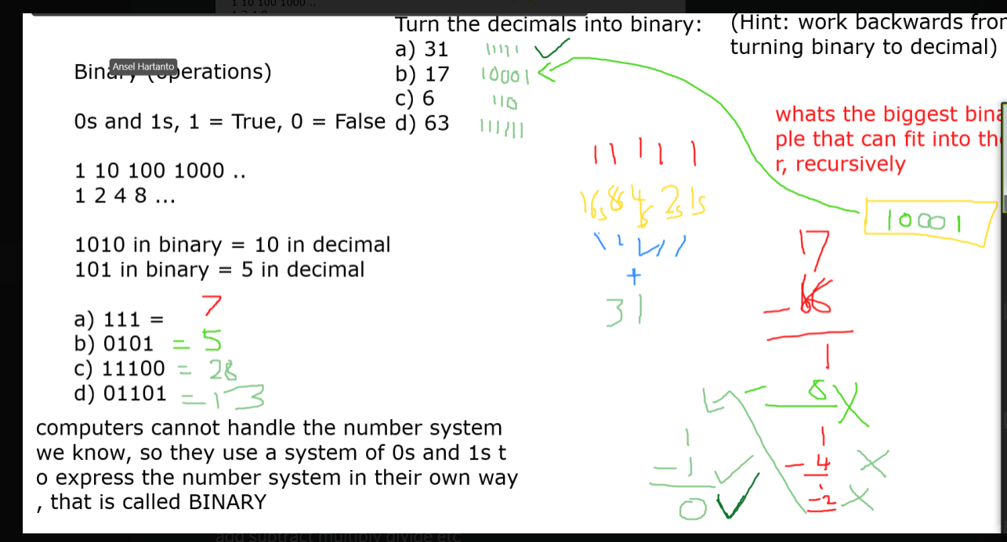

In the above example, we can see how we can do the reverse and convert normal numbers (decimals) into binary. We use the substraction method where we ask what is the biggest binary multiple that can be fitted inside the number. Then we take the remainder result and do the same process again and again until we are left with 0 at the end. We work down one multiple at a time (8 to 4 to 2 to 1 as an example). If we **CANNOT** fit the next binary multiple inside the number/remainder, then we mark that as a 0. If we **CAN**, then we mark that as a 1. (See the yellow box at the top right where I constructed the binary)

**Addition**

We learned we can add binary numbers together

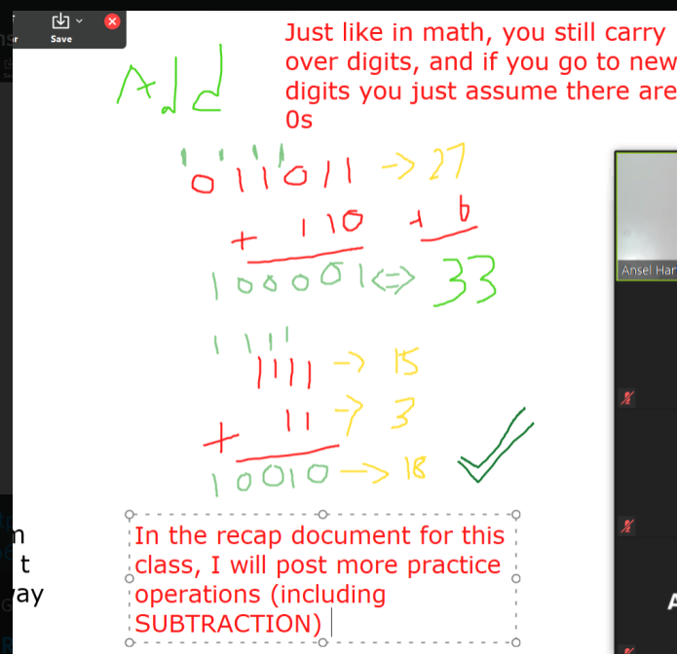

**Extra Practice**

1. Convert the following decimal (normal) numbers to binary
   1. 9
   2. 21
   3. 33
   4. 64
2. Convert the following binary numbers back to decimal (normal) numbers
   1. 10100
   2. 00101
   3. 10111
   4. 100000
   5. 101101
3. Add the following binary numbers, express your final answer as binary AND decimal (normal number)
   1. 1101 + 1011
   2. 01011 + 11
   3. 10000 + 111
   4. 110 + 1010

*I did not teach you substraction in binary but the principles of carrying AND borrowing are the same as normal math, knowing that just apply the same principles here to solve the substraction problems. You can do it!*

1. Substract the following binary numbers, express your final answer as binary AND decimal (normal number)
   1. 111 – 10
   2. 1011 – 100
   3. 1111 – 111
   4. 10101 – 101
   5. 1000 - 11