**Publishing our code to a URL (FULL INSTRUCTIONS)**

In order to publish your code to a URL and get it up and working you must do the following:

Step1: Make a GitHub account

Step2: Make a new repository by clicking **Repository** and clicking **New** (green button)

Step3: Under repository name, you **must** follow the format *username.*github.io. For example, if my GitHub username is ansel, then my github repository would be ansel.github.io. Also make sure your repository is **PUBLIC** and **NOT private.**

Step4: Click **Create Repository**

Step5: Download Git Bash on your local computer. You need Git Bash to run local commands. <https://git-scm.com/downloads>

Step6: Go back to Github and click at your new repository.

Step7: Click the clipboard icon on the right hand side to copy the repository URL.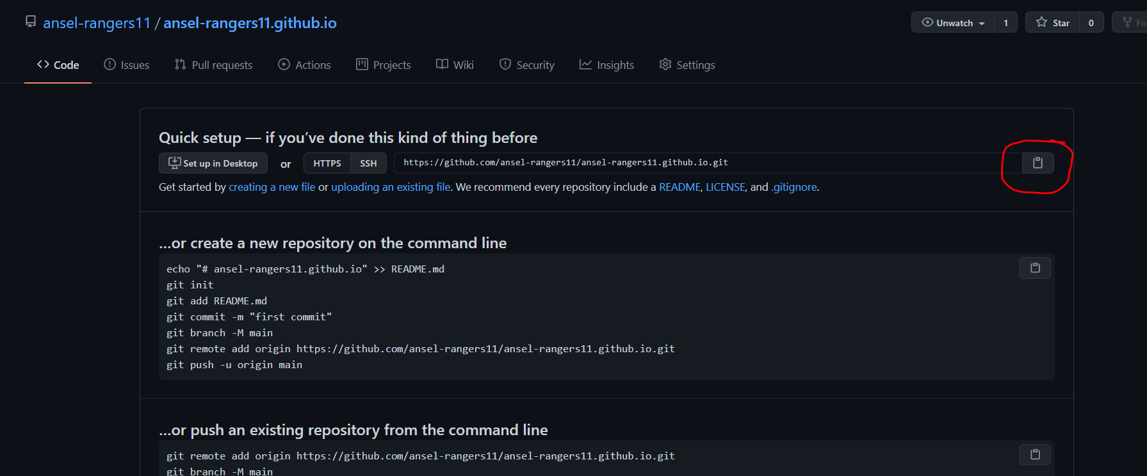

Step8: Open Git Bash and go to the folder you want your github repository to live in your computer. **NOTE: Watch this video first to understand how to navigate with command line (**[**https://www.youtube.com/watch?v=xp6oHaStwww&ab_channel=OneMonth**](https://www.youtube.com/watch?v=xp6oHaStwww&ab_channel=OneMonth)**)**

Step9: Once in the right directory, type in **git clone (repository URL you just copied)** See example below for reference. If successful, you should receive some warning that says “You appear to have cloned an empty repository

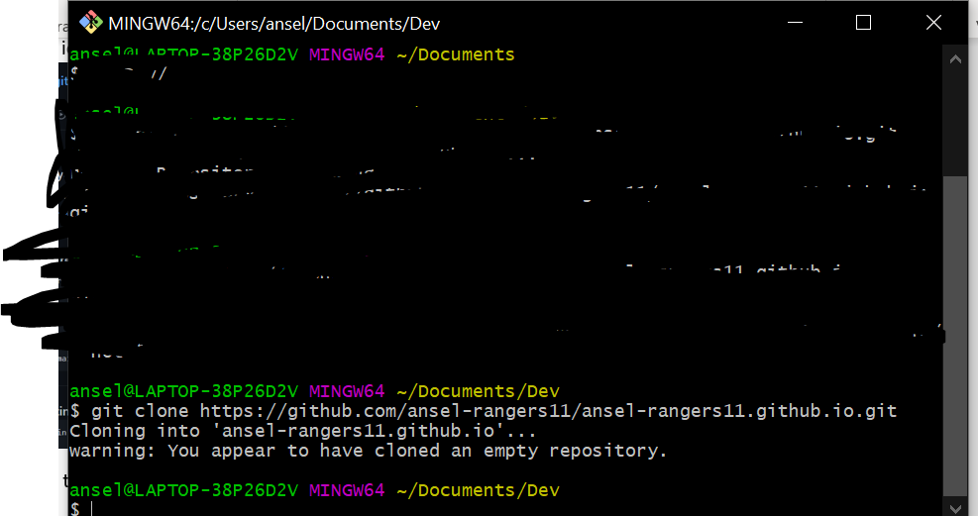

Step10: Copy and paste **all** the files you used in this course into the new repository you just made. Make sure you copy and paste your important HTML file and any image files that you need for your website.

Step11: Rename your main HTML file to **index.html** (i.e. for example mine is called ansel.html but you have to rename it to **index.html)**

Step12: You are done for now and please wait for next class for further instructions on how to get your website up and running on a URL.

Step13: Go into your repository folder ,wherever you made it, by using the **cd** command in Git Bash, if you do not know how to use cd command pause and watch this video ([**https://www.youtube.com/watch?v=xp6oHaStwww&ab_channel=OneMonth**](https://www.youtube.com/watch?v=xp6oHaStwww&ab_channel=OneMonth)**)**

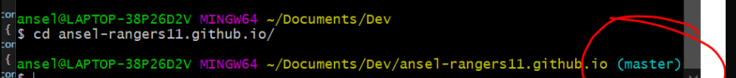

Step14: run **git status** in Git Bash, if you copy and paste all your code correctly inside your new repository a bunch of red lines should show up like this

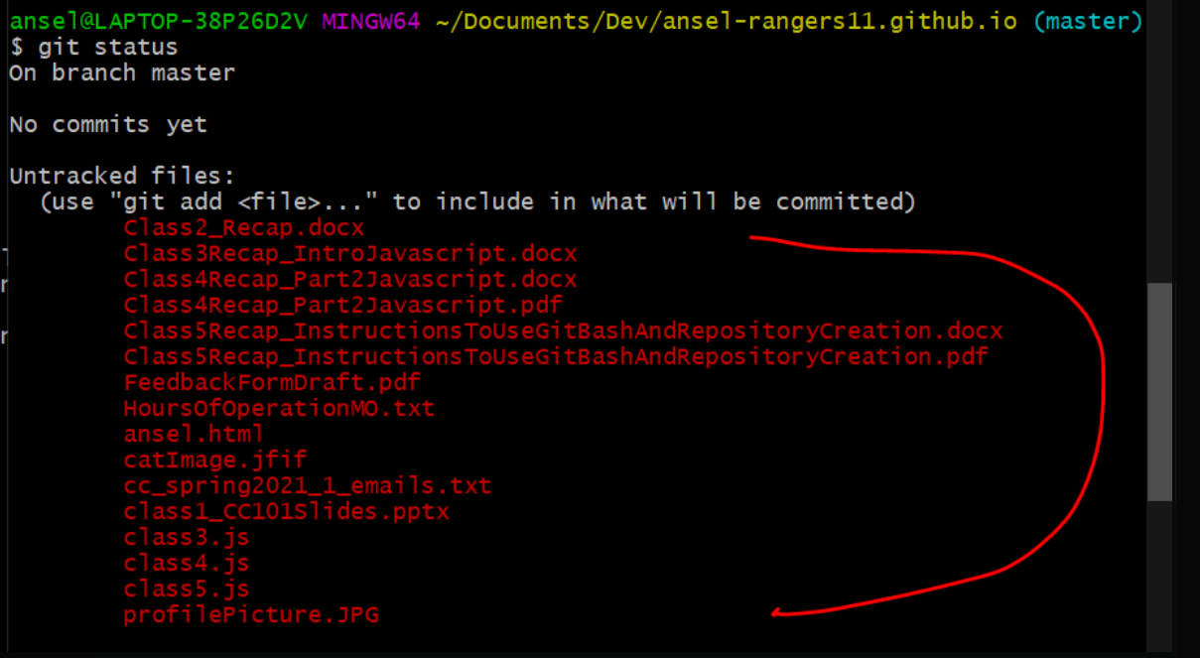

Step15: Run **git add \***



Step16: Run **git commit -m “personal website”**



Step17: Run **git push -u origin main**



Step18: Navigate to [https://***username****.github.io*](https://username.github.io)and you should see your website fully working. NOTE you must change the ***username*** to your GitHub username. Mine for example would be <https://ansel-rangers11.github.io>

**If you are having problems, try one of the following:**

* **Google is your best friend**, simply type whatever error you see into Google and 99% of the time someone else already solved it. A good site to check with is StackOverflow results.
* **Look back to the #class6 and #help channel,** we may have already resolved it in our class or I may have already said something about it. So please look in those Discord channels for similar problems
* **Post a message to the #help channel,** if you can’t find a solution online or in Discord, just ask your question to the #help channel and I (or your other classmates) can try to answer it as early as I can. Even though classes are over, I still want everyone to feel supported and learn so don’t hesitate to post a question.
* **Remake your repository again from scratch**, delete everything including your Github repository and follow these steps: <https://pages.github.com/>
* **Watch these Youtube videos to get your website up and running,** one of them should end up working for you**:**
  + <https://www.youtube.com/watch?v=8hrJ4oN1u_8>
  + <https://www.youtube.com/watch?v=M5mg0r4ajt4&ab_channel=ProgrammingKnowledgeProgrammingKnowledgeVerified>