**Recap of Class #2**

**1) Developer Tools Change Values**

Hope everyone learned a lot from today. Here is the recap of today:

- You can edit webpages by right-clicking anywhere and click "Inspect", from there you can temporarily change values from a webpage to make some funny text and numbers. The right side of your screen is where you change the values and is called **Developer Tools.**

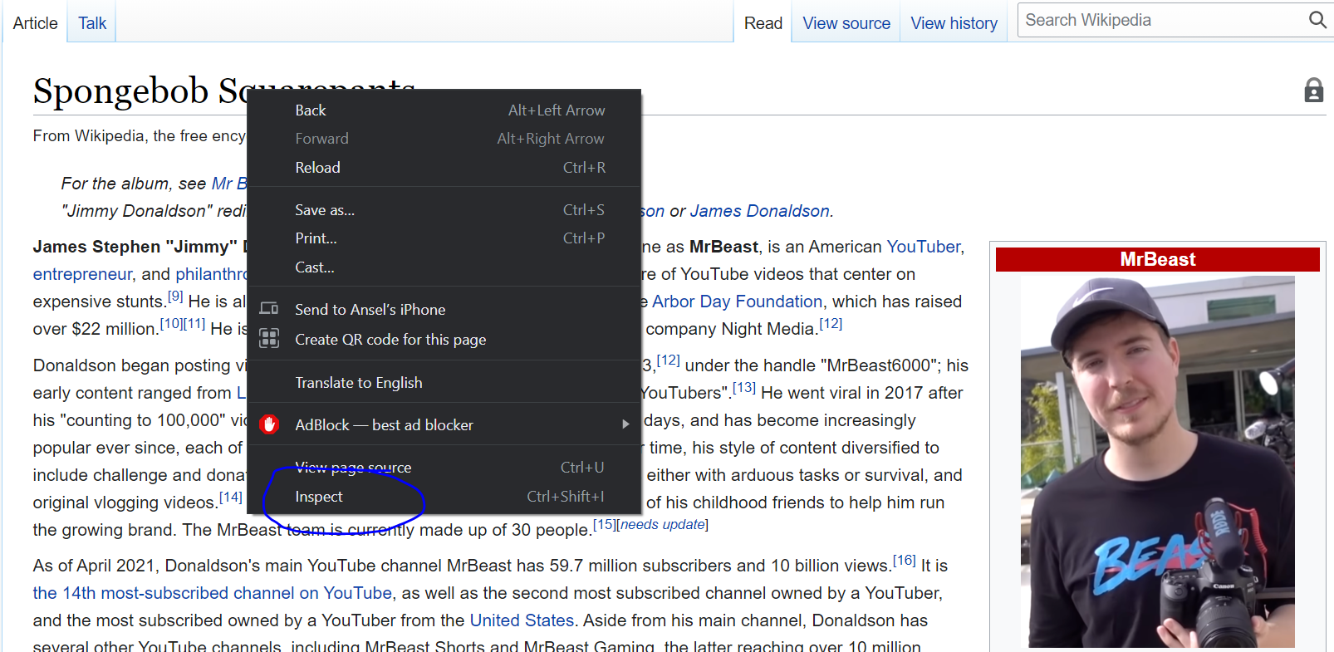

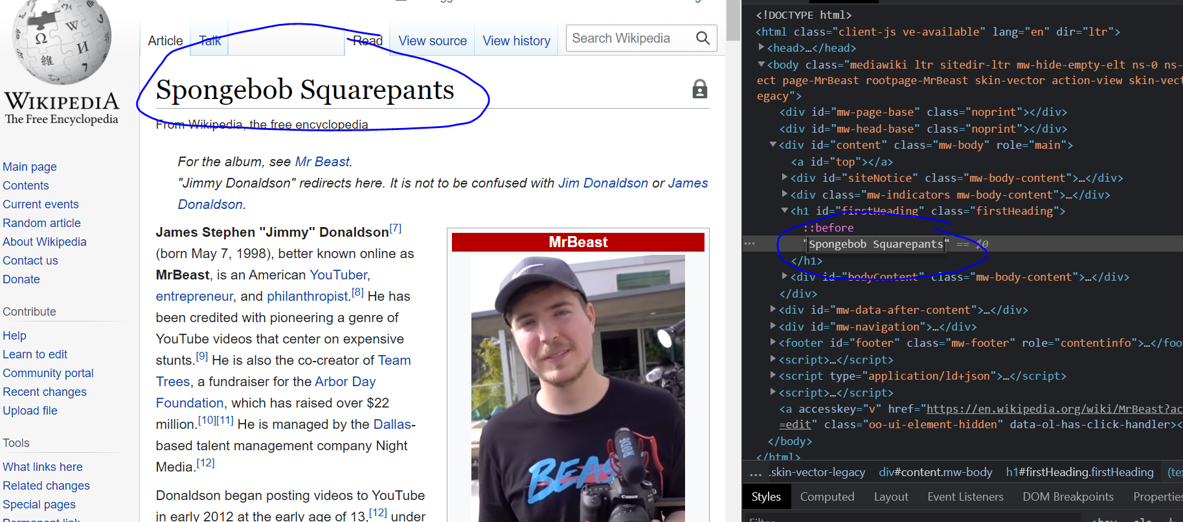

Doing this has implications to “trick” people by sending screenshots of fake values, this can spread misinformation and can cause consequences for people who are not well-versed in technology. Some examples include bank account numbers, passwords, and people in power (i.e. presidents, etc)

**2)** **Website coding tags**

Tags are the structure behind any website, just like a skeleton on human body. Tags need an **opening tag** (the tag with no /, goes in beginning) and a **closing tag** (the tag with /, goes at the end). In the middle is whatever you want to say.

* **<h1>** tag is for creating bold large text, really great for titles

<h1>Ansel's SUPER DUPER COOL Personal Website</h1>

* **<p>** tag is for creating normal small-font text

<p>I am 23 years old, I like hiking and riding bikes</p>

* **<img>** tag is for putting in images in your website

<img src="catImage.jfif" width="600" height="400">

note that the image needs supposed to be put in the same folder of the HTML code file. You cannot have any misspelling. You can also change the width, height of the image (see above example).

* **<a>** tag is for putting in hyperlinks that when you click leads you to a website

<a href="https://www.youtube.com/channel/UCX6OQ3DkcsbYNE6H8uQQuVA">Mr.Beast</a>

* **<style>** is for embedding CSS into your HTML code

<style>

 body {

   background-color: lightgreen;

    }

</style>

This code changes the background colour of your code. You can put the <style> within your <head> tags.

* **Comments** in the code can be made by example below. Comments can be put to make your code more organized and label things you might forget.

<!-- This is a comment, type whatever you want here! -->

**3) CSS vs HTML comparison**

HTML is all the tags we have learned in class like <a> and <p>, CSS is the stuff we put in the <style> tags that changes the “prettiness/beauty” of your website such as changing the colors or font-sizes. See this webpage on W3Schools for more details: <https://www.w3schools.com/html/html_css.asp>. A website with no CSS would be not visually appealing but a website cannot exist without HTML. So HTML is **necessary** but CSS is optional to make a website (although your website may not look very good).

**CHALLENGE:**

You can add CSS in-line with HTML tags to make various parts of your website even prettier, see here on how to do it. Try to change the font sizes of some of your <p> texts:

<https://www.w3schools.com/css/css_howto.asp>

**4) Assigned Readings** *(optional):*

The sections highlighted below in **BLUE** is for class #2 preparation, for class #3 please read the section highlighted below in **RED.** A reminder that assigned readings are **optional** so if you have free time and want to get a better understanding of the materials, please feel free to give it a read. It is helpful if you are feeling lost in class or the materials. The alternative is to build your website and use **#help** on Discord if you are having trouble understanding a concept or a code in your website.

<https://www.w3schools.com/html/default.asp>

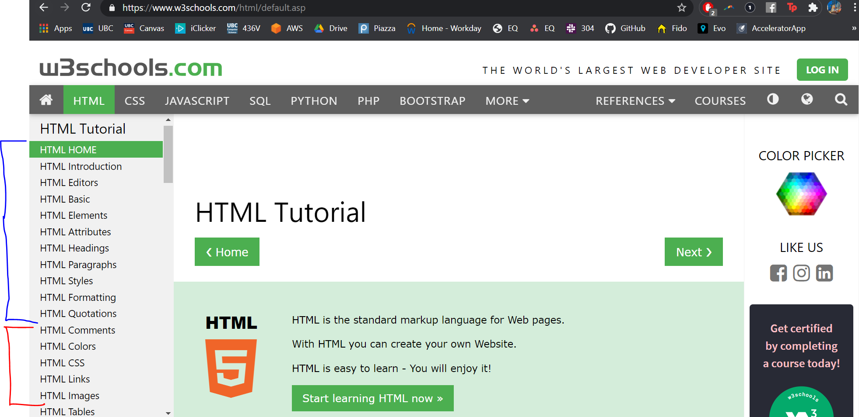

**5) Ansel’s Current Website Code (for reference)**

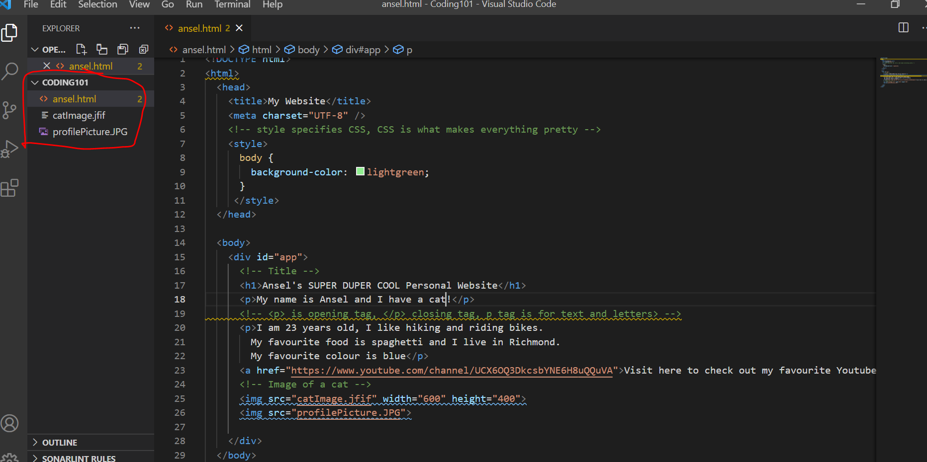

What it looks like, remember that to “run” the HTML all you have to do is **double left click** it.

