Kriging Disease Case Counts Across Singapore
  - SPH5105 Individual Assessment 2
Ansel Lim
9 October 2026

Abstract
Thirty sites in central Singapore reported disease case counts (0 to 6; 56 in total) and the percentage of surrounding green cover. Of 180 variogram settings searched, 5 gave stable fits. With 3 km lag bins (the narrowest with at least 30 pairs per bin) and a 10 km cutoff, a spherical model (nugget 1.47, partial sill 1.09 cases², range 7.1 km) reduced leave-one-out RMSE from 1.75 (pure nugget) to 1.40 cases, with a z-score SD near one (0.97).
Ordinary kriging on 1,017 nominal 1 km² land squares identified one contiguous top-quartile zone of 55.7 km² from Marina Bay to Hougang, with 1.9 times the predicted intensity of the rest of the sampled area. Its absolute density depends on the unknown area each count represents: 2.6 cases per km² for a 1 km² catchment, 0.4 for a 6.4 km² catchment (sampled land per site). Each 10 percentage points of green cover was associated with 27% fewer expected cases (count ratio 0.73, 95% CI 0.59 to 0.89), and positive residual spatial autocorrelation was not detected after adjustment for green space. Braddell Heights and Kampong Glam Community Clubs, both inside the zone and within 300 m of an MRT exit, are proposed as intervention centers; the choice did not change under alternative variogram models. Most of the island is unsampled, and without population denominators the results describe counts, not risk per person.

1. Introduction
Kriging predicts a spatially continuous quantity at unsampled locations from nearby observations, weighting each observation according to a model of how similarity between locations declines with distance (Matheron 1963; Cressie 1993). This report applies it to counts of an unnamed illness recorded at 30 sites in Singapore, together with the percentage of green cover around each site. The aims were (i) to estimate and justify a model of the spatial dependence of the counts; (ii) to map a continuous risk surface on a 1 km grid and delineate high-risk zones; (iii) to assess whether green cover is associated with the counts and accounts for their spatial pattern; and (iv) to quantify outbreak size in the high-risk zones and propose two accessible temporary intervention centers. Section 2 describes the methods, Section 3 to Section 7 report the results in the order of these aims, and Section 8 discusses their limitations.

2. Methods

2.1 Data and preprocessing
Each of the 30 sites has an identifier, WGS84 latitude and longitude, projected coordinates (x, y) in meters, the percentage of green cover around the site and a count of cases. The table was transcribed to CSV, checked cell by cell against the source document, and converted to a simple features point object (Pebesma 2018) in the SVY21 / Singapore TM projected coordinate reference system (EPSG:3414):
sites <- read.csv("../data/raw/assignment2.csv")
obs <- sf::st_as_sf(sites, coords = c("x", "y"), crs = 3414, remove = FALSE)
Geostatistical methods depend on distances between locations, and a degree of longitude is not a fixed distance, so all distance-based steps used the projected coordinates in meters. To confirm that both coordinate sets describe the same points, the latitudes and longitudes were reprojected to EPSG:3414 and compared with x and y.
Three external layers were obtained from data.gov.sg and projected to EPSG:3414: the Urban Redevelopment Authority Master Plan 2019 subzone boundary without sea, dissolved into a land outline (Urban Redevelopment Authority 2019); People’s Association community clubs (People’s Association 2024); and Land Transport Authority MRT station exits (Land Transport Authority 2026). The prediction grid consisted of 1 km × 1 km squares aligned to whole kilometers of the SVY21 grid and clipped to the land outline. Each square was represented by its center, or by a point inside its land portion where the center fell in the sea, and its land area was kept for area-based calculations. Squares overlapping the convex hull of the sites (the smallest convex polygon that contains them) formed the sampled area; predictions outside it are extrapolations.

2.2 The empirical variogram
Kriging requires a model of spatial dependence, that is, of how much more alike two counts are when their sites are close together than when they are far apart. The variogram expresses this as a function of the separation distance, or lag, h. For a single pair of sites, the semivariance is half the squared difference between their counts. If nearby sites have similar counts, semivariance is small at short lags and increases with lag until sites are far enough apart to be unrelated, where it levels off at the variance of the process (Matheron 1963; Oliver and Webster 2014).
Irregularly spaced sites are rarely separated by exactly the same distance, so pairs are grouped into distance intervals called lag bins. The empirical variogram is the mean semivariance in each bin (Matheron 1963):
γh=12Nhi,j∈Ph​zsi−zsj2,
where $P_{h}$ contains the unordered pairs $\left(i,j\right)$, with $i<j$, whose Euclidean separation $∥s_{i}−s_{j}∥$ falls in the bin around lag h, $N\left(h\right)=\left|P_{h}\right|$, and $z\left(s_{i}\right)$ is the count at site $s_{i}$. Semivariance has units of cases². Two analyst choices define the bins. The bin width sets how finely distance is resolved: narrow bins show the behavior at short lags, which has the most influence on kriging, but each mean rests on few pairs and is noisy, whereas wide bins are stable but blur short-range structure. The cutoff is the largest lag included. Long lags are represented by few pairs, mostly between sites at opposite edges of the study area, and estimate the variogram poorly. Journel and Huijbregts (1978, 194), as quoted by Cressie (1985), recommend using only lags with more than 30 pairs and only up to about half the largest lag. Following Dickens (2026b), the rule was applied by choosing the narrowest bin width for which every bin up to the cutoff holds at least 30 pairs. It is a heuristic that trades resolution at short lags against noise in bins with few pairs. Empirical variograms were computed with gstat::variogram for bin widths of 1, 1.5, 2, 2.5 and 3 km and cutoffs of 8, 9, 10 and 11 km.

2.3 Variogram models and their parameters
The empirical variogram is known only at the bin lags, whereas kriging needs the semivariance at every distance, between each site and the prediction location and between every pair of sites. A continuous model is therefore fitted to the empirical points. Only certain functions are valid, because the model must guarantee a non-negative kriging variance (Cressie 1993). Each model used here has three parameters (Figure 1). The nugget ($c_{0}$) is the semivariance just above zero lag; it represents measurement error and variation over distances shorter than the closest spacing of sites. Because the semivariance at exactly zero lag is zero by definition, the nugget appears as a jump at the origin. The sill ($c_{0}+c_{1}$) is the plateau reached by sites that are unrelated, equal to the variance of the process, and the partial sill ($c_{1}$) is the spatially structured part of that variance. The range is the lag at which the sill is reached, beyond which counts are uncorrelated; for models that approach the sill asymptotically, the practical range is the lag at which about 95% of the partial sill is reached. The nugget-to-sill ratio summarizes the strength of spatial dependence, conventionally classed as strong below 0.25, moderate from 0.25 to 0.75 and weak above 0.75 (Cambardella et al. 1994).
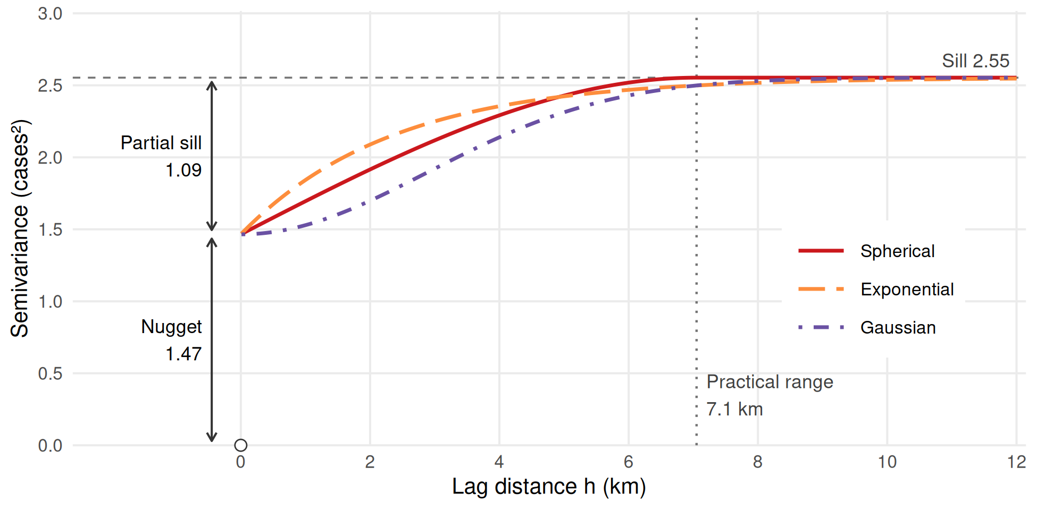
Figure 1: The three variogram model families, drawn with the nugget, partial sill and practical range of the selected model (Section 4.4). The open circle marks $γ\left(0\right)=0$; the nugget is the jump just above zero lag.
Table 1: Variogram model families. $c_{0}$: nugget; $c_{1}$: partial sill; $a$: range parameter as defined in gstat.
Model | $γ\left(h\right)$ for $h>0$ | Near the origin | Practical range | Implied surface
Spherical | $c_{0}+c_{1}\left[3/2h/a−1/2{\left(h/a\right)}^{3}\right]$ for $h≤a$; $c_{0}+c_{1}$ for $h>a$ | Linear | $a$ | Patches of finite size
Exponential | $c_{0}+c_{1}\left[1−e^{−h/a}\right]$ | Linear, steeper | $≈3a$ | Irregular (rough)
Gaussian | $c_{0}+c_{1}\left[1−e^{−{\left(h/a\right)}^{2}}\right]$ | Parabolic | $≈\sqrt{3} a$ | Very smooth

The three families differ in how quickly similarity is lost with distance (Table 1, Figure 1). The spherical model rises almost linearly and reaches the sill exactly at the range, so sites farther apart than that have zero modeled covariance; it suits processes organized in patches of a characteristic size. For the same practical range, the exponential model rises twice as steeply at the origin and then approaches the sill only gradually, so similarity is lost quickly at short distances but never vanishes completely; it suits processes that vary irregularly from place to place. The Gaussian model is flat near the origin and then rises steeply, which implies a very smooth spatially structured component; a nugget still allows abrupt local variation. It suits smoothly varying quantities such as elevation and can make the kriging equations numerically unstable without a nugget (Oliver and Webster 2014; Dickens 2026b). In gstat the range parameter equals the practical range only for the spherical model, so practical ranges are reported throughout.

2.4 Model fitting and convergence
Models were fitted with gstat::fit.variogram (Pebesma 2004; Gräler et al. 2016), which minimizes the weighted sum of squared differences between the empirical and model semivariances, j​wjγhj−γhj;θ2, over the parameters $θ=\left(c_{0},c_{1},a\right)$. Because the models are nonlinear in the range, the fit is computed iteratively from user-supplied starting values, stopping when the relative change in the weighted residual sum of squares falls below a tolerance. In gstat 2.1-6, weights are held fixed during a fit; method 2 uses the starting variogram to compute its model-dependent weights. Three weighting schemes were compared: $w_{j}=N_{j}$, which trusts bins with more pairs (gstat method 1); $w_{j}=N_{j}/γ_{start}{\left(h_{j}\right)}^{2}$, which down-weights bins with high starting-model semivariance (gstat method 2) (Cressie 1985); and $w_{j}=N_{j}/h_{j}^{2}$, which emphasizes short lags, where the kriging weights are largest (method 7, the gstat default) (Pebesma and Gräler 2026).
An iterative fit is reported as converged when its stopping criterion is met; this alone does not establish a global minimum. It can fail in two ways. It may reach the iteration limit without settling, which gstat reports with a warning (“No convergence after 200 iterations”), or the parameters may not be separable from one another, for example when a spherical range falls below the first lag: every modeled bin is at the sill, so the nugget and partial sill cannot be separated and the range is unidentified, which gstat flags as a singular fit. In both cases gstat still returns parameter values, so the absence of an error does not imply a valid fit. With few bins, a fit can also converge to different solutions from different starting values. Each combination of bin width, cutoff, model family and weighting (180 settings) was therefore fitted from four starting values: one read from the empirical variogram (nugget 1.5 and partial sill 1.5 cases², practical range 6 km) and three deliberately poor ones (practical range 0.6 km, practical range 60 km, and a nugget close to the full sill). A setting was classed as stable if (i) the sensible start converged without a warning or a singular fit; (ii) at least two starts converged and agreed within 1%; (iii) the parameters were plausible, with a positive partial sill, a practical range no longer than the cutoff (beyond which no bin carries information) and a sill at most twice the sample variance; and (iv) there were more bins than parameters.

2.5 Model selection by cross-validation
Stable fits were compared by leave-one-out cross-validation with gstat::krige.cv. Each site is removed in turn and its count is predicted by ordinary kriging from the other 29 sites, using the variogram fitted to all 30. From the observed counts $z_{i}$, the cross-validated predictions ${\hat{z}}_{−i}$ and their kriging standard deviations ${\hat{σ}}_{−i}$,
$$\text{RMSE}=\sqrt{\frac{1}{n}\sum_{i=1}^{n}{{\left(z_{i}−{\hat{z}}_{−i}\right)}^{2}}}, \text{MAE}=\frac{1}{n}\sum_{i=1}^{n}{\left|z_{i}−{\hat{z}}_{−i}\right|}, r_{i}=\frac{z_{i}−{\hat{z}}_{−i}}{{\hat{σ}}_{−i}}.$$
The root mean squared error (RMSE) and mean absolute error (MAE) measure accuracy in cases; RMSE gives more weight to large errors. The standardized errors (z-scores) $r_{i}$ test whether the kriging variance describes the actual errors. If it does, they have a mean near 0 and a standard deviation near 1; an SD above 1 indicates that the uncertainty is understated, and below 1 that it is overstated (Oliver and Webster 2014). The comparator was a pure-nugget model, which assumes no spatial correlation and therefore predicts every site by the mean of the others; a spatial model is worthwhile only if it predicts better than this control (Dickens 2026b). The selection rule, fixed before any mapping, was the lowest RMSE among stable fits whose bins all hold at least 30 pairs, provided the z-score SD lay between 0.8 and 1.2 and the RMSE was below that of the control. Moran’s I (Section 2.8) of the cross-validation errors tested for remaining positive spatial autocorrelation. The variogram was not refitted within each fold, and these same errors were used to select the setting. The reported accuracy may therefore be optimistic and does not validate the full model-selection procedure.

2.6 Kriging
Kriging predicts the count at an unsampled location $s_{0}$ as a weighted average of the observations, zs0=i​λizsi, with weights chosen to minimize the expected squared prediction error (the kriging variance) subject to unbiasedness; it is therefore the best linear unbiased predictor given the variogram (Cressie 1993). For ordinary kriging the weights solve
$$\begin{matrix}\sum_{j=1}^{n}{λ_{j}}γ\left(h_{ij}\right)+ψ & =γ\left(h_{i0}\right) \left(i=1,…,n\right), \\ \sum_{j=1}^{n}{λ_{j}} & =1, \\ σ^{2}\left(s_{0}\right) & =\sum_{i=1}^{n}{λ_{i}}γ\left(h_{i0}\right)+ψ.\end{matrix}$$
where $h_{ij}=∥s_{i}−s_{j}∥$ and $h_{i0}=∥s_{i}−s_{0}∥$ are Euclidean distances, $ψ$ is a Lagrange multiplier and $σ^{2}\left(s_{0}\right)$ is the kriging variance (Oliver and Webster 2014). The weights depend on the distances from $s_{0}$ to each site and on the distances among the sites. Nearby sites generally receive more weight, and clustered sites share weight because they carry overlapping information, which distinguishes kriging from inverse distance weighting. The kriging variance depends only on the variogram and the layout of the sites, not on the observed counts, and generally increases with distance from the sites. Weights can be negative and need not decrease strictly with distance. With a nugget, the prediction at a sampled site equals the observation, but the variance at any unsampled location is at least the nugget.
Applied to this study, kriging turns the fitted variogram into a predicted count for every grid square in four steps. First, the fitted model converts each distance into a semivariance, both between every pair of the 30 sites (the left side of the system) and between each site and the square’s prediction point (the right side). Second, the system is solved for that square, giving 30 weights that sum to one. Third, the prediction is the weighted sum of the 30 observed counts, and the kriging variance follows from the same solution. Fourth, the calculation is repeated for each of the 1,017 squares; only the right side changes from one square to the next. Table 2 shows the result for three squares, computed directly from the equations above; it reproduces the gstat output.
Table 2: Ordinary kriging worked through for three grid squares with the selected spherical model: the five largest weights (site id, observed cases, weight), the prediction and the kriging variance. Weights over all 30 sites sum to one.
Square | Nearest (km) | Five largest weights: site (cases): weight | Predicted count | Variance
Marina East (highest prediction) | 0.5 | 16 (6): 0.22; 12 (5): 0.17; 15 (5): 0.14; 14 (2): 0.12; 9 (4): 0.09 | 3.96 | 1.90
Bukit Batok (lowest in sampled area) | 0.1 | 6 (0): 0.29; 5 (0): 0.22; 7 (0): 0.10; 8 (1): 0.09; 25 (3): 0.05 | 0.60 | 1.92
North-Eastern Islands (outside sampled area) | 19.8 | 3 (0): 0.06; 26 (2): 0.05; 27 (2): 0.05; 21 (1): 0.05; 11 (0): 0.05 | 1.64 | 2.72

At the Marina East square most of the weight falls on the high-count Marina Bay sites within a few kilometers, so the prediction is high. Around Bukit Batok the nearest sites reported few cases, so it is low. At the North-Eastern Islands, about 20 km from the nearest site, no site lies within the range; the weights are distributed across all sites and the prediction equals the estimated constant mean, with the largest variance. These weights account for correlation among the sites, so this mean differs from the unweighted sample mean. A kriged value is therefore the count expected at a hypothetical additional site at that point, recorded in the same way and over the same period as the observed counts. It is not the number of cases inside the square; converting it to cases per km² requires an assumption about the area that each count represents (Section 2.7).
Table 3: Kriging variants (Goovaerts 1997; Dickens 2026b).
Method | Mean of the process | Constraint on the weights | Use in this report
Simple kriging | Constant and known | None; remaining weight on the known mean | Not used
Ordinary kriging | Constant but unknown | Sum to one | Primary analysis
Universal kriging | Trend in coordinates or covariates, known at every prediction location | Reproduce the trend | Sensitivity analysis (linear trend in x and y)
Block kriging | As ordinary kriging | Sum to one; predicts the mean over an area | Check of zone totals

The variants differ in their assumptions about the mean of the process (Table 3). Simple kriging assumes that the mean is known. Ordinary kriging assumes that it is constant but unknown and estimates it implicitly through the constraint that the weights sum to one. Universal kriging models the mean as a function of the coordinates or, as kriging with external drift, of a covariate, and estimates the variogram on the residuals from that trend; the trend variable must be known at every prediction location. Ordinary kriging with all 30 sites (formula cases ~ 1) was the primary method:
v <- gstat::variogram(cases ~ 1, obs, width = 3000, cutoff = 10000)
vfit <- gstat::fit.variogram(v, gstat::vgm(psill = 1.5, model = "Sph", range = 6000, nugget = 1.5))
ok <- gstat::krige(cases ~ 1, obs, newdata = cell_pts, model = vfit)
Kriging predictions refer to points. An average over a 1 km square (block support) has less variability than a point value because averaging reduces variation at short distances, including the nugget. Its prediction averages the conditional surface over the square and need not equal the prediction at its center. Block kriging was used to check zone totals. Because kriging minimizes the error at each location separately, it produces a surface smoother than the process it estimates: high values are underpredicted, low values overpredicted, and areas above a threshold understated (Dickens 2026b). To quantify this, 200 conditional simulations were drawn by sequential Gaussian simulation (Goovaerts 1997). The algorithm visits the prediction points in random order, kriges each from the data and the previously simulated points (here the 30 nearest), draws a value from a normal distribution with the kriging mean and variance, and adds it to the conditioning data. Each simulated surface honors the observations and reproduces the variogram, so the spread across simulations represents the variability that the kriged map smooths away. Each square was simulated at a 4 × 4 lattice of land points, together with its prediction point; their mean approximates the average over the square’s land portion. The main kriged map retains point support.

2.7 High-risk zones and outbreak size
High-risk squares were those in the sampled area with predictions at or above the 75th percentile (top 25%) of predictions in that area, and the core those at or above the 90th percentile (top 10%). Restricting the percentiles to the sampled area prevents extrapolated values from shifting the thresholds. The data do not state the catchment of each count, that is, the area whose cases the count records. Expressing outbreak size in cases per km² therefore requires an assumption, and two illustrative scenarios were used. Under the first, each count reflects about 1 km² around its site, the size of a grid square; each prediction is then an expected number of cases per km², and the expected number of cases in a zone is the sum over its squares of prediction × land area. Under the second, the 30 sites share the sampled region equally. The land inside the convex hull of the sites covers 191.1 km², or 6.4 km² per site, so each count is spread over 6.4 km² and all totals and densities are divided by 6.4. The true catchment is unknown and could be smaller or larger than either value. Because the assumption rescales every square by the same factor, it changes totals and densities but not the ranking of squares, the zones, relative intensities against the lower 75% of the sampled area, or the choice of centers.

2.8 Association with green space
The association between green space and counts was estimated at the 30 sites, not on the kriged grid, whose values are smoothed functions of the same 30 counts. Spearman’s rank correlation gave a distribution-free summary. Counts were modeled by Poisson regression with a log link, $logE\left(Y_{i}\right)=β_{0}+β_{1}x_{i}$, with green cover $x_{i}$ per 10 percentage points, so that $e^{β_{1}}$ is the ratio of expected counts for a 10-point increase. No offset was included because neither population nor observation time was available, so the ratio compares expected counts, not incidence rates (Dickens 2026a). Its 95% confidence interval was obtained from the profile likelihood and its p-value from a likelihood ratio test. Overdispersion was assessed by the Pearson statistic divided by the residual degrees of freedom, with a quasi-Poisson fit as a check.
Whether green space accounts for the spatial clustering of the counts was assessed with Moran’s I (Moran 1950),
I=ni​j​wij i​j​wijzi−zzj−zi​zi−z2,
where $w_{ij}$ is the neighbor weight between sites i and j. I is positive when neighboring sites have similar values, negative when they differ, and close to its expectation of $−1/\left(n−1\right)$ under no autocorrelation. It was computed for the counts and for the Pearson residuals of the Poisson model, with one-sided p-values for positive autocorrelation from 9,999 random permutations (Bivand and Wong 2018), under two row-standardized neighbor definitions: the four nearest neighbors of each site (made symmetric), and the shortest distance band that leaves no site without a neighbor. Following Dickens (2026a), a linear regression of counts on green space was also tested with one-sided Moran’s I of its residuals and with the robust Lagrange multiplier tests, which distinguish spatial dependence in the errors from dependence in the outcome (Anselin et al. 1996). Permuting fitted Poisson residuals is an exploratory diagnostic because the residuals are estimated from the same data.

2.9 Locating the intervention centers
Temporary intervention centers are short-term facilities from which an outbreak response is delivered to the affected population, for example testing, treatment, health information and the coordination of environmental control. A good location is one that people in the high-risk zone can reach easily, so the selection combined accessibility criteria with the kriged surface. Candidate venues were community clubs (People’s Association 2024), which are public, staffed buildings with halls located within housing estates. Clubs flagged in the 2024 dataset as under construction or pending upgrading or relocation were checked against the current official directory (People’s Association 2026). Accessibility was defined as lying within 500 m (straight line) of an MRT station exit (Land Transport Authority 2026), and proximity as lying within 1 km of the top-25% zone. The kriged surface supplies the demand: each square of the top-25% zone is weighted by its estimated number of cases (prediction × land area), so squares with more expected cases pull the centers toward them. From the clubs meeting both criteria, two centers were chosen by solving the two-facility p-median problem (Hakimi 1965), that is, by finding the pair of clubs $S$ that minimizes the case-weighted mean distance from the zone’s squares to the nearer center,
k​wkminj∈Sdkjk​wk,
where k indexes the squares of the zone, $w_{k}$ is the estimated number of cases in square k and $d_{kj}$ is the straight-line distance from square k to club j. Every pair was evaluated, so the solution is optimal within the candidate set. Because the catchment assumptions of Section 2.7 multiply every $w_{k}$ by the same constant, they do not affect the chosen pair.

2.10 Sensitivity analyses
The zones and centers were recomputed under the exponential and Gaussian models on the selected bins, a spherical model with 2.5 km bins and pair weights, the selected model refitted without site 25 (an influential site), and universal kriging with a linear trend in the coordinates. Agreement between top-25% zones was measured with the Jaccard index, the number of squares in both zones divided by the number in either, which ranges from 0 (no overlap) to 1 (identical zones).

3. Data preparation and exploration

3.1 Sites and spatial layout
Reprojecting the supplied latitudes and longitudes to EPSG:3414 reproduced x and y to within 0.75 mm, so both coordinate sets describe the same points. The sites span 20.6 km east to west and 13.5 km north to south (Figure 2). The median nearest-neighbor distance is 1.92 km (maximum 4.06 km) and the largest separation 22.1 km; sites 2 and 25 in Bukit Batok are 148 m apart. The north (Woodlands, Yishun, Sembawang), far west (Jurong West, Tuas), far east (Tampines, Pasir Ris, Changi) and offshore islands are unsampled.

3.2 Descriptive statistics
Table 4: Green space and case counts at the 30 sites.
Variable | N | Mean | SD | Median | Q1 to Q3 | Min to max
Green space (%) | 30 | 48.91 | 15.26 | 48.5 | 36.2 to 58.5 | 26.3 to 76.1
Cases | 30 | 1.87 | 1.72 | 2 | 0 to 3 | 0 to 6

Green cover ranged from 26.3% to 76.1% (mean 48.9%; Table 4) with a broad, non-normal distribution (Figure 3 C). Six sites with 68.8% to 76.1% cover lie in the western green belt around Bukit Batok and Jurong Lake and in the Central Water Catchment; the lowest values (26.3% to 27.1%) are at Marina Bay and Geylang (Figure 3 B). Nine sites reported no cases, and the variance of the counts (2.95) exceeded their mean (1.87). The highest counts were around Marina Bay and the city center (sites 12, 15 and 16: 5, 5 and 6 cases), whereas most western sites reported none (Figure 3 A).

3.3 Assumptions about scale and units
EPSG:3414 is a transverse Mercator projection designed for Singapore, so Euclidean distances in meters are accurate over the 22 km study extent; lags, ranges and buffers are reported in kilometers. Each count is assumed to be the number of cases recorded around a site over a common but unstated period. No population or time denominator is available, so counts are not rates. Counts are treated as point observations of a continuous risk surface, although the area each count represents (its support) is unknown; this matters when outbreak size is expressed per km² (Section 7.1). Green space is assumed to be the percentage of green cover within a common radius of each site, measured over the same period. Ordinary kriging further assumes a constant unknown mean and an isotropic variogram. Although predictions use a 1 km grid, sparse short-distance pairs limit fine-scale inference.
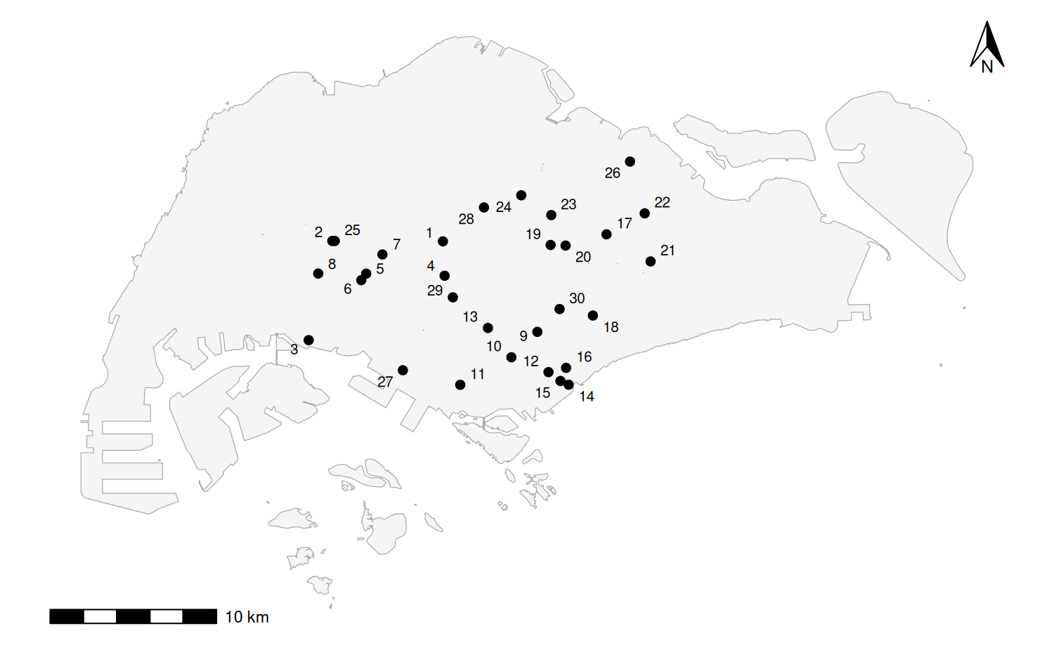
Figure 2: Locations of the 30 sites, labeled by id. Land outline: URA Master Plan 2019 subzone boundary without sea (Urban Redevelopment Authority 2019), EPSG:3414.

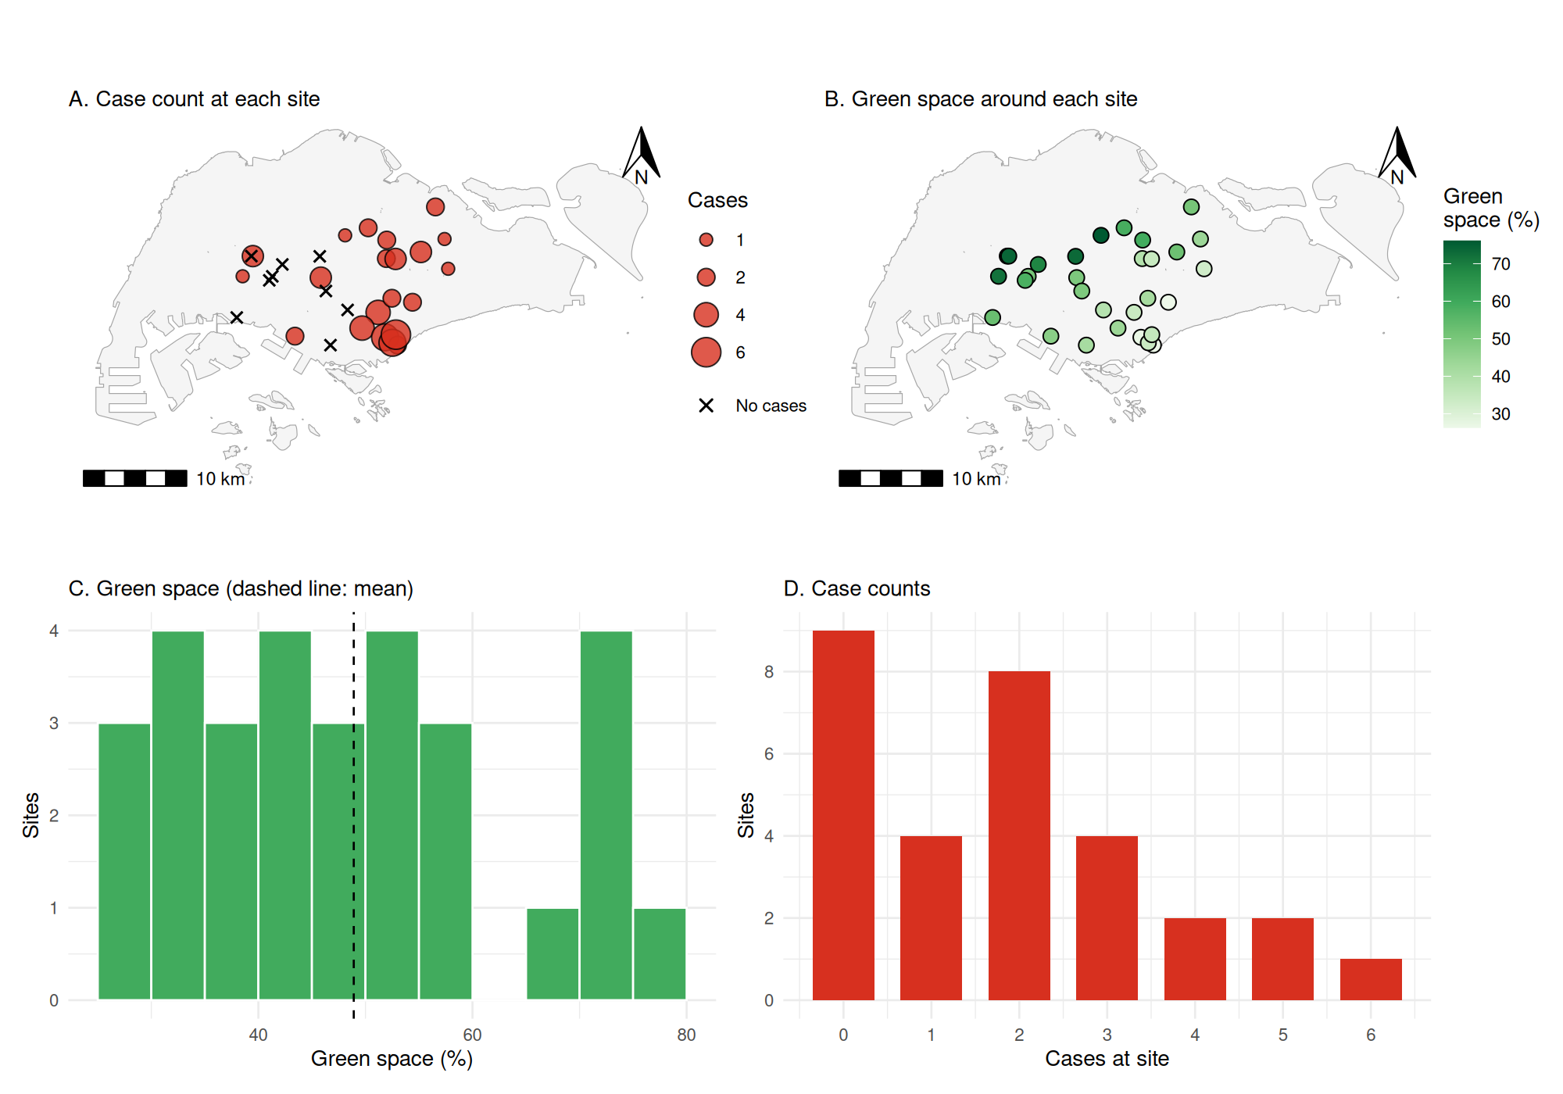
Figure 3: Case counts (A; crosses mark zero counts) and green space (B) by site, with the distributions of green space (C) and case counts (D).

4. Variogram construction and fitting

4.1 Empirical variogram
Table 5: Number of bins and, in parentheses, the smallest number of pairs in any bin, by bin width and cutoff.
Bin width | 8 km cutoff | 9 km cutoff | 10 km cutoff | 11 km cutoff
1 km | 8 (6) | 9 (6) | 10 (6) | 11 (6)
1.5 km | 6 (10) | 6 (10) | 7 (10) | 8 (10)
2 km | 4 (13) | 5 (13) | 5 (13) | 6 (13)
2.5 km | 4 (16) | 4 (24) | 4 (24) | 5 (24)
3 km | 3 (38) | 3 (38) | 4 (33) | 4 (38)

The 30 sites form 435 pairs, and half the largest separation is 11.1 km. Only 38 pairs are closer than 3 km, so no width below 3 km meets the 30-pair rule without discarding the shortest lags, which carry the information on the nugget (Table 5). With 3 km bins, a 9 km cutoff leaves three bins, too few for a three-parameter model, and no fit with an 11 km cutoff was stable (Section 4.2). A 10 km cutoff was therefore used. Its four bins hold 38, 80, 101, 33 pairs, with semivariances of 1.92, 2.38, 2.50, 2.83 cases² at mean lags of 2.0, 4.6, 7.5, 9.4 km. All lie below the sample variance (2.95) and increase with distance.
At every bin width the variogram has a substantial nugget (first bins at about 1.7 to 2.8 cases²) and levels off between about 6 and 9 km (Figure 4). The oscillation at short lags appears only with narrow bins, whose first bins hold 6 to 13 pairs. With an 11 km cutoff the last bin exceeds the sample variance (4.47 cases² at 10.7 km with 1.5 km bins, 19 pairs; Figure 6 C), as expected under a large-scale gradient from the high-count southeast to the low-count west (Dickens 2026b).
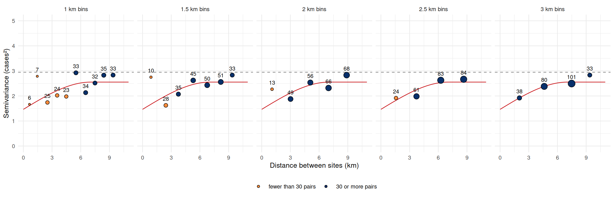
Figure 4: Empirical variograms at five bin widths (10 km cutoff) with the selected spherical model. Numbers are pairs per bin; orange points have fewer than 30 pairs. Dashed line: variance of the counts.

4.2 Model fitting and convergence
Of the 180 settings, 134 failed to converge or were singular, 41 converged to unstable or implausible solutions and 5 were stable, all with 2.5 or 3 km bins (Figure 5). Non-converged fits still return parameters: with 2 km bins and a 10 km cutoff, the spherical fit returned a nugget of 2.05, a partial sill of 3.20 and a range of 52 km, more than twice the study extent (Figure 6 B).
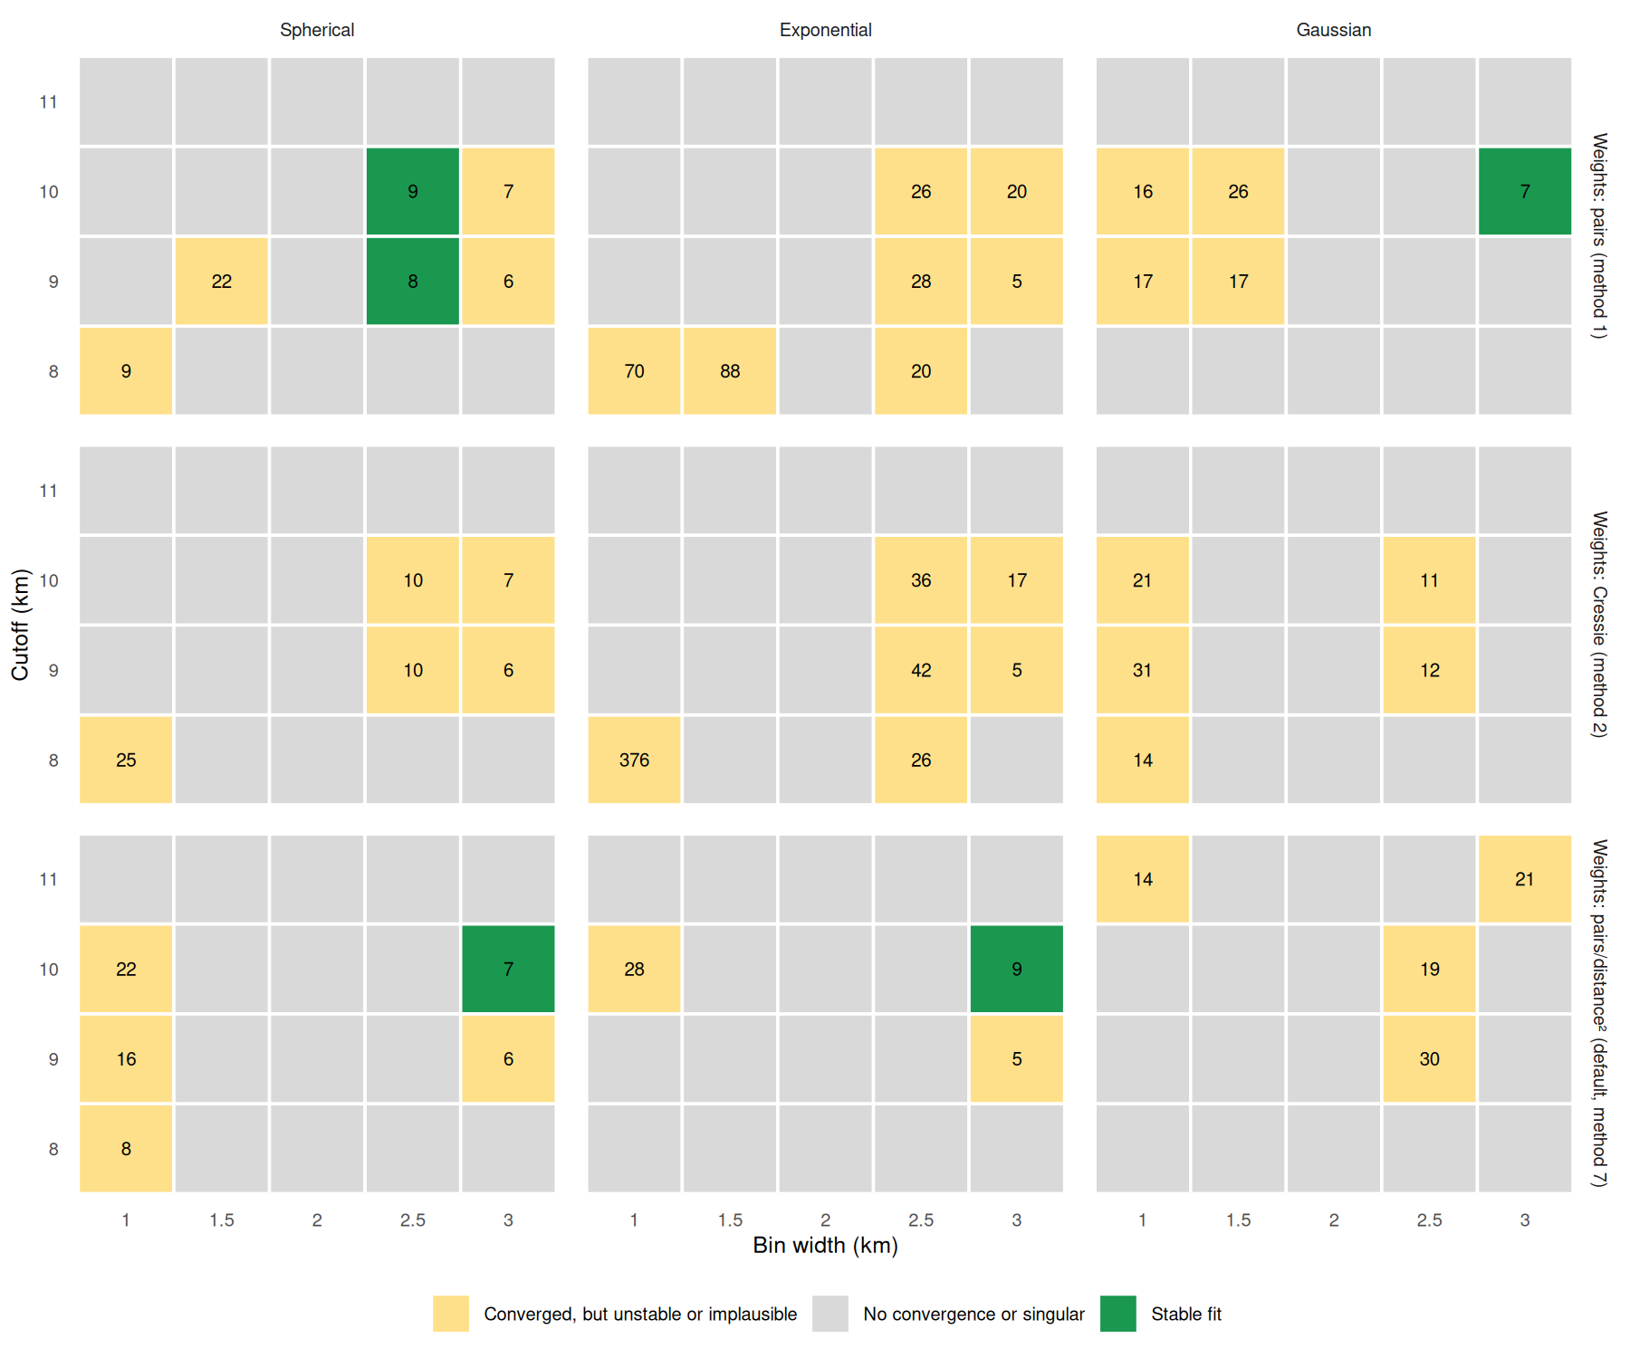
Figure 5: Outcome of the sensible start for all 180 settings. Green: stable. Numbers are the fitted practical range (km) where the sensible start converged.

Table 6: Starting values (nugget, partial sill, practical range in km) and fitted parameters for the selected setting (spherical, 3 km bins, 10 km cutoff, default weights). Psill: partial sill.
Start | Start values | Nugget | Psill | Range (km) | Outcome
Sensible | 1.5, 1.5, 6.0 | 1.47 | 1.09 | 7.1 | Converged
Range 0.6 km | 1.5, 1.5, 0.6 | 1.50 | 1.50 | 0.6 | Singular
Range 60 km | 1.5, 1.5, 60.0 | 1.50 | 0.79 | 29.7 | No convergence
Nugget near sill | 2.9, 0.1, 6.0 | 1.47 | 1.09 | 7.1 | Converged

For the selected setting, the sensible start and the nugget-near-sill start converged to identical parameters; the 0.6 km start gave a singular fit, and the 60 km start stopped without converging at a 30 km range (Table 6). The fit is therefore insensitive to how the starting sill is split between nugget and partial sill, but not to a starting range that is wrong by an order of magnitude.
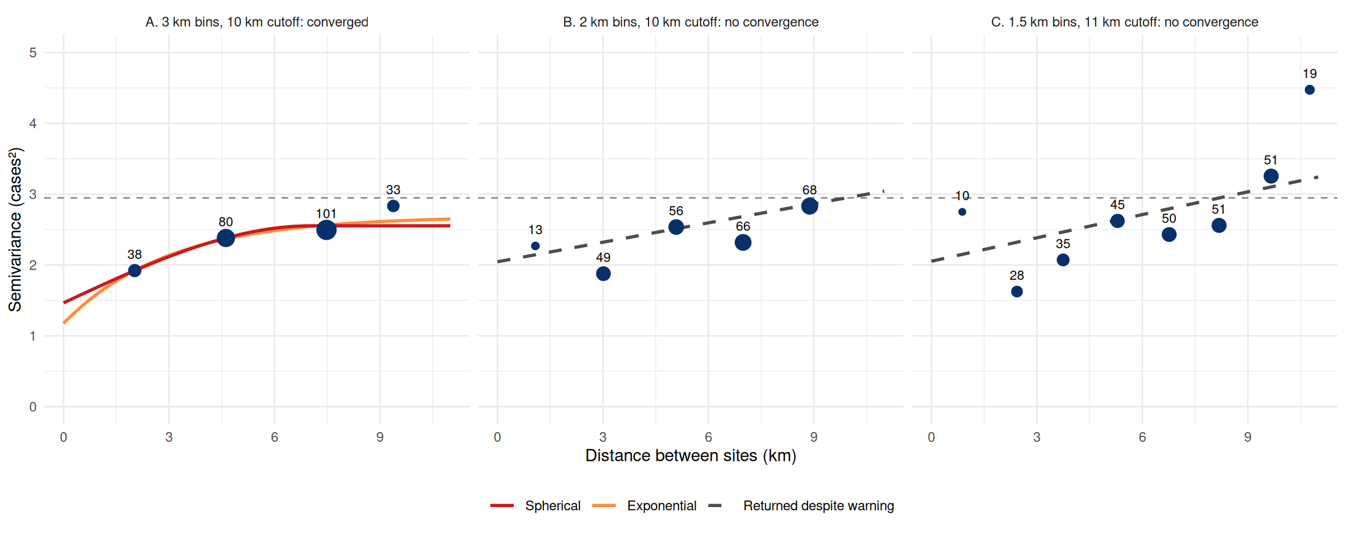
Figure 6: Fitted variograms. (A) Selected setting, where the spherical and exponential models both converge. (B, C) Settings where gstat warned of non-convergence but returned the dashed curve. Numbers are pairs per bin; dashed horizontal line: variance of the counts.

4.3 Model selection by cross-validation
Table 7: Leave-one-out cross-validation of the stable fits that meet the 30-pair rule, and of the pure-nugget control. Bins: width / cutoff (km). Range: practical range (km). Psill: partial sill. Weights: N, pairs per bin; Cressie, pairs divided by squared starting-model semivariance; N/h², pairs divided by squared lag (gstat default).
Model | Bins | Weights | Nugget | Psill | Range | RMSE | z SD
Spherical | 3 / 10 | N/h² | 1.47 | 1.09 | 7.1 | 1.402 | 0.965
Gaussian | 3 / 10 | N | 1.76 | 0.86 | 7.5 | 1.406 | 0.954
Exponential | 3 / 10 | N/h² | 1.17 | 1.51 | 8.9 | 1.413 | 0.988
Pure nugget (control) |  |  | 2.95 | 0 |  | 1.746 | 1.017

All 5 stable fits predicted better than the control (RMSE 1.40 to 1.44 against 1.75 cases). The spherical model with 3 km bins and default weights had the lowest RMSE (1.402, 20% below the control) and the lowest mean absolute error (1.206 against 1.398), with a mean z-score of -0.013 and a z-score SD of 0.965 (Table 7). No positive spatial autocorrelation was detected in its cross-validation residuals (Moran’s I = -0.10, p = 0.727). The exponential and Gaussian models on the same bins were close behind (RMSE 1.406 to 1.413), so the choice of family matters little for prediction; its effect on the zones is assessed in Section 8.1. The spherical model was preferred because it had the lowest error, reaches its sill at a finite range, and agrees with fits in neighboring settings (2.5 km bins with pair weights: nugget 1.39 to 1.40, partial sill 1.23 to 1.30, range 8.4 to 9.1 km).

4.4 Interpretation of the fitted parameters
With a = 7.05 km and $γ\left(0\right)=0$, the selected model is
$$γ\left(h\right)=1.465+1.088\left[3/2h/a−1/2{\left(h/a\right)}^{3}\right]\text{ for }0<h≤a, γ\left(h\right)=2.553\text{ for }h>a.$$
The nugget (1.47 cases²) combines the sampling variation of small counts with real variation over distances shorter than the site spacing. Sites 2 and 25 illustrate it: 148 m apart with near-identical green cover (73.5% and 74.0%), they reported 0 and 3 cases. The sill (2.55 cases², 87% of the sample variance) is the variance of the process, of which 1.09 cases² is spatially structured; the excess of the sample variance over the sill reflects the large-scale gradient. The nugget-to-sill ratio of 0.57 indicates moderate spatial dependence by the classification of Cambardella et al. (1994) (0.25 to 0.75). The range (7.1 km) is 3.7 times the median nearest-neighbor distance, so most locations in the sampled area have several sites within range, which is the condition for kriging to improve on the mean (Dickens 2026b). These values are plausible for the data (the range lies within the cutoff and the extent, the sill is close to the sample variance and the nugget is below the sill) but imprecise, because four bins leave one degree of freedom for three parameters.

5. Kriging interpolation

5.1 Prediction surface
The land outline (784.8 km²) was covered by 1,017 grid squares. Predictions ranged from 0.60 to 3.96 cases (Figure 7). They were highest in a band from Marina Bay through Kallang and Geylang to Serangoon and Hougang, and lowest around Bukit Batok and the western green belt. The sampled area comprised 223 squares. The remaining 78% of squares (72% of the land area) are extrapolations: predictions there relax toward the estimated mean and the variance approaches its maximum of 2.72 cases². They carry no information about the north, west or east of the island and are excluded from the zones.
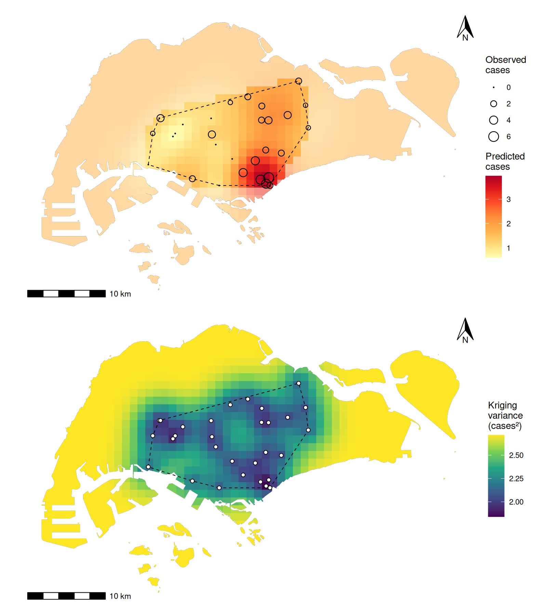
Figure 7: Ordinary kriging. Top: predicted cases, with observed counts as circles. Bottom: kriging variance, with sites in white. Dashed polygon: convex hull of the sites (the sampled area). Squares outside it are faded because their values are extrapolations.

5.2 High-risk zones
High-risk thresholds were the 75th (2.01 cases) and 90th (2.57 cases) percentiles of predictions within the sampled area. The top-25% squares form one contiguous zone of 55.7 km² spanning parts of Serangoon, Kallang, Hougang, Toa Payoh, Geylang, Downtown Core, Novena, Bukit Merah, Marina East, Rochor, Marine Parade, Newton, Outram and Marina South, in decreasing order of area (Figure 8). The top-10% core (22.7 km²) covers parts of Kallang, Downtown Core, Marina East, Rochor, Marine Parade, Outram and Marina South, around the Marina Bay and Kallang sites that reported 4 to 6 cases. Because squares partly overlapping the hull are included, the zone extends slightly beyond the hull in the southeast.
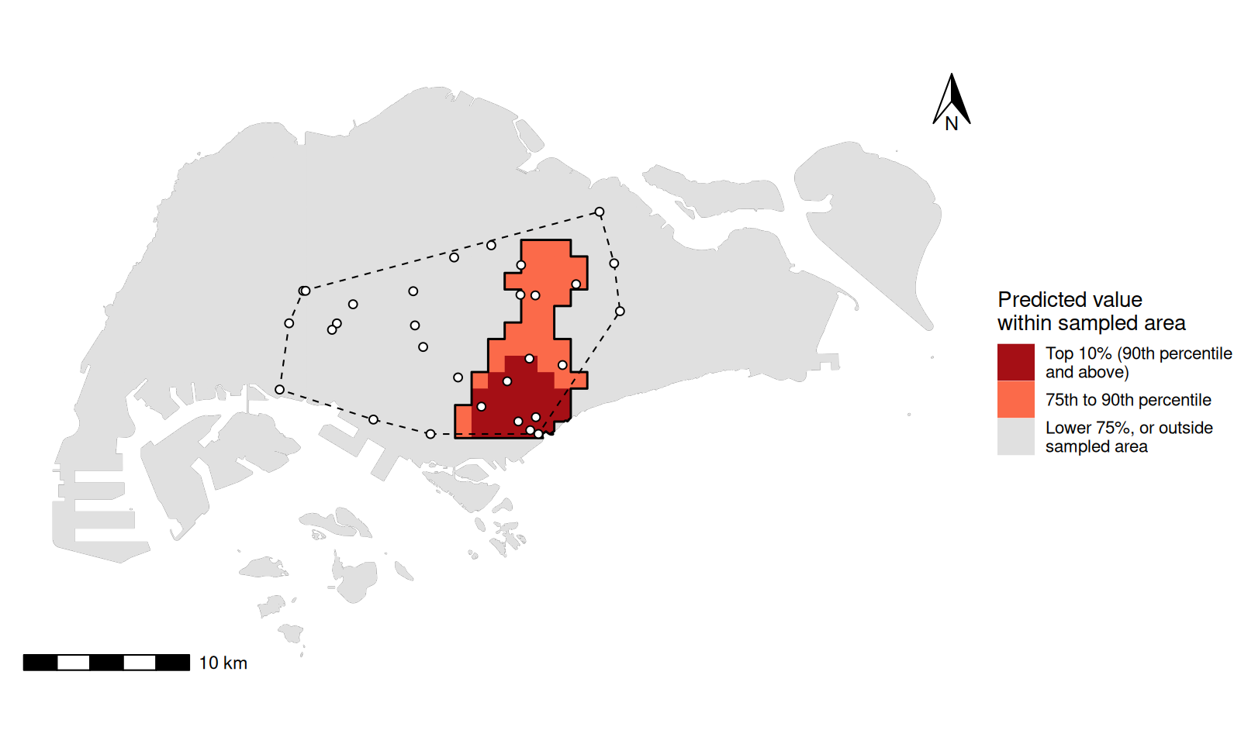
Figure 8: High-risk zones within the sampled area: top 10% (at least 2.57 cases) and the 75th to 90th percentile band (from 2.01 cases). Black outline: contiguous top-25% zone.

5.3 Sanity checks
Table 8: Sanity checks on the kriged surface and its variance.
Check | Result | Expectation
Range of predictions | 0.60 to 3.96 cases | Within observed 0 to 6
Negative predictions | 0 | None for counts
Mean prediction (sampled area) | 1.65 | Below observed mean 1.87
SD of predictions (sampled area) | 0.68 | Below observed SD 1.72
Range of kriging variance | 1.84 to 2.72 cases² | Above the nugget 1.47 away from sites
Variance vs. nearest site distance | Spearman 0.96 | Rises away from the data
Mean variance inside / outside hull | 2.19 / 2.65 | Higher outside
Variance after permuting counts | maximum change 0 | Unchanged for fixed variogram
Leave-one-out RMSE | 1.40 (control 1.75) | Lower than the control
Leave-one-out z-scores | mean -0.01, SD 0.97 | Mean near 0, SD near 1
Moran’s I of leave-one-out residuals | -0.10 (p 0.727) | No positive autocorrelation detected

The surface met every check (Table 8, Figure 9). Predictions stayed within the observed range, with none negative. The kriging variance was lowest next to sites, increased with distance to the nearest site (Spearman’s $ρ$ = 0.96) and leveled off beyond about 7 km at the sill plus the variance of the estimated mean. It never fell below the nugget away from the sites, because a new count at an unsampled location is uncertain by at least the nugget; at a site itself, ordinary kriging returns the observation with zero variance. Randomly permuting the counts among the sites left the variance unchanged while changing the predictions (correlation with the original surface -0.51). The variance therefore reflects the sampling layout rather than the counts (Dickens 2026b): it shows where predictions are supported, not where risk is high.
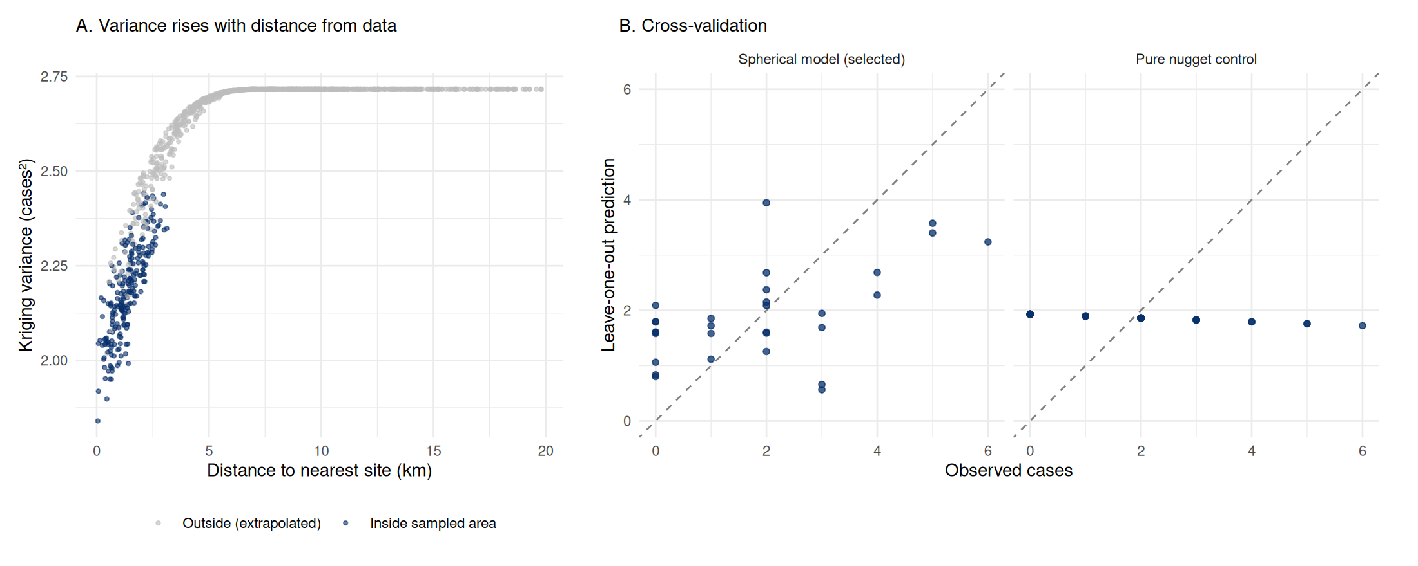
Figure 9: Sanity checks. (A) Kriging variance against distance to the nearest site. (B) Leave-one-out predictions for the selected model and the pure-nugget control.

5.4 Smoothing and threshold exceedance
The surface is smoothed as expected: within the sampled area the SD of the predictions (0.68) is well below that of the observations (1.72), and cross-validation underpredicts the highest counts and overpredicts the zeros (Figure 9 B). The 200 conditional simulations used 3,532 lattice points across the sampled area.
Table 9: Share of squares in the sampled area exceeding each threshold: on the kriged map, and averaged over 200 conditional simulations of 1 km² block means and of point values.
Threshold (cases) | Kriged map | Simulated 1 km² blocks | Simulated points
2 | 25.6% | 36.8% | 41.7%
3 | 6.3% | 11.4% | 20.8%
4 | 0.0% | 2.1% | 8.0%

Compared with simulated averages over the squares, the point-support kriged map shows about half as many squares above 3 cases as the simulations (6.3% against 11.4%), and none above 4 cases, against 2.1% in the simulations (Table 9). Point values exceed the thresholds more often (20.8% above 3 cases) because they retain the nugget variation that averages out within a square. The probability that a square’s mean exceeds 3 cases reaches 0.94 in the top-10% core and exceeds 0.5 in 52% of the core’s squares (Figure 10). Because the simulations are conditioned on the same data and centered on the kriged surface, they do not independently confirm the location of the zones; they illustrate the variability and threshold exceedance suppressed by smoothing. Treating counts as Gaussian makes these probabilities approximate.
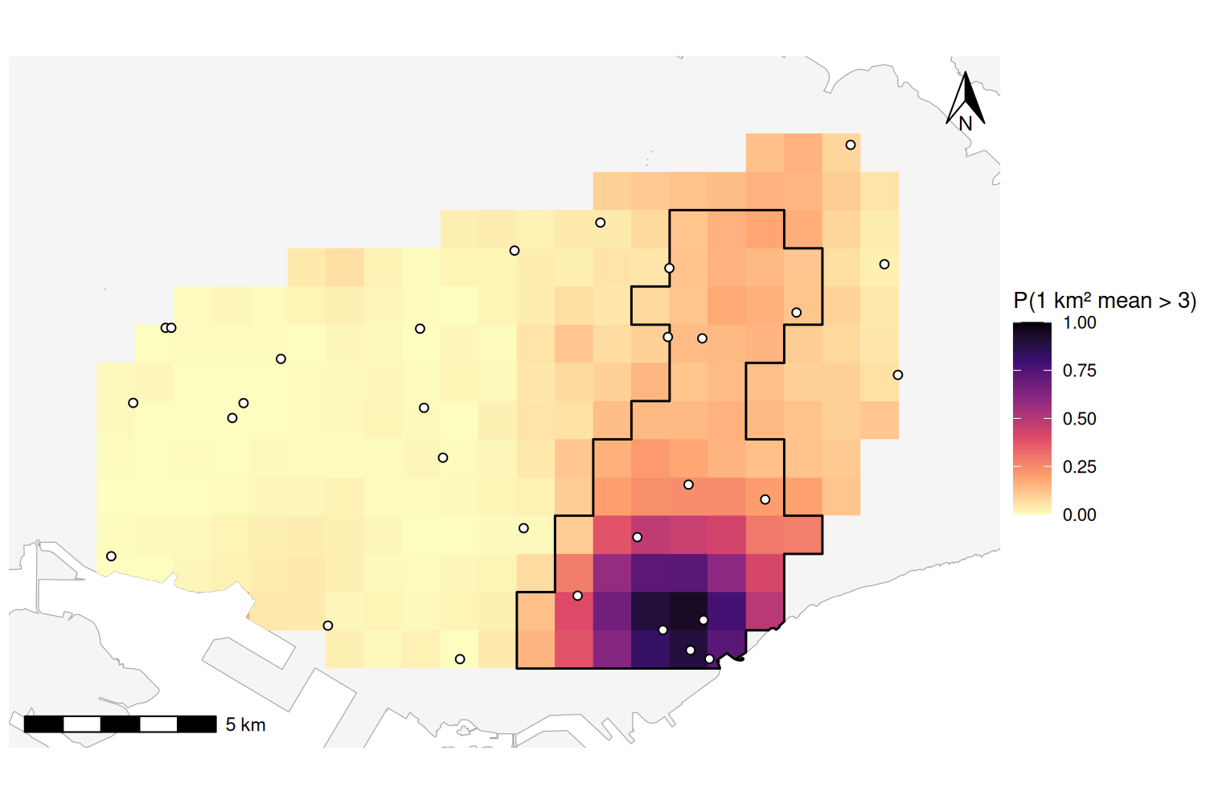
Figure 10: Probability that the mean of each square exceeds 3 cases, from 200 conditional simulations at 1 km² block support. Black outline: top-25% zone.

6. Spatial correlation with green space

6.1 Overlay and regression
The high-prediction band coincides with low green cover (Figure 11): 9 of the 10 sites inside the top-25% zone have 26% to 44% cover, the exception being site 17 in Hougang (52.5%). The lowest predictions in the west coincide with the greenest sites.
Spearman’s $ρ$ between cases and green space was -0.43 (p = 0.017).
Table 10: Poisson regression of case counts on green space (per 10 percentage points). Ratios are exponentiated coefficients. Green space: profile-likelihood interval and likelihood ratio p-value. Intercept (expected count at 0% green space): Wald statistics.
Term | Log coef. | SE | Ratio | 95% CI | p
Intercept | 2.057 | 0.454 | 7.82 | 3.21 to 19.04 | <0.001
Green space (per 10 points) | -0.314 | 0.102 | 0.73 | 0.59 to 0.89 | 0.001

Each additional 10 percentage points of green space multiplied the expected count by 0.73 (27% fewer cases; 95% CI 0.59 to 0.89; likelihood ratio p = 0.001; Table 10, Figure 12 A). The intercept lies outside the observed range of green space and has no substantive meaning. The Pearson dispersion statistic was 1.30, and a quasi-Poisson fit widened the interval only slightly (Wald interval 0.58 to 0.92). Green space explained 19% of the null deviance. Without a denominator, the ratio compares expected counts at sites, not incidence rates.
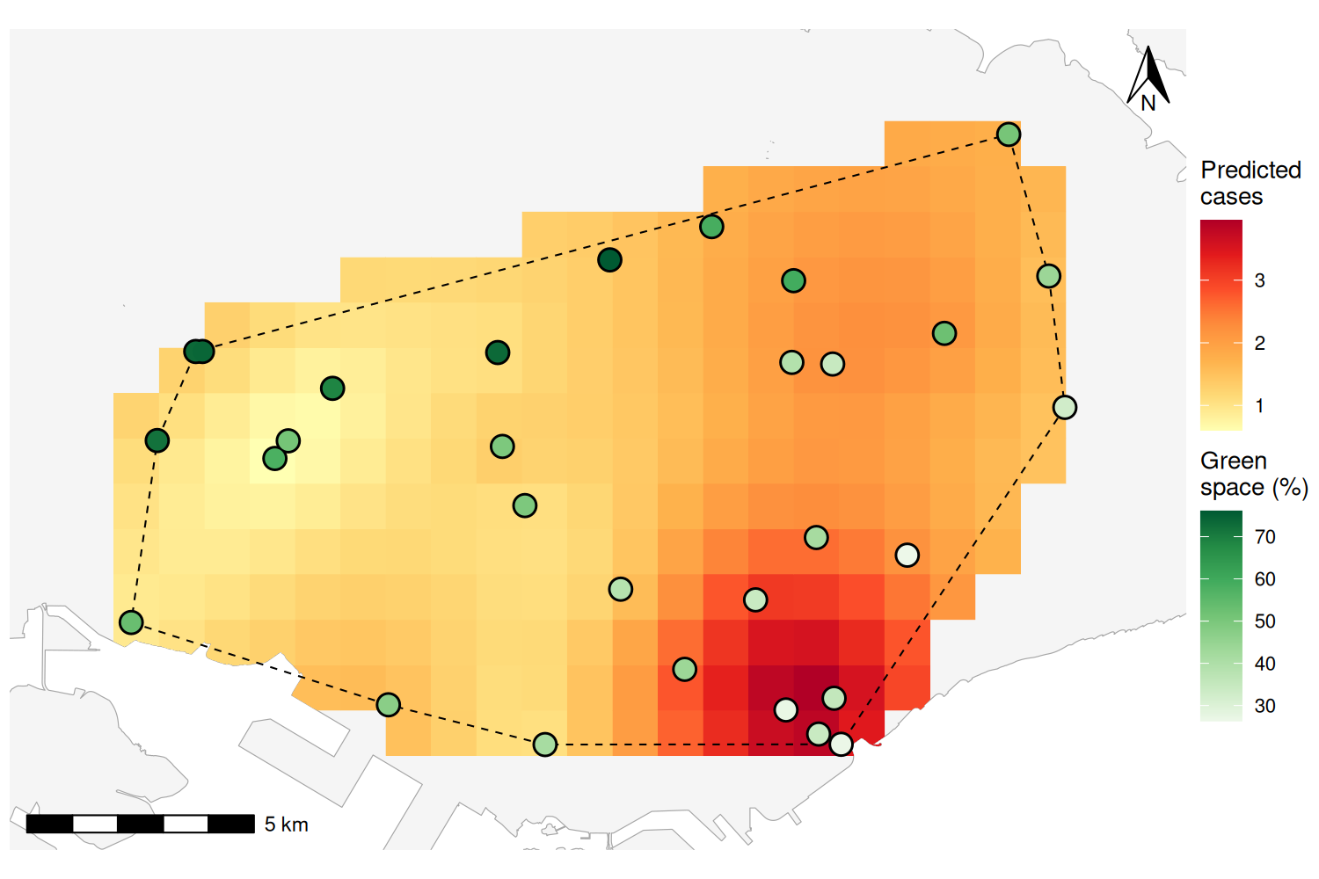
Figure 11: Green space at each site overlaid on the kriged surface within the sampled area.

6.2 Residual spatial dependence
The shortest distance band that leaves no site without a neighbor was 4.06 km.
Table 11: Moran’s I (p-value) for the case counts, the Pearson residuals of the Poisson model and the residuals of a linear model, with robust LM test p-values for the linear model. Links: mean number of neighbors. All Moran p-values are one-sided for positive autocorrelation. Counts and Poisson residuals use 9,999 permutations; linear-model values are from spdep::lm.morantest and spdep::lm.RStests (adjusted statistics).
Neighbors | Links | Counts | Poisson resid. | Linear resid. | LM error | LM lag
4 nearest | 5.1 | 0.422 (<0.001) | 0.017 (0.281) | 0.098 (0.055) | 0.024 | 0.007
4.06 km band | 4.3 | 0.424 (<0.001) | -0.032 (0.468) | 0.064 (0.158) | 0.024 | 0.010

The counts were clearly clustered (I = 0.422 and 0.424, both p $≤$ 0.001; Table 11), but positive autocorrelation was not detected in the Pearson residuals of the Poisson model (I = 0.017 and -0.032, p $≥$ 0.28). The linear model gave a less clear result. Its residual Moran’s I was borderline (p = 0.055 and 0.158), but the robust LM tests for both error and lag dependence were significant (p = 0.007 to 0.024). A straight line misfits the convex relationship between counts and green space (Figure 12 A), which leaves structure in its residuals, and all of these tests have low power with 30 sites. Consistent with the Poisson result, the variogram of residuals from a linear green-space trend is flat at their variance (2.31 cases²), whereas that of the raw counts rises with distance (Figure 12 B).
Green space therefore accounts for most of the spatial clustering described by the kriging model, but some residual dependence cannot be excluded. The course heuristic recommends considering a spatial Durbin model when both robust tests are significant (Dickens 2026a), but these tests do not identify it uniquely; for counts at 30 sites, a spatial Poisson model is the more appropriate extension (Section 8.3).
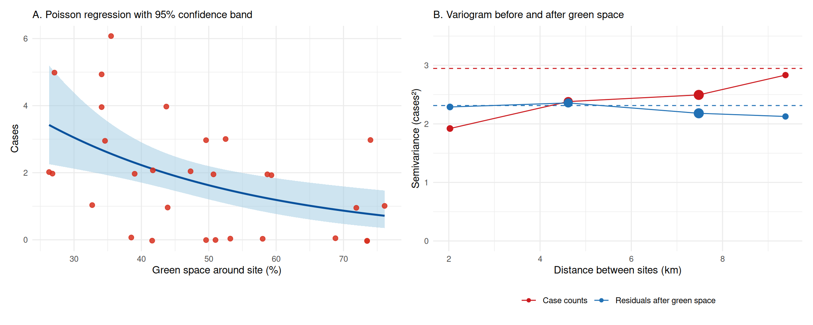
Figure 12: (A) Case counts against green space, with the fitted Poisson curve and 95% confidence band (points slightly jittered vertically). (B) Empirical variograms of the counts and of the residuals from a linear green-space trend (3 km bins); dashed lines mark each series’ variance.

7. Outbreak profiling and intervention targeting

7.1 Outbreak size
Under the assumption that each count reflects about 1 km² around its site (Table 12), integrating the surface over the top-25% zone gives 143 cases, or 2.6 per km². Block kriging of the same squares gives 143.0 cases against 143.5 from point predictions, so point and block estimates of this total are similar under the fitted model. If each count instead reflects the 6.4 km² of sampled land per site (land inside the convex hull divided by 30), all densities fall by that factor, to 0.4 per km² (23 cases). For comparison, the 10 sites inside the zone recorded 36 of the 56 cases (0.65 per km² of zone).
Table 12: Outbreak profile of the high-risk zones under two assumptions about the area each count represents.
Measure | Top-25% zone | Top-10% core
Area (km²) | 55.7 | 22.7
1 km squares | 56 | 23
Mean predicted value | 2.58 | 3.18
Estimated cases, 1 km² catchment | 143 | 72
Estimated per km², 1 km² catchment | 2.57 | 3.18
Estimated cases, 6.4 km² catchment | 23 | 11
Estimated per km², 6.4 km² catchment | 0.40 | 0.50
Intensity relative to lower 75% | 1.9 | 2.4
Sampled sites inside | 10 | 7
Recorded cases | 36 | 28
Recorded cases per km² | 0.65 | 1.23

The zone’s predicted intensity is 1.9 times the area-weighted mean of the lower 75% of the sampled area and the core’s is 2.4 times; the core covers 22.7 km² and contains 7 sites with 28 recorded cases.

7.2 Two temporary intervention centers
The 2024 club dataset flags five clubs near the zone as under construction or pending upgrading or relocation (Braddell Heights, Paya Lebar Kovan, Toa Payoh Central, Mountbatten and Bidadari), but the current official directory lists all of them as operating (People’s Association 2026), so the flags were disregarded. After removing one superseded address and venues that are not community clubs, 116 clubs remained, of which 32 lay within 500 m of an MRT exit and within 1 km of the top-25% zone, giving 496 candidate pairs.
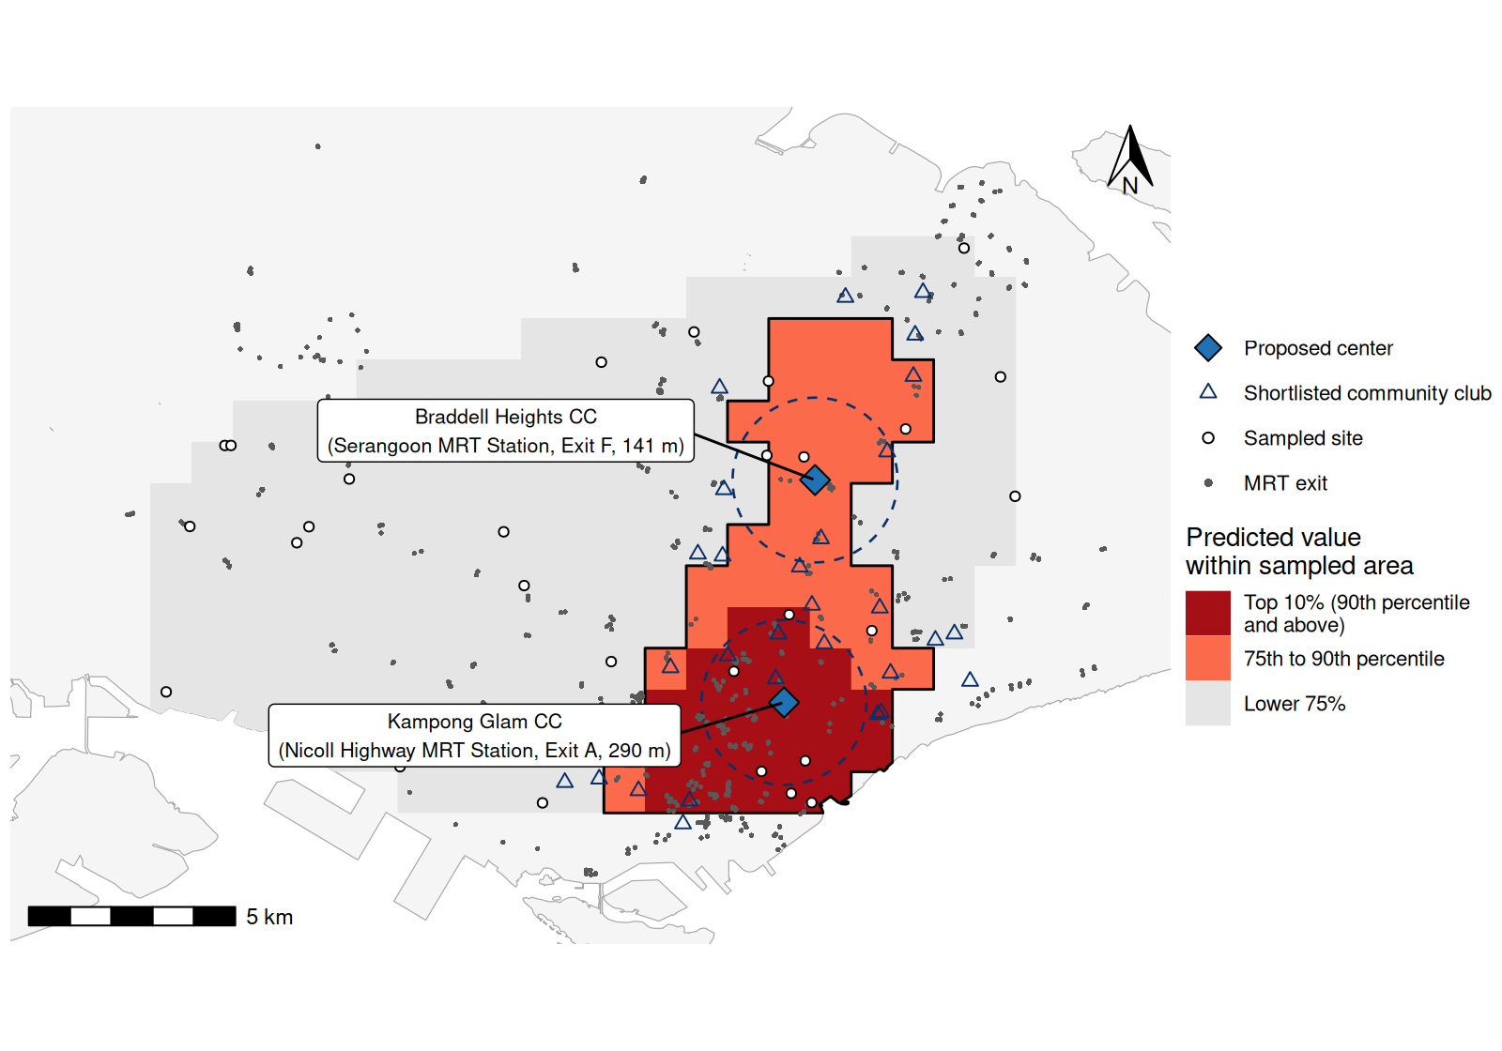
Figure 13: Proposed intervention centers (blue diamonds) with 2 km rings, shortlisted community clubs (triangles), MRT exits (gray points) and the high-risk zone.

Table 13: Proposed temporary intervention centers.
 | Braddell Heights CC | Kampong Glam CC
Address | 50 Serangoon Avenue 2 556129 | 385 Beach Road 199581
Planning area | Serangoon | Kallang
Nearest MRT exit | Serangoon, Exit F | Nicoll Highway, Exit A
Distance to exit (m) | 141 | 290
High-risk squares served | 23 | 33
Estimated cases served | 49 | 95
Mean distance served (km) | 2.15 | 2.13

Braddell Heights Community Club (50 Serangoon Avenue 2) lies in the northern part of the zone, 141 m from Exit F of Serangoon MRT station, an interchange of the North East and Circle lines next to Serangoon bus interchange. It is the nearer center for 23 squares holding about 49 estimated cases in the Serangoon, Hougang and Toa Payoh estates. Kampong Glam Community Club (385 Beach Road) lies inside the top-10% core, 290 m from Exit A of Nicoll Highway MRT station. It is the nearer center for 33 squares holding about 95 estimated cases, between the city center, Kampong Glam and Kallang, and is within reach of the daytime workforce around Marina Bay. The official directory, checked on 7 and 8 October 2026, lists both clubs at these addresses as wheelchair accessible (People’s Association 2026).
The case-weighted mean distance to the nearer center is 2.14 km; 40% of the zone’s estimated cases lie within 2 km of a center, and the farthest square is 4.4 km away (Figure 13). The same pair was selected under every alternative variogram model and without site 25 (Table 14). The objective is flat near its minimum, however: replacing Kampong Glam with Jalan Besar CC adds 51 m to the mean distance, and replacing Braddell Heights with Paya Lebar Kovan CC adds 82 m. Either is a reasonable substitute if a proposed venue is unavailable.

8. Interpretation and limitations

8.1 Strengths and limitations of kriging with 30 sites
Kriging derives its weights from the spatial correlation of the data rather than from an arbitrary inverse-distance power, shares weight among clustered sites (such as the four around Marina Bay) instead of counting each in full, and provides a prediction variance that separates supported predictions from extrapolations. Here it reduced cross-validated error by 20% relative to the mean-only model, with z-score SDs near one in every sensitivity scenario ( 0.95 to 1.04). The top-25% zone was largely stable across alternative variograms (Jaccard overlap 0.84 or more), and the same centers were chosen each time (Table 14).
Table 14: Sensitivity of the results to the variogram and data choices. Range: practical range (km). Overlap: Jaccard index between each scenario’s top-25% squares and those of the selected model. Same centers: whether the p-median again chose Braddell Heights CC and Kampong Glam CC.
Scenario | Nugget | Psill | Range | RMSE | z SD | Overlap | Same centers
Spherical (selected) | 1.47 | 1.09 | 7.1 | 1.402 | 0.97 | 1.00 | Yes
Exponential, same bins | 1.17 | 1.51 | 8.9 | 1.413 | 0.99 | 0.84 | Yes
Gaussian, same bins | 1.76 | 0.86 | 7.5 | 1.406 | 0.95 | 0.84 | Yes
Spherical, 2.5 km bins | 1.40 | 1.30 | 9.1 | 1.438 | 1.01 | 0.84 | Yes
Without site 25 | 0.79 | 1.75 | 6.3 | 1.273 | 0.96 | 0.84 | Yes
Universal kriging (x, y) | 2.02 | 0.00 | none | 1.541 | 1.04 | 0.45 | No

Most limitations follow from the sample size. The variogram is barely estimable: only 38 pairs are closer than 3 km, the 30-pair rule leaves four bins for three parameters, and 134 of 180 settings failed to converge. Across the stable fits the nugget ranged from 1.17 to 1.76 and the practical range from 7.1 to 9.1 km. Thirty sites is far below the 100 to 150 recommended for variogram estimation (Webster and Oliver 1992) and at the lower limit of 30 to 50 well-spread points below which a stable variogram is rarely obtained (Dickens 2026b). Single sites are influential: site 25 reported 3 cases while the five sites within 3 km of it reported 0 or 1, and removing it nearly halved the nugget (1.47 to 0.79) and raised the maximum prediction from 3.96 to 4.70. With a nugget of 57% of the sill and a median spacing of 1.9 km, the surface cannot resolve hotspots smaller than a few kilometers, and 78% of the squares are extrapolations.
The model is also misspecified for counts. Ordinary kriging is a linear predictor that ignores the discreteness of counts and the dependence of their variance on the mean, and Gaussian assumptions enter its intervals and the simulations. Without denominators it cannot separate risk from the number of people present, and the unknown support of the counts changes outbreak densities about six-fold (Gotway and Young 2002). The constant-mean assumption is doubtful given the large-scale gradient, but universal kriging with a linear trend in the coordinates performed worse: its residual variogram could only be fitted as a pure nugget, its RMSE was higher (1.54), and it predicted negative values (minimum -2.00) in extrapolated areas. Green space explains much of the gradient but cannot serve as a trend variable, because it is known only at the sites (Dickens 2026b). Isotropy cannot be tested with so few pairs per direction, and if sites were chosen because of high counts, preferential sampling would bias both the mean and the variogram (Diggle et al. 2010).

8.2 Green space as an environmental facilitator or barrier
The illness is not named, and green space could act in either direction depending on how it is transmitted. The observed negative association is consistent with green space as a barrier. Greener areas have fewer residents, workers and buildings, so contact rates for person-to-person transmission are lower. For dengue, transmission in Singapore is urban: Aedes aegypti breeds mainly in domestic containers (Ooi et al. 2006) and in outdoor drains, and incidence is highest in low-rise housing, where drainage networks are densest (Seidahmed et al. 2018). Green space is also associated with better general health and lower physiological stress (Twohig-Bennett and Jones 2018), which could reduce susceptibility or severity.
Vegetation can instead facilitate transmission by sheltering vectors and reservoir hosts. Aedes albopictus, originally a forest species, breeds in natural containers such as tree holes (Paupy et al. 2009), and leptospirosis is sustained by rodent reservoirs, contaminated soil and water, and recreational exposure (Bharti et al. 2003). These mechanisms could produce a positive association. The negative ecological association here cannot identify the transmission mechanism; population density could conceal a positive effect of vegetation.
A more parsimonious explanation is confounding by urban form. The least green sites are in the city center and dense estates and the greenest in nature reserves and the western green belt, so without denominators the count ratio of 0.73 cannot distinguish lower risk per person from fewer people at risk. The lack of detected positive residual autocorrelation is consistent with green space capturing part of the spatial gradient, but does not establish causality. Factors with a similar gradient, such as housing type or daytime population, could also explain the pattern. The association is ecological and cross-sectional and cannot be transferred to individuals (Morgenstern 1995). The buffer radius and type of green cover (managed parks or forest) are also unknown, and both bear on the mechanism.

8.3 Additional data
Population denominators (resident population by subzone and daytime working population) would convert counts to rates and allow Poisson kriging (Goovaerts 2005) or model-based geostatistics with an offset (Diggle et al. 1998). Information on the area or population each count represents would also fix the conversion to cases per km², which currently varies six-fold. Island-wide covariates, such as satellite vegetation indices or land-cover maps, housing type and building density, would allow kriging with external drift, so that the green-space association could inform predictions in the unsampled north, west and east. A denser design of about 100 to 150 sites (Webster and Oliver 1992), including pairs less than 1 km apart and sites in the unsampled regions, would stabilize the variogram and remove most of the extrapolation.
Case addresses, onset dates and the observation period would allow a space-time analysis of whether the zone is growing, moving or waning. If the illness is vector-borne, entomological surveillance, rainfall and temperature would allow the facilitator and barrier mechanisms to be tested directly. Bayesian disease-mapping models at subzone level (Besag et al. 1991; Waller and Gotway 2004) or continuous spatial count models fitted by the SPDE approach (Lindgren et al. 2011) would accommodate the residual dependence noted in Section 6.2 and propagate uncertainty to zone boundaries and outbreak size. Finally, walking and public transport travel times, hall capacity, opening hours and operator agreement are needed before the proposed centers can be confirmed.

8.4 Conclusion
With 30 sites, spatial correlation could be estimated only under carefully chosen settings, and most automated fits failed. A spherical variogram with 3 km bins converged and improved cross-validated prediction over a no-correlation model, with standardized error SD near one. Kriging identified one high-risk zone from Marina Bay to Hougang, consistent across alternative variograms, with about twice the predicted intensity of the rest of the sampled area. Green cover is lowest in this zone and accounts for most of the spatial clustering, although without denominators the association cannot be read causally. Braddell Heights and Kampong Glam Community Clubs are accessible, well-placed venues for temporary intervention centers. Uncertainty in the variogram, the unknown support of the counts and the large unsampled area limit the operational use of the map.

Declaration of AI use
Claude Code (Anthropic) and Codex (OpenAI) were used extensively in the preparation of this assignment: to write and debug the R code, to draft and revise the report, and to help me understand the background material and lectures required to perform the tasks. I take full responsibility for the submitted work.

References
Anselin, Luc, Anil K. Bera, Raymond Florax, and Mann J. Yoon. 1996. “Simple Diagnostic Tests for Spatial Dependence.” Regional Science and Urban Economics 26 (1): 77-104. https://doi.org/10.1016/0166-0462(95)02111-6.
Besag, Julian, Jeremy York, and Annie Mollié. 1991. “Bayesian Image Restoration, with Two Applications in Spatial Statistics.” Annals of the Institute of Statistical Mathematics 43 (1): 1-20. https://doi.org/10.1007/BF00116466.
Bharti, Ajay R., Jarlath E. Nally, Jessica N. Ricaldi, et al. 2003. “Leptospirosis: A Zoonotic Disease of Global Importance.” The Lancet Infectious Diseases 3 (12): 757-71. https://doi.org/10.1016/S1473-3099(03)00830-2.
Bivand, Roger S., and David W. S. Wong. 2018. “Comparing Implementations of Global and Local Indicators of Spatial Association.” TEST 27 (3): 716-48. https://doi.org/10.1007/s11749-018-0599-x.
Cambardella, C. A., T. B. Moorman, J. M. Novak, et al. 1994. “Field-Scale Variability of Soil Properties in Central Iowa Soils.” Soil Science Society of America Journal 58 (5): 1501-11. https://doi.org/10.2136/sssaj1994.03615995005800050033x.
Cressie, Noel. 1985. “Fitting Variogram Models by Weighted Least Squares.” Journal of the International Association for Mathematical Geology 17 (5): 563-86. https://doi.org/10.1007/BF01032109.
Cressie, Noel. 1993. Statistics for Spatial Data. Revised. Wiley. https://doi.org/10.1002/9781119115151.
Dickens, Borame L. 2026a. SPH5105 Session 5: Spatial Regression Models (Lecture, Code and Worked Answers). Course materials, Saw Swee Hock School of Public Health, National University of Singapore.
Dickens, Borame L. 2026b. SPH5105 Session 6: Kriging and Interpolation (Lecture, Code Handbook, Exercises and Worked Answers). Course materials, Saw Swee Hock School of Public Health, National University of Singapore.
Diggle, Peter J., Raquel Menezes, and Ting-li Su. 2010. “Geostatistical Inference Under Preferential Sampling.” Journal of the Royal Statistical Society: Series C (Applied Statistics) 59 (2): 191-232. https://doi.org/10.1111/j.1467-9876.2009.00701.x.
Diggle, Peter J., J. A. Tawn, and R. A. Moyeed. 1998. “Model-Based Geostatistics.” Journal of the Royal Statistical Society: Series C (Applied Statistics) 47 (3): 299-350. https://doi.org/10.1111/1467-9876.00113.
Goovaerts, Pierre. 1997. Geostatistics for Natural Resources Evaluation. Oxford University Press. https://doi.org/10.1093/oso/9780195115383.001.0001.
Goovaerts, Pierre. 2005. “Geostatistical Analysis of Disease Data: Estimation of Cancer Mortality Risk from Empirical Frequencies Using Poisson Kriging.” International Journal of Health Geographics 4: 31. https://doi.org/10.1186/1476-072X-4-31.
Gotway, Carol A., and Linda J. Young. 2002. “Combining Incompatible Spatial Data.” Journal of the American Statistical Association 97 (458): 632-48. https://doi.org/10.1198/016214502760047140.
Gräler, Benedikt, Edzer Pebesma, and Gerard Heuvelink. 2016. “Spatio-Temporal Interpolation Using gstat.” The R Journal 8 (1): 204-18. https://doi.org/10.32614/RJ-2016-014.
Hakimi, S. L. 1965. “Optimum Distribution of Switching Centers in a Communication Network and Some Related Graph Theoretic Problems.” Operations Research 13 (3): 462-75. https://doi.org/10.1287/opre.13.3.462.
Journel, Andre G., and Charles J. Huijbregts. 1978. Mining Geostatistics. Academic Press.
Land Transport Authority. 2026. LTA MRT Station Exit. Data.gov.sg. https://data.gov.sg/datasets/d_b39d3a0871985372d7e1637193335da5/view.
Lindgren, Finn, Håvard Rue, and Johan Lindström. 2011. “An Explicit Link Between Gaussian Fields and Gaussian Markov Random Fields: The Stochastic Partial Differential Equation Approach.” Journal of the Royal Statistical Society: Series B (Statistical Methodology) 73 (4): 423-98. https://doi.org/10.1111/j.1467-9868.2011.00777.x.
Matheron, Georges. 1963. “Principles of Geostatistics.” Economic Geology 58 (8): 1246-66. https://doi.org/10.2113/gsecongeo.58.8.1246.
Moran, P. A. P. 1950. “Notes on Continuous Stochastic Phenomena.” Biometrika 37 (1/2): 17-23. https://doi.org/10.2307/2332142.
Morgenstern, Hal. 1995. “Ecologic Studies in Epidemiology: Concepts, Principles, and Methods.” Annual Review of Public Health 16: 61-81. https://doi.org/10.1146/annurev.pu.16.050195.000425.
Oliver, M. A., and R. Webster. 2014. “A Tutorial Guide to Geostatistics: Computing and Modelling Variograms and Kriging.” Catena 113: 56-69. https://doi.org/10.1016/j.catena.2013.09.006.
Ooi, Eng-Eong, Kee-Tai Goh, and Duane J. Gubler. 2006. “Dengue Prevention and 35 Years of Vector Control in Singapore.” Emerging Infectious Diseases 12 (6): 887-93. https://doi.org/10.3201/eid1206.051210.
Paupy, C., H. Delatte, L. Bagny, V. Corbel, and D. Fontenille. 2009. “Aedes albopictus, an Arbovirus Vector: From the Darkness to the Light.” Microbes and Infection 11 (14-15): 1177-85. https://doi.org/10.1016/j.micinf.2009.05.005.
Pebesma, Edzer J. 2004. “Multivariable Geostatistics in S: The gstat Package.” Computers & Geosciences 30 (7): 683-91. https://doi.org/10.1016/j.cageo.2004.03.012.
Pebesma, Edzer J. 2018. “Simple Features for R: Standardized Support for Spatial Vector Data.” The R Journal 10 (1): 439-46. https://doi.org/10.32614/RJ-2018-009.
Pebesma, Edzer J., and Benedikt Gräler. 2026. gstat: Spatial and Spatio-Temporal Geostatistical Modelling, Prediction and Simulation. https://CRAN.R-project.org/package=gstat.
People’s Association. 2024. Community Clubs. Data.gov.sg. https://data.gov.sg/datasets/d_f706de1427279e61fe41e89e24d440fa/view.
People’s Association. 2026. onePA Community Club Directory. Onepa.gov.sg. https://www.onepa.gov.sg/cc.
Seidahmed, Osama M. E., Deng Lu, Chee Seng Chong, Lee Ching Ng, and Elfatih A. B. Eltahir. 2018. “Patterns of Urban Housing Shape Dengue Distribution in Singapore at Neighborhood and Country Scales.” GeoHealth 2 (1): 54-67. https://doi.org/10.1002/2017GH000080.
Twohig-Bennett, Caoimhe, and Andy Jones. 2018. “The Health Benefits of the Great Outdoors: A Systematic Review and Meta-Analysis of Greenspace Exposure and Health Outcomes.” Environmental Research 166: 628-37. https://doi.org/10.1016/j.envres.2018.06.030.
Urban Redevelopment Authority. 2019. Master Plan 2019 Subzone Boundary (No Sea). Data.gov.sg. https://data.gov.sg/datasets/d_8594ae9ff96d0c708bc2af633048edfb/view.
Waller, Lance A., and Carol A. Gotway. 2004. Applied Spatial Statistics for Public Health Data. Wiley. https://doi.org/10.1002/0471662682.
Webster, R., and M. A. Oliver. 1992. “Sample Adequately to Estimate Variograms of Soil Properties.” Journal of Soil Science 43 (1): 177-92. https://doi.org/10.1111/j.1365-2389.1992.tb00128.x.

Appendix A: Reproducibility
The modular analysis code, input data, and report are available in the public kriging-incidence repository.
The analysis runs through run_analysis.R, which calls the modules in R/, in about one minute (seed 5105), using R version 4.4.1 (2024-06-14), sf 1.1.3 (Pebesma 2018), gstat 2.1.6 (Pebesma 2004; Gräler et al. 2016), spdep 1.4.2 (Bivand and Wong 2018), dplyr 1.1.4, ggplot2 4.0.0 and GDAL 3.8.4; the last run was 2026-10-09 14:06 +08. External layers were downloaded from data.gov.sg on 7 October 2026: the URA 2019 subzone boundary (Urban Redevelopment Authority 2019), People’s Association community clubs (People’s Association 2024) and LTA MRT station exits (Land Transport Authority 2026). Club status and accessibility were checked against the official directory (People’s Association 2026).
A separate script, tests/check_outputs.R, independently recomputes key results, including the empirical variogram without gstat, the kriging predictions and variances from a direct solution of the kriging equations, the quantile thresholds and zone totals, the optimality of the chosen centers by brute force, the Poisson model and Moran’s I. All checks passed, and a fresh run in an empty folder reproduced every output table exactly.
Table 15: All stable variogram fits, with leave-one-out cross-validation. Bins: width / cutoff (km). Starts: number of the four starting values that converged cleanly. Range: practical range (km).
Model | Bins | Weights | Starts | Nugget | Psill | Range | RMSE | z SD
Spherical | 3 / 10 | N/h² | 2 | 1.47 | 1.09 | 7.1 | 1.402 | 0.965
Gaussian | 3 / 10 | N | 3 | 1.76 | 0.86 | 7.5 | 1.406 | 0.954
Exponential | 3 / 10 | N/h² | 3 | 1.17 | 1.51 | 8.9 | 1.413 | 0.988
Spherical | 2.5 / 9 | N | 2 | 1.39 | 1.23 | 8.4 | 1.424 | 1.000
Spherical | 2.5 / 10 | N | 2 | 1.40 | 1.30 | 9.1 | 1.438 | 1.009

Appendix B: R code
#!/usr/bin/env Rscript
# Run from the repository root: Rscript run_analysis.R
# Modules exchange explicit named lists; no intermediate objects enter .GlobalEnv.
main <- function() {
if (!file.exists("R/setup.R")) stop("Run from the kriging-incidence repository root.")
modules <- c("setup", "variogram_helpers", "zone_helpers", "facility_helpers",
"sensitivity_helpers", "data", "variograms", "kriging", "green_space",
"facilities", "sensitivity", "export")
for (module in modules) source(file.path("R", paste0(module, ".R")), local = TRUE)
load_dependencies()
config <- pipeline_config()
set.seed(config$seed)
message("Preparing data...")
data <- prepare_data(config)
message("Fitting and validating variograms...")
variograms <- fit_variograms(data, config)
message("Kriging and conditional simulation...")
surface <- interpolate_counts(data, variograms, config)
message("Green-space association and spatial diagnostics...")
green <- analyze_green_space(data, variograms, surface, config)
message("Optimizing center placement...")
facilities <- place_centers(data, surface, config)
message("Checking sensitivity...")
sensitivity <- analyze_sensitivity(data, variograms, surface, facilities, config)
export_results(data, variograms, surface, green, facilities, sensitivity, config)
}
main()
The complete implementation is in the repository’s R/ directory: data.R prepares and maps the observations; variograms.R fits and selects models; kriging.R interpolates counts and constructs zones; green_space.R fits the count models and checks spatial dependence; facilities.R optimizes center placement; sensitivity.R evaluates alternative specifications; and export.R saves the report inputs. Shared numerical helpers and output configuration are kept in separate modules. Run Rscript run_analysis.R from the repository root, then Rscript tests/check_outputs.R and python3 tests/check_reproduction.py.

