RIGCHECK

Product, UX, Branding & Technical Architecture Document
  - Final consolidated specification, technical stack, development standards, and delivery roadmap
Version 1.0 • 17 October 2026 • Final consolidated planning document

Purpose of this document
This is the living source of truth for RigCheck planning. It records decisions already agreed, candidate ideas that still need evaluation, and visual sketches that help us discuss the experience. We will update this document as planning continues.
Planning is sufficiently complete to begin implementation. This document consolidates the prior product and UX plan with the final branding, architecture, technology stack, development standards, and delivery phases. Recommendations are treated as confirmed decisions unless the project owner explicitly changes them. Coding starts only after explicit go-ahead.

Document map
1. Executive summary and product vision
2. Confirmed decisions and scope
3. User experience journeys
4. Concept drawings and low-fidelity wireframes
5. Game database and data-quality policy
6. Candidate data sources and links
7. Hardware identification and comparison principles
8. PC Builder concept
9. Trust, privacy, accessibility, and edge cases
10. Decisions still open
11. Planning checklist and change log
Appendix A. Source links and verification notes
How to read the status labels
CONFIRMED = agreed project decision. PROPOSED = a useful direction or sketch, not finalized. TO DECIDE = needs a future discussion. CANDIDATE SOURCE = possible external data source; not yet approved for production use.

1. Executive summary and product vision
RigCheck is a global, web-based PC gaming compatibility checker with a related PC build recommendation experience. The primary user goal is to answer “Can my PC run this game?” quickly and honestly. A secondary goal is to help users plan a compatible PC build around the games and performance targets that matter to them.
RigCheck is inspired by the functional approach of Can I Run It? by CtrlAltAlex, but not its visual design. The reference is for functional inspiration only. RigCheck should have its own identity and avoid a generic AI-generated look.

Product promise
Core promise
Help players understand whether their current PC meets a game’s published requirements, explain any likely limitations, and offer a sensible upgrade or build-planning path without making unsupported performance promises.

Primary audiences
- Players who want to look up a game’s system requirements before purchasing or installing it.
- Players who know their PC’s components and want an understandable component-by-component compatibility check.
- People planning a new PC around one or more games, a preferred resolution, a target FPS, and optionally a budget.
- Laptop owners, including users with integrated and dedicated graphics, who need model-specific rather than desktop-only guidance.

Product principles
- Game checker first; PC builder visible but secondary on the homepage.
- No account, sign-up, or application download required at launch.
- Tell users what is detected, what they entered, what is inferred, and what remains unknown.
- Prefer verified information over catalog size. Never fabricate missing system requirements.
- Explain the verdict. Do not hide behind a vague compatibility percentage.
- Recommend and explain; do not turn RigCheck into an online shop or shipping service.
- Do not promise FPS until reliable game-specific benchmark evidence is available.
- Preserve a user’s selected game and build preferences as they move between relevant screens.

2. Confirmed decisions and scope
Area | Status | Decision recorded
Product name | CONFIRMED | RigCheck.
Platform | CONFIRMED | Web only at launch. No separate mobile or desktop app planned for launch.
Accounts | CONFIRMED | No sign-up, login, user accounts, or mandatory email collection.
Audience | CONFIRMED | Global audience; users source recommended components themselves.
Homepage priority | CONFIRMED | “Can I Run This Game?” receives slightly more emphasis than PC building.
Game discovery | CONFIRMED | Users can search a game and read available requirements without entering specs, signing up, or downloading anything.
Launch game catalog | CONFIRMED | Begin with a smaller, carefully verified curated selection and expand over time.
FPS prediction | CONFIRMED | No FPS predictions at launch. Add only when reliable game-specific benchmark data becomes available.
Corrections | CONFIRMED | Users may report inaccurate game or requirement data; reports must be reviewed before acceptance.
Commerce | CONFIRMED | Not an ecommerce site. No cart, checkout, order management, live seller integration, or shipping/courier calculations at launch.
PC build outputs | CONFIRMED | Give complete component lists and let users find components themselves. No external parts listings are required at first.
Hardware detection | CONFIRMED | Browser-based, limited detection only. Users can manually provide or correct specifications.
Persistent profiles | CONFIRMED | No account-dependent profile. Current-session choices should be preserved during navigation; local save may be considered later.
Visual identity | TO DECIDE | Professional and original; avoid neon/cyberpunk/glassy/over-decorated AI-style visuals. No final colors or typefaces have been selected.
Implementation technology | TO DECIDE | No framework, database technology, or architecture is selected in this planning document.

In scope for the planned launch
- Search and view a curated game catalog with known minimum and recommended requirements.
- Optional hardware entry and limited browser-assisted detection, with user confirmation and correction.
- Explainable component-by-component compatibility outcomes.
- Practical guidance when the current PC may struggle or fall short, including settings considerations and relevant upgrade/build paths.
- A PC builder that produces Budget, Balanced, and High-Performance build options for chosen games and targets.
- Complete, compatible part lists with clear trade-offs and copy/save-friendly output.
- Source links, verification dates, data-quality status, and a reviewed correction-report pathway.
- Responsive layouts and accessible interaction states.

Explicitly out of scope at launch
- Native mobile app, desktop app, downloadable PC scanner, or background companion utility.
- User registration, login, cloud profiles, or mandatory email capture.
- Live FPS prediction, FPS overlays, automatic overclocking, or guarantees that a game will run at a particular frame rate.
- Retail checkout, product inventory, price comparisons based on live seller feeds, shipping costs, or courier calculations.
- A huge, unverified game catalog or automated acceptance of community-submitted requirements.
- An AI-only build generator that cannot validate physical component compatibility.

3. User experience journeys
The high-level UX journey mapping is complete. Detailed screen-by-screen layouts, final visual styling, exact interaction states, and mobile adaptations remain unfinished. The diagrams in Section 4 are planning sketches, not approved final UI.

3.1 Homepage
- Make game search the strongest first action.
- Show a clear “Check my PC” route, while providing an equally understandable manual-entry route.
- Show a small selection of popular/recent supported games to help users discover the catalog.
- Make PC Builder visible, but secondary to game checking.
- Keep the introduction brief; avoid a long marketing hero or lengthy explanation before the tool.
- Do not require registration or downloading software to use the core experience.

3.2 Game search and discovery
- Search should tolerate partial titles, common spelling variations, and alternate names when the data is available.
- Where games have editions, remasters, or separate PC versions, make the selected edition clear instead of treating them as interchangeable.
- Provide clear no-result and unsupported-game states. Users should be able to report a missing game rather than assume it is supported.
- Game requirements remain viewable before users enter hardware information.

3.3 Game details
- Show the game title, edition/platform information, release information when available, and minimum/recommended PC requirements.
- Display only fields published or verified for that game, such as OS, CPU, GPU, RAM, storage, DirectX/API, and other stated requirements.
- Show source attribution and last verification date for requirements.
- Provide a clear “Check Compatibility” path without hiding the requirements behind it.

3.4 Hardware detection and manual entry
- A normal browser can reliably expose only limited information, such as screen/display-related details in supported contexts; it generally cannot reliably identify exact CPU, GPU, RAM, or installed hardware drivers.
- Tell the user which fields are browser-detected, user-entered, or unknown; do not imply a full scan has happened.
- Offer manual entry and guided help identifying component models.
- Allow editing/correction of every detected or prefilled value.
- Account for laptops, dual-GPU systems, integrated graphics, and shared system memory.
- Keep the physical monitor’s current resolution separate from the target resolution a user wants to play at.

3.5 Compatibility results
- Show a plain-language outcome and explain each important component match or shortfall.
- Avoid a misleading single compatibility percentage as the primary verdict.
- Distinguish a match against published minimum/recommended requirements from actual game performance or FPS.
- Recognize at least four situations: suitable/likely to meet published requirements; may struggle; falls short; insufficient or conflicting data.
- When a PC is adequate, say so. Do not automatically push a user to build/buy a new PC.
- When performance may be limited, suggest realistic settings/target adjustments and identify the component(s) that need attention.

3.6 PC Builder journey
- Let users select one or more games, a target resolution, target FPS, and optionally a budget.
- Allow relevant optional preferences such as desktop versus full setup and new versus used parts; avoid asking unnecessary questions.
- Generate three comparison tiers: Budget, Balanced, and High-Performance.
- Each build should include the needed components: CPU, GPU, motherboard, RAM, storage, PSU, case, and cooling where required.
- Explain why components were selected, what trade-offs they involve, whether the list is compatible, and what to change if the target is unrealistic.
- Allow users to swap components, add another game, revise targets, and re-check compatibility without losing their selections.
- Let users copy/save a finished parts list and research purchases independently. External store links are not required for the first version.

3.7 Session, mobile, and edge-case behavior
- Preserve active selections during the current session as the user moves between game checks and build planning.
- Browser-local saving may be explored later; do not promise cross-device persistence without accounts or a confirmed mechanism.
- Support mobile layouts, readable text, keyboard access, explicit form labels, and verdicts that are not communicated by color alone.
- Plan for detection failure, unknown GPUs, multiple adapters, missing game requirements, conflicting sources, unsupported games, unrealistic budgets/targets, incompatible parts, and loss of local data.

4. Concept drawings and low-fidelity wireframes
Drawing status
These are newly created planning illustrations of the journeys already discussed. They do not finalize the RigCheck website’s design language, pixel-level layout, color palette, or component styling. As UX decisions are made, the drawings will be revised and the document version updated.
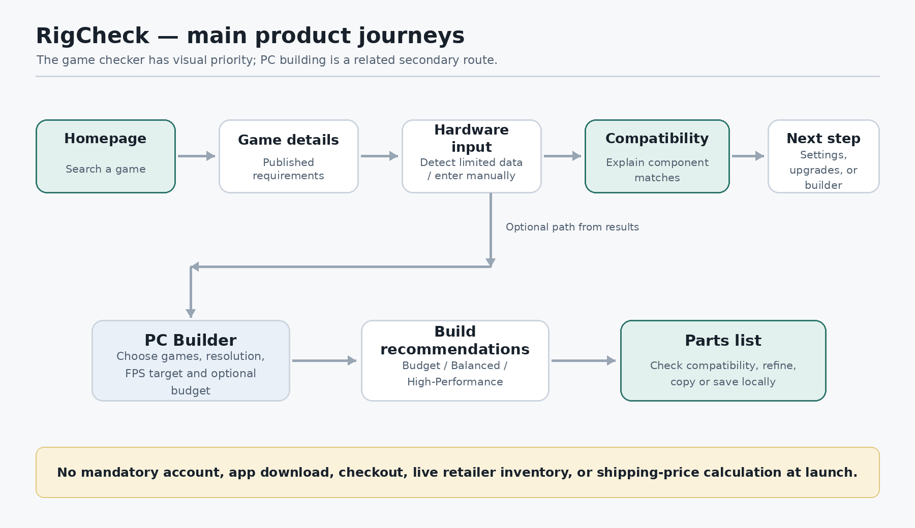
Figure 1. High-level product journeys and how the checker and builder connect.
The most common route begins with game search. A PC build can be started independently or from a compatibility result. These are related journeys, not separate products.

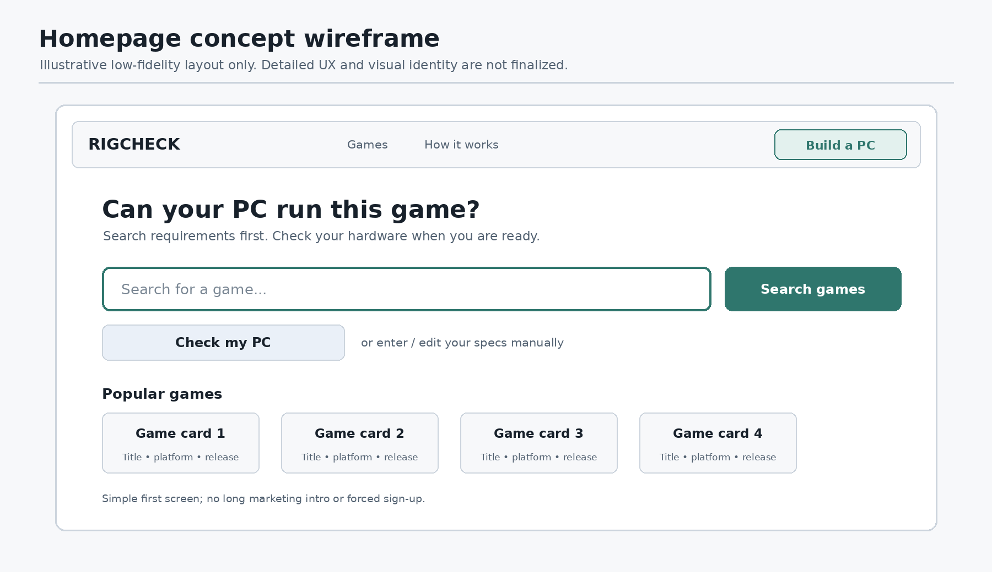
Figure 2. Proposed homepage wireframe. Illustrative only; not a finalized page design.
Homepage layout intent: game checking leads; PC building remains easy to find without competing for the main call to action. The exact card count, navigation labels, copy, and desktop/mobile arrangement are still to decide.
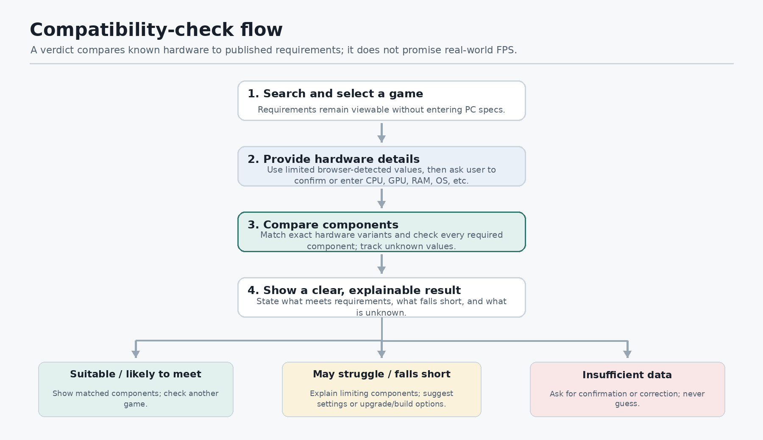
Figure 3. Compatibility-check flow and result outcomes.
The key design rule is honesty: if a required field is missing, RigCheck should say that confidence is limited and ask for clarification instead of producing an unsupported green “pass.”
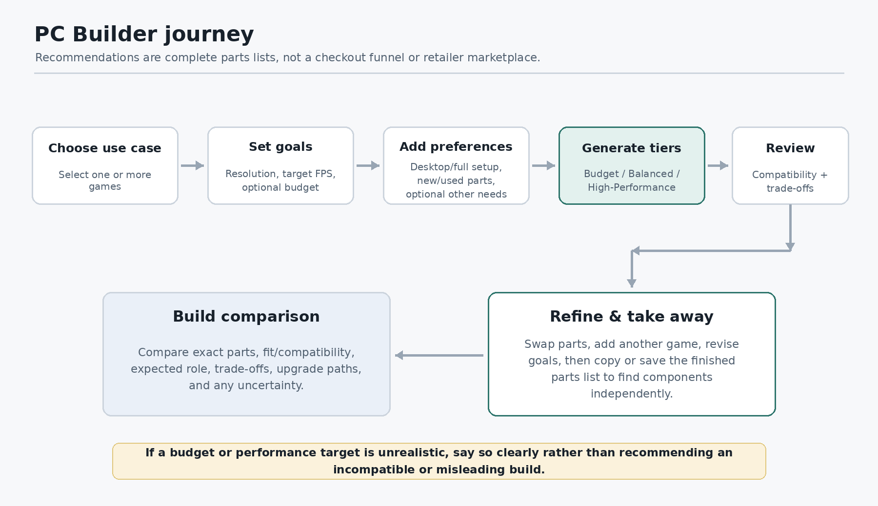
Figure 4. PC Builder flow from goals to tiered recommendations and a take-away parts list.
The builder is a planning and recommendation tool, not a checkout funnel. Budget and performance targets may conflict; the result should explain the constraint and offer realistic alternatives.
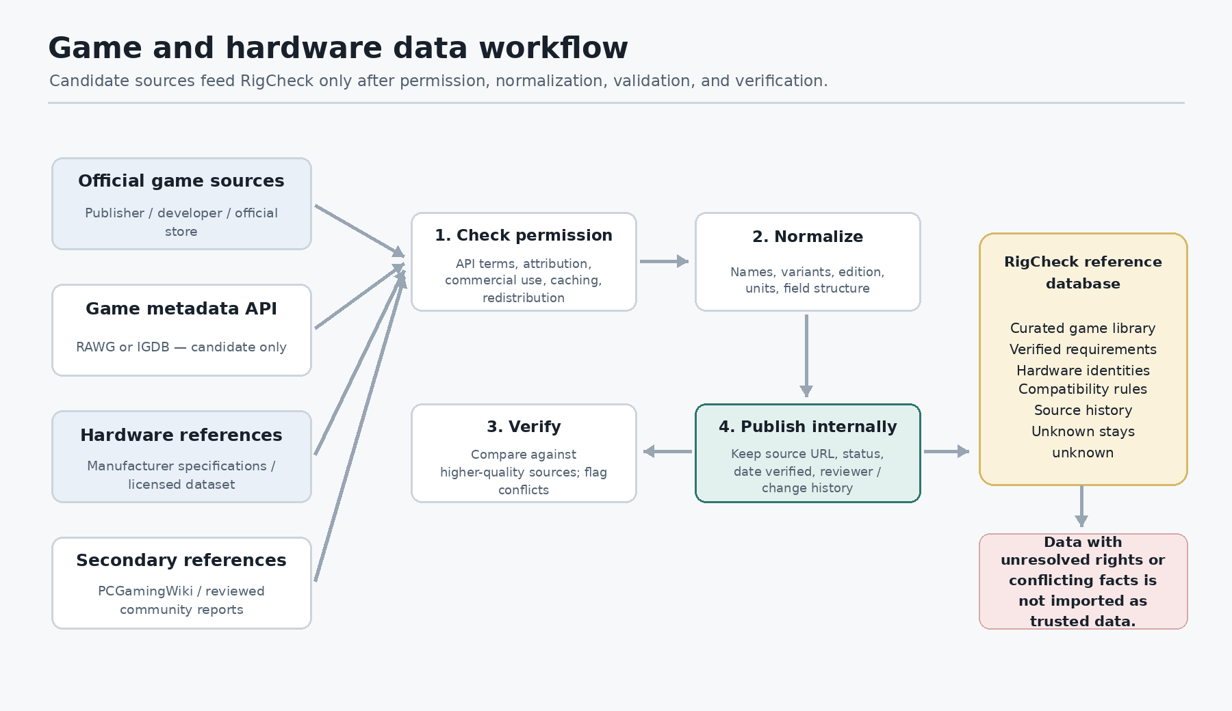
Figure 5. Proposed data sourcing and verification workflow.
The use of an external API or dataset depends on access terms and verified data rights. Public visibility does not automatically mean bulk reuse or redistribution is allowed.

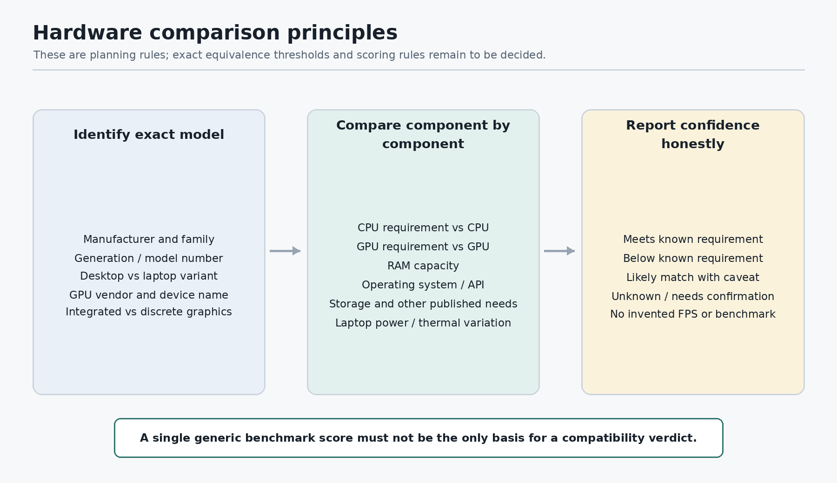
Figure 6. Hardware comparison principles to guide future rules; exact thresholds remain open.

5. Game database and data-quality policy

5.1 Launch philosophy
Confirmed approach
Launch with a smaller, carefully verified game library and expand over time. Prefer accurate coverage over a large catalog with missing or unreliable requirements.

5.2 Requirement source hierarchy
- Official publisher or developer system-requirements page.
- Official store listing (for example, the game’s Steam store page) where system requirements are published.
- A trusted technical reference as a cross-check or carefully reviewed gap-filler.
- Community reports as leads for investigation only; never auto-approve them as authoritative.

5.3 Quality rules
- Record the source URL, relevant edition/version, verification date, and review status for each requirement set.
- Do not invent values for missing fields. Mark data as verified, unverified, unavailable, not applicable, or conflicting as appropriate.
- Keep minimum and recommended requirements distinct; do not combine them into one synthetic set.
- Disambiguate editions, remasters, DLC/game versions, and OS/platform variants when these change requirements.
- Check terms, attribution, caching, and redistribution rules before importing external data in bulk.
- Provide a report-correction flow; review submitted changes against higher-quality sources before accepting them.
- No FPS predictions at launch. A later feature requires relevant game-specific benchmark evidence and a method to explain variation by resolution/settings.

5.4 Game record: planning fields
Data group | Potential fields (subject to final schema) | Quality notes
Identity | Game title; alternate names; edition/version; platform; release date | Avoid merging materially different editions.
Requirements | Minimum and recommended OS, CPU, GPU, RAM, storage, API/DirectX, other published fields | Only use fields present in a source; retain minimum/recommended distinction.
Provenance | Source URL; source type; date checked; verification state; note on conflicts | Visible source and verification information improves trust.
Editorial review | Correction report; review outcome; reviewer note; change history | Community input is not trusted until reviewed.
Future benchmark data | Game build/version; GPU/CPU; resolution; settings; average/low FPS; methodology | Out of initial launch scope; only considered if evidence is reliable and comparable.

6. Candidate data sources and links
No single external data source has been finalized. The sources below are candidates to test and review. Availability of an API is not the same as permission to use all of its data in a public or commercial product.
Source | Potential use | Status / caution | Link
RAWG API | Game titles, alternate names, release/platform metadata, some system requirements and related metadata. | CANDIDATE. API requires a key. RAWG’s current API page and terms contain different descriptions of plan eligibility; confirm current terms, attribution, limits and commercial use directly before relying on it. | See Appendix A
IGDB API | Game identity, alternate titles, releases, platforms, and broader game metadata. | CANDIDATE. Requires Twitch developer authentication. Commercial use is handled through an IGDB partnership process; confirm requirements for the intended use and attribution. | See Appendix A
PCGamingWiki | Manual cross-checks of technical PC game details and compatibility information. | SECONDARY REFERENCE CANDIDATE. Confirm any API availability, licensing, and reuse terms before automated or bulk import. | See Appendix A
Official publisher/developer pages | Authoritative minimum/recommended system requirements. | PREFERRED REQUIREMENTS SOURCE. Store source and date; each source may differ in format and completeness. | Game-specific
Official store pages (e.g. Steam) | Published PC system requirements where available. | PREFERRED SECONDARY OFFICIAL SOURCE. Use the individual game page and verify the correct edition/platform. | See Appendix A
Intel ARK | Intel CPU/integrated graphics specifications and model identity. | OFFICIAL HARDWARE REFERENCE. Useful for checking exact model variants and published specifications. | See Appendix A
AMD product specifications | AMD processor and graphics model details. | OFFICIAL HARDWARE REFERENCE. Model families can contain desktop and mobile variants that must stay distinct. | See Appendix A
NVIDIA GeForce graphics cards | Official product pages for GeForce graphics products. | OFFICIAL HARDWARE REFERENCE. Workstation and older mobile products may require additional official reference research. | See Appendix A
RightNow GPU Database (GitHub) | Possible seed data for GPU specifications across NVIDIA, AMD, and Intel. | CANDIDATE DATASET. Repository lists an Apache 2.0 license and says its data is sourced from TechPowerUp via dbgpu. Verify provenance, field coverage and whether all included data is covered by the stated license before use. | See Appendix A

6.1 Recommended sourcing strategy
- Use a game metadata provider only if its current terms fit RigCheck’s planned public use, caching/storage needs, attribution needs, and expected usage volume.
- Use official publisher/store pages to verify the actual system requirements that determine a verdict.
- Use manufacturer sources and a carefully vetted, suitably licensed hardware dataset to build the hardware reference catalog.
- Keep RigCheck’s own curated records with provenance and verification states so the user experience does not depend entirely on a third-party lookup at the moment of a check.
- Before any import, document API rate limits, key restrictions, caching terms, commercial-use terms, attribution requirements, and data-retention obligations.

7. Hardware identification and comparison principles
This area has been identified as the next technical-planning topic, but the detailed matching rules are not finalized. A wrong hardware identity can cause an incorrect verdict even when the game requirement itself is correct.

Rules already established at planning level
- Store exact model variants where possible rather than collapsing similar names into one record.
- Treat laptop and desktop GPUs as distinct variants, even when their names are similar.
- Identify integrated graphics separately from dedicated/discrete graphics; shared system memory is not the same as dedicated VRAM.
- Compare CPU, GPU, RAM, OS/API, and other published requirements by component instead of relying on one generic benchmark number.
- If a value is missing, unknown, or ambiguous, lower confidence and request confirmation rather than inventing a match.
- Explain why the system matches or falls short by naming the affected component(s).
- Do not confuse matching a published requirement with a guarantee of smooth gameplay or a specific FPS.

Still to decide
- What exact categories of verdict should be shown and the precise meaning of each category.
- What evidence qualifies one CPU/GPU as “comparable” to another where the game lists a specific model.
- How to represent hardware generations, OEM variants, laptop power limits, and systems with switchable graphics.
- How confidence should be displayed when some requirement fields are missing or sources conflict.
- Which hardware dataset or comparison reference has acceptable coverage and reuse rights.

8. PC Builder concept

Inputs
- One or more target games.
- Desired resolution (for example, 1080p, 1440p, or 4K).
- Target FPS as a planning preference only; launch recommendations must not falsely imply a guaranteed FPS.
- Optional budget and currency context, if price estimates are eventually supported.
- Optional desktop-only versus full setup preference, and new versus used component preference.
- Optional non-gaming workload requirements, where they materially change the recommendation.

Outputs
- Budget, Balanced, and High-Performance build tiers.
- A complete compatible component list, with the reason each part was chosen.
- Compatibility checks across motherboard/CPU socket, memory type, physical fit, PSU capacity/connectors, case/cooling, and other relevant constraints.
- Trade-offs in graphics quality, resolution headroom, upgrade potential, noise/power, or other relevant considerations when known.
- A transparent note when a target is unrealistic or data is uncertain, plus a realistic alternative.
- A path to swap parts, add a game, revise goals, revalidate compatibility, and copy/save the list.

Builder guardrails
- Do not steer a user into a new PC when their current system is adequate or a settings change may be enough.
- Do not fabricate live prices or claim current stock. Price display and external seller links are not required for the first version.
- Do not use compatibility as a pretext for checkout or shipping features.
- Use multiple target games to avoid recommending a build that meets one title but misses another selected title.

9. Trust, privacy, accessibility, and edge cases

Trust and privacy principles
- No account is required for core functionality, and no email is required just to check a game.
- Explain what data is used and whether each hardware field was detected, supplied by the user, or left unknown.
- Do not claim that browser-based checks reveal exact hardware where the browser cannot provide it reliably.
- Do not retain more personal/device information than the product needs; detailed retention and analytics policies remain to be decided.
- Source and correction history should support auditability.

Accessibility and usability
- Responsive desktop and mobile web experience.
- Readable text, sufficient contrast, keyboard navigation, explicit form labels, and clear focus states.
- Never communicate pass/fail/unknown using color alone; pair status with text or an icon/label.
- Avoid clutter, unnecessarily long pages, and repeated steps where sections can sit adjacent on desktop without compromising clarity.

Important edge cases
Situation | Expected behavior
Browser detection unavailable or partial | Offer manual entry; clearly label unknown fields.
Multiple GPUs / integrated + discrete | Ask the user to identify or confirm the GPU used by the game; avoid assuming the strongest adapter is always active.
Laptop GPU or CPU variant | Use the correct mobile variant where identified; explain remaining uncertainty.
Missing game requirement | Display it as unavailable/unknown; do not invent it.
Conflicting sources | Prefer the stronger source where justified, retain provenance, and flag unresolved conflicts.
Unsupported game or wrong edition | Say it is not yet verified/supported and offer reporting/correction.
Unknown hardware model | Ask for more details or provide a lower-confidence assessment rather than false precision.
Unrealistic budget or target | Explain the mismatch and offer adjusted goals or tiers.
Incompatible parts proposed | Do not present as a valid build until compatibility has been checked.
Local/session data is lost | Make limits clear; do not promise cloud persistence or cross-device recovery.

10. Decisions still open
These are open questions, not decisions that have already been made. They will be addressed in future planning sessions and recorded in the change log.
Topic | What remains to decide | Suggested sequence
Detailed UX | Exact page layouts, search states, game detail hierarchy, hardware form, result screen, builder wizard, mobile behavior. | Next: begin with homepage and proceed screen by screen.
Visual identity | Final colors, typography, logo direction, component styling and imagery. | After the main screen hierarchy has been reviewed.
Data providers | Choose a game metadata provider, or decide to maintain more manual curated data; verify terms and costs. | Before import or public launch.
Hardware catalog | Choose the exact CPU/GPU sources and check data provenance, licenses, coverage and model variants. | Before finalizing comparison rules.
Compatibility rules | Verdict categories, equivalent hardware rules, confidence display, laptop and integrated-GPU handling. | Before the checker can be trusted.
Launch catalog size | Initial curated game list and review/update cadence. | During data planning.
Build budgets and pricing | Whether the launch builder includes price estimates at all; if so, source and reliability. | Not required to launch the core builder.
Save/share behavior | Copy list is planned; local saves or shareable result URLs need separate decision. | After flows are designed.
Feedback/correction operations | How reports are reviewed and who approves corrections. | Before enabling public reports at scale.
Implementation decisions | Database, framework, hosting, import/update schedules, secrets handling. | Only after the user explicitly says to start coding.

11. Planning checklist and change log

Progress snapshot as of 15 October 2026
Work area | Status | Notes
Product purpose and scope | High-level complete | Name, audience, web-only launch, no accounts, no ecommerce scope, checker-first emphasis recorded.
UX journeys | High-level complete | All major journeys mapped; detailed layouts and interaction states remain open.
Concept drawings | Created in v0.1 | Six sketches included; they are conceptual, not final UI.
Game-data policy | High-level complete | Curated library, source hierarchy, verification, corrections, no launch FPS prediction.
Candidate data sources | Initial research recorded | No final API/dataset choice. Terms and rights need review.
Hardware comparison rules | Started, not finalized | Principles documented; equivalence thresholds/verdict semantics open.
PC Builder behavior | High-level complete | Inputs, tiers, compatibility, refinement and take-away list mapped.
Visual design system | Not started / not finalized | No final site palette or component design selected.
Coding / implementation | Not started by agreement | Do not move to implementation until the user explicitly asks.

Change log
Version / date | Change
v0.1 — 15 Oct 2026 | Initial living planning document created from the decisions and journeys established so far. Includes scope, UX flows, six concept drawings, database policy, candidate source links, hardware comparison principles, builder concept, open decisions and status snapshot.

Update rule
As we make new decisions, this document will be updated rather than restarted. Confirmed decisions will be labelled clearly, proposals will remain proposals until accepted, obsolete decisions will be amended with a note, and new versions will receive a dated change-log entry.

Appendix A. Source links and verification notes
The following pages were checked while preparing this version. They are references for future evaluation, not a claim that any API is already approved for production. External terms can change and must be checked again before use.
RAWG API documentation and plan details: Open source page
Shows API access requires an API key and describes game metadata and plan options.
RAWG API Terms of Service: Open source page
The currently surfaced terms explain usage plans and attribution; these should be rechecked because the API page and terms should be reconciled before selection.
IGDB API documentation: Open source page
Explains authentication, API endpoints, and requirements for using the service.
PCGamingWiki: Open source page
Candidate secondary source for game technical details; reuse rights/automation access must be confirmed.
Steam store: Open source page
Individual product pages may publish PC system requirements.
Intel ARK: Open source page
Official Intel product specifications.
AMD product specifications: Open source page
Official AMD CPU and graphics product specification pages.
NVIDIA GeForce graphics cards: Open source page
Official GeForce graphics product pages.
RightNow GPU Database repository: Open source page
Repository reports an Apache 2.0 license and describes a GPU dataset sourced from TechPowerUp via dbgpu; verify provenance/coverage before importing.
Functional inspiration reference: Open source page
Used for functionality inspiration only, not as a visual template.

Update Log
Version 0.2 — 15 October 2026
Added the confirmed homepage direction and detailed homepage UX baseline. Existing content and drawings are retained.

Homepage UX — Approved Direction
Status: Confirmed by the project owner.
Decision | Confirmed direction
Visual direction | Light and minimal: light background, dark readable text, restrained green accents. Avoid neon, excessive gradients, glassmorphism, and generic AI-looking decoration.
Game search | Compact search near the top. It remains the primary action without dominating the screen.
Game discovery | Popular games appear below the search. Popularity claims must be evidence-based; otherwise describe the list as curated.
PC Builder prominence | A separate, visible section below game discovery. The game checker remains the primary homepage journey.
Access | Core features require no account, signup, download, or email collection.

Homepage — Proposed Content Order
This is the planning baseline. Exact copy, spacing, and responsive behavior remain open.
- Header: RigCheck wordmark, Game Checker, PC Builder, and concise navigation.
- Compact game search: clear search action, keyboard support, and an example placeholder.
- Short primary message explaining that RigCheck compares a PC against published game requirements.
- Secondary hardware-entry action such as “Check my PC”.
- Popular games: curated cards; selecting one opens its game details. A card must not imply that the visitor’s PC is compatible.
- Separate PC Builder section below game discovery, focused on games and performance goals rather than shopping.
- Trust note: results compare hardware against published requirements and are not guaranteed FPS predictions.
- Footer links: how it works, report incorrect data, privacy, and source/attribution information.

Search Interaction Requirements
- Support partial titles and alternate names/spelling variants where available.
- Distinguish editions or releases when the requirements differ.
- Selecting a result opens its game page; do not claim compatibility before hardware is known.
- Provide typing, suggestions, no-results, loading, and error states.
- If a game is missing, offer a request/report path without implying it is already supported.
- Keep search usable on mobile without horizontal scrolling.

Popular Game Cards
- Show title and recognizable artwork only when the source and reuse terms permit it.
- Keep cards consistent and readable. Do not invent ratings, player counts, or compatibility badges.
- A card means the game is in the catalog, not that the current PC can run it.
- If no reliable popularity source is available, call the section a curated selection.

PC Builder Homepage Section
- Place it below popular game discovery.
- Explain that users can select games and performance goals to explore suitable component builds.
- Provide one clear action to begin the builder journey.
- No cart, checkout, shipping estimates, or retailer-style purchase flow.
- Carry selected games and target settings into the builder when entered from a game or compatibility result.

Responsive and Accessibility Rules
- Desktop: concise header, compact search, game cards in a row/grid, and a distinct builder section below.
- Mobile: stack sections, use touch-friendly controls, keep titles legible, and avoid dense horizontal navigation.
- Provide visible focus states, keyboard operation, meaningful labels, and adequate contrast.
- Never rely on color alone for compatibility states.
- Avoid effects or animations that obstruct controls or slow the main search journey.

Homepage Wireframe — Planning Sketch
Structural sketch only; not a final visual design.
HEADER
RigCheck wordmark Game Checker PC Builder
COMPACT SEARCH
[ Search a game title… ] [Search]
PRIMARY MESSAGE
Can your PC run this game?
SUPPORTING COPY
Compare your hardware with published system requirements.
SECONDARY ACTION
[ Check my PC ]
POPULAR GAMES
[ Game card ] [ Game card ] [ Game card ] [ Game card ]
PC BUILDER
Planning a PC? Choose games and performance goals. [Explore PC Builder]
TRUST / FOOTER
How it works · Report incorrect data · Privacy · Sources

Homepage Questions Still Open
- Final placement and wording of the headline relative to the compact search.
- Whether a theme toggle is required at launch or light mode is the only launch appearance.
- How many popular game cards to show and how the curated list will be refreshed.
- Whether “Check my PC” begins with manual entry, limited browser-detectable details, or a short choice screen. Do not promise reliable automatic CPU/GPU/RAM detection.
- Exact dimensions, spacing, breakpoints, and final visual styling.

UX Progress Tracker
Area | Status | Notes
High-level journeys | Complete | Main journeys from homepage through compatibility and PC Builder mapped.
Homepage direction | Approved baseline | Light/minimal; compact search; popular games; builder section below discovery.
Detailed homepage UX | In progress | Content order and interaction requirements documented.
Search/results UX | Next | Suggestions, editions, result cards, empty/error states.
Game details UX | Pending | Requirements layout, sources, verification dates, CTA.
Hardware entry UX | Pending | Manual input, limited detection, identification help, editing.
Compatibility results UX | Pending | Verdicts, component comparisons, limitations, next actions.
PC Builder UX | Pending | Wizard, constraints, tier comparison, parts list, refinement.
Living-document rule: Add confirmed decisions to the decision register and relevant sections, and add a version/update-log entry. Never present unresolved questions as confirmed.

RigCheck Product Planning — Update v0.3
UX decisions consolidated through 16 October 2026
This update preserves the existing planning document and adds the confirmed search, game details, hardware entry, compatibility results, and PC Builder decisions. Remaining open choices are assigned recommended defaults so planning can continue without repeatedly revisiting settled questions. This is a product/UX document only; coding and implementation have not started.

1. Recommended defaults for remaining open decisions
- Saved-build reopening: preserve the original snapshot, flag potentially outdated data, and offer fresh validation; do not silently overwrite the saved version.
- Build history: automatically preserve a baseline and meaningful versions, while allowing users to create named snapshots at important milestones.
- Homepage headline: use concise copy focused on checking whether a PC can run a game. Launch with the approved light/minimal appearance; defer a theme toggle unless later testing shows it is needed.
- Game discovery cards: start with a compact curated selection. Use “Popular games” only when popularity is supported by defensible data; otherwise label it “Featured games.” Review and refresh the selection as the catalog grows.
- “Check my PC” entry: open the single-page hardware form, explain the limits of browser detection, and allow manual correction. Never imply that a normal website can reliably detect CPU, GPU, and RAM.
- Build tiers: show Budget, Balanced, and High-Performance cards together where feasible, with expandable full parts lists. Stack cards on mobile.
- Pricing: use regional guidance only where reliable data exists. Label estimates, verified local prices, and unavailable prices clearly; never invent prices or imply stock availability.
- Unrealistic budget/target: show the best feasible within-budget build, explain the limitation, and optionally offer a clearly labelled stretch build.
- Validation: give immediate feedback for obvious issues and full validation on demand. Block verified critical incompatibilities; warn about uncertain or preference-related issues.
- Saved build refresh: preserve the original version/date where practical and let the user revalidate against current verified data.

2. Search and game discovery UX
- Live suggestions appear as the user types. Selecting a suggestion opens that game’s details page; pressing Enter opens a full results page.
- Support partial titles and known alternate names/spelling variants. Distinguish editions, remasters, expansions, and platforms where relevant.
- Suggestion rows show the title and a useful distinguishing detail, such as platform or edition. Support keyboard up/down, Enter, Escape, and touch interaction.
- Handle loading, errors, empty suggestions, and no results clearly. Keep the query editable on the full results page.
- Full results use responsive game cards showing permitted cover artwork, title, platform, and edition. Cards open details and must not imply compatibility.
- If a game is missing, explain that it is not yet in the catalog and offer a request/report form. Prefill the title where possible; platform, edition, and notes are optional. No account or email is required, and no publication date is promised.
- Requests are leads, not trusted catalog entries. Verify requirements and sources before publishing.

3. Game details page UX
- Show Minimum and Recommended requirements side by side on wide screens and in a readable stacked layout on narrow screens.
- Place the primary Check Compatibility action near the top and again after the requirements.
- Include platform/edition, storage and installation requirements, DirectX and other relevant technical details, caveats, and related games when reliable data exists.
- Put source links and verification dates in an expandable data-quality section. Mark missing fields “Not available”; never guess.
- Prioritize official developer/publisher requirements. Document conflicting sources and review discrepancies before publishing.
- On Check Compatibility, attempt only limited reliable browser/display detection, then offer hardware entry and correction. Reuse previously entered hardware when available.
- Distinguish published-requirement matching from guaranteed performance or FPS predictions. Do not launch FPS predictions without reliable game-specific benchmark evidence.

4. Hardware detection and manual entry UX
- Use one single-page form with sections for CPU, GPU, RAM, OS/storage, display, and gaming target.
- Prefill only reliable browser-detectable values and identify which values were detected, user-entered, or estimated. Ordinary browser pages generally cannot reliably identify CPU, GPU, and RAM.
- Provide searchable hardware model suggestions and “How do I find this?” guidance.
- Record multiple GPUs separately. Do not assume the most powerful-looking GPU is necessarily active for the game.
- Keep monitor native resolution separate from target gaming resolution.
- Allow partial entry and explain assessment limits when specs are unknown. Warn about suspicious mismatches but allow confirmation rather than blocking unfamiliar hardware.
- Save hardware locally across visits with edit and clear options. Explain that clearing browser data or changing devices may remove local data.
- Show an inline hardware summary and Check Compatibility action on the same page; no separate review screen.

5. Compatibility results UX
Present the overall verdict first, then separate minimum/recommended summaries and a component-by-component comparison.
Five overall verdicts:
- Meets recommended requirements
- Meets minimum only
- May struggle at minimum
- Falls below minimum
- Insufficient data
Comparison table columns: component, user hardware, minimum requirement, recommended requirement, and status at each requirement level.
- Evaluate minimum and recommended requirements separately. Explain each component’s result and how the overall verdict follows from the available evidence.
- If critical data is missing, show known comparisons and use Insufficient data when a reliable overall assessment is not possible.
- When the PC falls short, offer evidence-based settings advice and specific compatible upgrade candidates when sufficient data exists. State caveats; do not guarantee FPS.
- Label general advice as general guidance when it is not based on game-specific evidence.
- Include Edit hardware, Check another game, Build a PC for this game, Copy results, and Report an incorrect result.
- Carry the selected game and target settings into the builder and preserve saved hardware for later checks.
- New checks use latest verified requirements. Allow refresh/revalidation and preserve the earlier result’s data version/date where practical.
- The Report an incorrect result form asks for an explanation and optional details. Reports are reviewed before published data is changed.

6. PC Builder UX

6.1 Setup and preferences
- Use a hybrid experience: a short guided setup for essential choices, with optional advanced preferences available on the same page.
- Essential choices are game(s), target resolution, and target FPS. Budget is optional; users can request a build without entering one.
- Advanced preferences may include desktop tower versus full setup/peripherals, new versus used parts, preferred/excluded brands where relevant, upgradeability, size, noise, power efficiency, and other workloads.
- Carry games and target settings over from Compatibility Results so users do not need to enter them again.
- Offer an optional “Parts I already own” section and build around owned components where feasible.

6.2 Tiers, pricing, and unrealistic targets
- Show Budget, Balanced, and High-Performance cards side by side with key strengths and tradeoffs. Expand a card to see the complete parts list; stack cards on mobile.
- Provide specific compatible components such as CPU, GPU, motherboard, RAM, storage, PSU, case, and cooling as needed.
- Use regional pricing guidance only where reliable. Clearly distinguish verified local prices, estimates, and unavailable prices. Never invent prices or imply stock availability.
- If the budget cannot meet the target, explain why and show the best feasible within-budget option. Offer a clearly labelled stretch build when useful; state the overrun only when pricing data supports it.
- Do not silently exceed a budget, push unnecessary purchases, or recommend a new PC when a settings change or targeted upgrade is sufficient.

6.3 Customization and compatibility validation
- Allow individual component swaps and full-build regeneration.
- Show immediate feedback for obvious incompatibilities and provide full validation on demand. Recheck the complete build after component changes.
- Block finalization for verified critical incompatibilities and explain why. Warn about uncertain, unverified, or preference-related issues without presenting uncertainty as fact.
- Validate relevant socket, motherboard, memory, power, case-clearance, cooling, and other constraints when reliable data is available.
- If an owned component is incompatible or unsuitable, explain why and offer alternatives rather than silently removing it.

6.4 Saving, import, and export
- Save builds locally without requiring an account; allow users to rename and delete saved builds.
- Support exporting and importing a build file. Validate imported builds against current compatibility data before treating them as valid.
- Provide both a copyable plain-text parts list and a downloadable formatted document.
- Include build tier, target games/settings, components, known prices and caveats, compatibility warnings, and data date/version where practical.
- Automatically preserve a baseline and meaningful versions; allow users to create named snapshots.
- When reopening a saved/imported build, preserve its original snapshot, flag potentially outdated information, and offer fresh validation rather than silently overwriting it.
- Explain that local saves may be lost when browser data is cleared and exported builds are snapshots, not guarantees of current compatibility, pricing, or availability.

7. Data quality and sourcing principles
- Launch with a small, carefully verified game library and expand gradually.
- Prefer official developer/publisher/store requirements; use trusted secondary references for gaps. Treat community reports as leads, not automatic approval.
- Maintain source links and verification dates. Distinguish missing, unverified, and not-applicable data.
- Maintain a structured RigCheck database with provenance. Review API, dataset, and website reuse terms before imports or automated collection.
- Distinguish desktop/laptop GPU variants, integrated graphics/shared memory, model variants, and incomplete hardware names. Do not rely on a single generic benchmark score as the sole compatibility signal.
- Accept user reports for review; do not automatically publish unverified corrections.
- Do not launch FPS predictions until reliable game-specific benchmark data is available.

8. Cross-product UX principles
- Checker first, PC Builder second; do not let the builder dominate the homepage.
- No account, signup, or email is required for core functionality.
- No shopping cart, checkout, retailer integration, shipping estimates, or seller-like flow.
- Avoid compatibility percentages that imply unsupported precision. Explain evidence and limitations in plain language.
- Use responsive layouts, readable contrast, keyboard navigation, accessible labels, and status text/icons so verdicts are not communicated by color alone.
- Provide clear loading, empty, error, missing-data, and local-data states.
- Use cover artwork only where reuse terms permit; do not claim live popularity without supporting data.

9. UX progress tracker
Area | Status
Product identity and direction | Confirmed
Homepage baseline | Confirmed; remaining details use recommended defaults
Search and results flow | Confirmed
Game details page | Confirmed
Hardware detection and manual entry | Confirmed
Compatibility results | Confirmed
PC Builder setup and budget | Confirmed
Build tiers and unrealistic targets | Confirmed
Part swaps and compatibility validation | Confirmed
Owned components | Confirmed
Local save, file import/export, and parts-list export | Confirmed
Saved-build refresh and history | Defaulted to recommended approach
Detailed wireframes and edge-case review | Next planning stage
Coding/implementation | Not started; wait for explicit user instruction

10. Next planning stage
Proceed to detailed wireframes and edge-case review for the PC Builder and remaining user journeys. Use the defaults in this update rather than reopening settled questions. Do not begin or discuss coding/implementation until the user explicitly asks to start coding.

RigCheck Product Planning — Update v0.4
Final systematic UX review and UX completion status — 16 October 2026
This update adds the final end-to-end UX review to v0.3. Previously confirmed decisions and recommended defaults remain in effect. The review is a product-level UX sign-off; it does not mean the future interface has been implemented or usability-tested. No coding or implementation steps are authorized by this document.

1. UX sign-off status
Status: Core UX planning is complete at the product-decision level. The next phase is technical architecture and implementation planning. Coding must not begin until the user explicitly authorizes it.
The final review consolidated the complete user journeys, confirmed behavior for important edge cases, and adopted recommended defaults for remaining minor decisions instead of reopening settled choices.

2. End-to-end product journeys
- Primary journey — Check a game: Find a game, review published requirements and source quality, enter or reuse PC specifications, and receive an evidence-based compatibility result.
- Secondary journey — Build a PC: Choose games and target settings, optionally provide a budget and existing components, and compare compatible build recommendations.
- Supporting journey — Save and return: Save hardware and builds locally, export files, copy results, and refresh older results when the underlying data changes.
Product hierarchy: the compatibility checker remains the main purpose of RigCheck. The builder is discoverable but must not turn the product into a store or push unnecessary PC replacements.

3. Homepage and global navigation
- Use the approved light, minimal visual direction: readable dark text, restrained green accents, generous spacing, and no excessive gradients, neon, glassmorphism, or clutter.
- Homepage order: compact header; compact game search; concise explanation; secondary Check my PC action; curated game selection; separate PC Builder section; trust note; footer links for How it works, reporting incorrect data, privacy, and sources/attribution.
- Use “Popular games” only when supported by defensible popularity data; otherwise use “Featured games.” Game cards must not imply compatibility.
- Keep navigation consistent across pages and compact on mobile. Preserve the user's game, edition, hardware, and target settings as they move between related flows.
- Avoid losing work on browser navigation; confirm destructive actions such as deleting saved builds.

4. Search, discovery, and missing-game states
- Provide live suggestions; selecting a suggestion opens game details, while Enter opens full search results.
- Support partial titles and known alternate names. Distinguish editions, remasters, expansions, and platforms where requirements differ.
- Support keyboard up/down, Enter, Escape, and touch interactions. Show useful distinguishing details in suggestions.
- Results show permitted artwork, title, platform, and edition; cards open game details and do not imply compatibility.
- Design loading, error, no-suggestion, no-result, similar-title, and duplicate-edition states.
- For missing games, explain that the catalog lacks an entry and offer a request form. Prefill the title where possible; platform, edition, and notes are optional. No account/email is required and no publication date is promised.
- Treat requests as leads for review, not automatic catalog additions.

5. Game details and requirement quality
- Show minimum and recommended requirements side by side on wide screens and stacked on narrow screens.
- Place Check Compatibility near the top and after the requirements.
- Show platform/edition, storage/installation details, relevant technical requirements, caveats, and related games where reliable information exists.
- Prefer official developer, publisher, or store requirements. Record source links and verification dates; mark missing fields Not available rather than guessing.
- Document source conflicts and review them before publishing when possible.
- Clearly distinguish requirement matching from guaranteed performance or FPS.

6. Hardware detection and manual entry
- Use one page with sections for CPU, GPU, RAM, OS/storage, display, and gaming target.
- Attempt only reliable browser/display detection. Clearly distinguish detected, user-entered, and estimated values; do not claim ordinary browser pages can reliably identify CPU, GPU, or RAM.
- Provide searchable model suggestions and “How do I find this?” help.
- Distinguish laptop and desktop GPU variants, integrated graphics/shared memory, and multiple GPUs. Do not assume the highest-spec GPU is always the active gaming GPU.
- Keep monitor native resolution separate from target gaming resolution.
- Allow partial entry and explain assessment limits. Warn about suspicious mismatches but do not block unfamiliar hardware automatically.
- Save hardware locally with edit and clear controls. Explain that browser-data clearing or changing devices can remove local data.
- Show an inline hardware summary and Check Compatibility action on the same page.

7. Compatibility results and reporting
Present the overall verdict first, then minimum/recommended summaries and component comparisons.
- Use five verdicts: Meets recommended requirements; Meets minimum only; May struggle at minimum; Falls below minimum; Insufficient data.
- Compare component, user hardware, minimum requirement, recommended requirement, and status at each level.
- Derive the verdict from available evidence. Unknown critical data may require Insufficient data; do not use unsupported compatibility percentages.
- Offer evidence-based settings advice and specific compatible upgrade candidates only when data supports them. Label general guidance and caveats; do not guarantee FPS.
- Provide Edit hardware, Check another game, Build a PC for this game, Copy results, and Report an incorrect result.
- Carry game and target settings into the builder and preserve saved hardware for subsequent checks.
- Use latest verified data for new checks; allow refresh and preserve earlier result data version/date where practical.
- The incorrect-result form accepts an explanation and optional details. Review reports before changing published data.

8. PC Builder flow and recommendations
- Use a hybrid setup: short guided essentials with optional advanced preferences available on the same page.
- Essentials: one or more games, target resolution, target FPS, and optional budget. Generate a useful build without requiring a budget.
- Advanced preferences may include full setup/peripherals, new versus used parts, preferred/excluded brands, upgradeability, size, noise, power efficiency, other workloads, and existing parts.
- Show Budget, Balanced, and High-Performance cards side by side where feasible, with expandable complete parts lists; stack on mobile.
- Recommend compatible CPU, GPU, motherboard, RAM, storage, PSU, case, cooling, and other required components.
- If the target is unrealistic for the budget, explain why, show the best feasible within-budget option, and optionally offer a clearly labelled stretch build.
- Use regional pricing only when reliable. Clearly label verified prices, estimates, and unavailable pricing; never invent prices or imply stock.
- RigCheck is not a retailer: no cart, checkout, seller integration, shipping estimates, or courier features. Users source the parts themselves.
- Do not push a new PC when settings changes or a targeted upgrade are more reasonable.

9. Build customization, validation, and persistence
- Allow individual component swaps and full-build regeneration.
- Provide immediate feedback for obvious issues and full validation on demand.
- Block finalization for verified critical incompatibilities; explain the reason. Warn about uncertain or preference-related issues without presenting uncertainty as fact.
- Check relevant socket, board, memory, power, physical clearance, cooling, and other constraints when reliable data exists.
- Offer an optional section for existing components and build around them when feasible. Explain when an owned part prevents the target from being met.
- Save builds locally; allow renaming and deletion. Support build-file export/import, copyable text lists, and downloadable formatted documents.
- Validate imported builds against current compatibility data. Preserve a baseline and meaningful versions; allow named snapshots.
- When reopening a saved build, preserve the original snapshot, flag potentially outdated data, and offer fresh validation rather than silently overwriting it.
- Explain that local data can be lost and exported files are snapshots, not guarantees of current compatibility, pricing, or availability.

10. Edge cases and recovery
- Missing game: Explain catalog gap and offer a request form.
- Incomplete/conflicting requirements: Show known data, mark missing fields, document conflicts, and avoid guessing.
- Unknown or ambiguous hardware: Offer model search, identification help, manual entry, and reduced-confidence assessment.
- Detection failure: Fall back to manual entry without blaming the user.
- No FPS benchmark data: Compare published requirements only; do not predict FPS.
- Unrealistic budget/target: Explain the limitation and offer feasible alternatives.
- No defensible three-tier result: Show only valid recommendations and explain why other tiers are unavailable.
- Uncertain compatibility: Warn and identify what needs verification.
- Invalid build file: Reject safely, explain the problem, and preserve the current build.
- Outdated saved build: Preserve the snapshot and offer current validation.
- Missing local data: Explain the missing profile/build and allow manual continuation.
- Report submission: Confirm receipt without promising acceptance or publication.
- Missing pricing: Mark unavailable rather than inventing a price.
- Service/source failure: Show a recoverable error and retry option; do not present stale or incomplete information as fresh.
Error messages should explain what happened, what it means, and what the user can do next. Avoid unexplained technical traces, vague dead ends, and blame-oriented language.

11. Privacy, accessibility, and responsive design
- Core features do not require accounts, sign-up, or email collection.
- Explain what is stored locally and why; provide clear controls to clear saved hardware/builds.
- Explain when a request/report leaves the device for review. Avoid unnecessary personal data and provide a clear privacy page.
- Use readable text, sufficient contrast, keyboard-accessible navigation, associated labels, useful error messages, and accessible suggestions/dialogs/expanded lists.
- Use text and icons in addition to color for verdicts; never communicate a critical warning by color alone.
- Use side-by-side panels on wide screens and stacked/mobile-friendly layouts on narrow screens. Keep tables readable and controls touch-friendly.
- Respect reduced-motion preferences if animation is used.

12. Data governance and trust
- Launch with a small, carefully verified game catalog and expand gradually.
- Prefer official requirements; use trusted secondary sources for verified gaps and treat community reports as leads.
- Keep source provenance and verification dates; distinguish verified, unverified, missing, and not-applicable fields.
- Review data source/API/dataset licensing and access terms before importing data.
- Distinguish hardware variants and do not rely on a generic benchmark score as the sole compatibility signal.
- Review user-submitted corrections before publication.
- Defer FPS prediction until reliable game-specific benchmark data exists.
- Never invent compatibility, FPS, prices, availability, specifications, or popularity claims. Use artwork only where reuse terms permit.

13. UX completion status and next phase
UX planning is considered complete at the product-decision level. The final systematic review has covered the main journeys, cross-page continuity, error/empty/incomplete-data states, privacy, accessibility, responsive behavior, and data trust. The checklist is a planning sign-off, not evidence of implemented or user-tested UI.
Recommended next phase: technical architecture and implementation planning, covering:
- Stack and system architecture choices.
- Game/hardware data model, source provenance, and licensing review.
- Feasibility and limits of browser detection.
- Compatibility rules and how uncertainty is represented.
- Handling of game requests and incorrect-result reports.
- Implementation stages and testing checkpoints.
Important boundary: coding and implementation must not begin until the user explicitly says to start coding.

14. Version history
v0.2 — Homepage direction and UX baseline.
v0.3 — Confirmed search, game details, hardware entry, compatibility results, and PC Builder decisions; applied recommended defaults.
v0.4 — Added the final systematic UX review, end-to-end journeys, edge cases, privacy/accessibility requirements, and UX-completion status.

FINAL CONSOLIDATION ADDENDUM — VERSION 1.0
This addendum preserves all earlier product-planning and UX content in this document and adds the finalized brand identity, technical architecture, coding standards, and implementation roadmap. If an earlier “open decision” conflicts with a decision below, the confirmed decisions in this addendum take precedence.
Project status and decision policy
RigCheck is ready to begin Phase 1 once the project owner gives explicit permission to code. Do not continue planning indefinitely. Treat assistant recommendations as confirmed decisions unless the owner explicitly rejects or changes them. No code is authorized by this document alone.

12. Final brand identity and design system

Brand direction and logo
- Visual direction: Hardware Lab — an engineering-oriented, calm, precise, modern diagnostic utility. Keep the interface approachable and technically credible.
- Logo: combination mark with a simplified, simple geometric chip outline and wordmark “RigCheck” in title case.
- The checkmark is the main detail of the icon. Use Diagnostic Blue for the icon and Hardware Slate for the wordmark.
- Produce a standalone icon that remains recognizable at favicon sizes. No permanent tagline.
- Writing style: plain English first, technical detail when useful. Brand voice is clear, direct, honest, evidence-led, helpful, non-judgmental, and technically confident without exaggeration.

Color palette
Token | Hex | Usage
Diagnostic Blue | #3478D4 | Primary actions, links, active navigation, focus indicators, selected controls.
Hardware Slate | #202A36 | Primary text, headings, high-emphasis values and strong icons.
Cool Mist | #F3F5F7 | Page background and section separation.
Clean White | #FFFFFF | Cards, forms, modals and main surfaces.
Slate Gray | #64748B | Secondary text and metadata.
Pale Blue | #DCE8F8 | Selected surfaces, subtle callouts and active filters; use dark text.
Default border | #D8DEE6 | Normal UI boundaries.
Strong border | #AAB5C3 | High-emphasis boundaries.

Compatibility status colors
Status | Foreground/icon | Background
Meets recommended | #166534 | #DCFCE7
Meets minimum only | #1E40AF | #DBEAFE
May struggle at minimum | #92400E | #FEF3C7
Falls below minimum | #B91C1C | #FEE2E2
Insufficient data | #475569 | #F1F5F9

Always pair color with text and an icon or equivalent non-color indicator. Missing data alone must not be styled as a failure.

Typography and visual language
- Typeface: Inter. Headings use weight 600–700; body 400; buttons/navigation 500–600; hardware names 500–600; verdicts 600.
- Body text 14–16 px; metadata 12–13 px; major desktop headings 28–40 px and scaled down for mobile. Use monospace sparingly for selected technical identifiers or spec values.
- UI style: Soft Modern Utility; moderately rounded corners, borders first, subtle shadows only when useful, balanced information density, and compact comparison tables.
- Icons: clean outline/Lucide-style icons, used where they aid scanning rather than beside every label. Mostly functional imagery; game cover art only where permitted and useful.
- Primary buttons: solid Diagnostic Blue with white text. Hover #285FA8; pressed #214F8C. Forms use clean white outlined fields, readable labels, and visible focus rings.
- Compatibility states use soft tinted backgrounds. Motion is subtle and functional. Launch with a light theme; defer theme toggle.
- Avoid neon, esports motifs, decorative gradients, glassmorphism, heavy shadows, generic AI-looking visuals, and shopping/catalog styling.

Accessibility
Target WCAG 2.2 AA. Normal text contrast should be at least 4.5:1, large text at least 3:1, and meaningful UI boundaries/graphics generally at least 3:1. Verify final combinations before release. Ensure keyboard access, visible focus, responsive behavior, and status signals that do not depend on color alone.

13. Confirmed technology stack and system architecture
Layer | Confirmed choice | Responsibility
Frontend | React | Responsive public pages, search, game details, hardware entry, results, builder, browser saves, admin interface.
Backend | Node.js + Express | Versioned REST API, validation, compatibility service, rules-based build engine, moderation and protected admin operations.
Database | MongoDB | Shared catalog, requirements, hardware, compatibility facts, sources, submissions, audit records and related data.
API | Versioned REST API from launch | Predictable endpoints for games, hardware, compatibility results, builds and reports.
Hosting | Separate frontend and backend hosting | Independent deployments and configuration for each application.
Database hosting | Managed MongoDB | Managed database operations, access controls, backup and recovery planning.
Search | MongoDB search-friendly design initially | Normalized titles, aliases, indexes and relevance rules; add dedicated search only if needed.
Background work | Separate processing where useful | Imports, bulk validation and maintenance should not unnecessarily slow visitor requests.
Personal data | Browser-first local storage | Hardware profiles, builds, preferences and history without requiring accounts.

System boundaries
- React frontend communicates with the Express backend over HTTPS in production.
- Express exposes a versioned REST API and coordinates domain services; keep modules separate without starting with microservices.
- MongoDB stores shared catalog and application records. Browser local storage holds the visitor’s personal saved PC/build/history data initially.
- The compatibility engine compares hardware against published requirements using verified hardware identities and explicit uncertainty handling.
- The PC Builder uses deterministic rules and compatibility checks; AI does not replace the compatibility source of truth.
- The private admin dashboard uses authenticated, server-side role checks. Hiding admin UI elements is not sufficient security.
- Separate background processing for imports and bulk work when useful; do not add heavy infrastructure without a demonstrated need.

14. Confirmed architecture decisions (1–21)
# | Decision | Confirmed direction
1 | Application structure | Separate frontend and backend applications.
2 | Database | MongoDB; MERN-oriented architecture.
3 | Compatibility engine | Hardware-aware requirement matching; uncertainty is never presented as guaranteed.
4 | PC Builder engine | Rules-based generation using verified component data and compatibility rules.
5 | Game/hardware data | Hybrid curated database; import permitted data, verify it, and maintain RigCheck’s own records.
6 | Backend API | Versioned REST API for games, hardware, results, builds and reports.
7 | Admin tools | Private protected dashboard for source review, catalog editing and report approval.
8 | Saved user data | Browser-first hardware profiles, builds and history; no account required.
9 | Deployment | Separate frontend/backend hosting with managed MongoDB.
10 | Game data model | Separate main game identity from editions, platforms and requirement profiles.
11 | Hardware model | Normalized catalog of models, variants, specifications, aliases and verified equivalencies.
12 | Result history | Recalculate using current verified data while retaining dated/versioned snapshots.
13 | External imports | Controlled import/review with provenance, validation and approval before publication.
14 | Security | Layered protections: protected admin access, role checks, validation, rate limits, spam controls and audit logs.
15 | Admin access | Administrator and reviewer roles with least-privilege permissions.
16 | API versioning | Version the API from launch.
17 | Search | Normalized titles, aliases, indexes and relevance rules; dedicated search only if needed.
18 | Data workflow | Draft → review → publish with source, verification date, completeness and reviewer approval.
19 | Public submissions | Separate game-request and incorrect-data workflows; no required account or email.
20 | Background processing | Separate imports, bulk validation and maintenance from visitor requests where useful.
21 | Monitoring/recovery | Basic error and service-health monitoring, MongoDB backups and documented restoration procedures.

15. Core data models and governance
Domain record | Information to represent
Game | Canonical title, aliases, permitted metadata/artwork, discovery fields and publication status.
Edition/platform | Game reference, edition/remaster/expansion identity, platform and release distinctions.
Requirement profile | Game/edition/platform, minimum and recommended CPU/GPU/RAM/OS/storage/DirectX and relevant notes.
Hardware model/variant | Manufacturer, canonical model, component type, laptop/desktop distinction, variant identifiers and specifications.
Aliases/equivalencies | Alternate names, OEM names, verified equivalency relationship, evidence and confidence.
Component compatibility | Socket, motherboard support, memory, power, physical clearance, cooling and other relevant constraints.
Source/provenance | Source URL, provider, terms/licensing review, import date, verification date, reviewer and notes.
Compatibility snapshot | Entered hardware, data version/date, component comparisons, verdict, caveats and timestamp.
Build snapshot | Named build, target settings, components, validation, supported pricing evidence and snapshot version.
Public submission | Request/report type, issue details, optional notes, moderation status and timestamps; no required account/email.
Admin/audit record | Actor, role, action, target, timestamp and safe change summary; never store secrets.

Data quality workflow
- Draft: create the record and capture provenance; mark incomplete fields explicitly.
- Validate: check structure, required fields, duplicate identities and cross-record consistency.
- Review: verify source reliability, important specs, license/attribution permissions and discrepancies.
- Publish: only approved data becomes public catalog facts.
- Monitor: user reports are review leads, not automatic truth; preserve source links, dates and audit history.
Prefer official game developer/publisher requirements. Use secondary sources to fill verified gaps. Review terms before using RAWG, PCGamingWiki, IGDB, hardware datasets, or manufacturer data in automated imports. “Featured games” is preferred over “Popular games” unless popularity is supported by defensible evidence.

16. Compatibility engine and PC Builder rules

Compatibility engine
- Evaluate minimum and recommended requirements independently; return component-level comparisons and explain meaningful shortfalls.
- Use verified hardware equivalencies only when evidence is adequate. Carefully distinguish laptop/desktop GPUs, integrated graphics/shared memory, variants and multiple GPUs.
- Never invent missing requirements, treat an unknown as automatically incompatible, or promise FPS from system requirements alone.
- Use five verdicts: Meets recommended requirements; Meets minimum only; May struggle at minimum; Falls below minimum; Insufficient data.
- If key facts are missing, show known comparisons but use Insufficient data when a reliable overall verdict cannot be reached.
- Use the latest verified data for new checks while preserving dated/versioned snapshots where practical.
- Settings advice must be evidence-based; label general advice when game-specific evidence is absent. Suggest upgrades only when compatible data is sufficient.

PC Builder
- Inputs: one or more games, target resolution and FPS; optional budget, new/used preference, desktop/full setup, other use cases and existing parts.
- Outputs: Budget, Balanced and High-Performance tiers where data supports them, with CPU, GPU, motherboard, RAM, storage, PSU, case, cooling and other required components.
- Use deterministic rules and validate every proposed build. Check socket/support, memory, power, physical clearance, cooling and other relevant constraints when reliable data exists.
- Block verified critical incompatibilities; warn on uncertain/preference-related issues; explain missing data rather than asserting incompatibility.
- If budget and target conflict, show the best feasible within-budget option and optionally a clearly labelled stretch option; never silently exceed the budget.
- Revalidate the whole build after component swaps. Support local saves, names, delete/rename, snapshots, copy/export, import validation and stale-data warnings.
- Preserve an old build snapshot and offer fresh validation rather than silently overwriting it. Imported builds are not trusted as current until revalidated.
- Show prices only when supported by reliable, dated data; never invent price, stock, local availability or shipping cost. No cart, checkout or seller integration.

17. Security, privacy, administration, and operations

Privacy
- Core features require no account, sign-up or email collection.
- Save personal hardware profiles, builds, preferences and history in browser storage initially; provide edit/clear controls and explain browser-data loss risks.
- Build exports are snapshots, not guarantees of current compatibility, prices or availability.
- Collect only what is needed. Explain what public reports contain and how moderation works.

Roles and controls
Role | Permissions
Administrator | Manage admin access, source policies, imports, catalog records, publication, security settings and audit review.
Reviewer | Review drafts and public reports, verify evidence, edit permitted catalog fields and approve/publish within assigned permissions.

- Protect admin routes with server-side authentication and role authorization; apply least privilege.
- Validate public and admin input, cap request sizes, rate-limit abuse-prone endpoints, and add spam controls for submissions.
- Maintain audit logs for meaningful administrative changes and publication actions.
- Keep secrets outside source control and client bundles. Use least-privilege database credentials and restrict database network access.
- Use HTTPS and safe CORS configuration in production; do not expose stack traces or sensitive operational details to visitors.
- Track service health/errors, use managed MongoDB backups, define retention, and test restoration procedures.
- Keep logs useful without recording passwords, tokens or unnecessary personal information.

18. Mandatory coding and developer handover standards
Required: detailed, meaningful comments
All code must contain detailed, useful comments so the project owner or another developer who takes over can understand the purpose, intent, rules, assumptions, edge cases and maintenance implications without needing the original author to explain it.

Commenting rules
- Add file/module documentation where it clarifies purpose, boundaries or how the module fits into the architecture.
- Explain non-obvious business rules, compatibility verdicts, hardware equivalencies, data transformations, edge cases and security-sensitive behavior.
- Explain why a rule exists when that is not obvious; do not merely paraphrase each line of code.
- Document API contracts, request validation, error behavior, external integrations, and required environment variables.
- Explain complex React state flows and component responsibilities. Keep components small and names clear.
- Document MongoDB model fields, references, indexes, data constraints and important lifecycle states.
- For compatibility/build logic, explain confidence limits, missing-data behavior and why a verdict is reached.
- Never place real secrets in comments, examples, source files, screenshots or documentation.

General code quality and handover
- Use clear names, consistent formatting, modular responsibilities, predictable error handling and minimal necessary dependencies.
- Keep compatibility and build-validation logic independently testable from the UI.
- Use environment-specific configuration and provide an example environment file without real credentials.
- Write tests for all five compatibility verdicts, hardware matching, build validation, access control and critical API behavior.
- Keep README and architecture notes current as decisions change; use meaningful version-control commits.
- Make accessibility and responsive behavior part of implementation and testing, not a final cosmetic pass.
- Maintain root README, setup instructions, scripts, API contracts, data-model notes, source/license register, test guide, deployment guide, backup/restore steps and admin-operation notes.

19. Delivery roadmap and phase acceptance gates
Build in manageable phases, test each one, and do not let details belonging to future phases block a working foundation. This roadmap is the approved implementation sequence.

Phase 1 — Project foundation
Scope: Create separate React frontend and Node.js/Express backend; establish MongoDB connectivity, environment configuration, versioned REST API structure, baseline validation/error handling, modular folders, shared design tokens, lint/test foundations, README and detailed code comments.
Acceptance gate: Both applications run locally; backend health check works; MongoDB connection succeeds without exposing secrets; sample API request works; setup steps are reproducible and the structure is understandable.

Phase 2 — Homepage and game discovery
Scope: Build branded responsive homepage, compact search with aliases and keyboard/touch behavior, featured games, search results, game detail pages, and requirements/source presentation using a small verified seed catalog.
Acceptance gate: Search handles loading, aliases, no results and errors; editions are distinguishable; requirements show provenance and missing fields honestly; keyboard, responsive and accessibility checks pass.

Phase 3 — Hardware catalog and compatibility
Scope: Add normalized hardware models, variants, aliases/equivalencies, manual entry and identification help, limited honest browser detection, local hardware saves, comparison engine, five verdicts, component table, result snapshots and incorrect-data reports.
Acceptance gate: Minimum/recommended checks are separate; all five verdicts have tests; laptop/desktop GPU, integrated graphics, multiple GPUs and incomplete hardware cases behave transparently.

Phase 4 — Rules-based PC Builder
Scope: Add target selection, optional budget/preferences/existing parts, three build tiers, complete parts lists, compatibility checks, component swaps, copy/export, local saves, import validation, named snapshots and stale-data warnings.
Acceptance gate: Generated builds pass available rules; critical verified conflicts are blocked; missing/uncertain facts are explained; budget trade-offs are transparent; every swap triggers revalidation.

Phase 5 — Admin dashboard and data governance
Scope: Add protected administrator/reviewer roles, source review, draft → review → publish workflow, controlled import tracking, game requests, incorrect-data reports, moderation and audit history.
Acceptance gate: Unauthorized users cannot perform admin actions; role checks are server-side; imported data cannot bypass review; provenance and dates are visible to reviewers; public submissions are validated and rate-limited.

Phase 6 — Testing, hardening and deployment
Scope: Complete responsive/accessibility checks, security review, API and business-rule tests, basic error/service-health monitoring, managed MongoDB backups and restore test, production configuration, deployment and operational documentation.
Acceptance gate: Critical journeys work in production; secrets are not exposed; backup/restore is documented and tested; security/error states are verified; launch acceptance criteria pass.

20. Launch scope and later enhancements
Core launch | Later, when justified
Small verified game catalog with source-tracked minimum/recommended requirements. | Expand catalog and add data providers after terms and quality are reviewed.
Manual hardware entry and limited honest browser/display detection. | More advanced identification only where reliable and privacy-respecting.
Rules-based compatibility with five verdicts and component explanations. | FPS estimation only after trustworthy game-specific benchmark data is available.
Rules-based PC Builder with validated components and three tiers. | Optional AI help for explanation/research, never as compatibility source of truth.
Browser-first saves and export/import; no required accounts. | Optional cloud sync/accounts only if user needs justify extra complexity.
MongoDB indexes, normalized titles, aliases and relevance rules. | Dedicated search service if measured scale or quality requires it.
Basic monitoring, backups and restore procedure. | Advanced observability or queue infrastructure when justified by scale.
Light theme and confirmed design system. | Theme toggle and extra visual modes after core UX is validated.

21. Risks, assumptions, and implementation details that can wait
Risk | Mitigation
Incomplete/conflicting requirements | Prefer official sources, track provenance, mark missing data, review discrepancies.
Incorrect hardware equivalency | Use model/variant-specific evidence and explicit uncertainty; avoid benchmark-only decisions.
External provider terms change | Maintain a source register and review licenses/attribution before use; no single source is authoritative for everything.
Scope creep | Follow the six phases and focus on core compatibility before expanding features.
Spam and false reports | Validate, rate-limit, moderate and audit; never publish reports automatically as facts.
Stale saved builds | Preserve snapshot and offer fresh validation; do not silently overwrite history.
Browser storage loss | Explain limits and support export/import for builds.
Cost and operations complexity | Use managed services and modular architecture; add infrastructure only when necessary.

Exact package versions, folder names, endpoint paths, MongoDB field definitions, hosting provider selection, initial game list, and specific import/worker mechanisms can be resolved during implementation. They do not block Phase 1. Recommendations made during development are working decisions unless the project owner explicitly changes them.

22. Final implementation authorization checklist
- The project owner has explicitly given the go-ahead to begin coding.
- The repository/workspace and project location are identified.
- Local development tools and required service accounts are available.
- Secrets and database credentials will stay outside source control.
- Phase 1 acceptance criteria are understood.
- Detailed, meaningful code comments and developer handover documentation are mandatory.
Do not plan forever
Once the project owner gives the go-ahead, start Phase 1. Resolve reasonable implementation details as they arise; do not reopen already confirmed decisions or treat future-phase details as blockers.

Appendix: data-source candidates to evaluate
These are candidates, not pre-approved feeds. Verify current terms, licensing, attribution, authentication, rate limits, and storage/redistribution rights before using them.
Candidate | Potential use | Reference
RAWG API | Game discovery and metadata; check API key, terms and attribution. | https://rawg.io/apidocs
PCGamingWiki | Secondary technical reference; review access and reuse terms before automated imports. | https://www.pcgamingwiki.com/wiki/Home
IGDB API | Alternative game metadata; review authentication and terms. | https://api-docs.igdb.com/
Candidate GPU dataset | Potential hardware-data lead; verify provenance, coverage, license and accuracy. | https://github.com/techiechap/rightnow-gpu-database
Intel ARK | Official Intel processor specifications. | https://ark.intel.com/
AMD product specifications | Official AMD product specifications. | https://www.amd.com/en/products/specifications.html
NVIDIA graphics cards | Official NVIDIA GPU product information. | https://www.nvidia.com/en-us/geforce/graphics-cards/

Document control
Field | Value
Document | RigCheck Product, UX, Branding & Technical Architecture
Version | 1.0 — Final consolidated planning document
Date | 17 October 2026
Status | Planning is sufficiently complete to begin Phase 1; coding requires explicit project-owner go-ahead.
Source of truth | Preserve all earlier product/UX content; this addendum is authoritative for final branding, architecture, coding standards and delivery phases.
Handover standard | Detailed comments, clear naming, modular design, setup documentation, API/data-model notes, tests, deployment and recovery instructions.

