電通二甲微處理器實驗 實驗結報

實驗名稱 | 作業一
組別 | 05050643 | 組員 | 陳曦

- 實驗目的
使用Eagle跟tinkercad
- 實驗步驟
使用tinkercad畫出arduino跟led設定延遲閃動sos後使用Eagle畫出電路圖

- 程式碼
// pin13 has an LED connected on most Arduino boards.
// give it a name:
int led = 13;

//the setup routine runs once when you press reset:
void setup() {
// initialize the digital pin as an output.
pinMode(led, OUTPUT);
}
// the loop routine runs over and over again forever:
void loop() {
digitalWrite(led, HIGH); // turn the LED on (HIGH is the voltage level)
delay(1000); // wait for a second
digitalWrite(led, LOW); // turn the LED off by making the voltage LOW
delay(1000); // wait for a second
}

- 實驗結果及分析

- 心得討論

很多新的東西要學習上手還需要點時間
- 修正電路圖
- 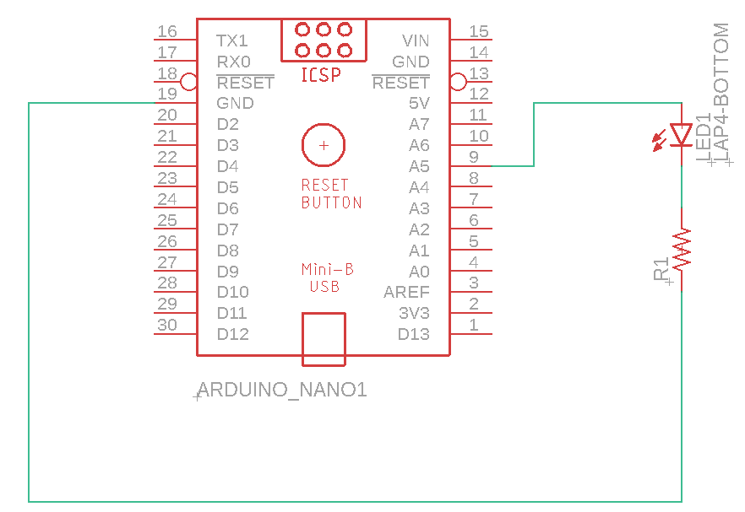
- 修正程式碼

int led = 13;
void setup() {
pinMode(led, OUTPUT);
}
void loop() {
digitalWrite(led, HIGH);
delay(2000);
digitalWrite(led, LOW);
delay(2000);
}
int led = 13;
void setup() {
pinMode(led, OUTPUT);
}
void loop() {
digitalWrite(led, HIGH);
delay(500);
digitalWrite(led, LOW);
delay(500);
}

