**Toolkit for Undergraduate Research Mentoring**

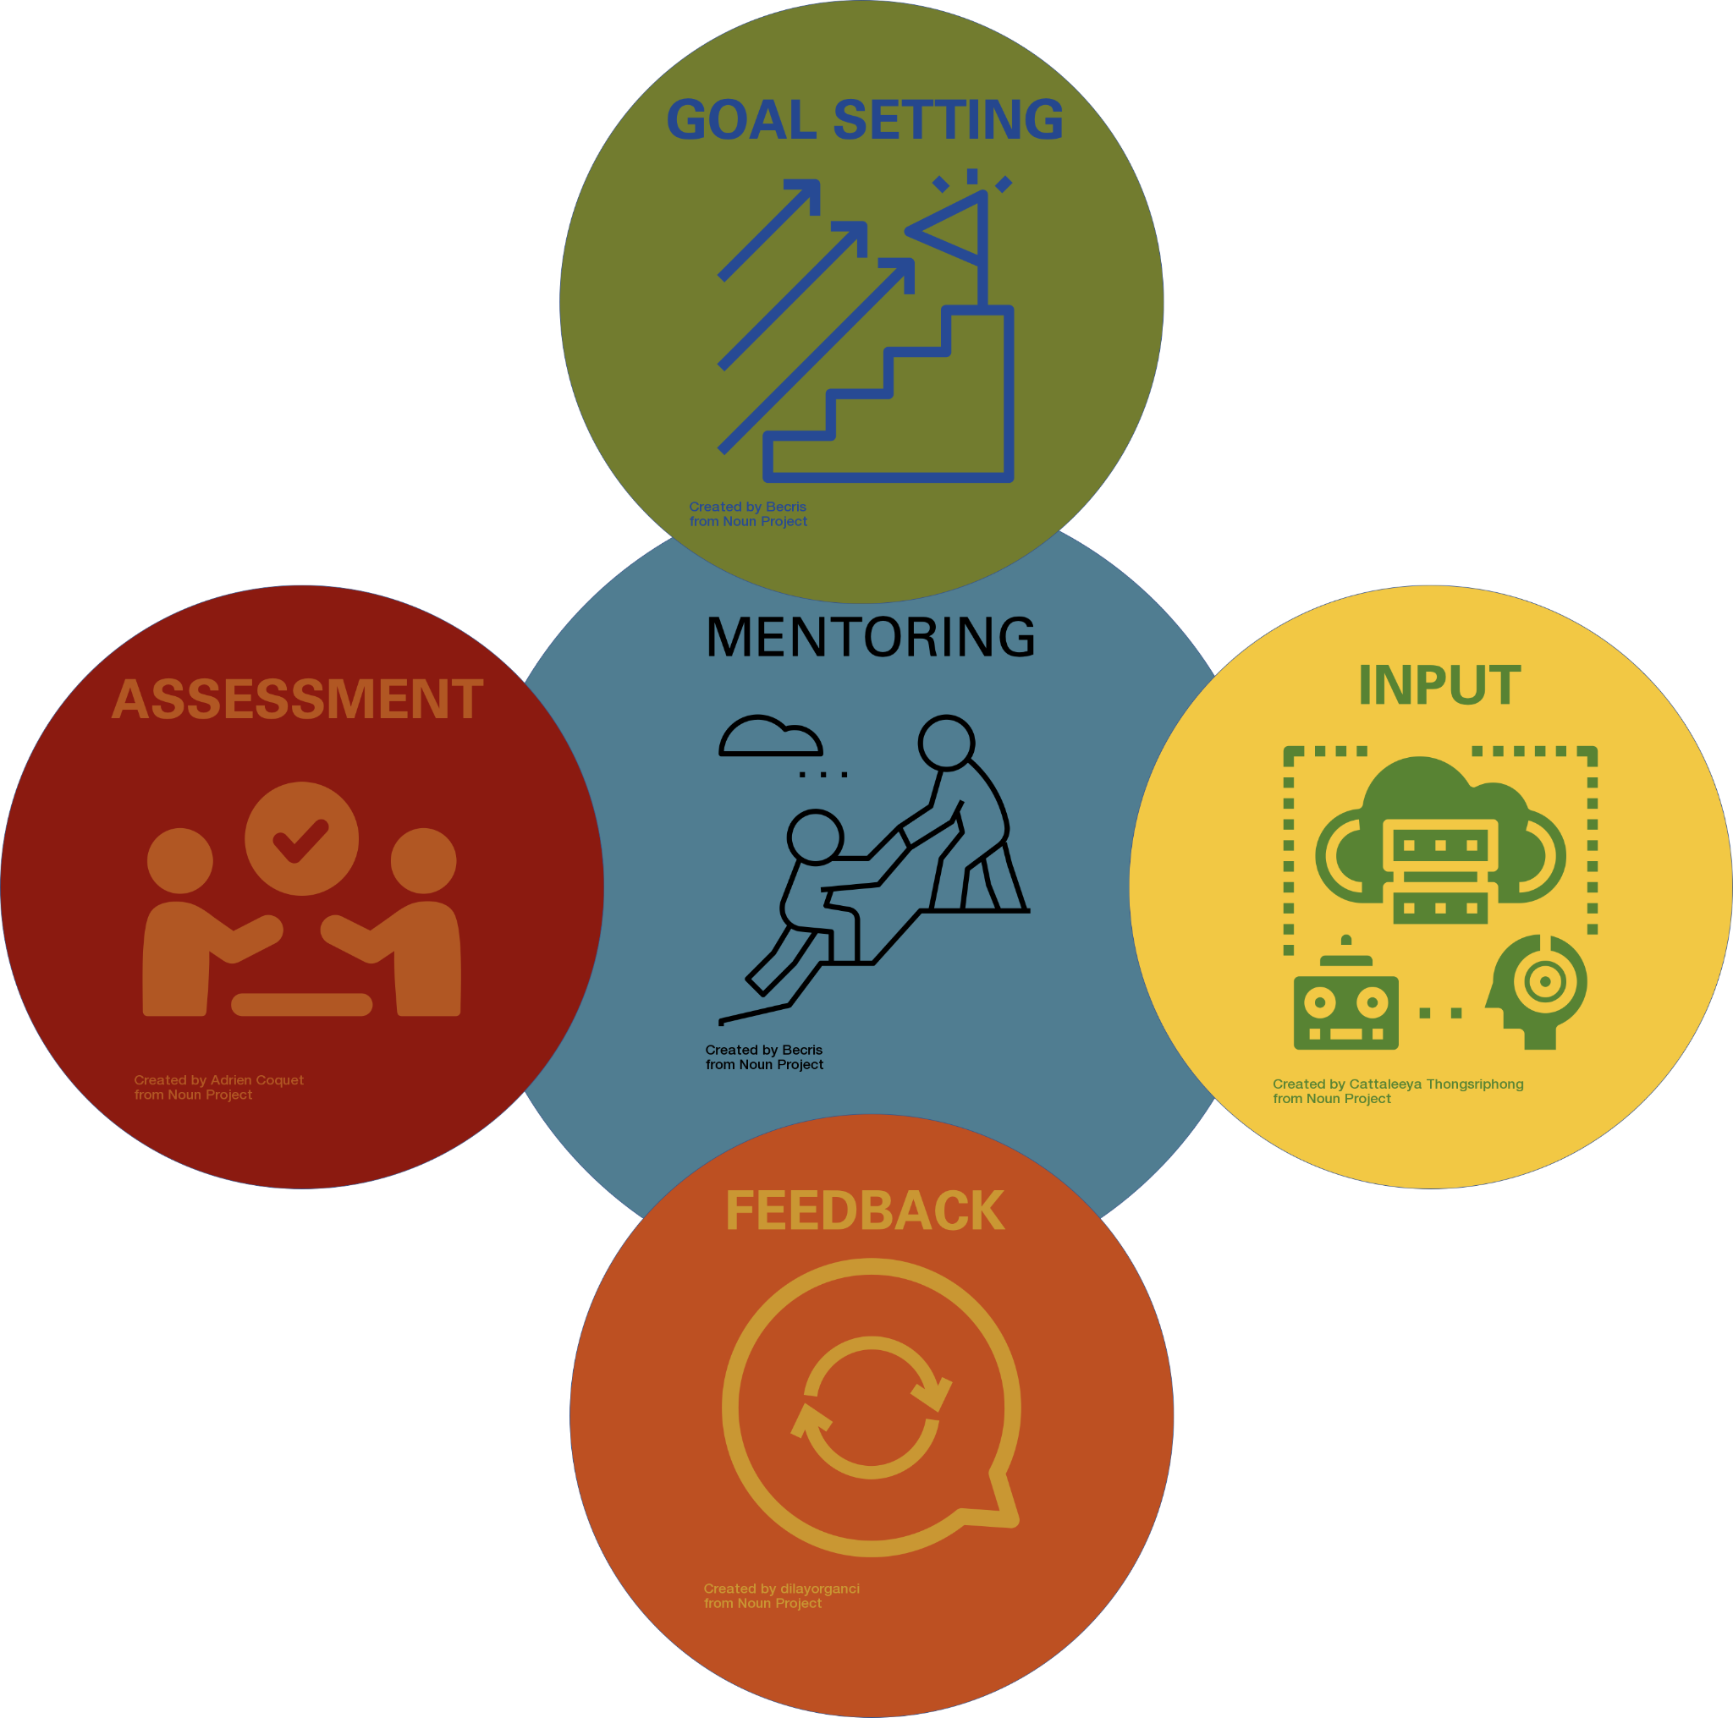

The academic relationship between a researcher and their mentor is a core feature of scientific research training. One of the most important aspects of this training dynamic is ongoing assessment provided through feedback in order to accelerate on-the-job training, foster a desire for learning and ultimately elevate every students’ potential to succeed in the STEM workforce. The aim of the Toolkit for Undergraduate Research Mentoring (TURMs) is to make the introduction of research mentorship as transparent as possible to undergraduates. This resource was developed to help make mentoring undergraduates a positive and constructive process that benefits both the mentee and the mentor.

# Quick Form Links

The four worksheets in this Toolkit will help set clear expectations (Form 1), train undergraduates to reflect on their goals and identify their struggles (Form 2), create the opportunity to model positive communication about scientific progress (Form 3), and evaluate the work, effort, and accomplishments of your researcher (Form 4). This Toolkit can be used in one finite research experience (like NCSU BIT SURE) and it can also be applied recursively to develop research skills, set goals, and prepare researchers for job evaluations that are essential for success in any future STEM career!

[FORM 1 - Goal Setting](https://docs.google.com/document/d/1kKFo1WaI07dZm04KhTQN7tMgSQqKNyI56p-RPf2jJY0/edit?usp=sharing/copy)

[FORM 2 - Undergraduate Input](https://docs.google.com/document/d/1kk0pI-zml4r6V2hhQR0SFmqq36n_CCqOnM3d3MxMx5g/edit?usp=sharing/copy)

[FORM 3 - Mentoring Feedback](https://docs.google.com/document/d/11q_cMXWiUuNbl754hNm0Jga3v7UMRwgcHDnIBXcq1GU/edit?usp=sharing/copy)

[FORM 4 - Evaluative Assessment](https://docs.google.com/document/d/1JS3TSm9xmOEhmt2-HesrMbpZYKkbtmjCjuQTBJOlw28/edit?usp=sharing/copy)

# Introduction to Mentoring Undergraduate Researchers

The objective of this toolkit is to lay out a model for positive formal evaluation that encourages undergraduates to take ownership of their work, drive their own formative evaluation process and support self-awareness. The scope of the role as a mentor far exceeds the resources that are provided here. Mentors will train new researchers, offer creative ideas, stimulate problem solving, provide wisdom, and model how our work as scientists is carried out. This guidance will advance their career goals, expose them to challenges, provide affirmation and guide them with constructive feedback. To the latter endeavor, this resource should provide an iterative template for a formal evaluation that encompasses goal setting, formative assessments, and an evaluative assessment.

Mentoring undergraduate researchers provides students the opportunity to confidently apply knowledge that is acquired in lecture halls and deepen their scientific understanding of life. It should be acknowledged that while mentoring undergraduates can be extremely rewarding, it can also be difficult as college students are limited in their availability, may only be able to commit in the short-term, and have split priorities that are concomitant with the demands on undergraduates. It is important to acknowledge these challenges without judgment in order to give undergraduate researchers the proper attention and training to carry out their given responsibilities, as we are preparing future scientists to enter the workforce as well as enriching our society with scientifically literate citizens. This resource was designed with all students in mind, not just graduate/professional school bound individuals. Providing undergraduates with clear expectations will improve any student’s productivity and research outcomes as well as set expectations for their future employment. The goal is to prepare all university diploma carriers to be successful, scientifically-minded employable adults.

Additionally, it is important to understand that mentoring has both formal and informal aspects. Giving clear and timely feedback is a considerable task that requires scope, intentionality, and clarity. It is critical to provide a sanctuary for mentees to confide their findings, ideas, and questions while challenging them to think for themselves and to arrive at their own conclusions. Growth is uncomfortable; and taking on a new challenge can be intimidating. Be sure that critical feedback is given with support and encouragement. Critical feedback clarifies a task, improves motivation, and is perceived as valuable. Good communication, trust and respect must be modeled by the mentor during each step in the feedback process. This resource focuses on how to introduce the nature of research to undergraduates through goal setting and iterative feedback. For additional guidance fostering healthy mentor-mentee relationships explore the resources at the end of this handbook!

# Critical feedback…

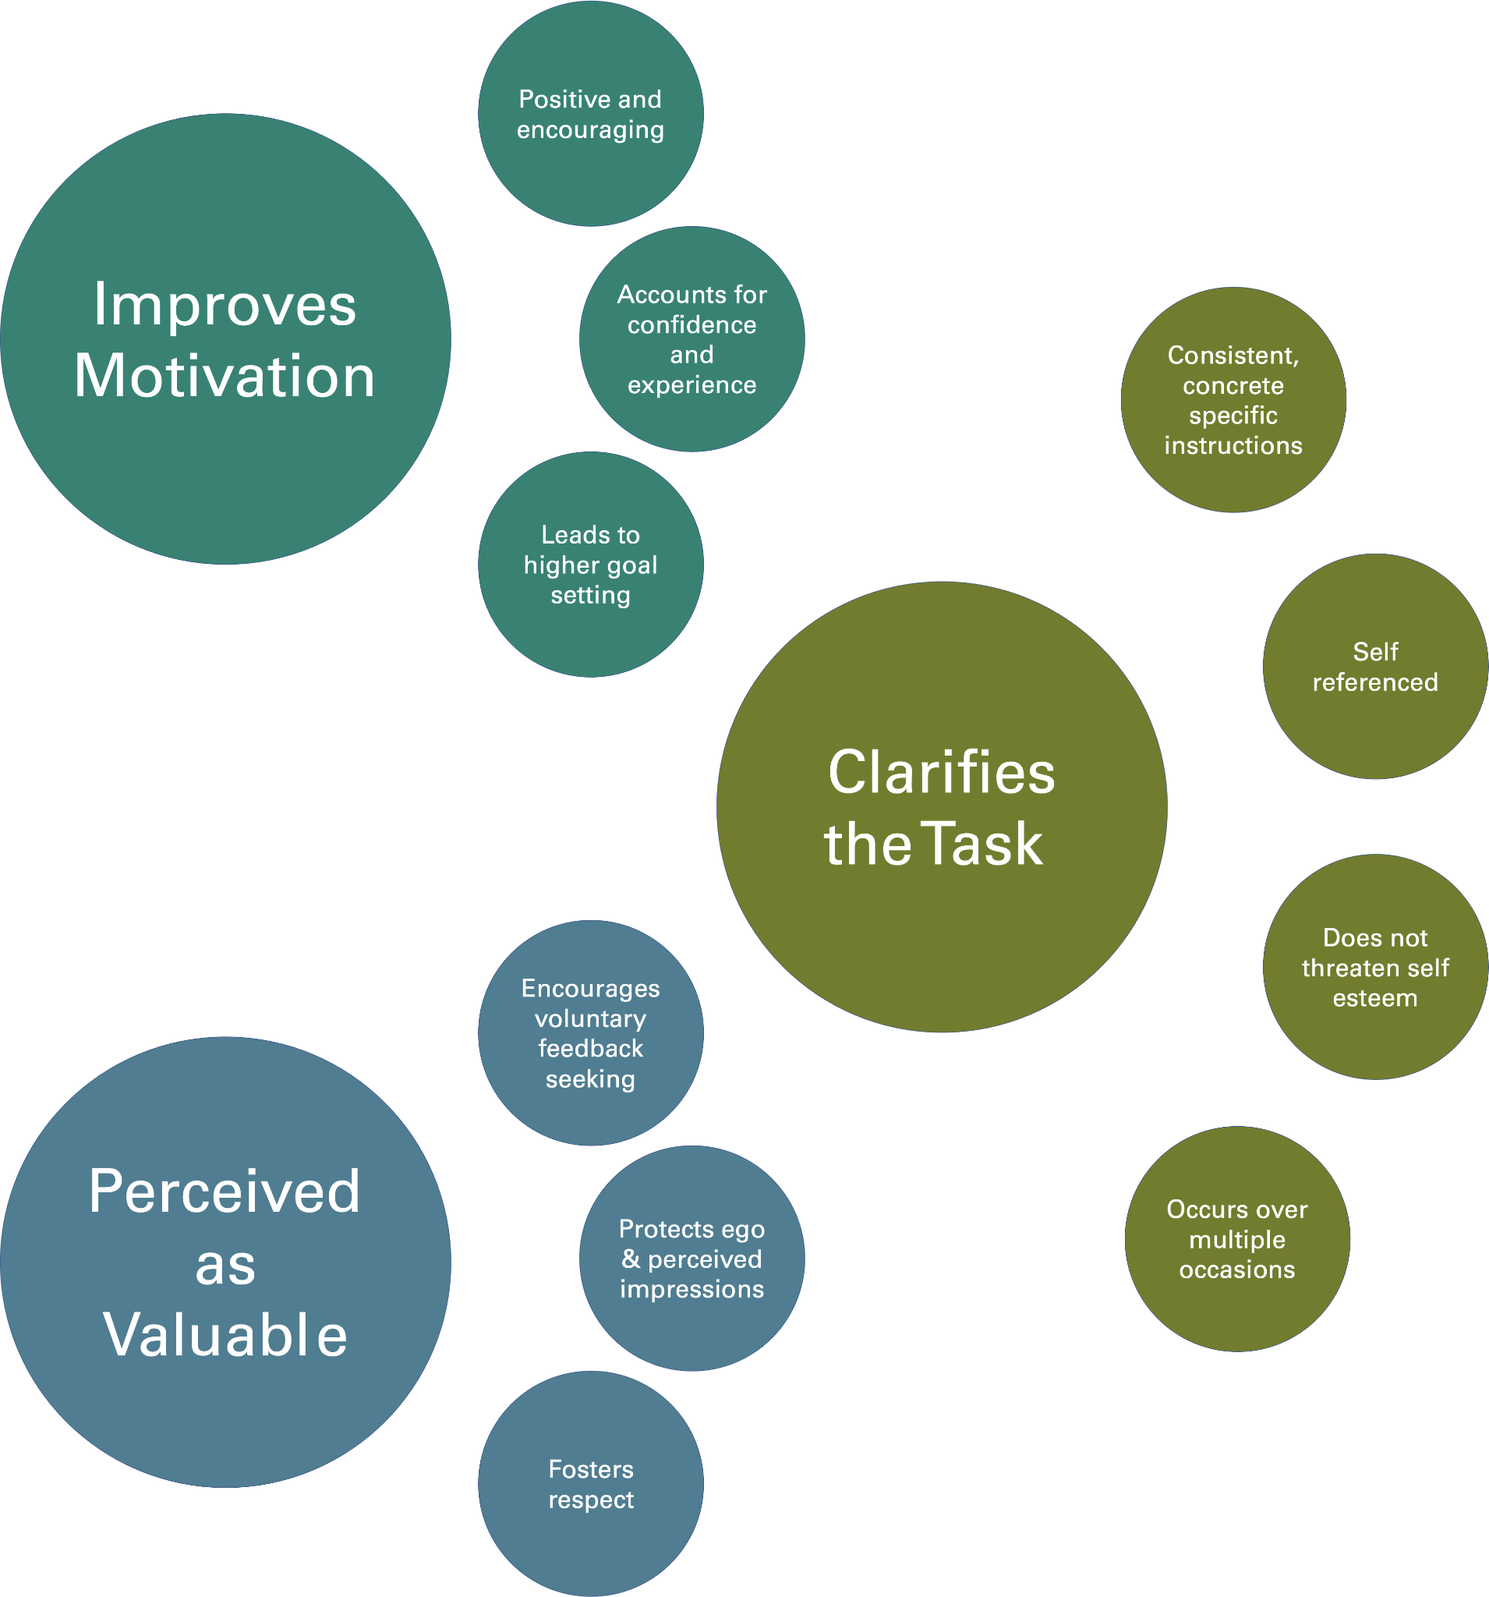

# Guidelines for implementing TURMs

## Form 1 - Goal Setting

At the beginning of an undergraduate research experience, both the mentor and mentee should meet and outline key aspects of the undergraduate researcher’s job. What are their responsibilities? What skills are they going to gain? What does success look like for their research? How does their role fit into a larger scientific question/project? Additionally, strong mentorship benefits from the mentor understanding the motivations of the mentee. Both the mentor and undergraduate researcher will outline these points as early on in a project as possible.

**COMPLETE** [**FORM 1**](https://docs.google.com/document/d/1kKFo1WaI07dZm04KhTQN7tMgSQqKNyI56p-RPf2jJY0/edit?usp=sharing/copy) **TOGETHER**

PART 1: The mentor should provide to the undergraduate with a research plan**:

• a description of the work the undergraduate will set out to accomplish

• the tasks they will undertake,

• the skills they will need in order to perform the tasks,

• and how the results will fit into the goals of its larger project.

**Often, research plans may change depending on the course of a project, and this should NOT be considered a contract of deliverables. The mentor should make this point clear to the undergraduate.

This is beneficial to the undergraduate, both to better understand their work, but to also know the skill sets they will acquire. Encourage the undergraduate to ask questions during your explanation of their project and they should be given the opportunity to change, add, or omit goals as they see reasonable. Beginning researchers may not yet have the scope to contribute to this section but you should prompt the undergrad that they can request changes. **If this toolkit is used repeatedly over a semester basis, begin again with Part 1 at the start of each term and encourage your undergraduate researcher to take ownership over the planning stage with your oversight and approval!

PART 2: The undergraduate should outline to the mentor:

• A description of the undergraduate’s goals and motivations

• their motivations for doing research

• their short-term academic goals

• their long-term career goals

• how doing research builds towards their goals

Writing out a description of the research that an undergraduate will embark on is a simple and easy way to remove a potential barrier to better understand their research topic. This establishes clear goals for their project, and it creates an opportunity to talk about the uncertainty of science research. They will likely be performing iterative experiments to acquire evidence supporting yet to be defined conclusions. As this is also likely to be their first experience tackling work without a prescribed answer, it helps prepare them for the uncertainty of scientific research.

Once completed and discussed, ensure that BOTH mentor and mentee have access to FORM 1 to reference frequently.

## Form 2 - Undergraduate Input

Midway through the semester, revisit the goals that were embarked on at the beginning of the semester. Tuning our goals over time is an inevitable aspect of science and this should be addressed proactively. Before making any changes by removing, adding, or editing goals, give the undergraduate the opportunity to outline the work they have done and also what still needs to be done in the near future. Prompting them to reflect on the goals that they have worked towards and to identify any struggles they are encountering will aid in your ability to guide them through their research.

**THE UNDERGRADUATE RESEARCHER COMPLETES** [**FORM 2**](https://docs.google.com/document/d/1kk0pI-zml4r6V2hhQR0SFmqq36n_CCqOnM3d3MxMx5g/edit?usp=sharing/copy)

• Undergraduate schedules a meeting with their mentor (encouragement may be necessary, but it is important to set a precedent for the mentee to seek feedback).

• Undergraduate completes FORM 2.

• At the meeting, both the mentor and mentee should have a copy of FORM 1 and FORM 2.

• Ask the undergraduate to share information written down on FORM 2 with the mentor.

• Undergraduate researchers should do 95% of the talking.

• Mentor should only talk to help encourage communication driven by the undergraduate and to clarify descriptions if unclear (not if descriptions are unpleasant to the mentor).

* Mentor should have access to FORM 2 at the end of the meeting.

At the end of the meeting, thank the undergraduate for reflecting on their work and let them know you will think over their self-assessment and meet again shortly to discuss further.

## Form 3 - Mentoring Feedback

Give yourself a week or two to fill out FORM 3 and then meet again for a mentor-led follow-up. This time-lapse serves a few purposes. First, it gives you time to evaluate the depth of understanding your researcher has on their project or where deficiencies exist. It is helpful to give yourself time to reflect rather than react and to devise a plan to address moving forward without being put on the spot. This may lead to a situation where an undergraduate needs to be challenged more if they are flourishing, or where a student may need more training or coaching. The mentor should address both the accomplishments and the struggles of their mentee. Mentors should be open to getting questions, helping resolve setbacks, and fostering positive communication about scientific progress. It is crucial to provide young researchers with a positive foundation for receiving constructive feedback and that the purpose of this is to clarify tasks, improve motivation, and is perceived as valuable to the undergraduate.

**THE MENTOR COMPLETES** [**FORM 3**](https://docs.google.com/document/d/11q_cMXWiUuNbl754hNm0Jga3v7UMRwgcHDnIBXcq1GU/edit?usp=sharing/copy)

• Mentors should consider all input from FORM 2 and address each point made by their undergraduate researcher.

• For each point, make sure that the undergraduate understands the feedback, and has the tools, instruction and support to be productive.

* While you are leading the conversation, you should aim to share communication 50:50 with your mentee.

## Form 4 - Evaluative Assessment

At the end of the semester, formally evaluate the work, effort, and accomplishments of the undergraduate. What progress have they made? What are strengths you have observed? Where do you see areas for them to improve? How can you both work to tackle challenges moving forward? (Are you moving forward together or is the undergraduate moving on?)

**THE MENTOR COMPLETES** [**FORM 4**](https://docs.google.com/document/d/1JS3TSm9xmOEhmt2-HesrMbpZYKkbtmjCjuQTBJOlw28/edit?usp=sharing)

• Both mentor and mentee should be given access to FORM 4.

• Undergraduates should schedule the meeting with the mentor.

• After the meeting, both the mentor and undergraduate keep their copy of FORM 4 and any new notes made during the meeting should be shared.

Seeing these accomplishments written down is so valuable for their intellectual growth as are areas for improvement. These evaluations can be saved and used to help students detail their resumes and seek job applications, affirming their abilities and strengths! This can even benefit you, as this can comprise foundational materials for letters of recommendation down the line!

# Resources

1. Christine Pfund, Janet Branchaw, Jo Handelsman. (2014). *Entering Mentoring.* W.H. Freeman Entering Mentoring Book Series. New York: W.H. Freeman & Co.
2. Janet L. Branchaw, Amanda R. Butz, Amber R. Smith. (2020). *Entering Research.* W.H. Freeman Entering Mentoring Book Series. New York: W.H. Freeman & Co.
3. Jo Handelsman, Sarha Miller, Christine Pfund. (2007). *Scientific Teaching*. Wisconsin Program for Scientific Teaching: New York: W.H. Freeman & Co.
4. Stephanie J. Slater, Timothy F. Slater, Janelle M. Bailey. (2010). *Discipline-Based Education Research*. Wisconsin Program for Scientific Teaching: New York: W.H. Freeman & Co.
5. Garold L. Markle. (2000) *Catalytic Coaching: The End of the Performance Review*. Quorum Books, Greenwood Publishing Group, Inc.
6. Montgomery, B. L. (2017). Mapping a Mentoring Roadmap and Developing a Supportive Network for Strategic Career Advancement. *SAGE Open*, *7*(2). <https://doi.org/10.1177/2158244017710288>.
7. Chen, J. E., & Glover, G. H. (2016). Culturally Diverse Undergraduate Researchers’ Academic Outcomes and Perceptions of Their Research Mentoring Relationships, *25*(3), 289–313. <https://doi.org/10.1007/s11065-015-9294-9>.
8. Brown, E. E. (2011). A Multicontextual Model for Broadening Participation in STEM Related Disciplines. *US-China Education Review*, *8*(3), 323–332. Retrieved from <http://libaccess.mcmaster.ca/login?url=http://search.proquest.com/docview/881461799?accountid=12347>.
9. Staller, M. V., Wunderlich, Z., Lopez Rivera, F., Bragdon, M. D. J., Biette, K. M., Park, J., … DePace, A. H. (2015). Yearly Planning Meetings: Individualized Development Plans Aren’t Just More Paperwork. *Molecular Cell*, *58*(5), 718–721. <https://doi.org/10.1016/j.molcel.2015.04.025>.
10. Chao, G. T., Walz, P. M., & Gardner, P. D. (1992). Formal and informal mentorships: A comparison on mentoring functions and contrast with nonmentored counterparts. *Personnel Psych.*, *45*(3), 619–635. Retrieved from <https://doi.org/10.1111/j.1744-6570.1992.tb00863.x>.
11. Hamlin, R. G., & Sage, L. (2011). Behavioural criteria of perceived mentoring effectiveness: An empirical study of effective and ineffective mentor and mentee behaviour within formal mentoring relationships.
12. Monroe, K., Ozyurt, S., Wrigley, T., & Alexander, A. (2008). Gender equality in academia: Bad news from the trenches, and some possible solutions. *Perspectives on Politics*, *6*(2), 215–233. <https://doi.org/10.1017/S1537592708080572>.
13. Anderson, L., Silet, K., & Fleming, M. (2012). Evaluating and Giving Feedback to Mentors: New Evidence-Based Approaches. *Clinical and Translational Science*, *5*(1), 71–77. <https://doi.org/10.1111/j.1752-8062.2011.00361.x>.
14. Chopra, V., Edelson, D. P., & Saint, S. (2016). Mentorship malpractice. *JAMA - Journal of the American Medical Association*, *315*(14), 1453–1454. <https://doi.org/10.1001/jama.2015.18884>.