**FORM 1: GOAL SETTING**

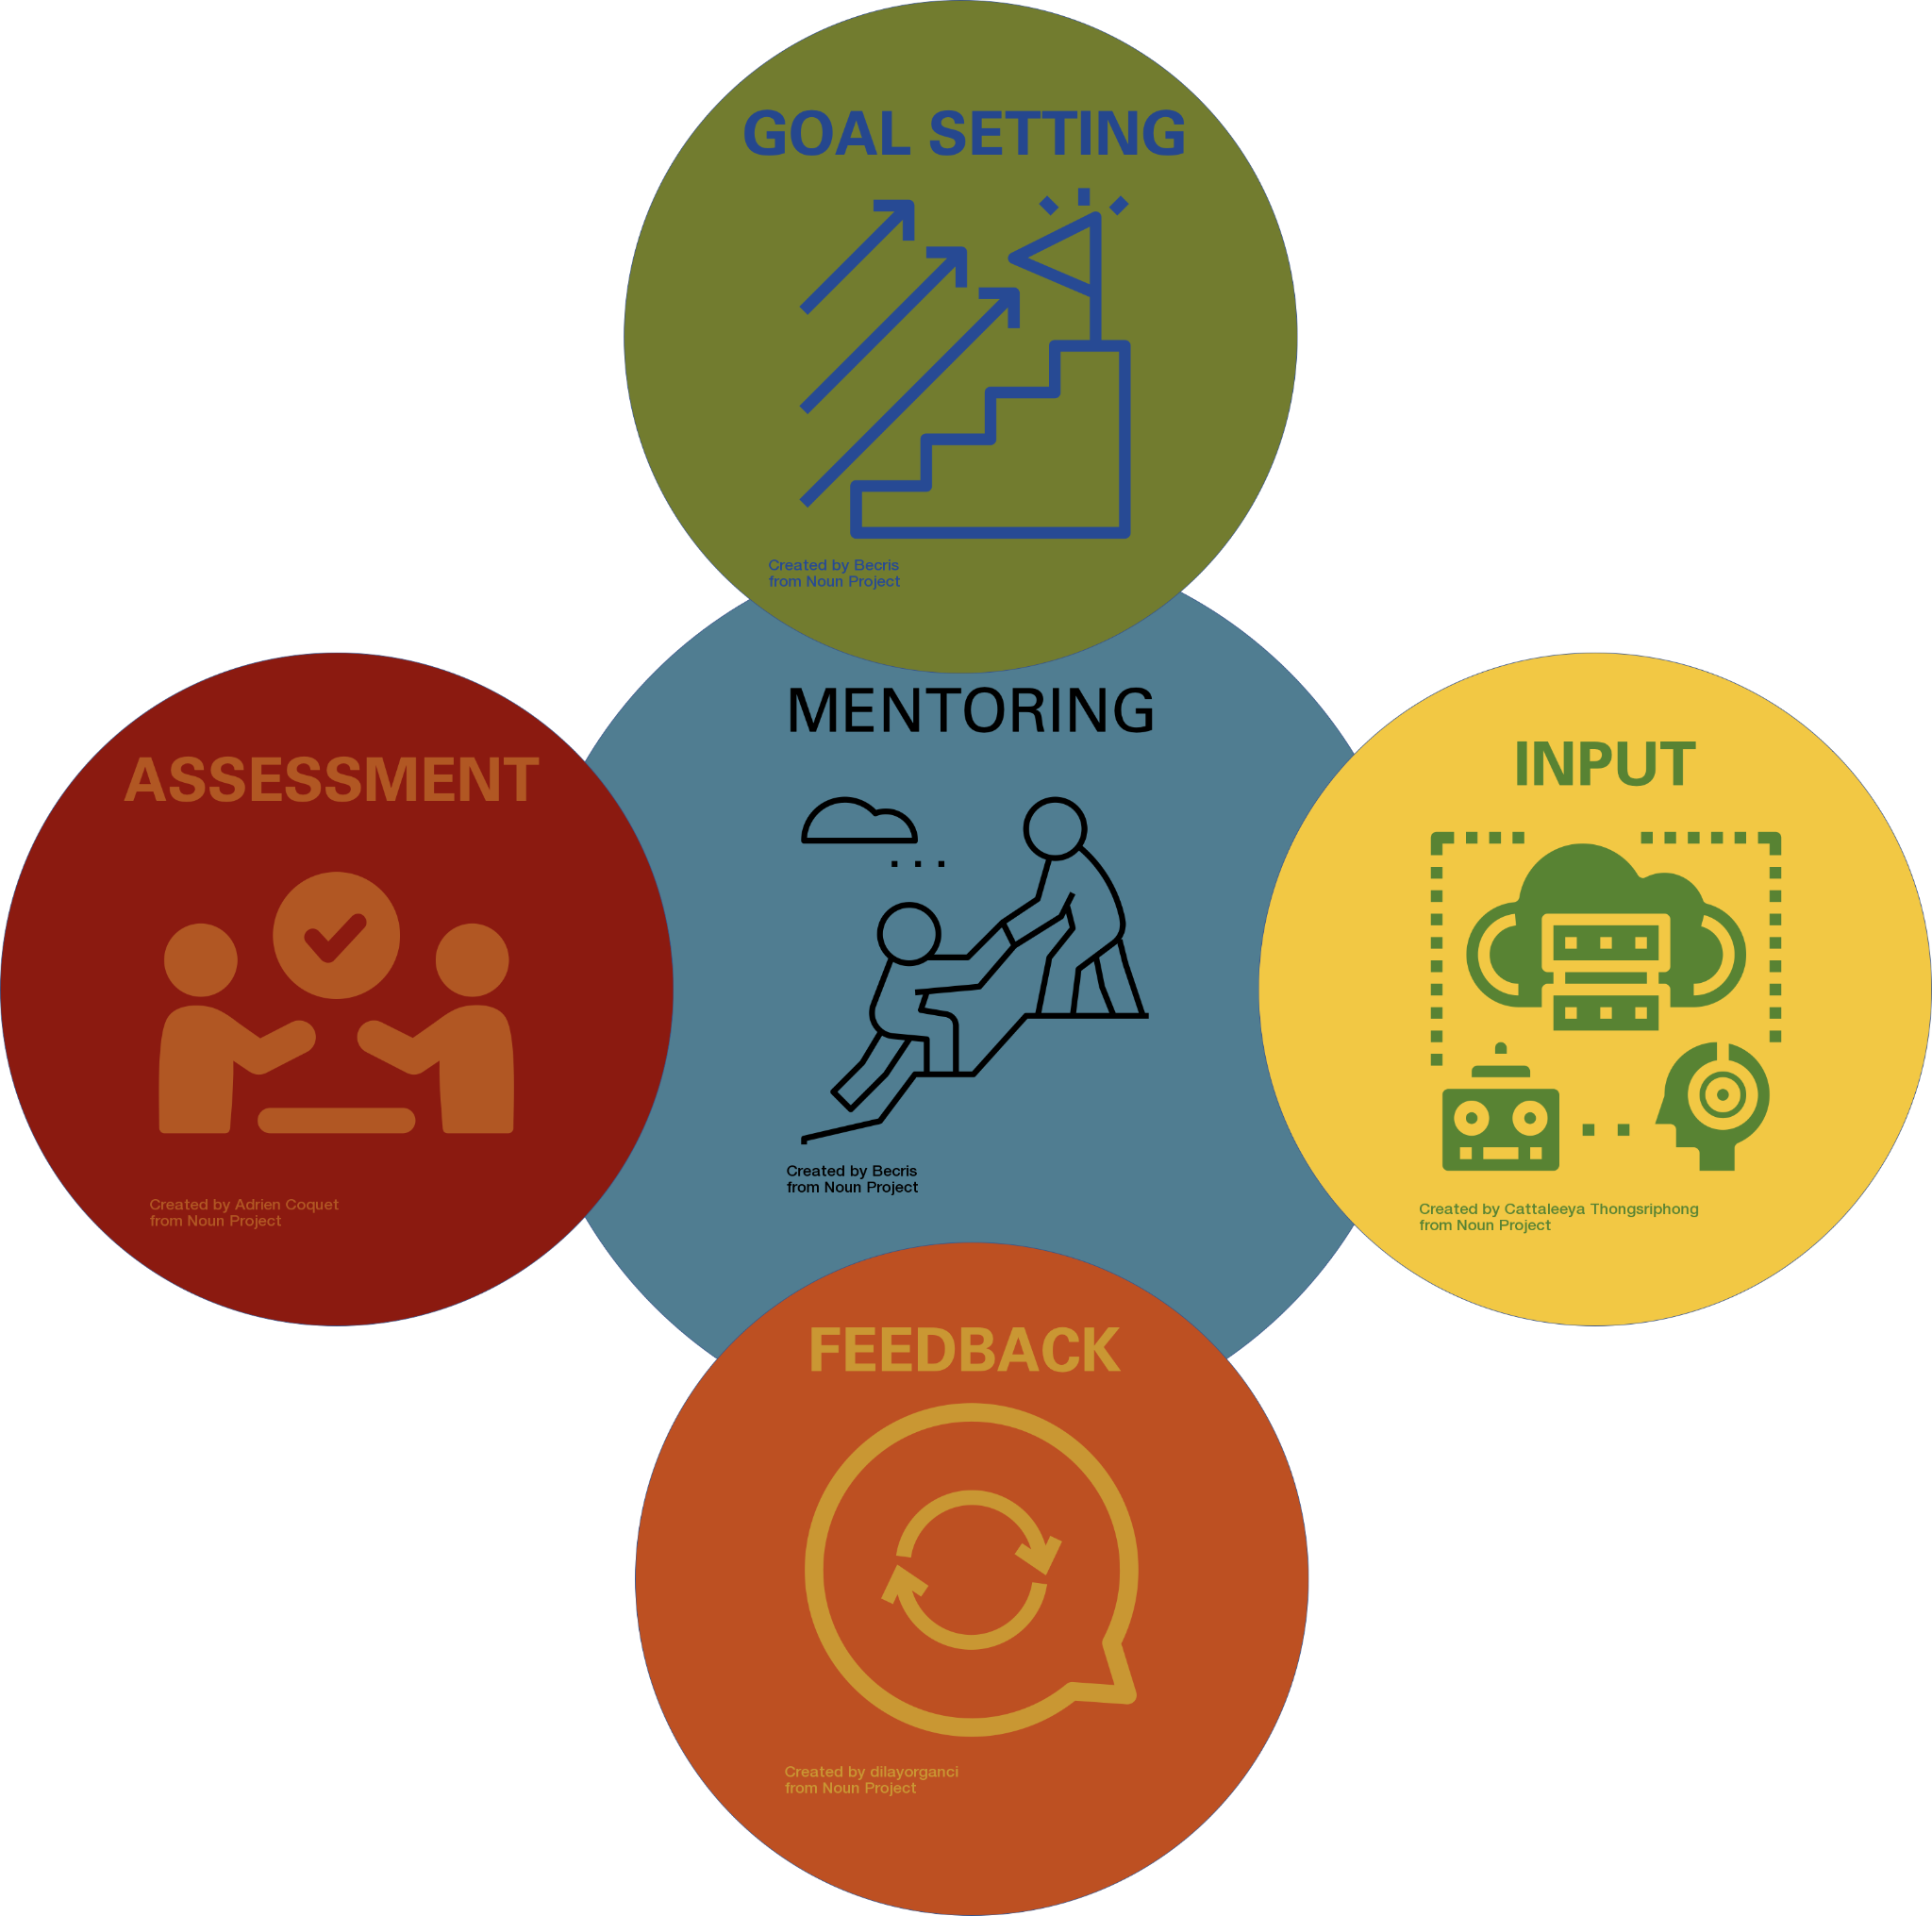

Together, let’s outline our research goals for the semester. This should serve to help you be successful and productive in the lab this semester (short-term goals), possibly in future semesters (intermediate-term goals), and to help you reach your ultimate career goals as well (long-term goals)! The plans described here may change depending on the course of our project, and this should NOT be considered a contract of deliverables.

UNDERGRADUATE RESEARCHER :___[NAME]_________________

MENTOR / PI :___[NAME]____________

## PART1: MENTOR CAN COMPLETE

**What project will the undergraduate researcher work on?**

**What will the undergraduate contribute to this project? What experiments will the undergraduate do?**

**How do these experiments fit into the project overall?**

**What skills are necessary to perform these experiments?**

## PART 2: UNDERGRADUATE WILL COMPLETE

**What are your motivations for doing research?**

**What are your academic goals for this semester, and for your undergraduate tenure?**

**What do you see yourself doing 5 years from now?**

**What are your long-term career goals?**

**How does this research help you progress towards your goals?**

UNDERGRADUATE SIGNATURE: ____________________________________________________

MENTOR SIGNATURE: ___________________________________________________________

DATE OF DISCUSSION: __________________________

Signatures designate these items were discussed by both mentor and undergraduate.