**FORM 3: MENTOR FEEDBACK**

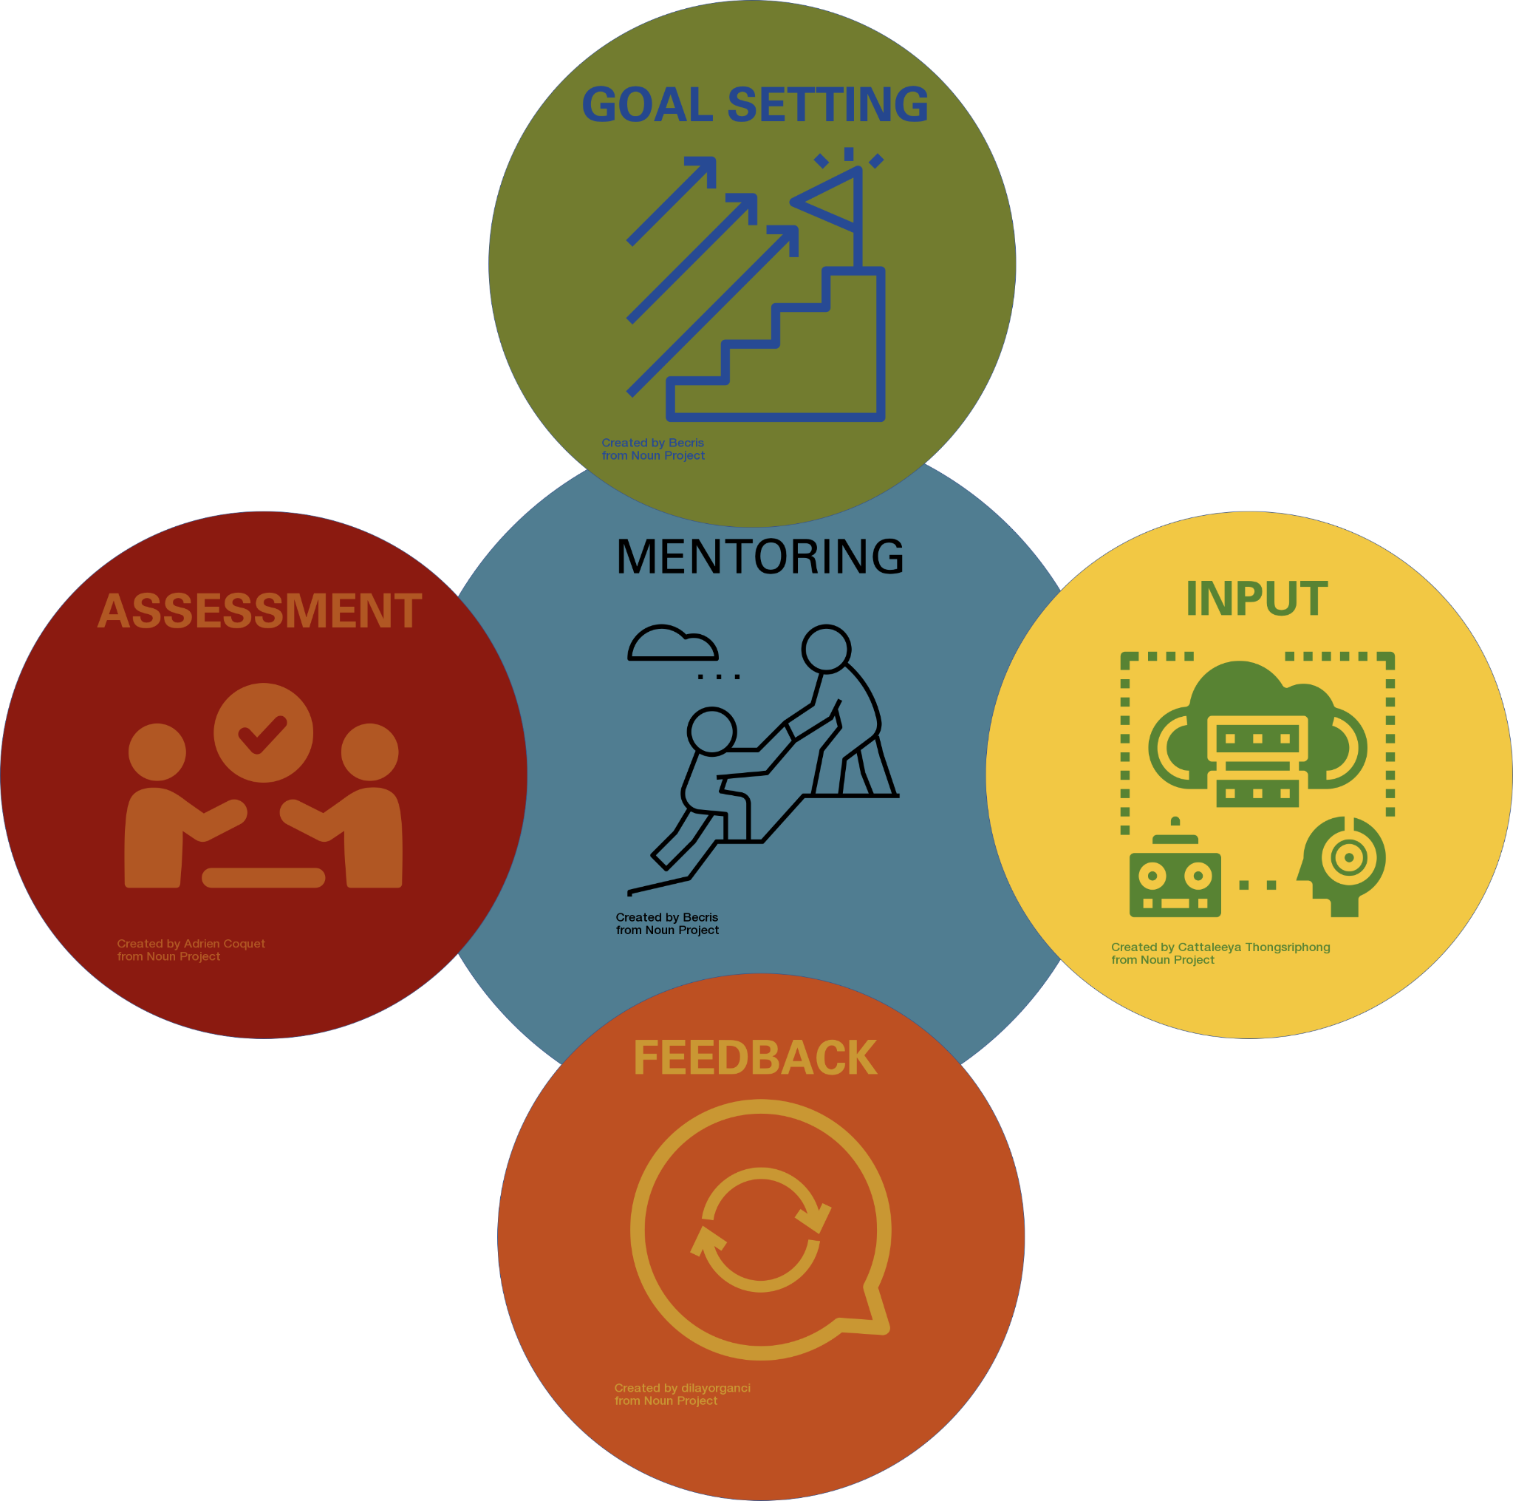

Reflect on the outline of our research goals for the semester. This should serve to acknowledge the growth of a new researcher and to motivate and advise undergraduate researchers to be successful and productive in the lab! The plans described here may change depending on the course of our project, and this should NOT be considered a contract of deliverables.

UNDERGRADUATE RESEARCHER :___[NAME]_________________________________________

MENTOR / PI :___[NAME]________________________________________________________

## MENTOR WILL COMPLETE FORM 3

Research Accomplishments

1. What results has the undergraduate produced this semester?
2. What marketable skills and experience has the undergraduate gained?
3. Who has my undergraduate worked with in order to achieve these results and attain new skills? Do I have suggestions to broaden this list?

Research Support

1. Where does my undergraduate see themselves struggling?
2. How can I help my undergraduate succeed with their research goals this semester?
3. How can I help my undergraduate succeed in connecting their research experience to their long term academic and career goals?
4. How can I support my undergraduate succeed with any additional comments/concerns/ questions they may have?

UNDERGRADUATE SIGNATURE: ____________________________________________________

MENTOR SIGNATURE: ___________________________________________________________

DATE OF DISCUSSION: __________________________

Signatures designate these items were discussed, as communicated by said undergraduate.