DEPARTMENT OF COMPUTER SCIENCE AND
ENGINEERING

2026–27

ODD SEMESTER

INFORMATION ASSURANCE AND SECURITY
(24CS3105)

ALM – PROTOTYPE REVIEW

submitted by
Ansh Shukla
2420090100

Cluster: 4 Section: 11

Course Instructor
Dr. Jagan Mohan Reddy Danda

Associate Professor



KONERU LAKSHMAIAH EDUCATION FOUNDATION,
BOWRAMPET

Hyderabad–500043, Telangana, India 2026–27

Abstract

Cryptography is an important component of information assurance because it provides mechanisms for protecting information during storage and communication. This project presents a prototype for studying different cryptographic techniques and understanding how plaintext, keys, ciphertext, encryption, decryption, and key exchange are related.
The prototype includes classical techniques such as Caesar Cipher, Playfair Cipher, Hill Cipher, and Vigenere Cipher. It also studies Simplified Data Encryption Standard (SDES), Advanced Encryption Standard (AES), and RC4 to demonstrate symmetric encryption concepts. Diffie–Hellman is included to explain secure key establishment, while RSA demonstrates the basic principles of asymmetric public-key cryptography.
The objective of the prototype is not only to study the theoretical working of these algorithms but also to observe their behaviour through implementation. By comparing algorithms from different generations of cryptography, the project provides a practical understanding of how information can be transformed and protected using mathemat-ical and key-based security mechanisms.

Contents

Abstract 1

Introduction 5
  - Objectives . . . . . . . . . . . . . . . . . . . . . . . . . . . . . . . . . . 5

Cryptographic Algorithms 7

2.1 | Caesar | Cipher . . . . . . . . . . . . . . . . . . . . . . . . . . . . . . . . | 7
 | 2.1.1 | Definition . . . . . . . . . . . . . . . . . . . . . . . . . . . . . . | 7
 | 2.1.2 | Mathematical Representation . . . . . . . . . . . . . . . . . . . | 7
 | 2.1.3 | Algorithm . . . . . . . . . . . . . . . . . . . . . . . . . . . . . . | 7
 | 2.1.4 | Observation . . . . . . . . . . . . . . . . . . . . . . . . . . . . . | 8
 | 2.1.5 | Prototype Screenshot . . . . . . . . . . . . . . . . . . . . . . . . | 8
2.2 | Playfair Cipher . . . . . . . . . . . . . . . . . . . . . . . . . . . . . . . |  | 8
 | 2.2.1 Definition . . . . . . . . . . . . . . . . . . . . . . . . . . . . . . |  | 8
 | 2.2.2 Working Principle . . . . . . . . . . . . . . . . . . . . . . . . . . |  | 8
 | 2.2.3 Algorithm . . . . . . . . . . . . . . . . . . . . . . . . . . . . . . |  | 9
 | 2.2.4 Observation . . . . . . . . . . . . . . . . . . . . . . . . . . . . . |  | 9
 | 2.2.5 Prototype Screenshot . . . . . . . . . . . . . . . . . . . . . . . . |  | 9
2.3 | Hill Cipher . . . . . . . . . . . . . . . . . . . . . . . . . . . . . . . . . . |  | 9
 | 2.3.1 Definition . . . . . . . . . . . . . . . . . . . . . . . . . . . . . . |  | 9
 | 2.3.2 Mathematical Representation . . . . . . . . . . . . . . . . . . . |  | 9
 | 2.3.3 Algorithm . . . . . . . . . . . . . . . . . . . . . . . . . . . . . . |  | 10
 | 2.3.4 Observation . . . . . . . . . . . . . . . . . . . . . . . . . . . . . |  | 10
 | 2.3.5 Prototype Screenshot . . . . . . . . . . . . . . . . . . . . . . . . |  | 10
2.4 | Vigenere Cipher . . . . . . . . . . . . . . . . . . . . . . . . . . . . . . . |  | 10
 | 2.4.1 Definition . . . . . . . . . . . . . . . . . . . . . . . . . . . . . . |  | 10
 | 2.4.2 Mathematical Representation . . . . . . . . . . . . . . . . . . . |  | 10

 | 2.4.3 Algorithm . . . . . . . . . . . . . . . . . . . . . . . . . . . . . . |  | 11
 | 2.4.4 Observation . . . . . . . . . . . . . . . . . . . . . . . . . . . . . |  | 11
 | 2.4.5 Prototype Screenshot . . . . . . . . . . . . . . . . . . . . . . . . |  | 11
2.5 | Simplified Data Encryption Standard (SDES) . . . . . . . . . . . . . . |  | 11
 | 2.5.1 Definition . . . . . . . . . . . . . . . . . . . . . . . . . . . . . . |  | 11
 | 2.5.2 Mathematical Representation . . . . . . . . . . . . . . . . . . . |  | 11
 | 2.5.3 Algorithm . . . . . . . . . . . . . . . . . . . . . . . . . . . . . . |  | 12
 | 2.5.4 Observation . . . . . . . . . . . . . . . . . . . . . . . . . . . . . |  | 12
 | 2.5.5 Prototype Screenshot . . . . . . . . . . . . . . . . . . . . . . . . |  | 12
2.6 | Advanced Encryption Standard (AES) . . . . . . . . . . . . . . . . . . |  | 12
 | 2.6.1 | Definition . . . . . . . . . . . . . . . . . . . . . . . . . . . . . . | 12
 | 2.6.2 | Key Sizes . . . . . . . . . . . . . . . . . . . . . . . . . . . . . . | 12
 | 2.6.3 | Major Operations . . . . . . . . . . . . . . . . . . . . . . . . . . | 13
 | 2.6.4 | Algorithm . . . . . . . . . . . . . . . . . . . . . . . . . . . . . . | 13
 | 2.6.5 | Observation . . . . . . . . . . . . . . . . . . . . . . . . . . . . . | 13
 | 2.6.6 | Prototype Screenshot . . . . . . . . . . . . . . . . . . . . . . . . | 13
2.7 | RC4 | Stream Cipher . . . . . . . . . . . . . . . . . . . . . . . . . . . . . | 13
 | 2.7.1 | Definition . . . . . . . . . . . . . . . . . . . . . . . . . . . . . . | 13
 | 2.7.2 | Mathematical Representation . . . . . . . . . . . . . . . . . . . | 13
 | 2.7.3 | Working Principle . . . . . . . . . . . . . . . . . . . . . . . . . . | 14
 | 2.7.4 | Algorithm . . . . . . . . . . . . . . . . . . . . . . . . . . . . . . | 14
 | 2.7.5 | Observation . . . . . . . . . . . . . . . . . . . . . . . . . . . . . | 14
 | 2.7.6 | Prototype Screenshot . . . . . . . . . . . . . . . . . . . . . . . . | 14
2.8 Diffie–Hellman Key Exchange 15
 | 2.8.1 | Definition . . . . . . . . . . . . . . . . . . . . . . . . . . . . . . | 15
 | 2.8.2 | Mathematical Representation . . . . . . . . . . . . . . . . . . . | 15
 | 2.8.3 | Algorithm . . . . . . . . . . . . . . . . . . . . . . . . . . . . . . | 15
 | 2.8.4 | Observation . . . . . . . . . . . . . . . . . . . . . . . . . . . . . | 16
 | 2.8.5 | Prototype Screenshot . . . . . . . . . . . . . . . . . . . . . . . . | 16
2.9 | RSA | . . . . . . . . . . . . . . . . . . . . . . . . . . . . . . . . . . . . . | 16
 | 2.9.1 | Definition . . . . . . . . . . . . . . . . . . . . . . . . . . . . . . | 16
 | 2.9.2 | Key Generation . . . . . . . . . . . . . . . . . . . . . . . . . . . | 16
 | 2.9.3 | Encryption . . . . . . . . . . . . . . . . . . . . . . . . . . . . . | 17
 | 2.9.4 | Decryption . . . . . . . . . . . . . . . . . . . . . . . . . . . . . | 17

    - Algorithm 17
    - Observation 17
    - Prototype Screenshot 18
- Comparison of Cryptographic Algorithms 19
  - Key Differences 19
- Prototype Implementation 20
  - Prototype Features 20
- Prototype Testing 22
  - General Testing Procedure 22
  - Diffie–Hellman Testing 22
  - RSA Testing 23

Chapter 1 Introduction
Information is one of the most valuable resources in modern computer systems. Or-ganizations and individuals continuously exchange data through networks, websites, mobile applications, databases, and cloud services. If this information is not properly protected, unauthorized users may intercept, read, modify, or misuse it.
Cryptography provides mathematical methods for protecting information. The read-able form of information is called plaintext. Encryption transforms plaintext into an unreadable representation called ciphertext. The corresponding decryption operation allows an authorized user to recover the original information.
Cryptographic techniques can be classified in several ways. Classical ciphers use substi-tution, character shifting, and mathematical transformations. Symmetric cryptography generally uses shared secret key material, whereas asymmetric cryptography uses math-ematically related public and private keys. Key-agreement algorithms solve the problem of establishing shared secret information between communicating parties.
This project studies these different approaches through a common cryptographic pro-totype.

  - Objectives
The major objectives of this project are:
    - To understand the role of cryptography in information assurance.
    - To study classical encryption techniques.
    - To implement encryption and decryption operations.
    - To understand the importance of cryptographic keys.
    - To study substitution and matrix-based encryption.
    - To understand symmetric block encryption.
    - To study stream cipher concepts.
    - To understand secure key establishment.

Information Assurance and Security ALM – Prototype Review

    - To study asymmetric public-key cryptography.
    - To compare the working principles of different cryptographic algorithms.

Chapter 2
Cryptographic Algorithms

  - Caesar Cipher
    - Definition
Caesar Cipher is a classical substitution technique in which every alphabetic character of the plaintext is shifted by a fixed number of positions. The shift value works as the encryption key.
For example, when the key value is 4:

A → E, B → F, C → G
Thus, the plaintext DATA becomes HEXE.

    - Mathematical Representation
Encryption is represented as:

C = (P + K) mod 26
Decryption is:

P = (C − K) mod 26
where P represents the plaintext character value, C represents the ciphertext value, and K represents the shift key.

    - Algorithm
      - Read the plaintext message.

      - Read the shift key.
      - Convert each character into its numerical position.
      - Add the shift value to the character.
      - Apply modulo 26.
      - Convert the result back into an alphabetic character.
      - Repeat the process for all characters.
      - Display the ciphertext.

    - Observation
Caesar Cipher is easy to understand and implement, but it provides weak security because only a small number of possible shift values exist. Its primary importance in this project is demonstrating the basic relationship between plaintext, ciphertext, and cryptographic keys.

    - Prototype Screenshot
Insert Caesar Cipher prototype screenshot here.

  - Playfair Cipher
    - Definition
Playfair Cipher is a digraph substitution cipher. Instead of encrypting one character at a time, the plaintext is divided into pairs of characters.
A keyword is used to construct a 5×5 character matrix. The letters I and J are generally combined so that the English alphabet can fit into 25 matrix positions.

    - Working Principle
The encryption rule depends on the positions of two characters in the matrix.
Same Row: Both characters are replaced by the characters immediately to their right.
Same Column: Both characters are replaced by the characters immediately below them.
Rectangle Rule: If the characters are located in different rows and columns, they form two corners of a rectangle. The other corners in their corresponding rows are selected.

    - Algorithm
      - Read the plaintext and keyword.
      - Remove repeated characters from the keyword.
      - Generate the 5 × 5 Playfair matrix.
      - Divide the plaintext into character pairs.
      - Locate each pair inside the matrix.
      - Apply the row, column, or rectangle rule.
      - Combine all encrypted pairs.
      - Display the ciphertext.

    - Observation
Playfair Cipher processes two letters together and therefore hides single-letter frequency patterns better than a simple substitution cipher. However, it does not provide sufficient security for modern digital communication.

    - Prototype Screenshot
- 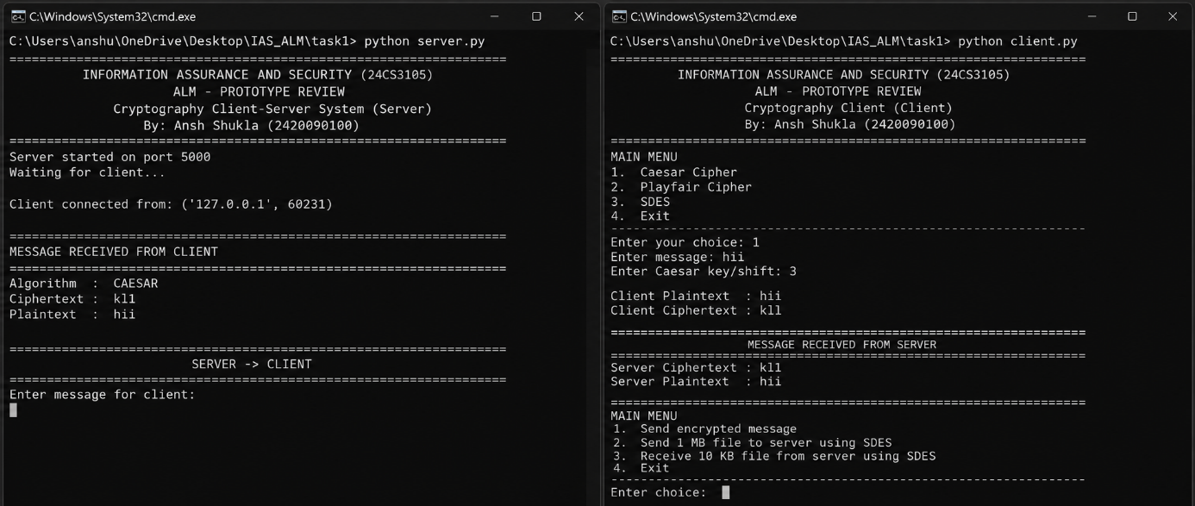

  - Hill Cipher
    - Definition
Hill Cipher is a classical cryptographic technique based on matrix multiplication and modular arithmetic. Plaintext characters are converted into numerical values and pro-cessed in groups.

    - Mathematical Representation
Encryption:

C = KP mod 26
Decryption:

P = K⁻¹C mod 26
where:
- P is the plaintext vector.

- C is the ciphertext vector.
- K is the key matrix.
- K⁻¹ is the modular inverse of the key matrix.

    - Algorithm
      - Select an invertible key matrix.
      - Convert plaintext characters into numerical values.
      - Divide the values into blocks.
      - Represent each block as a vector.
      - Multiply the vector by the key matrix.
      - Apply modulo 26.
      - Convert the result into ciphertext characters.
      - Use the inverse key matrix for decryption.

    - Observation
Hill Cipher demonstrates how linear algebra can be applied to cryptography. A single plaintext character may influence multiple ciphertext characters, demonstrating the basic concept of diffusion.

    - Prototype Screenshot
- 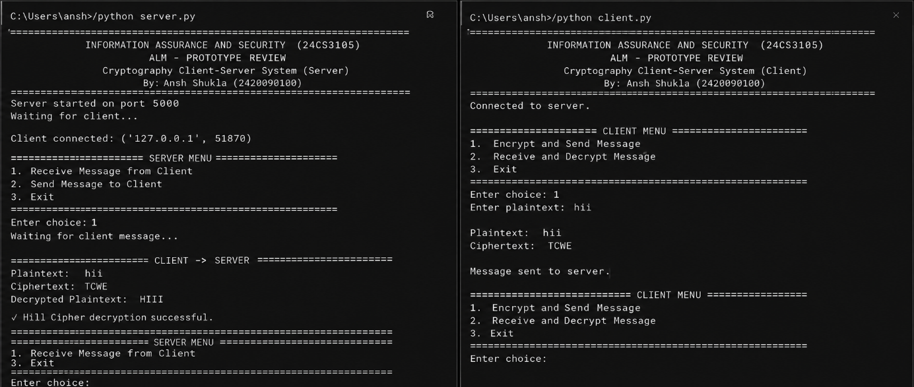

  - Vigenere Cipher
    - Definition
Vigenere Cipher is a polyalphabetic substitution technique. Instead of using one fixed shift for the complete plaintext, a keyword determines a sequence of different shifts.

    - Mathematical Representation
Encryption:

C_{i} = (P_{i} + K_{i}) mod 26
Decryption:

P_{i} = (C_{i} − K_{i}) mod 26

where K_{i} represents the corresponding key character.

    - Algorithm
      - Read the plaintext.
      - Read the keyword.
      - Repeat the keyword until it matches the plaintext length.
      - Convert plaintext and keyword characters into numbers.
      - Add corresponding plaintext and key values.
      - Apply modulo 26.
      - Convert the result back into alphabetic characters.
      - Display the ciphertext.

    - Observation
Vigenere Cipher improves on Caesar Cipher because different characters can be en-crypted using different shifts. However, repeated keywords can produce patterns that make the cipher vulnerable to cryptanalysis.

    - Prototype Screenshot
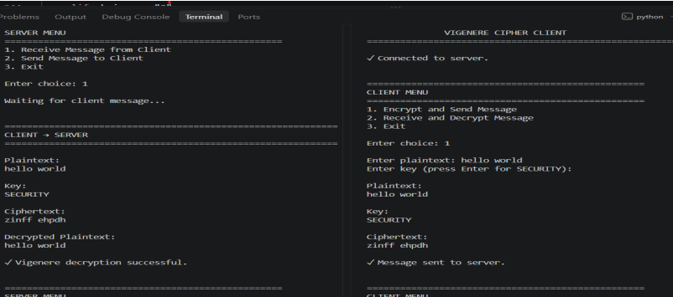

  - Simplified Data Encryption Standard (SDES)
    - Definition
Simplified Data Encryption Standard is an educational block cipher designed to demon-strate important concepts used by block encryption algorithms.
It introduces operations such as permutation, substitution, subkey generation, XOR, swapping, and multiple processing rounds.

    - Mathematical Representation
Encryption:

C = E_{K}(P )
Decryption:

P = D_{K}(C)
where K represents the secret key.

    - Algorithm
      - Generate subkeys from the original key.
      - Apply the initial permutation.
      - Divide the data into two portions.
      - Perform the first encryption round.
      - Swap the left and right portions.
      - Perform the second encryption round.
      - Apply the inverse permutation.
      - Generate the ciphertext.

    - Observation
SDES is designed for educational purposes and does not provide the security required for real-world sensitive information. Its simplified structure makes block cipher operations easier to understand.

    - Prototype Screenshot
- 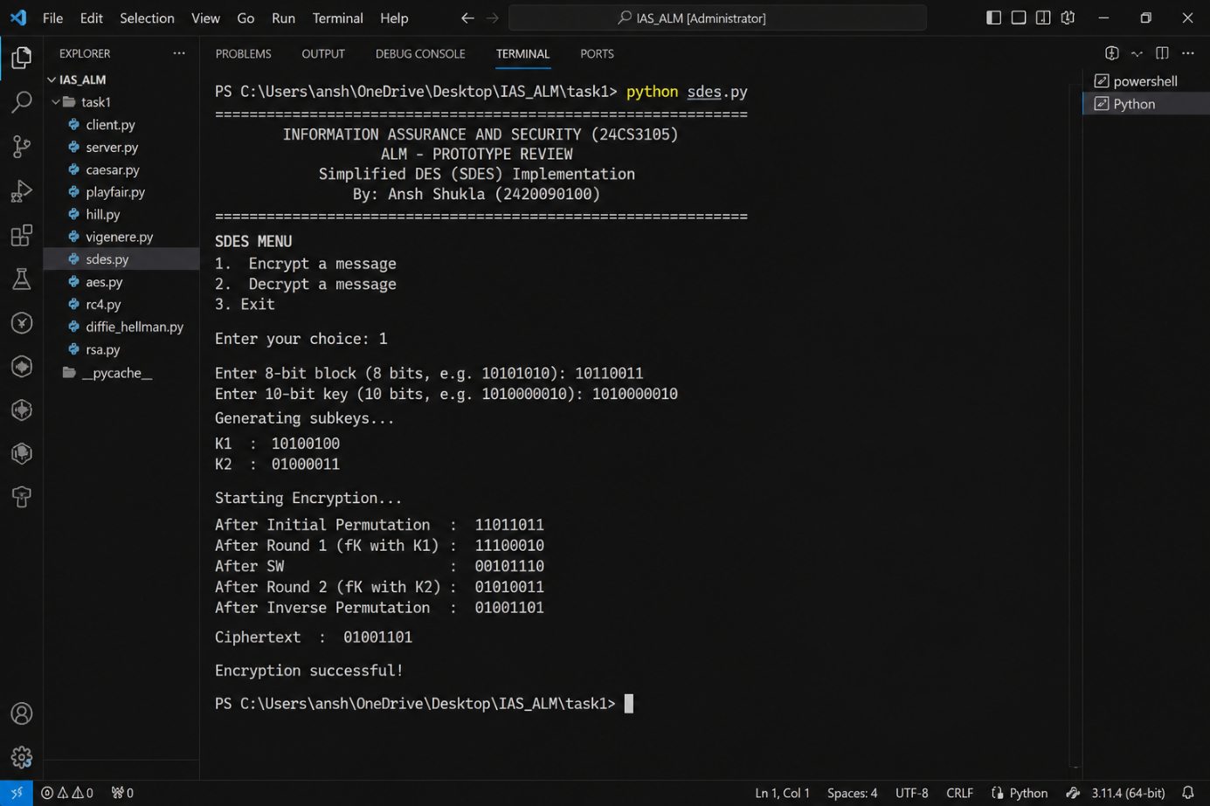

  - Advanced Encryption Standard (AES)
    - Definition
Advanced Encryption Standard is a symmetric-key block cipher used for protecting digital information. AES supports secret keys of different sizes and performs several transformation rounds.

    - Key Sizes

Table 2.1: AES Key Sizes and Rounds

AES Variant | Key Size | Number of Rounds
AES-128 | 128 bits | 10
AES-192 | 192 bits | 12
AES-256 | 256 bits | 14

    - Major Operations
AES performs four major transformations.
SubBytes: Each byte is substituted using a predefined substitution table.
ShiftRows: Rows of the internal data state are cyclically shifted. MixColumns: Values within each column are mathematically combined. AddRoundKey: The data state is combined with a round key using XOR.

    - Algorithm
      - Accept plaintext and encryption key.
      - Expand the original key into round keys.
      - Perform the initial AddRoundKey operation.
      - Perform SubBytes.
      - Perform ShiftRows.
      - Perform MixColumns.
      - Perform AddRoundKey.
      - Repeat the required encryption rounds.
      - Perform the final round without MixColumns.
      - Generate ciphertext.

    - Observation
AES provides much stronger security than the classical algorithms demonstrated in this prototype. It illustrates the principles of modern symmetric block encryption.

    - Prototype Screenshot
- 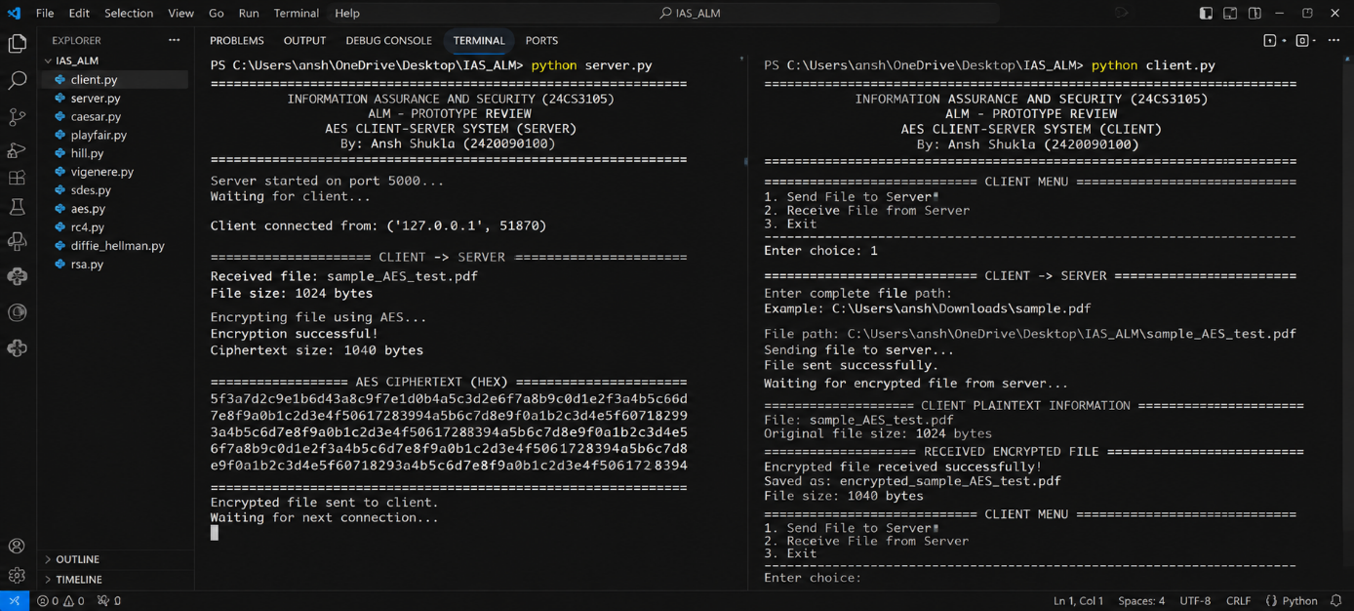

  - RC4 Stream Cipher
    - Definition
RC4 is a stream cipher that generates a pseudorandom sequence known as a keystream. The keystream is combined with plaintext using the XOR operation.

    - Mathematical Representation
Encryption:

C_{i} = P_{i} ⊕ K_{i}
Decryption:

P_{i} = C_{i} ⊕ K_{i}

    - Working Principle
RC4 contains two important stages.
Key Scheduling Algorithm (KSA): Initializes and rearranges the internal state using the secret key.
Pseudo-Random Generation Algorithm (PRGA): Generates the keystream used during encryption and decryption.

    - Algorithm
      - Initialize the state array.
      - Process the secret key.
      - Execute the Key Scheduling Algorithm.
      - Generate the pseudorandom keystream.
      - XOR plaintext with the keystream.
      - Generate ciphertext.
      - Apply the corresponding keystream for decryption.

    - Observation
RC4 played an important historical role in stream encryption. However, cryptographic weaknesses have been identified in the algorithm, and it is no longer recommended for modern secure systems.

    - Prototype Screenshot
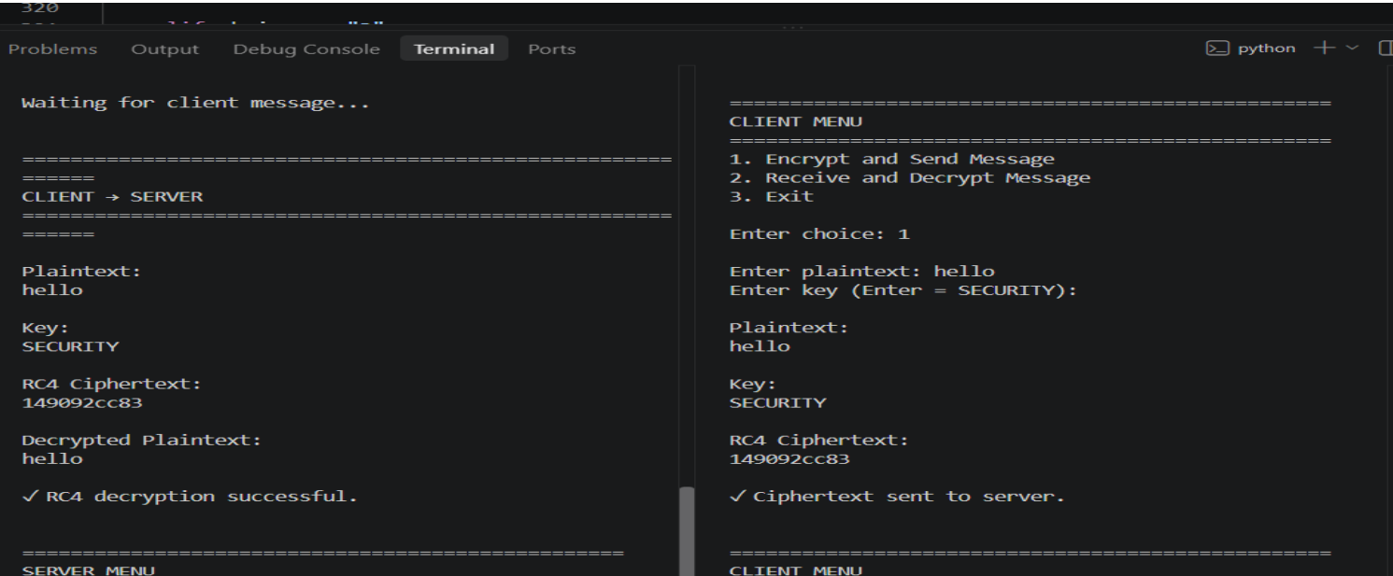
  - Diffie–Hellman Key Exchange
    - Definition
Diffie–Hellman is a key-agreement mechanism that allows two participants to establish a shared secret over an insecure communication channel.
The shared value can subsequently be used as key material for symmetric encryption.

    - Mathematical Representation
Let p be a public prime number and g be a public generator. User A selects private value a and calculates:

A = gª mod p
User B selects private value b and calculates:

B = g^{b} mod p
After exchanging the public values, User A calculates:

S = Bª mod p
User B calculates:

S = A^{b} mod p
Both participants obtain the same shared value:

S = g^{ab} mod p

    - Algorithm
      - Select public prime number p.
      - Select public generator g.
      - User A selects private value a.
      - User B selects private value b.
      - Calculate public value A.
      - Calculate public value B.
      - Exchange A and B.
      - User A calculates the shared secret.

      - User B calculates the shared secret.
      - Verify that both shared secrets are identical.

    - Observation
Diffie–Hellman demonstrates how two parties can establish common secret information without directly transmitting the private values through the communication channel.

    - Prototype Screenshot
- 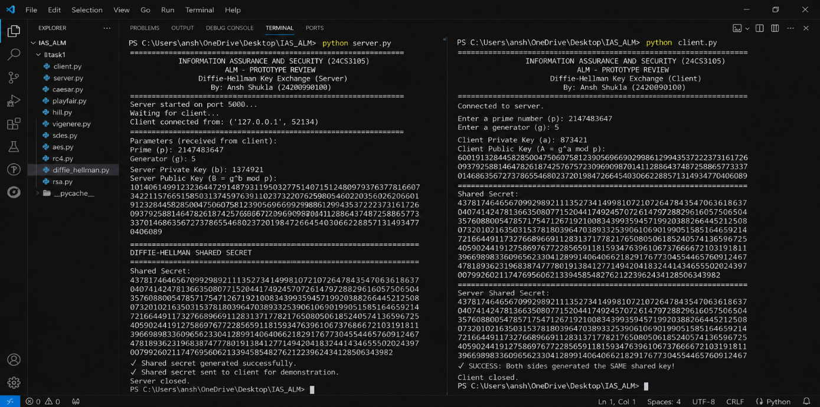

  - RSA
    - Definition
RSA is an asymmetric cryptographic algorithm that uses two mathematically related keys.
The public key can be distributed to other users, while the private key must remain confidential.

    - Key Generation
Select two prime numbers:

p, q
Calculate:

n = pq
Calculate Euler’s totient:

ϕ(n) = (p − 1)(q − 1)
Choose e such that:

gcd(e, ϕ(n)) = 1
Calculate d such that:

ed ≡ 1 (mod ϕ(n))
Therefore:

Public Key = (e, n)
and

Private Key = (d, n)

    - Encryption
For a message represented by M :

C = Me mod n

    - Decryption
The original message is recovered using:

M = C^{d} mod n

Algorithm
      - Select prime numbers p and q.
      - Calculate n = pq.
      - Calculate ϕ(n).
      - Select the public exponent e.
      - Calculate private exponent d.
      - Generate public key (e, n).
      - Generate private key (d, n).
      - Encrypt the message using the public-key operation.
      - Decrypt the ciphertext using the private-key operation.
      - Verify the recovered plaintext.

Observation
RSA demonstrates the basic concept of public-key cryptography. The separation of public and private key material distinguishes asymmetric cryptography from traditional shared-key encryption.

Prototype Screenshot

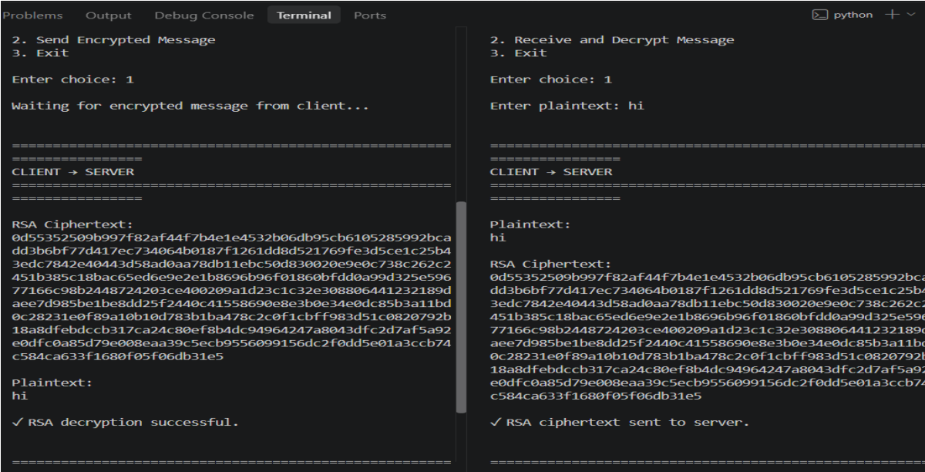
Chapter 3
Comparison of Cryptographic Algorithms

The algorithms implemented in this prototype demonstrate different approaches to information protection.
Table 3.1: Comparison of Cryptographic Algorithms

Algorithm | Category | Main Technique | Purpose
Caesar | Classical | Fixed character shifting | Basic substitution
Playfair | Classical | Digraph substitution | Pair-based encryption
Hill | Classical | Matrix multiplication | Mathematical transformation
Vigenere | Classical | Polyalphabetic substitution | Multiple shifts
SDES | Symmetric | Block transformations | Block cipher demonstration
AES | Symmetric | Multiple transformation rounds | Modern block encryption
RC4 | Stream Cipher | Keystream and XOR | Stream encryption
Diffie–Hellman | Key Agreement | Modular exponentiation | Shared-secret establishment
RSA | Asymmetric | Public/private key operations | Public-key cryptography

Key Differences
Classical algorithms are primarily useful for understanding fundamental cryptographic principles. They usually operate on letters or small groups of characters and are not appropriate for modern security requirements.
Symmetric algorithms use shared secret key material and are generally suited to efficient data encryption. AES represents modern block encryption, while RC4 demonstrates the concept of stream encryption.
Diffie–Hellman performs key agreement rather than conventional message encryption. RSA demonstrates asymmetric cryptography through the use of public and private keys.

Chapter 4
Prototype Implementation

The prototype integrates multiple cryptographic algorithms into one implementation. A user selects the required algorithm, provides the necessary input and key values, and executes the corresponding cryptographic operation.
For a normal encryption operation, the workflow is:

→ →
Ciphertext
Encryption
Plaintext
During decryption:

→ →
Recovered Plaintext
Decryption
Ciphertext
For Diffie–Hellman, the workflow is:

Private Values → Public Values → Exchange → Shared Secret
For RSA:

Key Generation → Public Key → Private Key → Cryptographic Operation

Prototype Features
The major features of the prototype include:
    - Selection of different cryptographic algorithms.
    - Plaintext input.
    - Ciphertext generation.
    - Encryption and decryption operations.
    - User-defined key input.
    - Caesar Cipher shift calculation.

Information Assurance and Security ALM – Prototype Review

    - Playfair matrix processing.
    - Hill Cipher matrix calculations.
    - Vigenere keyword processing.
    - SDES block operations.
    - AES symmetric encryption demonstration.
    - RC4 keystream processing.
    - Diffie–Hellman shared-secret generation.
    - RSA public and private key operations.
    - Result display for verification.

Chapter 5 Prototype Testing
Testing is performed to verify whether the implemented algorithms produce correct encryption and decryption results.

General Testing Procedure
The following procedure can be followed for encryption algorithms:
    - Enter a sample plaintext message.
    - Select the required cryptographic algorithm.
    - Enter the required key.
    - Execute encryption.
    - Record the generated ciphertext.
    - Supply the ciphertext to the decryption operation.
    - Enter the corresponding key.
    - Execute decryption.
    - Compare the recovered plaintext with the original input.
If the recovered message matches the original plaintext, the basic encryption and de-cryption workflow is functioning correctly for that test case.

Diffie–Hellman Testing
For Diffie–Hellman, two private values are selected and the corresponding public values are calculated.
After exchanging the public values, each participant independently calculates the shared secret.
The test is considered successful when:

Information Assurance and Security ALM – Prototype Review

S_{A} = S_{B}
where S_{A} is the secret calculated by User A and S_{B} is the secret calculated by User B.

RSA Testing
RSA testing consists of generating the required key values, processing a sample message using the public-key operation, and recovering the message using the corresponding private-key operation.
The final recovered message should match the original input.

Chapter 6 Conclusion
This project provides a practical study of different cryptographic techniques used to demonstrate information protection.
Caesar, Playfair, Hill, and Vigenere Ciphers explain important concepts from classi-cal cryptography. Caesar demonstrates basic shifting, Playfair introduces pair-based substitution, Hill applies matrix operations, and Vigenere demonstrates polyalphabetic substitution.
SDES introduces the structure of block encryption. AES demonstrates the principles of modern symmetric block cryptography, while RC4 illustrates stream-based encryption.
Diffie–Hellman demonstrates how communicating participants can establish a shared secret without directly transmitting their private values. RSA introduces asymmetric cryptography through mathematically related public and private keys.
By implementing these algorithms within a common prototype, the project connects theoretical concepts such as plaintext, ciphertext, cryptographic keys, encryption, de-cryption, key agreement, and public-key operations with practical implementation.
The prototype therefore provides a foundation for understanding the development of cryptographic systems and their role in information assurance.

