E-Commerce Analysis Project

Project Objective

The objective of this project is to analyze e-commerce sales, customer behavior, and delivery performance to uncover key business insights that support data-driven decision-making. The analysis focuses on identifying revenue trends, top-performing product categories, customer purchasing patterns, payment preferences, and delivery efficiency. By evaluating metrics such as total revenue, average order value, repeat customer rate, and delivery impact on customer ratings, the project aims to highlight opportunities for improving customer retention, optimizing sales strategies, and enhancing overall operational performance.

- Revenue Analysis Insights
1️⃣ Overall Performance
- Total Revenue: 15.42M
- Total Orders: 99K
- Average Order Value (AOV): 155
👉 Insight:
- Business has strong order volume.
- AOV is moderate — upselling opportunity exists.

2️⃣ Revenue Trend by Month
From the line chart:
- Constant upward growth in 2017
- Overall Strong performance around March–May combining all years (~1.5M–1.7M)
- Massive drop in Feb, Jun & Aug 2018

- Key Insight:
There is a sharp revenue decline in Feb & Q3 2018, especially starting June.
Possible reasons:
- Seasonality issue
- Delivery delays
- Marketing reduction
- Inventory issues
- Competitor discount campaigns

3️⃣ MOM Growth % (Latest Year)
- January high growth (27%)
- February decline (-10%)
- June big drop (-10%)
- August negative (-4%)
👉 Insight:
Revenue growth is inconsistent.
Business lacks stable growth momentum.

4️⃣ Top Revenue Product Categories
Top categories:
- health_beauty (1.42M)
- watches_gifts (1.27M)
- bed_bath_table (1.25M)
👉 Insight:
Health & Beauty is leading.
These are repeat-purchase categories → good retention opportunity.
Strategy:
- Bundle products
- Offer loyalty discounts

5️⃣ Revenue by Sellers
Top seller ~250K
But others close (~240K range)
👉 Insight:
Revenue is distributed.
No single seller dominating (good diversification).

6️⃣ Revenue & Orders by City
Sao Paulo dominates (15.5K orders).
Rio de Janerio (6.9k orders)
👉 Insight:
Revenue highly dependent on two major cities.
Risk if demand drops there.

- Customer Behavior & Delivery
7️⃣ Total Customers vs Repeated Customers
- Total Customers: 96K
- Repeated Customers: 2997
👉 Repeat Rate ≈ 3%
🚨 BIG INSIGHT:
Customer retention is extremely low.
This is the biggest problem in business.
Possible reasons:
- Delivery issues
- Poor experience
- Product quality mismatch
- No loyalty program

8️⃣ Delivery Status
- Early Delivered: 89%
- Delay: 6.5%
This is actually good delivery performance.
So delivery delay is NOT main reason for low retention.

9️⃣ Review Score
- Early Delivered → 4.3 ⭐
- On Time → 4.0 ⭐
- Delay → 2.3 ⭐
👉 Strong correlation:
Delay drastically reduces satisfaction.
Even small delay % can damage brand perception.

1️⃣0️⃣ Payment Type
- Credit Card: 75%
- Boleto: 19%
👉 Insight:
Heavy dependency on credit card.
Could expand wallet / UPI / EMI offers.

1️⃣1️⃣ Installments
Most orders = 1 installment (49K)
👉 Insight:
Customers prefer full payment.
Low EMI dependency.

MOST IMPORTANT BUSINESS PROBLEMS I SEE
1️⃣ Low Repeat Customers (Major Red Flag)
3% repeat rate is very low for e-commerce.
2️⃣ Inconsistent Revenue
Needs investigation.
3️⃣ High Dependence on São Paulo
Geographical concentration risk.

Project Conclusion

The analysis revealed that the business generated strong overall revenue and order volume, with certain product categories and major cities contributing significantly to sales. However, the study also identified key challenges, including low customer repeat rates and noticeable fluctuations in monthly revenue. While delivery performance was generally efficient, delayed deliveries were found to negatively impact customer ratings. These insights highlight opportunities for improving customer retention strategies, expanding market reach beyond key cities, and maintaining consistent revenue growth through better customer experience and targeted business strategies.

DASHOBOARDS
REVENUE ANALYSIS
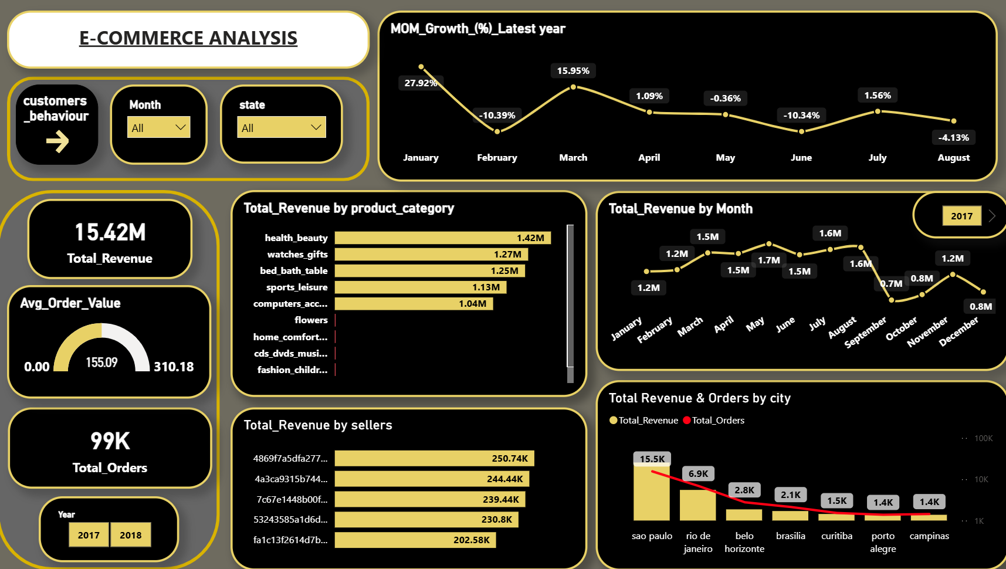

Customer Behavioural & Delivery Performance Analysis
