ANS 1.

In a fitness app redesign, **user engagement**, **data clarity**, and **visual appeal** work together to enhance the user experience:

1. **User Engagement**: Interactive features (e.g., progress trackers, challenges) motivate users and encourage consistent use through rewards like streaks and personalized goals.
2. **Data Clarity**: Clear, actionable insights (e.g., simple charts, real-time feedback) help users quickly understand and improve their workout progress without feeling overwhelmed.
3. **Visual Appeal**: A clean, intuitive design with consistent elements ensures ease of use and emotional connection, while motivating visuals enhance user satisfaction.

ANS 2.

A **scatter plot** and a **bubble plot** both visualize relationships between variables, but they serve slightly different purposes.

1. **Scatter Plot:**

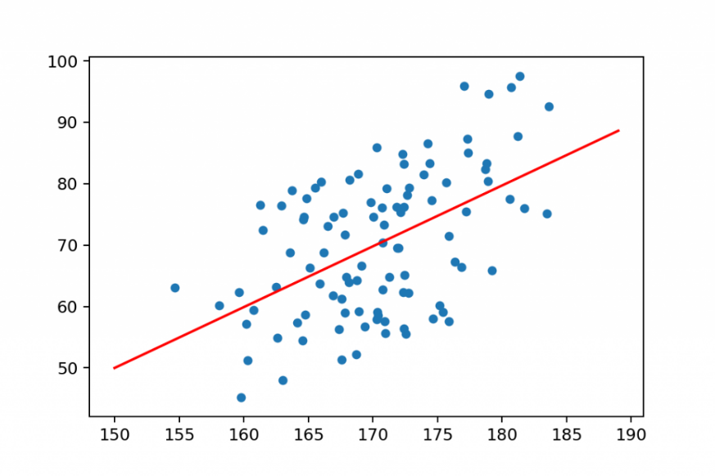

* **Purpose**: Used to show the relationship between two variables (e.g., advertising spend vs. sales). Each point represents a data observation, where the x-axis shows one variable (advertising spend) and the y-axis shows another (sales).
* **Use Case**: Ideal for identifying trends, correlations, or patterns between two variables. For example, a marketing analyst could use a scatter plot to observe if increasing advertising spend is associated with higher sales.
* **Visualization**: Simple points plotted on a two-dimensional graph. It provides a clear picture of how two variables relate but cannot show additional variables.

1. **Bubble Plot:**
2. 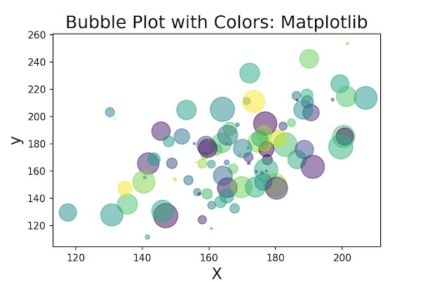

* **Purpose**: Extends the scatter plot by adding a third dimension through the size of the bubbles, which represents a third variable (e.g., social media engagement). The x-axis and y-axis still represent two variables (advertising spend and sales), but now the bubble size conveys additional information.
* **Use Case**: Useful for showcasing complex relationships where a third factor influences the interaction between the two main variables. For example, a bubble plot could help a marketing analyst understand not just how advertising affects sales, but also how social media engagement impacts that relationship.
* **Visualization**: Bubbles of different sizes are plotted, where each bubble's size provides extra insight beyond the two variables on the axes.

**Key Differences:**

* **Scatter Plot**: Visualizes two variables.
* **Bubble Plot**: Visualizes three variables by using bubble size to add depth to the data.

ANS 3.

In a financial planning app redesign, **user interaction**, **data clarity**, and **visual design** work together to enhance user engagement and improve insights into spending and savings. Here’s how each element contributes:

**1. User Interaction:**

* **Intuitive Navigation**: Simplified access to key features like budgeting tools, transaction tracking, and goal setting enhances user control and reduces friction.
* **Personalization**: Adaptive recommendations based on user spending patterns and savings habits increase relevance, keeping users engaged.
* **Feedback Loops**: Real-time feedback, such as progress toward savings goals or alerts for spending limits, encourages ongoing interaction.

**2. Data Clarity:**

* **Clear Visualization**: Simple graphs and charts that show spending categories, income trends, and goal progression help users quickly understand their financial situation.
* **Actionable Insights**: Offering clear breakdowns of spending behavior and personalized tips ensures that users can easily act on their data to improve financial habits.
* **Minimal Information Overload**: Focusing on the most important metrics avoids overwhelming users, allowing them to focus on actionable information.

**3. Visual Design:**

* **Aesthetic Simplicity**: A clean and minimal design reduces cognitive load, ensuring users can easily navigate the app and digest financial insights.
* **Consistent Layout**: A cohesive, well-structured interface with consistent fonts, icons, and colors ensures a smooth user experience.
* **Emotional Appeal**: Engaging colors and motivational visuals, such as progress bars or celebratory animations for reaching goals, provide emotional reinforcement.

**Combined Effect:**

**User interaction** keeps users engaged, while **data clarity** ensures they can easily understand and act on their financial situation. A thoughtful **visual design** ties everything together, making the experience enjoyable and motivating. Together, these elements create a satisfying user experience that fosters better financial habits and long-term app use.