Name: Diksha Mendhe
Project Name: E-commerce Website
Github Link: https://github.com/ansh-dulewale/Ecommrce-excellar-project/tree/Diksha
Dashboard Screenshot:
- Login Page
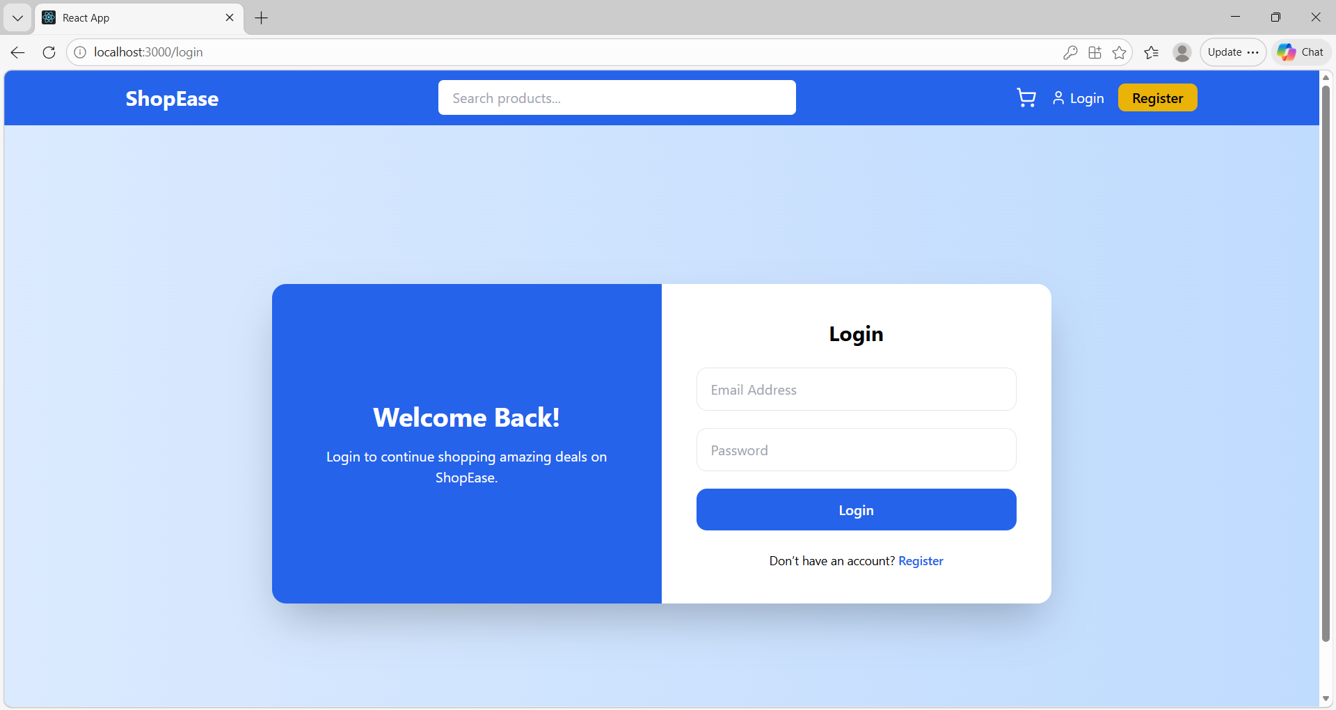
- Customer Landing Page
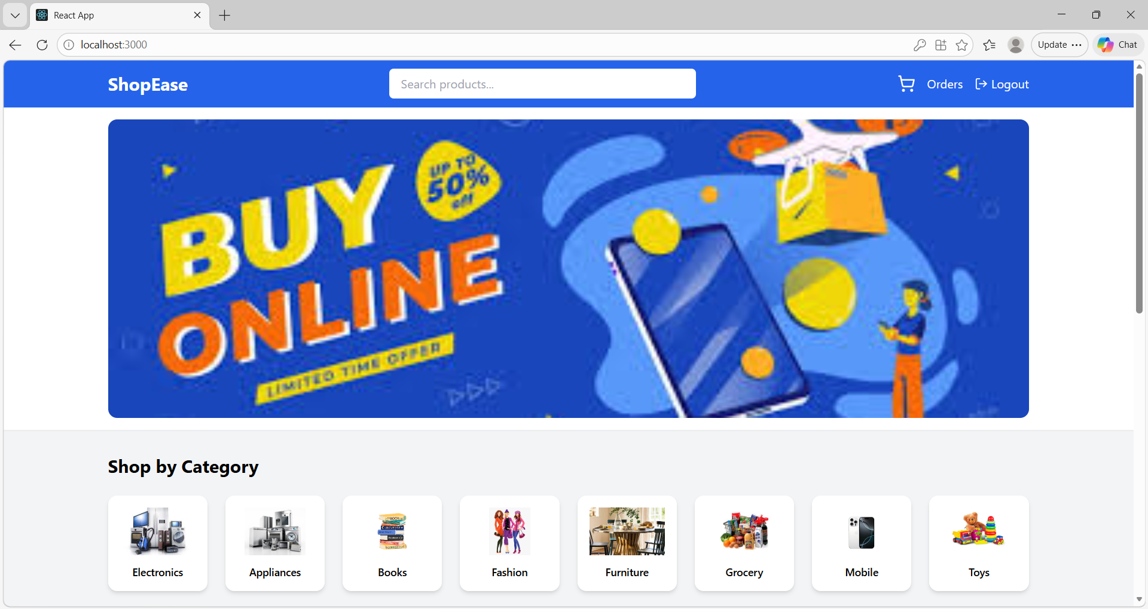
- Item listed page
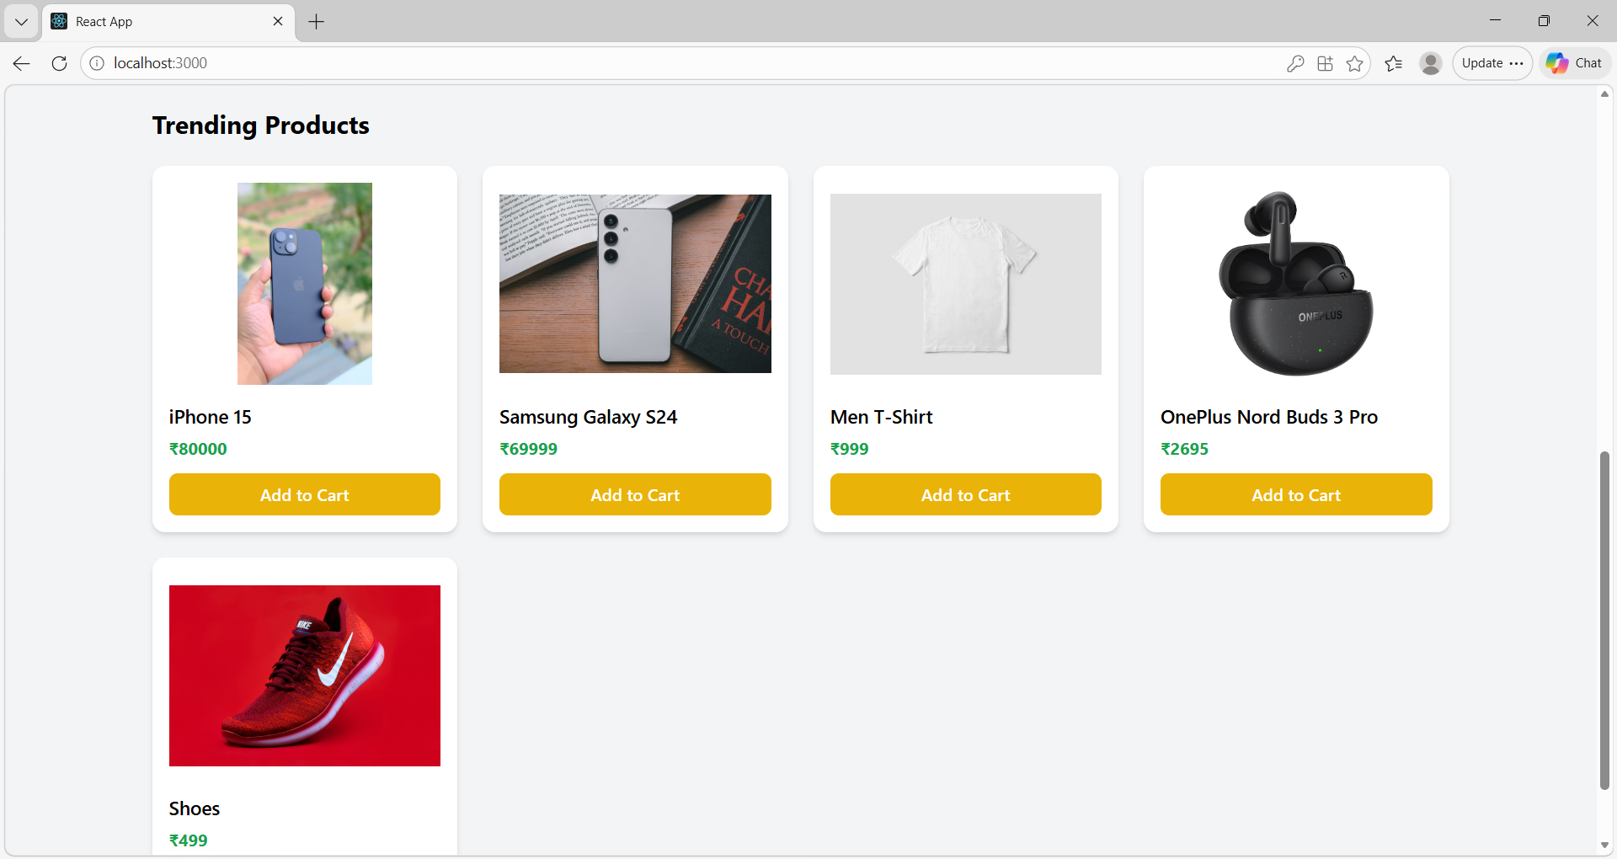
- Add to card option
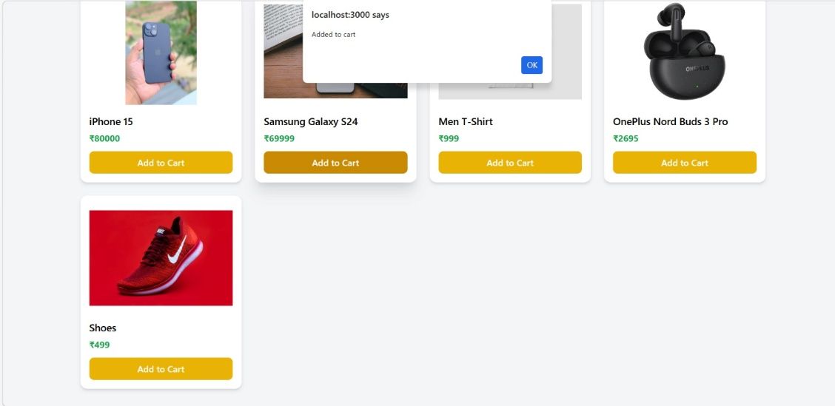
- Card Page
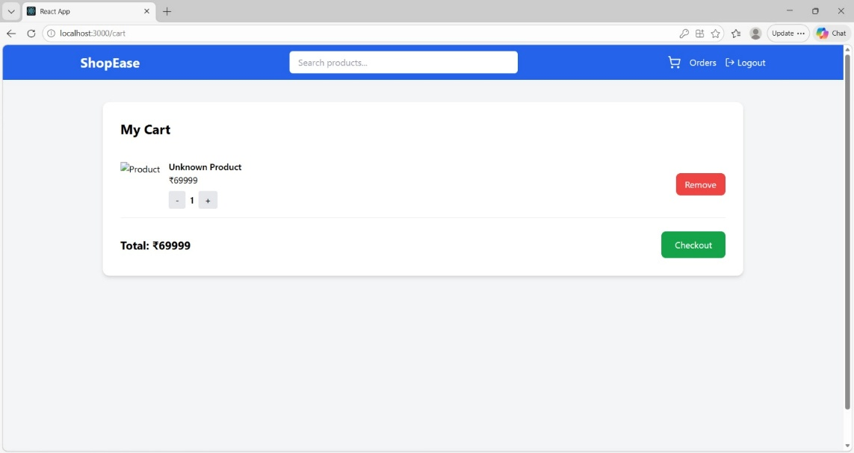
- Checkout (Order option)
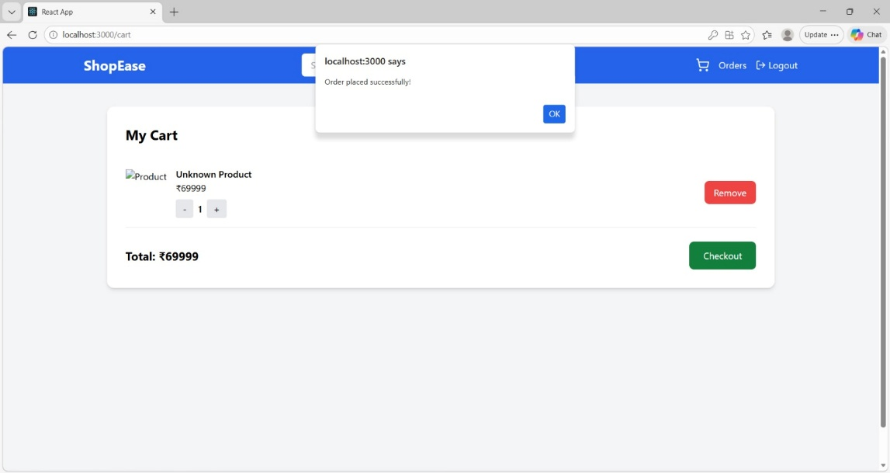

- Order Page
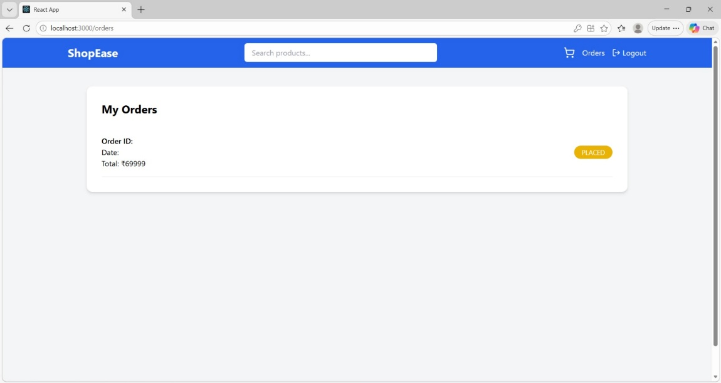
- Admin Landing Page (Navigation bar with admin option)
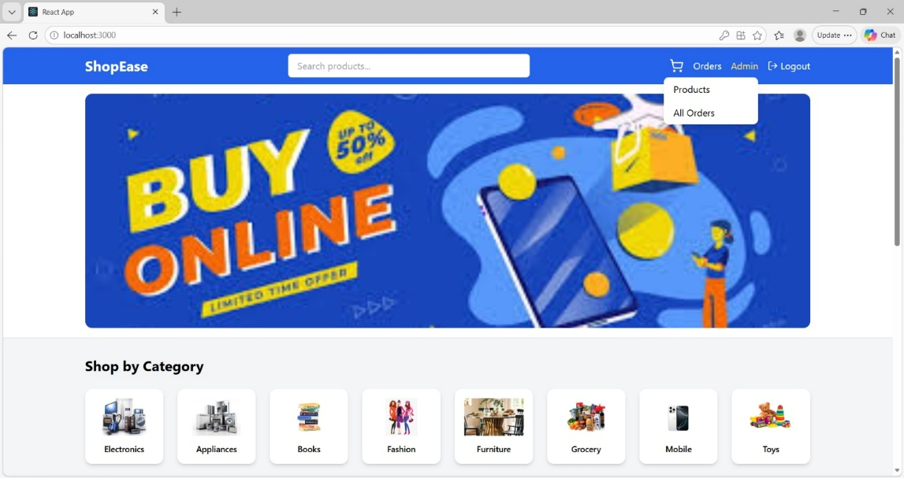
- Admin – All placed Order page
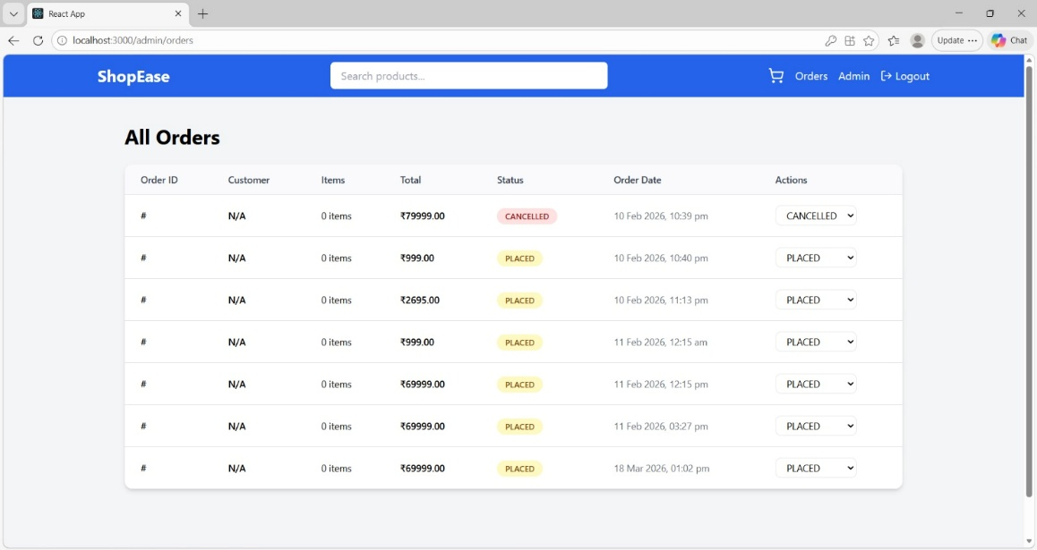

- Admin – Edit / Update product Page
