NAME – ANSH GOEL
REG NO. – 20BCE1798
COURSE NAME – FOUNDATION OF DATA ANALYTICS (FDA)
COURSE CODE: 3505
DATE – 4th AUGUST, 2022
LAB 2 – VECTORS, MATRICES, ARRAYS & CLASSES

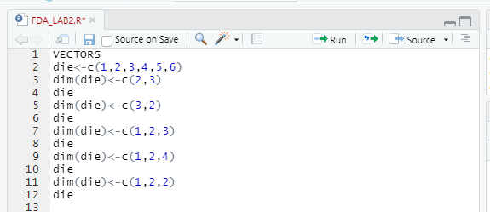
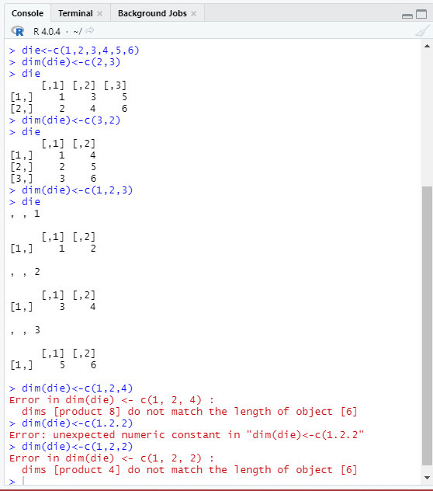

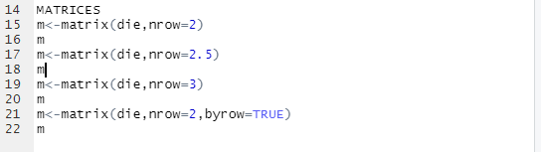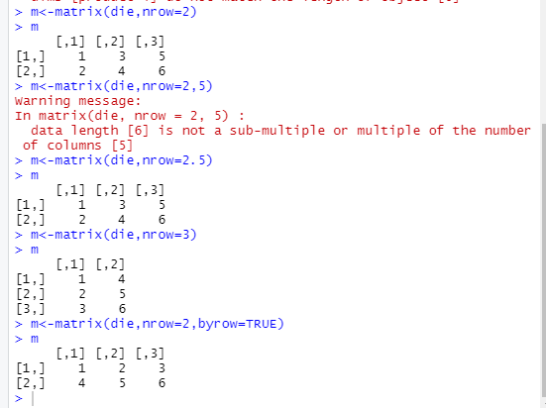

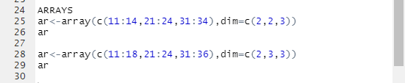
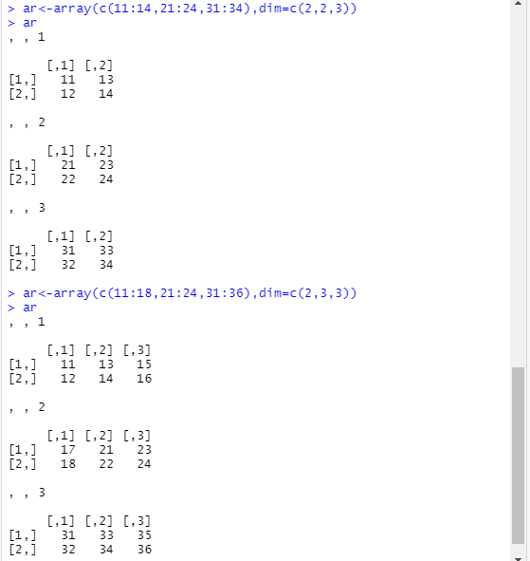

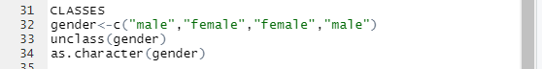
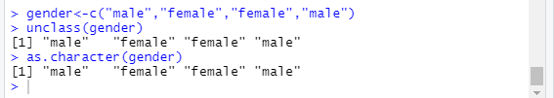

Q2)
Create 2 atomic vectors v1, v2 . v1has 3 elements and v2 has 6 elements.
Can you create an array of dimension 3x3x2?
Ans.
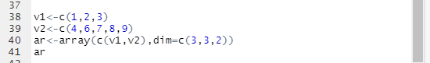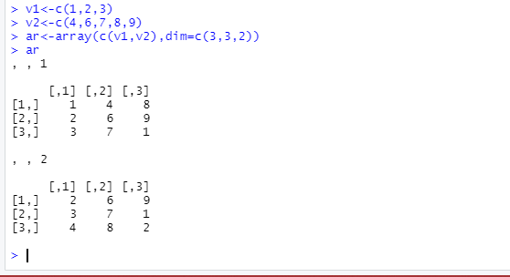

Q3)
For R objects given in the below code, add the dimension names rname, cname and mname and convert them into a 3x3x2 array.
rname<-c("r1","r2","r3")
cname<-c("c1","c2","c3")
mname<-c("mat1","mat2")
Ans.
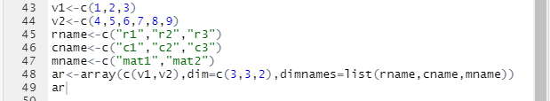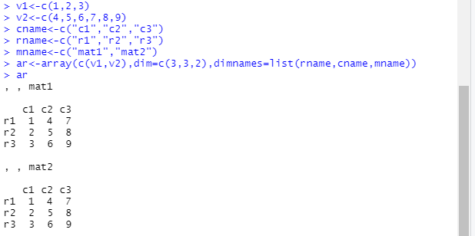

Q4)
For the 3x3x2 array created in the previous solution print the following
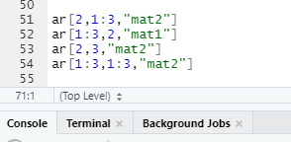

- Print the second row of the second matrix.
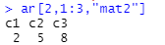
- Print the second column of the first matrix.
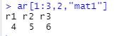
- Print the element in the second row and third column of second matrix.
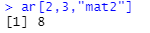
- Print the second matrix.
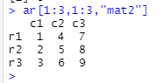

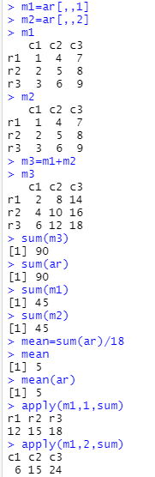
Q5)
Create the following matrix, which stores the name and suit of every card in a royal flush.

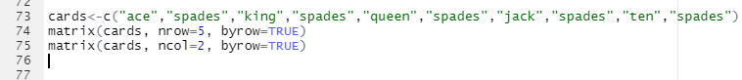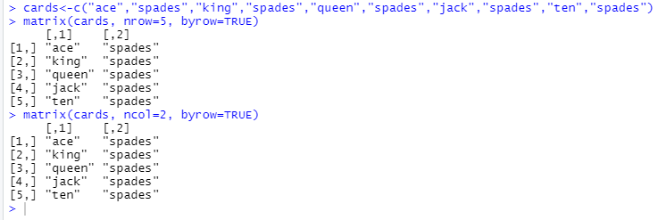

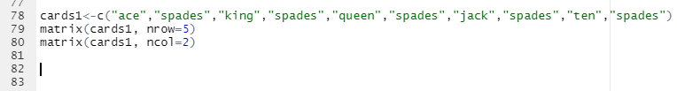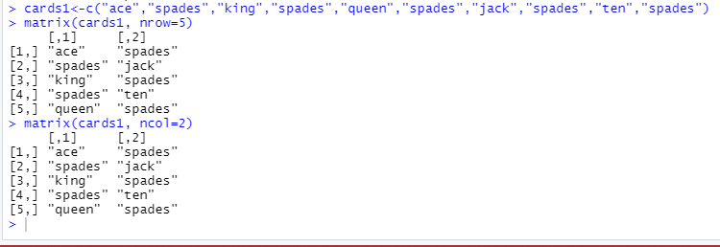

Q6)
Many card games assign a numerical value to each card. For example, in blackjack , each face card is worth 10 points, each number card is worth between 2 and 10 points, and each ace is worth 1 or 11 points, depending on the final score. Make a virtual playing card by combining “ace”, “heart”, and 1 into a vector. What type of atomic vector will result? Check if you are right.

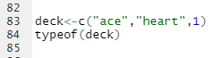
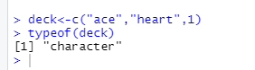
ANSWER IS VERIFIED.

