NAME – ANSH GOEL
REG NO. – 20BCE1798
COURSE NAME – FOUNDATION OF DATA ANALYTICS (FDA)
COURSE CODE: 3505
DATE – 20TH OCTOBER, 2022

LAB – 10

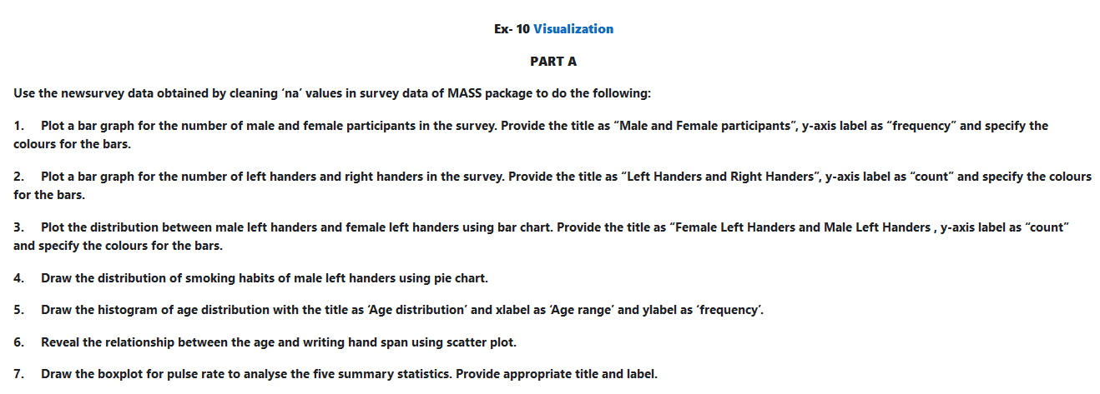

Use the newsurvey data obtained by mass library to do the following:
- Plot a bar graph for no of males and female participants in the survey. Provide the title as "Male and Female participants" and specify the colours for the bars.
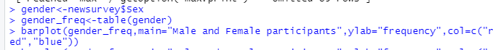
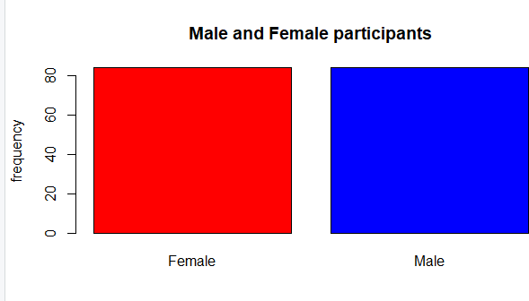

- Plot a bar graph for the number of left handers and right handers in the survey. Provide the title as "Left Handers ad Right Handers" and specify the colours for the bars.

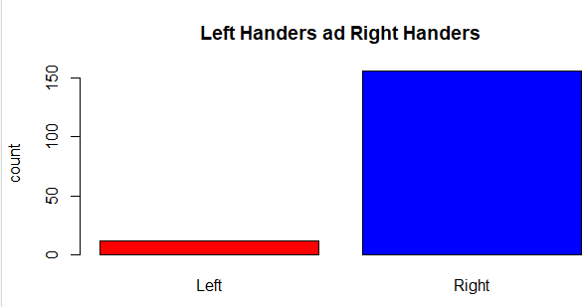

- Plot the distribution between male left handers and female left handers using bar chart. Provide the title as Female Left Handers and Male Left Handers, y-axis label as "count" and specify the colours for the bars.
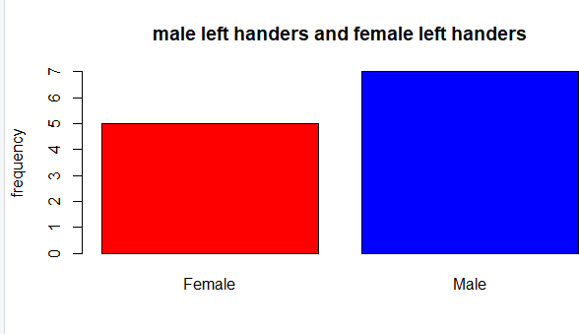

- Draw the distribution of smoking habits of male left handers using pie chart.

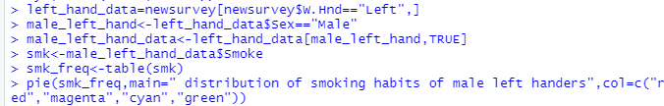

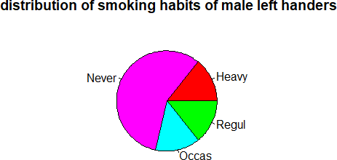

- Draw the histogram of age distribution with the title as age distribution and xlabel as age range and ylabel as frequency
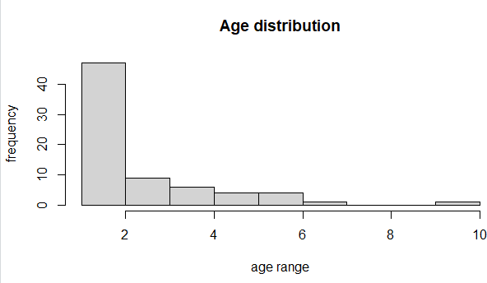

- Reveal the relationship between the age and writing hand span using scatter plot.

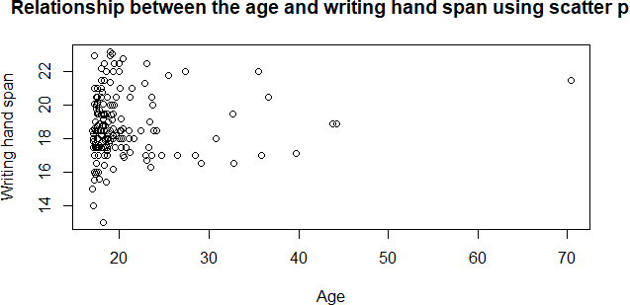

- Draw the boxplot for pulse rate to analyse the five summary statistics. Provide appropriate title and label.
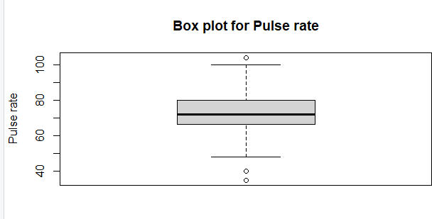

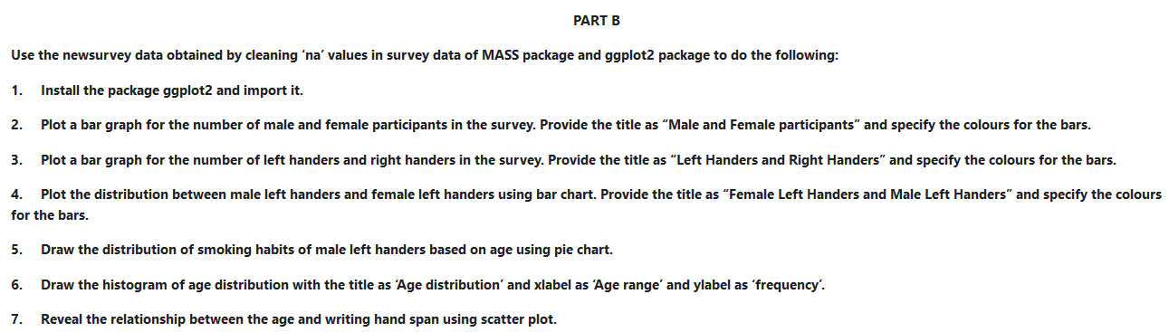
Part B

1.
library(MASS) library(ggplot2)

  - Plot a bar graph for the number of male and female participants in the survey. Provide the title as 'Male and Female participants' and specify the colors for the bar.

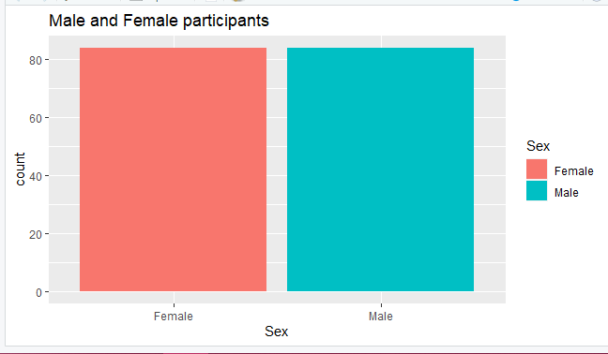

  - 3 Plot a bar graph for the number of left handers and right handers in the survey. Provide the title as “Left Handers and Right Handers” and specify the colours for the bars.

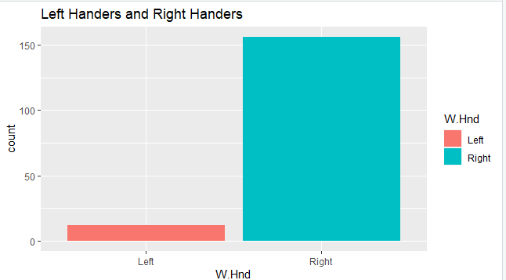

  - Plot the distribution between male left handers and female left handers using bar chart. Provide the title as “Female Left Handers and Male Left Handers” and specify the colours for the bars.
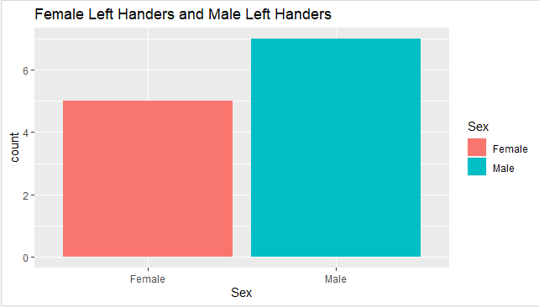

  - Draw the distribution of smoking habits of male left handers based on age using pie chart.

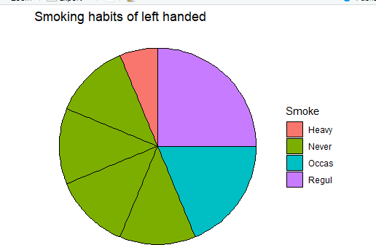

  - Draw the histogram of age distribution with the title as ‘Age distribution’ and xlabel as ‘Age range’ and ylabel as ‘frequency’.
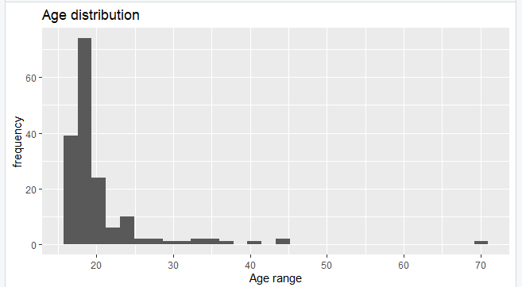

  - Reveal the relationship between the age and writing hand span using scatter plot.

