A project report on

Test Automation of Web Applications
Submitted in partial fulfillment for the award of the degree of

Computer Science and Engineering

for

CSE3002 – Internet and Web programming



By:

ANSH GOEL(20BCE1798)

KRITIKA AGRAWAL(20BCE1921)

AARYA MAHAJAN PABHA(20BCE1925)

SCHOOL OF COMPUTER SCIENCE AND ENGINEERING
November, 2022

Page 1



DECLARATION

We hereby declare that the project report entitled “Test Automation of Web Applications” submitted by us, for the award of the degree of Computer Science and Engineering, VIT is a record of bonafide work carried out by us under the supervision of Dr. Muthumanikandan V.

We further declare that the work reported in this project report has not been submitted and will not be submitted, either in part or in full, for the award of any other degree or diploma in this institute or any other institute or university.

Place: Chennai Date:

Signature of the Candidate

SCHOOL OF COMPUTER SCIENCE AND ENGINEERING
CERTIFICATE

This is to certify that the report entitled “Test Automation of Web Applications” is prepared and submitted by “AARYA MAHAJAN PABHA, KRITIKA AGRAWAL, ANSH GOEL” to VIT Chennai, in partial fulfillment of the requirement for ‘J’ component of CSE3002 – Internet and Web Programming subject is a bonafide record carried out under my guidance. The project fulfills the requirements as per the regulations of this University and in my opinion meets the necessary standards for submission.

Signature of the Guide:

Name: Dr. Muthumanikandan V Date:

ABSTRACT

Before deployment, every website that is built has to be validated and examined. The testing team is under more pressure to produce the product in a very constrained time frame as long as the business needs continue to expand. In terms of both human resources and time, manual testing is not appropriate for essential and complicated applications. Consequently, there is a critical need to suggest an automated testing framework that might decrease the overall software testing period In order to solve the issues with manual testing, automation testing has been created.
The goal of this study is to provide a brand-new automated testing framework that improves the automated procedure for testing web applicationsThe suggested framework can save up to 21% when compared to Selenium IDE and about 75% of the overall time and effort required for conventional automation.

ACKNOWLEDGEMENT

We wish to express our sincere thanks and deep sense of gratitude to our project guide, Dr. Muthumanikandan V, Assistant Professor(Senior), School of Computer Science and Engineering, for his consistent encouragement and valuable guidance offered to us in a pleasant manner throughout the course of the project work.
We are extremely grateful to dean name , Dean of School of Electronics Engineering, VIT Chennai, for extending the facilities of the school towards our project and for her unstinting support.

We express our thanks to our Head of the Department name of the hod for his support throughout the course of this project.
We also take this opportunity to thank all the faculty of the school for their support and their wisdom imparted to us throughout the course.

We thank our parents, family, and friends for bearing with us throughout the course of our project and for the opportunity they provided us in undergoing this course in such a prestigious institution.
Place: Chennai Date:
Name of the student

Table of Contents
- INTRODUCTION 8
  - OVERVIEW 09
  - CHALLENGES 09
  - PROJECT STATEMENT 10
  - OBJECTIVES 10
  - SCOPE OF THE PROJECT 10
- BACKGROUND 11
  - INTRODUCTION 11
  - SURVEY 11
- PROPOSED SYSTEM 16
  - SYSTEM DESIGN …………………………………………………… 16
  - SYSTEM DESIGN …………………………………………………… 16
  - ALGORITHM/TECHNIQUEUSED…………………………………… 17

- EXPERIMENTAL SETUP 19
  - SOFTWARE REQUIREMENTS 19
  - HARDWARE REQUIREMENTS 19
- PERFORMANCE EVALUATION 20
- RESULTS AND DISCUSSION 25
- CONCLUSION AND FUTURE WORKS 33
  - REFERENCES 33

Appendix

LIST OF FIGURES

    - Open site, wait to load and quit site
    - Open site and search a keyword in the tab and get result and quit
    - Open site and then click on 2 buttons and wait for results
    - Testing whole framework with keyword search
    - Testing load and reload of a website

6.1.1 This figure is showing the manual selenium testing.
6.1.2 This figure is showing the result of the selenium manual testing from Fig 6.1.1
6.1.3 This figure is showing selenium manual testing testcase-2
6.1.4 This figure is showing the result of Fig 6.1.3
6.1.5 This figure is showing the automation testing
6.1.6 This figure is showing the automation testing and viewing the images
6.1.7 This figure is showing the automation testing and extracting text by fieldname
6.1.8 This figure is showing the automation testing and click functionality
6.1.9 This figure is showing the automation testing and running sample testcase
6.1.10 This shows the various testing times of all the test cases of manual testing that we got.
6.1.11 This shows the various testing times of all the test cases of automated testing that we got.

Chapter 1

Introduction
The paper presents a comparative study done for web applications/websites built on different frameworks like REACT, flutter, etc. , they will be compared on their bootup-time , overall functionality, their responsiveness, load testing and other features . To achieve this testing, we will be using software's such as Selenium, Lambda test, QA Wolf and some other open-source software available.

In this study, we go beyond simply evaluating the homepage to include the whole website. This will help us understand which framework often results in better websites as well as which testing software is easier to use and offers a growing number of platforms to test the product on. These kinds of insights may truly aid in streamlining the process because everyone wants a website or web application in this day and age; it has become the fundamental standard.

Every software development process includes testing, and businesses invest a lot of time and energy into it. Online application testing has become more crucial due to the proliferation of web applications and their growing economic value in society.

It is sometimes necessary to combine a few suitable testing methodologies in order to thoroughly test software and verify its quality. Similarly, no one tool can meet all requirements for automated testing, which makes choosing the best tool combination challenging. Understanding the various testing techniques, tools, and frameworks is the first step to effective and successful software testing.

OVERVIEW

• As long as business requirements grow, the pressure increases on the testing team to deliver the product with high quality in a very tight time.
• Manual testing is not suitable for critical and complex applications in terms of both human resources and time.
• Therefore, there is a strong need to propose an automated testing framework which could reduce the overall software testing time.
• This study aims to propose a new automated testing framework for testing web applications that enhances the automated process.
• The proposed framework can save approximately about 75% of the total time/effort involved in the automation process using traditional automation and 21% compared to using Selenium IDE.

CHALLENGES

The challenge faced was compatibility between the web browser and the selenium tool. Sometimes the test cases unintentionally failed, and compatibility errors were noticed. Only some trivial challenges were faced, in the duration of the testing.
Although, the challenges faced were not many, since the testing was done on a small scale, but in general if the similar testing had to be performed for a large scale product, the issues that would be faced are,

1) Testing across browsers
Our website may occasionally respond differently depending on the browser being used, with the chance that it functions properly in Chrome but not in Firefox. Performing test automation on every browser may not be viable given the variety of browsers available today. However, we still need to make sure that the test application works flawlessly across the most popular browsers, including Chrome, Firefox, Safari, Edge, and IE. Testing on popular browsers alone is still insufficient; we may also need to test on popular browser versions, as well as on various operating systems and resolutions. This tactic, which may be summed up as cross-browser testing, makes it difficult for testers to automate tests.

2) False Positive and False Negative Results
For automation testers, false positive and false negative results have always been a concern. False Positive refers to a situation where we encounter errors in our test cases despite the fact that the application being tested is functioning normally. Contrarily, false-negative results refer to the circumstance in which we receive positive test case results but the programmed being tested has errors. Such sloppiness causes the testing team to be misled and widens the miscommunications between the development team and the QA team. For automation testers, managing flaky tests is a difficult challenge in and of itself.

We need to make sure that the test strategies, test cases, and testing environment are managed in an acceptable and orderly manner to get past this flakiness.

3) Higher chance of Risk –
In manual testing, there is a higher chance of risk involved of oversight and mistakes. In the testing process, testers may get tired, may not be very attentive as they have too many tasks to be done. Therefore, there will be unexpected errors or mistakes that can happen in entering data, in setting parameters, in execution, and in comparisons.

4) Time-Consuming –
Limited test resources make manual testing simply too time-consuming. Thus, automation testing in such cases is preferred.

PROJECT STATEMENT

We are using various testing manual and automation tools and software to come to the conclusion of which works best for various test cases of testing of web applications and websites.

  - OBJECTIVE

Having an effective test automation system is an absolute necessity in today’s agile software development environments. Automation works great, especially in case of smoke and regression tests and helps the engineers and testers to easily create and execute test cases that are complex in nature.
Most commonly faced issues in testing are, testing against wrong data. picking the right testing automation tool.

  - SCOPE OF THE PROJECT

Since raspberry is a low-cost measure with server capabilities that have been proved the scope of our project is we are able to provide self-hosted low cost and low maintenance servers that can be used by the masses.

Introduction
Chapter 2 BACKGROUND

The performance of several web apps and websites developed using various frameworks, such as, flutter, etc., will be compared in this study. Their boot-up times, general functioning, responsiveness, load testing, and other aspects will be compared. Software tools like Selenium, Lambda test, QA Wolf, and other open-source tools will be used.

Literature Survey

[1] D. Rajya Lakshmi et.al(2017)
It is offered a comparative analysis of some of the popular tools, approaches, and concepts for web application testing. Cost effectiveness and bug detection effectiveness are the key problems with testing. The practise of confirming the execution of certain software pieces is known as coverage-based testing. It aids in judging the level of "thoroughness" attained during testing.
- Tarek M Mahmoud et.al(2014)
This article describes a suggested Web testing strategy in which, starting with the home page, all of the website's hyperlinks are automatically followed one at a time to get all of its HTML contents. The article also discusses a method for testing automated Web applications that was created to put the suggested strategy into practise.
- Milad Hanna et.al(2018)
In a research, a new automated testing framework for web applications is proposed in an effort to speed up the automation process. The suggested framework can save up to around 75% of the overall time and effort required for the automation process when compared to Selenium and standard automation tools.
- Arora A. et.al(2012)
In our everyday lives, the quality of online apps is important. Online testing is playing a great part in ensuring the calibre of web applications. Various web testing issues have been solved through academic effort in recent years. It has been discovered that there are several tools, approaches, and methodologies for testing web applications effectively.
- Nadia Alshahwan et.al(2011)
The growing dependence on these systems for a variety of human and non-human operations explains the significance of automated web application testing. This article describes three connected algorithms and the SWAT tool for search-based software testing of automated web applications (SBST).
- Mubarak Albarka Umar et.al(2019)
The first step to completing a successful software testing project is being familiar with the various testing methodologies, tools, and frameworks. An extensive analysis of test automation tools and frameworks is presented in this article. Compared to manual testing, automated testing improves test accuracy and reduces tester effort and time.
- Fei Wang et.al(2012)
Explanation:
Authors created a Selenium and JMeter-based automated web application testing framework. Using a software framework improves automated test extensibility and reusability. The new software framework enhances software quality and development efficiency. Web application acceptability testing is generally manual. Efficiency, reusability, and comprehensiveness should be prioritised in web application testing. Selenium is the most complete open source Web test automation tool, particularly for BackBase-based applications. The test automation framework makes it easy to test web applications and exchange processes and data. It may be used to simulate high loads on a server, network, or other item to assess their strength and general performance. Selenium is user-level whereas JMeter is protocol-level.
- Prasad Mahajan et.al(2016)
The goal of software testing is to identify and fix bugs in the code. There are two main types of testing: manual and automated. Reliability testing, security testing, correctness testing, and performance testing are the four major subcategories of automated testing. The process and the test environment may be put through their paces with the help of a number of different technologies.
- Rucha Dave U et.al(2017)
An electric vehicle simulator board models its functionality (EV). EVSE charges electric vehicles. Repeatedly testing a large number of test cases is inefficient and time-consuming. To automate these test scenarios, a web page automatically logs into mobile and internet apps. Open Charge Point Protocol connects charging stations with central infrastructure (OCPP). Charging station networks are similar to cell phone networks. Mobile phones and internet provide remote access. car simulator's states
- Weider D et.al(2007)
The test cases and idea were shown using a Web-based test automation framework. The foundation of the test automation system does the complete testing task in the background when a tester clicks a few buttons on the user interfaces. The framework offers plug-ins for diverse testing workflows. Testing involves defining and running a limited number of test cases. This study focuses on workflow-based test framework systems that execute all software testing operations (SEBOK). Easy-to-use interfaces put users in control.
- Douglas Hiura et.al(2016)
Proposed web framework automates User Scenarios using User Interaction Diagrams (US-UID). US-UIDs reflect client needs and are developed before coding. The proposal assesses 8-puzzle US-IDs and a Web-code. app's The suggested framework may also indicate success, fault, or failure of US-ID-application interaction.
- Monika Sharma et.al(2014)
One of the most significant and critical phases in the software development life cycle is software testing. A system's quality assurance is dependent on automated testing, which lowers test costs and boosts labour productivity. In this article, we examined numerous web automation testing technologies that will help us understand automation testing and the tools available for it.
- Elis Pelivani et.al(2021)
Websites and online apps are now required for all types of corporations and commercial operations. The purpose of this study is to evaluate and compare web application testing automation solutions. Different characteristics of two testing tools, Katalon Studio and Selenium, will be explored and contrasted in this study.

- Kamble Namita Mohan et.al(2016)
To achieve a specific level of quality, software tests must be done often throughout development cycles. This article presents a novel record and playback approach for web applications utilising the Selenium framework and JavaScript. Once built, automated tests may be performed frequently at no additional cost, and they can be much faster than manual tests and are devoid of human mistakes. Automated software testing may reduce the time required to execute repeated tests from days to hours.
- G.Chandrasekaran et.al(2019)
The goal of software testing is to guarantee that the software system satisfies the user's requirements. Individual units or components are tested. This article shows how to do automated unit testing using JUnit, Selenium with Java, and Selenium with Python
- Dietmar Winkler et.al(2010)
With the increasing complexity of software components in automation systems, thorough and regular testing is required. Based on UML models and TFD, we provide a system for automating test procedures. Using this framework in prototype applications in an industrial setting highlighted it as a good contender for improving automation system development and product quality.
- Navneet Singh et.al(2020)
In certain cases, manual testing outperforms automated scripts/vulnerability scanners in detecting security flaws in online applications. The primary goal of this study is to identify and discuss specific cases that highlight the differences between automated and manual methods to Web application penetration testing.
- JohnCallahan et.al(1996)
White-box testing allows developers to determine whether or not a program is partially consistent with specified behavior and design through the examination of intermediate values of variables during program execution. These intermediate values are often recorded as an execution trace produced by monitoring code inserted into the program. This paper describes an approach to organize multiple execution traces into distinct equivalence partitions based on requirements specifications.
- Corina S. Pasareanu et.al(2009)
An approach that handles complex programming constructs such as input data structures, arrays, as well as multi-threading and multi-threading has been described by researchers at the University of California, Berkeley. A survey of some of the new research in symbolic execution focuses on test generation and program analysis.
- Pelin Akpinar et.al(2020)
Model-based software tests have a higher coverage rate and a faster test process on the system under test than traditional software tests. Modular tests were preferred in traditional tests, and the JUnit and TestNG libraries were used. The tests in the model-based test method were written using the Selenium library and GraphWalker tool.
- Satish Gojare et.al(2015)
A growing number of software systems are now available as web-based applications. These web applications are extremely complicated. Such complex web applications are extremely difficult to test. Automation tools are used in testing to reduce human intervention and repeatable tasks. We designed and implemented an automation testing framework for web applications in this paper. This new automation testing framework was built with the Selenium WebDriver tool. Using this framework, testers can quickly and efficiently write test cases. The tester does not need to study the Selenium web driver tool in depth. Because of the framework's screen shot property, this framework assists developers in analyzing their code.

- D. Rajya Lakshmi et.al(2017)

Testing is an essential component of any software development process, to which companies devote significant time and effort. The proliferation of web applications and their growing economic significance in society has made web application testing a critical area. Web applications generally have shorter and shorter release cycles, making testing difficult. Cost efficiency and bug detection efficiency are the two most important issues in testing. Coverage-based testing is the process of ensuring that specific programme elements are exercised. Coverage measurement aids in determining the thoroughness of testing. To assess the quality of web applications, an avalanche of tools, techniques, and frameworks emerged.

- Ms. S. Sharmila et.al(2014)

Web testing is a term used to describe software testing that focuses on web applications. Complete testing of a web-based system prior to going live can aid in the resolution of issues before the system is made public. Security of the web application, basic functionality of the site, accessibility to handicapped and fully able users, readiness for expected traffic and number of users, and the ability to survive a massive spike in user traffic, all of which are related to load testing.
The goal of Web application testing is to execute the application using various combinations of input and state to identify failures. A failure is defined as a system or component's manifest inability to perform a required function within specified performance requirements.

- Milad Hanna et.al(2014)

Customers frequently request that complex business logic be implemented in software applications. As a result, as business requirements grow, so does the pressure on the testing team to deliver a high-quality product in a short period of time. Manual testing is inefficient in terms of both human resources and time for critical and complex applications. As a result, there is an urgent need to propose an automated testing framework that can reduce overall software testing time. To address manual testing issues, automation testing has been introduced. The goal of this research is to propose a new automated testing framework for testing web applications that improves the automation process.

- Vishawjyoti et.al(2012)

The overarching goal of software development is to create high-quality software. Superior quality software has attributes such as low cost, dependability, and user satisfaction. Testing is the process of running a programme in order to find errors. This is a critical and necessary activity for discovering all errors early in the software development process. Effective and fruitful testing lowers system costs. Software development firms hire testing and quality assurance personnel to perform testing. Manual testing is when the testing activity is carried out by testing personnel. Manual testing necessitates a tester performing manual test operations on test software without the assistance of test automation. Manual testing is a process in which a tester frequently follows a written test plan that guides them through a set of critical test cases. In software testing, a test case is a set of conditions written for specific applications that the tester runs to ensure the correct functionality of the software applications. Selenium is a portable software testing framework that is used for automation testing. It is a framework that includes many tools for testing web applications. Selenium offers a record/playback tool for creating tests without having to learn a test scripting language (Selenium IDE). It includes a test domain-specific language (Selenese) that allows you to write test cases in a variety of popular programming languages such as C#, Java, Groovy, Perl, PHP, Python, and Ruby. All of these test cases can then be run against the majority of modern web browsers.
.

SYSTEM DESIGN

Chapter3 PROPOSED SYSTEM

Manual testing uses like lambda test, and selenium extension on google, to check the functionalities of a web page.
And for the automation testing, Selenium Python web driver extension was used along with google web driver.
The open source tools used for manual testing had a simple setup, only the extensions were loaded onto the web browser.
For automation testing, the setup required was a little tedious, the google web driver extension compatible with google chrome serving on the machine needed to be installed, and setup with environment variables of the system. The driver is then loaded with selenium extension onto the python directory. Before this, the selenium web driver is either directly installed onto the python directory or is globally installed and set up in the system.
These tools were used to automate the testing of websites based on different frameworks and then evaluating the results on the efficiency of the automation or the manual testing. Both the methods, work differently in different environment setup, and the use of the website. If the website is loaded with lakhs of users the method and testing applications are different from when the website is build for trivial use.

MODULES DESCRIPTION

- In the course of the project, different manual and automated testing was used to provide an analysis of how reliable and efficient which testing is.
- For manual testing the tools used were lambda test, and selenium extension on google, to check the functionalities of a web page and for the automation testing, Selenium Python web driver extension was used along with google web driver.
- These tools were used to automate the testing of websites based on different frameworks and then evaluating the results using graphs and analysis tools to see which ones are quick and give better results.
- In manual testing, the tester manually completed all test cases. It confirms whether or not the application functions as specified in the requirement document. Planning and execution of test cases allows for nearly complete software application completion. Additionally, test case reports are manually created.
- One of the most essential testing techniques is manual testing since it can identify both obvious and subtle software flaws. After the developer repaired the flaws, the tester received the product to retest.

- Before any freshly developed software is subjected to automated testing, manual testing is required.
- While for the automated testing the web driver is only loaded with condition like true and false and testcases are accordingly made and tested.

ALGORITHM/ TECHNIQUE USED

Selenium Python bindings provides a simple API to write functional/acceptance tests using Selenium WebDriver. Through Selenium Python API you can access all functionalities of Selenium WebDriver in an intuitive way. In the course of the automation testing, the preferred browser was Google Chrome, the google web driver was loaded and used with the selenium web driver extension.
In order to communicate with the selected browser, Selenium needs a web driver. Online drivers are a set of tools for interacting with web browsers. It communicates with the web browser or a distant web server via a universal wire protocol. You can download and set up the web drivers for your preferred browser.
The selenium web driver module provides all the WebDriver implementations. Currently supported WebDriver implementations are Firefox, Chrome, IE and Remote.
In the course of the project, Google Web driver was installed into the system, setup and then imported to the python file directory to be used.
The first thing to be done with the WebDriver is navigate to a link. The normal way to do this is by calling get method. The get method calls to the website link that needs to be tested.
Time directory is imported in all the codes and functionalities to test the automation time.
The driver automation can also be run for a controlled or set amount of time. Different elements or parts of website can be retrieved.
Methods like driver.find_element, were used to retrieve the access to different elements of the web page. The elements could be found by their name, or ID’s etc. While accessing the elements the function WebDriverWait is used to make the driver wait for some stipulated amount of time to notice the presence and the functionality of the specified element. Only after the functionality is noted, the web driver can either print the retrieved data, to allow the tester to gain insight or, the web driver can quit from the page.
WebDriver will wait until the page has fully loaded (that is, the onload event has fired) before returning control to your test or script. To note the fact that if your page uses a lot of AJAX on load then WebDriver may not know when it has completely loaded.
Once the element is accessed the sub-elements involved in the element for providing necessary details or performing a functionality an also be accessed in a similar manner.
Diving deeper into the detailed view of how after accessing the element, other functionalities like click, and text extraction can be done. To perform this, the element.click() function is used for an automated click and noting the time for the web browser to respond to the click function. The existence of the element is checked before the click function. Had the element not been present, or is not properly specified, the browser quits from the webpage. If the web page has to redirect to some other page on click, that shall also be automated.

The script mentioned above is for getting onto the website “Tech with Tim” and looking for the handle for geeks for geeks.
So let's check how it functions:

1. Launching a browser
2. Making a browser instance and connecting to the webpage with the.get function.
3. Locating the element, which may be anything from a button or input box, and interacting with it using a selenium method like click() or send keys().
4. Quitting from the browser

You must have recognised at this point that this automation script searches for elements and interacts with them iteratively. There are several ways to locate an element on a web page; simply right-click on the element, inspect it, and copy it using the name, a CSS selector, or an xpath.
The final method application that was done was, to provide sample test case for automation testing the, web driver is given sample test case only with the condition that it is either true or false, the web driver detects the testcase, and automates accordingly. Towards the end in the terminal, the results are noted, like how many testcases passed and how many could not, this gives the tester the insight of how efficient the website is in functioning. This functionality is usually preferred when the tester has to check details for login, signup, aur any other places where authentication is required.
Thus, the testing of different web pages was done by both the methods, manual and automated testing and the results were noted on which type of testing is more efficient for which functionality and type of use of the website.

Chapter 4

EXPERIMENTAL SETUP

The procedure to test websites via automation and manual testing required, extension of lambda test and selenium to be setup on chrome.
For automated testing, Google Web driver was setup in the system, selenium was imported and installed, and the automation scripting is done in the language python.
The website were tested with different functionalities being formed in both ways and the results were noted for comparison.

  - SOFTWARE REQUIREMENTS
    - Selenium
    - Python
    - Lambda Test
    - Chrome
    - QA WOLF
    - Google Web Driver
    - Selenium Web Driver

  - HARDWARE REQUIREMENTS

- A 64-bit operating system like Windows 7 or later.
- Microsoft Internet Explorer 9.0 or later.
- Intel Core i5 or Intel Core i7 (the 3rd generation).
- GB of RAM or more.
- GB of free disk space for installation, plus extra space for temporary files during test runs (see below).
- 1280 × 1024 or higher display resolution

Chapter 5 PERFORMANCE EVALUATION
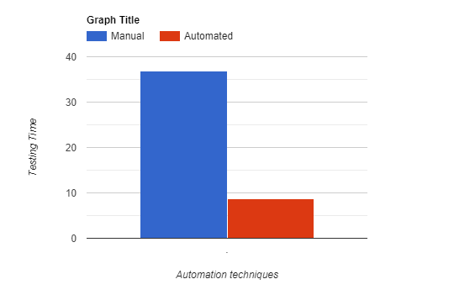

Figure 5.1.1 Open site, wait to load and quit site

From this graph we can infer that , in this case the automated model performs highly well in comparison to the manual testing software available , in the case that only the website is opened and then is waited for it to load , to have more accurate results, the testing is done on the same network and the same machine.

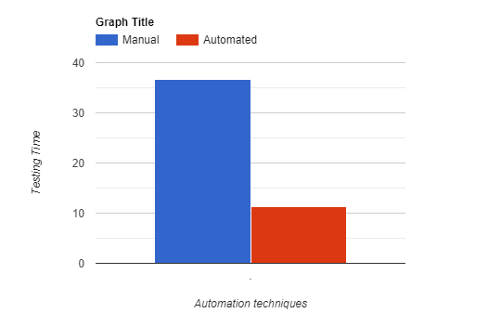

Figure 5.1.2 Open site and search a keyword in the tab and get result and quit

From this graph we can infer that, in this case the automated model performs highly well in comparison to the manual testing software available , in the case that only the website is opened and then is waited for it to load then we have searched for a keyword and then waited for the results , to have more accurate results, the testing is done on the same network and the same machine.

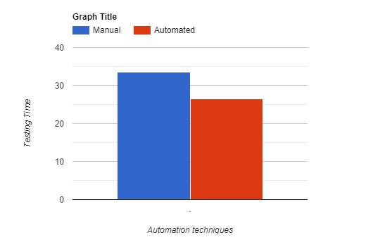

Figure 5.1.3 Open site and then click on 2 buttons and wait for results

From this graph we can infer that, in this case the automated model performs somewhat well in comparison to the manual testing software available , in the case that only the website is opened and then is waited for it to load then we have clicked on different articles to view the content, to have more accurate results, the testing is done on the same network and the same machine.

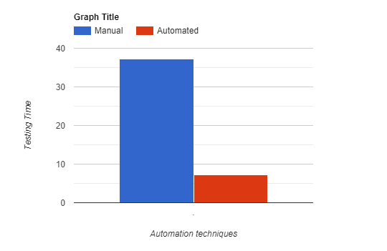

Figure 5.1.4 Testing whole framework with keyword search

From this graph we can infer that, in this case the automated model performs highly well in comparison to the manual testing software available , in the case that only the website is opened and then is waited for it to load then we have clicked on different hyperlinks to view the contents, to have more accurate results, the testing is done on the same network and the same machine.

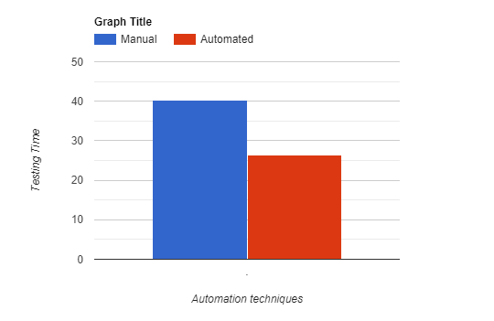

Figure 5.1.5 Testing load and reload of a website

From this graph we can infer that, in this case the automated model performs somewhat well in comparison to the manual testing software available , in the case that only the website is opened and then is waited for it to load then we load the different components of the website again and again, to have more accurate results, the testing is done on the same network and the same machine.

Chapter 6 RESULTS AND DISCUSSION

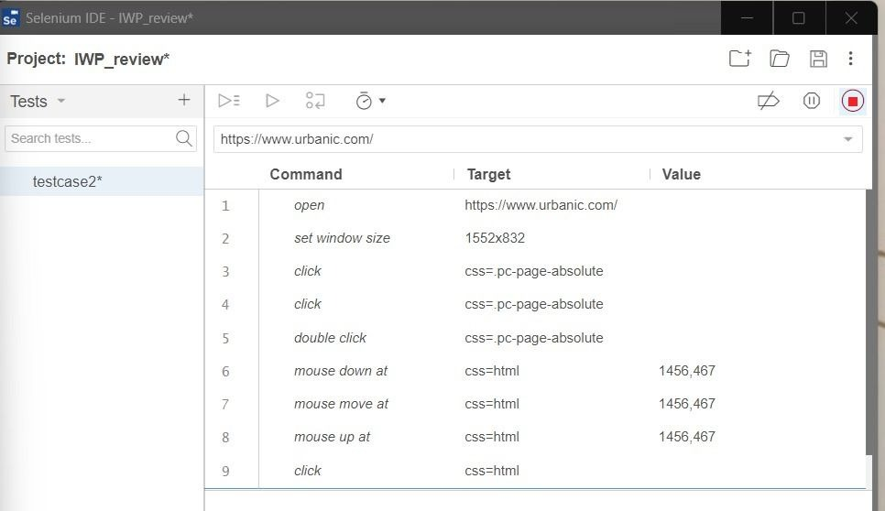

Figure 6.1.1 This figure is showing the manual selenium testing.

Figure 6.1.2 This figure is showing the result of the selenium manual testing from Fig 6.1.1

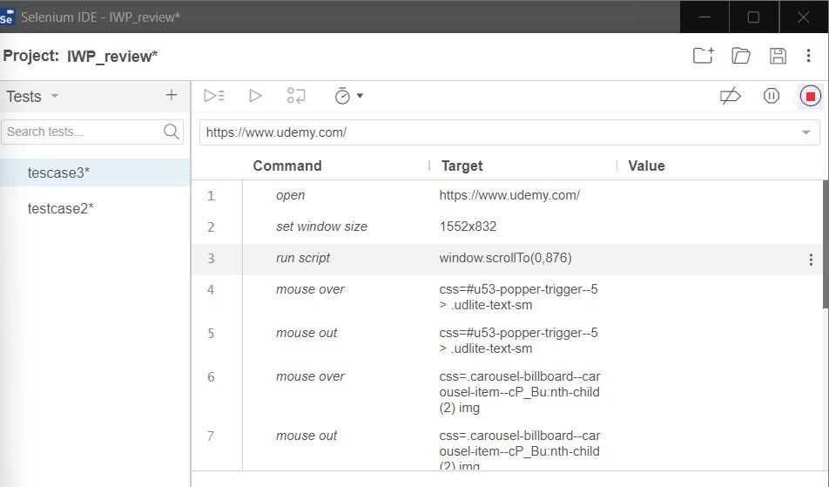
Figure 6.1.3 This figure is showing selenium manual testing testcase-2

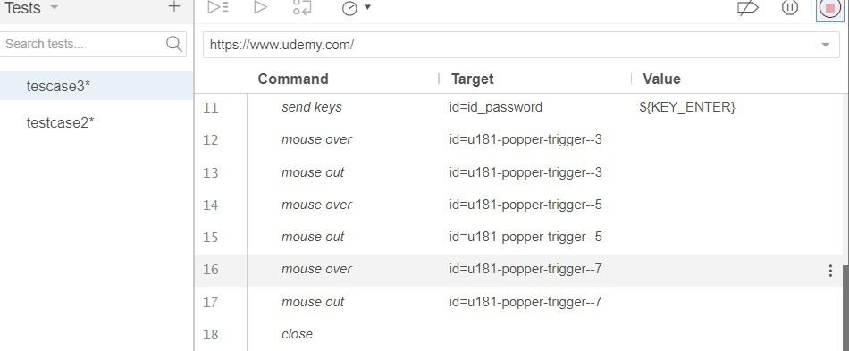
Figure 6.1.4 This figure is showing the result of Fig 6.1.3

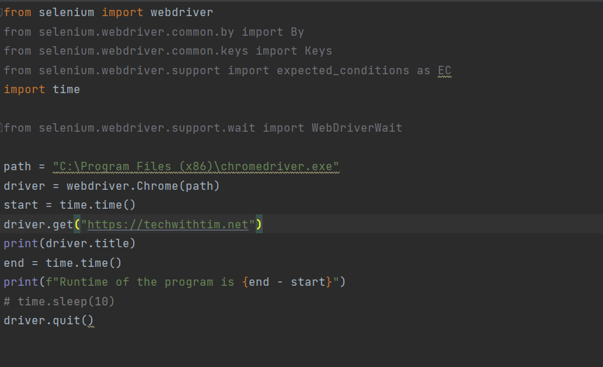
Figure 6.1.5 This figure is showing the automation testing

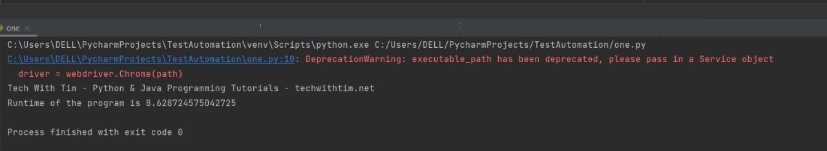
Figure 6.1.6 This figure is showing the automation testing and viewing the images

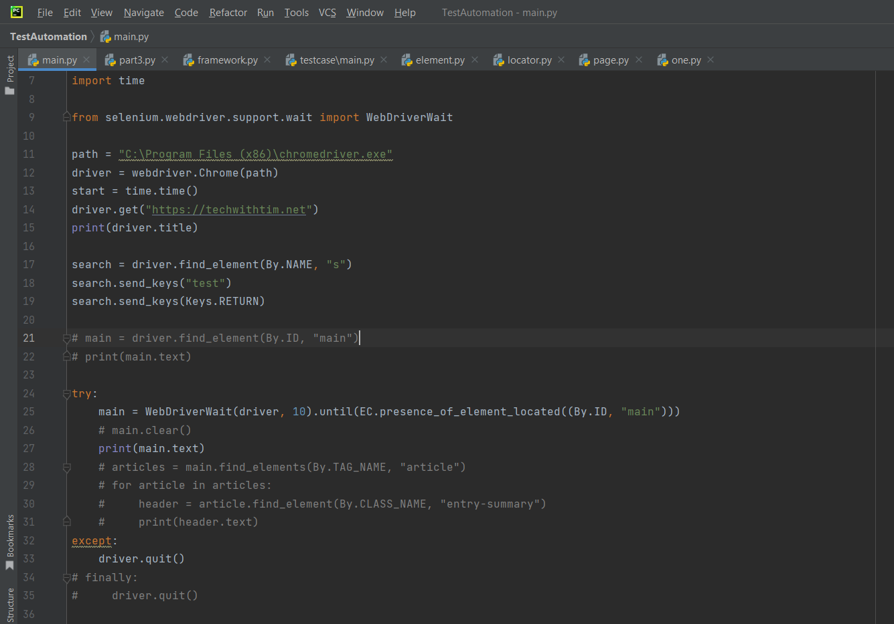
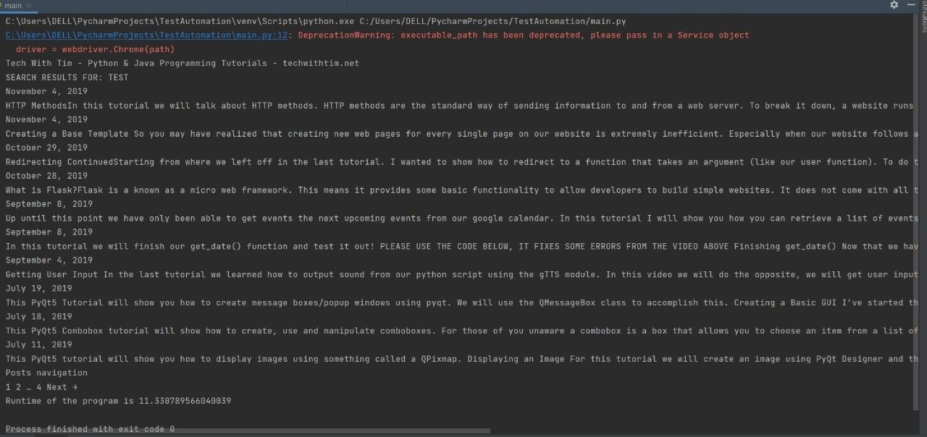
Figure 6.1.7 This figure is showing the automation testing and extracting text by fieldname
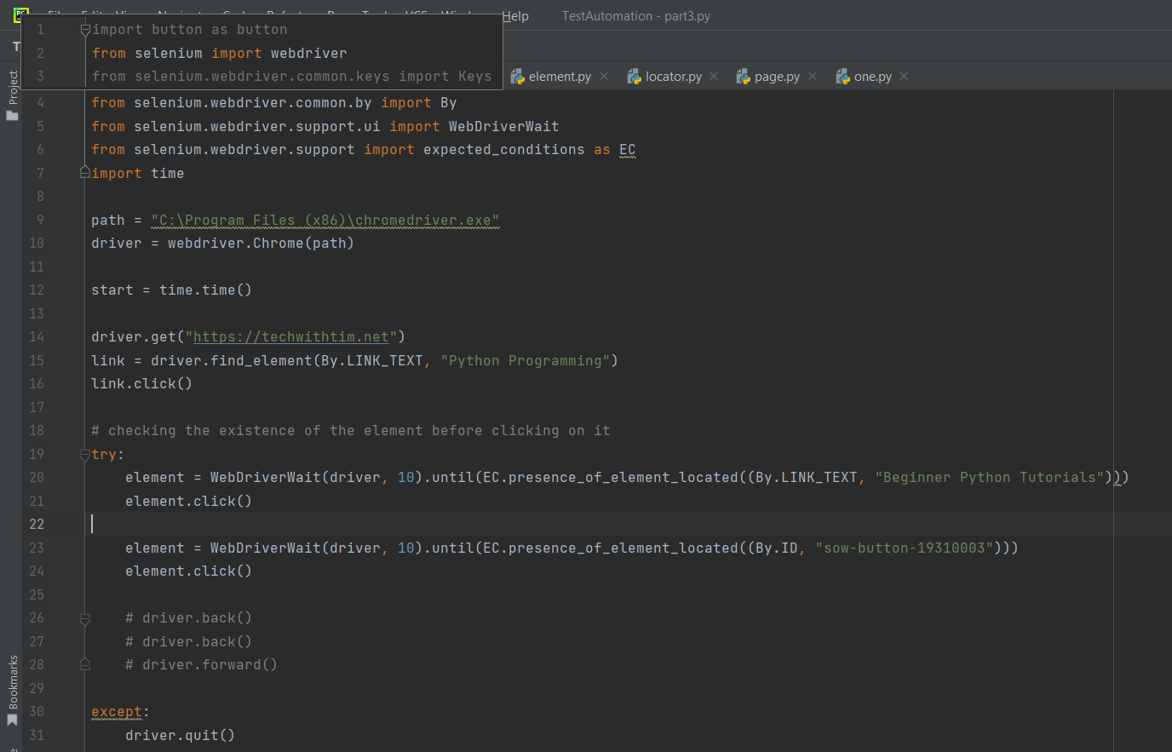
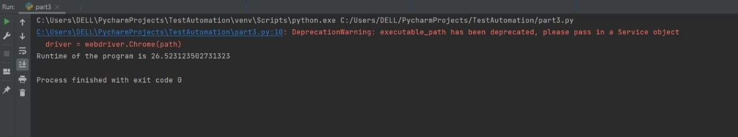
Figure 6.1.8 This figure is showing the automation testing and click functionality
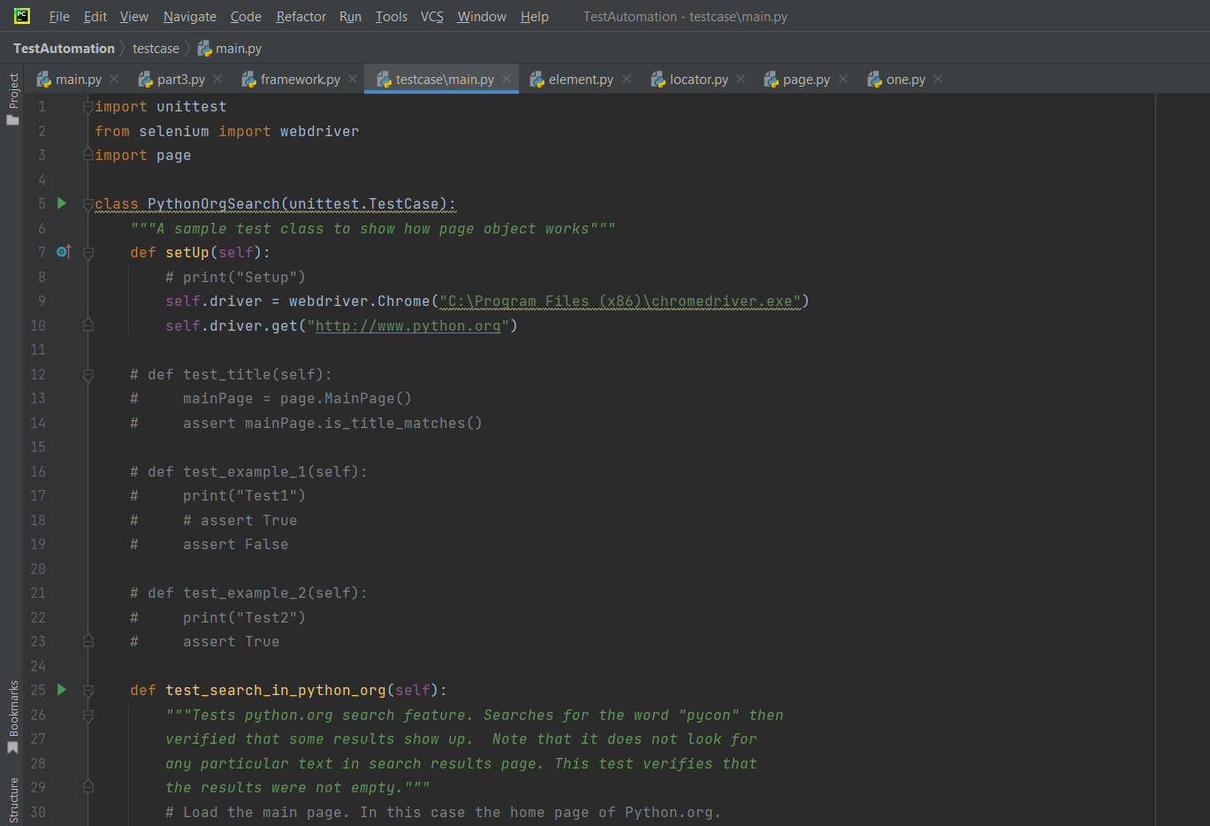
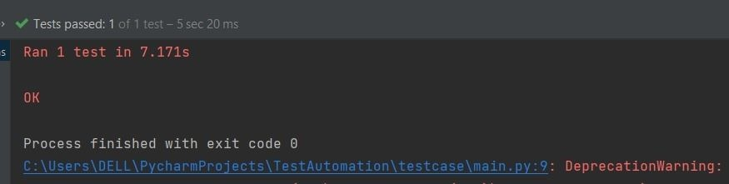
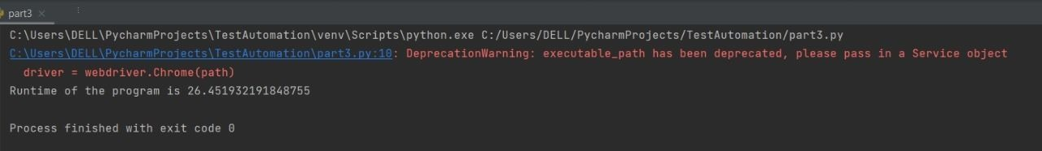
Figure 6.1.9 This figure is showing the automation testing and running sample testcase

Manual Tests
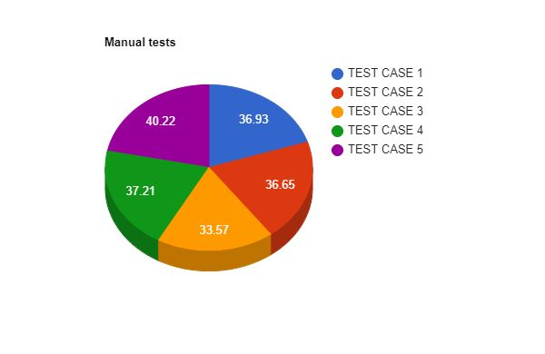
Fig no.6.1.10 This shows the various testing times of all the test cases of manual testing that we got.

Automated Tests
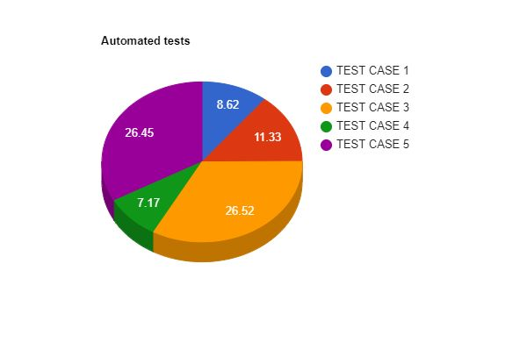
Fig no.6.1.11 This shows the various testing times of all the test cases of automated testing that we got.

Chapter 7 CONCLUSION & FUTURE WORK
FUTURE WORK
Experiments are conducted to assess the efficacy of the suggested framework by applying it to a case study. It can do so much work at once that manual testing are practically difficult to finish. The suggested technique also creates test cases in a standard tabular style, which is both simpler and more stringent than manually constructing them in standard English. Future work will focus on discovering more general approaches to improve overall testing effort and reach a greater degree of automation by auto-generating more abstract scripts. The suggested technique necessitates the creation of a framework to facilitate automated testing of a web application. With the whole web migrating to cloud-based services, it is vital to examine cloud-based web application testing at the next level. A bird's-eye perspective of testing web applications indicates the necessity for an online testing tool to examine the dynamic behaviour of web applications, since identifying such flaws is usually challenging because web applications are typically evaluated using standalone tools.
CONCLUSION
Automation Software testing is the most effective way to maximise the effectiveness, efficacy, and coverage of software programmed testing. Selenium is a testing framework for online applications that contains a number of tools. With the aid of a case study, we explore and uncover the testing of an online service as well as the usability of the automated testing tool "Selenium IDE." When a tester inserts information into a web software display, the TC is routinely logged in history using this process; these TCs are reusable in the Regression Testing environment. It will decrease the amount of people, cost, and time necessary to test and deliver high-quality items to clients.

References
[1]. A Review on Web Application Testing and its Current Research Directions
Lakshmi, D. R., & Mallika, S. S. (2017). A review on web application testing and its current research directions. International Journal of Electrical and Computer Engineering, 7(4), 2132.
[2]. An Automated Web Application Testing System
Girgis, M. R., Mahmoud, T. M., Abdullatif, B. A., & Zaki, A. M. (2014). An automated web application testing system. International Journal of Computer Applications, 975, 8887.
[3]. Automated Software Testing Framework for Web Applications
Hanna, M., Aboutabl, A. E., & Mostafa, M. S. M. (2018). Automated software testing framework for web applications. International Journal of Applied Engineering Research, 13(11), 9758-9767.
[4]. Web Application Testing: A Review on Techniques, Tools and State of Art
Arora, A., & Sinha, M. (2012). Web application testing: A review on techniques, tools and state of art. International Journal of Scientific & Engineering Research, 3(2), 1.
[5]. Automated Web Application Testing Using Search Based Software Engineering
Alshahwan, N., & Harman, M. (2011, November). Automated web application testing using search based software engineering. In 2011 26th IEEE/ACM International Conference on Automated Software Engineering (ASE 2011) (pp. 3-12). IEEE.
[6]. Study of Automated Software Testing: Automation Tools and Frameworks
Umar, M. A., & Zhanfang, C. (2019). A study of automated software testing: Automation tools and frameworks. International Journal of Computer Science Engineering (IJCSE), 6, 217-225.
[7]. A Test Automation Framework Based on WEB
Wang, F., & Du, W. (2012, May). A test automation framework based on web. In 2012 IEEE/ACIS 11th International Conference on Computer and Information Science (pp. 683-687). IEEE.
[8]. Automation Testing In Software Organization
Mahajan, P., Shedge, H., & Patkar, U. (2016). Automation testing in software organization. International Journal of Computer Applications Technology and Research, 5(4), 198-201.
[9] A Web Page for Automation Test Framework
Dave, R., & Patel, R. A Web Page for Automation Test Framework. International Journal of Computer Applications, 975, 8887.

[10]. A Workflow-Based Test Automation Framework for Web Based Systems
Weider, D. Y., & Patil, G. (2007, July). A workflow-based test automation framework for web based systems. In 2007 12th IEEE Symposium on Computers and Communications (pp. 333-339). IEEE.
[11]. A Web Framework For Test Automation: User Scenarios Through User Interaction Diagrams
Longo, D. H., Vilain, P., da Silva, L. P., & Mello, R. D. S. (2016, November). A web framework for test automation: user scenarios through user interaction diagrams. In Proceedings of the 18th International Conference on Information Integration and Web-based Applications and Services (pp. 458-467).
[12]. Web based Automation Testing and Tools
Sharma, M., & Angmo, R. (2014). Web based automation testing and tools. International Journal of Computer Science and Information Technologies, 5(1), 908-912.
[13]. A comparative study of automation testing tools for web applications
Pelivani, E., & Cico, B. (2021, June). A comparative study of automation testing tools for web applications. In 2021 10th Mediterranean Conference on Embedded Computing (MECO) (pp. 1-6). IEEE.
[14]. Script less GUI Automation Testing Tool for Web Applications
Malhotra, R., Bansal, A., & Jajoria, S. (2016, September). An automated tool for generating change report from open-source software. In 2016 International Conference on Advances in Computing, Communications and Informatics (ICACCI) (pp. 1576-1582). IEEE.
[15]. Impact of Unit Testing in Web Automation Testing
Authors: G.Chandrasekaran, V.Neethidevan, J.Murugachandravel
[16]. A framework for automated testing of automation systems
Winkler, D., Hametner, R., Östreicher, T., & Biffl, S. (2010, September). A framework for automated testing of automation systems. In 2010 IEEE 15th Conference on Emerging Technologies & Factory Automation (ETFA 2010) (pp. 1-4). IEEE.
[17]. Automated versus Manual Approach of Web Application Penetration Testing
Singh, N., Meherhomji, V., & Chandavarkar, B. R. (2020, July). Automated versus manual approach of web application penetration testing. In 2020 11th International Conference on Computing, Communication and Networking Technologies (ICCCNT) (pp. 1-6). IEEE.
[18]. Automated Software Testing Using Model-Checking

Callahan, J., Schneider, F., & Easterbrook, S. (1996, August). Automated software testing using model-checking. In Proceedings 1996 SPIN workshop (Vol. 353).
[19]. A survey of new trends in symbolic execution for software testing and analysis.
Păsăreanu, C. S., & Visser, W. (2009). A survey of new trends in symbolic execution for software testing and analysis. International journal on software tools for technology transfer, 11(4), 339-353.
[20]. Web Application Testing with Model Based Testing Method
Akpinar, P., Aktas, M. S., Keles, A. B., Balaman, Y., Guler, Z. O., & Kalipsiz, O. (2020, June). Web application testing with model based testing method: case study. In 2020 International Conference on Electrical, Communication, and Computer Engineering (ICECCE) (pp. 1-6). IEEE.
[21]. Analysis and Design of Selenium WebDriver Automation Testing Framework
Gojare, S., Joshi, R., & Gaigaware, D. (2015). Analysis and design of selenium webdriver automation testing framework. Procedia Computer Science, 50, 341-346.

[22]. A Review on Web application Testing and its Current Research Directions
Lakshmi, D. R., & Mallika, S. S. (2017). A review on web application testing and its current research directions. International Journal of Electrical and Computer Engineering, 7(4), 2132.

[23]. Analysis of performance Testing on Web Applications

Sharmila, S., & Ramadevi, E. (2014). Analysis of performance testing on web applications.
[24]. Automated Software Testing Framework for Web Application

Hanna, M., Aboutabl, A. E., & Mostafa, M. S. M. (2018). Automated software testing framework for web applications. International Journal of Applied Engineering Research, 13(11), 9758-9767.
[25]. Study and analysis of automation testing techniques
Sharma, S., & VISHAWJYOTI, M. (2012). Study and analysis of automation testing techniques. Journal of global research in computer science, 3(12), 36-43.

