**Implementation Of Project Requirements On ReQtest**

**(Online Requirements Tool)**

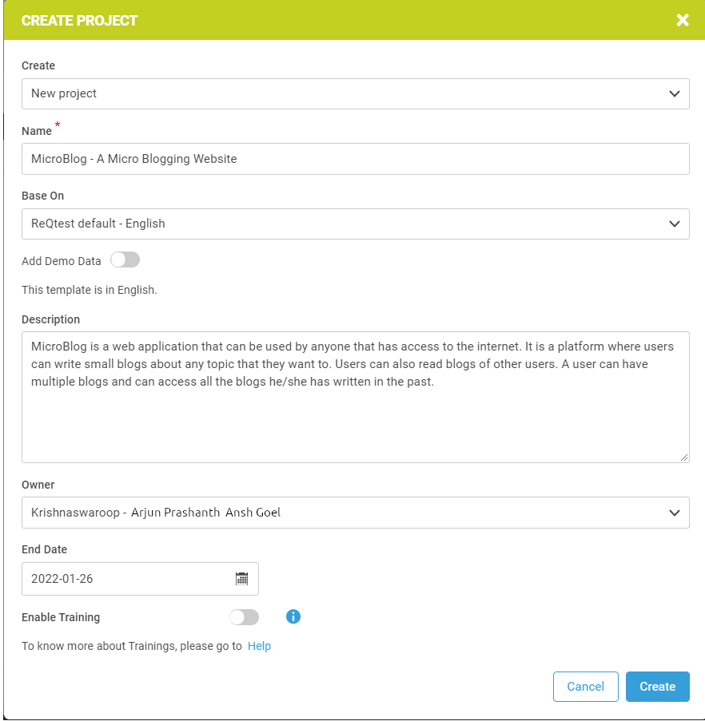

**Requirements:**

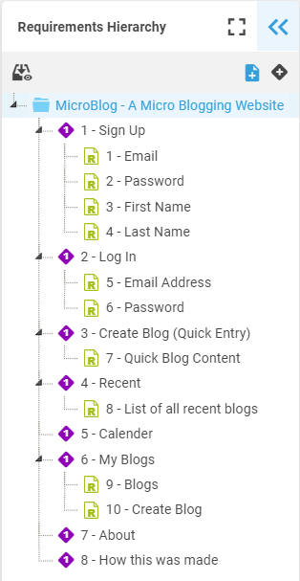

* REQ-1 : Sign Up

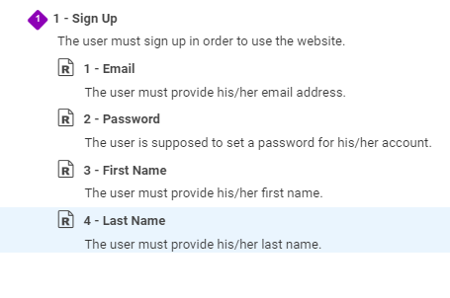

* REQ-2 : Log In

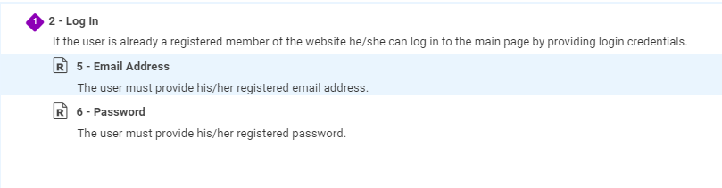

* REQ-3 : Quick Entry (Blog)

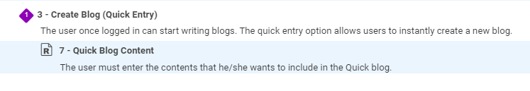

* REQ-4 : Recent

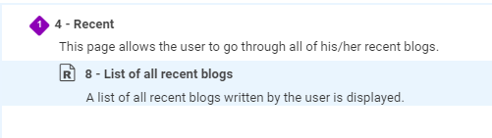

* REQ-5 : Calendar

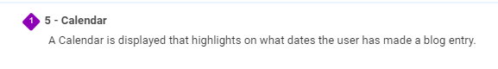

* REQ-6 : My Blogs

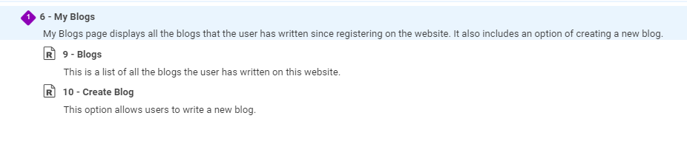

* REQ-7 : About and REQ-8 : How this was made (Non-Fn Requirements)



