Naming the file: Regno_Name_Ex1_Basic_Commands

RegNo: 20BCE1798
Name: ANSH GOEL

Course Code: CSE2005
Course Name: Operating Systems (Embedded Lab)

Slot: L27+L28

Ex No 1: Basic Commands
Date: 07-01-22

Command 1: DATE

$date +%A Full Week Day
$date +%B Full Month
$date +%c Current Day and Time
$date +%D Day in “mm/dd/yyyy”
$date +%T HH:MM:SS

OUTPUT:

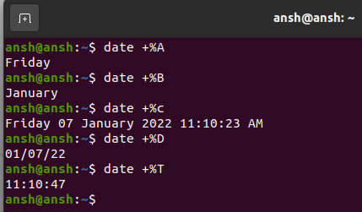

Command 2: Calendar

$cal <year> Entire Calendar of the Year
$cal <month> <year> Particular Month of a Year

OUTPUT:
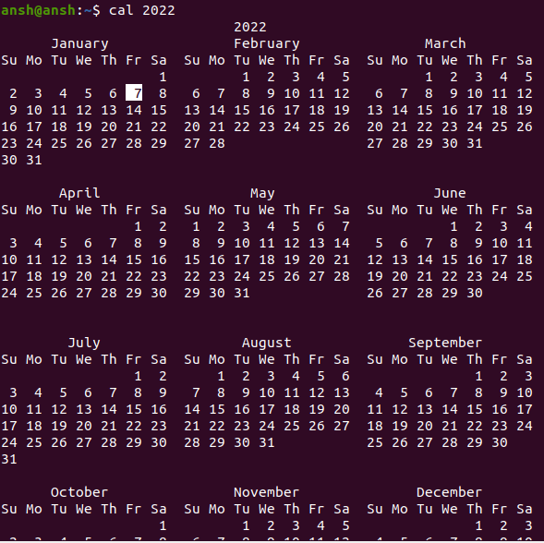

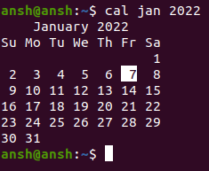

Command 3: Echo

$echo <text> Echo “welcome >You >all

OUTPUT:

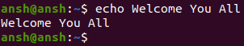
Command 4: Banner

$banner <text> Banner WELCOME

OUTPUT:

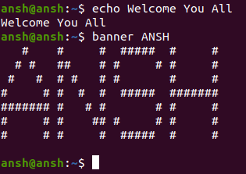

Command 5: WHO

$who -H Display the Output with Headers
$who -b Display the Last Booting Date and Time

OUTPUT:

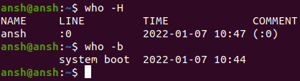

Command 6: Tty

$tty Display the Terminal Name

OUTPUT:

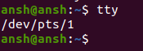

Command 7: Clear

$clear Clear the Screen

OUTPUT:

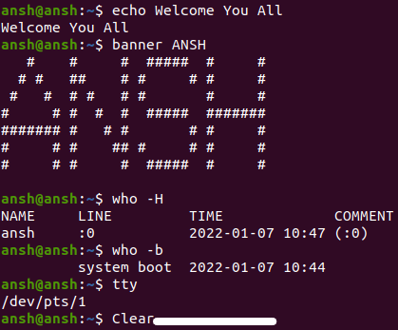
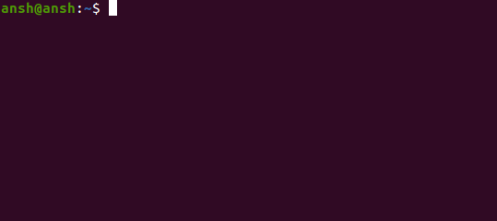

Command 8: MAN

$man <text> Help Manual
$man <command name>
OUTPUT:
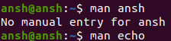
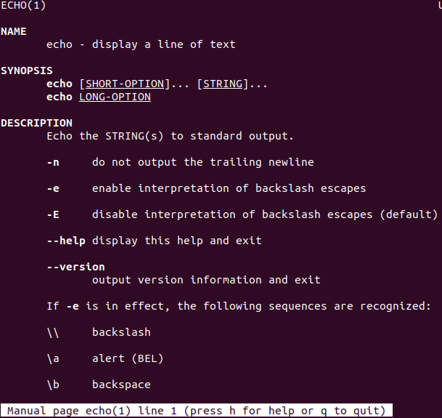

Command 9: MANIPULATION
$tput longname Display the Complete Name of the Terminal
$tput smso Background – White, Foreground – Black
$tput rmso Background – Black, Foreground – White
$tput cup r c Move the Cursor Position to the Specified Location
$tput cols Display the Number of Columns in our Terminal
OUTPUT:
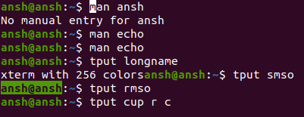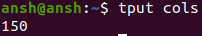

Command 10: LIST
ls -a Used to List all the Files
ls -c List all the Files Column-wise
ls -d List all the Directories
ls -m List the Files Separated by Commas
ls -p List Files Include / to all the Directories
OUTPUT:
