

CSE4001 – PARALLEL AND DISTRIBUTIVE COMPUTING

Embedded Project

FALL SEMESTER – 2022~2023

PARALLELIZATION OF LOCAL SEQUENCE ALIGNMENT

Submitted By :
Ansh Goel : 20BCE1798
Khushi Mattu: 20BCE1189
Uditi Gupta: 20BCE1445

Under the guidance of Prof. Kumar R

Index:

- Abstract 3
- Introduction 3

- Motivation 3
- Project Scope 4
- Aim 4
- Objective 5
- Acknowledgement 5
- Package Requirements 5
- Algorithm Explanation 6
- Existing Tool 7
- Proposed Model/Procedure 7
- Code Implementation 9
- Docker Implementation 14
- Output Screenshots 15
- Result Analysis 17
- Conclusion 18
- References 18

Abstract:

Parallel and Distributed computing is the future of technology. All products and their fundamental concepts are being shifted to a parallel computing model. Everybody would agree that serial computing is easy to implement and use, but simply not efficient enough for industry- level purposes.
Due to this reason, day by day higher number of industries are providing and using cloud solutions which work on the basis on parallel and distributed computing.
For instance, Amazon’s AWS or Google’s Google Cloud platform are becoming the centre for development, may it be in the field of web development, or in the field of data analytics.
To cope up with the fast-paced improvement in technology, one must also become familiarized with this domain, and hence this project.
Gene sequencing problem is one of the major issues for researchers regarding optimized system models that could help optimum processing and efficiency without introduction overheads in terms of memory and time. Bioinformatics and computational biology is a latest multidisciplinary field which explains many aspects of the fields of computer science, while computational biology harnesses computational approach and technologies to respond biological questions conveniently.

Introduction:

Genome is an emerging field, constantly presenting many new challenges to researchers in both biological and computational aspect of application. Sequence comparison is a very essential and important operation. They detect similar or identical parts between two sequences called the query sequence and the reference sequence.
The global and local alignments are the most prevalent kinds of sequence alignment. In global alignment, we find the superior counterpart between parts of the sequences. On the other hand, local alignment algorithms try to match parts of sequences and not the entirety of them.
Local alignment is faster than global alignment, due to the lack of need to align the entire sequences. In our project, we would be implementing the Smith-Waterman Algorithm in a serial and parallel manner to for comparison and analysis. As common sense suggests, the parallel implementation should execute and provide the same result as the serial implementation but in a lesser amount of time.

Motivation:

As time passes, the world is becoming more and more oriented towards Parallel Computing. Many of the tasks that were once carried out sequentially are now being carried out in parallel so as to use resources more efficiently and get faster results.
Research is being done in the Biology with the application Smith–Waterman algorithm it is possible to process and understand nucleic acid/ protein sequences.
Thus, in this project, we use this inspiration to create something on a smaller scale, but with a large scope.

Project Scope:

  - A highly efficient and simple implementation of the Smith-Waterman algorithm for local alignment of sequences.
  - This project would roughly be over a span of two-three months (August - October).

  - We would be learning mainly how to detect sequences in proteins and nucleic acids and how to detect them using parallel computing using multiple threads

  - We would also learn how to apply parallel processing into a real world problem – something we don’t have the opportunity to do in our university curriculum.

  - There would be several limitations – we would only be creating a basic model and not a full-fledged model that will be 100% accurate.

  - At the end of the project term, we should be able to deliver a working model that should be able to provide an accurate detection of sequences present,

Aim [Problem Statement]:

Comparison between serial and parallel implementation of Smith Waterman local sequence alignment algorithm for randomly generated nucleotide sequences.

Objective:

- To learn and use openmp and its related packages

- To learn and use Parallel processing and compare its efficiency with serial execution by implementing the above mentioned algorithm
- This would be done in parallel and in serial and a comparison between them would be done.
- To work in a team and understand the advantages of teamwork by assigning roles for each member and deadlines for the project, which would help us get suited to a work-based environment and benefit us in the future.
- To improve our report writing and presentation skills through the frequent Reviews conducted to check on our progress.

Acknowledgement:

We would like to express our special thanks of gratitude to our teacher Kumar R. in the CSE4001 Parallel and Distributed Computing Course, who gave us the golden opportunity to do this wonderful project on the
topic of Smith-Waterman Algorithm which helped us in doing a lot of research and learn tons of useful skillsets which would be helpful to us in the near future. We appreciate his continued support and patience throughout the timeframe of this project.

Package Requirements:
- <stdio.h> The C programming language provides many standard library functions for file input and output. These functions make up the bulk of the C standard library
- <stdlib.h> stdlib.h is the header of the general purpose standard library of C programming language which includes functions involving memory allocation, process control, conversions and others. It is compatible with C++ and is known as cstdlib in C++. The name "stdlib" stands for "standard library"
- <math.h> The math.h header defines various mathematical functions and one macro. All the functions available in this library take double as an argument and return double as the result.
- <omp.h> It is a library that allows memory multiprocessing programming in C.

- <time.h> In C programming language time.h (used as ctime in C++) is a header file defined in the C Standard Library that contains time and date function declarations to provide standardized access to time/date manipulation and formatting.

Algorithm Explanation:

Smith-Waterman algorithm calculates the local alignment of two sequences. It guarantees to find out the best possible local alignment taking into account the specified scoring system. This includes a substitution matrix and a gap-scoring method. Scores consider match, mismatch and substitution. To measure the comparison between two sequences, a score be calculated as follows:
Given an alignment between sequences S0 and S1, the following values must be assigned, for each column:
  - ma = (+5) [Match]
  - mi = (-3) [Mismatch]
  - G = (-4) [Gap]

Procedure:
- Initialization of the matrix and consider two sequences A and B.
- Matrix filling with the suitable scores. The two sequences are set in a matrix form by means of A+1 columns and B+1 rows. The value in the first row and first column are set to zero.
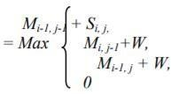
- The second and essential step of the algorithm is filling to entire matrix. To fill each and every cell it is important to know the diagonal values.
- Trace back the sequence for an appropriate alignment is trace backing; before that the maximum score obtained in the entire matrix has to be detected for the local alignment of the sequences.
It is likely to those maximum scores can be present in one or more than one cell, in such case there may be option of two or more alignments, and the best alignment can be obtained by scoring it.
- Tracing back begins from the position which has the highest value, pointing back with the pointers, consequently find out the possible predecessor, then go to next predecessor and continue until it reaches the score 0.

Example:
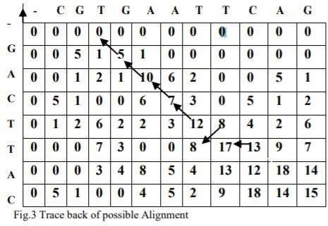

Existing Tool:

There are few existing tools which have a parallel implementation of the Smith-Waterman algorithm, but the most prominent one is Clustal W [EMBOSS WATER].
Link: https://www.ebi.ac.uk/Tools/psa/emboss_water/
EMBOSS Water uses the Smith-Waterman algorithm (modified for speed enhancements) to calculate the local alignment of two sequences.
We can perform the alignment for protein, DNA or RNA sequences.

Proposed Model/Procedure:

The problem at hand was tackled with a modular approach. Eight functions were constructed, each of which would be explained as follows:
  - nElement – This function is used to calculate the number of elements that have been found by the Smith Waterman Algorithm. Three conditions are given: One of which is to find out if the number of elements in the diagonal are increasing, decreasing or stable.

  - calcFirstDiagElement – This function is used to calculate the position of the maximum scored value in the matrix. This value needs to be found because the

algorithm suggests that the backtracking to find the path should be started from this particular point.

  - similarityScore – This function is used to find out the optimal order of execution based on three conditions, which are used to calculate the new values of left, upper and the diagonal elements.

If the diagonal element > maximum element, Move diagonally upwards

If upper element > maximum element, Move upwards

If left element > maximum element, Move leftwards

Every iteration, the values of maximum element is updated and inserting into the similarity and predecessor matrices.

  - matchMismatchScore – This function is used to calculate a similarity function or the alphabet for a match or mismatch.
If the value of the two elements are equal, it is a match, otherwise it’s a mismatch.

  - Backtrack – The purpose of this function is to modify the matrix that needs to be printed and helps us identify the path that needs to be taken to get the most optimum solution.

  - printMatrix – It’s a looped iteration implementation to display the matrix.

  - printPredecessorMatrix - It is in this function in which we print the arrows depicting the path of local alignment.

  - Generate – This function generates the two sequences A and B which would be locally aligned with each other. A random seed is used to ensure the reproducible nature of the output.

Code Implementation:
// IMPORTING ALL THE HEADER FILES NEEDED FOR THE IMPLEMENTATION
#include <stdio.h> #include <stdlib.h> #include <math.h> #include <omp.h> #include <time.h>

// DEFINING THE GLOBAL VARIABLES AND FIXED VARIABLES
#define RESET "\033[0m"
#define BOLDRED "\033[1m\033[31m" #define PATH -1
#define NONE 0
#define UP 1
#define LEFT 2
#define DIAGONAL 3
#define min(x, y) (((x) < (y)) ? (x) : (y)) #define max(a,b) ((a) > (b) ? a : b)

// FUNCTION DEFINITIONS
void similarityScore(long long int i, long long int j, int* H, int* P, long long int* maxPos);
int matchMissmatchScore(long long int i, long long int j); void backtrack(int* P, long long int maxPos);
void printMatrix(int* matrix);
void printPredecessorMatrix(int* matrix); void generate(void);
long long int nElement(long long int i);
void calcFirstDiagElement(long long int *i, long long int *si, long long int
*sj);

// DEFINING THE MAIN VARIABLES
long long int m ; //Columns - Size of string a long long int n ; //Lines - Size of string b int matchScore = 5;
int missmatchScore = -3; int gapScore = -4;
char *a, *b;

// MAIN FUNCTION FOR EXECUTION
int main(int argc, char* argv[]) {
int thread_count = strtol(argv[1], NULL, 10); m = strtoll(argv[2], NULL, 10);
n = strtoll(argv[3], NULL, 10); #ifdef DEBUG
printf("\nMatrix[%lld][%lld]\n", n, m); #endif
a = malloc(m * sizeof(char));

b = malloc(n * sizeof(char)); m++;
n++;
int *H;
H = calloc(m * n, sizeof(int)); int *P;
P = calloc(m * n, sizeof(int)); generate();
long long int maxPos = 0; long long int i, j;
double initialTime = omp_get_wtime(); long long int si, sj, ai, aj;
long long int nDiag = m + n - 3; long long int nEle;
#pragma omp parallel num_threads(thread_count) \
default(none) shared(H, P, maxPos, nDiag) private(nEle, i, si, sj, ai, aj)
{
for (i = 1; i <= nDiag; ++i)
{
nEle = nElement(i); calcFirstDiagElement(&i, &si, &sj); #pragma omp for
for (j = 1; j <= nEle; ++j)
{
ai = si - j + 1; aj = sj + j - 1;
similarityScore(ai, aj, H, P, &maxPos);
}
}
}
backtrack(P, maxPos); #ifdef DEBUG
printf("\nSimilarity Matrix:\n"); printMatrix(H); printf("\nPredecessor Matrix:\n"); printPredecessorMatrix(P);
#endif
double finalTime = omp_get_wtime();
printf("\nElapsed time: %f\n\n", finalTime - initialTime); free(H);
free(P);
free(a);
free(b); return 0;
}
long long int nElement(long long int i) { if (i < m && i < n) {
return i;

}
else if (i < max(m, n)) { long int min = min(m, n); return min - 1;
}
else {
long int min = min(m, n);
return 2 * min - i + abs(m - n) - 2;
}
}

// FUNCTION TO CALCULATE THE ELEMENT FROM WHICH THE ALIGNMENT MUST START
void calcFirstDiagElement(long long int *i, long long int *si, long long int
*sj) {
if (*i < n) {
*si = *i;
*sj = 1;
} else {
*si = n - 1;
*sj = *i - n + 2;
}
}

// FUNCTION TO CALCULATE THE SIMILARITY SCORES OF THE TWO SEQUENCES
void similarityScore(long long int i, long long int j, int* H, int* P, long long int* maxPos) {
int up, left, diag;
long long int index = m * i + j; up = H[index - m] + gapScore; left = H[index - 1] + gapScore;
diag = H[index - m - 1] + matchMissmatchScore(i, j); int max = NONE;
int pred = NONE;
if (diag > max) { //same letter ↖
max = diag; pred = DIAGONAL;
}
if (up > max) { //remove letter ↑ max = up;
pred = UP;
}
if (left > max) { //insert letter ← max = left;
pred = LEFT;
}
H[index] = max; P[index] = pred;
if (max > H[*maxPos]) {

#pragma omp critical
*maxPos = index;
}

}

// FUNCTION TO CALCULATE THE MISMATCH SCORES FOR THE TWO SEQUENCES
int matchMissmatchScore(long long int i, long long int j) { if (a[j - 1] == b[i - 1])
return matchScore;

else

}

return missmatchScore;

// THE MAIN BACKTRACKING FUNCTION FOR SEQUENCE ALIGNMENT
void backtrack(int* P, long long int maxPos) {
//hold maxPos value long long int predPos; do {
if (P[maxPos] == DIAGONAL) predPos = maxPos - m - 1;
else if (P[maxPos] == UP) predPos = maxPos - m;
else if (P[maxPos] == LEFT) predPos = maxPos - 1;
P[maxPos] *= PATH; maxPos = predPos;
} while (P[maxPos] != NONE);
}

// FUNCTION TO PRINT THE MATRIX
void printMatrix(int* matrix) { long long int i, j; printf("-\t-\t");
for (j = 0; j < m-1; j++) {
printf("%c\t", a[j]);
}
printf("\n-\t");
for (i = 0; i < n; i++) { //Lines for (j = 0; j < m; j++) {
if (j==0 && i>0) printf("%c\t", b[i-1]); printf("%d\t", matrix[m * i + j]);
}
printf("\n");
}
}

// FUNCTION TO PRINT THE MAIN ALIGNMENT MATRIX

void printPredecessorMatrix(int* matrix) { long long int i, j, index;
printf(" ");
for (j = 0; j < m-1; j++) {
printf("%c ", a[j]);
}
printf("\n ");
for (i = 0; i < n; i++) { //Lines for (j = 0; j < m; j++) {
if (j==0 && i>0) printf("%c ", b[i-1]); index = m * i + j;
if (matrix[index] < 0) { printf(BOLDRED);
if (matrix[index] == -UP) printf("↑ ");
else if (matrix[index] == -LEFT) printf("← ");
else if (matrix[index] == -DIAGONAL) printf("↖ ");
else
printf("- ");
printf(RESET);
} else {
if (matrix[index] == UP) printf("↑ ");
else if (matrix[index] == LEFT) printf("← ");
else if (matrix[index] == DIAGONAL) printf("↖ ");
else
printf("- ");
}
}

printf("\n");
}
}

// FUNCTION TO GENERATE THE SEQUENCES RANDOMLY
void generate() { srand(0);
long long int i;
for (i = 0; i < m; i++) { int aux = rand() % 4; if (aux == 0)
a[i] = 'A';
else if (aux == 2) a[i] = 'C';
else if (aux == 3)

a[i] = 'G';
else
a[i] = 'T';
}
for (i = 0; i < n; i++) { int aux = rand() % 4; if (aux == 0)
b[i] = 'A';
else if (aux == 2) b[i] = 'C';
else if (aux == 3) b[i] = 'G';
else
b[i] = 'T';
}
}

Docker Implementation:
docker build -t myapp .
winpty docker run --interactive --tty jiez/openmpi-controller bash gcc serial.c -o serial -fopenmp -DDEBUG
./serial 10 10
gcc Parallel.c -o par -fopenmp -DDEBUG
./par 4 10 10

Output Screenshots: [For Serial and Parallel]

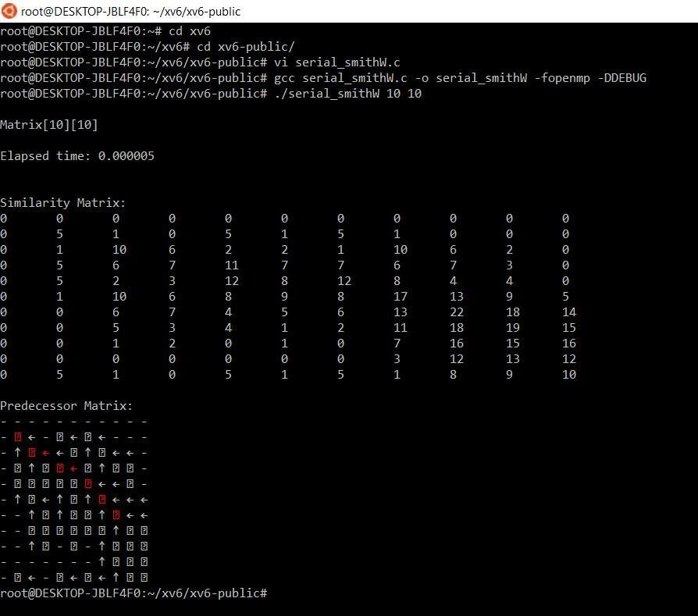

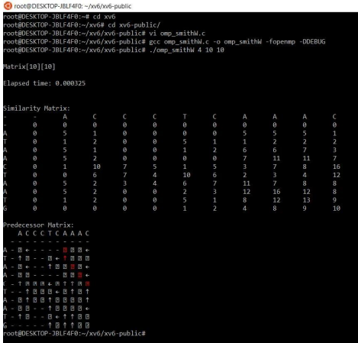

Virtual Box Implementation

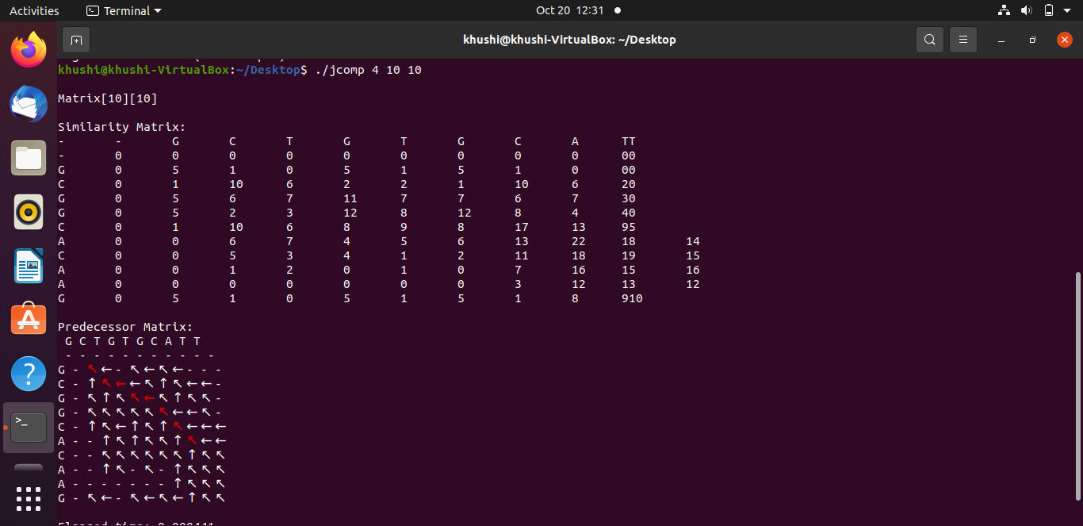

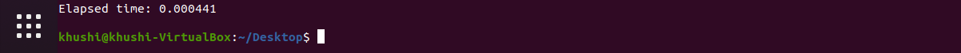

14. Result Analysis:

The code was run for various lengths of sequences, and the elapsed time was recorded in each case (as shown in the aforementioned outputs).
After tabulating all the execution times, we get:

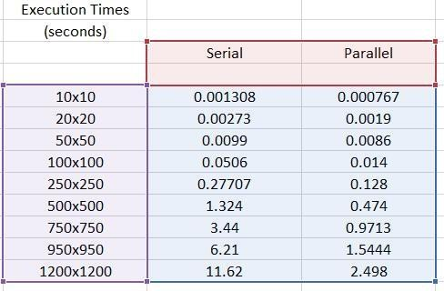

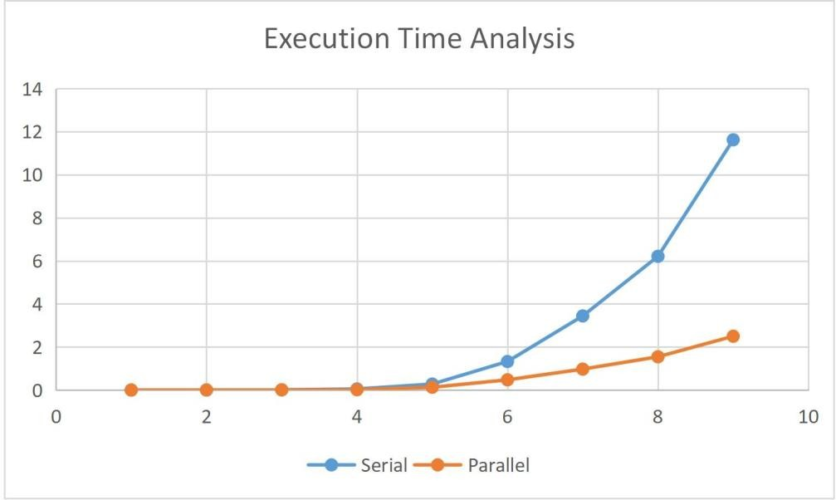

Conclusion:

As we can see in the above graph, for small lengths of the sequence, serial and parallel programs tend to give the output in almost the same amount of time. However, as the length increases, the execution time for serial implementation also increases exponentially, hence forming a steep graph.
However, the parallel implementation remains stable with not a high rise in the execution time because of the parallel execution of the task with two threads, making the process faster than its serial counterparts.

References:

  - http://www.ijritcc.org/download/1433580671.pdf
[A paper about parallel implementation of Smith Waterman algorithm]

  - http://vlab.amrita.edu/?sub=3&brch=274&sim=1433&cnt=1 [Useful resource for learning about the algorithm in detail]

  - http://deeplearning.lipingyang.org/2017/01/30/openmp-on-ubuntu/ [Tutorial for interfacing and running openmp codes on Ubuntu terminal]

  - https://www.geeksforgeeks.org/backtracking-algorithms/
[Basic examples of backtracking and also dynamic programming to learn and understand the algorithms]

