Automated Question Bank Generation
A Project Based Learning Report Submitted in partial fulfilment of the requirements for the award of the degree

of

Bachelor of Technology
in The Department of Computer Science Engineering
Data Structure and Algorithm – 25CS2103E

Submitted by
2510030002 : Anshjeet Singh
2510030120 : Ashritha Kulshrestha
2510030176 : Jogu Akshitha

Under the guidance of
Dr. Anitha Patil



Department of Computer Science and Engineering
Koneru Lakshmaiah Education Foundation, Aziz Nagar
Aziz Nagar – 500075
FEB – 2026.

Abstract
Preparing a question bank by hand takes a great deal of time and often leads to repeated questions, uneven difficulty and incomplete coverage of the syllabus. This project, Automated Question Bank Generation, is an AI-assisted system that converts study material into a structured question bank using Natural Language Processing (NLP) and Machine Learning. The system accepts a PDF file, a TXT file or typed content and generates questions according to the topic, question type, difficulty level and number of questions chosen by the teacher.
The system follows a modular pipeline. The input is cleaned, tokenized and segmented into sentences; keywords, topics and entities are extracted as key concepts; and a Transformer-based question generation engine produces MCQs, short-answer questions and long-answer questions from those concepts. Each question is then classified by type and by difficulty level (Easy, Medium or Hard) and passed through a validation stage that checks relevance and grammar and removes duplicate or highly similar questions using text-similarity techniques.
Validated questions are stored in a database (MongoDB or MySQL) and presented through a web interface where the teacher can review, edit, organize, search and export them. The system is implemented in Python with Transformers, PyTorch or TensorFlow, and NLTK or spaCy, and with Flask, FastAPI or Streamlit for the interface. Observations show that the system generates questions automatically in several formats and difficulty levels, identifies important concepts, removes repeated questions, and significantly reduces the time and manual effort needed to prepare a question bank, while the teacher keeps final control over the content. Multilingual generation, LLM integration, Bloom's Taxonomy classification and automatic answer generation are identified as future work.
Keywords: Automated question generation, NLP, Transformer models, question bank, difficulty classification, duplicate detection, semantic similarity, educational assessment
List of Figures
Figure 1: Use case diagram showing the actors and their use cases
Figure 2: Overall architecture of the Automated Question Bank Generation system
Figure 3: Layered design of the system
Figure 4: Stages of text preprocessing
Figure 5: Classification of a question by difficulty and type
Figure 6: Validation flow for a generated question
Figure 7: Entity relationship diagram of the question bank database
Figure 8: Working process from study material to question bank
Figure 9: Context-level data flow diagram
Figure 10: Level-1 data flow diagram
Figure 11: Sequence of a question generation request
List of Tables
Table 1: Comparison of question generation approaches
Table 2: Functional requirements of the system
Table 3: Non-functional requirements of the system
Table 4: Software and hardware used for development and execution
Table 5: Technology stack used in the project
Table 6: Modules of the system
Table 7: Guidelines used to assign difficulty levels
Table 8: Algorithms and techniques used in the system
Table 9: Collections or tables of the database
Table 10: Illustrative questions generated from one concept
Table 11: Processes of the level-1 data flow diagram
Table 12: Main validation rules
Table 13: Tools used during development
Table 14: Main parts of the project structure
Table 15: Levels of testing applied to the system
Table 16: Test scenarios and expected system behaviour
Table 17: Traceability between requirements and test scenarios
Table 18: Automated generation compared with manual question-bank preparation
Table 19: Design challenges and the approach used
Table 20: Glossary of terms used in this report
Table of Contents
1. Introduction
a. Background and Motivation
b. Problem Statement
c. Objectives
d. Scope and Limitations
e. Organization of the Report
2. Literature Review
a. Manual and Template-Based Question Generation
b. Natural Language Processing for Educational Text
c. Transformer-Based Language Models
d. Large Language Models and Retrieval-Augmented Generation
e. Duplicate Detection and Quality Validation
f. Existing Approaches and Research Gap
3. Requirements Analysis
a. Functional Requirements
b. Non-Functional Requirements
c. Actors and Use Cases
d. Software and Hardware Requirements
4. Methodology
a. System Architecture
b. Layered Design and Module Description
c. Input Collection and Text Preprocessing
d. Key Concept Extraction
e. Question Generation Engine
f. Question Classification
g. Quality Validation
h. Algorithms and Techniques
i. Database Design and Storage
j. Working Process with an Example
5. Data Flow and Detailed Design
a. Context-Level Data Flow
b. Level-1 Data Flow
c. Generation Request Sequence
d. Validation Rules
e. Error Handling Strategy
6. Implementation
a. Development Environment and Tools
b. Input and Preprocessing Module
c. Concept Extraction and Question Generation Module
d. Classification Module
e. Validation and Duplicate Detection Module
f. Teacher Interface
g. Project Structure
7. Experiments
a. Experimental Setup
b. Test Strategy
c. Functional Test Cases
d. Requirements Traceability
e. Limitations of the Testing
8. Results
a. Performance Observations
b. Comparison with Manual Preparation
c. Advantages and Applications
d. Challenges and Solutions
e. Discussion
9. Conclusion and Future Work
a. Conclusion
b. Key Learning Outcomes
c. Future Enhancements
References
Appendix A: Glossary of Terms
Appendix B: Using the System
Automated Question Bank Generation using NLP and Transformer Models
Ansh (2510030002), Akshitha (2510030176), Ashritha (2510030120)

Introduction

Background and Motivation
Assessment is a central part of every educational institution, and a large, well-organized question bank is the foundation of good assessment. Teachers use question banks to prepare class tests, practice sheets, quizzes, semester examinations and online assessments. A good bank contains questions of different types, such as multiple-choice questions (MCQs), short-answer questions and long-answer questions, spread across all topics of the syllabus and across easy, medium and hard difficulty levels. Building such a bank, however, is slow work. A teacher must read the study material, decide which concepts matter, write each question, label its type and difficulty, check that it is correct, and finally organize everything so that it can be reused.
Manual preparation also brings quality problems. The same concept is often asked more than once in slightly different words, some topics receive many questions while others are skipped, and the difficulty labels depend on the personal judgement of the author. When several teachers contribute to one bank, these inconsistencies grow. As the amount of digital learning content increases through e-books, lecture notes, slides and online courses, the effort needed to keep a question bank up to date grows with it.
Natural Language Processing (NLP) and Machine Learning offer a practical way to reduce this effort. NLP techniques can clean raw text, split it into sentences and tokens, and identify keywords, topics and named entities. Transformer-based language models, introduced by Vaswani et al. and extended by models such as BERT, can understand the meaning of sentences in context and can be used to generate fluent questions from them. Similarity measures based on text embeddings can detect questions that repeat each other. Combining these techniques makes it possible to convert study material into a structured question bank automatically, while leaving the final decision with the teacher.
This report presents Automated Question Bank Generation, an AI-assisted system that accepts study material as a PDF, a text file or typed content and produces a categorized question bank. The system extracts the important concepts, generates questions from them, classifies each question by type and difficulty, validates the questions for relevance, grammar and duplication, and stores them so that the teacher can review, edit, organize and export them. The overall idea is shown in the pipeline of study material, AI processing and question bank, which is expanded into the full architecture in Figure 2.

Problem Statement
Manual question-bank creation requires significant time and effort and may result in repetitive questions, inconsistent difficulty levels and incomplete syllabus or topic coverage. An automated solution is therefore needed that can generate questions according to the topic, the question type, the difficulty level, the supplied study material and the number of questions required. The solution must also provide quality checks, so that weak, irrelevant or repeated questions are filtered out, and it must keep the teacher in control by allowing generated questions to be reviewed and edited before use.

Objectives
The main objective is to build an automated system that converts study material into a validated, categorized question bank. The specific objectives of the project are listed below.
- To generate questions automatically from the supplied study material.
- To reduce the time needed to prepare a question bank.
- To generate questions at multiple difficulty levels, namely Easy, Medium and Hard.
- To support different question types, namely MCQs, short-answer questions and long-answer questions.
- To reduce repetitive questions by detecting similar questions with text-similarity techniques.
- To improve topic coverage by basing questions on concepts extracted from the whole material.
- To allow teachers to review, edit and organize the generated questions before use.

Scope and Limitations
The scope of the project covers the complete path from study material to question bank: input collection from PDF, TXT or typed content, text preprocessing, key concept extraction, question generation with NLP and Transformer models, classification by type and difficulty, quality validation, storage in a database and presentation to the teacher through a user interface. The following limitations apply. The quality of the generated questions depends on the quality of the input text, so noisy or poorly structured material gives weaker questions. Generative models can occasionally produce questions that are contextually incorrect, which is why validation and teacher review are part of the design. Difficulty classification is an approximation and may not match every teacher's own judgement. Transformer models need more computing power than simple template methods, and the system is designed for a laptop or desktop with at least 8 GB of RAM rather than for large-scale production use. Answer generation, multilingual support and diagram-based questions are treated as future work.

Organization of the Report
The report is organized as follows. The Literature Review compares manual, template-based, NLP-based, Transformer-based and LLM-based approaches and states the research gap. Requirements Analysis lists the functional and non-functional requirements, the actors and the software and hardware needed. Methodology describes the architecture and each stage of the pipeline, including the algorithms and the database design. Data Flow and Detailed Design presents the data flow diagrams, the sequence of a generation request and the validation rules. Implementation describes the tools, modules and representative code. Experiments describes the setup and the test scenarios, and Results summarizes the observations and compares the system with manual preparation. The report ends with the conclusion, future work, references and appendices.

Literature Review
This chapter reviews the main ideas and technologies on which the system is built. The aim is to explain why each technique was chosen, using standard references, and to show how existing approaches to question creation compare with the proposed system.

Manual and Template-Based Question Generation
The traditional method of building a question bank is manual: a subject expert reads the material and writes questions. This approach relies on human judgement and produces high-quality questions, but it is time-consuming and does not scale to large amounts of content. Template-based systems were an early attempt at automation. They convert a sentence into a question using fixed patterns, for example turning a definition sentence into a What-is question. Such systems are easy to implement and predictable, but they produce limited variety and fail when the source sentence does not match a pattern.

Natural Language Processing for Educational Text
NLP provides the basic tools needed to understand educational text. Tokenization splits text into words or sub-word units, sentence segmentation finds sentence boundaries, and part-of-speech tagging and named entity recognition identify the role of words and the entities mentioned [5][8]. Keyword and topic extraction then select the terms that best represent a passage. Libraries such as NLTK and spaCy offer these functions in a form that can be combined into a preprocessing pipeline [4][5]. NLP-based question generators use these linguistic features to select important sentences and to transform them into questions. They understand the textual content better than templates do, but they may still produce questions that are contextually incorrect.

Transformer-Based Language Models
The Transformer architecture, based on the self-attention mechanism, replaced earlier recurrent models for most language tasks [1]. Because attention lets every word look at every other word in the passage, Transformers capture long-range context far better than earlier approaches. BERT showed that a model pre-trained on large amounts of text can be fine-tuned for many tasks, including text classification and semantic similarity [2]. Sequence-to-sequence Transformer models can be fine-tuned to produce a question from a context passage and an answer span. Their strong language understanding makes the generated questions more fluent and varied, at the cost of higher computational requirements.

Large Language Models and Retrieval-Augmented Generation
Large language models (LLMs) can generate flexible and diverse questions from a short instruction and a passage of text. Their weakness is that they can produce statements that are not supported by the source, so their output requires validation. Retrieval-Augmented Generation (RAG) reduces this problem by retrieving the relevant passages first and asking the model to generate from them, which ties the output to the study material [3]. The present system keeps this idea in mind by always generating from extracted concepts and passages of the supplied material, and it lists LLM integration as a future enhancement.

Duplicate Detection and Quality Validation
A question bank is only useful if its questions are distinct, relevant and well formed. Duplicate detection compares a new question with the existing ones using text similarity. Simple measures compare shared words, while embedding-based measures convert each question into a numerical vector and compare vectors with cosine similarity, so that questions with the same meaning but different wording are also detected [2][9]. Relevance checking verifies that the question can be linked to the source text, and grammar or quality checks reject malformed questions. These validation steps are the main protection against the weaknesses of generative models.

Existing Approaches and Research Gap
The approaches discussed above are compared in Table 1. Each has a clear strength and a clear limitation. Existing systems often provide limited control over difficulty, topic coverage, question type and quality validation. The proposed system aims to fill this gap by combining concept extraction, generation, classification and validation in one pipeline, and by giving the teacher the final control through review and editing.
Table 1: Comparison of question generation approaches
Approach | Strength | Limitation
Manual question generation | Human judgement | Time-consuming
Template-based systems | Easy to implement | Limited question variety
NLP-based systems | Understand textual content | May produce contextually incorrect questions
Transformer-based systems | Strong language understanding | Higher computational requirements
LLM-based systems | Flexible and diverse generation | Require validation
Proposed system | Concept-based generation with type, difficulty and quality control | Depends on input quality; teacher review recommended

Requirements Analysis
Requirements describe what the system must do and the qualities it must have. They were derived from the problem statement and from the way teachers prepare question banks in practice.

Functional Requirements
Table 2: Functional requirements of the system
ID | Feature | Requirement
FR1 | Input collection | The system shall accept study material as a PDF file, a TXT file or typed text
FR2 | Text extraction | The system shall extract plain text from the supplied file
FR3 | Preprocessing | The system shall clean the text, tokenize it and segment it into sentences
FR4 | Concept extraction | The system shall identify keywords, topics and entities in the text
FR5 | Question generation | The system shall generate questions from the extracted concepts using NLP and Transformer models
FR6 | Question types | The system shall support MCQ, short-answer and long-answer questions
FR7 | Difficulty classification | The system shall label each question as Easy, Medium or Hard
FR8 | Generation settings | The teacher shall choose the topic, question type, difficulty and number of questions
FR9 | Duplicate detection | The system shall detect and remove duplicate or highly similar questions
FR10 | Quality validation | The system shall check relevance and grammar before accepting a question
FR11 | Storage | The system shall store accepted questions in a database
FR12 | Review and edit | The teacher shall be able to review, edit, delete and organize questions
FR13 | Search and filter | The question bank shall support searching and filtering by topic, type and difficulty
FR14 | Export | The teacher shall be able to export the question bank

Non-Functional Requirements
Table 3: Non-functional requirements of the system
Quality | Requirement
Accuracy | Generated questions shall be relevant to the source material and grammatically acceptable
Efficiency | The system shall reduce the time needed to prepare a question bank compared with manual writing
Usability | The interface shall be simple so that a teacher can generate a bank in a few steps
Scalability | The pipeline shall be modular so that models and storage can be replaced or scaled
Maintainability | Each stage of the pipeline shall be a separate module with a clear interface
Reliability | Invalid input or a model failure shall produce a clear message and shall not corrupt stored data
Portability | The system shall run on an ordinary laptop or desktop without special hardware
Controllability | The teacher shall always have the final say over which questions enter the bank

Actors and Use Cases
The system has two main actors. The Teacher uploads or enters study material, chooses the generation settings, reviews and edits the generated questions, removes duplicates, searches the bank and exports it. The Student is a secondary actor who consumes the exported questions, for example as practice questions, and can search and filter the published bank. Figure 1 shows the main use cases of each actor.
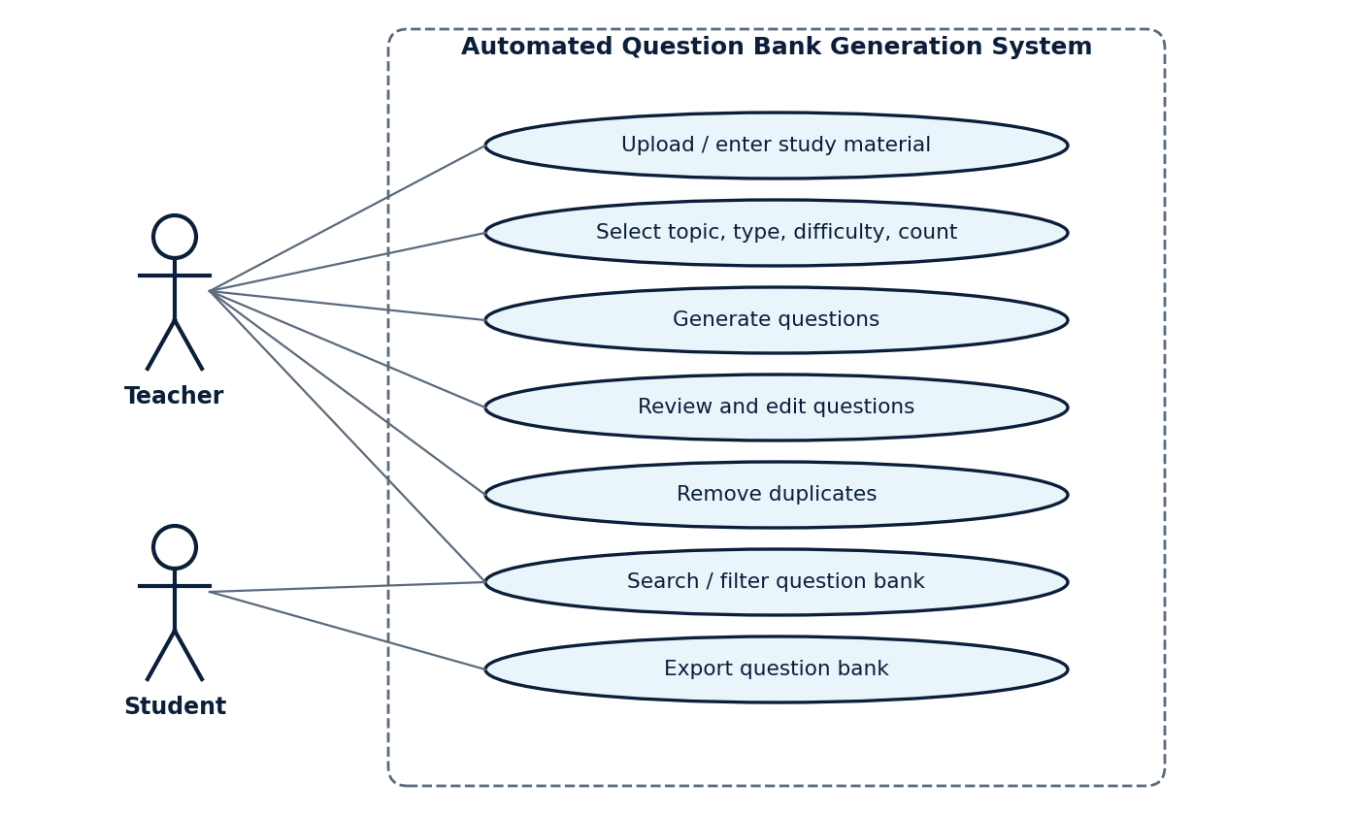
Figure 1: Use case diagram showing the actors and their use cases

Software and Hardware Requirements
Table 4: Software and hardware used for development and execution
Item | Description
Programming languages | Python for the NLP and ML pipeline; HTML, CSS and JavaScript for the user interface
NLP and ML libraries | Transformers, PyTorch or TensorFlow, NLTK or spaCy
Web framework | Flask, FastAPI or Streamlit
Database | MongoDB or MySQL
Development tools | VS Code, Jupyter Notebook, Git and GitHub
Operating system | Windows, macOS or Linux
Hardware | Laptop or desktop computer with a minimum of 8 GB RAM

Methodology

System Architecture
The system follows a modular pipeline architecture. Study material enters through the input module and passes through text preprocessing, key concept extraction, the question generation engine, classification and validation, and the accepted questions are stored in the question bank, which the teacher accesses through the user interface. Each stage reads the output of the previous stage and adds information to it. Figure 2 shows the complete architecture and Table 5 lists the technology used at each layer.
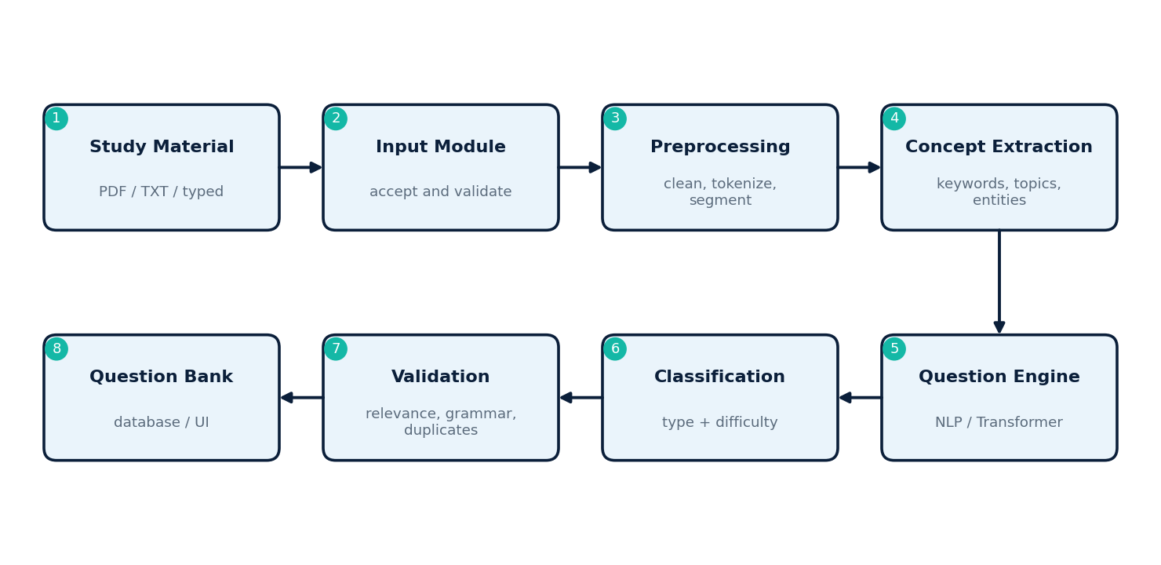
Figure 2: Overall architecture of the Automated Question Bank Generation system
Table 5: Technology stack used in the project
Layer | Technology | Purpose
Programming | Python, HTML, CSS, JavaScript | Pipeline logic and user interface
NLP | NLTK / spaCy | Tokenization, sentence segmentation, keyword and entity extraction
Deep learning | Transformers, PyTorch / TensorFlow | Question generation, classification and embeddings
Web layer | Flask / FastAPI / Streamlit | Upload, settings, review and export screens
Database | MongoDB / MySQL | Store materials, concepts, questions and similarity records
Development | VS Code, Jupyter Notebook, Git and GitHub | Coding, experimentation and version control

Three design principles guided the architecture. The first is that generation is always grounded in the study material: questions are produced from extracted concepts and source sentences rather than from free text. The second is that every generated question passes through validation before it reaches the bank. The third is that the teacher remains in control, so generated questions are suggestions that can be edited or rejected.

Layered Design and Module Description
Inside the project the responsibilities are divided into four layers, shown in Figure 3. The presentation layer contains the pages for upload, settings, review and export. The application layer contains the routes, request validation and the orchestration of a generation job. The NLP and ML layer contains preprocessing, concept extraction, the generation model, the classifier and the similarity checker. The data layer stores everything in the database. Table 6 describes each module of the system.
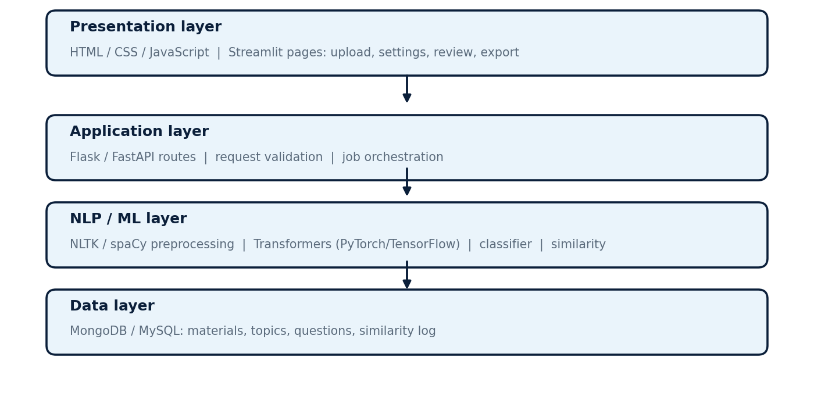
Figure 3: Layered design of the system
Table 6: Modules of the system
Module | Description
Input module | Accepts PDF, TXT or typed content and extracts plain text from it
Preprocessing module | Cleans the text, tokenizes it and segments it into sentences
Concept extraction module | Finds keywords, topics and named entities that represent the content
Question generation engine | Generates questions from concepts and source sentences using NLP and Transformer models
Classification module | Assigns the question type and the difficulty level
Validation module | Checks relevance and grammar and detects duplicate questions
Storage module | Saves accepted questions and their metadata in the database
User interface | Lets the teacher set options, review, edit, search and export questions

Input Collection and Text Preprocessing
The first step of the pipeline is input collection. The teacher uploads a PDF or TXT file or types content directly. For PDF files the text layer is extracted, and the system reports an error if the file contains no readable text. The raw text is then preprocessed. Cleaning removes page numbers, repeated headers, stray symbols and extra white space. Tokenization splits the text into words or sub-word units, and sentence segmentation divides it into sentences. Preprocessing matters because every later stage depends on it: poor input text, such as broken lines from a scanned page, is one of the main causes of poor questions. The stages are shown in Figure 4.
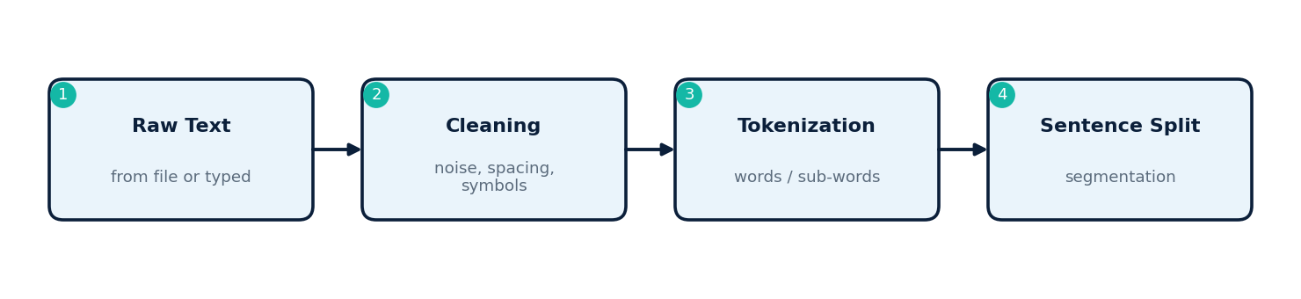
Figure 4: Stages of text preprocessing

Key Concept Extraction
After preprocessing, the system identifies the concepts that deserve a question. Keyword extraction ranks terms by how well they represent the passage, topic identification groups related sentences, and named entity recognition finds the names of people, places, organizations, dates and technical terms. The extracted concepts are linked back to the sentences they come from, so that each question can later be checked against its source. Basing generation on concepts rather than on randomly chosen sentences is the main way the system improves topic coverage, because the concept list can be inspected to confirm that every part of the material is represented.

Question Generation Engine
The question generation engine receives a concept together with its source sentence or short passage and produces a question. A Transformer-based sequence-to-sequence model is used to generate fluent questions for the three supported types. For short-answer and long-answer questions the model forms a What, Why, How or Explain question from the passage. For MCQs the model first forms the question stem from the passage and the correct answer, and then the distractors are chosen from other concepts of the same topic so that they look plausible without being correct. The teacher's settings, namely the topic, the type, the difficulty and the number of questions, decide which concepts are used and how many questions are produced. Because a generative model can occasionally produce an incorrect question, every output is sent to the validation stage.

Question Classification
Each question is classified by type and difficulty. The type is known from how the question was generated, and it is confirmed from the question form, for example the presence of answer options for MCQs. Difficulty is predicted by a text classifier that uses features of the question and its source, such as the question word, the length and complexity of the sentence, the number of concepts involved, and whether the answer is stated directly or must be explained. Questions that ask for a definition or a fact are usually Easy, questions that ask about a relationship or a role are usually Medium, and questions that ask for an explanation or a process are usually Hard. Figure 5 shows the classification step and Table 7 summarizes the guidelines used.
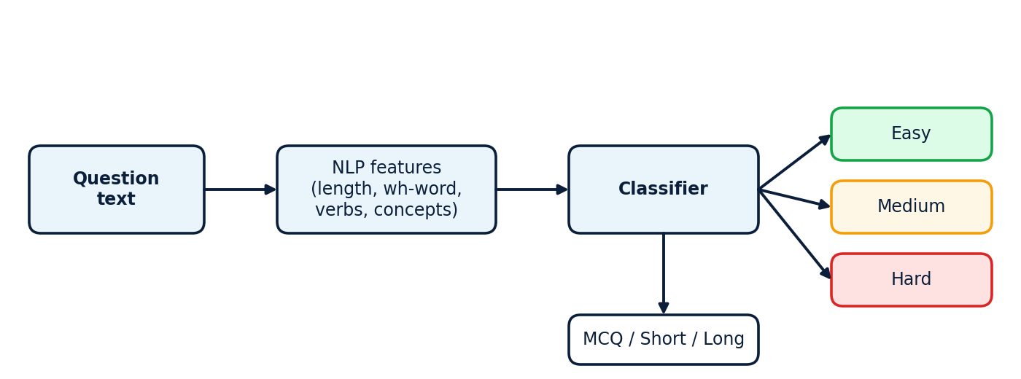
Figure 5: Classification of a question by difficulty and type
Table 7: Guidelines used to assign difficulty levels
Level | Typical question form | Typical expectation from the learner
Easy | What is ...? Define ... | Recall a definition or a stated fact
Medium | What role does ... play in ...? How are ... and ... related? | Understand a relationship or a role
Hard | Explain how ... Why does ... lead to ...? | Explain a process or reason across several ideas

Quality Validation
Validation protects the bank from weak questions and has three parts. Relevance checking verifies that the question can be linked to its source concept and sentence, for example by comparing the question and the source with a semantic similarity score. Grammar and quality checking rejects questions that are incomplete, ungrammatical or too short to be meaningful. Duplicate detection compares the new question with the questions already in the bank. Each question is converted into an embedding vector, and if the cosine similarity with an existing question is above a threshold, the new question is treated as a duplicate and removed. The decision flow is shown in Figure 6. Questions that pass all checks are accepted, and borderline questions can be flagged so that the teacher decides.
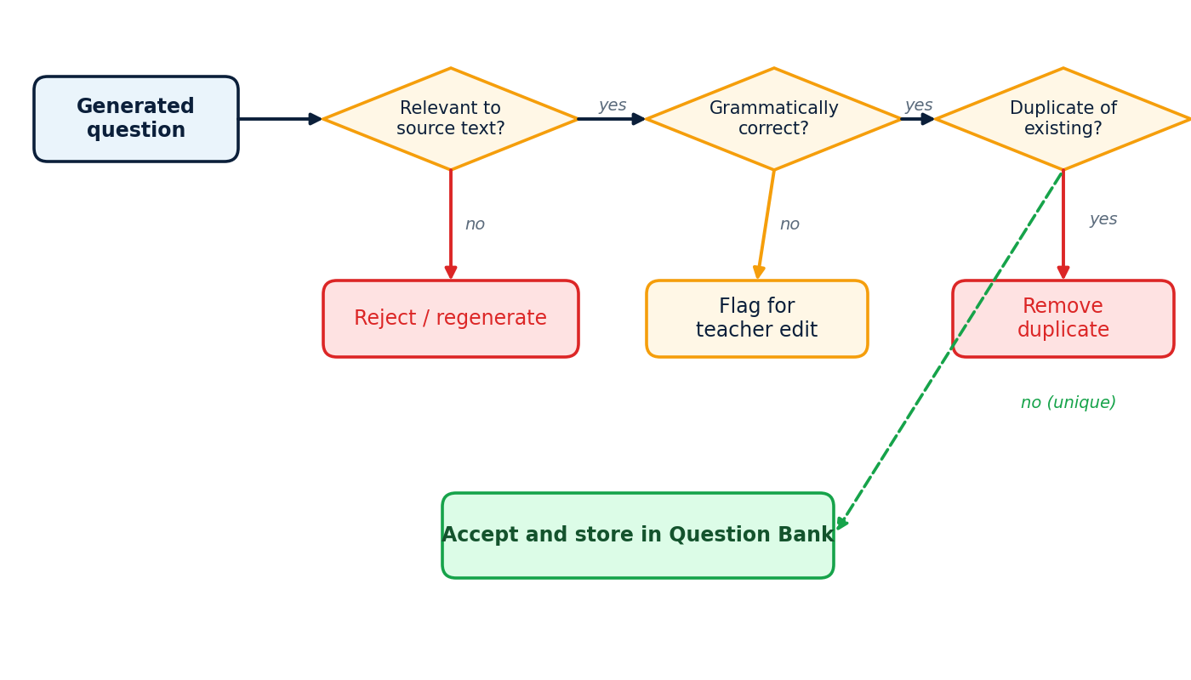
Figure 6: Validation flow for a generated question

Algorithms and Techniques
The system combines techniques from NLP, machine learning and similarity analysis. They are summarized in Table 8. The features produced by NLP are passed to a Transformer model for generation, to a classifier for type and difficulty, and to similarity and quality checks, and the output is the set of validated questions.
Table 8: Algorithms and techniques used in the system
Area | Technique | Use in the system
NLP | Tokenization, sentence segmentation, keyword extraction, text preprocessing | Prepare text and find concepts
Machine / deep learning | Transformer-based language models | Generate questions from concepts and passages
Machine / deep learning | Text classification | Assign difficulty and confirm question type
Machine / deep learning | Semantic similarity with embeddings | Compare questions and sources
Question validation | Similarity-based duplicate detection | Remove repeated questions
Question validation | Relevance checking | Keep questions tied to the source text
Question validation | Grammar and quality validation | Reject malformed questions

Database Design and Storage
Accepted questions are stored in a database so that they can be searched, filtered, edited and reused. The design needs only a few entities, shown in Figure 7: users, the materials they upload, the topics extracted from each material, the questions generated for each material and topic, and a similarity log that records which existing question a rejected question matched. Either a document database such as MongoDB or a relational database such as MySQL can hold this data, and Table 9 describes the collections or tables. Each question keeps its type, difficulty, answer and review status, and a link to its source material and topic, which makes it possible to measure coverage by topic.
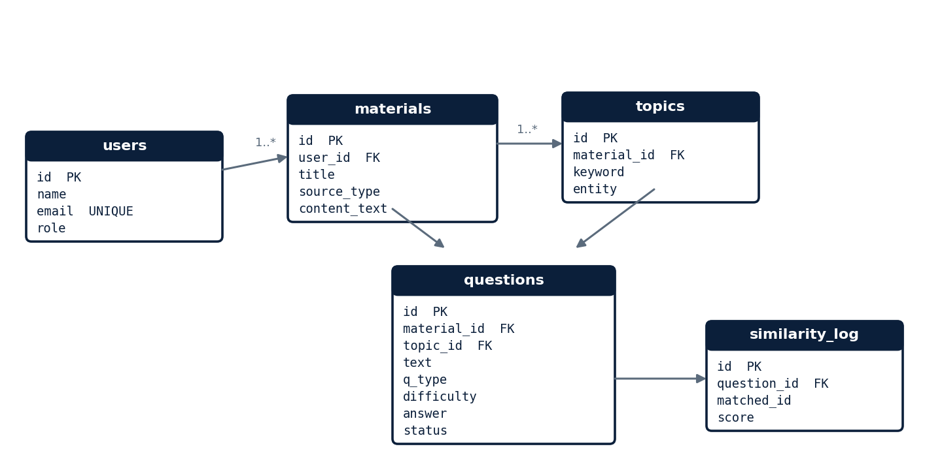
Figure 7: Entity relationship diagram of the question bank database
Table 9: Collections or tables of the database
Name | Purpose
users | Teachers and students who use the system
materials | Uploaded or typed study material with its extracted text
topics | Keywords, topics and entities extracted from each material
questions | Generated questions with type, difficulty, answer and review status
similarity_log | Record of detected duplicates and their similarity scores

Working Process with an Example
The complete working process follows eight steps: upload the study material, extract the text, preprocess the content, identify concepts, generate questions, classify the difficulty, remove duplicates and display the question bank, as shown in Figure 8. A short illustrative example shows the idea. Suppose the input concept is the statement that photosynthesis is the process by which green plants convert light energy into chemical energy. The system can produce the questions listed in Table 10, one for each difficulty level.
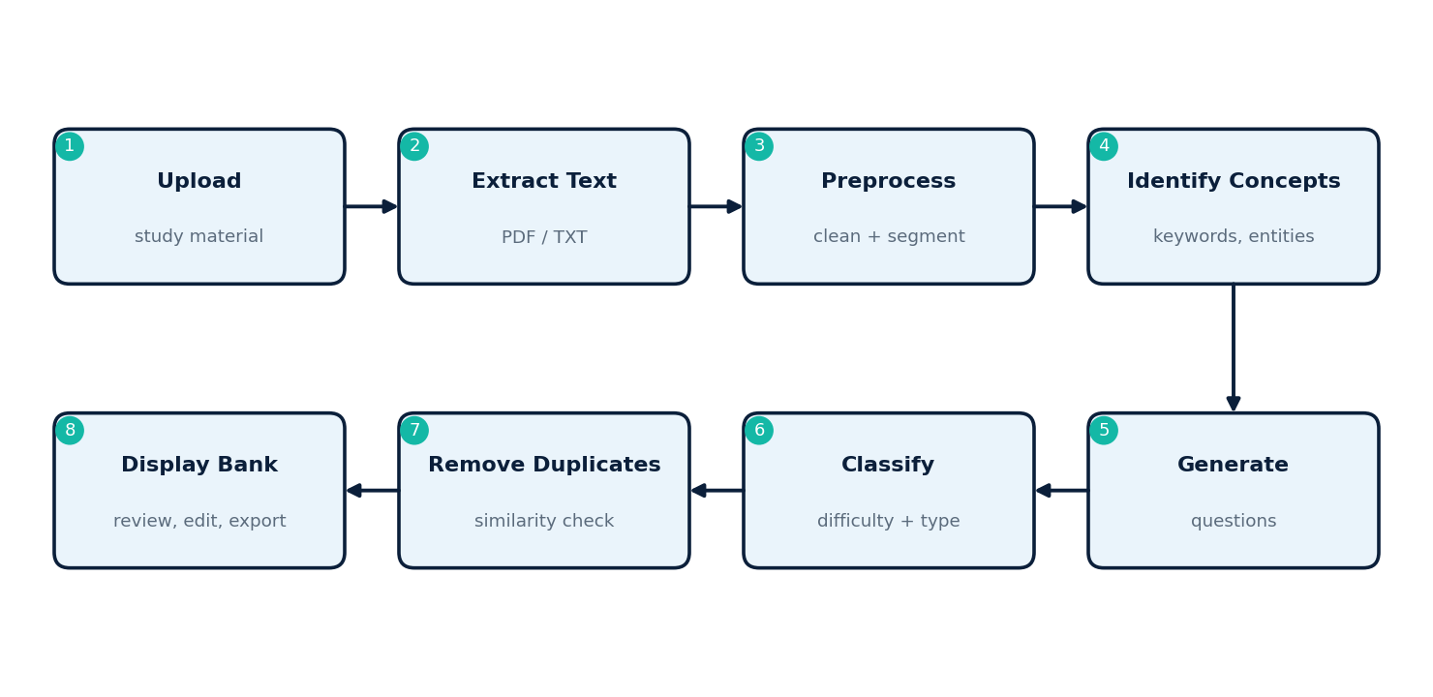
Figure 8: Working process from study material to question bank
Table 10: Illustrative questions generated from one concept
Level | Generated question | Reason for the level
Easy | What is photosynthesis? | Asks for a definition stated in the text
Medium | What role does sunlight play in photosynthesis? | Asks for the role of one element in the process
Hard | Explain how photosynthesis converts light energy into chemical energy. | Asks for an explanation of the whole process

Data Flow and Detailed Design

Context-Level Data Flow
The context-level data flow diagram in Figure 9 shows the system as one process with its external entities. The Teacher gives study material and generation settings and receives generated questions for review. The question bank database receives validated questions and returns stored questions for searching and duplicate comparison. The Student receives practice questions drawn from the bank.
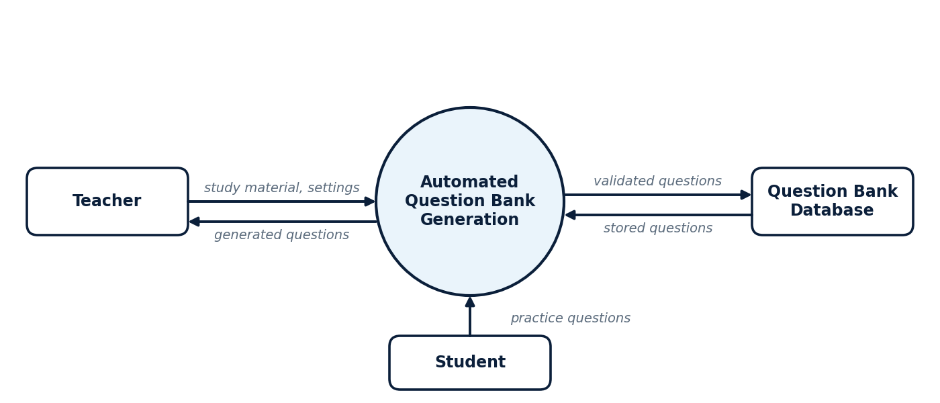
Figure 9: Context-level data flow diagram

Level-1 Data Flow
Figure 10 expands the system into six processes, which are described in Table 11. Data flows from input and extraction through preprocessing, concept extraction, question generation and classification to validation, and the validated questions are written to the question bank data store. A second data store holds the concept and similarity index used by extraction and validation.
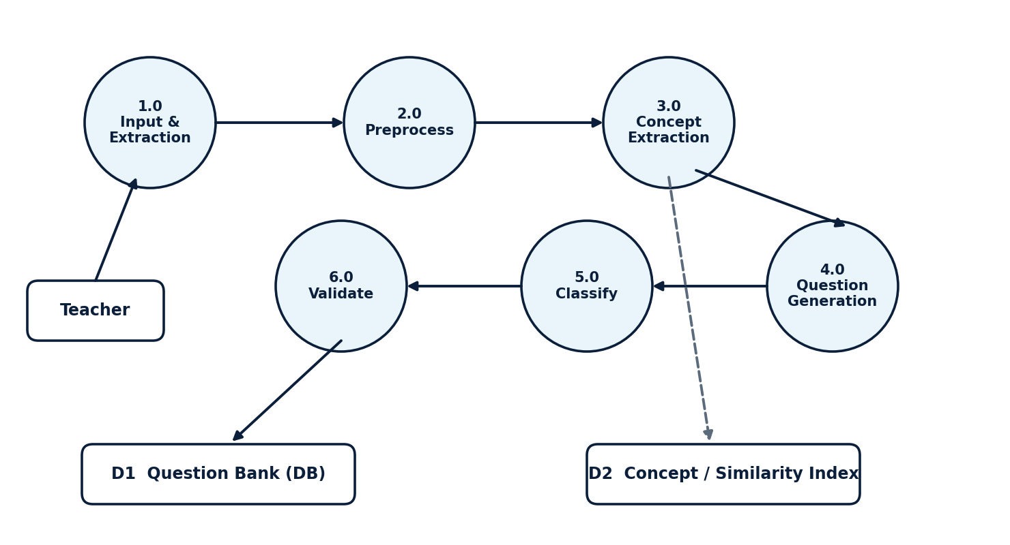
Figure 10: Level-1 data flow diagram
Table 11: Processes of the level-1 data flow diagram
No. | Process | Input | Output
1.0 | Input and extraction | PDF, TXT or typed content | Raw text
2.0 | Preprocessing | Raw text | Cleaned, tokenized sentences
3.0 | Concept extraction | Sentences | Keywords, topics and entities
4.0 | Question generation | Concepts and source passages | Candidate questions
5.0 | Classification | Candidate questions | Questions with type and difficulty
6.0 | Validation | Classified questions and existing bank | Validated questions stored in the bank

Generation Request Sequence
Figure 11 shows what happens when the teacher submits a generation request. The user interface sends the settings and the material to the backend. The backend calls the NLP pipeline, which preprocesses the text, extracts concepts, generates and classifies candidate questions and returns them. The backend then checks duplicates against the database, saves the accepted questions and returns them to the interface, where the teacher reviews them.
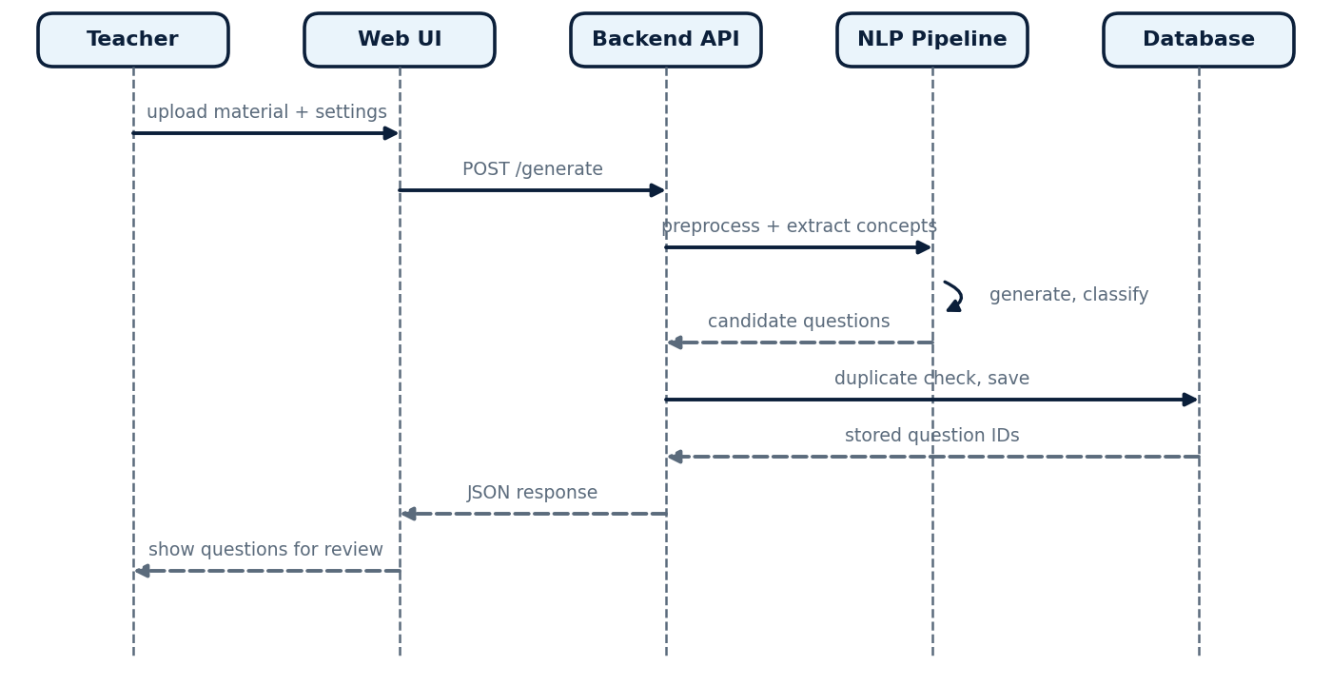
Figure 11: Sequence of a question generation request

Validation Rules
Table 12: Main validation rules
Stage | Rule | Action on failure
Input | File must be PDF or TXT, or typed text must not be empty | Show an error message
Input | Extracted text must contain enough readable content | Ask the teacher for better material
Generation | Number of questions must be a positive number within the allowed limit | Reject the request
Relevance | Question must be linked to a source concept and passage | Reject or regenerate the question
Grammar | Question must be complete and well formed | Reject or flag for editing
Duplicate | Similarity with an existing question must be below the threshold | Remove the duplicate and log the match
MCQ | Exactly one correct option and the other options distinct from it | Regenerate the options

Error Handling Strategy
Errors can occur at several points: an unreadable file, an empty extraction result, a model that fails or times out, or a database connection problem. The system handles each of them at the stage where it occurs and returns a clear message to the teacher. A generation job is processed in steps, and only questions that pass validation are written to the database, so a failure in the middle of a job never leaves half-processed or unvalidated questions in the bank. If the model fails, the job can be repeated without affecting the questions already stored.

Implementation

Development Environment and Tools
Table 13: Tools used during development
Tool | Use
Python | Main language of the pipeline
Jupyter Notebook | Experiments with preprocessing, generation and similarity
VS Code | Writing and organizing the project code
NLTK / spaCy | Tokenization, sentence segmentation and keyword or entity extraction
Transformers with PyTorch / TensorFlow | Question generation, classification and embeddings
Flask / FastAPI / Streamlit | Backend routes and user interface
MongoDB / MySQL | Question bank storage
Git and GitHub | Version control and teamwork

Input and Preprocessing Module
The input module reads the uploaded file and returns plain text. The preprocessing module then cleans the text and segments it into sentences. Listing 1 shows representative Python code for this stage; the names and details in the actual project may differ slightly.
import re
import nltk
nltk.download("punkt", quiet=True)

def clean_text(raw: str) -> str:
text = re.sub(r"\s+", " ", raw) # collapse white space
text = re.sub(r"Page \d+", "", text) # remove page markers
return text.strip()

def split_sentences(text: str) -> list[str]:
sentences = nltk.sent_tokenize(text)
return [s for s in sentences if len(s.split()) >= 5]
Listing 1: Representative code for text cleaning and sentence segmentation

Concept Extraction and Question Generation Module
The concept extraction module ranks keywords and selects the sentences that contain them. The generation module sends each selected sentence and its key term to the Transformer model and collects the candidate questions. Listing 2 shows a representative generation step using the Hugging Face Transformers library [6]. In practice a model fine-tuned for question generation is used, and the model name below is only a placeholder.
from transformers import pipeline

qg = pipeline("text2text-generation", model="<question-generation-model>")

def generate_question(passage: str, key_term: str, qtype: str) -> str:
prompt = f"generate {qtype} question: {key_term} context: {passage}"
out = qg(prompt, max_new_tokens=48, num_beams=4)
return out[0]["generated_text"].strip()
Listing 2: Representative code for question generation with a Transformer model

Classification Module
The classification module receives each candidate question and predicts its difficulty. Features such as the question word, the length of the question, the number of concepts and the length of the source passage are given to a text classifier. The module returns Easy, Medium or Hard together with the question type. The result is stored with the question so that the teacher can filter the bank by difficulty.

Validation and Duplicate Detection Module
The validation module removes questions that repeat each other. Listing 3 shows a representative duplicate check that compares sentence embeddings with cosine similarity, using a Sentence-BERT style model [9]. A new question is accepted only if its similarity with every stored question is below the threshold.
from sentence_transformers import SentenceTransformer, util

model = SentenceTransformer("all-MiniLM-L6-v2")

def is_duplicate(new_q: str, bank: list[str], threshold: float = 0.85) -> bool:
if not bank:
return False
emb_new = model.encode(new_q, convert_to_tensor=True)
emb_bank = model.encode(bank, convert_to_tensor=True)
score = util.cos_sim(emb_new, emb_bank).max().item()
return score >= threshold
Listing 3: Representative code for similarity-based duplicate detection

Teacher Interface
The user interface is organized around the teacher's workflow. The upload page accepts a file or typed content. The settings page lets the teacher choose the topic, the question type, the difficulty and the number of questions. The review page lists the generated questions with their type and difficulty and lets the teacher edit, delete or accept each one. The bank page supports searching and filtering by topic, type and difficulty, and the export option produces the final question bank for use in assessments.

Project Structure
Table 14: Main parts of the project structure
Folder / file | Content
app/ | Web application, routes and user interface pages
pipeline/preprocess.py | Cleaning, tokenization and sentence segmentation
pipeline/concepts.py | Keyword, topic and entity extraction
pipeline/generate.py | Question generation with the Transformer model
pipeline/classify.py | Type and difficulty classification
pipeline/validate.py | Relevance, grammar and duplicate checks
db/ | Database connection and storage functions
notebooks/ | Jupyter notebooks used for experiments

Experiments

Experimental Setup
The system was developed and run on a laptop with at least 8 GB of RAM, using Python, the Transformers library with PyTorch or TensorFlow, NLTK or spaCy, and a web framework for the interface. The experiments use short passages of educational text on subjects such as science and computing, supplied as typed content and as TXT and PDF files. The goal of the experiments is to check that each stage of the pipeline behaves as designed and that the complete system turns study material into a validated, categorized question bank.

Test Strategy
Table 15: Levels of testing applied to the system
Level | What is checked
Module testing | Each stage is run alone on sample text: extraction, preprocessing, concept extraction, generation, classification and validation
Integration testing | The full pipeline is run from input to stored questions and the hand-over between stages is checked
Input testing | PDF, TXT and typed input, empty files and unreadable files
Validation testing | Duplicate, irrelevant and malformed questions are given to the validation stage
Review testing | Editing, deleting, searching, filtering and exporting questions in the interface

Functional Test Cases
The main test scenarios and the behaviour expected from the system are listed in Table 16. Each scenario was designed to exercise one requirement of the system.
Table 16: Test scenarios and expected system behaviour
ID | Scenario | Expected behaviour
T1 | Upload a TXT file with a clear passage | Text is extracted and sentences are segmented
T2 | Upload a PDF with a readable text layer | Text is extracted and cleaned
T3 | Upload an empty or unreadable file | A clear error message is shown and nothing is stored
T4 | Request questions for a selected topic | Questions are generated from concepts of that topic
T5 | Request MCQ, short-answer and long-answer questions | Each type is produced in the right form, with options for MCQs
T6 | Request Easy, Medium and Hard questions | Questions carry the requested difficulty label
T7 | Generate two almost identical questions | The similar question is detected and removed
T8 | Generate a question that cannot be linked to the source | The question is rejected or flagged
T9 | Edit and delete a generated question | The change is saved and shown in the bank
T10 | Search and filter by topic, type and difficulty | Only matching questions are listed
T11 | Export the question bank | The exported file contains the accepted questions

Requirements Traceability
Table 17: Traceability between requirements and test scenarios
Requirement | Description | Test scenario
FR1, FR2 | Input collection and text extraction | T1, T2, T3
FR3, FR4 | Preprocessing and concept extraction | T1, T4
FR5, FR6, FR8 | Generation, question types, settings | T4, T5
FR7 | Difficulty classification | T6
FR9, FR10 | Duplicate detection and quality validation | T7, T8
FR11, FR12 | Storage, review and edit | T9
FR13, FR14 | Search, filter and export | T10, T11

Limitations of the Testing
The tests use a limited set of sample materials and the judgement of the team members to decide whether a question is relevant and correctly labelled. Question quality and difficulty are partly subjective, so the results should be seen as evidence that the pipeline works as designed rather than as a final measurement of accuracy. A larger evaluation with materials from many subjects and with ratings from several teachers would give a more reliable picture, and it is listed under future work.

Results

Performance Observations
The observations from running the system on the sample material are summarized below.
- The system successfully generates questions automatically from the provided study material.
- Questions can be generated in different formats, namely MCQs, short-answer questions and long-answer questions.
- Generated questions can be categorized into Easy, Medium and Hard difficulty levels.
- The system identifies important concepts in the input content and uses them to create relevant questions.
- Duplicate or highly similar questions can be detected and removed using text-similarity techniques.
- The automated approach significantly reduces the time and manual effort needed to prepare a question bank.
- The generated questions can be reviewed, edited and organized before they are used for assessments.
The end-to-end flow behind these observations is the pipeline of input material, concept extraction, question generation, classification, validation and the final question bank, which was shown in Figure 2.

Comparison with Manual Preparation
Table 18: Automated generation compared with manual question-bank preparation
Aspect | Manual preparation | Automated generation
Time and effort | High, every question is written by hand | Much lower, questions are generated and only reviewed
Question volume | Limited by the teacher's time | Large banks can be produced from the same material
Question types | Depends on the author | MCQ, short and long answer supported
Difficulty labels | Personal judgement | Classifier-based labels, adjustable by the teacher
Repetition | Common when many authors contribute | Detected by similarity checks
Topic coverage | Uneven | Based on concepts extracted from the whole material
Quality control | Author review | Automatic validation plus teacher review

Advantages and Applications
The main advantages of the system are that it saves time, reduces manual effort, generates large question banks, supports several question types, provides difficulty classification, reduces repetition and improves topic coverage. These advantages make it useful in schools, colleges, universities and coaching institutes, and in digital settings such as e-learning platforms, online quiz systems and Learning Management Systems.

Challenges and Solutions
Table 19: Design challenges and the approach used
Challenge | Approach
Poor-quality input text | Cleaning and sentence filtering in preprocessing; error message for unreadable files
Repetitive questions | Embedding-based similarity check against the existing bank
Contextually incorrect questions | Relevance check against the source passage and teacher review
Difficulty classification | Feature-based classifier with teacher-adjustable labels
Computational requirements | Modular pipeline, small pre-trained models and a laptop-friendly setup

Discussion
The results show that the pipeline design addresses the problem stated at the beginning of the report. Basing generation on extracted concepts supports topic coverage, the classifier provides a consistent starting point for difficulty labels, and the validation stage removes repeated and weak questions. The teacher review step is important because it keeps human judgement in the process and catches the occasional contextually incorrect question. The main limitation is that the quality of the output depends on the quality of the input and on the generation model, so the system is best seen as a tool that does most of the routine work and leaves the final decision to the teacher.

Conclusion and Future Work

Conclusion
The proposed system uses NLP and AI techniques to automate question-bank creation, reduce manual effort, support different question types and difficulty levels, and provide a scalable solution for educational assessment. Study material in PDF, TXT or typed form is converted into a validated and categorized question bank through preprocessing, concept extraction, Transformer-based generation, classification and validation, and the teacher can review, edit, organize and export the result. By combining generation with duplicate detection and quality checks, the system addresses the three problems of manual preparation, namely the time required, the repetition of questions and the uneven coverage of topics.

Key Learning Outcomes
- Understanding how NLP preprocessing and concept extraction prepare text for question generation.
- Applying Transformer-based models to a practical educational problem.
- Using embeddings and cosine similarity for duplicate detection and relevance checking.
- Designing a modular pipeline with clear stages and a human review step.
- Designing a simple database and user interface around a real workflow.

Future Enhancements
- Multilingual question generation for study material in several languages.
- Integration of large language models with retrieval to improve variety and accuracy.
- Adaptive question generation that adjusts to the learner's performance.
- Classification of questions using Bloom's Taxonomy levels.
- Automatic answer generation, including model answers and MCQ explanations.
- Image and diagram-based questions.
- Personalized question banks for individual learners.
- Automatic question-paper generation from the bank.

References
- A. Vaswani, N. Shazeer, N. Parmar, J. Uszkoreit, L. Jones, A. N. Gomez, L. Kaiser and I. Polosukhin, "Attention Is All You Need," in Advances in Neural Information Processing Systems (NeurIPS), 2017.
- J. Devlin, M.-W. Chang, K. Lee and K. Toutanova, "BERT: Pre-training of Deep Bidirectional Transformers for Language Understanding," in Proc. NAACL-HLT, 2019.
- P. Lewis et al., "Retrieval-Augmented Generation for Knowledge-Intensive NLP Tasks," in Advances in Neural Information Processing Systems (NeurIPS), 2020.
- D. Jurafsky and J. H. Martin, Speech and Language Processing, 3rd ed. (draft). Available: https://web.stanford.edu/~jurafsky/slp3/
- S. Bird, E. Klein and E. Loper, Natural Language Processing with Python. O'Reilly Media, 2009.
- Hugging Face, "Transformers Documentation." [Online]. Available: https://huggingface.co/docs/transformers
- PyTorch, "PyTorch Documentation." [Online]. Available: https://pytorch.org/docs/
- NLTK Project, "NLTK Documentation." [Online]. Available: https://www.nltk.org/
- N. Reimers and I. Gurevych, "Sentence-BERT: Sentence Embeddings using Siamese BERT-Networks," in Proc. EMNLP-IJCNLP, 2019.

Appendix A: Glossary of Terms
Table 20: Glossary of terms used in this report
Term | Meaning
NLP | Natural Language Processing: techniques that let computers process human language
Tokenization | Splitting text into words or sub-word units
Sentence segmentation | Dividing text into individual sentences
Named entity | A name of a person, place, organization, date or technical term found in text
Transformer | A neural network architecture based on self-attention, used for language tasks
BERT | A pre-trained Transformer language model that can be fine-tuned for many tasks
Embedding | A numerical vector that represents the meaning of a word, sentence or question
Cosine similarity | A measure of how similar two embedding vectors are
MCQ | Multiple-choice question with one correct option and several distractors
Distractor | An incorrect but plausible option in an MCQ
RAG | Retrieval-Augmented Generation: generating text from retrieved source passages
LLM | Large language model
Bloom's Taxonomy | A classification of learning objectives from remembering to creating
Question bank | A stored collection of categorized questions that can be reused for assessments

Appendix B: Using the System
A typical session with the system follows the steps below.
- Open the application in a web browser and go to the upload page.
- Upload a PDF or TXT file, or type or paste the study material.
- Open the settings page and choose the topic, question type (MCQ, short answer or long answer), difficulty level and the number of questions.
- Start generation and wait while the system preprocesses the text, extracts concepts, generates and classifies questions and removes duplicates.
- Open the review page, then edit, delete or accept each generated question.
- Use the bank page to search and filter by topic, type and difficulty.
- Export the final question bank for use in a test, quiz or learning management system.

