**Night Vision cameras - Technology details and applications**

|  |  |
| --- | --- |
| Sheetal Mani | Nirakh Satsangi |
| Faculty of Engineering | Faculty of Engineering |
| Dayalbagh Educational Institute | Dayalbagh Educational Institute |
| Dayalbagh, Agra | Dayalbagh, Agra |

**1.** **ABSTRACT**

Image Processing refers Capturing and manipulating images to enhance or extract information. Image processing is a form of signal processing for which the input is an image, such as a photograph or frame. The output of image processing may be either an image or, a set of characteristics or parameters related to the image. This paper is about Night vision Technology, by definition, literally allows one to see in the dark, originally developed for military use. Night vision can work in two very different ways, depending on the technology used. Image enhancement–This works by using the lower portion of the infrared light spectrum. Thermal imaging - This technology operates by using the upper portion of the infrared light spectrum.

**Keywords**

Night vision Technology, Image enhancement, Image intensifier tube, Thermal imaging (Un-cooled, cryogenically cooled), near infrared, Mid-infrared, Thermal infrared.

Near-infrared (near-IR) - Closest to visible light, near-IR has wavelengths that range from 0.7 to 1.3 microns, or 700billionths to 1,300 billionths of a meter.

Mid-infrared (mid-IR) - Mid-IR has wavelengths ranging from1.3 to 3 microns. Both near-IR and mid-IR are used by a variety of electronic devices, including remote controls.

Thermal-infrared (thermal-IR) - Occupying the largest part of the infrared spectrum, thermal-IR has wavelengths ranging from 3 microns to over 30 microns.

The key difference between thermal-IR and the other two is that thermal-R is emitted by an object instead of reflected off it. Infrared light is emitted by an object because of what is happening at the atomic level.

**2. INTRODUCTION**

Night Vision technology:

Night vision technology was developed by the US defense department mainly for defense purposes, but with the development of technology night vision devices are being used in day to day lives. Night Vision can work in two different ways depending on the technology used.

1. Image enhancement- This works by collecting the tiny amounts of light including the lower portion of the infrared light spectrum, those are present but may be imperceptible tour eyes and amplifying it to the point that we can easily observe the image.
2. Thermal imaging- This technology operates by capturing the upper portion of the infrared light spectrum, which is emitted as heat by objects instead of simply reflected as light. Hotter objects, such as warm bodies, emit more of this light than cooler objects like trees or buildings.

To understand night vision, it is important to understand something about light. The amount of energy in alight wave is related to its wavelength. Shorter wavelengths have higher energy. Of visible light, violet has the most energy, and red has the least. Just Next to the visible light spectrums the infrared spectrum. Infrared light can be split into three categories:

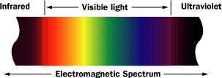

**3.** **Thermal Imaging and Image Enhancement:**

Here's how thermal imaging works:

A special lens focuses the infrared light emitted by all the objects in view.

The focused light is scanned by phased array of infrared-detector elements. The detector elements create a very detailed temperature pattern called a thermogram. It only takes about one-thirtieth of a second for the detector array to obtain the temperature information to make the thermogram. This information is obtained from several thousand points in the field of view of the detector array.

The thermogram created by the detector elements is translated into electric impulses.

The impulses are sent to a signal-processing unit, a circuit board with a dedicated chip that translates the information from the elements into data for the display.

The signal-processing unit sends the information to the display, where it appears as various colors depending on the intensity of the infrared emission. The combination of all the impulses from all the elements creates the image.

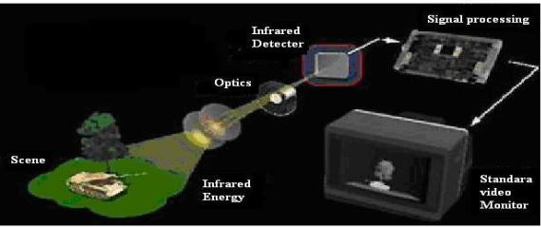

**Fig 1**

There are two common types of thermal-imaging devices:

Un-cooled - This is the most common type of thermal-imaging device. The infrared-detector elements are contained in a unit that operates at room temperature. This type of system is completely quiet, activates immediately and has the battery built right in.

Cryogenically cooled - More expensive and more susceptible to damage from rugged use, these systems have the elements sealed inside a container that cools them to below 32F (zero C). The advantage of such a system is the incredible resolution nd sensitivity that results from cooling the elements. Cryogenically- cooled systems can "see" a difference as small as 0.2 F (0.1 C) from more than 1,000 ft (300 m) away, which is enough to tell if a person is holding a gun at that distance.

**4.** **Image Enhancement:**

Image-enhancement technology is what most people think of when you talk about night vision. In fact, image-enhancement systems are normally called night-vision devices (NVDs). NVDs rely on a special tube, called an image-intensifier tube, to collect and amplify infrared and visible light.

Here’s how image enhancement works:

A conventional lens, called the objective lens, captures ambient light and some near-infrared light.

The gathered light is sent to the image-intensifier tube. In most NVDs, the power supply for the image testifier tube receives power from two N-Cell or two “A" batteries. The tube outputs a high voltage, about 5,000 volts, to the image-tube components.

The image-intensifier tube has a photocathode, which his used to convert the photons of light energy into electrons.

As the electrons pass through the tube, similar electrons are released from atoms in the tube, multiplying the original number of electrons by a factor of thousands using a micro channel plate (MCP) in the tube. An MCP is a tiny glass dis chat has millions of microscopic holes (micro channels) in it, made using fiber-optic technology. The MCP is contained in a vacuum and has metal electrodes on either side of the disc. Each channel is about 45 times longer than it is wide, and it works as an electron multiplier. When the electrons from the photo cathode hit the first electrode of the MCP, they are accelerated into the glass micro channels by the 5,000-V bursts being sent between the electrode pair. As electrons pass through the micro channels, they cause thousands of other electrons to be released in each channel using a process called cascaded secondary emission. Basically, the original electrons collide with the side of the channel, exciting atoms and causing other electrons to be released. These new electrons also collide with other atoms, creating a chain reaction that results in thousands of electrons leaving the channel where only a few entered. An interesting fact is that the micro channels in the MCP are created at a slight angle (about a5-degree to 8-degree bias) to encourage electron collisions and reduce both ion and direct-light feedback from the phosphors on the output side.

At the end of the image- intensifier tube, the electrons hit a screen coated with phosphors. These electrons maintain their position in relation to the channel they passed through, which provides a perfect image since the electrons stay in the same alignment as the original photons. The energy of the electrons causes the phosphors to reach an excited state and release photons. These phosphors create the green image on the screen that has come to characterize night vision.

**Fig 2**

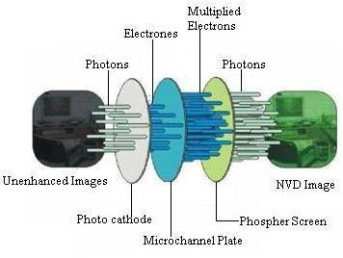

The green phosphor image is viewed through another lens, called the ocular lens, which allows you to magnify and focuses the image. The NVD may be connected to an electronic display, such as a monitor, or the image may be viewed directly through the ocular lens.

**5.** **Characteristics of Night Vision:**

Using intensified night vision is different from using regular binoculars and/or your own eyes. Below are some of the aspects of night vision that you should be aware of when you are using an image intensified night vision system.

Textures, Light and Dark:

Objects that appear light during the day but have a dull surface may appear darker, through the night vision unit, than objects that are dark during the day but have a highly reflective surface. For example, a shiny dark colored jacket may appear brighter than a light-colored jacket with a dull surface.

Depth Perception:

Night vision does not present normal depth perception. Fog and Rain:

Night vision is very responsive to reflective ambient light; therefore, the light reflecting off of fog or heavy rain causes much more light to go toward the night vision unit and may degrade its performance.

Honeycomb:

This is a faint hexagonal pattern which is the result of the manufacturing process.

Black Spots:

A few black spots throughout the image area are also inherent characteristics of all night vision technology. These spots will remain constant and should not increase in size or number.

**6.** **Night vision technology:**

Night vision devices (NVDs) are apparently simple systems built from three main blocks: optical objective, image intensifier tube, and optical ocular (Fig. 1). The task of the optical objective is to create low intensity, invisible image of the observed scenery at input plane of the image intensifier tube. The latter tube consisting of a photocathode, an anode in form of a phosphor screen, and other components, intensifies an input low−luminance image into a brighter image created on the anode (screen). The latter im− age is seen by human observer using the optical ocular. Design of NVDs is apparently easy because crucial modules like image intensifier tube, optical objectives, optical oculars (eyepieces) are available on the market from dozen or more sources. However, in spite of this

apparent design simplicity, the process of creating output image by these imaging systems is quite sophisticated. Many design rules must be well understood by manufacturers to deliver high performance NVDs. Every manufacturer of NVDs must carry out some kind of performance/cost optimization that requires deep knowledge of process of influence of dif− ferent modules on quality of final image and functionality of final night vision device.

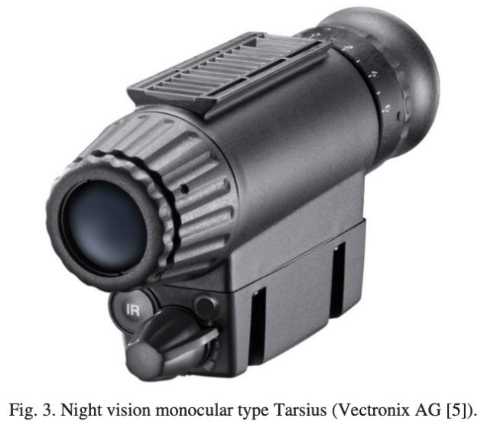

**7.** **Design configuration:**

There is no internationally accepted division of NVDs. The same types of NVDs can have different names in different literature sources. Here we will follow a division, and a terminology used at websites of two big manufacturers of NVDs and divide modern night vision devices into four basic types [2,3]: 1. Night vision goggles; 2. Night vision monocular; 3. Night vision sights; 4. Night vision binoculars.

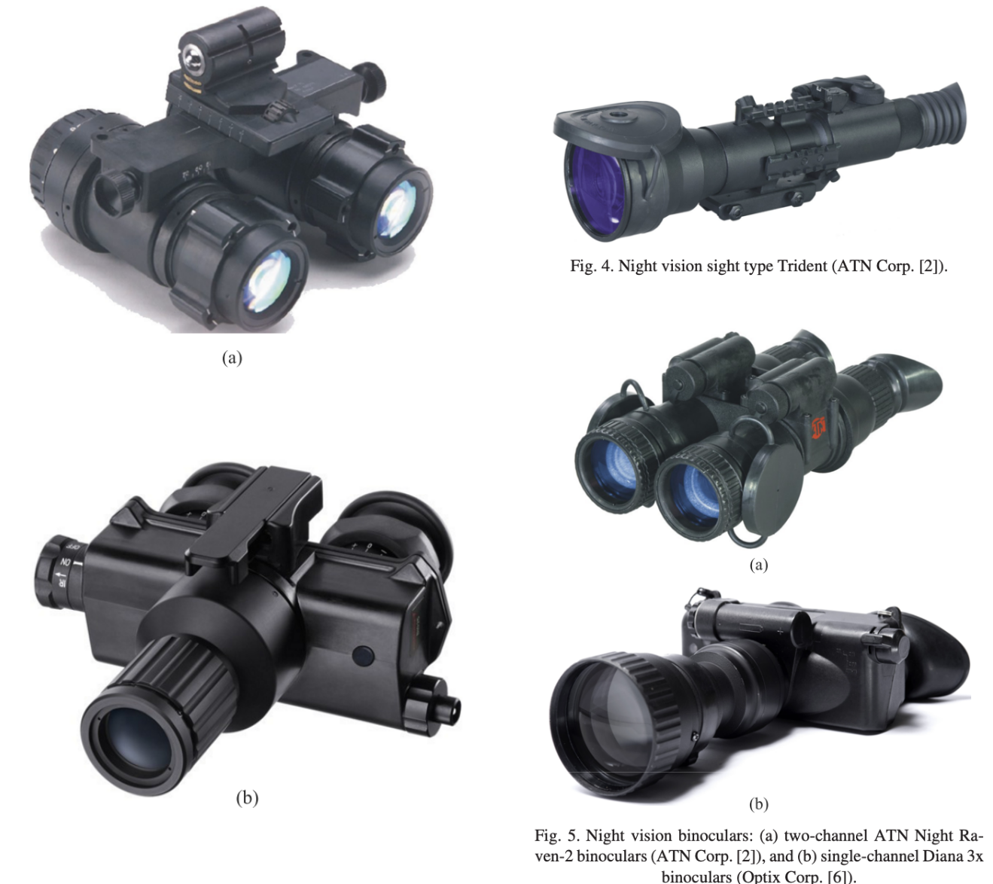

|  |  |  |
| --- | --- | --- |
| Fig. 2. Night vision goggles: (a) binocular night vision |  |  |
| goggles type AN/AVS–9 (ITT Night Vision [4]), and (b) | The first two groups of NVDs (goggles, monoculars) are basically |  |
| monocular night vision goggles type BIG 25 (Vectronix AG |  |
| [5]). | devices of a wide field of view (FOV) similar to human vision (FOV |  |
|  | about 40°, magnification equal to one). These NVDs can be treated as |  |
|  | human eyes of improved sensitivity. Binocular night vision goggles |  |
|  | enable observation using two eyes to achieve stereo vision |  |
|  | (three−dimensional (3D) vision). In other words, human using |  |
|  | binocular night vision goggles can achieve perception of depth from |  |
|  | two slightly different projections of the world onto the retinas of the |  |

two eyes. Binocular night vision goggles are typically used by pilots, drivers or other people who need a 3D−vision of sur− rounding scenery at night conditions. Monocular night vision goggles can be treated as a cheaper version of the earlier discussed binocular night vision goggles. Two costly image intensifier tubes are replaced by one tube. A comfortable two−eye observation is still possible. Some depth perception is still achieved even during a single−channel observation. In case of night vision monoculars the simplification process goes even further. The monoculars are practically one−channel binocular night vision goggles. Price is reduced by factor at least two in comparison to binocular night vision goggles. Additional advantage is small size and mass of these devices. The last two groups of NVDs (sights, binoculars) are basically devices of narrow field of view (FOV from about 4° to about 13°, magnification from about 3 to about 10). These devices can be treated as human eyes of improved sensitivity equipped with magnifying optical scope. Night vision sights (called also often night vision scopes) are generally monoculars of a narrow FOV that pro− vide magnification of an image perceived by a human operator by a factor from 3 to 10. These devices are typically attachable to weapons. Night vision binoculars are night vision goggles built by using bigger optical objectives of a longer focal length. The binoculars enable magnification of an image perceived by a human operator by a factor from 3 to 10 like typical day level binoculars. If built using two separate optical channels, then the binoculars offer also stereoscopic vision.

So far, we listed four different basic types of NVDs that look and work differently from final user point of view. However, night vision devices can be divided in different way considering their design. From the latter point of view differences between goggles and binoculars, and between monoculars and sights are small. The differences are caused only by one module: optical objective. Because of this minor technical difference, the borders between earlier discussed groups of NVDs are fluid. Night vision goggles can be easily converted to night vision binoculars if optical objectives are exchanged for bigger objectives of a longer focal length or some afocal adapters are added. Then, night vision monoculars can be converted into night vision sights by exchanging objective and by adding some mechanics that make possible to attach the monocular to weapons. There are many such NVDs on the market. Therefore, from designer point of view, NVDs are divided into three basic types (Fig. 6): 1. Bino−channel NVDs; 2. Mixed channel NVD; 3. Mono−channel NVD. Technical differences are significant between them, and it is not possible to convert easily one type of NVDs to another types of NVDs. The latter division is based on more logical ground and presents deeper differences than the earlier discussed commercial division. However, the first division is more popular and should be remembered if someone wants to understand terminology used by manufacturers of NVDs. So far NVDs have been divided using easily visually noticeable differences (number of objectives, number of oculars, size of objective, field of view). Now, let us discus more subtle, but also more important differences between different NVDs.

1. **Image intensifier tubes:**

Image intensifier tubes (IITs) are vacuum tubes that amplify a low light−level image to observable levels. The incoming light is converted into photoelectrons through a photocathode of the tube. Next, highly intensified photoelectrons strike the phosphor screen (anode) and a bright image is created that human can easily see. Image intensifier tubes are the most important component of night vision devices and typical classification of night vision devices is based on a tube classification. IITs are typically divided into several generations in dependence of the method to amplify incoming light (photocathode material, tube design structure) as the basic criterion. IITs can be also classified by using other criteria like type of input optics, type of output

optics, phosphor screen, photocathode size, or tube performance. Five parameters of IITs must be defined to enable precision discussion about division of these tubes: 1. Radiant sensitivity is a ratio of current induced into a photocathode (in mA units) of tested tubes by incoming light (in Watt units) for a specified wavelength. 2. Luminous sensitivity is a ratio of current induced into a photocathode (in μA units) of the tested tube by flux (in lumen units) of incoming polychromatic light of col− our temperature equal to 2856 K. 3. Luminance gain is a ratio of luminance of output image (tube screen) to luminance of input image (tube photo− cathode). Measurement is done using light source of colour temperature equal to 2856 K. Luminance gain can be presented in several ways: in cd/lx¨·m2 units (candela per lux times square meter), in lm/lm units (lumen per lumen), or in fL/fc (foot−lambert per foot candela). Image generated by a tube of low luminance gain looks darker than image generated by a tube of high luminance gain at the same input illuminance conditions. 4. Resolution is defined as a spatial frequency of a minimal 3−bar pattern of USAF 1951 target that can be resolved by an observer. Resolution is presented in lp/mm (line pairs per millimeter) units. Simulated images of USAF 1951 target of two tubes of different resolution at input illumination about 3 mlx generated using a Nightmet computer simulator program are shown in Fig. 7 [7]. Nowadays, resolution of typical IITs available on market is about 50–57 lp/mm; resolution of the best tubes can reach level of 81 lp/mm. 5. Signal to noise ratio (SNR) is a ratio of two components of a light signal emitted by a small part of a tube screen: average signal to root mean square signal (noise). The output signal is generated by illuminating a small part of photocathode (diameter

0.2 mm) at typical level of 108 μlx. Simulated images of USAF 1951 target of two tubes of different SNR at input illumination about 0.3 mlx obtained using Nightmet computer simulator program [7] are shown in Fig. 8. Nowadays, SNR of typical IITs available on market is about 18–22; SNR of the best tubes can reach level of 30.

**8.1 Generations of image intensifier tubes:**

First night vision devices were developed during the Second World War [1]. The technology of image intensifier tubes has progressed very significantly since that time. This progress can be described using different divisions but the most popular is division onto generations. US military has dictated the name of the generation of IITs over the last five decades. It should be however remembered that the division on generations is assumed in USA and presents US point of view on the night vision technology. There are so far four generations of image intensifier tubes: Gen 0, Gen 1, Gen 2, Gen 3 – at least according to the official US terminology. In general, generation numbering is related to significant changes in design of IITs that improve (with some exceptions) performance of these tubes. As we see in Fig. 9, different generations of IITs use different photocathodes. There is a big positive difference bet− ween S–1 photocathode used by Gen 0 tubes and S–10 photocathode used by Gen 1 tubes. The positive difference between S–25 photocathode used by Gen 2 tubes and S–10 photocathode used by Gen 1 tubes is not so obvious. How− ever, we must consider that critical parameter of photocathodes of IITs – luminous sensitivity – is measured using light sources of 2856K color temperature.

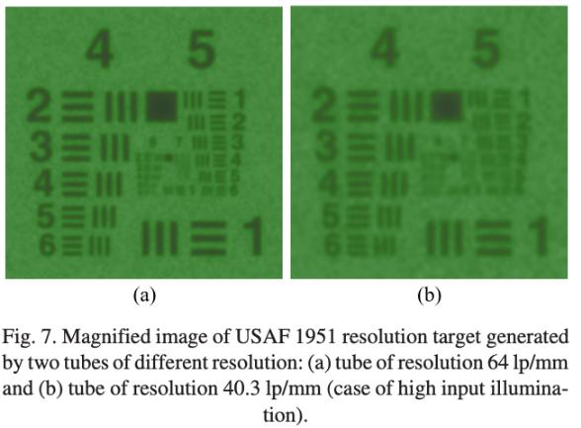

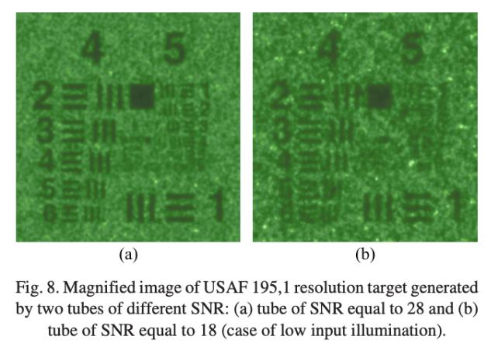

This measurement method (simulating to some degree real applications) strongly favors photocathodes more sensitive in near infrared range – in this case S–25 photocathode. Finally, GaAs photocathodes used in Gen 3 tubes are again clearly more sensitive than S–25 photocathodes used in tubes of previous generation. It should be noted that radiant sensitivity of photocathodes type S1, S20, S25 and GaAs can vary significantly. The graphs presented in Fig. 9 refer to tubes considered as typical based on practical experience of author.

**Generation 0** refers to the technology developed during World War II, employing fragile, vacuum−enveloped image converters with poor sensitivity and little gain. These were single stage tubes that achieved image intensification due to acceleration by high voltage of electrons emitted by the photocathode and striking the phosphor screen. S–1 (silver−oxygen−caesium) photocathode, electrostatic inversion and electron acceleration were typically used to increase brightness of input image. S–1 photocathode has two small peaks of its sensitivity: the first in ultraviolet (UV) and the second in near infrared (NIR) about 800 nm but is characterized by low sensitivity at visible band (Fig. 9). This situation fits badly for a task to amplify brightness of input image created by nocturnal light characterized by negligible amount of UV light and high amount of visible light. Therefore, luminous sensitivity of S–1 photocathodes was not higher than about 60 μA/lm (microampere per lumen). Further on, luminance gain was no more than about 150 lm/lm. Such a low luminance gain is not sufficient to create a bright image of scene of interest at typical night conditions. Therefore, Gen 0 tubes were in the past used in active night vision systems cooperating with an IR illuminator. High power tungsten bulbs covered with an IR filter suppressing visible radiation were used as illuminators. Active character of use of these first night vision devices was their significant disadvantage.

**Generation 1.** First Gen 1 tubes were in general im− proved Gen 0 tubes. Initial experiments with new photo− cathode materials showed that S–11 photocathode (cesium− −antimony) is characterized by an extremely high quantum efficiency up to 20%) but only in a visible range. Therefore, only slight improvement of luminous sensitivity to the level of 80 μA/lm was achieved using this new type of photo− cathodes because the value of luminous sensitivity depends more on tube sensitivity in near infrared band than on sensitivity in visible band. The breakthrough came about 1956 with a discovery of S–20 photocathode (multialkali photocathode: sodium−potassium−antimony−cesium) that is sensitive in both visible and near infrared (Fig. 9). Significantly improved photocathode sensitivity (luminous sensitivity up to 200 μA/lm), and improved technique of electrostatic inversion and electron acceleration enabled to achieve luminance gain from about 400 lm/lm to about 800 lm/lm. Because of this quite high luminance gain some of Gen 1 NVDs were used as passive night vision systems, but majority of Gen 1 tubes was still used in active systems. The reason for using support of artificial infrared

illuminators is the fact that much higher luminance gain in the order over 30 000 times is nec− essary to achieve ability to see even at medium illuminated (overcast quoter moon) night conditions.

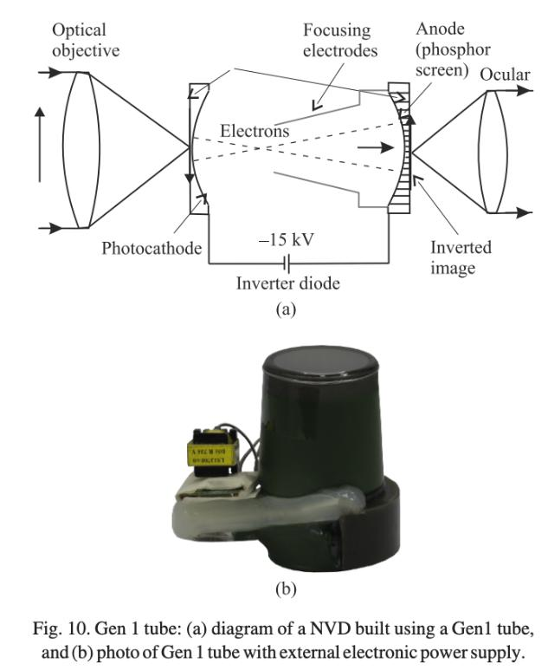

**Generation 2** image intensifier tubes represent a significant breakthrough in night vision technology. These are small, compact IITs that offered luminance gain at the level of about 30 000 lm/lm and the later even more. Such a significant increase of tube luminance gain, while making tube also smaller, was achieved due to four basic reasons. First, Gen 2 tubes use microchannel plate (MCP) to amplify electrons emitted from photocathode (Fig. 11). The MCP is a very thin plate of conductive glass containing mil− lions of small holes. An electron entering a channel strikes the wall and creates additional electrons, which in turn create more electrons (secondary electrons), again and again (Fig. 11). The microchannel plate is an array of miniature electron multipliers oriented parallel to one another and have length to diameter ratios between 40 and 100. Channel axes are typically normal to or biased at a small angle (8°) to the MCP input surface. The channel matrix is usually fabricated from a lead glass, treated in such a way as to optimize the secondary emission characteristic of each micro− channel and to render the channel walls semiconducting, so as to allow charge replenishment from an external voltage source. Parallel electrical contact to each channel is pro− vided by the deposition of a metallic coating on the front and rear surfaces of the MCP, which then serve as input and output electrodes, respectively. The total resistance between electrodes is in the order of

1. Such microchannel plates allow electron multiplication factors of 103–105 de− pending on channel length and number of layers. Spatial resolution is limited by channel dimensions and spacing; 12 μm diameter channels with 15 mm center−to−center spacings was typical for first and second generation tubes. Nowadays both dimensions and spacing can be about two times smaller. Second, Gen 2 tubes use new S–25 photocathode. This is actually the same multialkali photocathode as S–20 photocathode used in Gen 1 tubes but S–25 photocathode is built using thicker layers of the same materials. In this way extended red response and reduced blue response was achieved making sensitivity spectrum of S–25 photocathode well matched to spectrum of nocturnal light. Luminous sensitivity of the first S–25 photocathodes was about 250 μA/lm. It is a noticeable improvement in comparison to S–20 photocathode used in Gen 1 tubes but almost

negligible in comparison to revolution in luminance gain achieved by introduction of MCP plate.

**Generation 3** tubes are very similar to the Gen 2 tubes from design point of view. The primary difference is the material used for the photocathodes. The second-generation image intensifiers use photocathodes with a multialkali coating whereas the third generation image intensifiers uses photocatodes with a GaAs/GaAsP coating. The latter photocathodes are characterized by higher sensitivity and addition− ally the spectral sensitivity band is extended more in near infrared. Gen 3 Filmless tubes are characterized by excellent SNR (can be even over 30) and can produce clear image of scenery of interest even under very dark, moonless nights. Therefore, Gen 3 Filmless tubes are often used in night vision goggles for aviators or for special operation teams but are avoided in night vision sights due to their vulnerability to mechanical shock.

**9.** **Optics of NVDs:**

Image intensifier tube is rightly considered as the most important module of night vision devices. Because of this unquestionable importance of the tubes there is a tendency to decrease design complexity of optical modules of NVDs and influence of optical modules on overall performance of NVDs.

**Ocular:**

There are five main requirements on oculars for modern NVDs:

1. Large exit pupil. It is typically expected 14 mm pupil at 25 mm distance from input plane. 2. Wide field of view. It is typically required that the oculars should project high resolution image of the tube screen in wide field close to 40°. 3. Optimization for curvature of output optics of IITs. Majority of tubes used on modern NVDs use curved output optics and oculars must be optimized for such an input curvature to project a sharp image generated at screen of such tubes. 4. High resolution. The latter parameter of optical oculars should be significantly higher (typically two times better) than resolution of image intensifier tubes. In case of oculars for NVDs built using high−res tubes it is required that ocular resolution is higher than about 120 lp/mm. 5. High transmittance. In order to minimize light losses on oculars transmittance higher than about 0.95 is expected. The requirement is typically fulfilled by reducing number of lenses (replacement of spherical lenses by aspherical lenses) and improved antireflection coatings. 6. Low mass. The latter requirements are achieved by using thin glass lenses or by using ultra-light plastic lenses. Fulfilling all these requirements on oculars for NVDs at the same time is difficult and design of such oculars is typically a compromise between these requirements.

**Beam splitter:**

Beam splitter is used in monocular NVG to split and project image from screen of a single IIT into two optical channels optimized for two human eyes [(Fig. 6(b)]. Splitting image generated by IIT into two images automatically reduces perceived brightness gain of NVG by a factor of two. Practically, there are some additional losses due to limited transmittance of the beam splitter. Therefore, high transmittance of this optical module at a level over 90% is critical to assure acceptable brightness gain of such goggles. Next, beam splitter should be designed in a way that minimizes the vignetting of propagated optical beam. If the latter condition is not fulfilled the centre of FOV is significantly brighter than peripheral parts of image seen by human observer.

**Optical filter:**

Optical filter is an optional module used to modify spectral sensitivity of NVD in comparison to spectral sensitivity of IIT. Spectral sensitivity of majority of NVDs is the same as spectral sensitivity of IIT used in NVD. Such situation occurs because

most NVD are built by using optical modules of flat spectral transmittance in VIS/NIR range. Practically, it means that typical NVDs are sensitive in spectral band from about 400 nm to about 850 nm, if Gen 2 tube is used, or in spectral band from about 500 nm to about 900nm if Gen 3 tube is used. This wide spectral sensitivity band is not acceptable in two cases: 1. NVDs are to be used to help pilots to navigate helicopters/aircraft at night conditions; 2. NVDs are to be protected against common lasers. Reasons for modification of spectral sensitivity of aviator NVGs are explained in Sect. 7.2. Aviator NVG are typically equipped with a long bandpass filter that blocks light of wavelength below about 630 nm (Class A filters), below about 650 nm (Class B filters). Class C filters are more sophisticated as these filters are a combination of a long bandpass filter (blocking below about 680 nm) and a bandpass filter (partial transmission in band from about 530 nm to 570 nm). Protecting NVDs against lasers is needed to eliminate possibility that pilots, drivers, snipers or other people using NVDs are blinded using commonly available lasers; or even that NVDs are destroyed. Such a protection is achieved using special optical filters that are expected to attenuate incoming laser radiation. Precision requirements on such protecting filters in military NVDs are not known publicly. Such data are considered as a secret in USA and dissemination of any information related to this technology is prohibited [23]. However, it can be logically expected that these protecting filters are manufactured as a combination of an interference filter with a substrate of absorptance depending on power of incoming light. The interference filter should have several absorption peaks optimized for wavelengths of typical lasers in visible/NIR range. The substrate should offer broadband ab− sorption covering spectral band of NVD and attenuation of this substrate should be at least proportional to power of incoming light. Short temporal inertia at a level of several milliseconds is also a critical condition. It is possible that protecting filters in high−tech military NVDs are modified filters used for protecting eyes of welders. Protecting filters to be used in NVDs for civilian market are much simple. Here requirements are generally limited to attenuation of green and blue lasers. Practically, these are requirements for long pass filter blocking visible light with exception of red light. Such protecting filters are commercially available and can be easily added to typical NVGs [24]. However, practically such commercial−grade protecting filters offer very limited protection because NVD equipped with a such filter is still vulnerable to red lasers and lasers operating in NIR range.

**10. Technology trends:**

Forecasting technology trends in night vision technology is risky. However, based on analysis of data available from manufacturers of NVDs and manufacturers of IITs, seven separate development trends can be determined:

1. Digital NVDs
2. Enhanced (dual sensor) NVDs
3. Active NVDs.
4. Ultra-sensitive NVDs.
5. NVD of enlarged field of view.
6. Ultralight NVDs.
7. Low cost NVDs.

The first three trends represent basically new types of night vision systems. The latter four trends are generally improvements of classical NVDs.

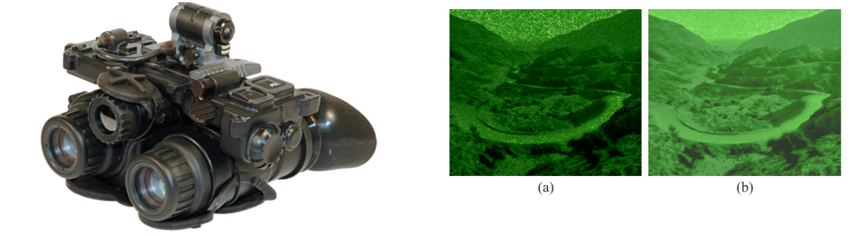

|  |  |  |
| --- | --- | --- |
|  | **Fig:** Photo of low contrast mountain landscape at moonless night |  |
|  | obtained using two NVG of different design: (a) NVG built by using |  |
| **Fig: Enhanced (dual sensor) NVDs** | typical F1.2 optics and typical IIT of SNR equal to 22 and (b) NVG |  |
| built using F0.9 optics and IIT of SNR equal to 32. |  |

**Fig: Images of forest scenery at foggy conditions generated by classical NVGs (left) and ENVG (right)**

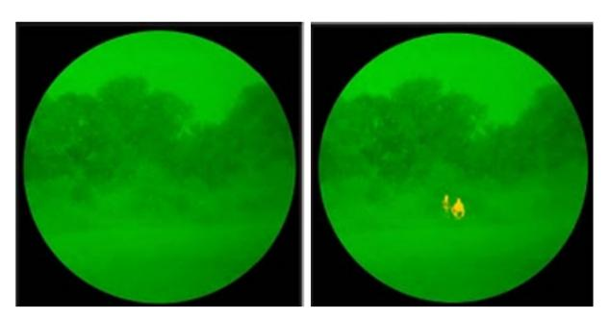

**10.1 Ultra-Sensitive NVDs:**

Recent military conflicts have shown that present generation of NVDs still performs rather poorly at very dark night conditions (overcast starlight) or even at relatively good illumination conditions (quarter moon) but in areas of low terrain reflectance (like mountains of Afghanistan). At present level of night vision technology dark nights can still significantly reduce military activities. Some elite units equip− ped with ultra−high sensitivity NVDs can carry out operations even at overcast starlight illumination conditions but effectiveness of surveillance is limited. Present ultra−sensitive NVDs are built by using Gen 3 Filmless/Gen 3 Thin Film tubes and ultra bright optical objectives of F−number as low as 0.9. It can be expected that further technological improvements of sensitivity of Gen 3 Filmless tubes or Gen 3+ Thin Film tubes (SNR as high as 35) combined with improvement of high resolution ultra− −fast objectives of ultra-low F−number (as low as 0.65) will improve sensitivity of NVDs even more. As it was shown in Fig. 38 there is a big difference in performance in dark night conditions between a typical NVG and an ultra sensitive NVG. The latter NVGs enable safe flights for helicopter pilots when use of the first ones can lead to accidents. Ion barrier film is the main factor that limits further improvement of Gen 3+ Thin Film tubes and it is doubtful if these tubes can ever achieve earlier mentioned level of SNR parameter. It is more probable that the best of Gen 3 Filmless tubes will offer SNR equal to 35 or higher in near future.

**11. Applications:**

Common applications for night vision include:

1. Military
2. Law enforcement
3. Hunting
4. Wildlife observation
5. Surveillance
6. Security
7. Navigation
8. Hidden-object detection

The original purpose of night vision was to locate enemy targets at night. It is still used extensively by the military for that purpose, as well as for navigation, surveillance and targeting. Police and security often use both thermal- imaging and image- enhancement technology, particularly for surveillance. Hunters and nature enthusiasts use NVDs to maneuver through the woods at night. Detectives and private investigators use night vision to watch people they are assigned to track. Many businesses have permanently mounted cameras equipped with night vision to monitor the surroundings.

an amazing ability of thermal imaging is that it reveals whether an area has been disturbed -- it can show that the ground has been dug up to bury something, even if there is no obvious sign to the naked eye. Law enforcement as used this to discover items that have been hidden by criminals, including money, drugs and bodies. Also, recent changes to areas such as walls can be seen using thermal imaging, which has provided important clues in several cases.

Gallium Arsenide (GaAs):

The semiconductor material used in manufacturing the Gen 3photocathode.GaAs photo cathodes have a very high photo sensitivity in the spectral region of about 450 to 950nanometers (visible and near-infrared region). High light shut off an image intensifier protection feature incorporating a sensor,

microprocessor and circuit breaker. This feature will turn the system off during periods of extreme bright light conditions.

Interpupillary Distance:

The distance between the user's pupils (eyeball centers). The 95th percentile of US military personnel falls within the 55to72mm range of IPD.

**IR Illuminator:**

Many nights vision devices incorporate a built-in infrared (IR) diode that emits invisible light, or the illuminator can be mounted on to it as a separate component. IR light cannot be seen by the unaided eye; therefore, a night vision device is necessary to see this light. IR Illuminators provide supplemental infrared illumination of an appropriate wavelength, typically in a range of wavelengths (e.g. 730nm, 830nm, 920nm), and eliminate the variability of available ambient light, but also allow the observer to illuminate only specific areas of interest while eliminating shadows and enhancing image contrast.

**IR Laser:**

High-power devices providing long-range illumination capability. Ranges of several thousand meters are common. Most are not eye-safe and are restricted in use. Each IR laser should be marked with a warning label like the one shown here. Consult FDA CFR Title 21 for specific details and restrictions.

1. **CONCLUSION**

In this paper we have described various night vision technologies which are available and its working in order to avoid various low light problem, this paper shows that how efficiently a soldiers can work efficiently during night also wildlife observer can work during dark and also shown how surveillance can be kept in low light condition.

The Night vision device (NVD) is undoubtedly one of the most enduring features of the automobile industry. It has lasted from its initial introduction in 2000 to the present day and in some places, still hardly different from its Victorian origins. There have been many improvements over the years without any skill required.

Night vision based on technology of image intensifier tubes is the oldest electro−optical surveillance technology. How− ever, despite strong competition from thermal imagers, visible/NIR cameras and digital night vision, this old mature technology is still in a phase of growth. There are no signs of possible demise of classical optical NVDs in near future. Night vision is a fully matured technology that has found mass applications in both military, security and defense sectors. NVDs are offered on international market in form of a long series of devices of different design configuration, type of image intensifier tube, type of night vision optics, and performance. Proper understanding and evaluation of NVDs is a complicated task as many details are to be considered. This review of modern night vision technology can help readers to understand sophisticated situation on international night vision market. However, reading of literature on characterization and testing of night vision devices, and analysis of dynamic situation in trends of night vision technology is recommended as a supplement to this paper.

1. **REFERENCES**
2. [www.Explainthatstuff.com.](http://www.explainthatstuff.com/)
3. Hussain, Z. “Digital Image Processing”. Practical Applications of Parallel Processing Techniques. Published by: Ellis Horwood Limited, 1991.
4. Parker, J., R., “Algorithms for Image Processing and Computer Vision”, Wiley Computer Publishing, 1997.
5. Parker, J., R., “Practical Computer Vision using C”, Wiley Computer Publishing, 1994.
6. Ritter, G., X., Wilson, J., N., “Handbook of Computer Vision Algorithms in Image Algebra”, CRC Press, 1996.
7. Russ, J. C., “The Image Processing Handbook”. CRC Press, 1992.
8. Sanz, J. L. “Advances in Machine Vision”, Spring-Verlag, 1989.
9. [http://www.bps.go.id](http://www.bps.go.id/)
10. [www.amswer.com](http://www.amswer.com/)
    1. [www.nightvision.com](http://www.nightvision.com/)
    2. Belhumeur, P., hespanha, J., and Kriegman, D., "Eigen faces vs. Fisher faces
11. www.nightvision.com/products/military/case_study−gen3.htm
12. [www.photonis.com/en/night_vision](http://www.photonis.com/en/night_vision)
13. aunv.blackice.com.au/cgi−bin/nightvision/forum?index=dis−

cussions&story=omni

1. www.exelisinc.com/News/PressReleases/Pages/Omni−VIII.as px
2. L. Bosch, “Tube performance that matters”, Proc. SPIE 4128, 65– 78, (2000).
3. MIL−I−49453 CR, Image intensifier assembly, 18 millimiter microchannel wafer, MX 10130/UV, 1989
4. www.colutron.com