**Collaboration / Workflow Exercises workflow**

Two different approaches:

1. Small Team Workflow
   1. Single repo, multiple contributors
   2. Owner of repository provides editing rights to contributor
2. Fork and Pull Request
   1. Fork an open source project receiving contributions
   2. Contributor does not have editing rights in repository

Approach I. Small Team Workflow

1. Log into your account.
2. Click on the green “New” button to the left of the webpage

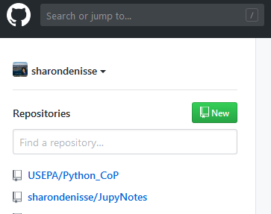

1. Name your new repository

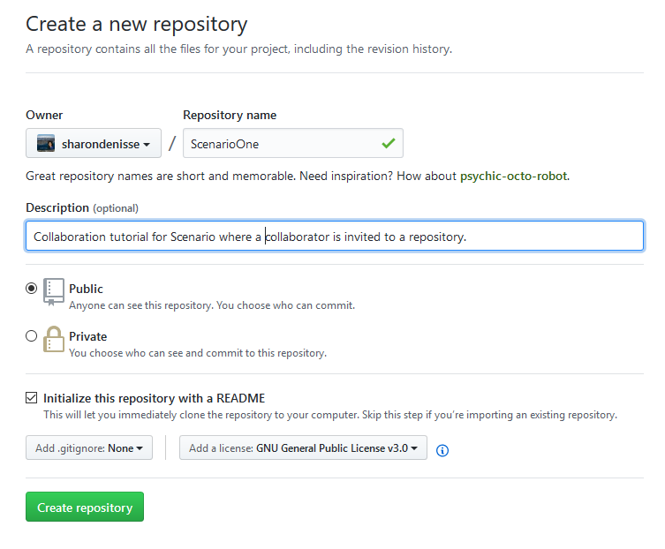

1. Click on settings. It will take you to this page:

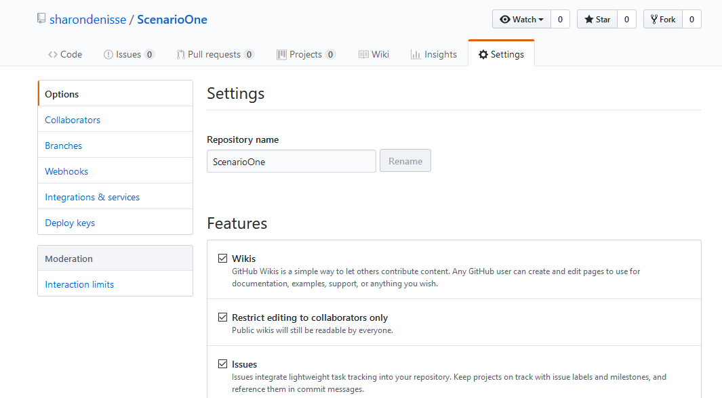

1. On the left, there is a column where you can click on **Collaborators**.
2. Write the user name or email of the person you are searching for and click Add collaborator.

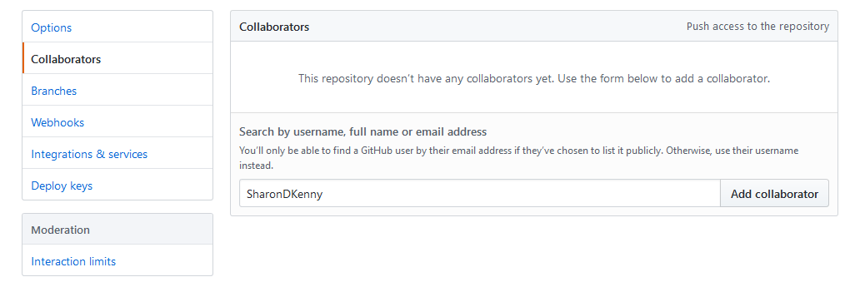

* 1. If the user has opted to receive notifications, an email will reach them with the invitation.

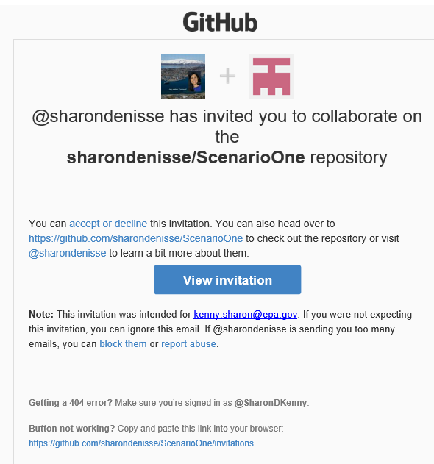

* 1. You can copy the invite link to send via email directly to the user you would like to collaborate with. That invite link is a repository invitation URLs that will work for invited users only.
     1. If the invited user is not logged into Github, the page will load a 404 warning.

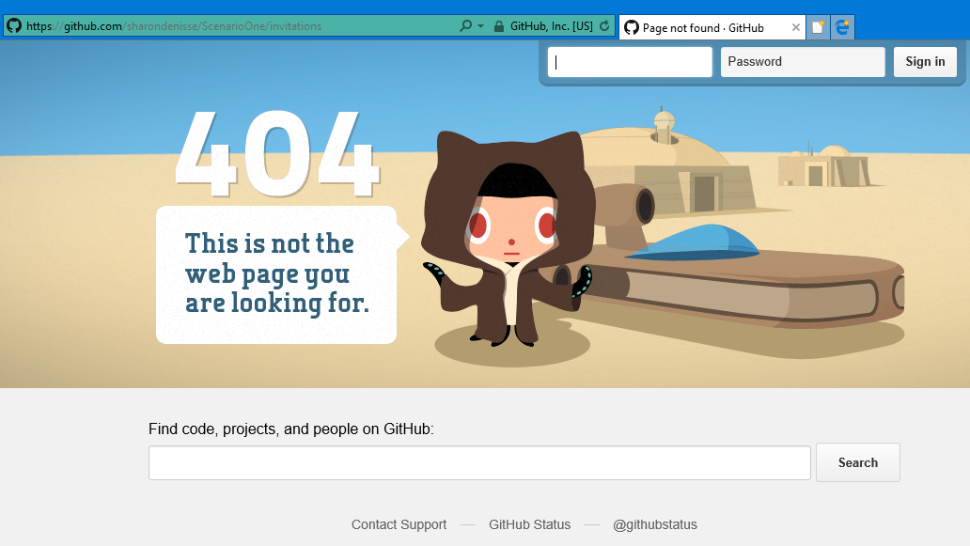

1. Upon signing in, the page will change to this webpage:



1. When you accept the invitation, you will be taken directly to the repository

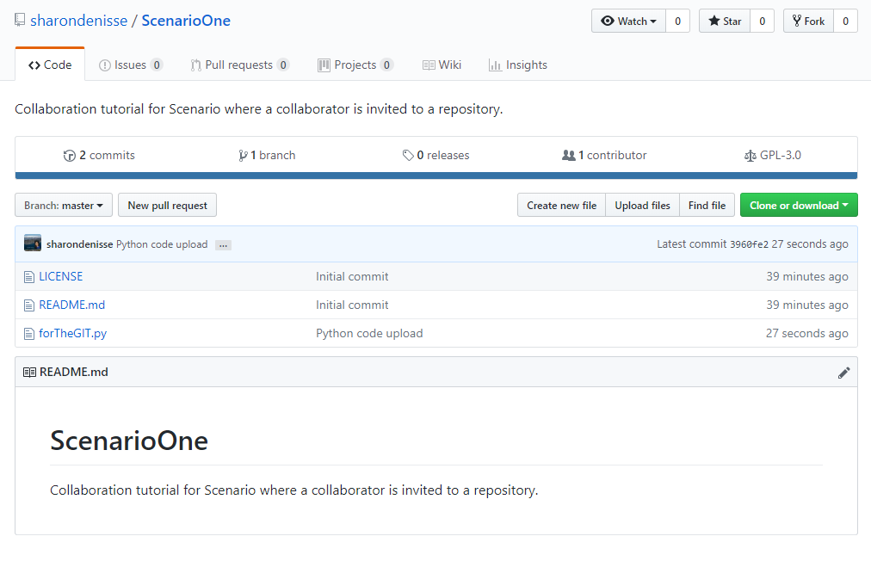

1. Editing a file:
   1. In the master branch
      1. Click the file forTheGIT.py

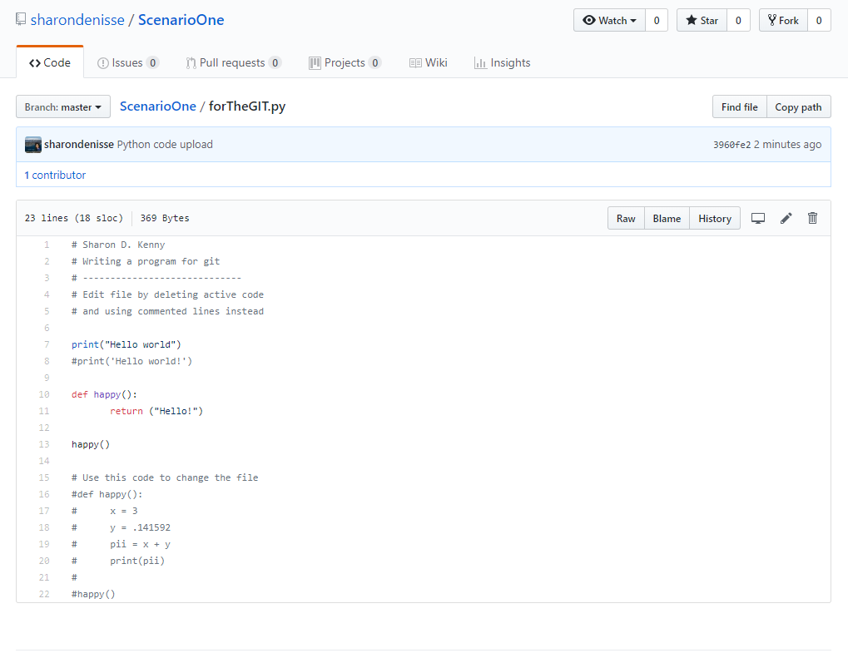

* + 1. Click on the pencil to the right of the page to be able to edit the file. Change the function that is currently running as follows

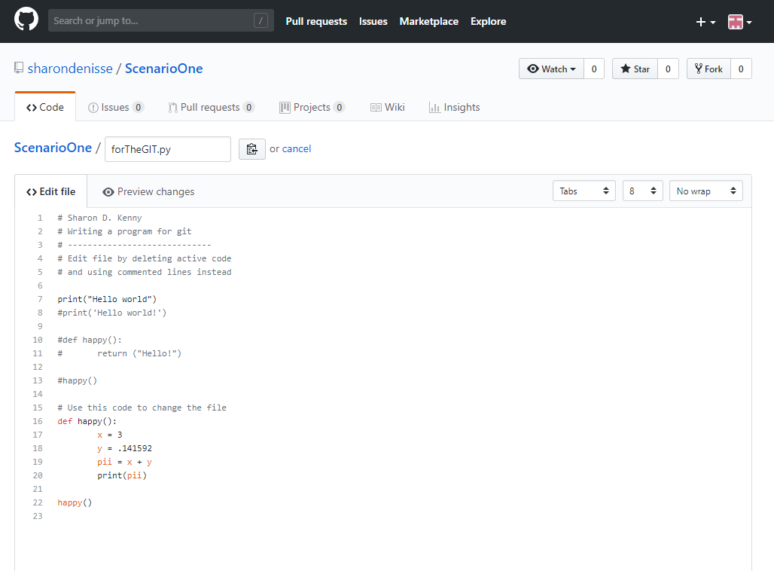

* + 1. Scroll down to commit

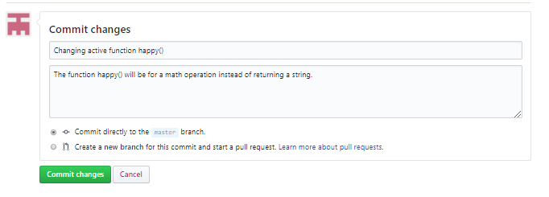

* + 1. Commit directly to the master branch
  1. In a separate branch
     1. Follow 9.a.i to 9.a.iv
     2. Select “Create a new branch”

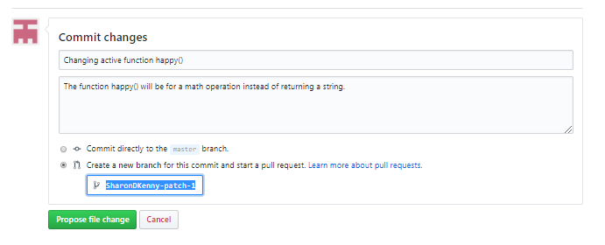

* + 1. The page opens titled Open a pull request. Write comments and press green button Create pull request.

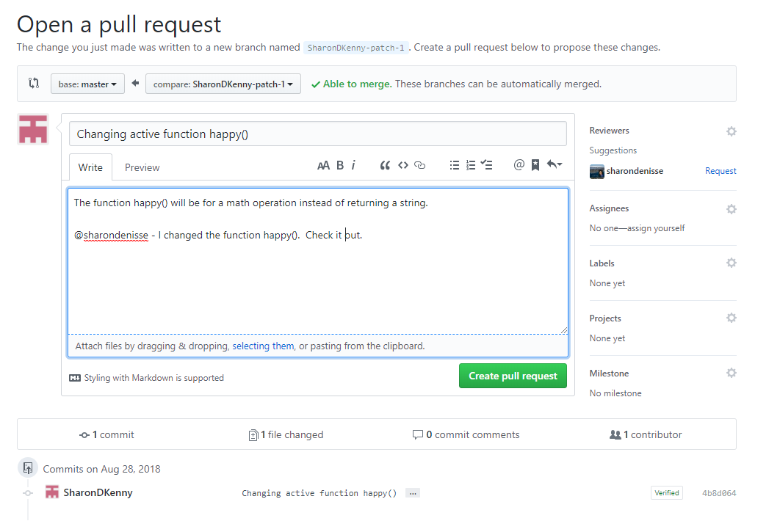

* + - 1. When using an @ sign next to the user name, the user will receive an email if the account has been set to allow notifications.

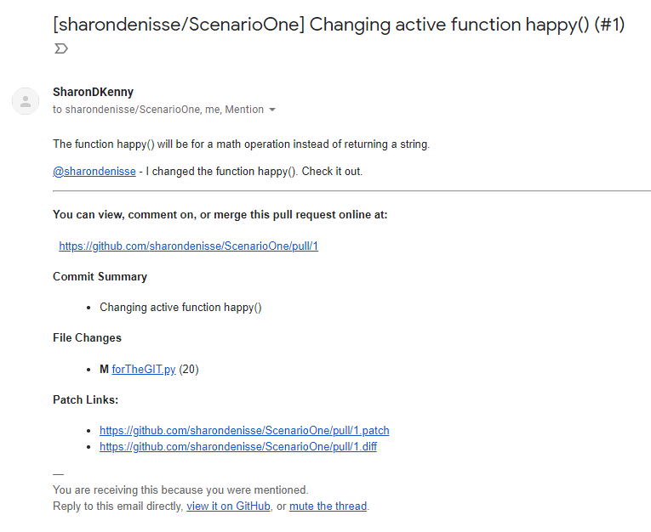

* + 1. After pressing the green button **Create pull request** you will be taken to the page to merge the pull request. Either you or the invited collaborator can press the green button to **Merge pull request**. Below is the collaborator’s page view

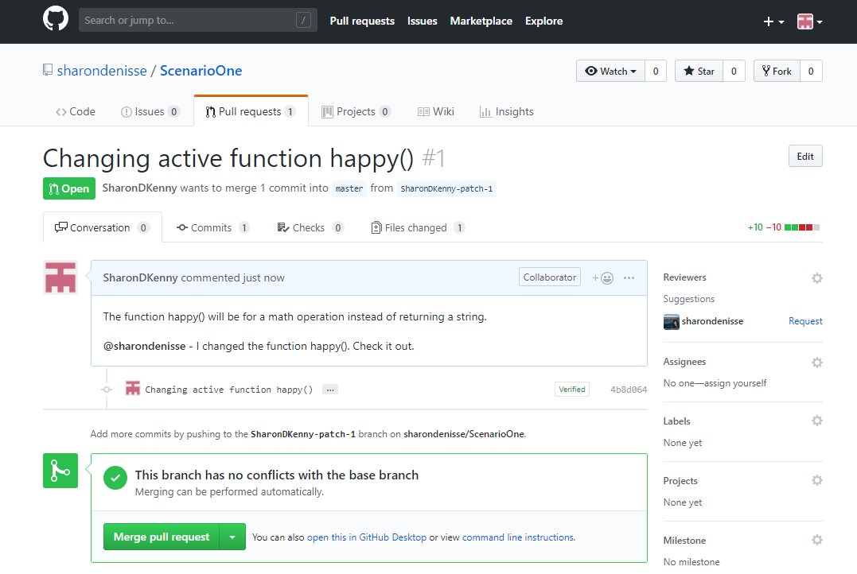

* + 1. The owner of the repository will be able to see that there is a repository with a merge pull request in the top the website page.

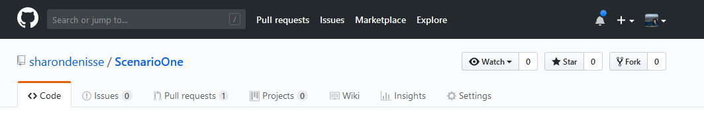

* + 1. Once merged, the branch can stay or be deleted.