**Instructions for getting started on GitHub**

by Sharon D. Kenny (R3)

1. Opening an Account on GitHub
   1. Visit [https://github.com](https://github.com/)
   2. Click the “[**Sign up**](https://github.com/join?source=header-home)**”** button at upper right corner.
   3. Fill the form (see below), selecting a username, password, and an email address; then press the “**Create an Account**” button.

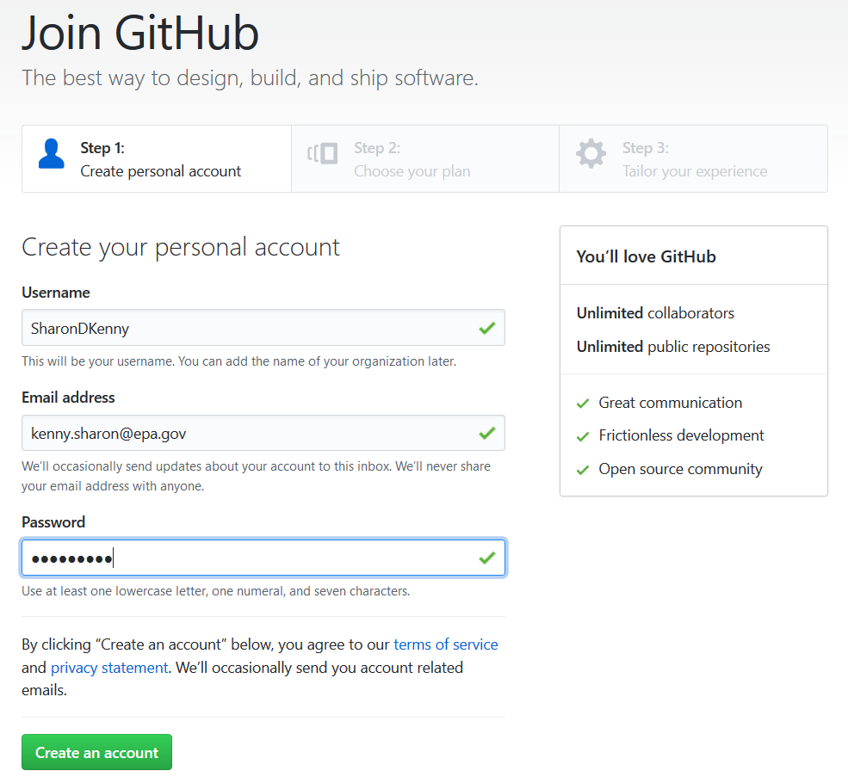

* 1. Another page will open. Choose the personal plan “Unlimited public repositories for free”, then press “**Continue**”.

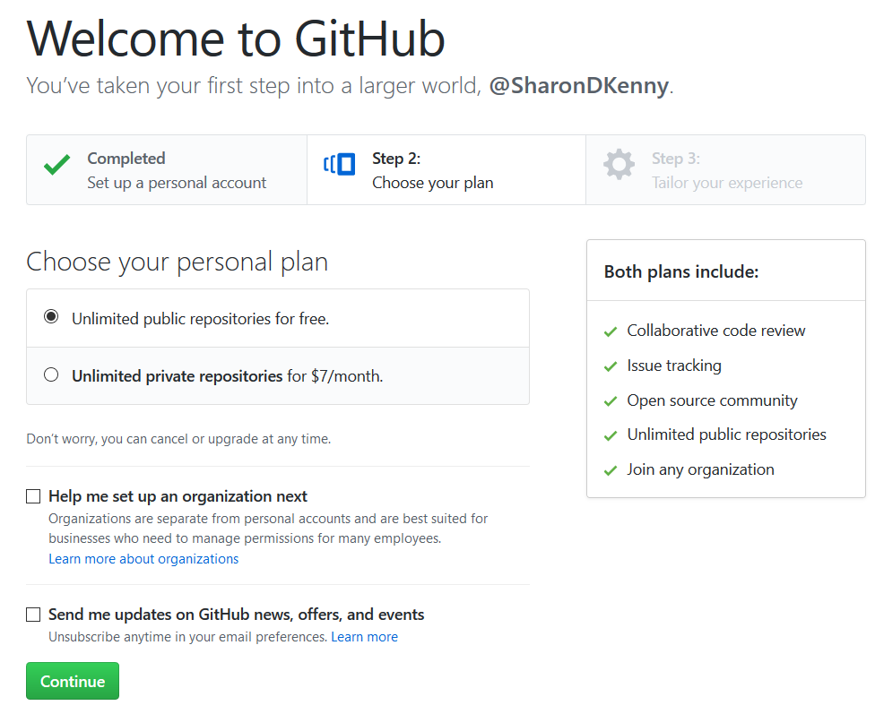

* 1. The page that opens next can be skipped. Scroll all the way to the bottom (unless you are want to share more information about yourself with Microsoft) to select “**skip this step**”, which is located to the right of the green button “Submit”.



* 1. You are now inside GitHub. Click the button “**Start a Project**”

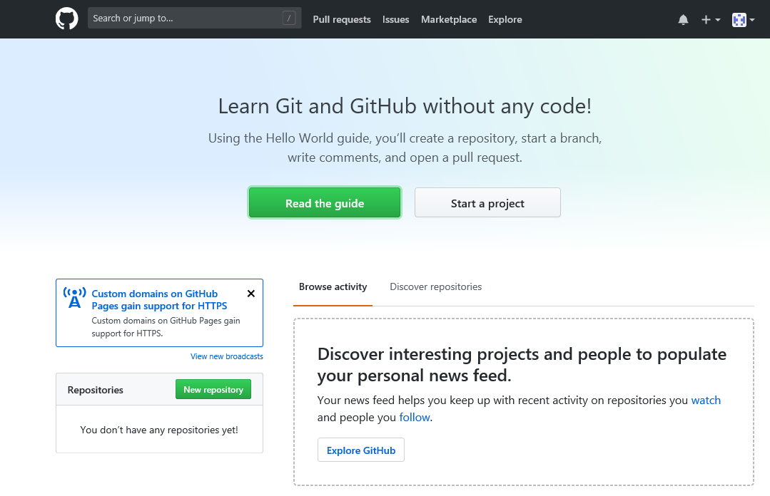

* 1. A page will open, where you will be asked to confirm your email.

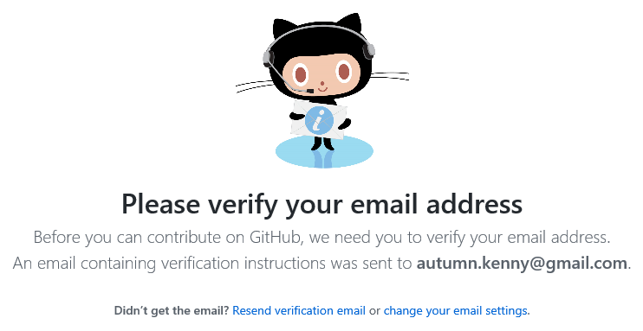

* 1. Log in to the email account that you used to register, and you will see an email from GitHub (see below). Click on the blue button “**Verify email address**”. This will take you back to the page illustrated in step I.6. This concludes the GitHub registration process.

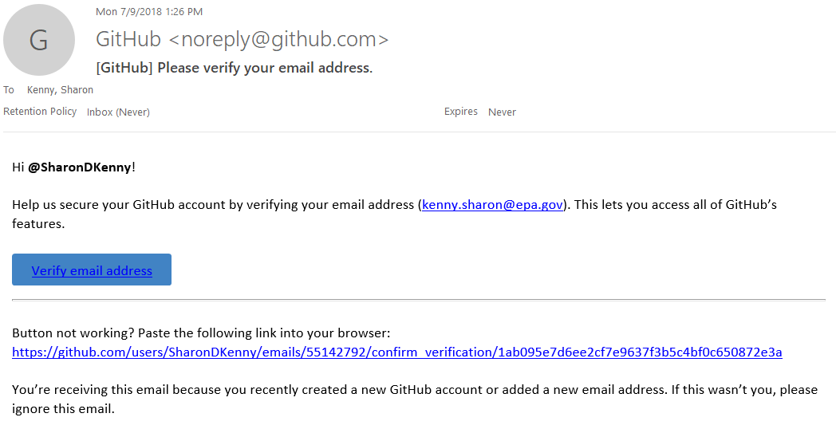

1. Create a repository
   1. Now that your email has been verified, you can create a new repository. On the same page as step II.1, click on the “plus” symbol located in the upper right side of the page. Select “**New Repository**”.

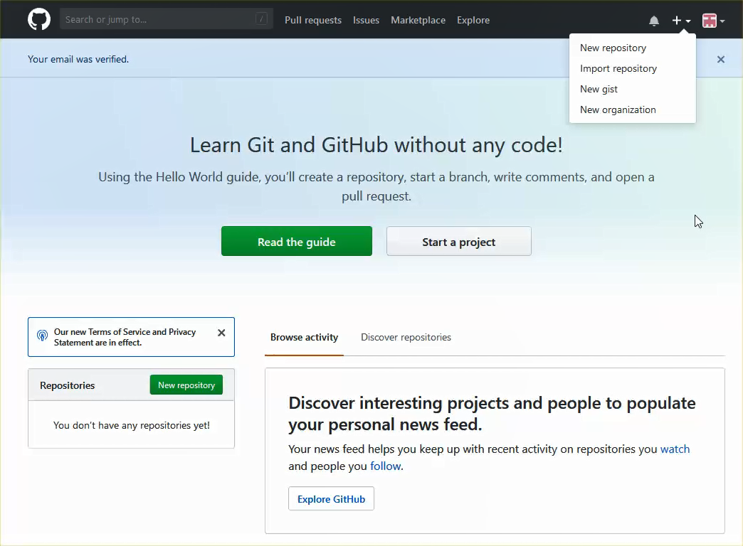

* 1. Name the repository, initialize the repository with a README, and a license (I recommend [GNU General Public License v3.0](https://www.gnu.org/licenses/gpl-3.0.en.html)), and click on “**Create Repository**”.

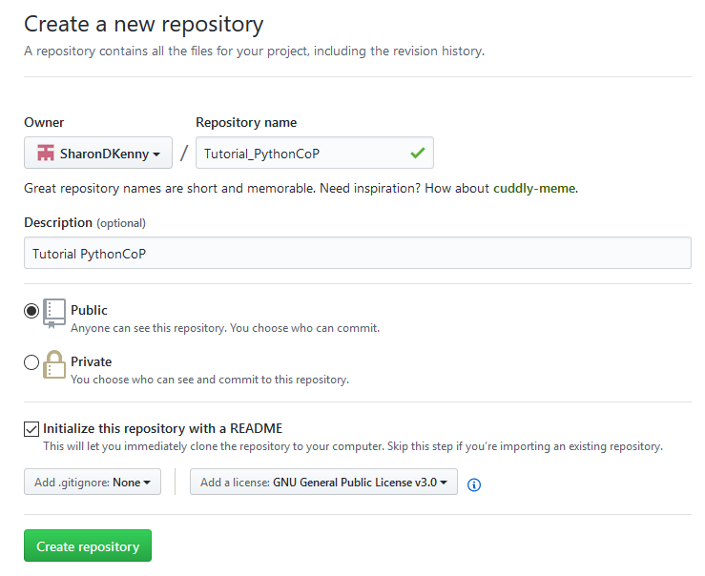

* 1. Now, let’s bring a file into this new repository by clicking on the “**Upload Files**” button. Press “**Commit new file**”.

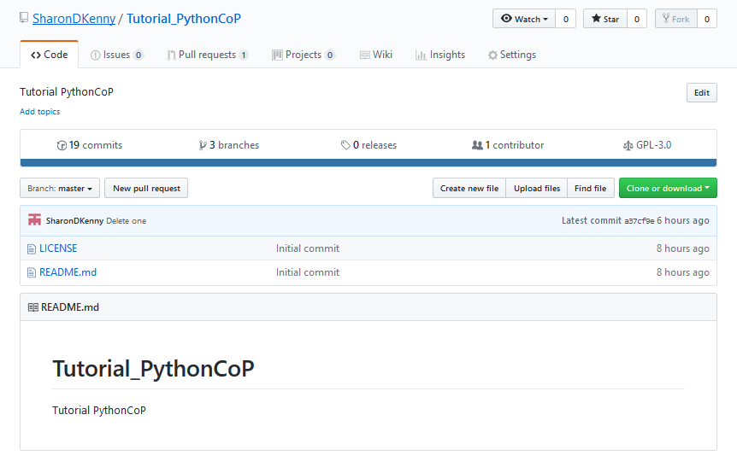

* 1. A new page will take you to the option of dragging or searching for the file. I will be uploading the Python code contained in a file called “forTheGIT.py”. Once uploaded, it will show in gray lettering below the large box, on the left corner. Fill in a description for the file in the area titled “Commit changes”. Accept the default option, then press “**commit changes**” to the master branch.

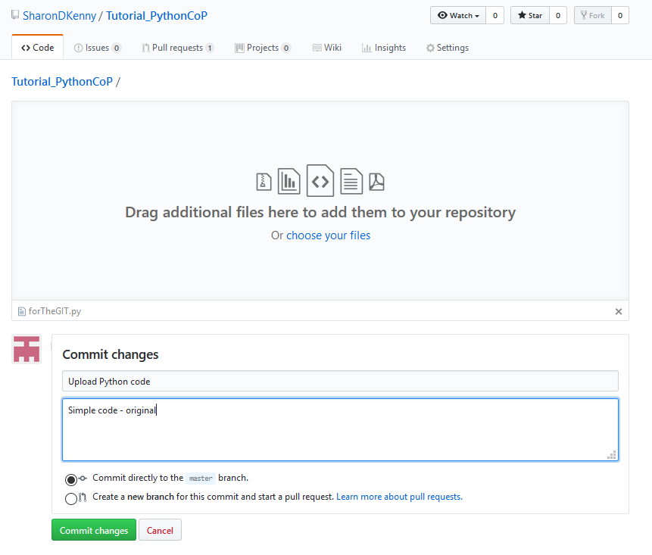

* 1. You will be taken next to the directory page where you uploaded your file. Congratulations! You have uploaded your first file!

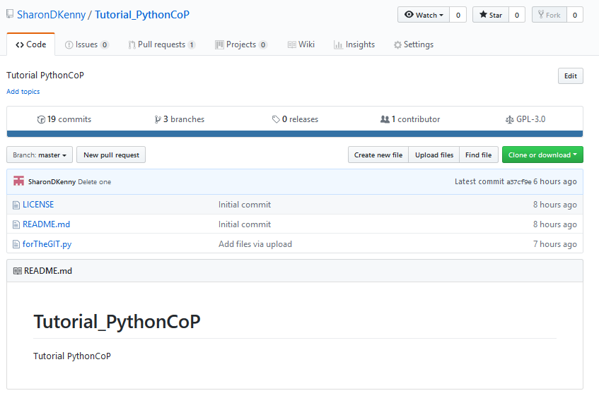

1. Editing your own document

There are various ways to edit your document. You can either open the document within GitHub, or you can make the changes in your desktop, uploading the updated file with the same name. Here we will make a change using the second option.

IMPORTANT: GitHub does not have the capability to show you the changes that were made in Word documents. You can see changes in files ending in .txt, though.

* 1. When you upload the edited file, DO NOT upload to the master. Instead, create a new branch (as shown by the arrow below). This will allow you to compare both files with the same name.

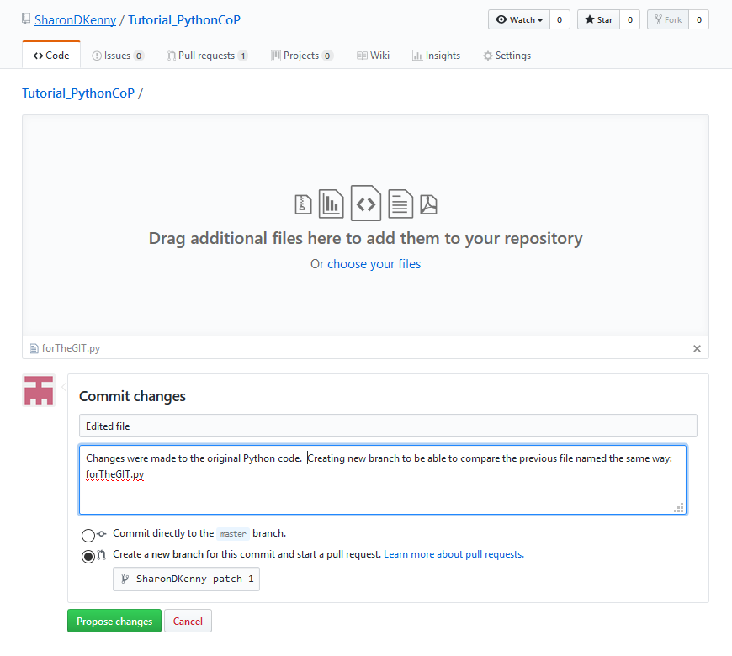

* 1. Compare the files by looking at the content in green and red (see below). Green represents text additions, red represents deletions, and white represents text that is common to the new and old file.

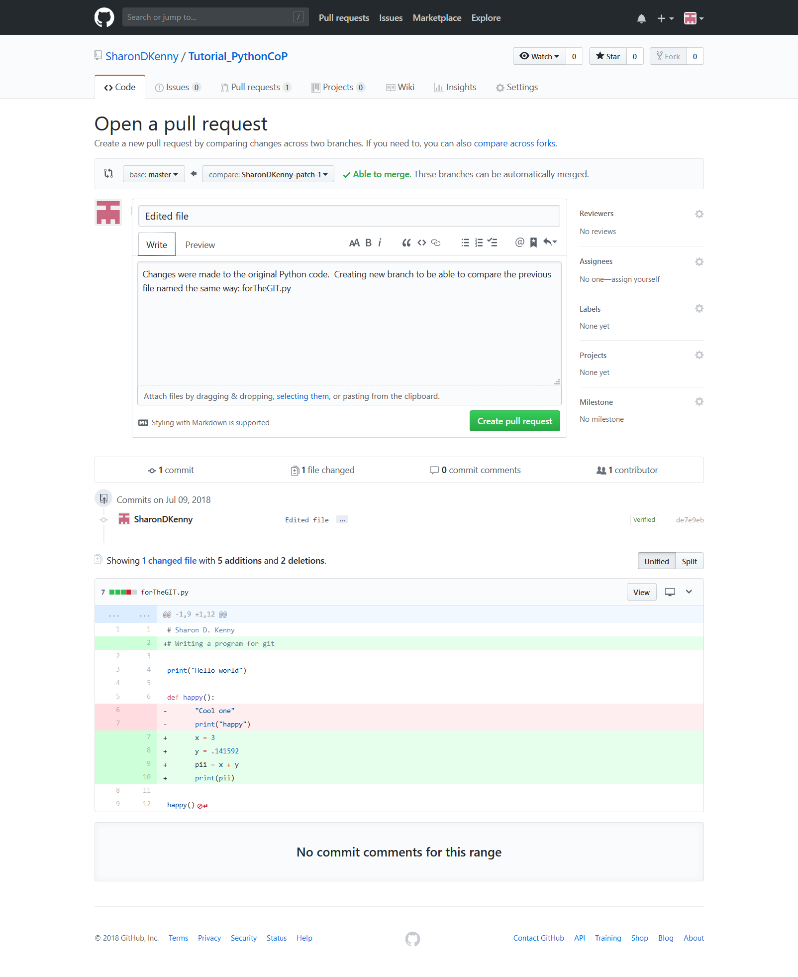

* 1. Press “**Create pull request**”. Another page will open, where you could write comments, and also notify another GitHub user of your activity. To “ping” users, include the @ before their user name. In this case, the user SharonDenisse will receive an email with your comment if they have turned on notifications from GitHub.

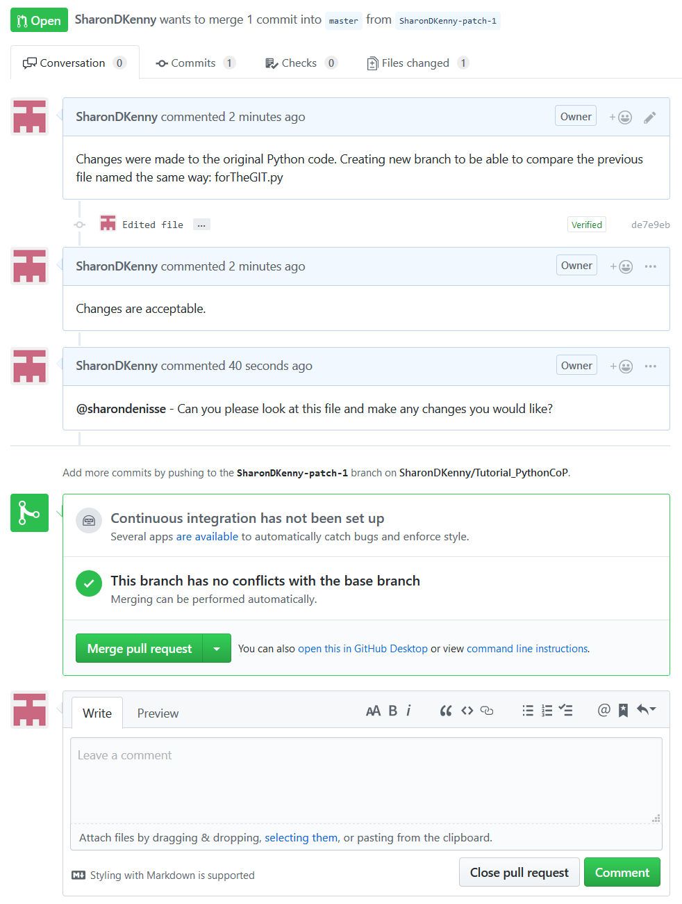

* 1. To complete the process, press “**Merge pull request**” and then again “**Confirm merge**”.

Congratulations! You have completed your first steps into using GitHub!