Pre-Workshop Setup

Install or Update Git

1. Create a new folder where to work with git, something like this: C:\Users\USERNAME\Programs\Git\
2. Download git and save it in the folder you created.
   1. Visit either [Git for Windows](https://gitforwindows.org/) or <https://git-scm.com/downloads>
   2. Select [64-bit Git for Windows Setup](https://github.com/git-for-windows/git/releases/download/v2.18.0.windows.1/Git-2.18.0-64-bit.exe) **and save in the Downloads folder or elsewhere**
3. **Go to the directory where you saved it and click on it to open**
4. Accept all the default options or make changes as you see fit (especially when it comes to Editors), and make sure you have selected the path as follows:

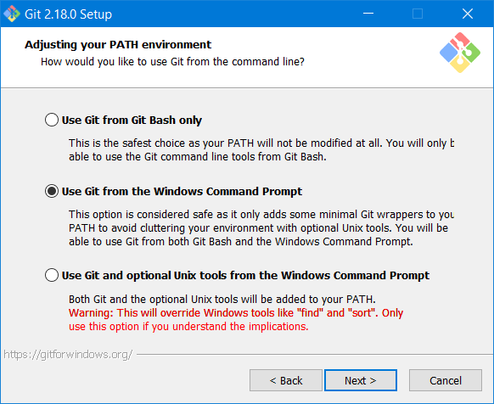

Test your Installation

1. **Open a command prompt or the Git Bash you just installed and type the following:**
   1. **git –version**
2. **Hopefully you see something like this:**

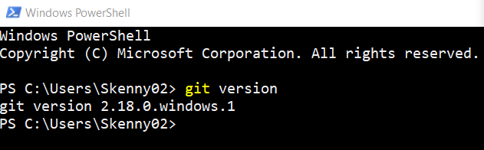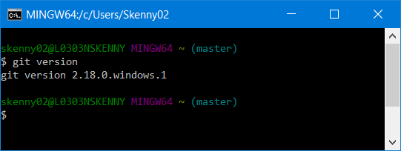

Verify git installation a.k.a., Introduce yourself to git

<http://happygitwithr.com/hello-git.html>

1. Configure git by adding your user name and email

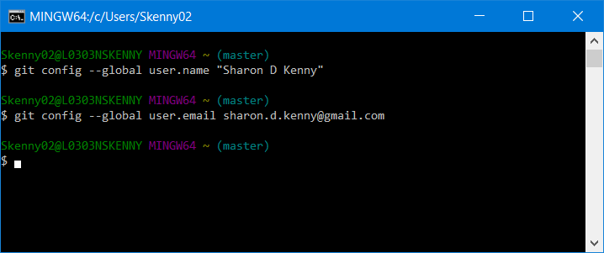

1. Configure the text editor

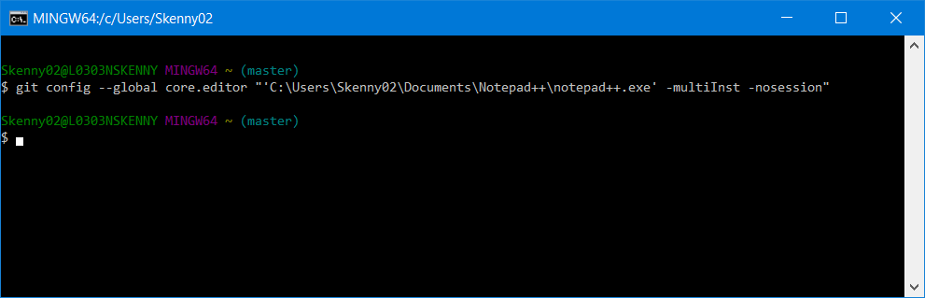

1. Confirm your profile with the command: git config --list
   * 1. If necessary, type q after the colon symbol to exit the list of configurations
2. Confirm the entries you provided

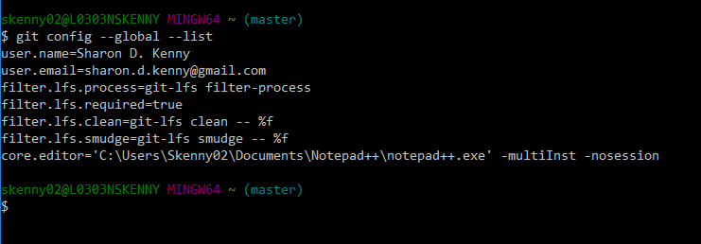

I would make another subtitle named Git Gui

R ????!!!?!?!?!?!

## Prove Git can Talk to Github a.k.a. Connect to GitHub

http://happygitwithr.com/push-pull-github.html

1. Make repo on GitHub
2. Clone to local computer
3. Change, commit, and push on local computer
4. Confirm changes in GitHub
5. Clean up

## Cache Username and Password for Github

http://happygitwithr.com/credential-caching.html

Create a repository in your computer

* 1. Using the Bash, travel to the directory you created that contains the text file

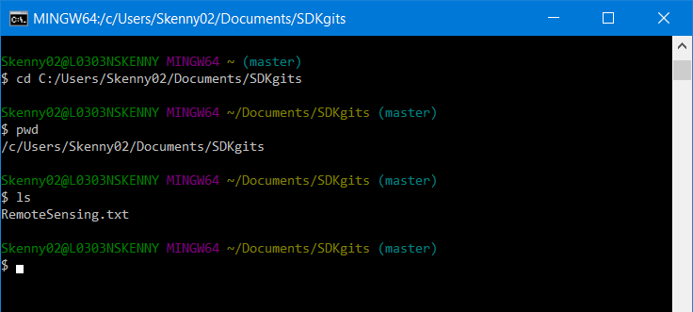

* 1. Type git init to initialize the directory and then type git status to see details

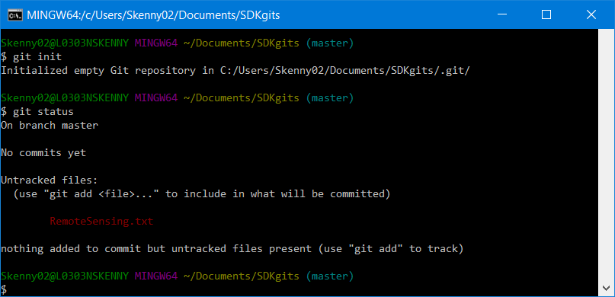

1. Add documents to be tracked
   1. git add RemoteSensing.py
   2. check status to see difference

