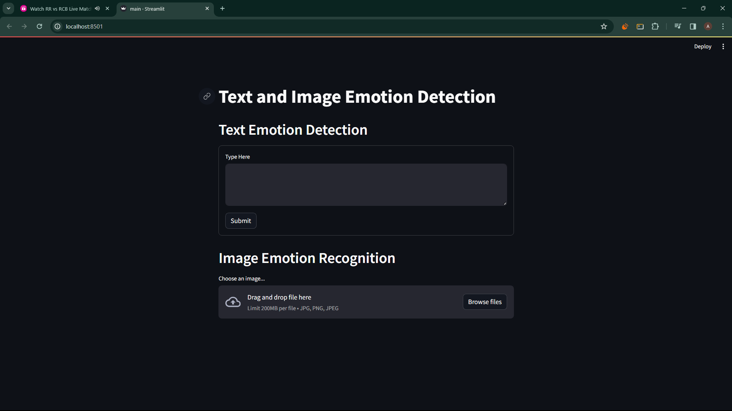

Emotion detection from text

Emotion detection from Image

