

Document Version / Details: Ver. 2.0/ 14-Sep-2024

PowerShell - Scenario

WORD DOCUMENT

NAME: ANSH KUMAR

PS NO: 10745941

BATCH: 35.2

Note: Paste the relevant screenshot for every question once completed

Lab time: _5__ hrs

1. You are asked to display the following every time you open PowerShell console.

a. List current execution policy

b. List HDD size information (total & free space).

c. List the username logged

d. Number of processors.

e. BIOS Information

f. Checking IP address of your computer

1. List the top 10 application logs of your computer and display them on HTML page.
2. Write a PowerShell script to list top 10 processes with highest CPU utilization.
3. Write a script to get information about all the stopped services where “start type” is automatic for your computer.
4. Write a PowerShell script that pings to multiple websites (of your choice) by accessing the site names from a text file. Ensure the pingable websites are in GREEN colour and non-pingable in RED colour.
5. Create a program to count the number of SVCHOSTS services running on your domain controller.
6. Write a program to automatically open a list of the following applications at once.

a. Notepad

b. Calc

c. MS-paint

d. Command Prompt

e. PowerShell ISE

1. Use switch statement and create a calculator that performs addition, subtraction, multiple and division by asking the user to input 2 numbers.
2. Open 10 notepad applications manually named notepad – 1, notepad – 2 …. & notepad 10, use PowerShell script that displays all running notepad processes and kill those processes all at once.
3. Write a PowerShell script that executes cmdlet using non-persistent (1-to-many-remoting)

Answer 1:

1. Open powerShell and run as administrator
2. Use command
3. “Notepad.exe $profile” and give all the commands in notepad file given below and save it
4. Get-ExecutionPolicy
5. Get-WmiObject -Class Win32_logicaldisk | `

Select-Object deviceID, `

@{ label = "FreeSpace in GB" ;exp={[math]::Round(($_.FreeSpace/1GB),2)}}, `

@{label = "Size in GB" ; exp = {[math]::Round(($_.Size/1GB),2)}}

1. $env:USERNAME
2. Write-Host "Total no of processor are : "(Get-WmiObject Win32_processor | measure).Count -ForegroundColor Green
3. Get-WmiObject -Class Win32_BIOS | Format-Table
4. (Get-NetIPAddress | Where-Object {$_.PrefixOrigin -eq "DHCP"}).IPAddress

Close the powershell and again open it

Answer 2:

Use command

Get-EventLog -LogName Application | `

Select-Object -First 10 | `

ConvertTo-Html

To see in powershell itself

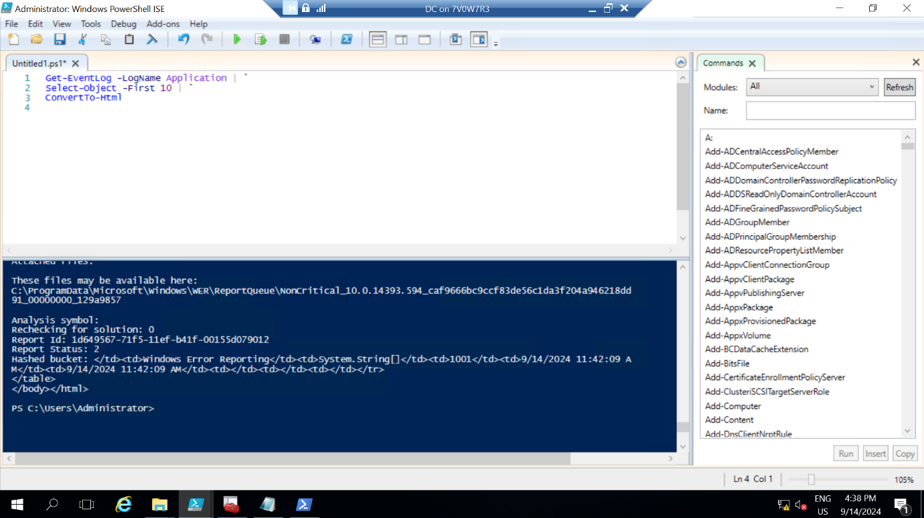

Get-EventLog -LogName Application | `

Select-Object -First 10 | `

ConvertTo-Html | `

Out-File TopTenAppEVENTS.html

File will be saved sa “TopTenAppEvents.html” in the location which is in powershell consol

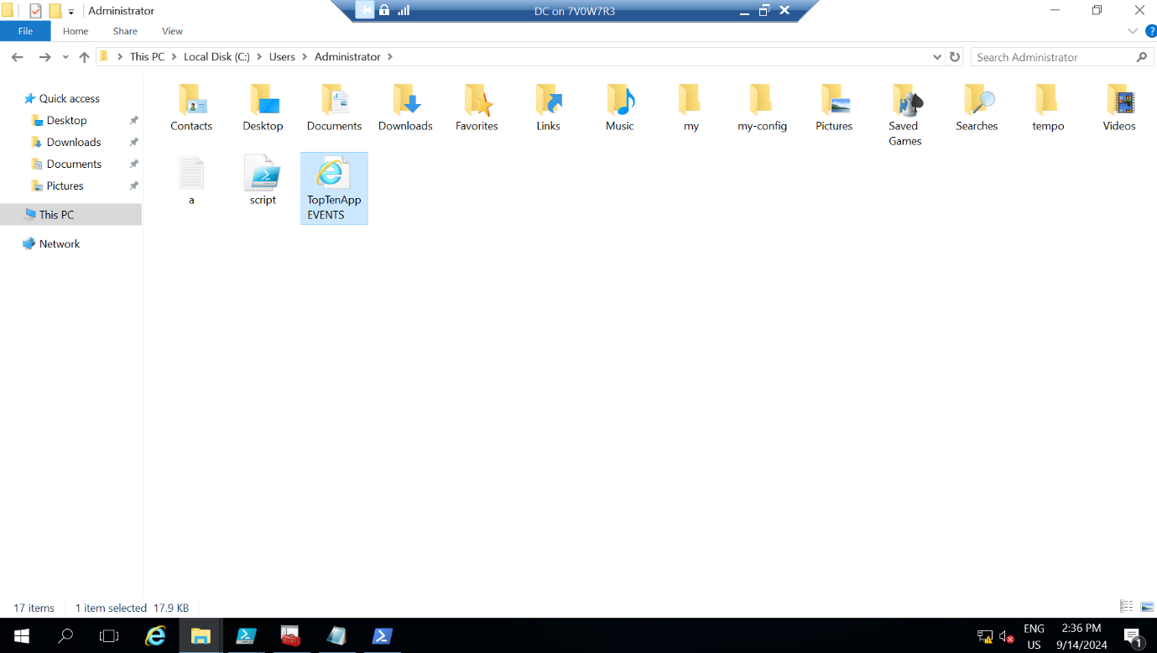

Answer 3:

Get-Process | Sort-Object -Property CPU -Descending `

| Select-Object -First 10 -Unique

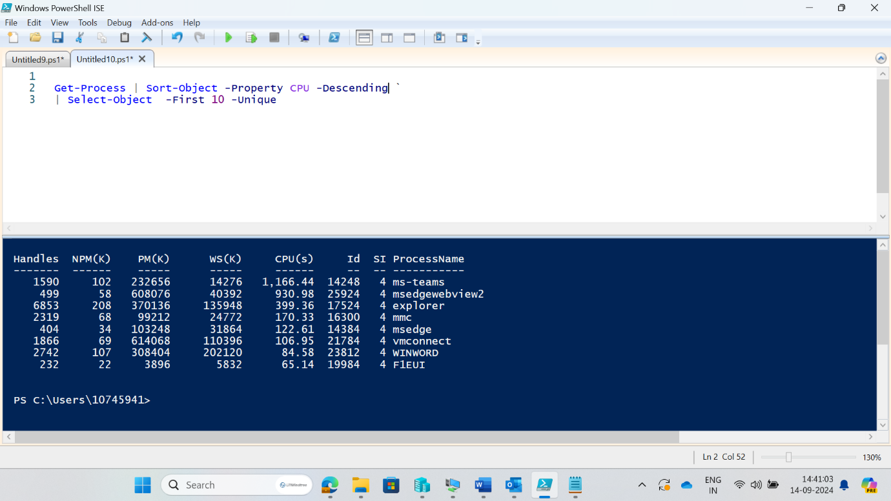

Answer 4:

Get-Service | where {$_.StartType -eq "Automatic"}

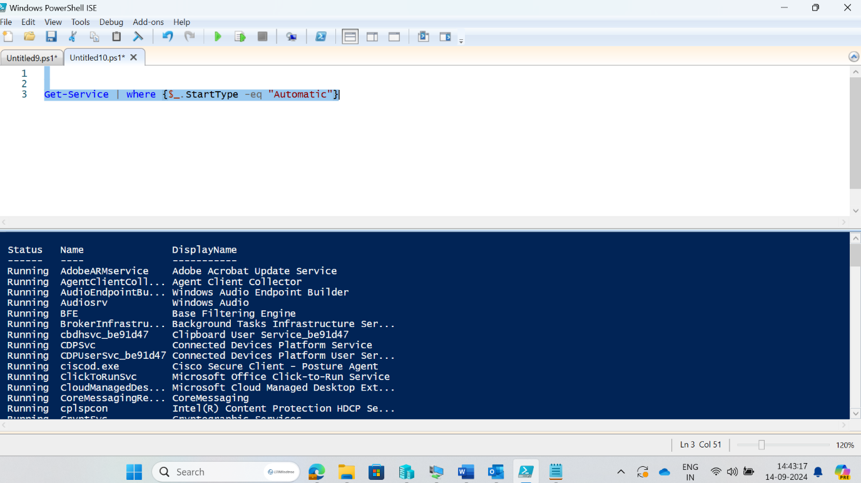

Answer 5:

$web = @("www.google.com","facebook.com","youdfgfcgjhfctube.com","instagram.com","flipkart.com")

foreach($w in $web){

if(Test-Connection $w -Count 1 -ErrorAction SilentlyContinue){

Write-Host "Pinging websites: "$w -ForegroundColor Green

}

else{

Write-Host "Non Pinging websites: "$w -ForegroundColor Red

}

}

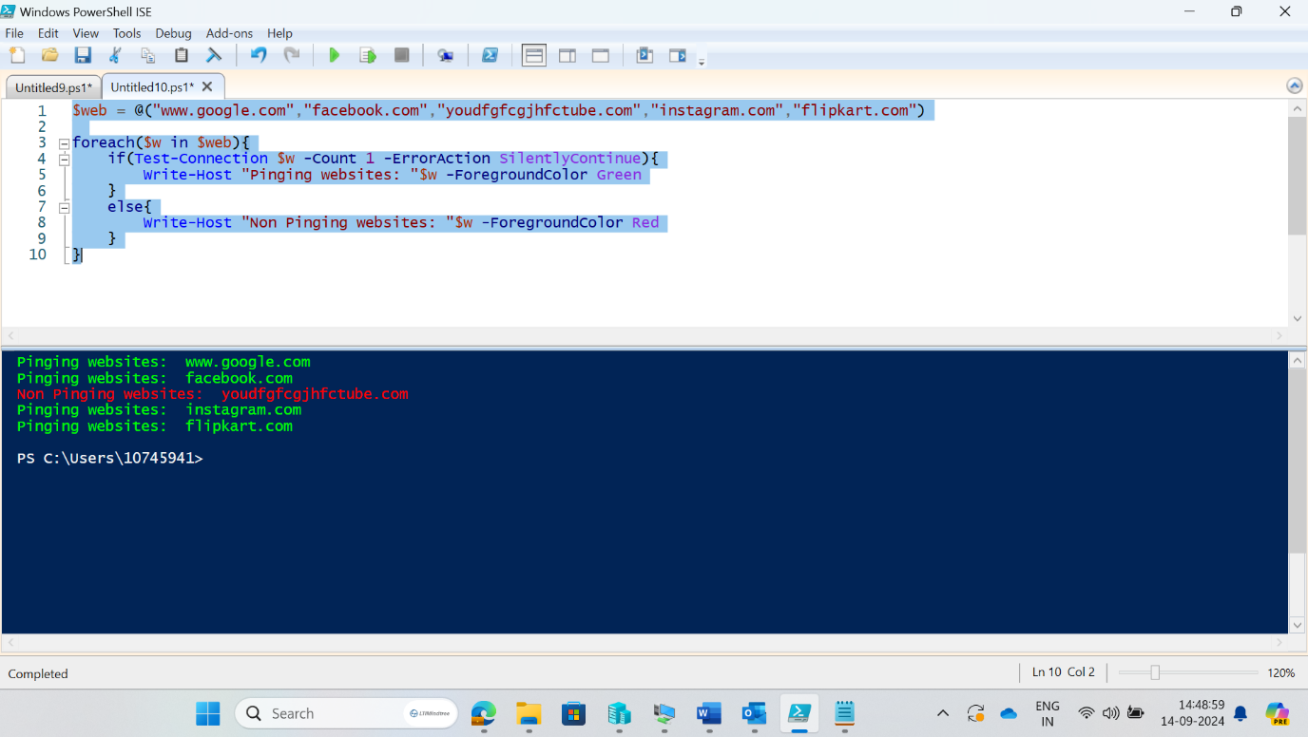

Answer 6:

Get-Process -Name svchost | measure

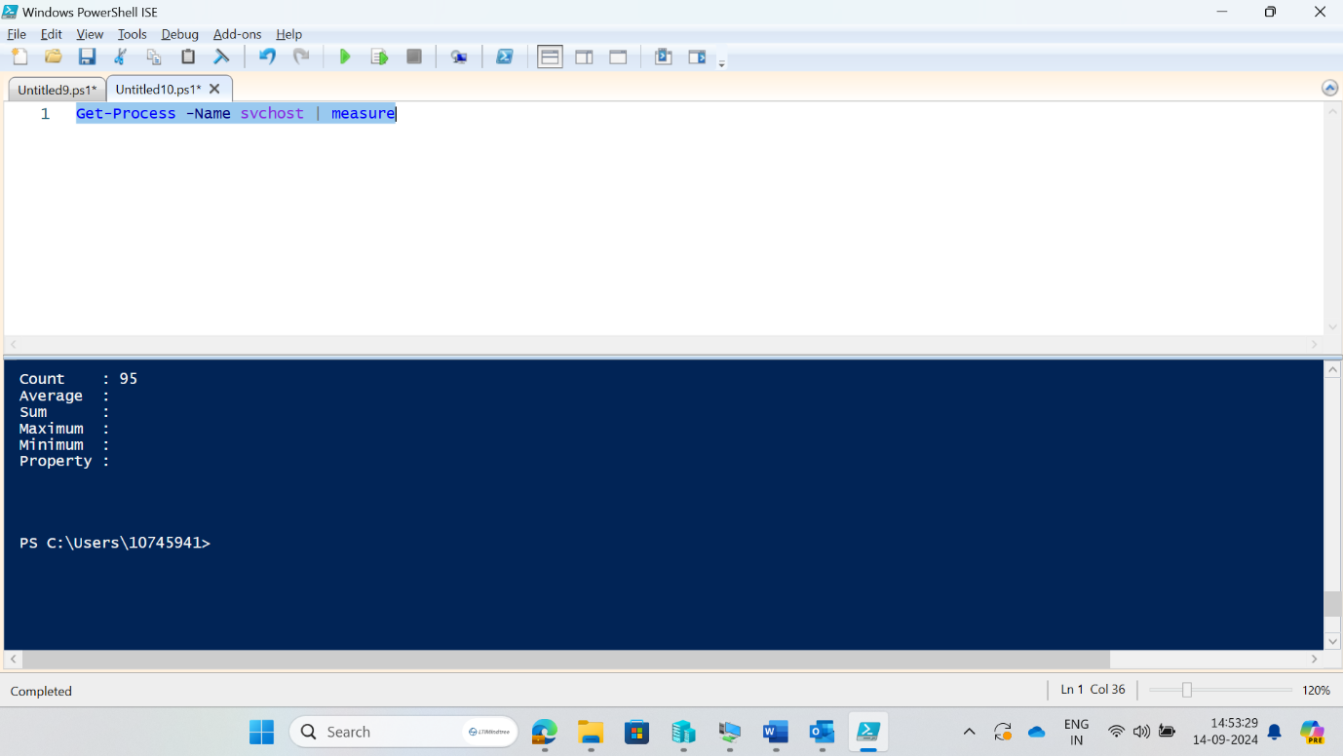

Answer 7:

$app = @("notepad","calc","mspaint","cmd","powershell_ise")

foreach($a in $app){

Start-Process $a

}

Here is the proof that all the applications run successfully

Answer 8:

do{

Write-Host "1: Addition"

Write-Host "2: Subtraction"

Write-Host "3: Division"

Write-Host "4: Multiplication"

Write-Host "5: Exit"

$ch = Read-Host "please select your choice: "

$a = Read-Host "Enter the first number"

$b = Read-Host "Enter the second number"

switch($ch){

1{$([int]$a+[int]$b)}

2{$([int]$a-[int]$b)}

3{$([int]$a/[int]$b)}

4{$([int]$a*[int]$b)}

5{break}

default{Write-Host "Please choose a number b/w 1 to 5"}

}

}while($ch -lt 5)

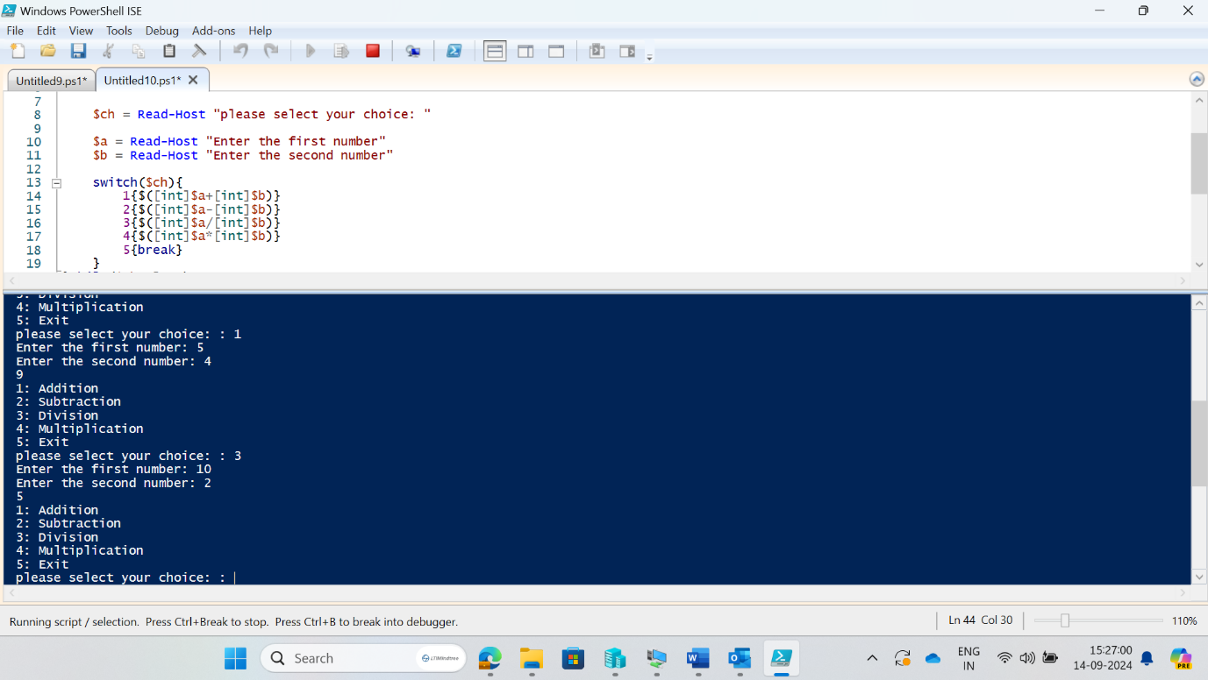

Answer 9:

To see all the notepad process

Get-Process -Name Notepad

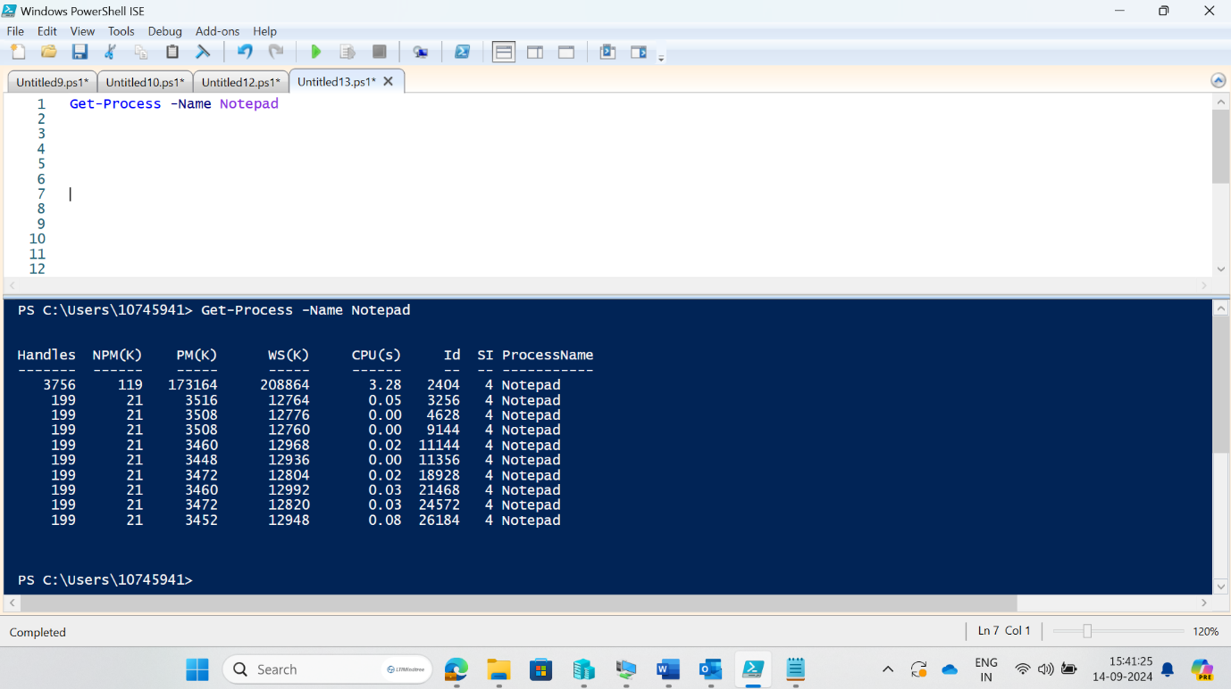

To kill all the notepad process

Stop-Process -Name Notepad

Answer 10:

1. Enable-PSRemoting
2. Start-Service -Name WinRM
3. A screenshot of a computer

   Description automatically generated
4. Do step 1 and 2 on member server also
5. notepad.exe pcNAmes.txt
6. now give the name of the Domain Controller Machine first then only member server
7. 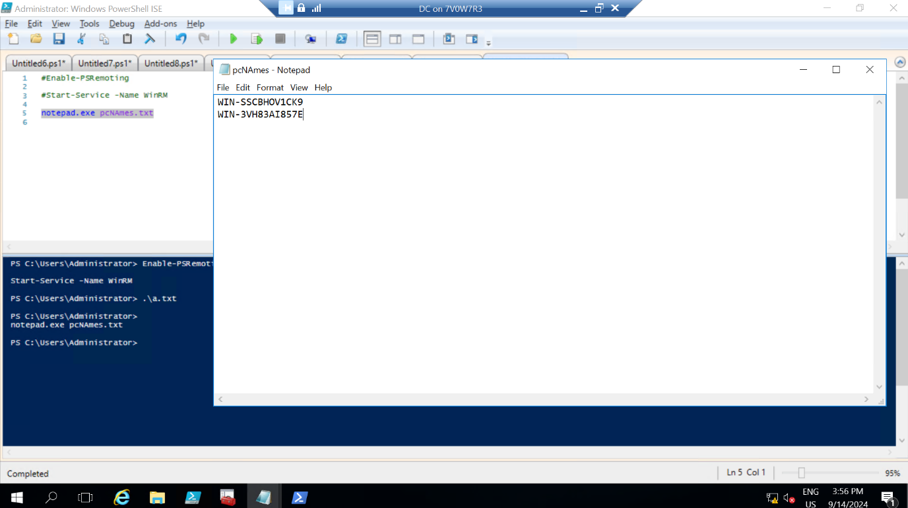

$comp = Get-Content .\pcNAmes.txt

Invoke-Command -ComputerName $comp -ScriptBlock{

New-Item -Path c:\ansh -ItemType Directory -Force

}

1. Ansh is a directory name is created in both the machines
2. A screenshot of a computer

   Description automatically generated
3. Can see the folder name “ansh” which was previously not there
4. Now use command

New-PSSession -ComputerName WIN-3VH83AI857E

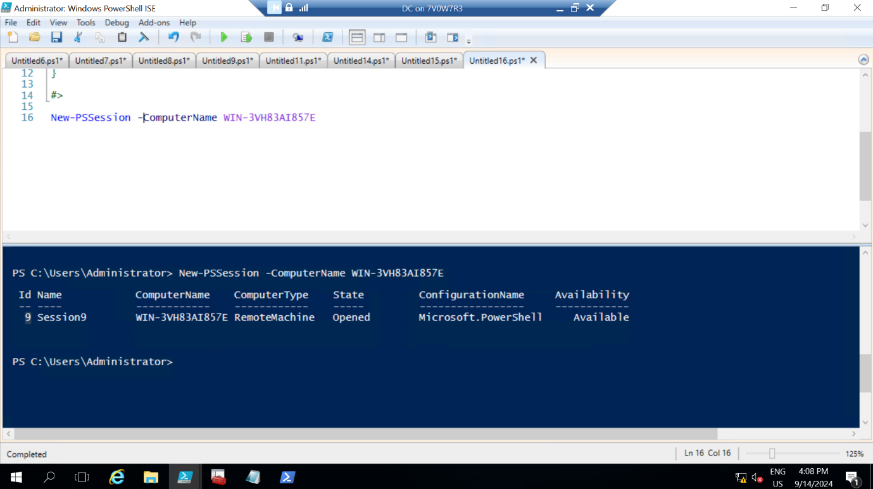

You can see my session id is “9”.

So ill use 9

Now use command

Enter-PSSession -id 9

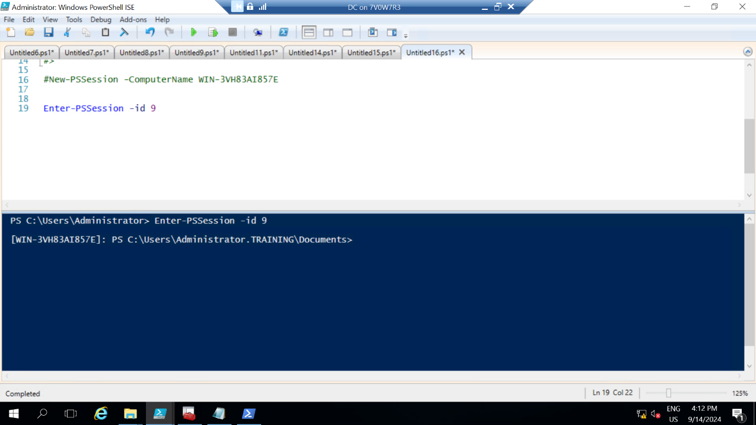

Now you can see the difference.

And now

Can see the folder’s and now ill make folder here with the help of remoting

Go to dc

Go to location c:\

And use command “mkdir remote_folder”

Now open the member server and check folder is created or not

