Q2]

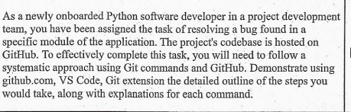

Command For GitHub

* **git clone** [**https://github.com/AayushD15/DevOps.git**](https://github.com/AayushD15/DevOps.git)

This command creates a local copy of the project's repository on your machine.

* **cd .\DevOps\**

This changes the current working directory to the cloned repository.

* **git checkout -b fix-bug-123**

This creates a new branch named "fix-bug-123" and switches to it, allowing you to work on the bug fix without affecting the main codebase.

* **git add Hello.py**

This command stages the modified module file, preparing it to be committed.

* **git commit -m "Fix bug #123 in module_file.py"**

This creates a new commit with the bug fix, using the provided commit message.

* **git push origin fix-bug-123**

This command pushes the "fix-bug-123" branch to the remote repository, making the changes available for review.

Output of Commands

1]

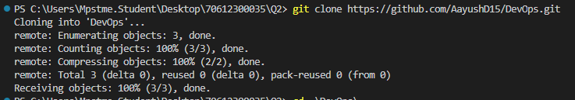

2]



3]



4]

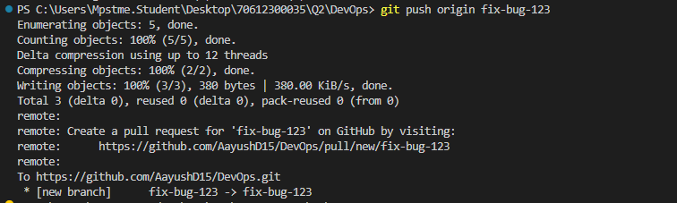

Output:



