**IPR CELL**

**DESIGN REQUISITES DRAFT**

1. **Full Name and Address of the inventor(s) and applicant(s)**

**Ramdeobaba University, Nagpur**

|  |  |  |  |  |  |
| --- | --- | --- | --- | --- | --- |
| **SN** | **Name of applicant** | **Designation Faculty /UG/PG**  **student/Research scholar** | **E mail ID** | **Mobile Number** | **Address** |
| **1.** | **Ramdeobaba University, Nagpur** | **RBU** | [**ipr@rknec.edu**](mailto:ipr@rknec.edu) | **-** | **Ramdeobaba University, Nagpur** |
| **2.** | **Dr.Chithraja Rajan** | **Faculty** | **rajanc@rknec.edu** | **9400317219** | **Ramdeobaba University, Nagpur** |
| **3.** | **Priti Dubey** | **Student** | **dubeypp_1@rknec.edu** | **9284092073** | **School of Computer Science and Engineering,**  **Ramdeobaba University, Nagpur** |
| **4.** | **Ayush Goyal** | **Student** | **goyalar_1@rknec.edu** | **8767593598** | **School of Computer Science and Engineering,**  **Ramdeobaba University, Nagpur** |
| **5.** | **Kunal Pusdekar** | **Student** | **pusdekarkw@rknec.edu** | **9561126268** | **School of Computer Science and Engineering,**  **Ramdeobaba University, Nagpur** |
| **6.** | **Piyush Sharma** | **Student** | [**sharmapa_1@rknec.edu**](mailto:sharmapa_1@rknec.edu) | **8668379551** | **School of Computer Science and Engineering,**  **Ramdeobaba University, Nagpur** |
| **7.** | **Divyansh Kumbhat** | **Student** | **kumbhatd@rknec.edu** | **9561126268** | **School of Computer Science and Engineering,**  **Ramdeobaba University, Nagpur** |

# AI-Powered Intelligent Access Control System with Face Detection Using ESP32 CAM

**Working:-**

* + **Power On:** The system is powered on, initializing the ESP32 CAM, relay module, and solenoid lock.
  + **Face Detection Activated:** The ESP32 CAM activates the AI-powered face detection feature, continuously scanning for a face in front of the camera.
  + **Face Recognition:** Once a face is detected, the AI processes the image and compares it with stored data to identify the person.
  + **Authentication Check:** If the face matches the authorized users, the system sends a signal to the relay module.
  + **Door Unlocks:** The relay module activates the solenoid lock, unlocking the door and allowing access.
  + **LED Indication:** The LED lights up to indicate successful authentication and unlock.
  + **System Loop:** The system resets and continuously monitors for new face detections, providing real-time access control.

# Advantages:-

* + **Enhanced Security:** The AI-powered face detection system ensures that only authorized individuals can unlock the door, providing high-level security.
  + **Hands-Free Operation:** No need for physical keys or cards; the system offers a seamless and contactless access solution.
  + **Fast Authentication:** Real-time face recognition allows for quick and efficient authentication, reducing wait times at the door.
  + **Energy Efficient:** The system operates on low power, using components like the ESP32 CAM and solenoid lock, ensuring minimal energy consumption.
  + **Customizable Access Control:** User access can be easily updated by modifying the stored data, providing flexibility for adding or removing users.
  + **Scalability:** The system can be scaled for multiple doors or integrated into larger smart home or office environments.
  + **Data Logging:** The system can be configured to log access attempts and successful entries, providing useful data for security audits.
  + **Cost-Effective:** Using affordable components like the ESP32 CAM and relay modules, the system offers a low-cost yet powerful solution for intelligent access control.

# Innovation:-

* + **AI-Driven Adaptive Learning:** The face recognition system uses AI to continuously improve accuracy by learning from new data and adapting to different lighting and angles.
  + **Multi-Factor Authentication Integration:** The system can be enhanced to include voice or gesture recognition for additional layers of security.
  + **Remote Monitoring & Control:** Users can manage access remotely via a mobile app, allowing them to lock/unlock doors and receive notifications in real-time.
  + **Battery-Powered Backup System:** In case of power failure, the system can operate on a backup battery, ensuring uninterrupted access control.
  + **Low-Power Sleep Mode:** The system can enter a low-power sleep mode when idle, conserving energy and only activating face detection when motion is detected.
  + **Tamper Detection Alerts:** The system can be designed to trigger alerts if there is any attempt to tamper with the door or components.
  + **Customizable LED Status Indicator:** The LED light system can be customized to show different colours for various states, such as successful unlock, denied access, or system errors.

# New :-

* **Integration with IoT and Cloud Services:** The system can be connected to the cloud for centralized monitoring and management of multiple access points, with real-time data accessible from anywhere.
* **Mobile App for User Access:** A user-friendly mobile application can allow remote unlocking, access logs, and face data management, enhancing convenience and control.
* **AI-Powered Predictive Security Analytics:** AI algorithms can analyze entry patterns and predict potential security risks, providing alerts for unusual access behaviors.
* **Smart Alerts and Integration with Security Systems:** The system can send automatic alerts to security personnel or homeowners via SMS or app notifications in case of unauthorized access attempts or system failures.
* **Scalability to Commercial and Industrial Settings:** The system can be expanded for use in commercial and industrial environments, managing access for large facilities with multi-level security features.
* **Voice-Enabled Access Integration:** The system can integrate with voice assistants, allowing users to control door access via voice commands for a

seamless smart home exper

**4.Photographs/ Drawings of articles in Seven Views**

**Front View**

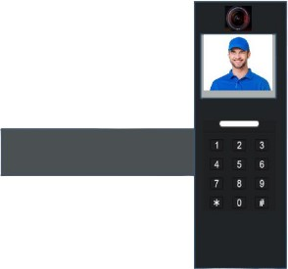

Back View



Top View:

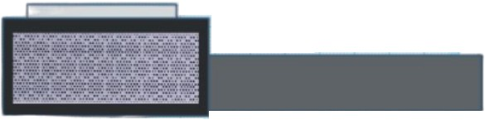

Left view:



RIGHT VIEW:

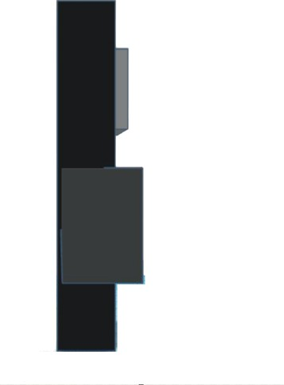

Isometric View:

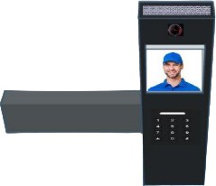

Bottom View:

