Observable-preserving correction of hidden error in reduced-order models
Ansh Mishra1* and Aryan Senthilkumar1
1 Independent researchers. *e-mail: correspondence to A.M.

Abstract
Reduced-order models accelerate simulation by evolving a small subspace of a high-dimensional state, but they accumulate error, and most of that error collects in coordinates the model does not report. We show that this hidden error can be reconstructed from the model's own inconsistency with the governing equations — using no observations and no reference trajectory — and that correcting it improves subsequent forecasts of the reported quantities while leaving every reported quantity bit-for-bit unchanged. Across 36 controlled interventions in three-dimensional Navier–Stokes the correction reduced future observable error by 39.4% in every case, while a sign-reversed control degraded it in every case. We derive a reachability bound that determines what any hidden correction can achieve, confirmed without exception over 300 test windows, and an exact identity that predicts the achievable improvement from two computable quantities. The identity holds to at most 5.4 × 10⁻¹² across four systems spanning quadratic and cubic nonlinearity, spectral and finite-difference discretisation, and modal and point-sensor observables. Because the improvement can be predicted before acting, the method selects its own correction and declines when none would help, outperforming a tuned ensemble variational scheme that consumes observations the method never sees. The approach corrects reduction error and assumes the governing equations are correct: under deliberate model-form error its predictions become optimistic, which bounds its scope and identifies observation-driven assimilation as its complement rather than its competitor.

Main
Simulating a turbulent flow, a combustor, or a climate subsystem at full fidelity is often unaffordable, and reduced-order models (ROMs) substitute a low-dimensional surrogate for the full state¹·². Every such surrogate is wrong, and a large literature addresses how wrong: a posteriori error estimators certify accuracy³⁴, adjoint-weighted residuals identify where refinement pays⁵⁶, and closure models supply the terms projection discards⁷⁸. What unites these approaches is that they estimate or bound an error magnitude in order to improve the model.
We take a different object as the target. Partition the state by a fixed projector P selecting the coordinates the model is required to report — spectral modes, sensor readings, an engineering functional — and let Q = I − P be its complement. Any error splits exactly as e = Pe + Qe. The resolved part Pe is visible and measured. The unresolved part Qe is invisible to every reported quantity, and it is where most accumulated error lives: in our Navier–Stokes testbed the hidden component exceeds the visible one by a factor of 23 at late times.
Hidden error is not inert. Nonlinear dynamics transport a fraction of it back into the reported coordinates, where it accounts for roughly 45% of late single-segment drift. This raises a question that error estimation does not address: can the hidden component be reconstructed and removed, and does doing so improve what the model reports?
Both halves are non-obvious. Reconstruction appears to require the reference trajectory, which is the object the ROM exists to avoid computing. And a correction confined to Q changes nothing observable at the moment it is applied, so any subsequent improvement must arrive through the dynamics rather than through the correction itself.

Reconstructing hidden error without a reference
The route around the reference trajectory is the model's own inconsistency. Let Φ be the full-order flow map over one segment and Vₖ the reduced state. The defect
ηₖ = Φ(Vₖ) − Vₖ₊₁ (1)
asks where the true equations would carry the model's current state relative to where the model went. It requires no knowledge of the truth. Writing eₖ = Uₖ − Vₖ for the true error, an exact identity follows by adding and subtracting Φ(Vₖ), and Taylor expansion gives
eₖ₊₁ = ηₖ + Jₖ eₖ + ½ Hₖ[eₖ , eₖ] + O(‖eₖ‖³) (2)
with J and H the first and second derivatives of the flow map. Every term on the right is computable from the reduced trajectory alone, so the recurrence can be run blind. Defect-based corrections have been used to make error estimators independent of the time-integration scheme⁹, where the defect is the local truncation error of an imposed scheme measured on full-order snapshots⁹; equation (1) is a different object — the mismatch between the full flow map and the reduced model's own step — computed online with no training data, and used to reconstruct an error vector rather than to bound a magnitude.
Across 132 test points spanning four flow topologies and three viscosities, the reconstructed hidden component matched the true one to a median relative residual of 1.06 × 10⁻⁴, with a direction cosine of 0.99999999 and an amplitude ratio of 1.0000108. The second-order term in equation (2) is essential: retaining only the linear term degrades the reconstruction by a median factor of 44.8, and every one of the 132 points improved when it was included.

Hidden state carries causal information
Because a correction c ∈ range(Q) satisfies P(V + c) = PV identically, the intervention can be made rigorous. From a single reduced state we evolved four branches with identical reported coordinates: the uncorrected baseline; the truth-free estimate V + Qê; a sign-reversed control V − Qê of the same magnitude; and an oracle V + Qe using the true hidden error. The measured mismatch in the reported coordinates at the moment of intervention was 0.000 × 10⁰ — exactly zero, not approximately.
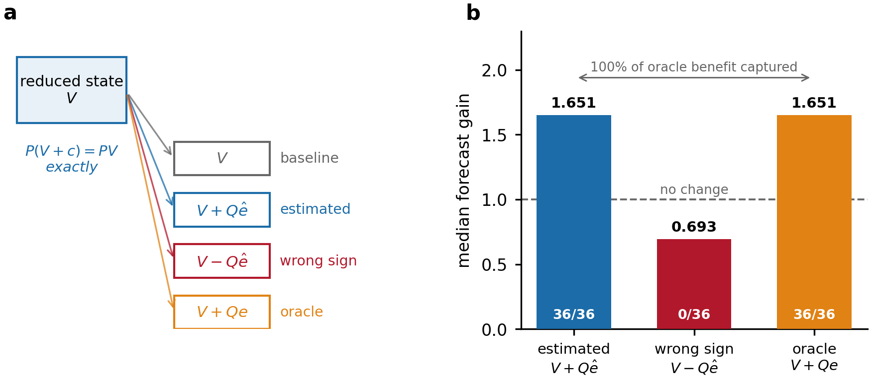
Fig. 1 | The observable-preserving intervention. a, Four branches are evolved from one reduced state. A correction confined to the unresolved block leaves every reported coordinate bit-for-bit unchanged, so the branches are indistinguishable to any measurement at the moment of intervention. b, Median forecast gain over 36 interventions in three-dimensional Navier–Stokes (12 flow configurations × 3 intervention times). The truth-free estimate improved the forecast in every window; the sign-reversed control, of identical magnitude, degraded it in every window. Bar labels give the number of windows improved.
The estimate improved the future reported error in 36 of 36 windows, with a median gain of 1.651 (39.4% error reduction) and a tenth percentile of 1.300. The sign-reversed control degraded it in 36 of 36, median gain 0.676. The estimate captured 100% of the oracle's benefit, so the truth-free reconstruction is not the limiting factor.
The wrong-sign arm is what makes this causal rather than correlational. For small corrections the observable response is Δ(±c) = ±Tc + ½H[c,c] + O(‖c‖³), so reversing the sign flips the leading directional transfer while leaving the curvature unchanged. A perturbation of the right magnitude but arbitrary direction cannot produce this asymmetry. Consistent with this, degrading the estimate with random noise in Q at relative amplitudes from 0.03 to 1.00 — a 33-fold range — moved the median gain by 2%, because a random direction in a space of dimension 10⁵ has negligible overlap with the few directions that transport error into the reported block.

What a hidden correction can reach
The improvement is bounded, and the bound is structural. For an anchored projection ROM with reduced subspace S, one segment from anchor A returns A + s with s ∈ S. For any c ∈ range(Q), the increment is c + sᶜ with sᶜ ∈ S, and applying P annihilates c, so
Δ(c) = P[Ψ(V + c) − Ψ(V)] = P sᶜ ∈ P·S (3)
for every hidden correction. The observable effect of any such correction is confined to the image of the reduced subspace under P. Writing ρ for the fraction of the baseline observable error lying in that image, the achievable gain obeys
gain ≤ 1 / √(1 − ρ²) (4)
Neither the size of the hidden reservoir nor the accuracy of the reduced model appears in this bound. We tested it on 20 unseen initial conditions across five reduced-model variants at three intervention times — 300 windows — constraining in each the truth-free correction and the oracle correction separately, since the bound covers every hidden correction. There were no violations in any of the 600 comparisons.
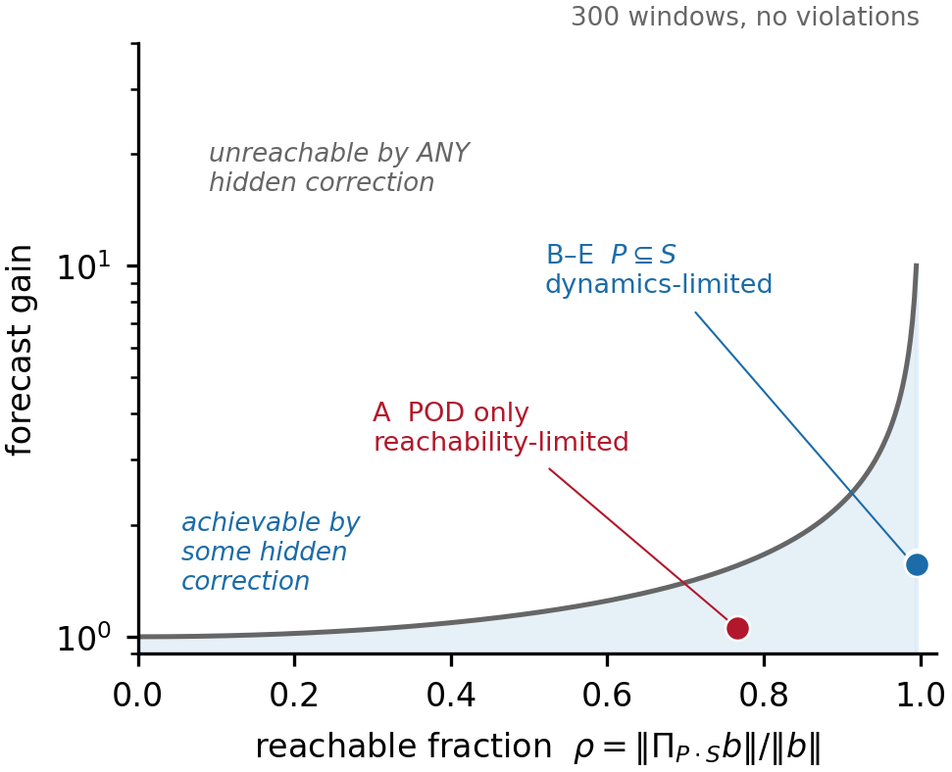
Fig. 2 | The reachability bound. Achievable gain against the reachable fraction ρ, with the bound of equation (4). A proper-orthogonal-decomposition subspace that does not contain the reported coordinates (variant A) is reachability-limited: only 77% of its observable error is attainable by any hidden correction, and it realises 70% of a hard ceiling of 1.555. Variants B–E, whose subspaces contain P, face no such constraint and are limited by the dynamics instead. Points are medians over 20 unseen initial conditions.
The bound binds only when the reduced subspace is impoverished by construction. Probing the dynamical transport operator T = P·DΦ·Q directly and projecting the error forecast onto its range gives a reachable fraction of exactly 1.000 in every window tested (n = 63, four dynamical regimes), with the rank of T equal to the full observable dimension. A map from roughly four hundred unresolved coordinates into twelve reported ones is generically surjective, so every reported direction is reachable by some hidden correction and the ceiling is vacuous. Correctability is therefore not limited by WHICH directions a hidden correction can reach; it is limited by the size and alignment of the response, which is what the next section quantifies.
This yields a design condition. Containing the reported coordinates inside the reduced subspace removes the reachability constraint; nothing else in the model does. Attributing the difference between a plain POD subspace (gain 1.054) and one containing P (1.583) on a logarithmic scale assigns 101.1% to containment, 0.1% to the local trajectory jet, and −1.2% to retaining the global POD modes. Notably, adding the trajectory jet reduces baseline model error eighty-fold while contributing essentially nothing to correctability: what makes a reduced model accurate is not what makes it correctable.

An exact law for the achievable improvement
Within the reachable set, the realised improvement is fixed exactly by two quantities. With b the baseline future observable error and Δ the observable effect of the correction,
gain = ‖b‖ / ‖b + Δ‖ = 1 / √(1 + 2λ cos θ + λ²) (5)
λ = ‖Δ‖ / ‖b‖ cos θ = ⟨b, Δ⟩ / (‖b‖ ‖Δ‖) (6)
Equation (5) is algebra rather than a model: λ measures how large the hidden contribution to the observable error is, and cos θ how well it opposes that error. Neither the hidden-reservoir ratio nor the reachable fraction appears, which is why three candidate correlational explanations for effect size failed before this identity was written down.
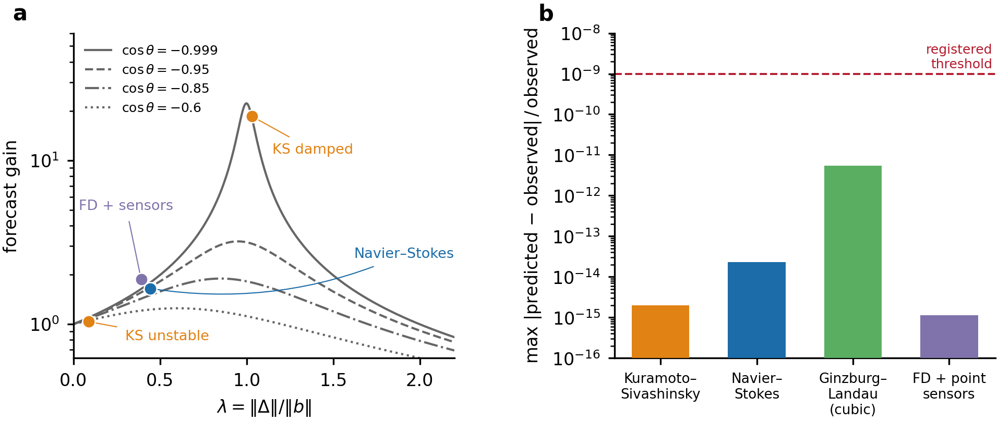
Fig. 3 | The effect-size law. a, Equation (5) for four values of the alignment cos θ, with measured systems overlaid. Gain rises sharply as λ approaches unity and the correction becomes well-opposed to the existing error. b, Maximum relative discrepancy between predicted and observed gain, per window, across four systems: Kuramoto–Sivashinsky and Navier–Stokes (quadratic nonlinearity, spectral, modal observables), complex Ginzburg–Landau (cubic nonlinearity), and finite-difference Kuramoto–Sivashinsky observed through point sensors. Dashed line, the threshold registered before the tests were run.
The identity holds to at most 5.4 × 10⁻¹² across all four systems, and to 2 × 10⁻¹⁵ on two of them. It also explains variation within a single system: across the twelve Navier–Stokes configurations λ ranges from 0.236 to 0.813 and the Spearman correlation between λ and realised gain is 0.986, with predicted and oracle gains agreeing to four decimals in all twelve. Where cos θ turns positive the law predicts that correction should harm, and it does: in one regime the gain falls to 0.966 while the sign-reversed arm rises to 1.097.

Where the law applies
Equation (5) is exact by construction, but predicting λ in advance requires a linear-response argument, and that argument has a boundary. Holding the solver, the equation, the discretisation and the observable dimension fixed and changing only the character of the observable, the reconstruction error of the predictive form separates by a factor of 200: 0.003 for modal observables against 0.55 for point sensors.
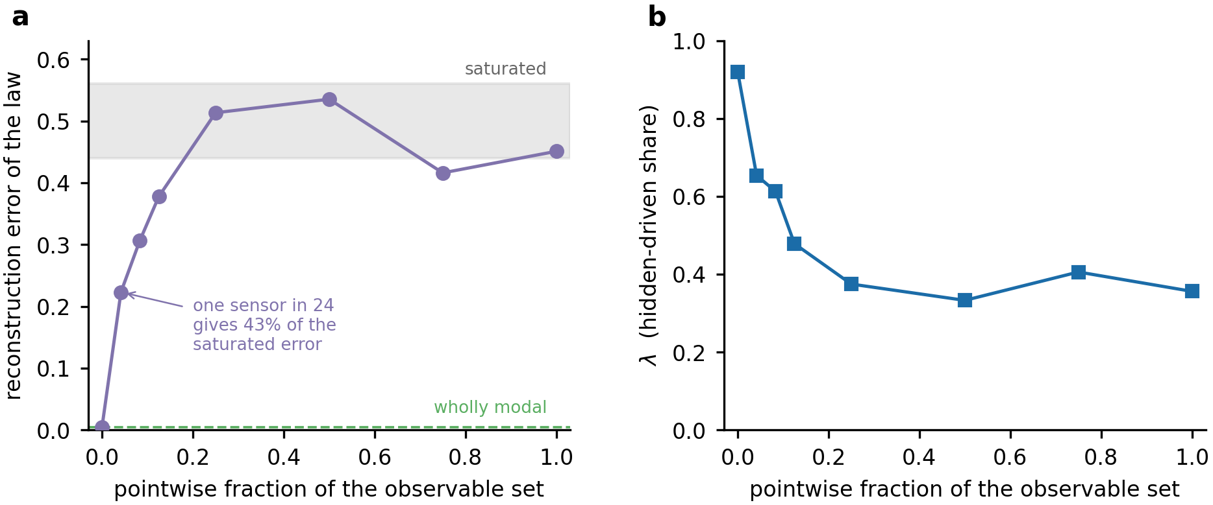
Fig. 4 | The validity boundary is set by the observation operator. a, Reconstruction error of the predictive form against the pointwise fraction of the observable set, at fixed total dimension (24 directions, n = 160). One point sensor among 23 modal directions already produces 49% of the saturated error; three produce 84%; the curve saturates by a quarter. b, The hidden-driven share λ falls monotonically as the observable set becomes more pointwise, so pointwise observation changes the quantity being measured and not merely its representability.
The mechanism is directional, not a matter of scale. Testing linearity directly by scaling the perturbation over three decades, the response ratio converges for both observable types, so a linear limit exists in both cases and the pointwise response is differentiable. What differs is where that limit points: the cosine between the infinitesimal and finite-amplitude responses converges to 0.965 for modal observables and 0.685 for pointwise ones. The derivative is well defined and simply does not represent the response at the amplitudes that matter, so reducing the perturbation cannot recover the prediction. Magnitude nonlinearity is harmless — the modal response is twice its linear prediction and the law still holds — whereas directional rotation is fatal.

Selecting the correction without a reference
Because equation (5) is built from quantities the reduced model can evaluate for itself, the improvement can be predicted before acting. Propagating the defect recurrence forward supplies an estimate b̂ of the future observable error; evaluating the reduced model from perturbed states supplies the response Δ̂ to each candidate correction; and the predicted gain is Ĝ = ‖b̂‖ / ‖b̂ + Δ̂‖. No reference trajectory is consulted at any point.
Ĝ predicts the realised gain with a Spearman correlation of 1.0000 on Kuramoto–Sivashinsky, 0.9997 on Ginzburg–Landau, 1.0000 on the finite-difference sensor system, and 1.0000 in three-dimensional Navier–Stokes, with median relative error 0.0000. The method therefore chooses among candidate corrections — hidden-only, observable-only, and a range of amplitudes — and declines when no candidate is predicted to help.
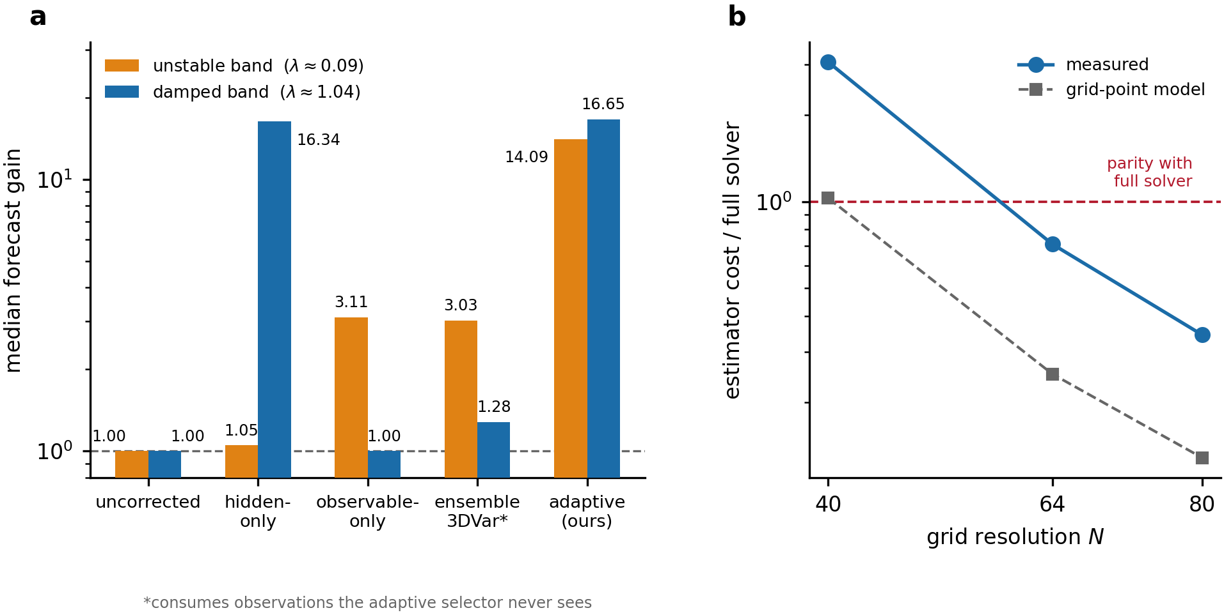
Fig. 5 | Adaptive selection and cost. a, Median forecast gain in two dynamical regimes, n = 60 windows each. Hidden-only correction is dominant where the hidden-driven share λ is large and near-useless where it is small; observable-only correction reverses. Selecting between them using only the model's own prediction wins in both, and exceeds an ensemble variational scheme that consumes observations the selector never sees. b, Measured wall-clock cost of the estimator relative to one full-solver segment, against grid resolution, with the grid-point cost model for comparison. The estimator becomes cheaper than the solver it corrects between N = 40 and N = 64.
The regimes reverse completely. Where λ ≈ 1.04 the hidden-only correction gives 16.34 and the observable-only correction gives nothing; where λ ≈ 0.09 the ordering inverts and hidden-only correction is the weakest method tested. The selector resolves this without seeing λ or any reference, choosing observable-touching corrections in 51 of 60 windows in the first regime and hidden-only in 51 of 60 in the second. In three-dimensional Navier–Stokes it reached 3.811 against 2.119 for the best fixed strategy.
The decomposition matters for interpretation. Holding the amplitude fixed at unity, selection between correction subspaces yields only 1–2% over the best fixed strategy; the remaining factor comes from amplitude selection. Subspace selection buys correctness of regime, amplitude selection buys magnitude, and both are required.
Against an ensemble variational baseline the comparison is deliberately unfavourable to our method: the baseline is given true observations of the reported coordinates at the analysis time, with a background covariance estimated from the model's own error ensemble, and it corrects the hidden block through the observation via cross-covariance. It attained 1.28 and 3.03 in the two regimes against 16.65 and 14.09 for the truth-free selector, and was insensitive to its observation-error parameter across four decades. This is a single-time, static-covariance scheme; we do not claim to have outperformed data assimilation in general.

Cost
The estimator evaluates the full flow map, which would be self-defeating if it were required at full resolution. It is not: the directions that transport hidden error into the reported block sit at wavenumbers 4.5–8.2 across every topology and viscosity tested, set by the reported band and the energy-containing scales rather than by the dissipation range. The defect can therefore be computed on a coarse grid, and the coarse resolution required falls as the fine grid is refined — in eight cases spanning three resolutions, it decreased or held constant in all eight and increased in none.
Measured wall-clock cost of the estimator relative to one full-solver segment is 3.06 at N = 40, 0.711 at N = 64 and 0.343 at N = 80. A grid-point count underestimates this by factors of 2.6 to 24, because the coarse evaluation is latency-bound rather than arithmetic-bound: per-call cost is identical at coarse grids of 28, 20 and 14 modes, while the fine solver scales as N³ to within 15%. The correct model is a fixed floor rather than a ratio, so the saving is whatever the solver costs above that floor and grows with resolution.

Generality
The mechanism is not specific to the reduced model in which it was found. Under a frozen-basis protocol — basis built from twelve training trajectories, rank selected on a separate validation split, evaluation on twenty unseen initial conditions, statistics over independent trajectories — a proper-orthogonal-decomposition ROM showed the same behaviour: improvement in 20 of 20 trajectories and 60 of 60 windows, the sign-reversed control losing in 20 of 20, and 100.04% of the oracle benefit captured.
Table 1 | Transfer across systems.
System | Nonlinearity | Discretisation | Observable | Causal signature
Navier–Stokes | quadratic | spectral | modal | 36/36
Kuramoto–Sivashinsky | quadratic | spectral | modal | 12/12 configs
Ginzburg–Landau | cubic | spectral | modal | 120/120
Kuramoto–Sivashinsky | quadratic | finite difference | point sensors | 36/36
A prospective test on complex Ginzburg–Landau, with four predictions registered before the run, passed all four at n = 120. Its cubic nonlinearity matters: the other systems are exactly quadratic, a property the estimator exploits, and the identity's survival there shows it is not an artefact of that structure.
The observation operator generalises to instrument readings. Replacing the spectral projector with point velocity probes in a three-dimensional flow, the correction left all twenty-four probe readings identical to a relative 3.1 × 10⁻¹¹ while improving the next reading from those same probes by 46.8%, in 36 of 36 windows. We note that the baseline model error in this configuration is 0.56%, an order of magnitude below the 1.8–11.3% band of the frozen-basis test above; the result demonstrates the observation operator at three-dimensional scale on an already accurate model, and a repetition at larger baseline error would strengthen it.
Run in closed loop over six segments and gated on its own predicted improvement, the method reduced observable error from 6.276% to 0.129% — a factor of 48.5 — without divergence in any of twelve configurations, and with a median final error fourteen times the estimator's own noise floor, confirming that the loop corrects rather than reconstructs.

The scope limit: correct equations
Every experiment above generates the reference trajectory from the same governing equations the reduced model projects, so the only error present is reduction error. Deployed models are not generally like that: they carry mis-specified coefficients and missing terms. The distinction matters because the defect of equation (1) then contains two different objects. Reduction error is a state error and is correctable. Model-form bias is a persistent difference between two equations, and no change of state can remove it.
We tested this by evolving the reference under the exact equation while the model — both the reduced model and the full map inside the estimator — used a single coefficient scaled by 1 + δ, for each of the three terms in turn (n = 100 per term). Two things survive and one does not. The causal signature is unaffected: the correctly signed correction beat its reverse in 20 of 20 windows at every δ in every term, so hidden state error remains real and remains transported even when the equations are wrong. The gain degrades, as it must, because a growing share of the reported error is bias rather than state error.
The predictor, however, does not stay honest. At δ = 0.10 the method retains roughly a tenth of its benefit while reporting that it retains about two thirds; the ratio of predicted to realised gain rises from 0.99 at δ = 0 to 6.1 and 6.3 for the two dissipative terms. The reason is structural rather than a defect of implementation: the bias enters the reduced model and the estimator identically, so the method is internally consistent and cannot detect the inconsistency. It corrects accurately toward its own attractor, which is no longer the true one. Perturbing the transport coefficient is the mild case, at 2.3, so model error in the dissipative terms is what breaks calibration.
This bounds the method precisely. It addresses reduction error and assumes the governing equations are correct, and its trust gate is calibrated against reduction error alone. Detecting model-form error requires information the method deliberately does not use — which is exactly what observations supply. That makes observation-driven assimilation the natural complement to this approach rather than its competitor.

Discussion
The results establish that a reduced model's unreported state carries recoverable, causally relevant information about the future of what it does report, and that the information can be extracted from the model's own inconsistency with the governing equations. Two bounds delimit what follows: equation (4) fixes what any hidden correction can reach, and equation (5) fixes what it will achieve within that reach.
The practical consequence is a correction that knows its own worth in advance. Because Ĝ predicts the realised gain essentially exactly, the method is never a gamble: it selects the correction that suits the regime and declines when none would help. Fixed-amplitude correction degraded 4.2% of windows in one regime; predicted-amplitude selection eliminated all of them, with a worst case of exactly no change. This occupies a gap that data assimilation cannot: assimilation requires observations¹⁰,¹¹, and this requires none.
Three limitations bound the claim. The predictive form of the effect-size law applies to modal observables and degrades steeply once the observable set contains pointwise functionals — the identity remains exact, but λ ceases to be predictable in advance. Hidden-state correction is the wrong instrument when λ is small, and although the method detects this and switches, the detection rather than the correction is what carries that regime. And the estimator is cheaper than the solver only above roughly N = 64; below that it buys accuracy at a cost premium.
The most consequential open question is what sets λ, and five attempts to answer it place the obstruction in one place. Response alignment against observable dimension, and an advective-locality group built from transport distance and sensor spacing, were both tested and rejected. A closed form in the hidden-driven share failed, and failed further when its neglected term was restored. The geometric route is vacuous, as shown above: the reachable set is the whole reported space.
What does survive is an empirical transfer. The ratio of hidden-block to observable-block response is computable without a reference, tracks its own truth-free estimate at Spearman 1.0000, and orders λ across a 24,000-fold range. Fitting a single monotone calibration of λ against that ratio on Kuramoto–Sivashinsky alone, freezing it, and applying it without refitting to complex Ginzburg–Landau and to the finite-difference sensor system (n = 89 held out) orders λ at Spearman 0.72 and halves the error of a constant baseline. But the calibration over-predicts the pointwise-observable system by a factor of about 2.5 while transferring accurately across the quadratic-to-cubic boundary.
The failure is therefore the same boundary reported above, reached by an independent route: λ transfers across equations and nonlinearity classes and not across observation-operator classes. A predictive theory of correctability, as distinct from a transferable ordering, remains open, and the evidence indicates it will have to account for the observation operator rather than the dynamics alone.

Methods

Governing equations and discretisation
Incompressible Navier–Stokes was solved pseudospectrally on a periodic box of side 8.0 in rotational form, with Leray projection and two-thirds dealiasing applied after every nonlinear evaluation, and advanced by classical fourth-order Runge–Kutta. The right-hand side is exactly quadratic in the state, so central differencing of the Jacobian carries zero truncation error; the entire finite-difference residual is floating-point roundoff amplified by the inverse step. This was verified directly: across twelve flow-viscosity cases the single- to double-precision residual ratio was 5.385 × 10⁸ against a machine-epsilon ratio of 5.369 × 10⁸, agreeing to 0.3%. All reported results use double precision with an analytically derived Jacobian-vector product; single precision was found to inflate the measured improvement, and the correction is documented in Supplementary Information.
Kuramoto–Sivashinsky¹²,¹³ was solved in one dimension both pseudospectrally and, independently, by second-order finite differences with no spectral operators anywhere in the solver. Complex Ginzburg–Landau¹⁴ was solved pseudospectrally; its cubic nonlinearity makes the Jacobian real-linear rather than complex-linear, so the state is treated as a real vector space with conjugate-symmetric basis pairs and real reduced coordinates.

Observable projector
The Navier–Stokes projector selects 24 Fourier modes forming 12 conjugate pairs at wavenumber magnitudes 1, √2, 4.47, 4.58 and 5, fixed in absolute wavenumber and independent of grid resolution. The conjugate-pair structure is load-bearing: constructing observable directions as independent complex unit vectors destroys Hermitian symmetry and yields a non-real field (measured imaginary-to-real ratio 1.000, against 0.000 for the paired cosine–sine construction). For sensor observables the projector is the orthonormalised span of the Riesz representers of point-evaluation functionals; the hidden block is then the null space of the measurement operator, and a hidden correction is one every instrument reads as identical.

Reduced model
The reduced subspace comprises the observable projector augmented by two hidden directions constructed from the local trajectory jet: the component of the velocity field outside the observable block, and the component of the acceleration outside the observable block and the first hidden direction. This is the dimension-minimal augmentation matching the first two trajectory derivatives with the observable projector held fixed, and it yields fourth-order local observable error against third order for velocity matching alone. Measured convergence orders were 3.965 to 3.999 with coefficient of determination 1.0000 across four topologies, and moving the fitting window tenfold earlier reduced the deviation from four by factors of 9.7 to 11.8, as the leading correction term predicts.

Intervention protocol
Interventions were performed at three times along each baseline trajectory for each of twelve configurations (four topologies × three viscosities), giving 36 windows. At each intervention four branches were launched from reduced states with identical reported coordinates and evolved independently for two segments, after which the relative error in the reported coordinates was compared against the reference. The mismatch in reported coordinates at the intervention was verified to be identically zero in every window. Gate thresholds were fixed before each run and were not adjusted; where a gate failed, the missing physics was diagnosed and a new test designed rather than the threshold moved.

Definition of the effect-size quantities
Throughout, Δ denotes the FINITE-AMPLITUDE observable response to the correction, Δ = P[Φ_ROM(V + Qe) − Φ_ROM(V)], evaluated by running the reduced model from the perturbed state; it is not a linearisation. The baseline observable error is b = P[Φ_ROM(V) − U], with U the reference. Then λ = ‖Δ‖/‖b‖ and cos θ = ⟨b, Δ⟩/(‖b‖‖Δ‖), and equation (5) follows by expanding ‖b + Δ‖². The identity is therefore exact by construction; what requires a linear-response argument, and what carries the validity boundary reported in the main text, is predicting λ in advance rather than measuring it. The reconstruction error plotted in Fig. 4 is the discrepancy between λ measured this way and the value predicted from the ratio of hidden-block to observable-block responses under that argument.

Model-form error
The reference was evolved under the exact Kuramoto–Sivashinsky equation while the reduced model and the full map inside the estimator both used a single coefficient scaled by 1 + δ, applied in turn to the advective, diffusive and hyperdiffusive terms, with δ ∈ {0, 0.005, 0.02, 0.05, 0.10} and n = 100 windows per term. δ = 0 recovers the configuration used elsewhere. The reported calibration ratio is the median of predicted over realised gain across windows.

Transport-operator reachability
The finite-time operator T = P·DΦ·Q was probed with 24 random orthonormal directions in the unresolved block at relative amplitude 10⁻⁶, the responses assembled in the packed observable coordinates, and an orthonormal basis for the range obtained by singular value decomposition. The reachable fraction is the norm of the projection of the truth-free error forecast onto that range, divided by its own norm. Singular values below 10⁻¹⁰ of the leading one were discarded.

Blind calibration transfer
A two-parameter monotone map λ = (aκ)/((aκ)^p + 1)^(1/p), chosen for its limits rather than its flexibility, was fitted by median absolute deviation on Kuramoto–Sivashinsky windows alone, written to disk, and applied without refitting to the held-out systems. Predictions were recorded before the corresponding corrections were scored. The constant baseline against which it is compared predicts the median calibration-set λ for every held-out window.

Statistical treatment
For the genericity tests, statistics are reported over independent trajectories rather than over intervention windows, since windows along one trajectory are not independent; confidence intervals are percentile intervals over trajectories. Rank correlations are used where a monotone relationship is at issue and log-log fits where an exponent is claimed, following an earlier error in which a rank correlation against a monotone function of a parameter was mistaken for evidence about a scaling exponent.

Baselines
The ensemble variational baseline is deliberately advantaged, and its exact information budget should be stated. Its background covariance is estimated from an ensemble of past error snapshots U(t_j) - V(t_j), which are formed using the reference trajectory; it additionally consumes the true observable at the analysis time. It therefore uses strictly more external information than the method it is compared against, which uses none. It applies the analysis increment B Hᵀ(H B Hᵀ + R)⁻¹(y − H x_b) with x_b the background state, solved exactly in the low-rank ensemble subspace, so that it corrects the hidden block through the observation via cross-covariance. It was checked against its observation-error parameter at 10⁻⁸, 10⁻⁴ and 10⁻², yielding gains of 1.26, 1.20 and 1.12. Because the baseline is advantaged in this way, the comparison establishes that hidden-state correction is competitive under a strictly smaller information budget; it does not establish superiority over data assimilation in general.
Full-state correction is excluded from the candidate set on grounds established by measurement rather than by preference. With an estimator of this accuracy, adding the entire estimated error reproduces the reference trajectory: in three-dimensional Navier–Stokes it yielded a nominal gain of 87.0 with a corrected error of 5.6 × 10⁻⁵, below the estimator's own residual of 1.1 × 10⁻⁴. That is state replacement rather than model correction, and its apparent gain measures estimator precision. A degeneracy guard flags any window whose corrected error falls below the estimator residual.

References
1. Benner, P., Ohlberger, M., Cohen, A. & Willcox, K. (eds) Model Reduction and Approximation: Theory and Algorithms (SIAM, Philadelphia, 2017).
2. Kramer, B., Peherstorfer, B. & Willcox, K. E. Learning nonlinear reduced models from data with operator inference. Annu. Rev. Fluid Mech. 56, 521–548 (2024).
3. Homescu, C., Petzold, L. R. & Serban, R. Error estimation for reduced-order models of dynamical systems. SIAM J. Numer. Anal. 43, 1693–1714 (2005).
4. Feng, L., Chellappa, S. & Benner, P. A posteriori error estimation for model order reduction of parametric systems. Adv. Model. Simul. Eng. Sci. 11, 5 (2024).
5. Blonigan, P. J. & Parish, E. J. Evaluation of dual-weighted residual and machine learning error estimation for projection-based reduced-order models of steady partial differential equations. Comput. Methods Appl. Mech. Eng. 409, 115988 (2023).
6. Carlberg, K. Adaptive h-refinement for reduced-order models. Int. J. Numer. Methods Eng. 102, 1192–1210 (2015).
7. Parish, E. J. & Duraisamy, K. Non-Markovian closure models for large eddy simulations using the Mori–Zwanzig formalism. Phys. Rev. Fluids 2, 014604 (2017).
8. Wang, Q., Ripamonti, N. & Hesthaven, J. S. Recurrent neural network closure of parametric POD-Galerkin reduced-order models based on the Mori–Zwanzig formalism. J. Comput. Phys. 410, 109402 (2020).
9. Chellappa, S., Feng, L. & Benner, P. Accurate error estimation for model reduction of nonlinear dynamical systems via data-enhanced error closure. Comput. Methods Appl. Mech. Eng. 420, 116712 (2024).
10. Law, K., Stuart, A. & Zygalakis, K. Data Assimilation: A Mathematical Introduction (Springer, Cham, 2015).
11. Asch, M., Bocquet, M. & Nodet, M. Data Assimilation: Methods, Algorithms, and Applications (SIAM, Philadelphia, 2016).
12. Kuramoto, Y. & Tsuzuki, T. Persistent propagation of concentration waves in dissipative media far from thermal equilibrium. Prog. Theor. Phys. 55, 356–369 (1976).
13. Sivashinsky, G. I. Nonlinear analysis of hydrodynamic instability in laminar flames. Acta Astronaut. 4, 1177–1206 (1977).
14. Aranson, I. S. & Kramer, L. The world of the complex Ginzburg–Landau equation. Rev. Mod. Phys. 74, 99–143 (2002).
15. Kalman, R. E. On the general theory of control systems. IFAC Proc. Vol. 1, 491–502 (1960).
16. Parish, E. J. & Duraisamy, K. A dynamic subgrid scale model for large eddy simulations based on the Mori–Zwanzig formalism. J. Comput. Phys. 349, 154–175 (2017).
17. Drohmann, M. & Carlberg, K. The ROMES method for statistical modeling of reduced-order-model error. SIAM/ASA J. Uncertain. Quantif. 3, 116–145 (2015).

Data availability
Console outputs, intervention tables and summary statistics supporting the findings, including the recovered experimental record with original run outputs preserved, are deposited in the project repository and are also available from the corresponding author.

Code availability
Solver, reduced-model, estimator, baseline and analysis code for all four systems is deposited in the project repository. The single-system experiments require only NumPy and run on CPU; the three-dimensional Navier–Stokes runners additionally require PyTorch and a GPU.

Author contributions
A.M. developed the computational framework and the physical formulation, implemented all numerical experiments and performed the analysis. A.S. contributed to model development and the aerodynamic formulation. Both authors discussed the results and contributed to the manuscript.

Competing interests
The authors declare no competing interests.

