Task 2: Aggregate Revenue Reporting on Orders
Write SELECT queries using aggregate functions and GROUP BY to produce a restaurant-level revenue summary from order data.
- Create an orders table with columns: order_id, restaurant_id, customer_name, total_amount, and order_date. Insert at least 12 orders distributed across at least 4 restaurants.
- Write a query to show total revenue and average order value per restaurant.
- Write a query using HAVING to list only restaurants whose total revenue exceeds Rs 5,000.
- Write a query to retrieve the 5 most recent orders using ORDER BY and LIMIT
Ans:
CREATE TABLE orders (
order_id INT PRIMARY KEY AUTO_INCREMENT,
restaurant_id INT,
customer_name VARCHAR(100),
total_amount DECIMAL(10,2),
order_date DATE
);

INSERT INTO orders
(restaurant_id, customer_name, total_amount, order_date)
VALUES
(1, 'Abhishek', 1200.00, '2026-09-20'),
(1, 'Rahul', 1800.00, '2026-09-21'),
(1, 'Amit', 2500.00, '2026-09-22'),
(2, 'Priya',1500.00, '2026-09-23'),
(2, 'Neha', 2200.00, '2026-09-24'),
(2, 'Rohit', 1800.00, '2026-09-25'),
(3, 'Ankit', 900.00, '2026-09-24'),
(3, 'Sneha', 1200.00, '2026-09-25'),
(3, 'Vikas', 1500.00, '2026-09-26'),
(4, 'Pooja', 2000.00, '2026-09-26'),
(4, 'Karan', 1800.00, '2026-09-27'),
(4, 'Simran', 2500.00, '2026-09-28');

SELECT
restaurant_id,
SUM(total_amount) AS total_revenue,
AVG(total_amount) AS average_order_value
FROM orders
GROUP BY restaurant_id;
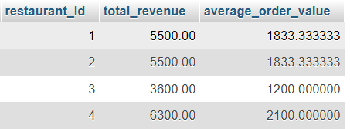

SELECT
restaurant_id,
SUM(total_amount) AS total_revenue
FROM orders
GROUP BY restaurant_id
HAVING SUM(total_amount) > 5000;
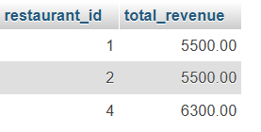

SELECT *
FROM orders
ORDER BY order_date DESC
LIMIT 5;
