Task 3: Multi-Table JOINs and Menu Summary View
Build a two-table schema for restaurants and menu items, write JOIN queries to combine data, and create a summary VIEW.
- Create two tables: restaurants (restaurant_id, name, city) and menu_items (item_id, restaurant_id, item_name, price, category). Link them with a FOREIGN KEY on restaurant_id.
- Insert at least 5 restaurants and 12 menu items; at least one restaurant must have no menu items.
- Write an INNER JOIN query listing restaurant name, item name, and price for all available items.
- Write a LEFT JOIN query so that restaurants with no items also appear in results, with NULL values in item columns.
- Create a VIEW named restaurant_menu_summary showing restaurant name, total number of menu items, and average item price grouped by restaurant
Ans:
CREATE TABLE restaurants (
restaurant_id INT PRIMARY KEY AUTO_INCREMENT,
name VARCHAR(100) NOT NULL,
city VARCHAR(50)
);
INSERT INTO restaurants (name, city)
VALUES
('Spice Garden', 'Delhi'),
('Pizza Hub', 'Mumbai'),
('Dosa Corner', 'Bangalore'),
('Royal Biryani', 'Lucknow'),
('Food Palace', 'Surat');

CREATE TABLE menu_items (
item_id INT PRIMARY KEY AUTO_INCREMENT,
restaurant_id INT,
item_name VARCHAR(100),
price DECIMAL(10,2),
category VARCHAR(50),
FOREIGN KEY (restaurant_id)
REFERENCES restaurants(restaurant_id)
);
INSERT INTO menu_items
(restaurant_id, item_name, price, category)
VALUES
(1, 'Paneer Tikka', 250.00, 'Starter'),
(1, 'Butter Naan', 60.00, 'Bread'),
(1, 'Dal Makhani', 180.00, 'Main Course'),
(2, 'Margherita Pizza', 299.00, 'Pizza'),
(2, 'Farmhouse Pizza', 399.00, 'Pizza'),
(2, 'Garlic Bread', 149.00, 'Starter'),
(3, 'Masala Dosa', 120.00, 'South Indian'),
(3, 'Idli Sambar', 100.00, 'South Indian'),
(3, 'Vada', 80.00, 'South Indian'),
(4, 'Chicken Biryani', 350.00, 'Biryani'),
(4, 'Mutton Biryani', 450.00, 'Biryani'),
(4, 'Raita', 70.00, 'Side Dish');

SELECT
r.name AS restaurant_name,
m.item_name,
m.price
FROM restaurants r
INNER JOIN menu_items m
ON r.restaurant_id = m.restaurant_id;
Output
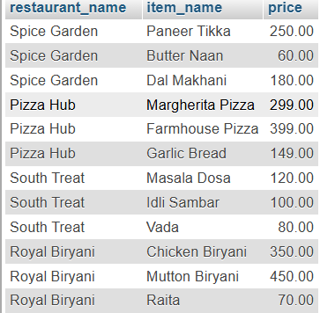

SELECT
r.name AS restaurant_name,
m.item_name,
m.price
FROM restaurants r
LEFT JOIN menu_items m
ON r.restaurant_id = m.restaurant_id;
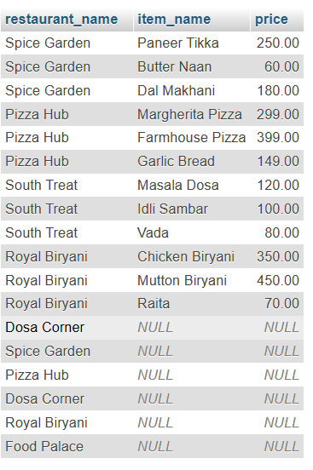

CREATE VIEW restaurant_menu_summary AS
SELECT
r.name AS restaurant_name,
COUNT(m.item_id) AS total_menu_items,
AVG(m.price) AS average_item_price
FROM restaurants r
LEFT JOIN menu_items m
ON r.restaurant_id = m.restaurant_id
GROUP BY r.restaurant_id, r.name;

SELECT * FROM restaurant_menu_summary;
