STEP 1 · BUILD WITH AI
Use an AI tool of your choice (ChatGPT, Claude, GitHub Copilot, etc.) to help you write a stored procedure that:
- Accepts a restaurant_id and a month number (1–12) as inputs and returns a summary showing total orders, total revenue, and average order value for that restaurant in that month.
- Handles the case where the restaurant has no orders in that month by returning a meaningful message rather than an empty result.
- Uses a SELECT with GROUP BY and aggregate functions to compute the summary values correctly.
- Runs successfully in MySQL Workbench — screenshot output for at least two different restaurant_id and month combinations.
STEP 2 · TEST & DEBUG (WITHOUT AI)
Then, working without AI, test the stored procedure and find at least one bug, limitation, or improvement in the AI's solution. Fix it yourself.
SUBMIT
- The exact prompt(s) you gave the AI tool.
- The AI's original stored procedure code and your corrected/improved version.
- A 3–4 line note explaining what you changed and why the AI's version needed improvement.

Ans:
- Exact Prompt Given to AI
Write a MySQL stored procedure that accepts restaurant_id and a month number
(1–12) as input parameters.
The procedure should return a summary for that restaurant in that month,
including total orders, total revenue, and average order value.
If the restaurant has no orders in that month, it should return a meaningful
message instead of an empty result.
Use SELECT, GROUP BY, and aggregate functions such as COUNT(), SUM(), and AVG().
The procedure must run successfully in MySQL Workbench.

- AI's Original Stored Procedure
DELIMITER $$

CREATE PROCEDURE get_monthly_restaurant_summary(
IN p_restaurant_id INT,
IN p_month INT
)
BEGIN

SELECT
r.name AS restaurant_name,
COUNT(o.order_id) AS total_orders,
SUM(o.total_amount) AS total_revenue,
AVG(o.total_amount) AS average_order_value
FROM restaurants r
JOIN orders o
ON r.restaurant_id = o.restaurant_id
WHERE r.restaurant_id = p_restaurant_id
AND MONTH(o.order_date) = p_month
GROUP BY r.restaurant_id, r.name;

END$$

DELIMITER ;

Testing
CALL get_monthly_restaurant_summary(1, 9);

CALL get_monthly_restaurant_summary(2, 9);
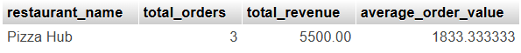

3. Corrected / Improved Version
I would improve the procedure by:
- Validating the month is between 1 and 12
- Checking whether orders exist
- Returning a meaningful message when there are no orders
- Using COUNT(), SUM(), AVG() and GROUP BY
- Also checking whether the restaurant exists

DELIMITER $$

CREATE PROCEDURE get_monthly_restaurant_summary(
IN p_restaurant_id INT,
IN p_month INT
)
BEGIN

DECLARE v_restaurant_count INT DEFAULT 0;
DECLARE v_order_count INT DEFAULT 0;

IF p_month < 1 OR p_month > 12 THEN

SELECT 'Invalid month. Please enter a month between 1 and 12.'
AS message;

ELSE
SELECT COUNT(*)
INTO v_restaurant_count
FROM restaurants
WHERE restaurant_id = p_restaurant_id;

IF v_restaurant_count = 0 THEN

SELECT 'Restaurant does not exist.'
AS message;

ELSE
SELECT COUNT(*)
INTO v_order_count
FROM orders
WHERE restaurant_id = p_restaurant_id
AND MONTH(order_date) = p_month;

IF v_order_count = 0 THEN

SELECT
'No orders found for this restaurant in the selected month.'
AS message;

ELSE
SELECT
r.name AS restaurant_name,
COUNT(o.order_id) AS total_orders,
SUM(o.total_amount) AS total_revenue,
AVG(o.total_amount) AS average_order_value
FROM restaurants r
JOIN orders o
ON r.restaurant_id = o.restaurant_id
WHERE r.restaurant_id = p_restaurant_id
AND MONTH(o.order_date) = p_month
GROUP BY
r.restaurant_id,
r.name;

END IF;

END IF;

END IF;

END$$
DELIMITER ;

4. Test the Procedure
Because your existing sample orders were inserted with the current order_date, you can first check the month:
SELECT order_id, restaurant_id, total_amount,order_date
FROM orders;
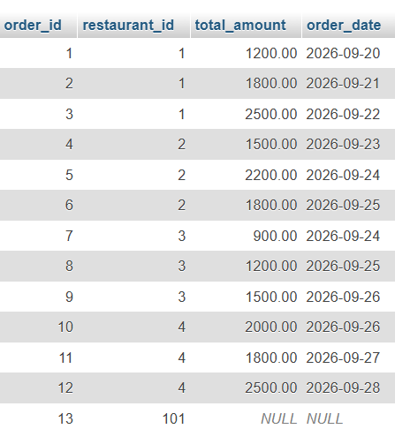
Restaurant 1
CALL get_monthly_restaurant_summary(1, 10);
Restaurant 2
CALL get_monthly_restaurant_summary(2, 10);
Test no-order condition
CALL get_monthly_restaurant_summary(1, 5);
Output:
No orders found for this restaurant in the selected month.

- 3–4 Line Note for Submission
The AI-generated procedure worked correctly when orders existed for the selected restaurant and month. However, when there were no orders, it returned an empty result instead of a meaningful message. I fixed this by adding validation for the month, checking whether the restaurant exists, and checking the order count before running the summary query. I also kept GROUP BY with COUNT(), SUM(), and AVG() to calculate the monthly summary correctly.

