SQL
Session-9
Q-1: Create a SQL script to insert a new order into an Orders table, then use COMMIT to save the transaction and verify that the new order persists after reconnecting to the database.
Ans:
START TRANSACTION;

INSERT INTO Orders (order_id, user_id)
VALUES (201, 1);

COMMIT;

SELECT *
FROM Orders
WHERE order_id = 201;
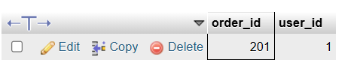
Q-2: Simulate a Zomato-style food order process: insert two new items into an OrderItems table, then use ROLLBACK to undo the changes before committing. Check that no new items remain in the table after rollback.
Ans:
START TRANSACTION;

INSERT INTO OrderItems
(order_item_id, order_id, item_name, quantity)
VALUES
(301, 201, 'Pizza', 1),
(302, 201, 'Burger', 2);

SELECT *
FROM OrderItems
WHERE order_item_id IN (301, 302);

ROLLBACK;

SELECT *
FROM OrderItems
WHERE order_item_id IN (301, 302);
Output:
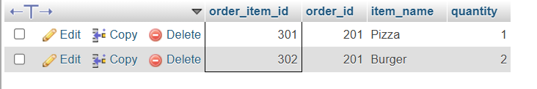

Q-3: In a Flipkart-like shopping cart scenario, use SAVEPOINT to mark a point after adding a product to the Cart table, add another product, then use ROLLBACK TO SAVEPOINT to undo only the last addition. Show the final contents of the Cart table.
Ans:
CREATE TABLE IF NOT EXISTS Cart (
cart_id INT PRIMARY KEY,
product_name VARCHAR(100),
quantity INT
) ENGINE = InnoDB;

START TRANSACTION;

INSERT INTO Cart (cart_id, product_name, quantity)
VALUES (1, 'Laptop', 1);

SAVEPOINT product_added;

INSERT INTO Cart (cart_id, product_name, quantity)
VALUES (2, 'Mouse', 1);

ROLLBACK TO SAVEPOINT product_added;

SELECT * FROM Cart;

COMMIT;
Output
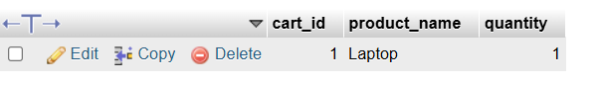
Q-4: Write a trigger on a Wallet table that automatically deducts the purchase amount from the user's balance whenever a new transaction is inserted, similar to how Paytm updates wallet balance after a payment.
Ans:
CREATE TABLE Wallet (
user_id INT PRIMARY KEY,
balance DECIMAL(10,2)
);
CREATE TABLE Transactions (
transaction_id INT PRIMARY KEY,
user_id INT,
amount DECIMAL(10,2)
);
INSERT INTO Wallet (user_id, balance)
VALUES
(1, 5000.00),
(2, 3000.00);

DELIMITER //

CREATE TRIGGER deduct_wallet_balance
AFTER INSERT ON Transactions
FOR EACH ROW
BEGIN
UPDATE Wallet
SET balance = balance - NEW.amount
WHERE user_id = NEW.user_id;
END //

DELIMITER ;
INSERT INTO Transactions (transaction_id, user_id, amount)
VALUES (101, 1, 1500.00);
Output

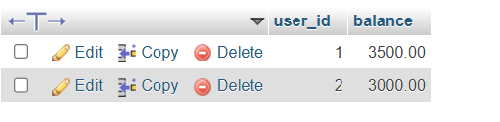
Q-5: Use ChatGPT to generate a SQL test scenario where a trigger incorrectly updates a user's balance after an expense entry. Paste the scenario and your corrected trigger code, explaining how you fixed the error.
Hint: Ask ChatGPT for a buggy trigger example and a test case that exposes the bug.
Ans:
CREATE TABLE Wallet (
user_id INT PRIMARY KEY,
balance DECIMAL(10,2)
);

CREATE TABLE Expenses (
expense_id INT PRIMARY KEY,
user_id INT,
amount DECIMAL(10,2)
);

INSERT INTO Wallet VALUES (3, 5000.00);
DELIMITER //

CREATE TRIGGER buggy_expense_trigger
AFTER INSERT ON Expenses
FOR EACH ROW
BEGIN
UPDATE Wallet
SET balance = balance + NEW.amount
WHERE user_id = NEW.user_id;
END //

DELIMITER ;

INSERT INTO Expenses
VALUES (102, 2, 1000.00);

SELECT * FROM Wallet;
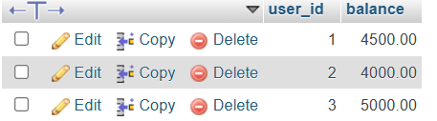
DROP TRIGGER buggy_expense_trigger;

DELIMITER //

CREATE TRIGGER correct_expense_trigger
AFTER INSERT ON Expenses
FOR EACH ROW
BEGIN
UPDATE Wallet
SET balance = balance - NEW.amount
WHERE user_id = NEW.user_id;
END //

DELIMITER ;
INSERT INTO Expenses
VALUES (103, 1, 1000.00);
SELECT * FROM Wallet;
