SQL
Session-1
Q-1: Install MySQL Workbench on your computer, connect to the local MySQL server, and take a screenshot of the default databases shown in the Schemas panel.
Ans:
Q-2: Create a new database called InstaClone in MySQL Workbench, then create a table named Users with columns: user_id (INT, primary key), username (VARCHAR), email (VARCHAR), and followers_count (INT).
Ans:
CREATE DATABASE InstaClone;
USE InstaClone;

CREATE TABLE Users (
user_id INT PRIMARY KEY,
username VARCHAR(50),
email VARCHAR(100),
followers_count INT
);
Q-3: Insert 3 sample users into the Users table you created, using realistic Instagram-style usernames and follower counts.
Ans:
INSERT INTO Users (user_id, username, email, followers_count)
VALUES
(1, "abhishek_pandey", "abhishek@gmail.com", 1698),
(2, "neha_pal", "neha@gmail.com", 567),
(3, "rishi_prajapati", "rishi@gmail.com", 1234),
(4, "sanjana_singh", "sana@gmail.com", 1785);

Output:
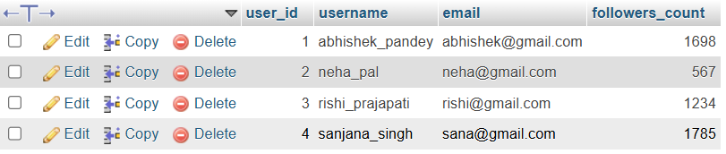

Q-4: Create another table in the InstaClone database called Posts with columns: post_id (INT, primary key), user_id (INT), caption (VARCHAR), and post_date (DATE). Add a foreign key from Posts.user_id to Users.user_id to establish a relationship.
Ans:
CREATE TABLE Posts(
Post_id INT PRIMARY KEY,
User_id INT,
caption VARCHAR(200),
post_date DATE,
FOREIGN KEY (user_id) REFERENCES Users(user_id)
);
Q-5: Write a short comparison (3-4 lines each) of MySQL, PostgreSQL, Oracle, and SQLite, focusing on where each one is commonly used (for example: web apps, mobile apps, enterprise systems, etc.).
Ans:
1. MySQL
MySQL is widely used for web applications and websites.
It is commonly used with PHP, Node.js, Python, and other backend technologies.
It is popular because it is easy to use, fast, and has a large community.
2. PostgreSQL
PostgreSQL is commonly used for web applications, data-intensive applications, and analytics.
It supports advanced SQL features and complex data structures.
It is often chosen when applications need strong data integrity and flexibility.
3. Oracle
Oracle Database is mainly used in large enterprise systems, banking, finance, and government organizations.
It is designed to handle large amounts of data and high transaction loads.
It provides advanced security, scalability, and enterprise-level features.

4. SQLite
SQLite is a lightweight database that runs inside an application without a separate database server.
It is commonly used in mobile apps, desktop applications, embedded systems, and small projects.
It is especially useful when a simple, local database is required.

