SQL
Session-5
Q-1: Create two tables in SQL: influencers (with influencer_id as PRIMARY KEY and name) and posts (with post_id as PRIMARY KEY, influencer_id as FOREIGN KEY, and caption). Insert at least 3 influencers and 2 posts for each influencer.
Ans:
CREATE TABLE influencers (
influencer_id INT PRIMARY KEY AUTO_INCREMENT,
name VARCHAR(100)
);

CREATE TABLE posts (
post_id INT PRIMARY KEY,
influencer_id INT,
caption VARCHAR(200),
FOREIGN KEY (influencer_id)
REFERENCES influencers(influencer_id)
);

INSERT INTO influencers (name)
VALUES
('Abhishek Pandey'),
('Vipul Singh'),
('Aman Gupta');

INSERT INTO posts (post_id, influencer_id, caption)
VALUES
(101, 1, 'My first post'),
(102, 1, 'Coding is fun'),
(103, 2, 'Enjoying my day'),
(104, 2, 'Travel memories'),
(105, 3, 'My new photo'),
(106, 3, 'Fitness motivation');
SELECT * FROM influencers;
SELECT * FROM posts;
Output:
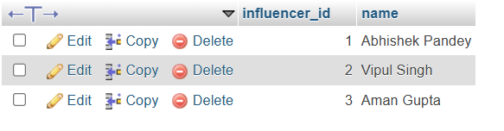
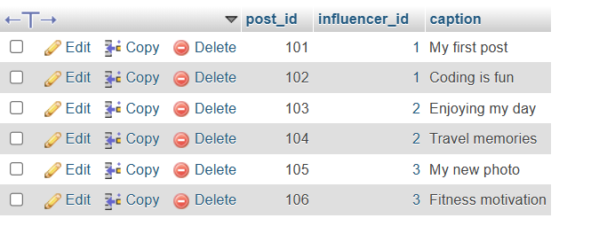

Q-2: Write an SQL query using INNER JOIN to display each post's caption along with the name of the influencer who posted it, based on the tables you created.
Ans:
SELECT posts.caption, influencers.name FROM posts
INNER JOIN influencers
ON posts.influencer_id = influencers.influencer_id;
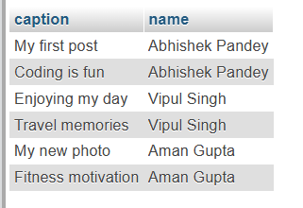
Q-3: Write an SQL query using LEFT JOIN to show all influencers and their posts, including influencers who haven't posted anything yet. If an influencer has no posts, display 'No Posts' in the caption column.
Hint: Use IFNULL or COALESCE to handle NULL values in the result.
Ans:
SELECT i.influencer_id, i.name, p.post_id,
COALESCE(p.caption, 'No Posts') AS caption
FROM influencers i
LEFT JOIN posts p
ON i.influencer_id = p.influencer_id;
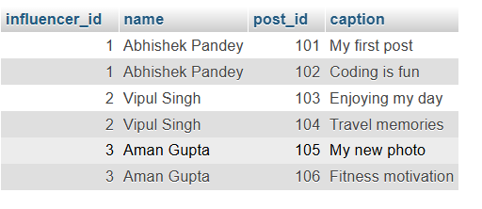

Q-4: Write an SQL query using RIGHT JOIN to list all posts and the corresponding influencer's name, ensuring that even posts without a matching influencer_id (if any) are shown.
Ans:

SELECT p.post_id, p.caption, p.influencer_id,
i.name AS influencer_name
FROM influencers i
RIGHT JOIN posts p
ON i.influencer_id = p.influencer_id;
