SQL
Session-6
Q-1: Create a SQL query using GROUP BY to show the total number of orders placed by each user in an 'orders' table, displaying user_id and order_count.
Ans:
SELECT user_id,
COUNT(*) AS order_count
FROM orders GROUP BY user_id;
Output:
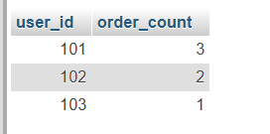

Q-2: Write a SQL query to display the names of restaurants from a 'restaurants' table that have received an average rating above 4.0, using GROUP BY and HAVING.
Ans:
SELECT name, AVG(rating) AS average_rating
FROM restaurants
GROUP BY name
HAVING AVG(rating) > 4.0;
Output:
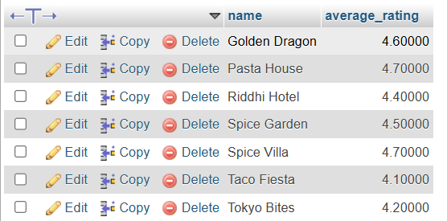

Q-3: Suppose you have a 'payments' table with columns user_id, amount, and payment_date. Write a subquery to find user_ids who have made a single payment above ₹2000 in any transaction.
Ans:
SELECT DISTINCT user_id
FROM payments
WHERE user_id IN (
SELECT user_id
FROM payments
WHERE amount > 2000
Output
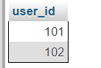

Q-4: Using a nested subquery, display the names of movies from a 'movies' table that have a higher average rating than the overall average rating of all movies.
Hint: Use a subquery to calculate the overall average rating, then compare each movie's average rating against it in the main query.
Ans:

SELECT movie_name
FROM movies
WHERE rating > (
SELECT AVG(rating)
FROM movies
);
Output


