SQL
Session-7
Q-1: Create a table called Restaurant with columns: id, name, location, and cuisine. Apply NOT NULL constraint to name and location, and make id the PRIMARY KEY.
Ans:
CREATE TABLE Restaurant (
id INT PRIMARY KEY,
name VARCHAR(100) NOT NULL,
location VARCHAR(100) NOT NULL,
cuisine VARCHAR(50)
);

Q-2: Create a table called FoodOrder with columns: order_id, restaurant_id, user_id, and order_total. Set order_id as PRIMARY KEY, and add a FOREIGN KEY constraint on restaurant_id referencing Restaurant(id).
Ans:
CREATE TABLE FoodOrder (
order_id INT PRIMARY KEY,
restaurant_id INT,
user_id INT,
order_total DECIMAL(10,2),
FOREIGN KEY (restaurant_id) REFERENCES Restaurant(id)
);

Q-3: Insert 6 rows into a table called SpotifyUser with columns: user_id, username, email, and subscription_type. Ensure that username is UNIQUE and email is NOT NULL.
Hint: Use the UNIQUE and NOT NULL constraints when creating the table.
Ans:
CREATE TABLE SpotifyUser (
user_id INT PRIMARY KEY,
username VARCHAR(50) UNIQUE,
email VARCHAR(100) NOT NULL,
subscription_type VARCHAR(20)
);

INSERT INTO SpotifyUser
(user_id, username, email, subscription_type)
VALUES
(1, 'abhishek', 'abhishek@gmail.com', 'Premium'),
(2, 'rahul', 'rahul@gmail.com', 'Free'),
(3, 'priya', 'priya@gmail.com', 'Premium'),
(4, 'amit', 'amit@gmail.com', 'Free'),
(5, 'neha', 'neha@gmail.com', 'Family'),
(6, 'rohan', 'rohan@gmail.com', 'Student');

SELECT * FROM SpotifyUser;
Output:
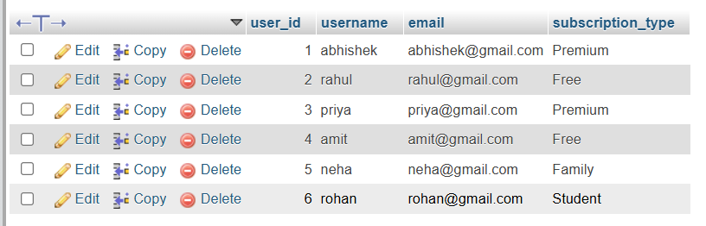

Q-4: Create a VIEW named TopSpendersView that shows usernames and order_total from a FoodOrder table where order_total is greater than 1000.
Ans:
CREATE VIEW TopSpendersView AS
SELECT
SpotifyUser.username,
FoodOrder.order_total
FROM FoodOrder
INNER JOIN SpotifyUser
ON FoodOrder.user_id = SpotifyUser.user_id
WHERE FoodOrder.order_total > 1000;
SELECT * FROM TopSpendersView;
Output:
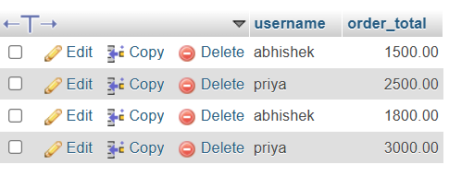
Q-5: Write a SQL query to list all users from the TopSpendersView who have spent more than 2000, sorted by order_total descending.
Constraint: Only use the TopSpendersView for your query, not the original FoodOrder table.
Ans:
SELECT username, order_total
FROM TopSpendersView
WHERE order_total > 2000
ORDER BY order_total DESC;
output

