SQL
Session-8
Q-1: Write a PL/SQL block that declares two variables: one for a user's name (VARCHAR2) and one for their age (NUMBER). Assign values and print both using DBMS_OUTPUT.PUT_LINE.
Ans:
DECLARE
name varchar2(20):= 'Abhishek';
age number:= '21';
BEGIN
dbms_output.put_line(name);
dbms_output.put_line(age);
END;
/
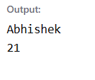
Q-2: Create a PL/SQL block that uses an IF statement to check if a given order amount is above 500. If yes, print 'Eligible for free delivery', else print 'Delivery charges apply'.
Ans:
DECLARE
amount float:= 2000;
BEGIN
if amount > 500 then
dbms_output.put_line('Eligible for free delivery');
else
dbms_output.put_line('Delivery charges apply');
end if;
END;
/
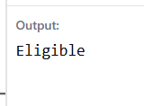
Q-3: Write a PL/SQL block that uses a simple LOOP to print the numbers 1 to 5 using DBMS_OUTPUT.PUT_LINE.
Hint: Use a counter variable and EXIT WHEN condition inside the loop.
Ans:
DECLARE
i NUMBER := 1;
BEGIN
LOOP
DBMS_OUTPUT.PUT_LINE(i);
i := i + 1;
EXIT WHEN i > 5;
END LOOP;
END;
/
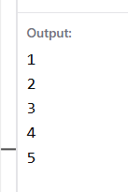

Q-4: Declare a cursor in PL/SQL to select all product names from a table called PRODUCTS. Fetch each product name and print it using DBMS_OUTPUT.PUT_LINE.
Hint: Assume the PRODUCTS table has a column PRODUCT_NAME.
Ans:
DELIMETER //

CREATE PROCEDURE getPnameByRow()
BEGIN
DECLARE id INT;
DECLARE song_name VARCHAR(100);
DECLARE done INT DEFAULT 0;

DECLARE playlistCursor CURSOR FOR
SELECT id, song_name FROM playlist;
DECLARE CONTINUE HANDLER FOR NOT FOUND
SET done = 1;

OPEN playlistCursor;

ploop: LOOP
FETCH playlistCursor INTO id, song_name;

IF done = 1 THEN
LEAVE ploop;
END IF;

SELECT id, song_name;

END LOOP ploop;

CLOSE playlistCursor;

END //

DELIMITER ;

CALL getPnameByRow();
Output:
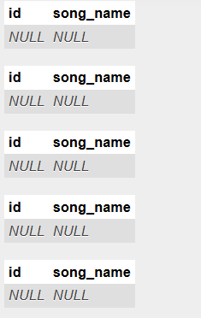

Q-5: Write a PL/SQL block that tries to divide two numbers entered as variables. If a division by zero occurs, catch the exception and print 'Cannot divide by zero'. Otherwise, print the result.
Ans:
DECLARE
a NUMBER := 10;
b NUMBER := 0;
result NUMBER;
BEGIN
result := a / b;
DBMS_OUTPUT.PUT_LINE('Result: ' || result);

EXCEPTION
WHEN ZERO_DIVIDE THEN
DBMS_OUTPUT.PUT_LINE('Cannot divide by zero');
END;
/
