1.Tooling Requirements

Category | Tool | Cost
Runtime | Node.js (Express or Fastify) | Free
WAF engine | Coraza + OWASP CRS v4, via coraza-node adapter | Free
Fallback WAF | NGINX + ModSecurity + OWASP CRS | Free
GraphQL guard | graphql-depth-limit, graphql-query-complexity, or GraphQL Armor | Free
Rate limiting | rate-limiter-flexible | Free
Schema validation | zod or joi, express-mongo-sanitize | Free
Session/headers | helmet, jsonwebtoken | Free
Logging | pino → ELK stack | Free
Metrics | prom-client → Prometheus + Grafana | Free
Attack simulation | OWASP ZAP, Burp Suite Community, Postman/Newman | Free
Load testing | k6 | Free
Containers | Docker / Docker Compose | Free
Version control | Git / GitHub | Free
Test targets | OWASP Juice Shop, AndroGoat, DVGA (Docker images) | Free

2.Non-Functional Requirements

ID | Requirement | Notes
NFR1 | Latency overhead < 50ms per request under defined load scenarios | Benchmarked, not assumed
NFR2 | Resource overhead reported per load tier (100/500/1000 req/s) — not a single flat number | See Section 5
NFR3 | No PII/transaction data logged (privacy-by-design) | Already in Charter
NFR4 | All testing confined to isolated Docker sandboxes | Ethical sandbox integrity
NFR5 | System reproducible via documented Docker Compose + scripts | Already in Charter

3. HTTP Method

3.1. Core POS Endpoints (The Protected API)

HTTP Method | Endpoint | Description | Threat Vector / Attack Type
POST | /api/v1/auth/login | Authenticate cashier/manager | Brute force PIN attacks, Credential stuffing
GET | /api/v1/products | Fetch item catalog & prices | Scraping / High-frequency automated calls
GET | /api/v1/orders/{id} | Fetch specific transaction receipt | BOLA / IDOR Attacks (reading unauthorized store/customer receipts)
POST | /api/v1/checkout | Process a new sale / payment | Price Tampering (e.g. sending {"item_id": 12, "price": ...})
PUT / PATCH | /api/v1/inventory/{id} | Update stock levels | Unauthorized privilege escalation / inventory theft masking
POST | /api/v1/discounts/apply | Apply promo code or manual discount | Discount code brute forcing / >100% discount exploit

3.2. Security/Admin Endpoints (Threat Data & Monitoring)

HTTP Method |  | Endpoint | Description
GET | /api/v1/security/metrics |  | Returns total request count, total blocked threats, and current system risk score for the dashboard.
GET | /api/v1/security/threats |  | Retrieves a list of flagged suspicious requests, including anomaly scores and rule violations.
POST | /api/v1/security/blocklist |  | Manually or automatically adds a suspicious IP address or User ID to a temporary blocklist.
GET / WS | /api/v1/security/traffic |  | Feeds the live-stream traffic map on your security dashboard (useful for demoing).

3.3 HTTP Simulation & Tools

To effectively simulate a sudden spike in internet traffic for your ArmourAPI capstone project, you need tools that can generate high volumes of HTTP/HTTPS requests, simulate concurrent users, and stress-test your backend API and web server logic.

Since ArmourAPI is a "right-sized" solution, your testing should demonstrate that your system can distinguish between legitimate traffic bursts (e.g., a "Black Friday" event) and malicious traffic spikes (e.g., a Layer 7 DDoS attack).

Here are the most effective tools and methods to stimulate these traffic spikes, categorized by your research environments:

1. Load Testing Tools (For High-Volume Simulation)
These tools are excellent for simulating massive, simultaneous user traffic to see if your system remains stable under load.

Locust (Highly Recommended):
Why: It is an open-source, Python-based load testing tool. It allows you to write "swarms" of users in code, making it very easy to simulate complex user behaviours (e.g., logging in, adding to cart, checking out) on your OWASP Juice Shop or DVGA instances.
Use Case: You can ramp up the number of simulated users from 10 to 10,000 to see at what point your backend resources begin to throttle.

Apache JMeter:
Why: An industry-standard, Java-based application. It is more GUI-driven than Locust and provides detailed reports on response times, latency, and throughput.
Use Case: Ideal for measuring the "performance tax" that ArmourPOS adds to transaction processing during high-traffic scenarios.

k6 (by Grafana):
Why: A modern, developer-centric tool that uses JavaScript. It is extremely lightweight and efficient, often requiring fewer machine resources to generate the same amount of traffic as JMeter.
Use Case: Perfect for testing mobile API spikes against your DVGA environment.

2. Attack Simulation Tools (For Malicious Spikes)
Since ArmourPOS is a security product, you likely want to simulate a "spike" that is actually a DoS (Denial of Service) or a brute-force attack to prove that your filtering logic works.

SlowHTTPTest:
Why: This tool simulates attacks that keep connections open for as long as possible (Slowloris, Slow Read).
Use Case: This is crucial for verifying that ArmourPOS effectively identifies and drops connections from clients that are behaving maliciously, rather than just slowing down your server.

Hulk (HTTP Unbearable Load King):
Why: A DoS tool specifically designed to bypass caching engines by generating unique URLs.
Use Case: Use this against your web endpoints to prove that your security layer is not reliant on static caching and can inspect dynamic, high-frequency requests.

Suggested Test Methodology for your Capstone

Organizing stress tests into three "Traffic Scenarios":
Scenario | Objective | Recommended Tool
The "Flash Sale" | Simulate legitimate, massive concurrent checkouts to prove your system doesn't introduce unnecessary latency. | Locust
The "Credential Stuffing" Spike | Simulate a sudden surge of login attempts to test your API filtering logic. | k6
The "Resource Exhaustion" Attack | Simulate a high-frequency, malicious request flood to ensure ArmourPOS mitigates it without crashing. | SlowHTTPTest

4. Cyber Attacks

4.1 Core attack classes covered

- SQL Injection ·
- XSS ·
- Path Traversal ·
- SSRF · malicious/malformed payloads ·
- brute force ·
- credential stuffing ·
- GraphQL excessive depth ·
- GraphQL excessive complexity ·
- GraphQL batching abuse ·
- GraphQL introspection abuse

4.2 Monitored (not necessarily blocked)

- request rate ·
- blocked-request count by category ·
- source IP ·
- endpoint ·
- response status ·
- latency ·
- CPU ·
- memory

4.3 API Security & Threat Matrix

Threat Category / Attack Vector | Real-World Attack Scenario | Anomaly / Detection Indicator (SIEM / WAF) | Defensive Architecture & Mitigation Strategy
BOLA / IDOR  (API1:2023 - Broken Object Level Authorization) | A cashier modifies parameter IDs (GET /api/v1/receipts/1042 $→$ /1043) to view unauthorised store transactions. | Mismatch between token store_id/user_id and the requested object owner; sequential enumeration spikes. | Enforce server-side Attribute-Based Access Control (ABAC); bind database queries to the authenticated tenant/user context; replace sequential IDs with UUIDv4.
Mass Assignment & Price Tampering  (API3:2023 - Broken Object Property Level Auth) | Client intercepts request and injects {"price": 0.01} into POST /api/v1/checkout to override retail pricing. | Unexpected schema properties in the JSON payload; mismatch between the client-submitted value and the catalogue database. | Strict schema validation (JSON Schema / Pydantic); decouple input models using DTOs (Data Transfer Objects); never trust client-side financial calculations.
Brute Force & Credential Stuffing  (API4:2023 - Unrestricted Resource Consumption) | Attacker runs automated dictionary attacks on POST /api/v1/auth/login, trying thousands of 4-digit PINs per minute. | Rapid threshold breach (>10 failed login attempts per minute per IP/Account); burst traffic spikes. | Multi-tier Token Bucket Rate Limiting at API Gateway; progressive delays/tarpitting; account lockouts and IP blocklisting via Redis cache.
Credential / Token Theft & Hijacking  (API2:2023 - Broken Authentication) | A captured JWT token issued in Auckland is used from a foreign IP address 2 minutes later. | Impossible Travel alerts; sudden shifts in User-Agent, ASN, or TLS client fingerprint (JA3/JA4). | Short-lived access tokens (15m) + secure HTTP-only refresh tokens; Device Fingerprinting; token revocation lists (Redis blocklist).
Broken Function Level Authorisation (BFLA)  (API5:2023) | A standard cashier invokes PUT /api/v1/inventory/bulk-adjust to wipe out inventory logs without manager approval. | User role (Cashier) is invoking an administrative/managerial endpoint without the appropriate scope. | Fine-grained Role-Based Access Control (RBAC) via API Gateway gateway filters; enforce explicit @RequireRoles('Manager') annotations.
Server-Side Request Forgery (SSRF)  (API7:2023) | Attacker inputs a malicious webhook URL (e.g., [http://169.254.169.254/metadata](http://169.254.169.254/metadata)) into the receipt delivery settings. | Outbound network calls to loopback (127.0.0.1), link-local, or internal private IP subnets (10.x.x.x, 192.168.x.x). | Dedicated isolated egress proxy; strict URL whitelist validation; disable following HTTP redirects on outbound hooks.
API Abuse / High-Frequency Scraping  (API4:2023 - Rate Limiting & DoS) | Competitor runs automated headless bots against GET /api/v1/products to scrape real-time pricing and stock data. | High query volume with missing standard browser headers, non-human browsing intervals, or headless signatures. | Client behavioural analysis; API keys tied to query tier quotas; Proof-of-Work (PoW) or invisible challenges for high-volume endpoints.
Injection (SQLi / NoSQLi / Command)  (API8:2023 - Security Misconfiguration) | Submitting payload ' OR '1'='1 in search or discount fields (POST /api/v1/discounts/apply). | Regex match on SQL/NoSQL control characters; unhandled backend database syntax error exceptions. | Parameterised queries (Prepared Statements / ORM); strict input type casting and sanitisation before processing.

5. Armour API Testing

To deploy ArmourAPI for testing in an academic or lab environment, you set up a Reverse Proxy / Inline Orchestration Testbed.

Because ArmourAPI is designed as a server-side, lightweight EDR, you don't need to install heavy software agents on the target apps. Instead, you route all incoming web, mobile, and GraphQL API traffic through ArmourAPI before it reaches your target applications.

Here is the step-by-step deployment and methodology:
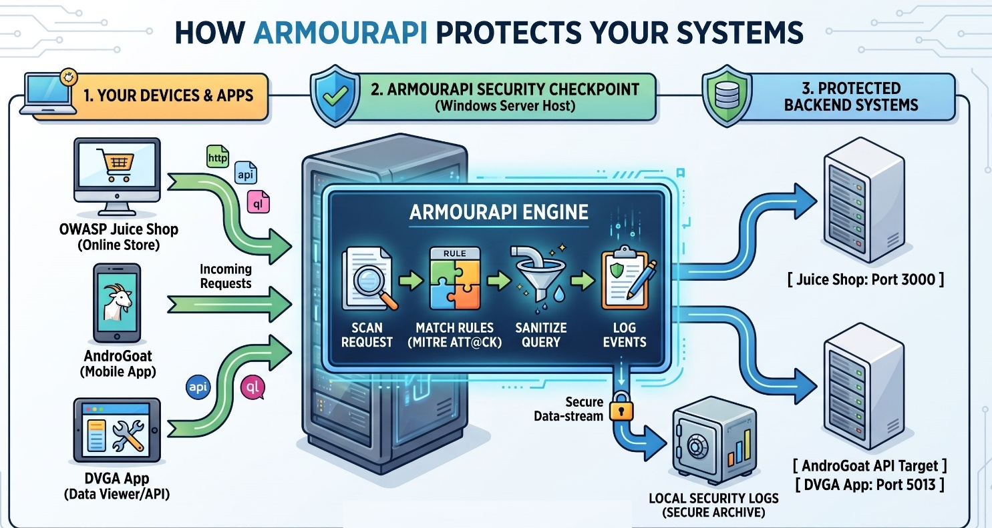

5.1. Step-by-Step Deployment Process

Step 1: Set Up the Vulnerable Testbeds (Docker Desktop)
First, spin up the three benchmark environments locally using Docker containers. This isolates the vulnerable code while keeping resource overhead low:

OWASP Juice Shop (Web Base):
Bash
docker run -d -p 3000:3000 --name juice-shop bkimminich/juice-shop

DVGA (GraphQL API Base):
Bash
docker run -d -p 5013:5013 -e WEB_HOST=0.0.0.0 --name dvga dolevf/dvga

AndroGoat (Mobile Backend API):
Host the AndroGoat backend API service locally on an isolated port (e.g., Port 5000) or emulate it via an Android Virtual Device (AVD).

Step 2: Deploy ArmourPOS as a Reverse Proxy Gateway

Position ArmourPOS on your Windows Server VM to listen on standard incoming web ports (e.g., Port 80 / Port 443).

Traffic Routing: Configure ArmourPOS to route incoming API requests to the corresponding target containers:
Path /app/* $→$ Forward to Juice Shop (localhost:3000)
Path /graphql/* $→$ Forward to DVGA (localhost:5013)
Path /api/v1/* $→$ Forward to AndroGoat backend (localhost:5000)

Step 3: Configure Detection & Policy Engine (SecDLC)

Load your security policy rules into ArmourPOS before executing tests:

SQLi / Injection Rules: Filter parameters for characters like ' OR 1=1 -- (OWASP Juice Shop validation).

Rate Throttling Rules: Set thresholds (e.g., max 5 request failures per IP/sec) for credential stuffing (AndroGoat validation).

GraphQL Parsing Limits: Cap query depth to a max of 5 levels to block recursive Denial-of-Service attacks (DVGA validation).

5.2. How to Execute Test Scenarios
To prove ArmourPOS works for your thesis evaluation, run tests in two distinct phases:

Phase A: Baseline Testing (ArmourPOS Disabled)

Point attack tools (Burp Suite, Postman, or Python Scripts) directly to the application ports (3000, 5013, 5000).
Run automated exploit payloads (SQLi, Credential Stuffing, Deep GraphQL Queries).

Record Findings: Document successful exploits, system crash points, and CPU/RAM spikes on the server.

Phase B: Protected Testing (ArmourPOS Enabled)

Re-route your attack traffic through the ArmourPOS gateway on Port 80/443.
Re-run the exact same attack payloads.

Record Mitigation: Confirm ArmourPOS inspects the payload, matches it against MITRE TTPs, drops the request (403 Forbidden), and writes an entry to the event log.

5.3. Key Performance Metrics to Capture

When documenting your results for your Level 7 report, compare this baseline vs. protected metrics:

Metric | Target Goal | How to Measure
Detection Rate | $>90\%$ Threat Interception | Blocked attack payloads / Total attack payloads
Latency Overhead | $<15\text{ ms}$ added response time | Postman response timing benchmark
CPU/RAM Footprint | $<5\%$ CPU, $<256\text{ MB}$ RAM | Windows Task Manager / Resource Monitor
False Positive Rate | Zero valid orders blocked | Submit 100 legitimate Juice Shop user checkouts

6 Attack Corpus & Baseline-vs-Protected Methodology

This is what makes the validation defensible instead of anecdotal. Build a small, versioned test corpus per attack class, run it twice, and diff the results.

Procedure (repeat per testbed)
Baseline run — fire the corpus directly at Juice Shop / DVGA / AndroGoat backend (no ArmourPOS).
Record: succeeded / blocked.

Protected run — same corpus through ArmourPOS. Record: succeeded / blocked / rate-limited.
Report as a before/after table per attack class — this is the Validation Test Report deliverable.

Keep the corpus in the repo (Postman/Newman collections or k6 scripts) so it's reproducible, matching the Charter's "Reproducibility" note.

6.1 Benchmark Methodology
Define controlled load tiers instead of asserting one universal "<5% CPU":
Load Tier | Req/s | Concurrency | Payload Size
Light | 100 | 10 | 1–5 KB
Medium | 500 | 50 | 5–20 KB
Heavy | 1000 | 100 | 20–50 KB

6.2 For each tier, report baseline vs. protected:
Metric | Baseline | ArmourPOS
Avg latency
P95 / P99 latency
CPU %
RAM (MB)
Throughput (req/s)
Detection rate | — | %
False positive rate | — | %

The Proposal's <5% CPU / <256MB RAM / <50ms targets stay as the goal, but are now validated under stated conditions rather than claimed universally — much stronger for a Level 7 report.

7. Risk Register
Risk | Mitigation
coraza-node is preview software; Node/WASM integration may break | Proven or rejected by Week 4; documented NGINX+ModSecurity+CRS fallback behind the same adapter interface
GraphQL complexity scoring needs per-schema tuning | Dedicated Weeks 9–10, not a drop-in
AndroGoat traffic doesn't route through ArmourPOS as expected (cert/networking issues) | Explicit Week 11 task, tested before building on top of it
Flat CPU/RAM claims are not defensible without load context | Controlled load-tier benchmarking (Section 5)
Overclaiming "blocks OWASP Top 10" broadly | Scoped attack-class list (Section 3) stated explicitly in report
Scope creep into custom dashboard UI | Reuse Grafana (FR10 = Could Have, minimal effort)

8. Deliverables
- ArmourPOS Core Engine (proxy + WAF adapter + GraphQL guard + rate limiter + validator)
- Empirical Performance Report (Section 5 tables)
- Research Project write-up (SecDLC + MITRE ATT&CK mapping, unchanged from Proposal)
- Deployment Guide
- Target Testbed Sandbox (Docker Compose, versioned)
- Threat Mapping Matrix (OWASP API Top 10 ↔ MITRE ATT&CK ↔ ArmourPOS rules)
- Validation Test Report (Section 4 baseline-vs-protected tables, per attack class)
- Final Capstone Report + presentation
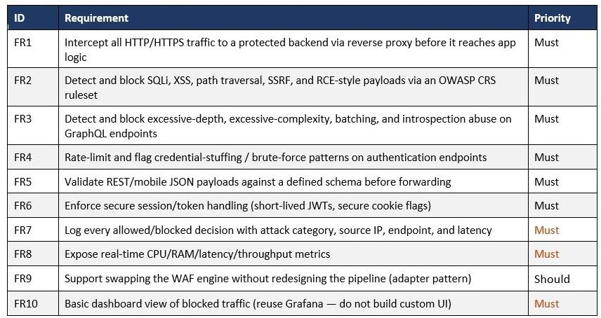
9. Functional Requirements

10 Attack Simulation

1. How do we simulate an attack on the OWASP Juice Shop?
Because Juice Shop is designed for security research, it has built-in, exploitable vulnerabilities. You do not need to "hack" the system in a way that requires external tools.
- The "Manual" Method: You can use your browser’s "Developer Tools" (F12) to inspect the network requests made when you click "Checkout." You can then use a tool like Postman or Burp Suite Community Edition to replay those requests and inject malicious payloads (e.g., placing a <script> tag in the address field).
- The "Automated" Method (Better for Level 7): Since you are already using k6 for performance testing, you can create a specific k6 test script that sends "malformed" requests to the checkout endpoint. This allows you to prove that your ArmourPOS middleware successfully intercepts and drops these requests during a simulated "attack."

2. Can we manually change the code to show different attacks?
Yes, and you should. You have two ways to do this:
- Modify the Payloads: Since you control the test environment, you can edit your k6 test scripts to try different types of payloads (e.g., changing an SQL Injection string to an XSS script) to show your supervisor that your Regex/Detection Logic is flexible and can handle multiple attack vectors.
- Modify the Detection Logic: You can "tune" your ArmourAPI middleware. You can intentionally disable a rule in your middleware, show an attack succeeding, then enable the rule and show the attack being blocked. This is a very powerful "Live Demo" for your final presentation.

