**ANDROID**

## What is Android OS?

Android OS is a Linux-based mobile operating system that primarily runs on smartphones and tablets.

* Android is developed by a partnership of developers known as the Open Handset Alliance and commercially sponsored by Google.
* **Developer** : mostly Google
* **ANDROID Inventors** : Andy Rubin,Nick Sears,Rich Miner
* **WRITTEN in**: Java,Kotlin,C,C++,Rust and others
* **OS Family** : Unix

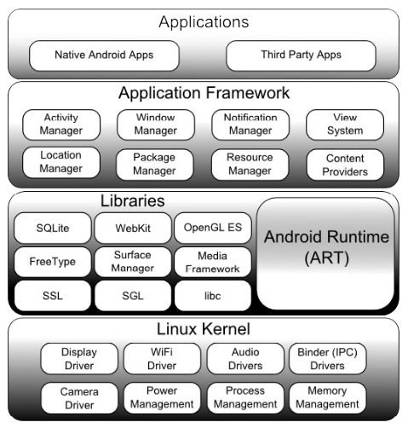

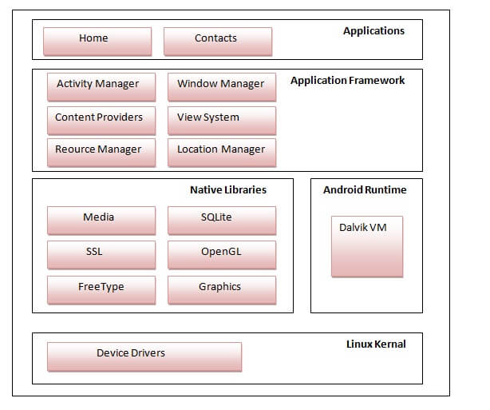

* **Android Libraries** :
  + **android.app**
  + **android.content**
  + **android.database**
  + **android.graphics**
  + **android.hardware**
  + **android.opengl**
  + **android.os**
  + **android.media**
  + **android.net**
  + **android.print**
  + **android.provider**
  + **android.text**
  + **android.util**
  + **android.view**
  + **android.widget**
  + **android.webkit**
* **C/C++ Libraries :**
  + Java Wrappers.
* Android RUNTIME – ART :
  1. It provides the base for the application framework and powers our application with the help of the core libraries.
  2. DEX format[Dalvin Executable Format]-. When an android app is built with Android Studio it is compiled into intermediate bytecode format known as DEX
  3. Like Java Virtual Machine (JVM), Dalvik Virtual Machine (DVM) is a register-based virtual machine designed and optimized for Android to ensure that a device can run multiple instances efficiently.
  4. AOT (Ahead Of Time).
  5. Each time the application is subsequently launched,the ELF (Executable and Linkable Format)executable version is run.
* Application Framework :
  1. Activity manager.
  2. Content Provider : Allows applications to publish and share data with other applications.
  3. Rsource Manager : Provides access to non-code embedded resources such as strings, colour settings and user interface layouts.
  4. Notification Manager:  Allows applications to display alerts and notifications to the user.
  5. View system : An extensible set of views used to create application user interfaces.
* Applcations :
  1. An application is the top layer of the android architecture. The pre-installed applications like camera, gallery, home, contacts, etc., and third-party applications downloaded from the play store like games, chat applications, etc., will be installed on this layer.
* DEX compiler :

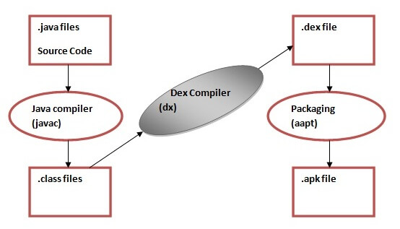

* Android Intents :

is the message that is passed between components such as activities, content providers, broadcast receivers, services etc

* 1. Implicit Intent
  2. Explicit Intent
* Broadcast Intent
* Android Services.(Eg:Toast messages).