**C#**

* C# (C-Sharp) is a **object-oriented** **programming language** **developed by Microsoft** that **runs on the .NET** Framework.
* C# is used to develop web apps, desktop apps, mobile apps, games and much more.

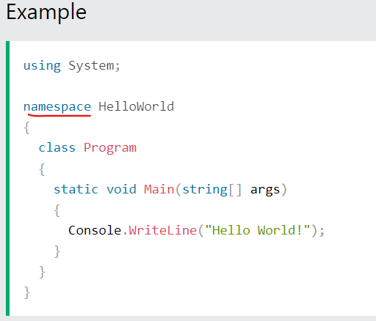

* **INSTALL** :

1. IDE :**Ms Visual Studio**
2. SDK : **.NET**

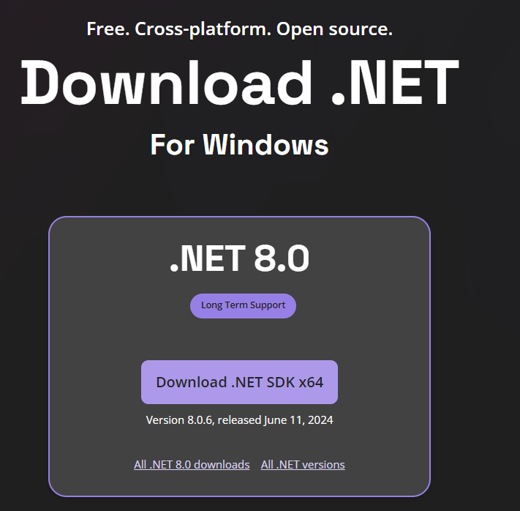

* **Syntax:**

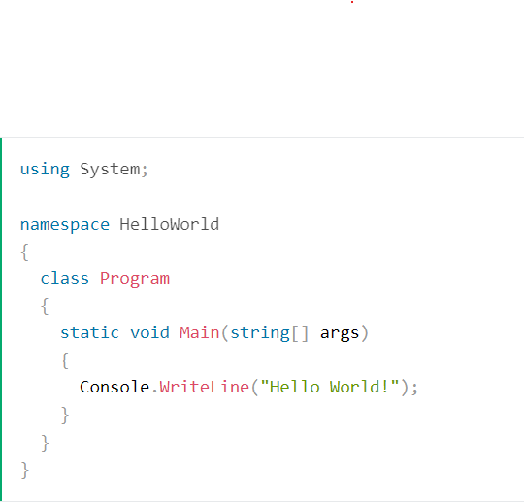

****Line 1:**** using System means that we can use classes from the System namespace.

****Line 2:**** A blank line. C# ignores white space. However, multiple lines makes the code more readable.

****Line 3:**** namespace is used to organize your code, and it is a container for classes and other namespaces.

****Line 4:**** The curly braces {} marks the beginning and the end of a block of code.

****Line 5:**** class is a container for data and methods, which brings functionality to your program. Every line of code that runs in C# must be inside a class. In our example, we named the class Program.

****Line 7:**** Another thing that always appear in a C# program is the Main method. Any code inside its curly brackets {} will be executed. You don't have to understand the keywords before and after Main. You will get to know them bit by bit while reading this tutorial.

****Line 9:**** Console is a class of the System namespace, which has a WriteLine() method that is used to output/print text. In our example, it will output "Hello World!".

* **C# using VS CODE :**

1. Create a folder for your project and open it in VS Code.
2. Then open that in Terminal and type ‘**dotnet new console**’.To create console based App.
3. To run : ‘**dotnet run**’
4. **C# Output** :

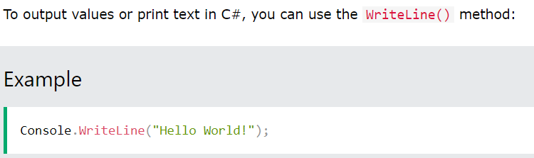

1. **C# Comments :**
   1. Single Line comment.(**//**)
   2. Multi line comments :(**/*  */**)
2. **C# Variables :**

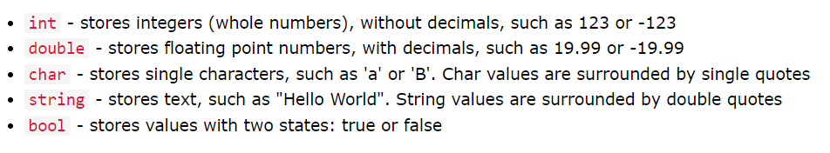

1. **C# constants:**
   1. If you don’t want others to overwrite the existing value of your variable then use : **const keyword**
2. **Asd**
3. **asd**