**JAVASCRIPT-codecademy**

1. drawName() is a set of repeatable code that we’ve defined elsewhere called a [function](https://www.codecademy.com/resources/docs/general/function" \t "https://www.codecademy.com/courses/learn-what-to-learn/lessons/welcome-to-codecademy/exercises/_blank).

red = [0, 100, 63];

orange = [40, 100, 60];

green = [75, 100, 40];

blue = [196, 77, 55];

purple = [280, 50, 60];

message = 'Change the color!';

drawName(message, blue);

bounceBubbles();

1. There is a new variable named letterColors :
   1. The displayed text in the browser panel will cycle through the values in letterColors in order when drawName() is called with letterColors.

// Color variables:

red = [0, 100, 63];

orange = [40, 100, 60];

green = [75, 100, 40];

blue = [196, 77, 55];

purple = [280, 50, 60];

// Letters in the message will cycle through these colors:

letterColors = [red, orange, green, blue, purple];

message = 'Multiple colors!';

drawName(message, letterColors);

bounceBubbles();

1. Three variables let you experiment with the animation physics: mouseResponseThreshold, friction, and rotationForce.:
   1. mouseResponseThreshold affects how close the mouse pointer needs to be to affect the dots that make up the letters. The larger the number, the more powerful the effect of the mouse interaction.
   2. You’ll probably want to keep friction between 0 and 1.
   3. rotationForce  represents how much each animated dot will try to rotate when interacting with the mouse.
2. Console:The console is a panel that displays important messages, like [errors](https://www.codecademy.com/resources/docs/javascript/errors" \t "https://www.codecademy.com/courses/introduction-to-javascript/lessons/introduction-to-javascript/exercises/_blank), for developers.
   1. console.log(5); :This example logs 5 to the console.
3. Comments:
   1. Single line comment : console.log(5);  // Prints 5
   2. Multi Line comment :

/*This is all commented   
console.log(10);  
None of this is going to run!  
console.log(99);  
*/ .

1. Datatypes:
   1. Number.
   2. BigInt.
   3. String.
   4. Boolean.
   5. Null.
   6. Undefined : undefined means that a given value does not exist
   7. Symbol : symbols are unique identifiers, useful in more complex coding
   8. Object : Collections of related data.
   9. 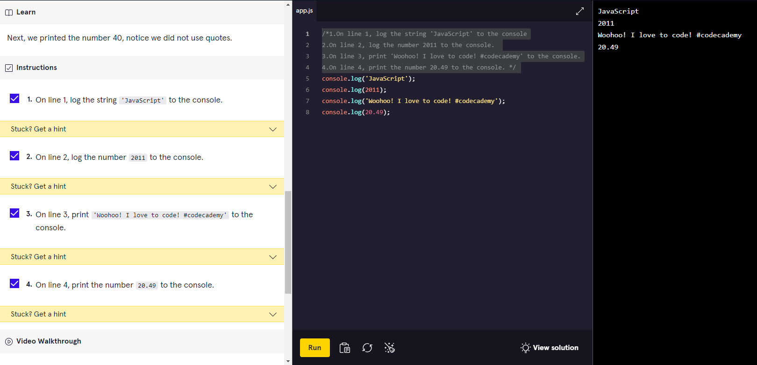
2. Arithmetic Operators:
   1. 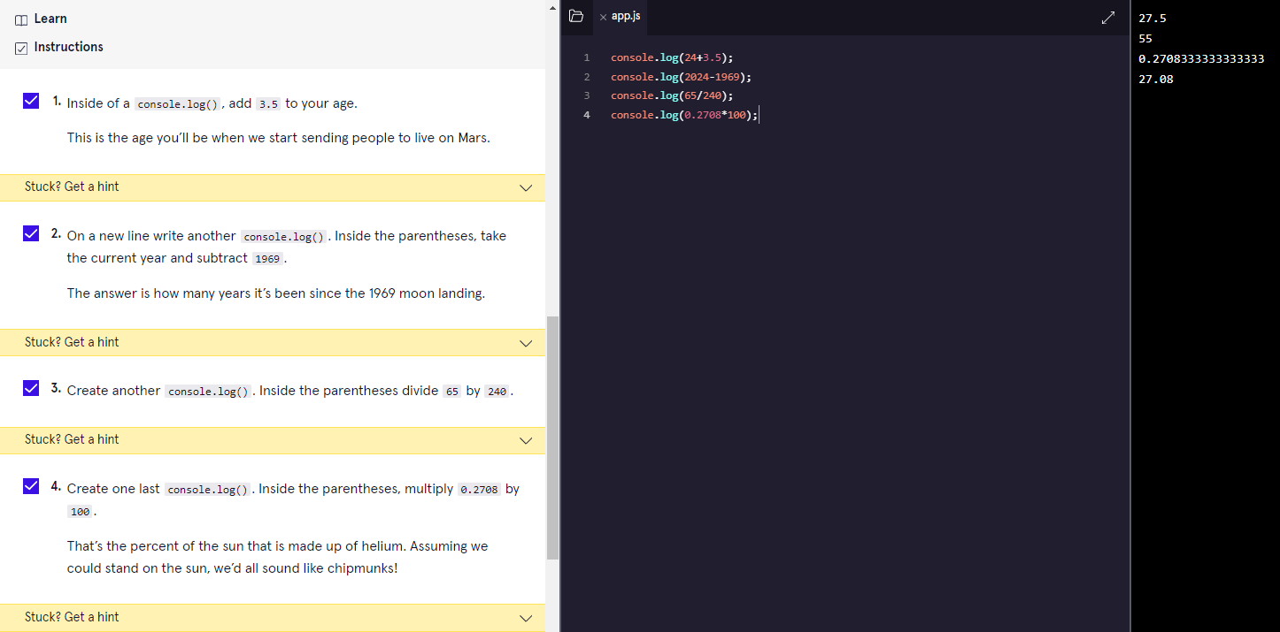
3. String Concentration:
   1. 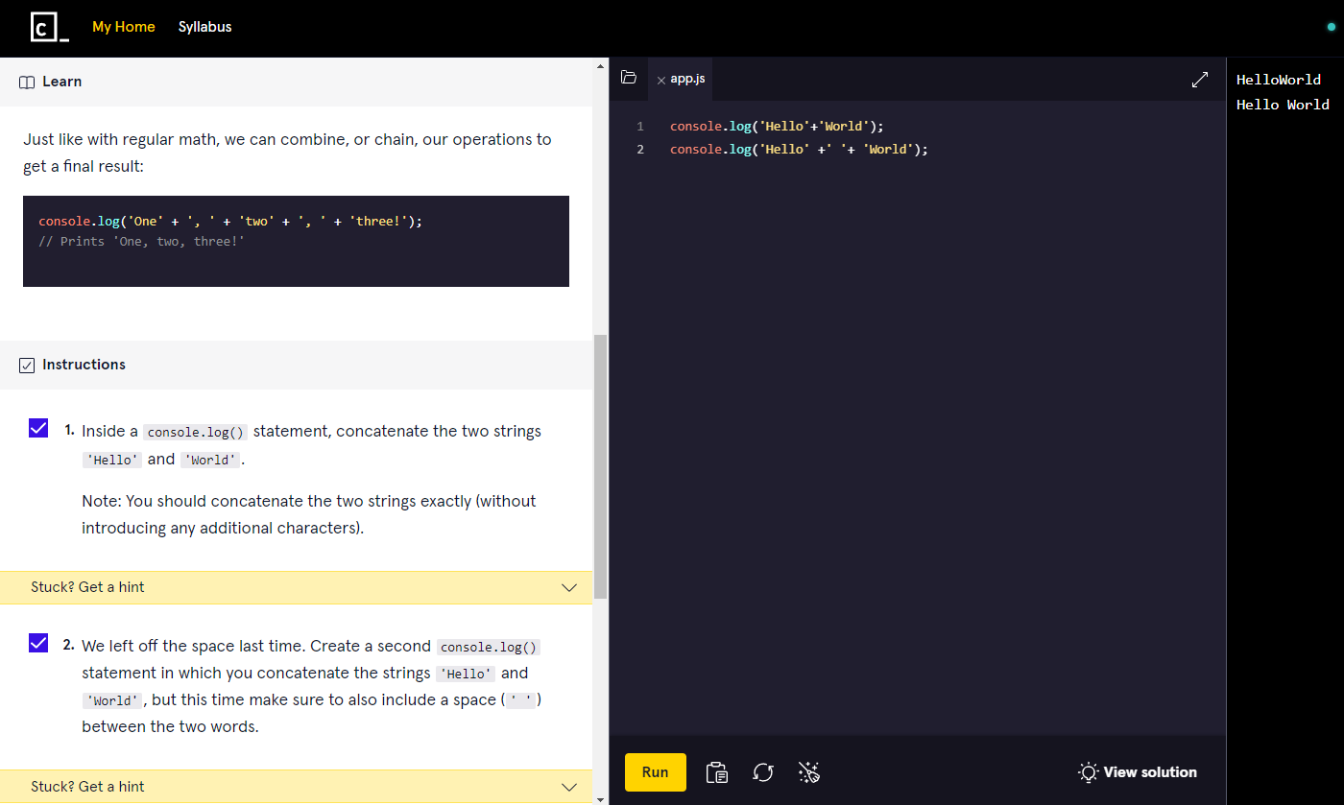
4. Properties:
   1. 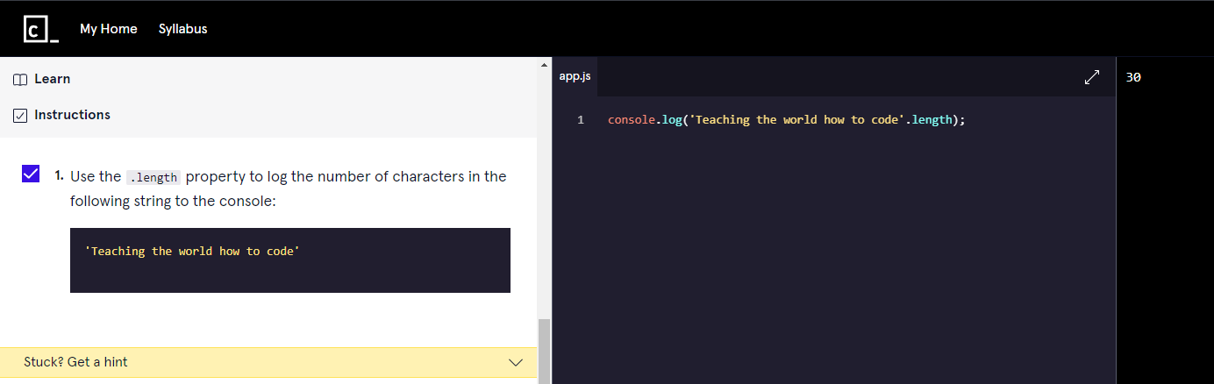
5. Methods:
   1. 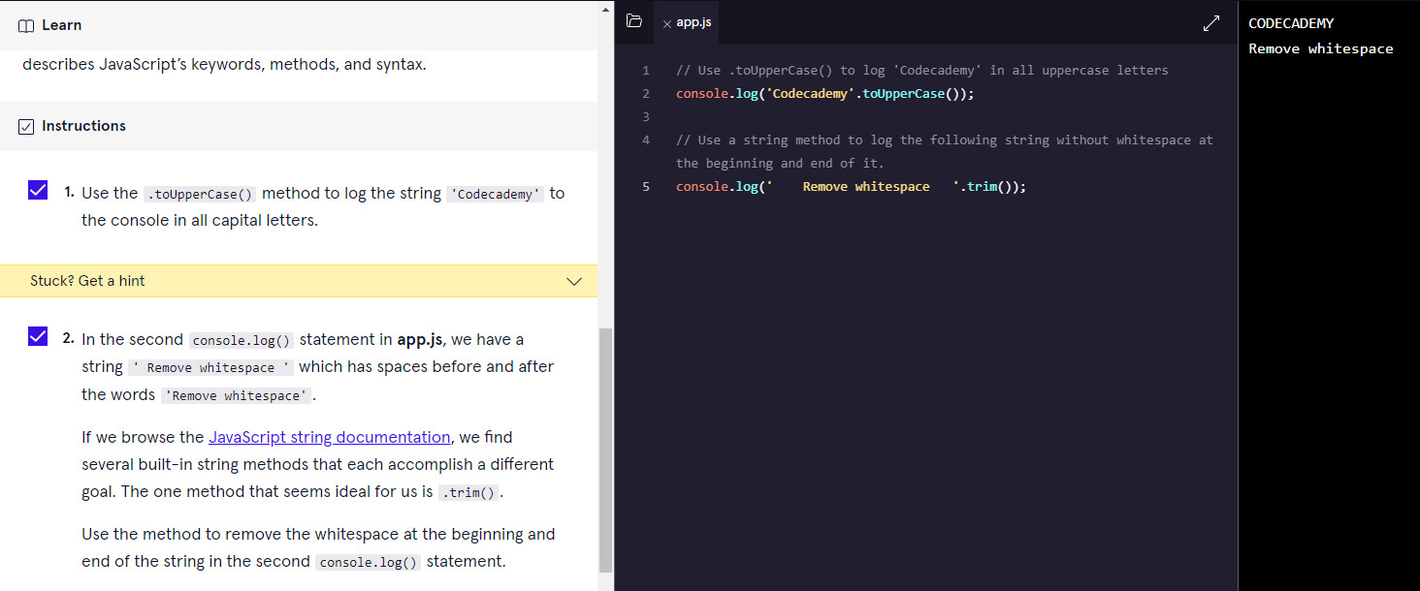
6. Built-in Objects:
   1. 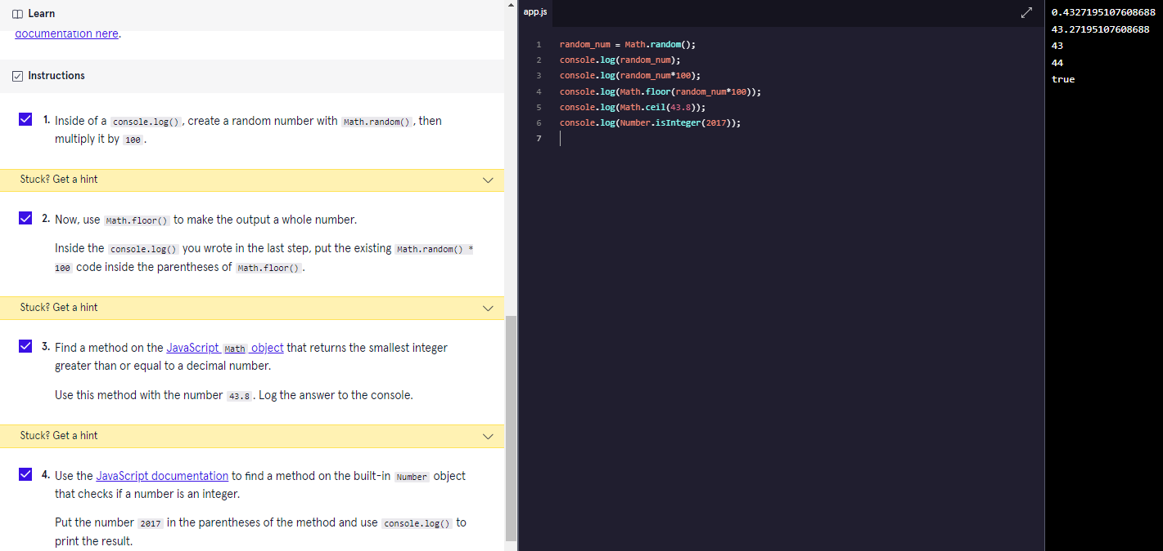
7. Variables:
   1. Var.
   2. Let :let keyword signals that the variable can be reassigned a different value.

let changeMe = true;

console.log(changeMe);

changeMe = false;

console.log(changeMe);

* 1. Const :const variable cannot be reassigned because it is constant. If you try to reassign a const variable, you’ll get a TypeError.

const entree = 'Enchiladas';

console.log(entree);

entree = 'Tacos' //TypeError: Assignment to constant variable.

* 1. Mathematical Assignment Operators :

let levelUp = 10;

let powerLevel = 9001;

let multiplyMe = 32;

let quarterMe = 1152;

// Use the mathematical assignments in the space below:

levelUp += 5;

powerLevel -= 100;

multiplyMe *= 11;

quarterMe /= 4;

// These console.log() statements below will help you check the values of the variables.

// You do not need to edit these statements.

console.log('The value of levelUp:', levelUp);

console.log('The value of powerLevel:', powerLevel);

console.log('The value of multiplyMe:', multiplyMe);

console.log('The value of quarterMe:', quarterMe);

* 1. The Increment and Decrement Operator :

let gainedDollar = 3;

let lostDollar = 50;

gainedDollar++;

lostDollar--;

* 1. String Concatenation with Variables:

let favoriteAnimal="Lion";

console.log('My favorite animal: '+favoriteAnimal);

* 1. String Interpolation:a template literal is wrapped by backticks ` (this key is usually located on the top of your keyboard, left of the 1 key) :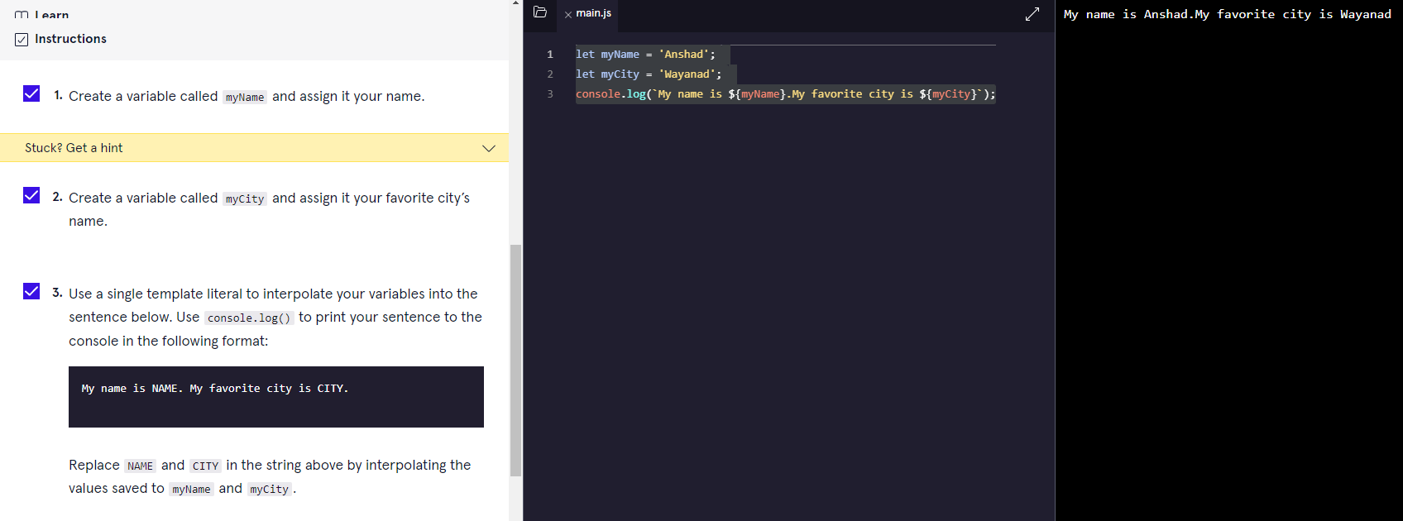
  2. typeof operator : The typeof operator checks the value to its right and returns, or passes back, a string of the data type.

let newVariable = 'Playing around with typeof.';

console.log(typeof newVariable);

newVariable = 1;

console.log(typeof newVariable);

1. PROJECT-kelvin to Fahrenheit:

//A constant variable 'kelvin' is assigned with a value 293

const kelvin =0;

//variable celsius

const celsius = kelvin-273;

//variable fahrenheit

let fahrenheit = celsius * (9 / 5) + 32 ;

//getting floor value

fahrenheit = Math.floor(fahrenheit);

console.log(`The temperature is ${fahrenheit} degrees Fahrenheit`);

//convert to Newton

let newton = celsius * (33 / 100);

newton = Math.round(newton);

console.log(`The temperature is ${newton} degrees Newton`)

1. PROJECT-DOG YEARS:

//declare age as constant

const myAge = 23;

//declare earlyYears

let earlyYears = 2;

earlyYears *= 10.5;

//declare laterYears

let laterYears = myAge - 2;

laterYears *= 4;

console.log(earlyYears);

console.log(laterYears);

//add two years

let myAgeDogYears = earlyYears + laterYears;

//lowercase

let myName = 'ANSHAD'.toLowerCase();

console.log(`My name is ${myName}. I am ${myAge} years old in human years which is a ${myAgeDogYears} years old in dog years.`);

1. Conditional Statements:
   1. If statement.

let sale =true;

sale=false;

if (sale) {

  console.log('Time to buy!');

}

* 1. If...Else Statement.

let sale = true;

sale = false;

if(sale) {

  console.log('Time to buy!');

}

else{

  console.log('Time to wait for a sale.');

}

* 1. Comparison Operators.(<,>,<=,>=,===,!==)

let hungerLevel = 7;

if (hungerLevel > 7){

  console.log('Time to eat!');

}

else{

  console.log('We can eat later!');

}

* 1. Logical Operators. (&&,||,!)

let mood = 'sleepy';

let tirednessLevel = 6;

if(mood === 'sleepy' && tirednessLevel > 8){

  console.log('time to sleep');

}

else{

  console.log('not bed time yet');

}

* 1. Truthy and Falsy.

let myVariable = 'I Exist!';

if (myVariable) {

   console.log(myVariable)

} else {

   console.log('The variable does not exist.')

}

* (The code block in the if statement will run because myVariable has a truthy value,even though the value of myVariable is not explicitly the value true).
* **The list of falsy values includes**:

[ 0, Empty strings like "" or '' ,null ,undefined ,NaN ].

let wordCount = 1;

if (wordCount) {

  console.log("Great! You've started your work!");

} else {

  console.log('Better get to work!');

}

let favoritePhrase = '';

if (favoritePhrase) {

  console.log("This string doesn't seem to be empty.");

} else {

  console.log('This string is definitely empty.');

}

* 1. Truthy and Falsy Assignment.
* The code below checks if username is defined and assigns a default string if it is not:

let username = '';

let defaultName;

if (username) {

  defaultName = username;

} else {

  defaultName = 'Stranger';

}

console.log(defaultName);

OR use the || operator :

let username = '';

let defaultName = username || 'Stranger';

console.log(defaultName);

* 1. Ternary Operator.

Example1:

isNightTime ? console.log('TRUE') : console.log('False section');

Example.2:

let favoritePhrase = 'Love That!';

favoritePhrase === 'Love That!'

?

  console.log('I love that!')

:

  console.log("I don't love that!");

* 1. Else If Statements.

let season = 'summer';

if (season === 'spring') {

  console.log('It\'s spring! The trees are budding!');

}

else if(season === 'winter'){

  console.log('It\'s winter! Everything is covered in snow.');

}

else if(season === 'fall'){

  console.log('It\'s fall! Leaves are falling!')

}

else if(season === 'summer'){

  console.log('It\'s sunny and warm because it\'s summer!');

}

else {

  console.log('Invalid season.');

}

* 1. The switch keyword.

let athleteFinalPosition = 'first place';

switch (athleteFinalPosition){

  case 'first place':

    console.log('You get the gold medal!');

    break;

  case 'second place':

    console.log('You get the silver medal!');

    break;

  case 'third place' :

    console.log('You get the bronze medal!');

    break;

  default :

    console.log('No medal awarded.');

    break;

}

* 1. Magic Eight Ball-PROJECT:

let username='';

username ? console.log(`Hello,${username}!`) :

console.log('Hello!');

const userQuestion ='How Many Ball?';

console.log(username+userQuestion);

//We need to generate a random number between 0 and 7.

let randomNumber = Math.floor(Math.random() * 8);

let eightBall = '';

console.log(randomNumber);

switch(randomNumber){

  case 0:

    eightBall ='It is certain';

    break;

  case 1:

    eightBall ='It is decidedly so';

    break;

  case 2:

    eightBall ='Reply hazy try again';

    break;

  case 3:

    eightBall ='Cannot predict now';

    break;

  case 4:

    eightBall ='Do not count on it';

    break;

  case 5:

    eightBall ='My sources say no';

    break;

  case 6:

    eightBall ='Outlook not so good';

    break;

  case 7:

    eightBall ='Signs point to yes';

    break;

  default:

    console.log('Invalid');

    break;

}

console.log(eightBall);

1. PROJECT:
2. PROJECT:
3. PROJECT:
4. PROJECT:
5. PROJECT:
6. PROJECT:
7. PROJECT:
8. PROJECT:
9. PROJECT:
10. PROJECT: