**REACT - SCALAR**

1. ***Introduction to React JS* :**
   1. **Introduction :**

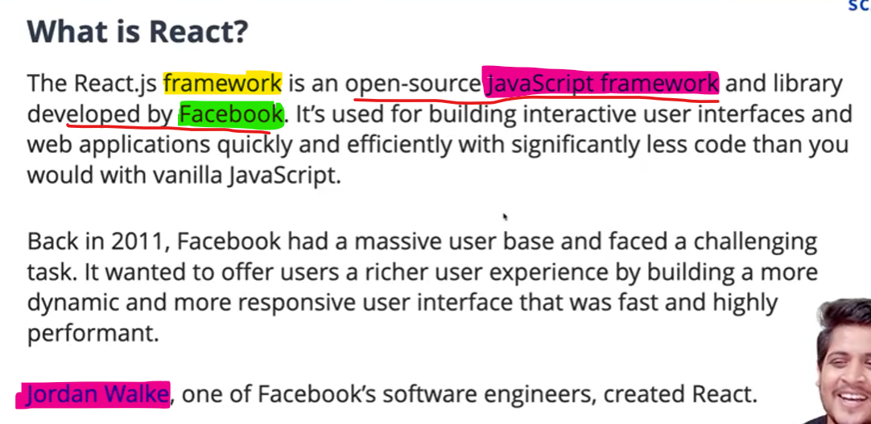

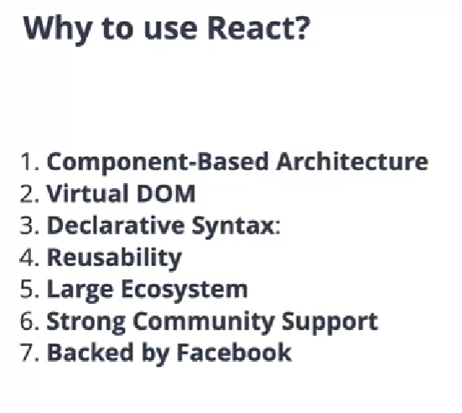

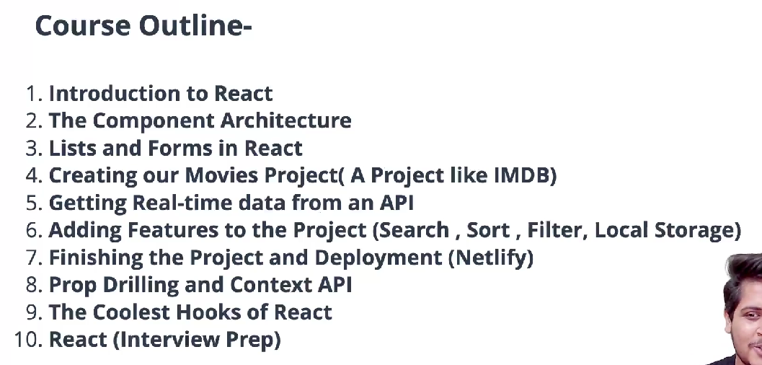

* 1. **Setting Necessary Tools for React :**
     1. **VS CODE.**
     2. **Install extension in VS Code:**

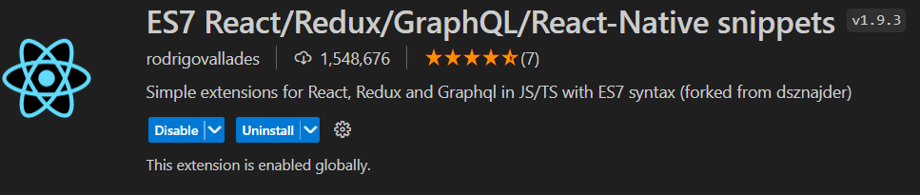

* + 1. **Install extension “prettier” in VS code :**

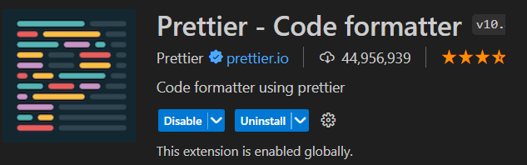

* + 1. **Install NodeJS . (React need support of Node JS).**
  1. **React with CDN :**
     1. Using CDN links in React gives quick and convenient way to integrate React into your projects without the need for a package manager.
     2. Type “cdn links for react” and go to the first link.

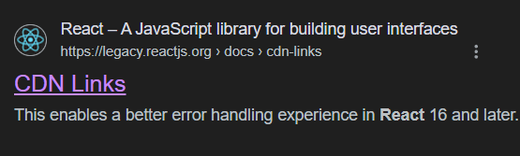

* + 1. Then copy and paste the two script links to your “index.html”(One link is react script and other is react-dom script).

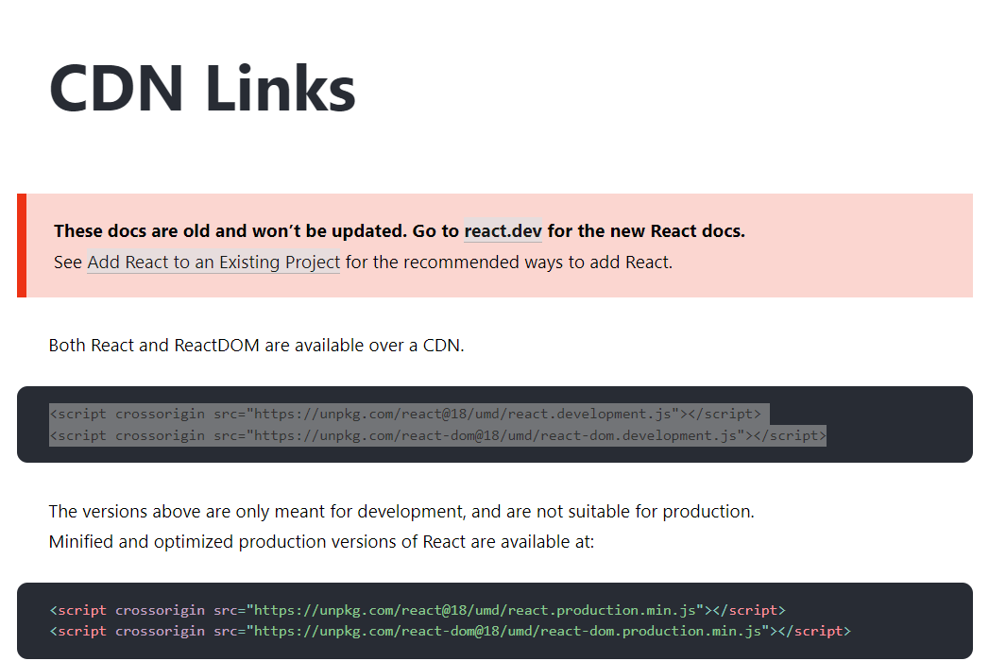

* + 1. React is an External Library(JS Library).Our browser doesn’t know react exist or not.Our browser only knows the ‘DOM’.So the above two script links(1st link has all the properties and 2nd link helps React to communicate with DOM ) helps the the browser to get React .

“index.html” :

<!DOCTYPE html>

<html lang="en">

  <head>

    <meta charset="UTF-8" />

    <meta name="viewport" content="width=device-width, initial-scale=1.0" />

    <title>Document</title>

  </head>

  <body>

    <div id="root">

      <h1>Hello from HTML!</h1>

    </div>

    <!-- <script>

        //How to add h1 tag using JS:

        const message = document.createElement('h1');//h1 element created

        message.innerHTML = 'Hello From JavaScript';//message created

        const root = document.getElementById('root');//Getting the id of div tag to pass the message.

        root.appendChild(message);//message appended to div with id "root"

    </script> -->

    <!--CDN Links-->

    <script

      crossorigin

      src="https://unpkg.com/react@18/umd/react.development.js"

    ></script>

    <script

      crossorigin

      src="https://unpkg.com/react-dom@18/umd/react-dom.development.js"

    ></script>

  </body>

</html>

* 1. **Your First React code :**
     1. Goto inspect and select console and type ‘React’ ,then it will display all properties/methods of react :

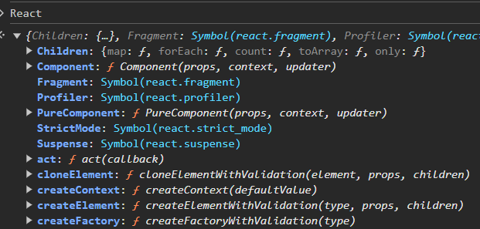

* + 1. Method “createElement”:

<!--First React code-->

<script>

//step 1:create an element

const message = React.createElement('h1',{},'Hello From React.');

//step 2:setting root for the React.Here the root is the div with id='root'

      const root = ReactDOM.createRoot(document.getElementById('root'));

//inside the root the above specified 'h1' will be created.

      root.render(message);//whole message get rendered over here

</script>

**OUTPUT:**

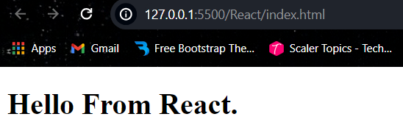

* 1. **Challenges with React CDN:**
     1. To Pass parameters (),specify it inside the “{ }” :

const message = React.createElement('h1',{id:'message1'},'Hello From React.');

**Inspect:**

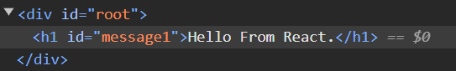

* + 1. Now we have to build following in React:

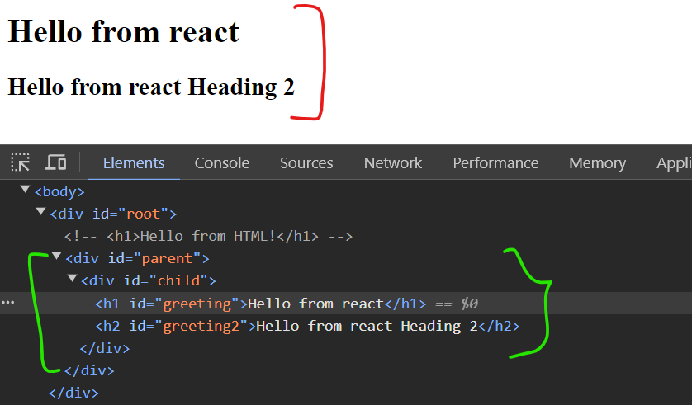

* + 1. So comment div with id=’root’ and build React code to display like above.Previously when we passed ‘Hello from react’ there had only one div with id=’root’.But Here we have two divs ,i.e div with id=’child’ inside div with id=’parent’.So instead the message we have to put one more ‘React.createElement()’ :

**Body:**

<div id="parent">

        <div id="child">

          <h1 id="greeting"></h1>

          <h2 id="greeting2"></h2>

        </div>

      </div>

**Script :**

<script>

      const message = React.createElement(

        "div",

        { id: "parent" },

        React.createElement("div", { id: "child" }),[ //using array to store multiple element

        React.createElement("h1",{id:"greeting"},'Hello from react.'),

        React.createElement("h2",{id:"greeting2"},'Hello from react heading2.')

        ]

      );

      const root = ReactDOM.createRoot(document.getElementById("parent")); //step 2:setting root for the React.

      root.render(message); //whole message get rendered over here

    </script>

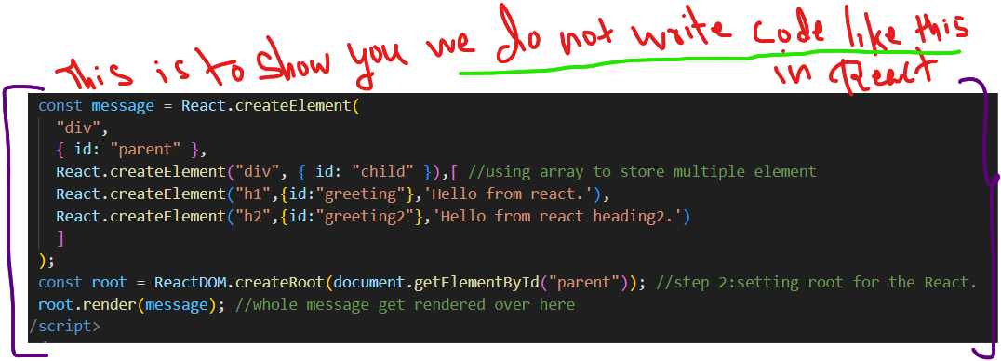

1. ***Setting up the Development Environment :***
   1. **Setting up NPM:**
      1. Since React CDN has some Challenges.Complex codes.So we make use of some Built Tools.
      2. Before moving to Built tools like (webpack,vite,parcel etc..) ,We need to understand about NPM(Node Package Manager).
      3. **NPM :** *How to Install and use an NPM Package* ?

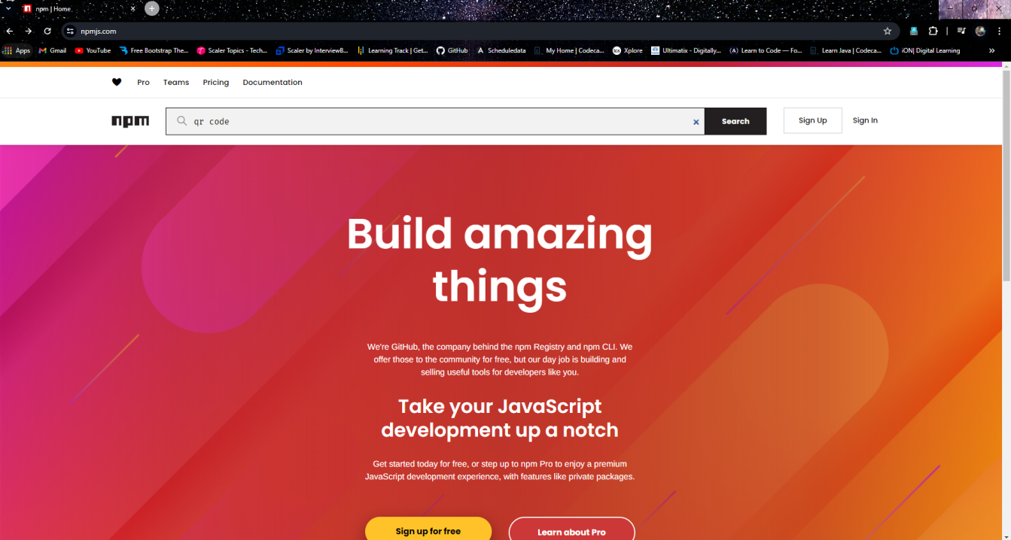

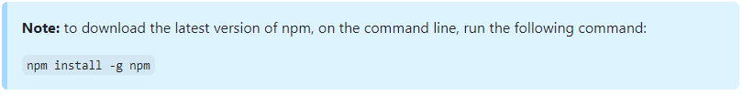

* + 1. How to Initialize/ Use npm for your directory,Open certain folder in terminal and type:’npm init’ :

npm init

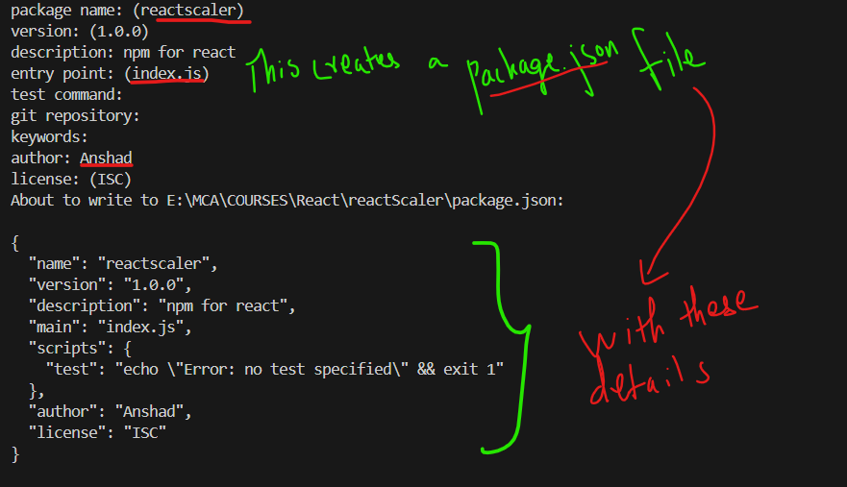

* 1. **Setup React App with Vite(a built in tool) :**
     1. What is Vite tool?

**Vite is a next-generation, front-end tool that focuses on speed and performance.**

* + 1. Why Vite is used?

**It Lets the browser take over part of the job of a bundler.[** Our project will have all type of files like html,css,images,js and so on.So this vite **bundles these all together** and **browser to understand** all these codes and for better performance.**]**

* + 1. Features of Vite(Goto vite website):

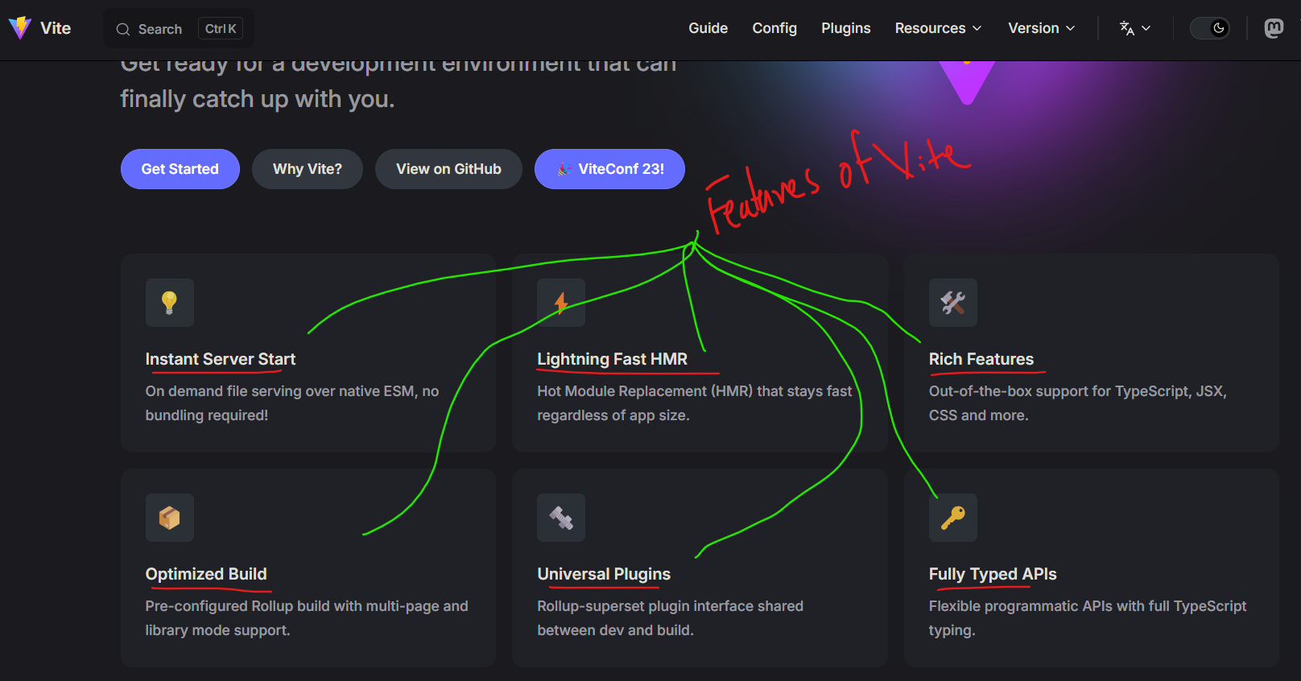

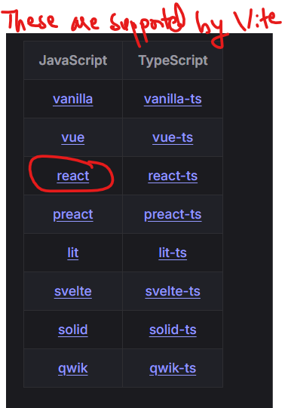

* + 1. How to use Use Vite inside your folder ?

1. First run command “**npm create vite@latest**”.
2. Give project name ->Eg:vite-project
3. Select Framework ->React.
4. Select variant-> JavaScript.

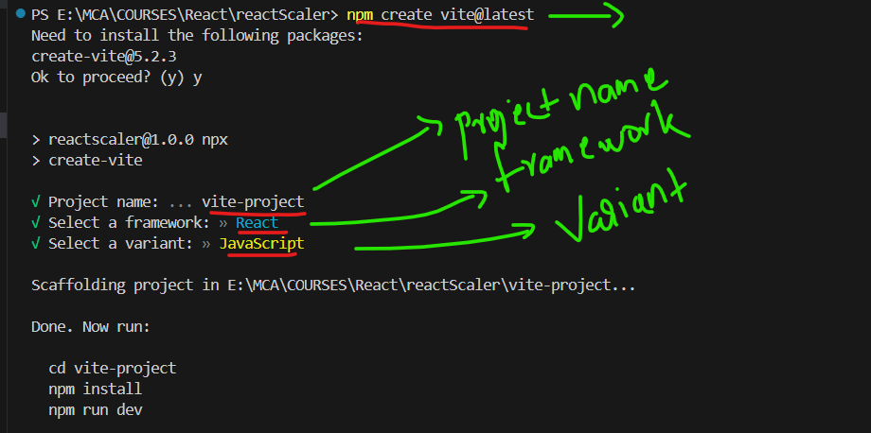

1. Now open that ‘vite-project’ folder in terminal and install npm : “npm install”.So that ‘vite-project’ will get all the dependencies .

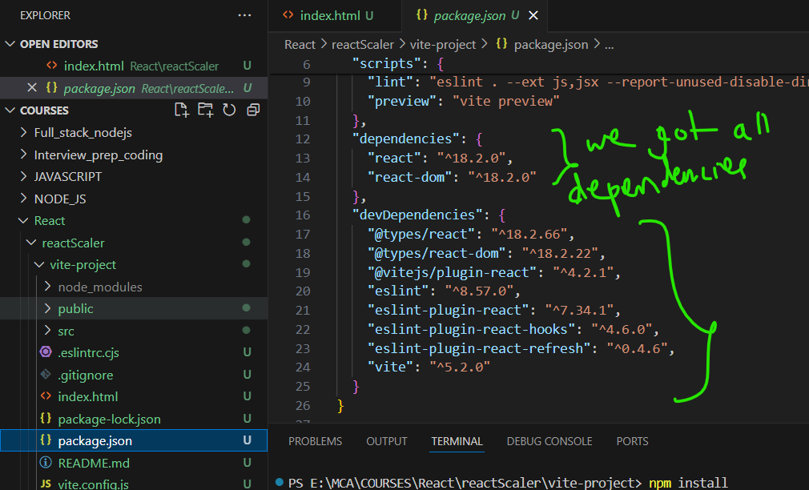

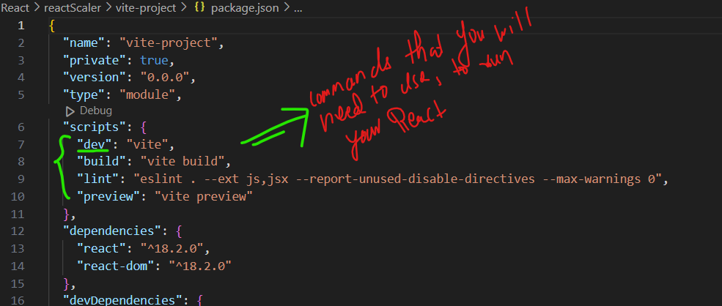

1. ‘dev’ command is used to RUN your React project: “npm run dev”.

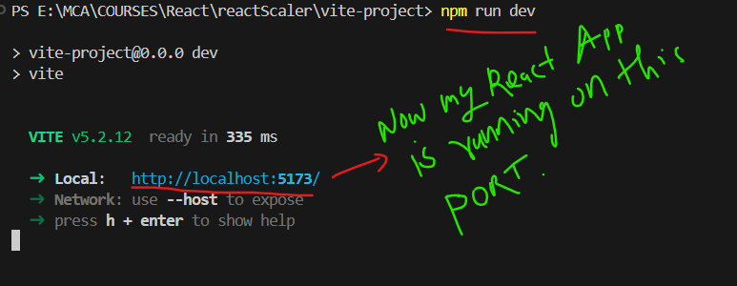

1. Now our React App is Ready:

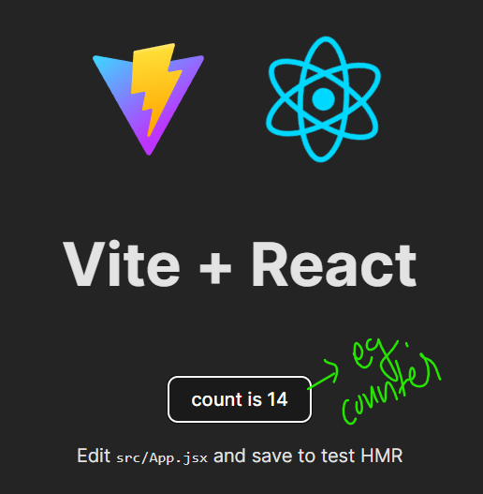

* 1. **Folder Structure :**
     1. Open src>‘main.jsx’ file .
     2. ‘.jsx’ is the new way of writing JS files recommended by React.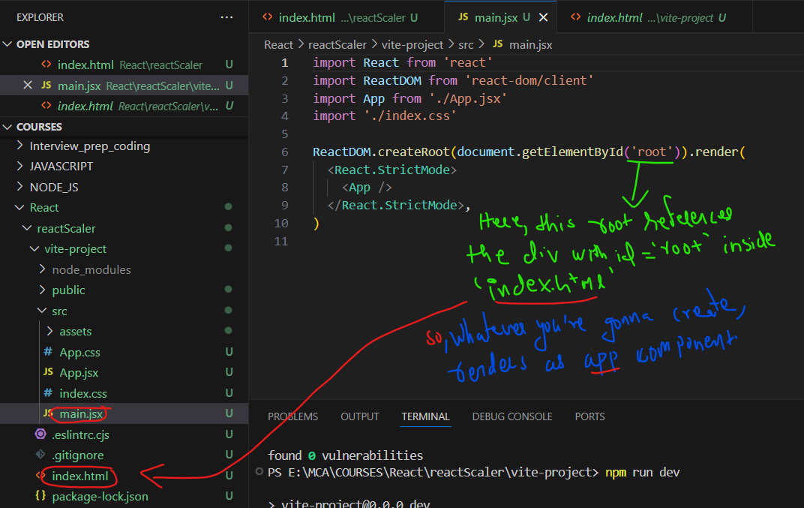

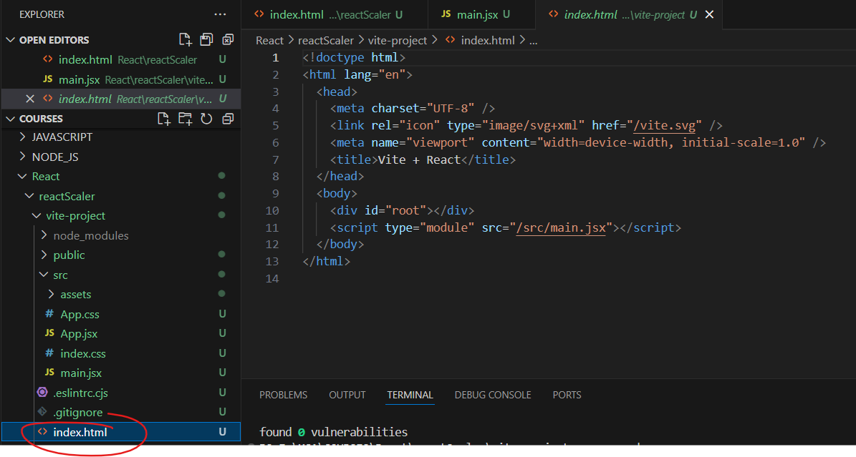

* + 1. So whatever we are gonna create is rendered as App component.
    2. What is Component ?=> Eg:-We can see different sections in Instagram like stories,feed and so on.To Manage our application in Efficient way.Components are just part of your Application.So this Component will also be inside one component right.That top most component is <App> .
    3. So “App.jsx” file is the component <App> file.What we saw previously in browser is the output of this file.

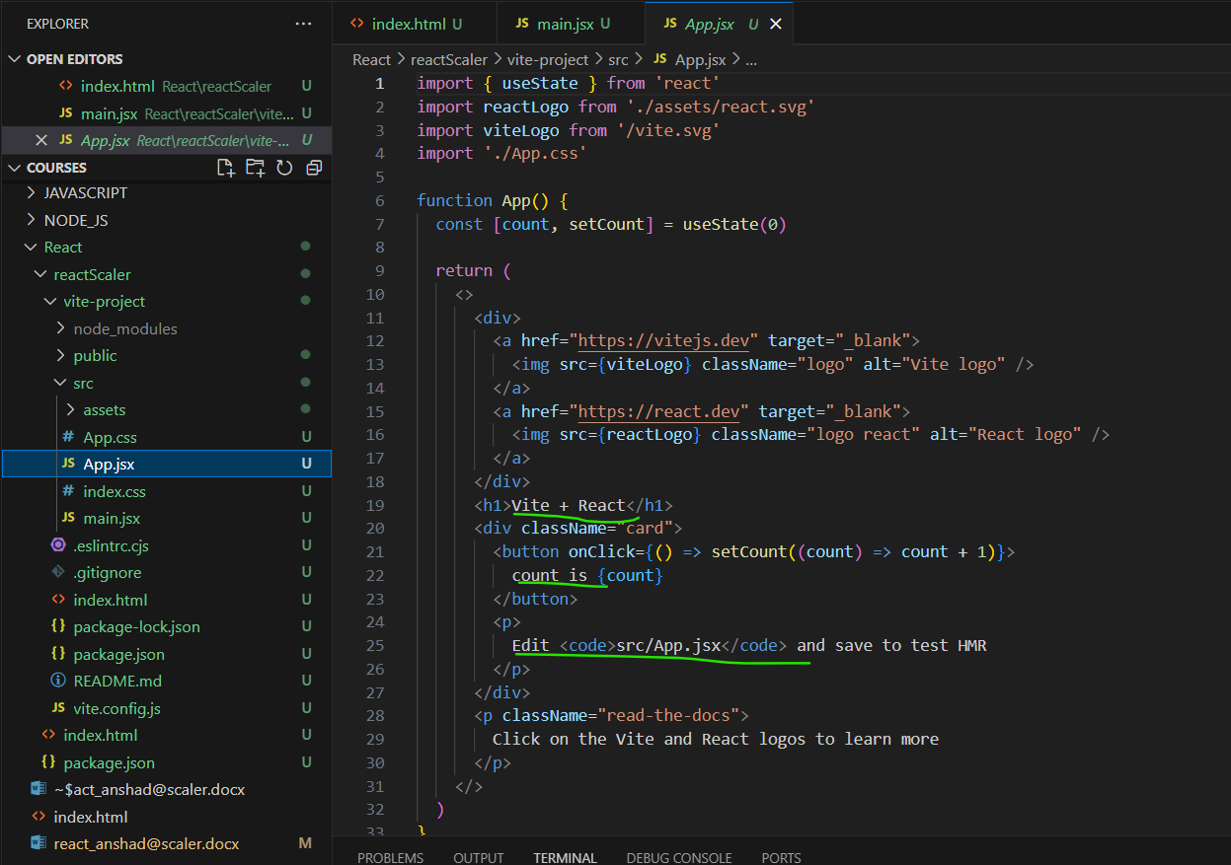

**OUTPUT:**



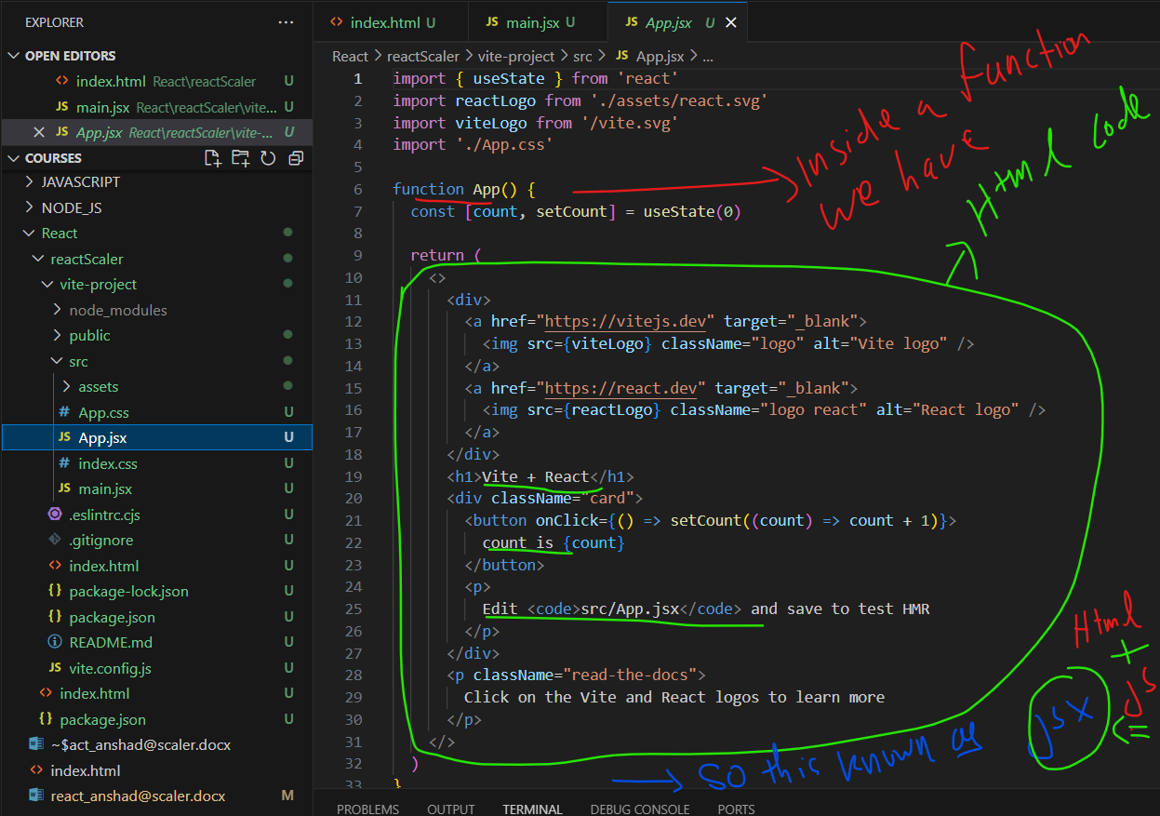

* + 1. Here in ‘App.jsx’ we can see html code inside function.So that is why this is a jsx file [HTML + JavaScript =>jsx]
    2. How browser Understands this Html code inside a Javascript code ?=

=>With the Help of Tool Babel.It **Takes the JavaScript code and Transfile it to HTML** code .So that browser can understand it.

* + 1. ‘index.css’ and ‘App.css’ are default css files which gives a default style to the APP.

1. ***The Component Architecture and JSX :***
   1. **Create Your First React Component :**
      1. Before creating First Component,lets clear some deafult code in ‘App.jsx’(It is our Parent component):

function App() {

  return (

    <h1>Hello From React</h1>

  )

}

export default App

* + 1. First Create a **Folder** named ‘components’ inside ‘src’ .
    2. Now Create a **Component** inside folder ‘components’ say ‘Hello.jsx’(This component Prints Hello).
    3. [NOTE:**The first letter of component should be CAPS**] .
    4. Now we are gonna use this component inside the Parent component ‘App.jsx’.For that First we have to Export that ‘Hello.jsx’ :

function Hello(){

    return

    <h1>Hello from hello Component.</h1>

}

export default Hello

* + 1. Same like,we have to Import that exported component in ‘App.jsx’ :

import Hello from './components/Hello'

* + 1. Now we need to use this component ‘Hello’ :

import Hello from './components/Hello'

function App() {

  return (

    <Hello/> //Here we  use the component 'Hello' which is imported.

  )

}

export default App

OUTPUT:

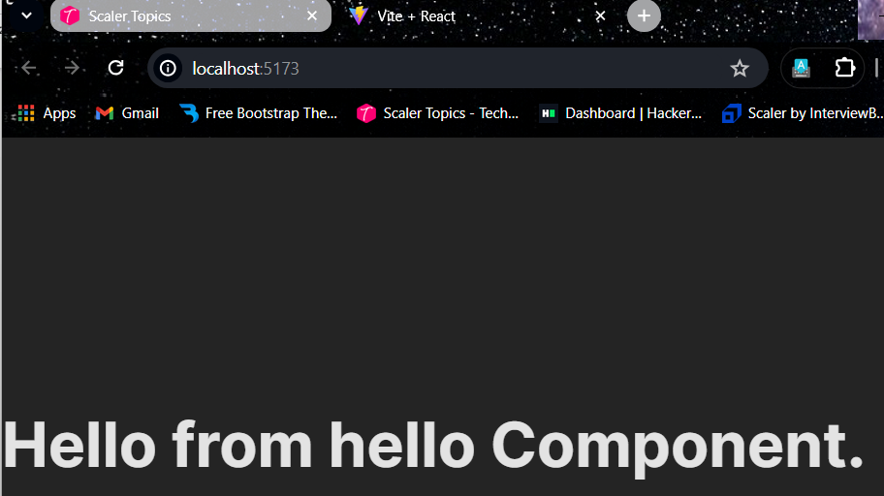

* + 1. Now lets create another component say ‘Bye.jsx’ .
    2. **[Note :** For Shortcut type ‘rfce’ and enter to get a structure of code . **]**

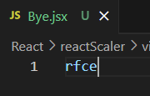

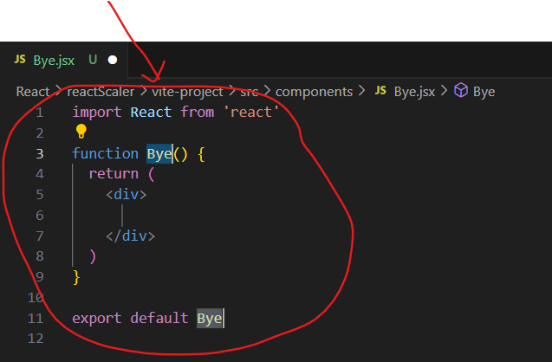

* + 1. Now Edit this code according your need:

import React from 'react'

function Bye() {

  return (

    <h1>Bye from Bye component</h1>

  )

}

export default Bye

* + 1. Then import this Bye component inside ‘App.jsx’:

import Bye from './components/Bye'

* + 1. Now we have to Use this component.But we already have used another component ‘Hello’ .

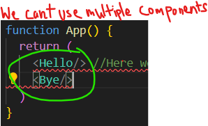

* + 1. To use multiple components together :We need to use ‘React Fragments’.
    2. HThat is we have to wrap your whole components inside ‘<> </>’ :

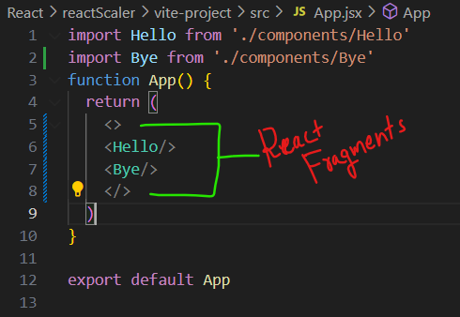

Output :

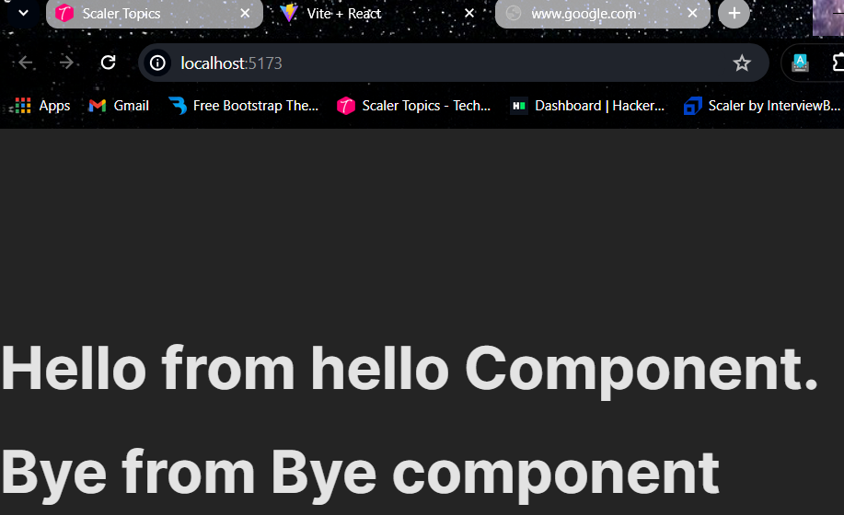

* 1. **Properties of JSX:**
     1. What if we write ‘{10 + 20}’ inside the html content like this :

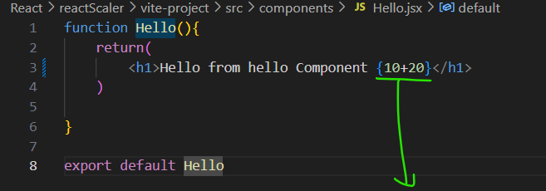

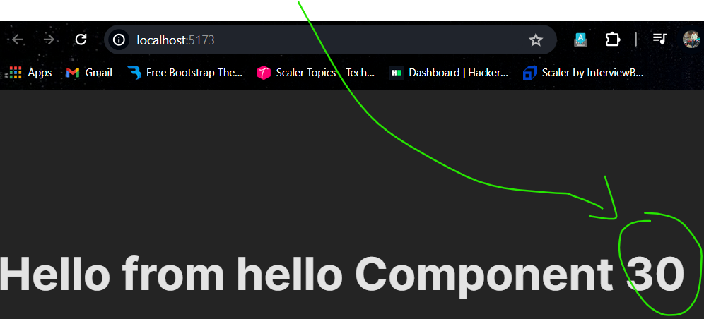

* + 1. So whatever you write inside curly braces will be evaluated as JS.
    2. Lets try using variables and functions inside this :

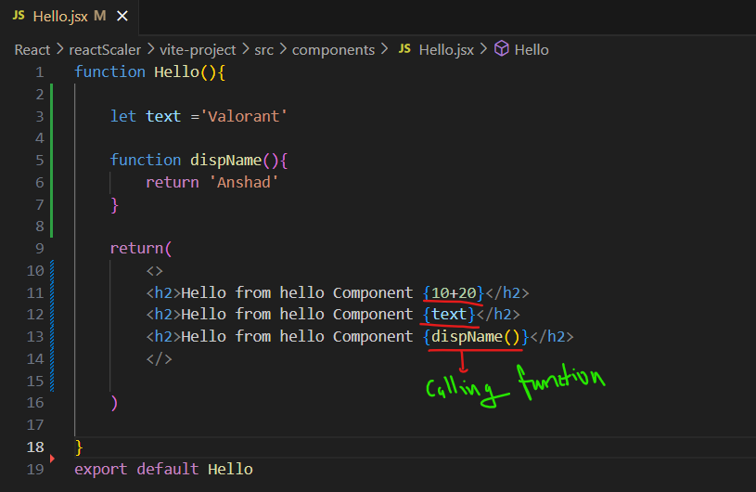

**Output** :

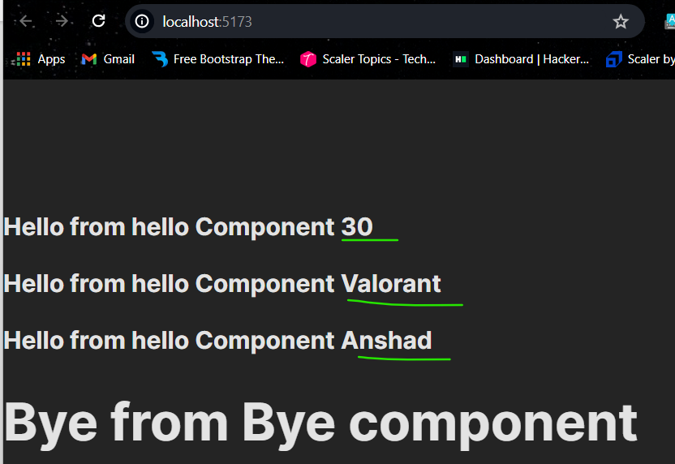

* 1. **Props and Reusing Components :**
     1. Props will help your component Go Dynamic.
     2. Asd
     3. As
     4. Da
     5. Sd
     6. Asd
     7. Sad
  2. **Asd**
  3. **Asd**
  4. **Asd**
  5. **Asd**
  6. **asd**
     1. Inside the folder ‘models’ create a file ‘courseModel.js’: