SOC HOME LAB
SIEM Monitoring & Attack Detection
SOC Portfolio Project | March 2026

Author | Muhammed Anshad
Certification | Certified SOC Analyst (CSA) – EC-Council
Project Type | SOC Home Lab – Portfolio Project
Target Role | SOC Analyst L1 / Cybersecurity Analyst
Tools Used | VMware, Kali Linux, Windows Server 2022, Splunk
Date | March 2026
Status | Completed ✓

1. Project Overview
The objective of this project is to build a Security Operations Center (SOC) home lab environment to simulate real-world cyber attacks and practice security monitoring and incident detection using a SIEM platform.

The lab environment consists of two virtual machines running inside VMware Workstation Pro 17. An attacker machine running Kali Linux was used to simulate attacks against a target machine running Windows Server 2022. Security logs generated by the target system were collected and analyzed using Splunk Enterprise to detect suspicious activities such as network scanning and failed login attempts.

This project demonstrates the following practical SOC analyst skills:
- Setting up and managing a virtualized SOC lab environment
- Installing and configuring Splunk SIEM for log collection and analysis
- Simulating cyber attacks using Kali Linux tools (Nmap, Hydra)
- Detecting and investigating security events using Splunk search queries
- Identifying suspicious activity using Windows Event IDs
- Mapping attack techniques to the MITRE ATT&CK framework

2. Lab Architecture
The SOC home lab consists of two virtual machines connected through a shared NAT network inside VMware Workstation Pro 17.

Component | System | IP Address | Role
Attacker Machine | Kali Linux 2025.2 | 192.168.52.x | Simulate cyber attacks
Target Machine | Windows Server 2022 | 192.168.52.136 | Generate security logs
SIEM Platform | Splunk Enterprise 10 | 127.0.0.1:8000 | Collect & analyze logs
Virtualization | VMware Workstation Pro 17 | Host Machine | Run virtual machines

Lab Flow
Kali Linux → Attack Simulation → Windows Server 2022 → Splunk SIEM → Log Investigation

Lab Environment – VMware Workstation
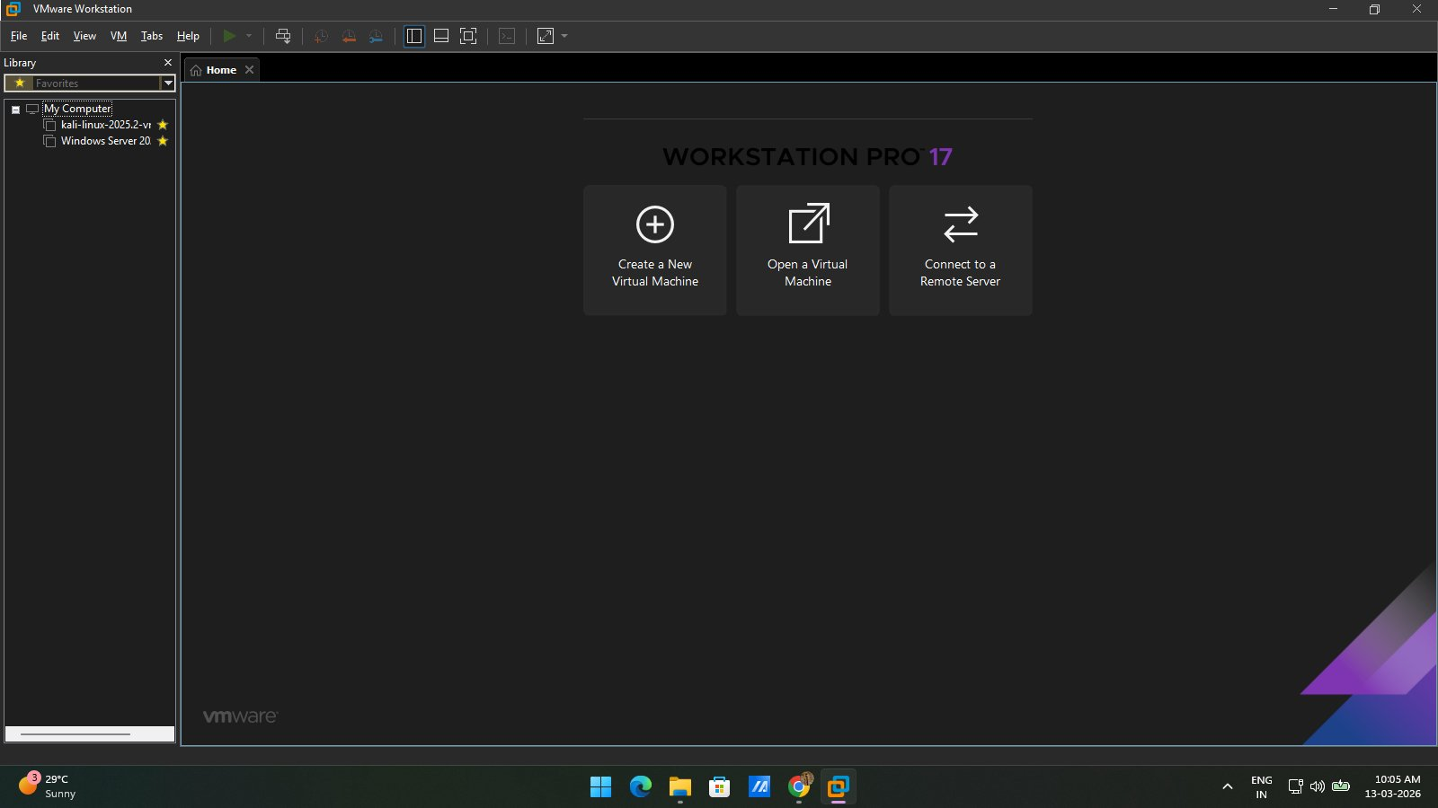
Figure 1: VMware Workstation Pro 17 showing both virtual machines (Kali Linux and Windows Server 2022)

3. Tools Used
Tool | Version | Purpose
VMware Workstation Pro | 17 | Create and manage virtual machines for the SOC lab
Kali Linux | 2025.2 | Attacker machine for simulating cyber attacks
Windows Server 2022 | Build 20348 | Target/victim machine generating security logs
Splunk Enterprise | 10.0.1 | SIEM platform for log collection and analysis
Nmap | 7.95 | Network scanning and port discovery attack
Hydra | 9.5 | Brute force login attack simulation

4. Lab Setup

4.1 Attacker Machine – Kali Linux
Kali Linux 2025.2 was configured as the attacker machine. It contains pre-installed security tools including Nmap and Hydra which were used to simulate attacks against the target machine.

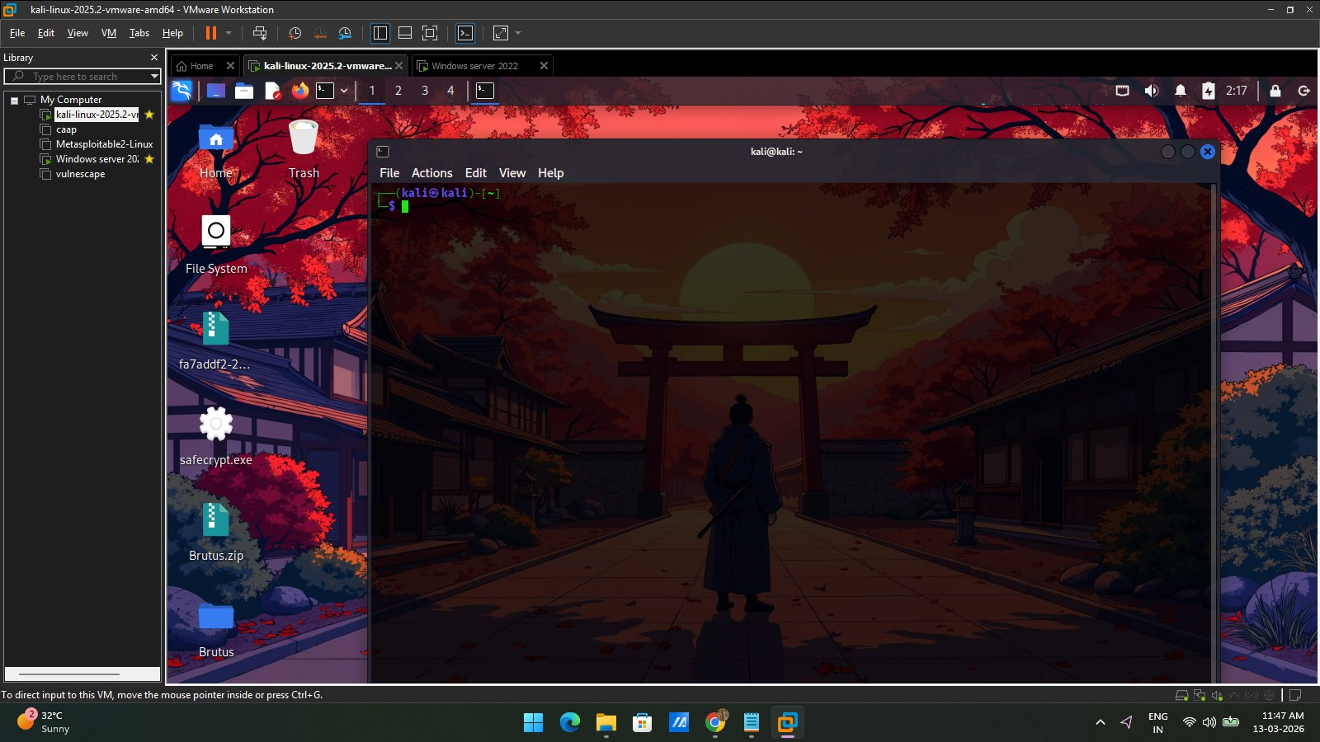
Figure 2: Kali Linux 2025.2 running inside VMware Workstation – Attacker Machine

4.2 Target Machine – Windows Server 2022
Windows Server 2022 Standard Evaluation was configured as the target machine. This system generated Windows Security Event logs which were collected and analyzed by Splunk.

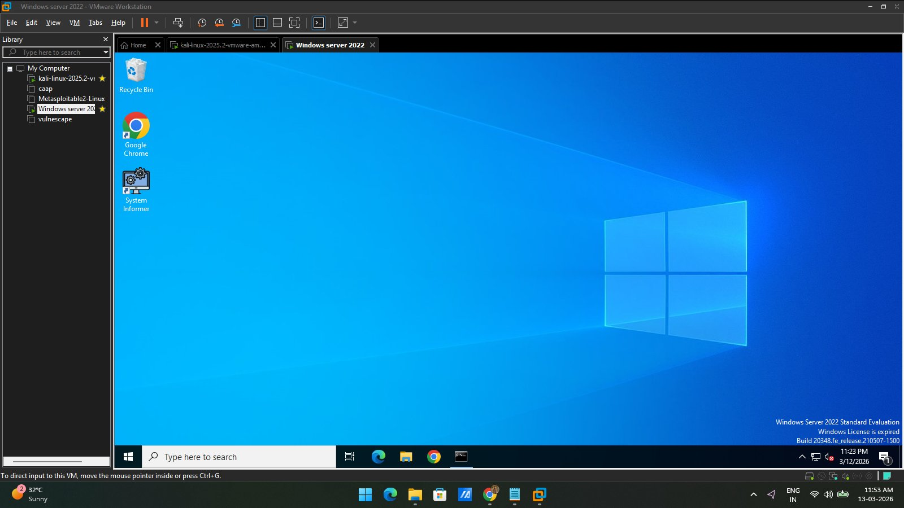
Figure 3: Windows Server 2022 running inside VMware Workstation – Target Machine

4.3 Network Connectivity Test
Network connectivity between the attacker machine (Kali Linux) and the target machine (Windows Server 2022) was verified using the ping command. The Windows Firewall ICMP rule was enabled to allow ping requests.

ping 192.168.52.136

The ping test confirmed successful communication between both machines with response times between 0.37ms and 1.31ms, confirming the lab network was fully operational.

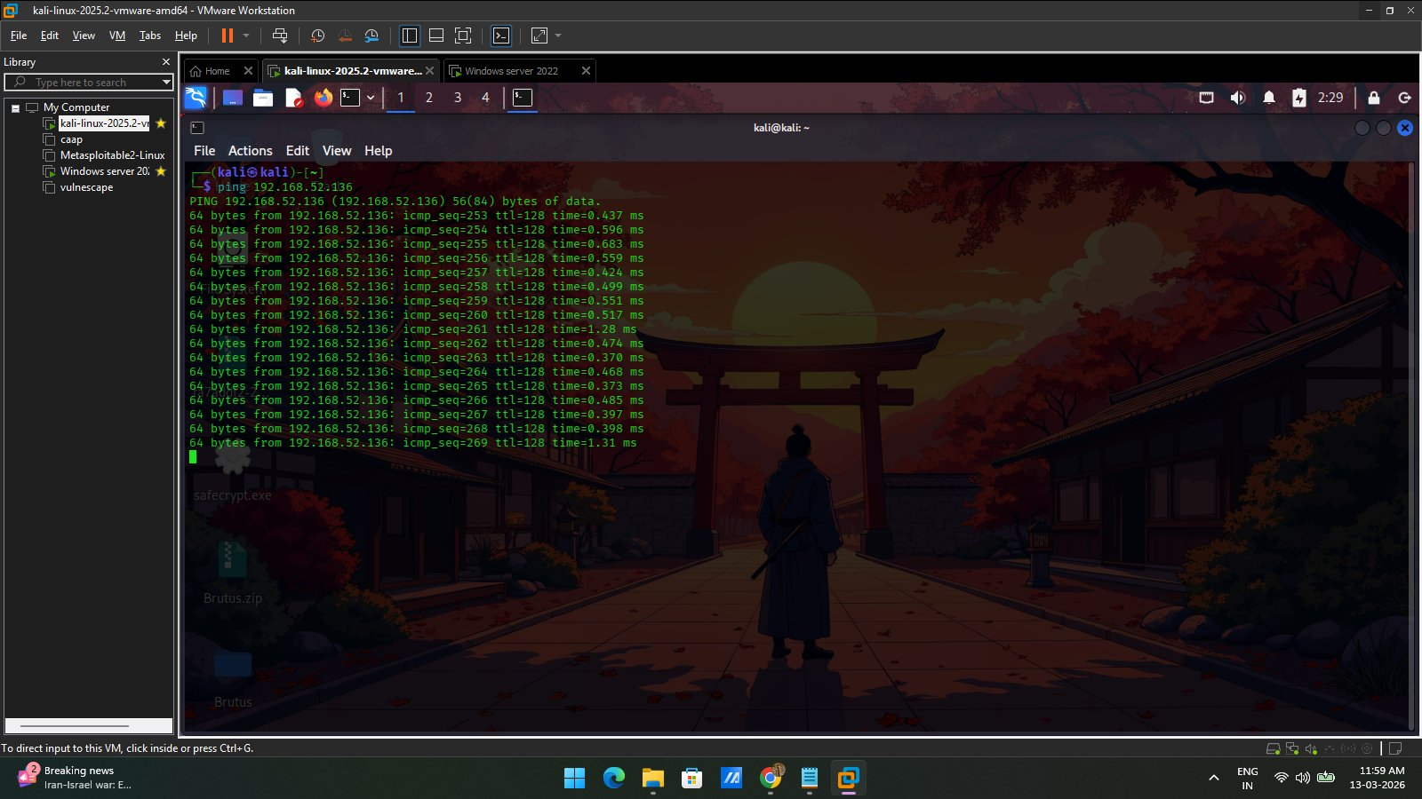
Figure 4: Successful ping from Kali Linux to Windows Server 2022 (192.168.52.136)

5. SIEM Setup – Splunk Configuration

5.1 Splunk Dashboard
Splunk Enterprise 10.0.1 was installed on the Windows Server 2022 machine and accessed via the web interface at http://localhost:8000. The SIEM platform was configured to monitor and analyze Windows security logs in real time.

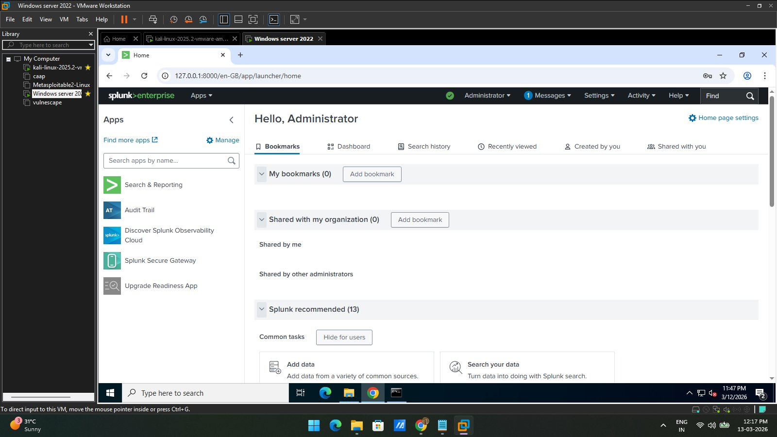
Figure 5: Splunk Enterprise dashboard running on Windows Server 2022 at http://localhost:8000

5.2 Windows Event Log Collection
Windows local event logs were configured as a data input in Splunk. The following log sources were added for monitoring:
- Security logs – authentication events, login attempts, privilege use
- System logs – system-level events and service changes
- Application logs – application-level events

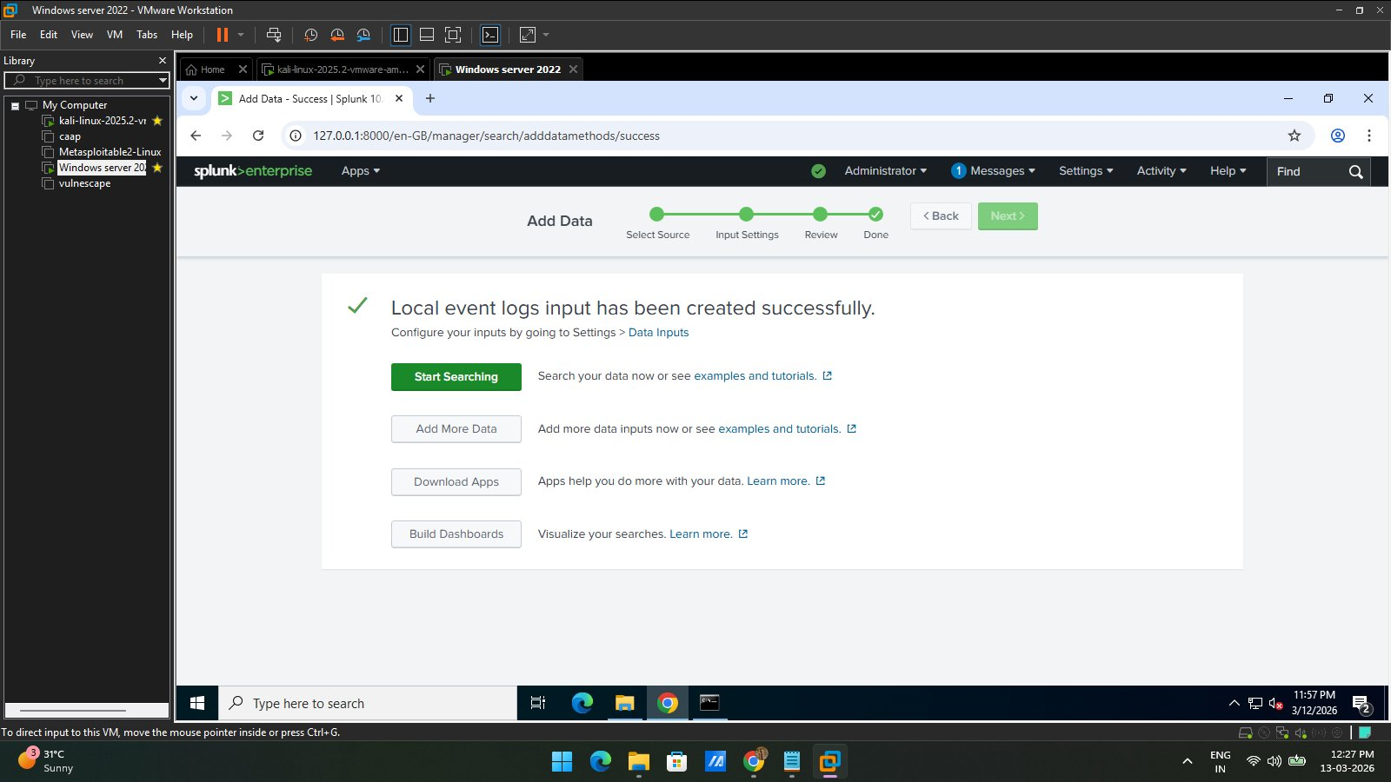
Figure 6: Splunk confirming successful creation of Windows event log data input

5.3 Log Verification
After configuring the data input, logs were verified by running a search query in Splunk. Windows Event Logs from the Security and Application sources were successfully collected, confirming the SIEM was fully operational.

index=main

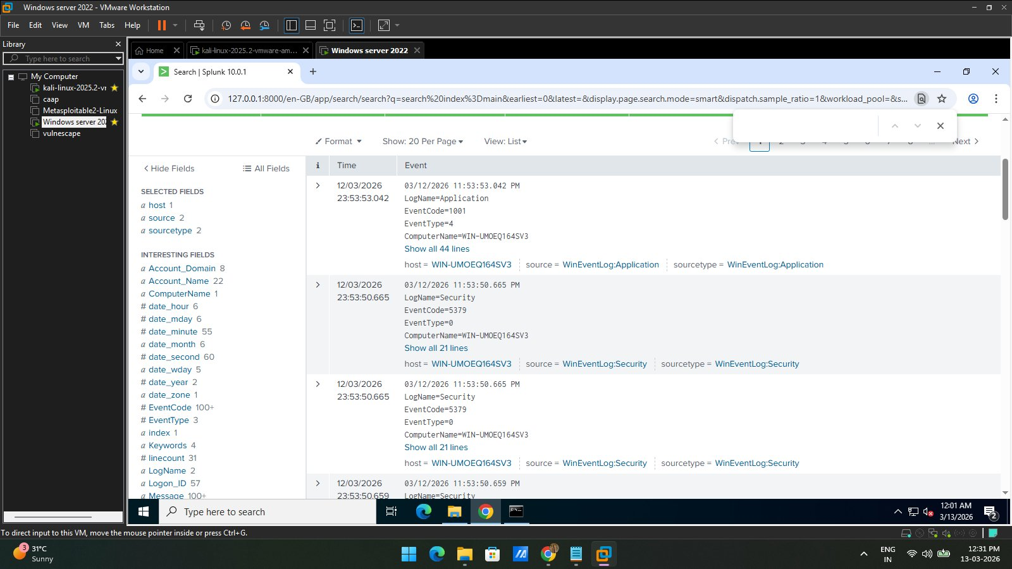
Figure 7: Splunk search results showing Windows Security and Application logs being collected in real time

6. Attack Simulation

6.1 Attack 1 – Network Scanning (Nmap)
A network scan was performed from the Kali Linux attacker machine against the Windows Server 2022 target to identify open ports and running services. This simulates a reconnaissance attack that a real threat actor would perform before targeting a system.

MITRE ATT&CK Technique: T1046 – Network Service Discovery

nmap -sV 192.168.52.136

Scan Results:
- Host: 192.168.52.136 – Status: UP (0.00041s latency)
- Port 5357/tcp – OPEN – Microsoft HTTPAPI httpd 2.0 (SSDP/UPnP)
- Port 5985/tcp – OPEN – Microsoft HTTPAPI httpd 2.0 (SSDP/UPnP)
- OS Detected: Windows
- MAC Address: 00:0C:29:C4:07:62 (VMware)

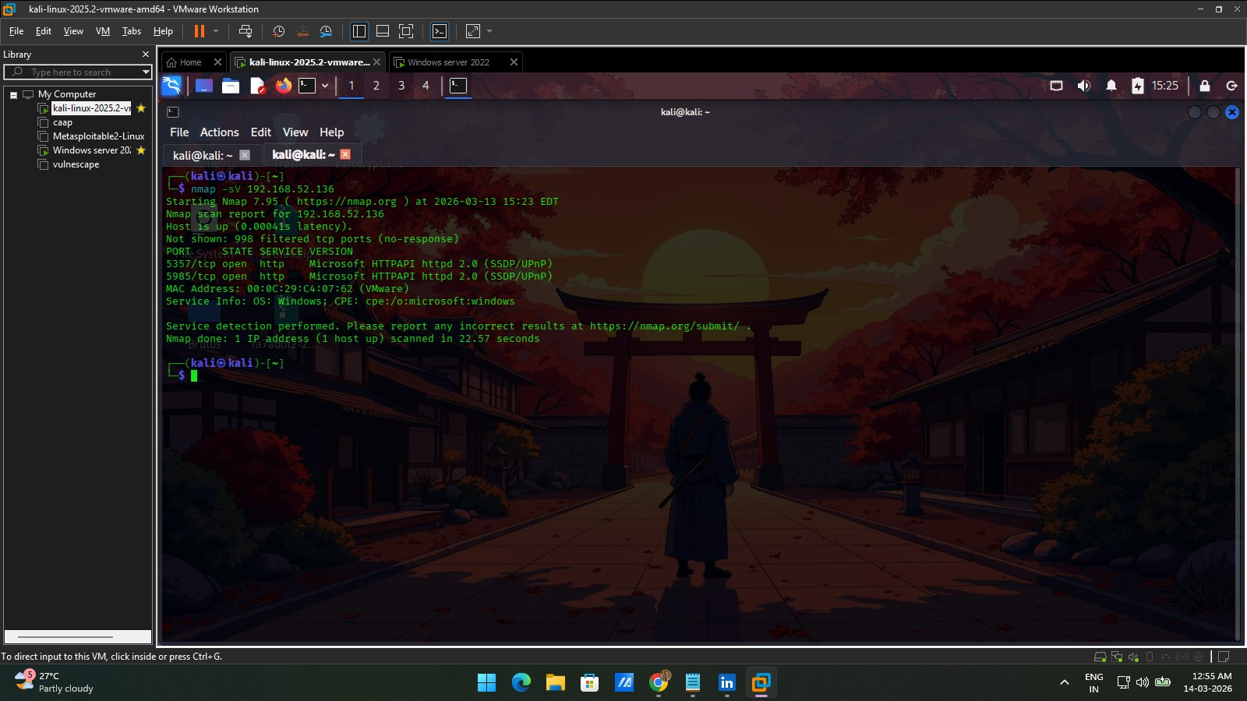
Figure 8: Nmap service version scan from Kali Linux identifying open ports on Windows Server 2022

6.2 Attack 2 – Brute Force Login Attack (Hydra)
A brute force login attack was simulated using Hydra from the Kali Linux machine targeting the SMB service (port 445) on the Windows Server. This simulates a credential stuffing attack and generates multiple failed authentication events in the Windows Security logs.

MITRE ATT&CK Technique: T1110 – Brute Force

hydra -l administrator -P /usr/share/wordlists/rockyou.txt 192.168.52.136 smb -V -f

Attack Details:
- Target service: SMB on port 445
- Target username: administrator
- Wordlist: rockyou.txt (14,344,399 password attempts)
- Hydra generated multiple failed login attempts against the Windows Server

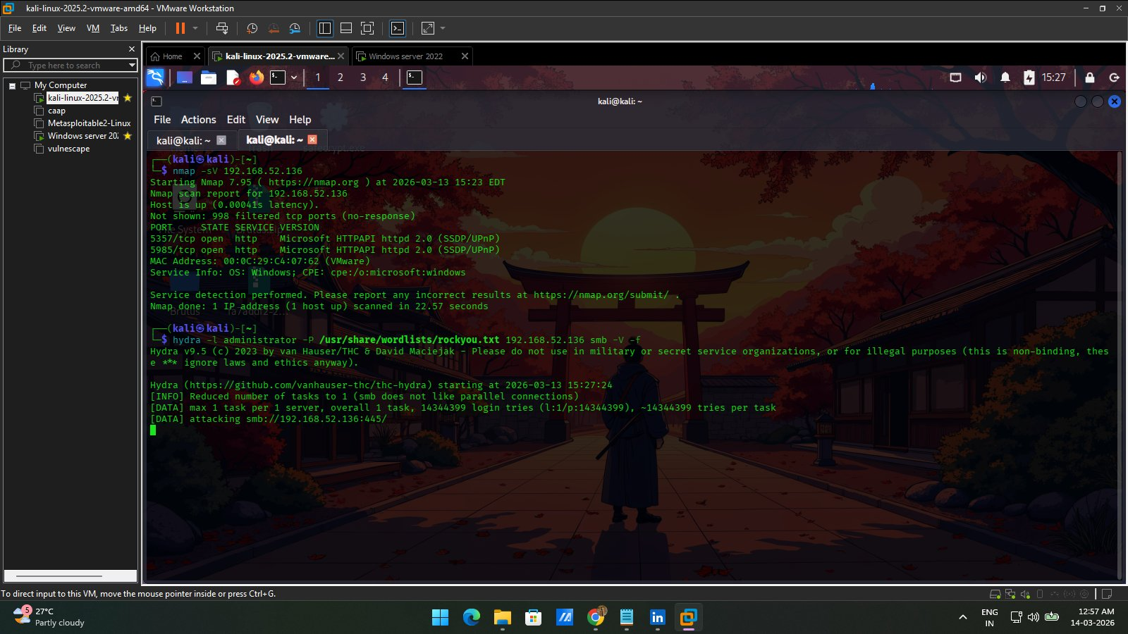
Figure 9: Hydra brute force attack running from Kali Linux targeting SMB on Windows Server 2022

7. Log Analysis & Investigation

7.1 Windows Event IDs Reference
The following Windows Event IDs were used during the investigation to identify suspicious activity:

Event ID | Event Name | Description
4624 | Successful Logon | A user account successfully logged on to the system
4625 | Failed Logon | A user account failed to log on – indicates brute force attack
4688 | Process Creation | A new process was created – monitors suspicious executions
4672 | Special Privileges | Special privileges assigned to new logon – privilege escalation

7.2 Splunk Investigation – Failed Login Detection
After running the brute force attack, Splunk was searched for EventCode 4625 (Failed Logon) to detect the attack activity. The query returned 15 failed login events, confirming that the brute force attack was successfully detected by the SIEM.

index=main EventCode=4625

Investigation Results:
- 15 failed login events (EventCode=4625) detected in Splunk
- Log sources: WinEventLog:Security and WinEventLog:Application
- Target machine: WIN-UMOEQ164SV3 (Windows Server 2022)
- Authentication package and caller process information captured
- Failure_Reason field available for detailed investigation

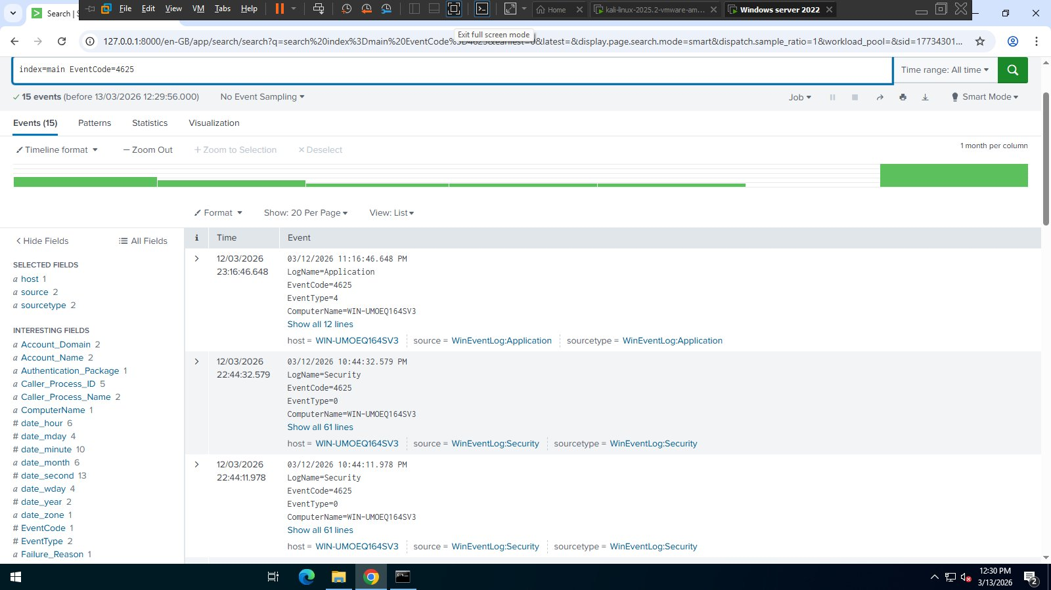
Figure 10: Splunk search showing 15 EventCode=4625 (Failed Logon) events detected from the brute force attack

8. Findings
The following security findings were identified during the SOC Home Lab investigation:

# | Finding | Evidence | MITRE ATT&CK
1 | Network Reconnaissance | Nmap scan detected open ports 5357 and 5985 on Windows Server | T1046 – Network Service Discovery
2 | Brute Force Attack | 15 failed login events (EventCode=4625) detected in Splunk SIEM | T1110 – Brute Force
3 | SMB Service Targeted | Hydra targeted SMB port 445 on the Windows Server | T1021.002 – SMB/Windows Admin Shares

9. Conclusion
This SOC Home Lab project successfully demonstrated how a Security Operations Center analyst monitors, detects, and investigates cyber attacks in a controlled lab environment.

The lab simulated two real-world attack scenarios — network reconnaissance using Nmap and brute force login attempts using Hydra — and both attacks were successfully detected and investigated using Splunk SIEM.

Key skills demonstrated in this project:
- Building and configuring a virtualized SOC lab using VMware
- Installing and configuring Splunk SIEM for Windows log collection
- Simulating cyber attacks from an attacker machine (Kali Linux)
- Detecting attacks using Splunk search queries and Windows Event IDs
- Mapping attack techniques to the MITRE ATT&CK framework
- Documenting findings in a professional SOC investigation report

This project reflects practical, hands-on experience with the tools and workflows used by SOC analysts in real enterprise environments and demonstrates readiness for an entry-level SOC Analyst role.

10. Tools & References
- VMware Workstation Pro 17 – vmware.com
- Kali Linux 2025.2 – kali.org
- Splunk Enterprise 10.0.1 – splunk.com
- Nmap 7.95 – nmap.org
- Hydra 9.5 – github.com/vanhauser-thc/thc-hydra
- MITRE ATT&CK Framework – attack.mitre.org
- EC-Council Certified SOC Analyst (CSA) Courseware

Muhammed Anshad | Certified SOC Analyst (CSA) – EC-Council | March 2026

