

**Name: Muhammad Ans Shakeel**

**Reg #: SWEN18111113**

**Submitted to : Engr. Zainab Saleem**

**Statement 1:**

**SQL Query:**

CREATE TABLE employee(

empl_id int UNIQUE,

first_name varchar(50),

last_name varchar(50),

gender varchar(6),

phone int,

salary int,

appointment_date date,

department varchar(50),

designation varchar(50)

);

**Statement 2:**

**SQL Query:**

INSERT INTO employee(empl_id,first_name,last_name,gender,phone,salary,appointment_date,department,designation) VALUES

(1,'Ans','Shakeel','Male',0323,20000,'2001-04-15','CPEN','HOD'),

(2,'Uzair','khan','Male',0323,20000,'2001-04-15','CVEN','FAC'),

(3,'iqra','khan','Female',0323,80000,'2018-01-01','CPEN','HOD'),

(4,'salman','khan','Male',0323,620000,'2017-04-15','CSD','STU'),

(5,'ali','Shakeel','Male',0323,30000,'2001-04-15','MATH','HOD'),

(6,'aisha','biii','Female',0323,90038,'2012-04-15','CPEN','HOD'),

(7,'ahmaed','Shakeel','Male',0323,220000,'2001-04-15','PHY','Teacher'),

(8,'zain','ali','Male',0323,110000,'2001-04-15','CPEN','HOD'),

(9,'xasd','aakhan','Male',0323,20000,'2001-04-15','CVEN','FAC'),

(10,'asdas','bkhan','Female',0323,100000,'2018-01-01','CPEN','HOD'),

(11,'ffff','bkhan','Male',0323,620000,'2012-04-15','CSD','STU'),

(12,'dsads','bShakeel','Male',0323,900000,'2000-04-15','MATH','HOD'),

(13,'aisas','biisi','Female',0323,900038,'2012-04-15','CPEN','HOD'),

(14,'ahmsassed','sShakeel','Male',0323,220000,'2001-04-15','PHY','Teacher'),

(15,'zaisnss','aali','Male',0323,110000,'2009-04-15','CPEN','HOD'),

(16,'Anss','Shakeel','Male',0323,20000,'2001-04-15','CPEN','HOD'),

(17,'Uzsair','khan','Male',0323,20000,'2001-04-15','CVEN','FAC'),

(18,'iqsra','khan','Female',0323,80000,'2018-01-01','CPEN','HOD'),

(19,'saslman','khan','Male',0323,620000,'2017-04-15','CSD','STU'),

(1101,'alsi','Shakeel','Male',0323,30000,'2001-04-15','MATH','HOD'),

(10012,'aissha','biii','Female',0323,90038,'2012-04-15','CPEN','HOD'),

(20,'ahmsaed','Shakeel','Male',0323,220000,'2001-04-15','PHY','Teacher'),

(21,'zasin','bali','Male',0323,110000,'2001-04-15','CPEN','HOD'),

(22,'xasd','aakhan','Male',0323,20000,'2001-04-15','CVEN','FAC'),

(23,'asadas','bkhan','Female',0323,100000,'2018-01-01','CPEN','HOD'),

(24,'ffff','bkhan','Male',0323,620000,'2012-04-15','CSD','STU'),

(125,'sdsds','bShakeel','Male',0323,900000,'2000-04-15','MATH','HOD'),

(25,'aaiss','biisi','Female',0323,900038,'2012-04-15','CPEN','HOD'),

(26,'ahmassed','sShakeel','Male',0323,220000,'2001-04-15','PHY','Teacher'),

(127,'zaisnss','aali','Male',0323,110000,'2009-04-15','CPEN','HOD')

**Statement 3:**

**SQL Query:**

SELECT * FROM employee;

**Result Screenshot:**

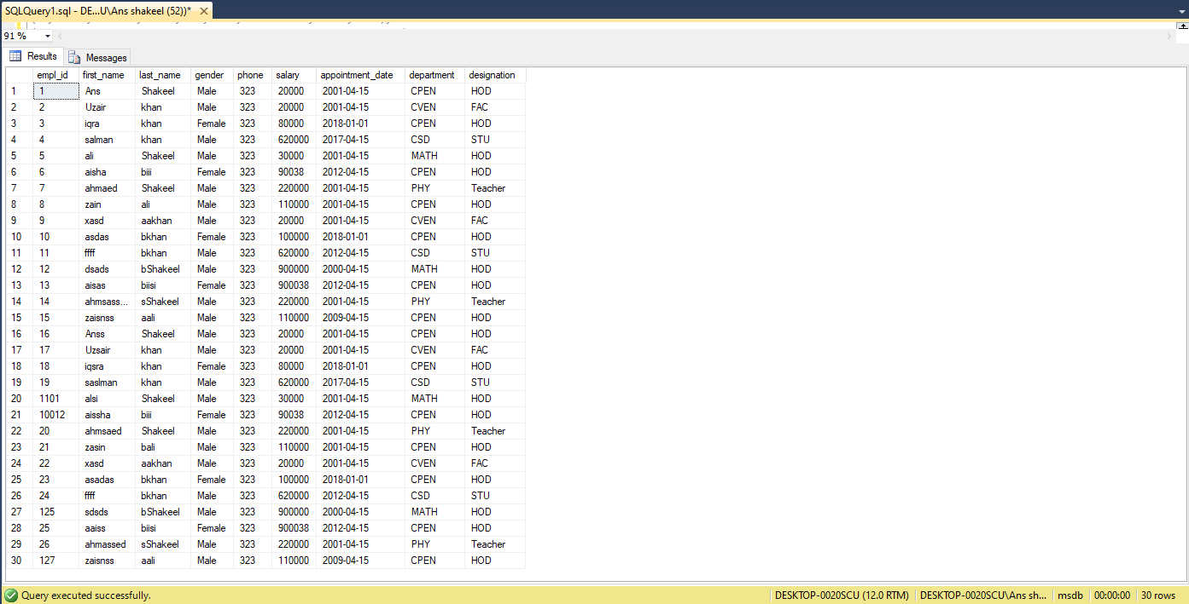

**Statement 4:**

**SQL Query:**

SELECT empl_id,first_name,last_name FROM employee;

**Result Screenshot:**

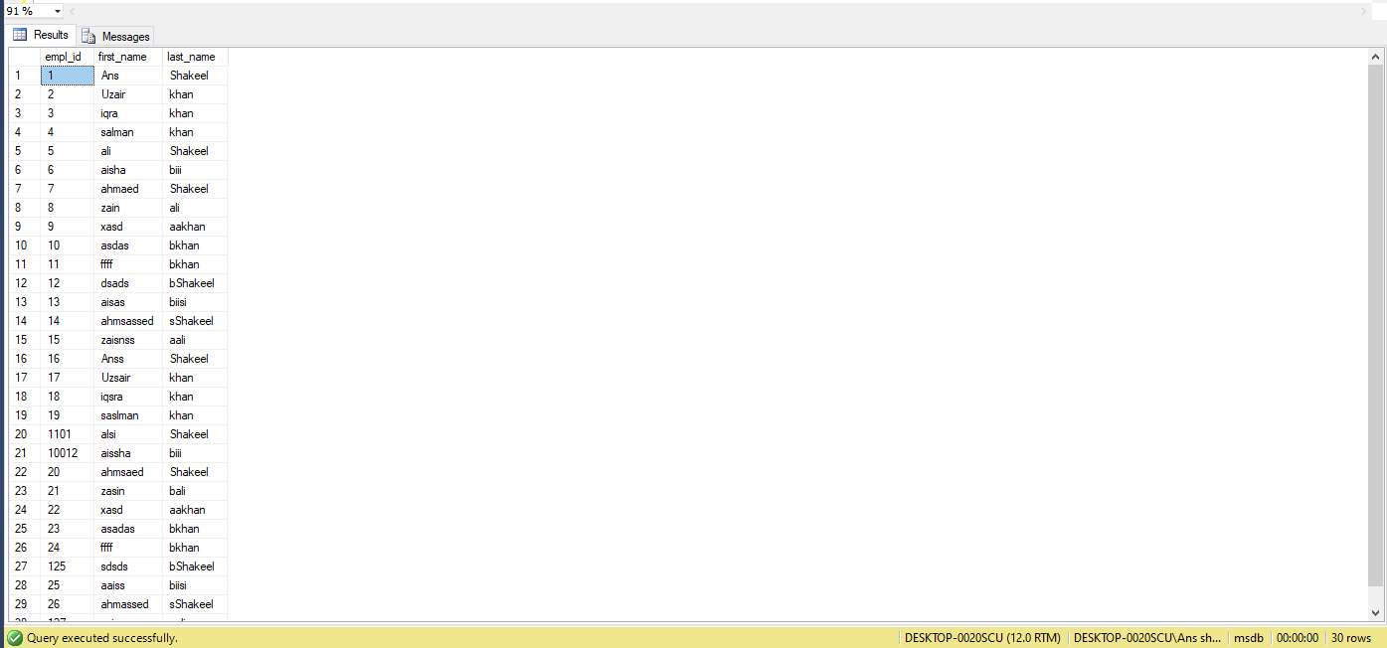

**Statement 5:**

**SQL Query:**

SELECT designation FROM employee;

**Result Screenshot:**

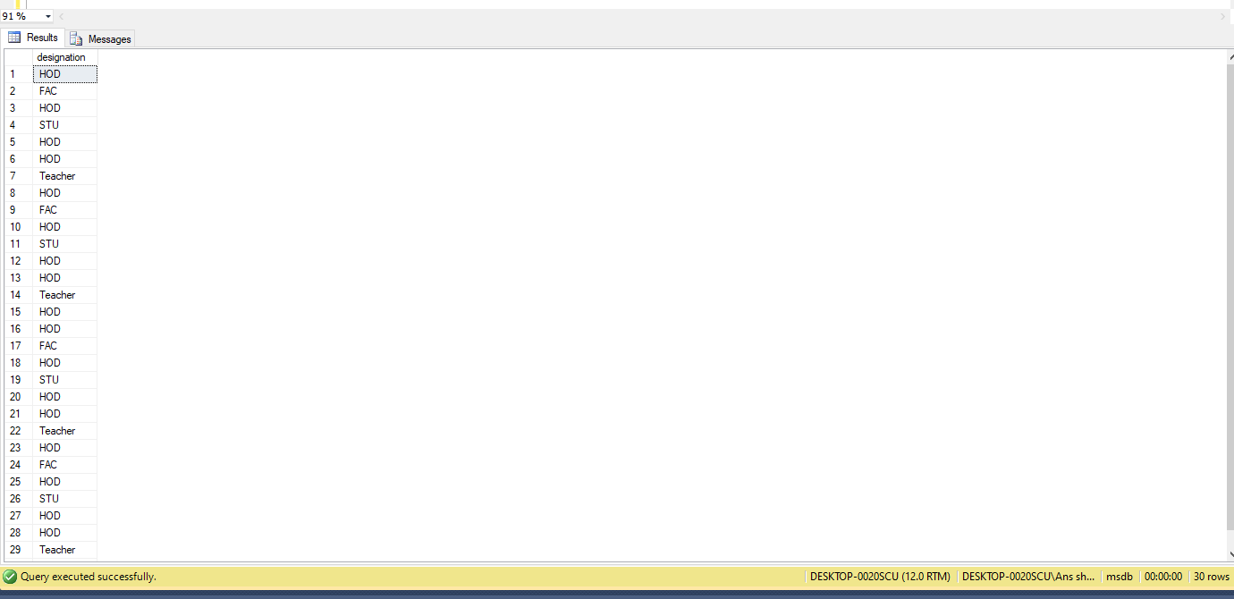

**Statement 6:**

**SQL Query:**

SELECT DISTINCT designation FROM employee;

**Screenshot Result:**

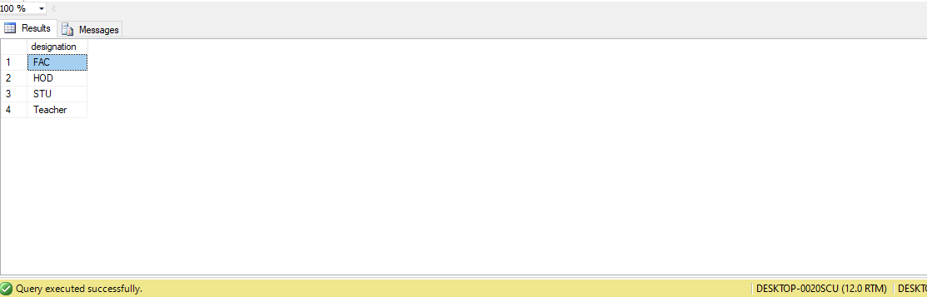

**Statement 7:**

**SQL Query:**

SELECT first_name , last_name FROM employee ORDER BY first_name ASC, last_name ASC;

**Screenshot Result:**

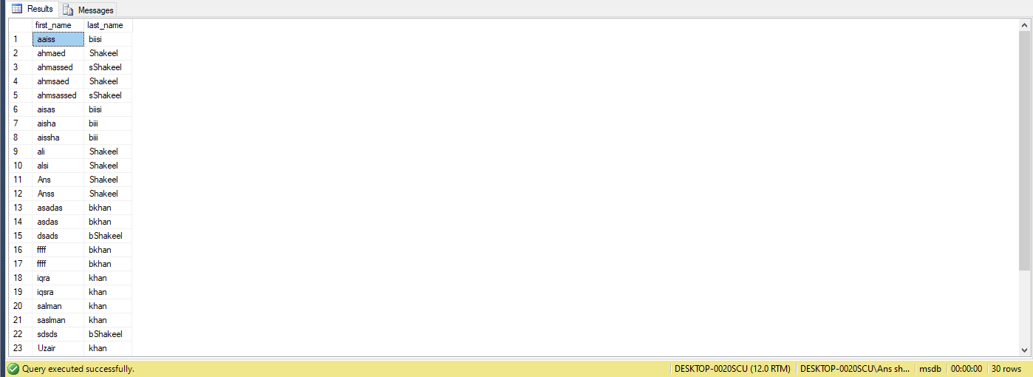

**Statement 8:**

**SQL Query:**

SELECT COUNT(DISTINCT empl_id) FROM employee;

**Screenshot Result:**

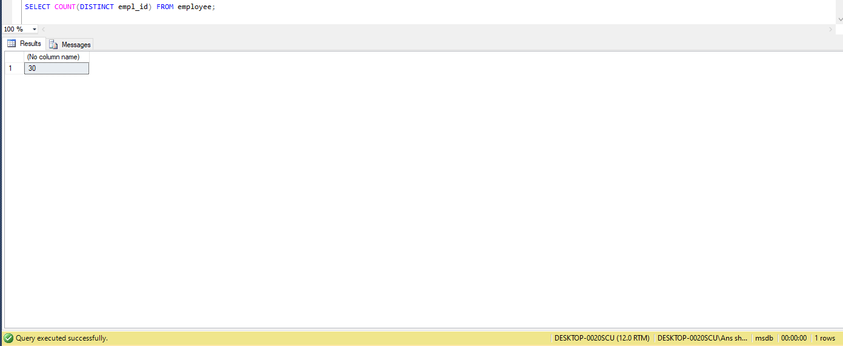

**Statement 9:**

**SQL Query:**

SELECT * FROM employee WHERE gender = 'Female';

**Screenshot Result:**

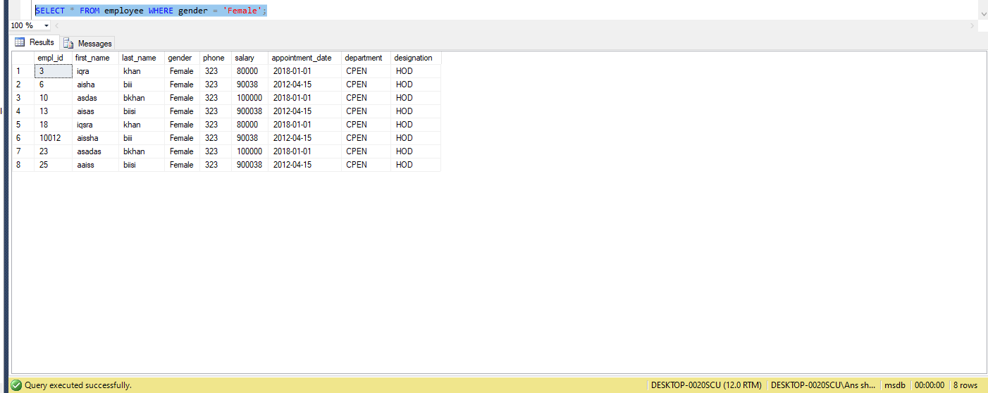

**Statement 10:**

**SQL Query:**

SELECT * FROM employee WHERE appointment_date < '2018-01-01' and last_name = 'khan';

**Screenshot Result:**

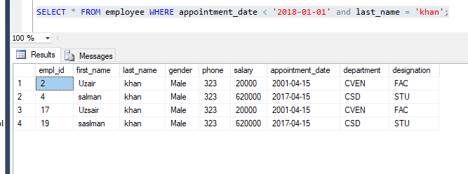

**Statement 11:**

**SQL Query:**

select count(last_name) as 'total with B' from employee where CHARINDEX('b',last_name)=1 or CHARINDEX('B',last_name)=1;

**Screenshot Result:**

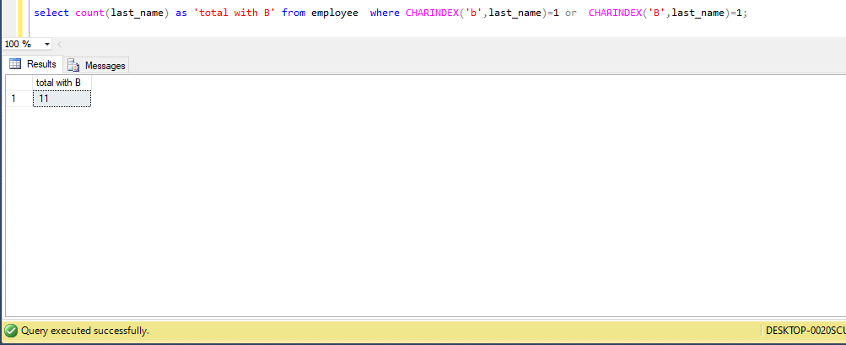

**Statement 12:**

**SQL Query:**

select * from employee where salary > 90000 and salary < 90040 ;

**Screenshot Result:** 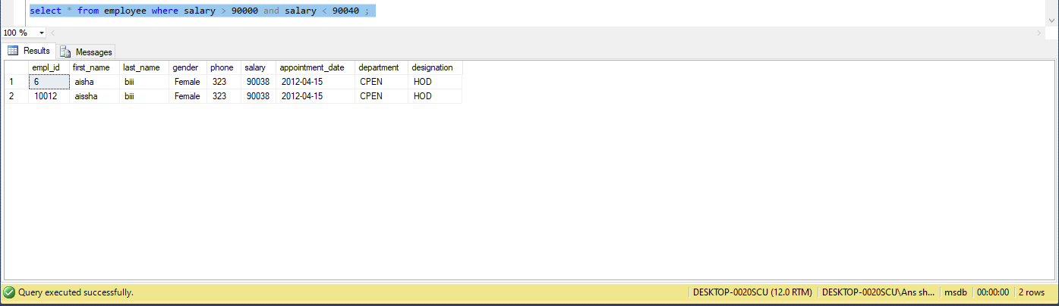

**Statement 13:**

**SQL Query:**

select distinct first_name , last_name from employee where salary > 90000 order by first_name desc , last_name desc;

**Screenshot Result:**

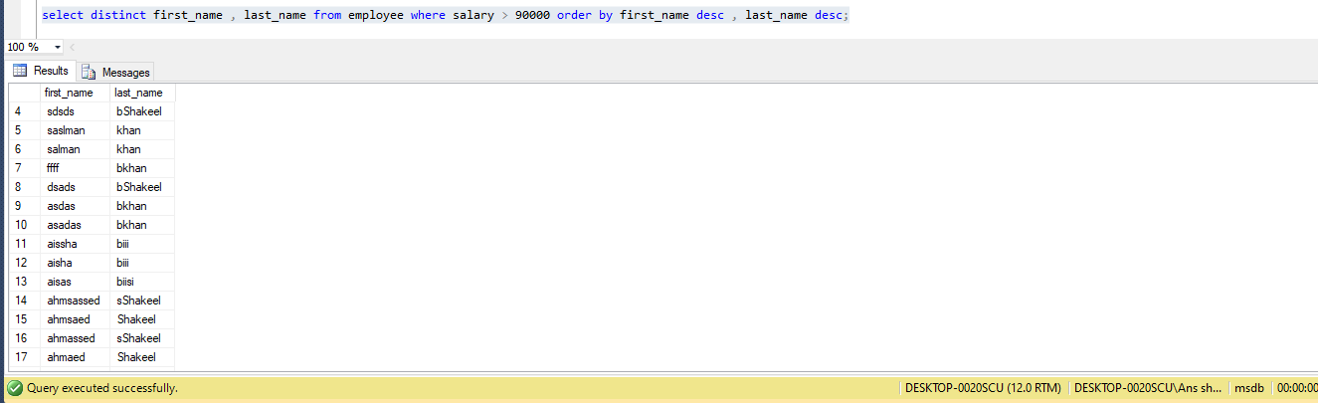

**Statement 14:**

**SQL Query:**

select * from employee where empl_id = 10012;

**Screenshot Result:**

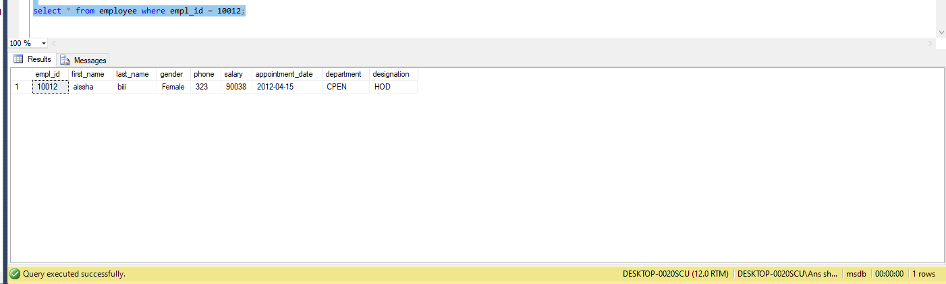

**Statement 15:**

**SQL Query:**

CREATE TABLE emp_training(

trainer_no int IDENTITY (1,1) PRIMARY KEY,

first_name varchar(30) NOT NULL,

last_name varchar(30) NOT NULL,

t_module varchar(20),

);

**Statement 16:**

**SQL Query:**

INSERT INTO emp_training(first_name,last_name,t_module) VALUES

('joe','Bloggs','Google Docs'),

('Fred','Bloggs','Google Sheets');

**Statement 17:**

**SQL Query:**

drop table emp_training;

**Statement 18:**

**SQL Query:**

ALTER TABLE employee ADD email varchar(20);

**Statement 19:**

**SQL Query:**

UPDATE employee SET email = 'gfacello@gmail.com' WHERE empl_id=10001;