# WELCOME TO CHITRAL NATIONAL PARK

**Chitral Gol National Park** ([Urdu](https://en.wikipedia.org/wiki/Urdu_language): پارک نل. ش; نی. گول ترال چ ) is one of the [National Parks](https://en.wikipedia.org/wiki/National_park) of [Pakistan](https://en.wikipedia.org/wiki/Pakistan). It is located in [Lower Chitral District](https://en.wikipedia.org/wiki/Lower_Chitral_District) in [Khyber-Pakhtunkhwa](https://en.wikipedia.org/wiki/Khyber_Pakhtunkhwa) province of Pakistan beside the [Chitral River](https://en.wikipedia.org/wiki/Chitral_River), at a distance of two hours drive from [Chitral](https://en.wikipedia.org/wiki/Chitral) town. The park is also known as **Chitral National Park**.

## Parameters

The way leading to the park is quite narrow and dangerous, yet more risky during the rainy days. It is located between 1450 [metre](https://en.wikipedia.org/wiki/Metre) and about 5000 [metre](https://en.wikipedia.org/wiki/Metre) above sea level. It has an area of 7750 [hectares](https://en.wikipedia.org/wiki/Hectare).

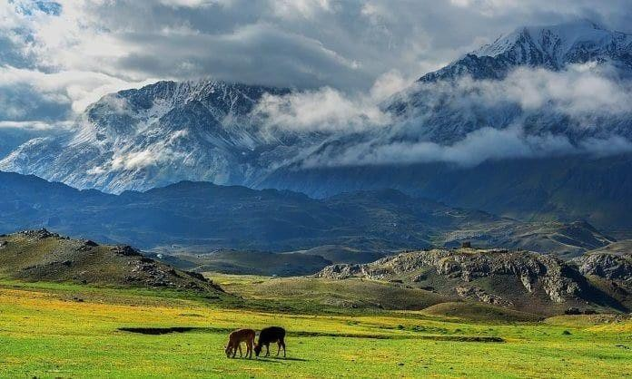

This park includes three valleys. Several [glaciers](https://en.wikipedia.org/wiki/Glacier) also lie in the park through which several springs make their way and ultimately form a stream which runs 18 [kilometres](https://en.wikipedia.org/wiki/Kilometre). The cold water of this stream flows towards the east, into the [River Chitral](https://en.wikipedia.org/wiki/Kunar_River). The park is rich in trees particularly [cedar](https://en.wikipedia.org/wiki/Cedar_wood) trees. The park also serves to provide shelter to a vast [bio-diversity](https://en.wikipedia.org/wiki/Biodiversity), especially [markhor](https://en.wikipedia.org/wiki/Markhor), an endangered wild goat species. Some of the larger mammals found in the park include:[[6](https://en.wikipedia.org/wiki/Chitral_National_Park#cite_note-iucn-6)[][7]](https://en.wikipedia.org/wiki/Chitral_National_Park#cite_note-7)

* [Kashmir Markhor](https://en.wikipedia.org/wiki/Markhor)
* [Siberian ibex](https://en.wikipedia.org/wiki/Siberian_ibex)
* [Snow leopard](https://en.wikipedia.org/wiki/Snow_leopard)
* Ladakh Urial

# WELCOME TO CENTRAL KARAKORAM NATIONAL PARK

**Central Karakoram National Park** [(Urdu](https://en.wikipedia.org/wiki/Urdu_language): **باغ ملی قراقرم میانی**) is a [national park](https://en.wikipedia.org/wiki/List_of_national_parks_of_Pakistan) located in [Skardu](https://en.wikipedia.org/wiki/Skardu) district of [Gilgit-Baltistan](https://en.wikipedia.org/wiki/Gilgit-Baltistan) in [Pakistan](https://en.wikipedia.org/wiki/Pakistan). It encompasses some of the world’s highest peaks and largest glaciers. Internationally renowned for mountaineering, rock climbing and trekking opportunities, it covers an area of about 10,000 sq. km and contains the greatest concentration of some of the tallest mountains on Earth. It has four peaks over 8,000 m including [K2](https://en.wikipedia.org/wiki/K2) (8611 m), [Gasherbrum-I](https://en.wikipedia.org/wiki/Gasherbrum-I) (8068 m), [Gasherbrum-II](https://en.wikipedia.org/wiki/Gasherbrum-II) (8035 m) and [Broad](https://en.wikipedia.org/wiki/Broad_Peak) [Peak](https://en.wikipedia.org/wiki/Broad_Peak) (8051 m), and sixty peaks higher than 7,000 m. The park was placed on the World Heritage Site Tentative List in 2016.

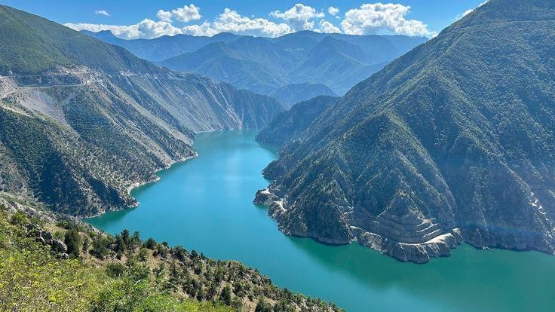

## Ecological zones[[edit](https://en.wikipedia.org/w/index.php?title=Central_Karakoram_National_Park&action=edit&section=2)]

The park has several distinct ecological zones, each with its own natural vegetation which is closely related to the climate and topography; in general, the area has low precipitation and experiences humid westerly winds. The villages are in the valley bottoms where [wheat](https://en.wikipedia.org/wiki/Wheat), [maize](https://en.wikipedia.org/wiki/Maize) and [potatoes](https://en.wikipedia.org/wiki/Potato) are grown, and [pomegranate](https://en.wikipedia.org/wiki/Pomegranate) and [apricot](https://en.wikipedia.org/wiki/Apricot) trees thrive. The lower slopes consist of "alpine dry steppes". They have gravel and moraine soils and support sparse grass and scrub. The "sub-alpine scrub zone" is found beside rivers and streams, in gullies and ravines. It consists of bushes and small deciduous trees and provides browsing for livestock and wild ungulates. Higher up there is the "alpine meadows and alpine scrub zone" which has high pasture and open coniferous forest and is only available for grazing in summer. Above this are permanent snowfields and cold desert areas which occupy the 4,200 to 5,100 m (13,780 to 16,732 ft) zone, and here there are isolated patches of stunted grass and hardy, low vegetation.

# WELCOME TO BORGHIL NATIONAL PARK

## Geography

Broghil Valley National Park abbreviated as **BVNP**, lies 250 kilometres (160 mi) from the main city of [Chitra](https://en.wikipedia.org/wiki/Chitral)[l[6]](https://en.wikipedia.org/wiki/Broghil_Valley_National_Park#cite_note-Dawn-6) and is the northernmost valley within the Upper Chitral district.

Broghil Valley borders the [Gilgit Baltistan](https://en.wikipedia.org/wiki/Gilgit_Baltistan) on the Afghan [Wakhan corridor](https://en.wikipedia.org/wiki/Wakhan_corridor), which stretches between [Tajikistan](https://en.wikipedia.org/wiki/Tajikistan) and [Pakistan](https://en.wikipedia.org/wiki/Pakistan).

The area is mostly mountainous. The elevation of the national park ranges from 3,217 m (10,554 ft) to 5,696 m (18,688 ft) above the sea level.[[7]](https://en.wikipedia.org/wiki/Broghil_Valley_National_Park#cite_note-7) The terrain is undulating with mountains, grassy plains, and valleys. It includes almost 3,400 ha of peatlands and lakes.[[8]](https://en.wikipedia.org/wiki/Broghil_Valley_National_Park#cite_note-8) The valley features around 30 freshwater lakes and is surrounded by glaciers and mountains.

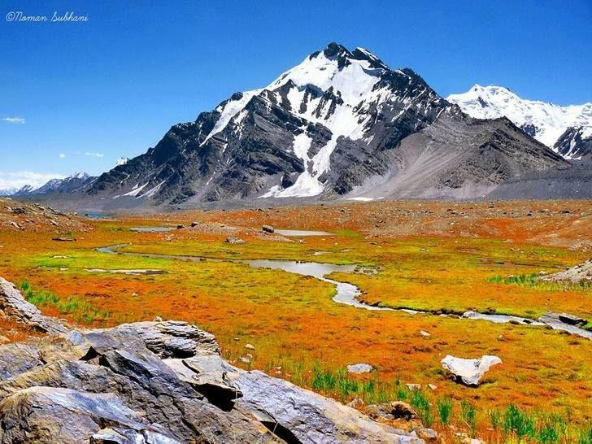

The remote location of the Broghil Valley makes it a hard-to-reach the tourist destination. Many communities in Broghil lack access to basic facilities and services. The annual [Broghil Festival](https://en.wikipedia.org/w/index.php?title=Broghil_Festival&action=edit&redlink=1) attracts visitors,[[9]](https://en.wikipedia.org/wiki/Broghil_Valley_National_Park#cite_note-9) however it lacks basic road and hospitality infrastructure. Attendees enjoy attractions and activities such as yak polo and exhibitions of woolen handicrafts, accompanied by traditional food and music.[[10]](https://en.wikipedia.org/wiki/Broghil_Valley_National_Park#cite_note-10) However, a recently constructed 32 km (20 mi) road by [Aga Khan Rural Support Programme](https://en.wikipedia.org/wiki/Aga_Khan_Rural_Support_Programme), connects Kishmanja village of the park to other villages such as Pechus and Vedin Khot and other areas.

**Mammals**[[edit](https://en.wikipedia.org/w/index.php?title=Broghil_Valley_National_Park&action=edit&section=5)]

* [Siberian ibex](https://en.wikipedia.org/wiki/Siberian_ibex), *C.s.sakeen*
* [Bharal](https://en.wikipedia.org/wiki/Bharal), *P.n.nayaur*

# WELCOME TO SAIF-UL-MULUK NATIONAL PARK

**Saiful Muluk National Park** ([Urdu](https://en.wikipedia.org/wiki/Urdu_language): پارک نل. ش; نی. الملوک ف سی) is situated in the [Kaghan Valley](https://en.wikipedia.org/wiki/Kaghan_Valley) within the [Mansehra District](https://en.wikipedia.org/wiki/Mansehra_District) of [Khyber Pakhtunkhwa](https://en.wikipedia.org/wiki/Khyber_Pakhtunkhwa), [Pakistan](https://en.wikipedia.org/wiki/Pakistan). The park was officially declared in 2003,[[1]](https://en.wikipedia.org/wiki/Saiful_Muluk_National_Park#cite_note-govpark-1) and is centred upon the alpine [Saiful Muluk Lake](https://en.wikipedia.org/wiki/Lake_Saiful_Muluk).

### Flora and fauna

The flora includes the trees, shrubs, perennials, and herbs of the [Himalayan](https://en.wikipedia.org/wiki/Himalaya) [Western](https://en.wikipedia.org/wiki/Western_Himalayan_subalpine_conifer_forests) [Himalayan subalpine conifer forests](https://en.wikipedia.org/wiki/Western_Himalayan_subalpine_conifer_forests) and higher elevation [Western Himalayan alpine shrub](https://en.wikipedia.org/wiki/Western_Himalayan_alpine_shrub_and_meadows) [and meadows](https://en.wikipedia.org/wiki/Western_Himalayan_alpine_shrub_and_meadows) ecoregions.[[1]](https://en.wikipedia.org/wiki/Saiful_Muluk_National_Park#cite_note-govpark-1)

Some of the park's fauna includes the [snow leopard](https://en.wikipedia.org/wiki/Snow_leopard), [Asiatic black bear](https://en.wikipedia.org/wiki/Asiatic_black_bear), [marmot](https://en.wikipedia.org/wiki/Marmot), [weasel](https://en.wikipedia.org/wiki/Weasel), [eurasian lynx](https://en.wikipedia.org/wiki/Eurasian_lynx), [Indian leopard](https://en.wikipedia.org/wiki/Indian_leopard), [Himalayan snowcock](https://en.wikipedia.org/wiki/Himalayan_snowcock), and the [snow partridge](https://en.wikipedia.org/wiki/Snow_partridge). The park's lakes and [wetlands](https://en.wikipedia.org/wiki/Wetland) [habitats](https://en.wikipedia.org/wiki/Habitat) are of significant ecological importance for resident fauna and [migratory](https://en.wikipedia.org/wiki/Bird_migration) [waterfowl](https://en.wikipedia.org/wiki/Waterfowl).[[1]](https://en.wikipedia.org/wiki/Saiful_Muluk_National_Park#cite_note-govpark-1)

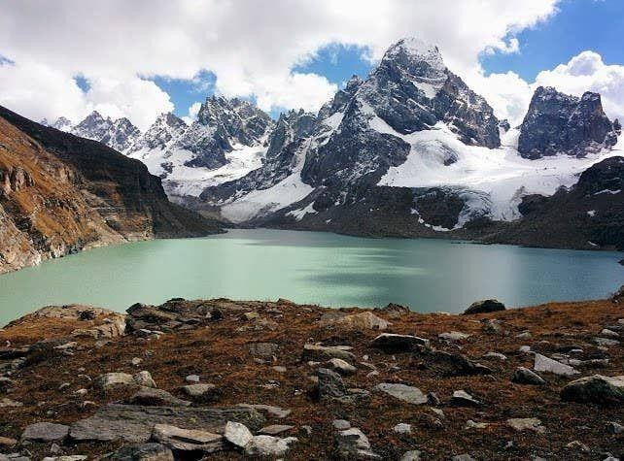

### Region

[Lulusar-Dudipatsar National Park](https://en.wikipedia.org/wiki/Lulusar-Dudipatsar_National_Park), with [Lulusar Lake](https://en.wikipedia.org/wiki/Lulusar) and [Dudipatsar Lake](https://en.wikipedia.org/wiki/Dudipatsar), is adjacent to Saiful Muluk National Park in the [Kaghan Valley](https://en.wikipedia.org/wiki/Kaghan_Valley) region. Together the parks protect 88,000 hectares (220,000 acres).[[1]](https://en.wikipedia.org/wiki/Saiful_Muluk_National_Park#cite_note-govpark-1)

# WELCOME TO DEOSAI NATIONAL PARK

**Deosai National Park** [(Urdu](https://en.wikipedia.org/wiki/Urdu_language): ملی پاغ. ئی, وسا دی) is a [high-altitude](https://en.wikipedia.org/wiki/High-altitude) [alpine](https://en.wikipedia.org/wiki/Alpine_climate) [plain](https://en.wikipedia.org/wiki/Plain) and [national park](https://en.wikipedia.org/wiki/National_park) located between the [Skardu District](https://en.wikipedia.org/wiki/Skardu_District) and [Astore District](https://en.wikipedia.org/wiki/Astore_District) in [Gilgit-Baltistan](https://en.wikipedia.org/wiki/Gilgit-Baltistan), Pakistan. Lying to the east of [Nanga Parbat](https://en.wikipedia.org/wiki/Nanga_Parbat) and in the western [Himalayas](https://en.wikipedia.org/wiki/Himalaya_Range), close to the central [Karakoram](https://en.wikipedia.org/wiki/Karakoram_Range) [Range](https://en.wikipedia.org/wiki/Karakoram_Range) surrounded by Deosai Mountains, the national park is in the [tentative list](https://en.wikipedia.org/wiki/List_of_World_Heritage_Sites_in_Pakistan#Tentative_list) under World Heritage Site of Pakistan.[[4](https://en.wikipedia.org/wiki/Deosai_National_Park#cite_note-Unesco-4)[][5](https://en.wikipedia.org/wiki/Deosai_National_Park#cite_note-fweb-5)[][6](https://en.wikipedia.org/wiki/Deosai_National_Park#cite_note-6)[][7](https://en.wikipedia.org/wiki/Deosai_National_Park#cite_note-Nyla-7)[][8]](https://en.wikipedia.org/wiki/Deosai_National_Park#cite_note-8)

The Deosai Plains are situated at an average elevation of 4,114 metres (13,497 ft) above sea level.[[9]](https://en.wikipedia.org/wiki/Deosai_National_Park#cite_note-Ozturk-9)

### Etymology

'Deosai' ([Urdu](https://en.wikipedia.org/wiki/Urdu_language): وسای دی s ) means 'the land of Giants' in Urdu.[[2]](https://en.wikipedia.org/wiki/Deosai_National_Park#cite_note-The_Nation-2) The [Balti people](https://en.wikipedia.org/wiki/Balti_people) call this place 'Ghabiarsa' ([Balti](https://en.wikipedia.org/wiki/Balti_language): ,(نارسہ ب.غ. meaning 'summer's place' because it is only accessible in summer.

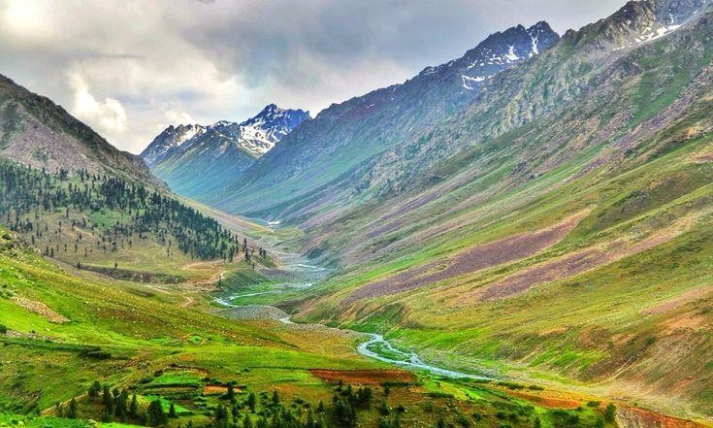

### Travel routes

Deosai is accessible from [Astore District](https://en.wikipedia.org/wiki/Astore_District) in the west, [Skardu District](https://en.wikipedia.org/wiki/Skardu_District) in the north, and [Galtari](https://en.wikipedia.org/wiki/Galtari) Tehsil of [Skardu District](https://en.wikipedia.org/wiki/Skardu_District) in the south-east. It is also accessible from Mehdiabad via Mehdiabad-Dapa Road. Deosai is located approximately 30 kilometres (19 mi) from [Skardu](https://en.wikipedia.org/wiki/Skardu) city, which is the shortest route to visit Deosai. Another route is from Astore valley via Chilim. It is also accessible from Shila valley. The people of Galtari travel via Deosai. While it is a National Park, the [Gujjar](https://en.wikipedia.org/wiki/Gujjar)-[Bakwarwal](https://en.wikipedia.org/wiki/Bakarwal) travel large distances to utilize the Deosai National Park as grazing lands.[[11]](https://en.wikipedia.org/wiki/Deosai_National_Park#cite_note-11) There is another route called Burgy la via Burgy Nala Skardu.

# WELCOME TO AYUBIA NATIONAL PARK

**Ayubia National Park** ([Urdu](https://en.wikipedia.org/wiki/Urdu_language): ,(باغ ملی ایوبیہ also known as **Ayubia** ([Urdu](https://en.wikipedia.org/wiki/Urdu_language): ,(ایوبیہ is a [protected area](https://en.wikipedia.org/wiki/Protected_area) of 3,312 hectares (33 km2)[[1]](https://en.wikipedia.org/wiki/Ayubia_National_Park#cite_note-wwf_panda-1) located in [Abbottabad District](https://en.wikipedia.org/wiki/Abbottabad_District), [Khyber](https://en.wikipedia.org/wiki/Khyber_Pakhtunkhwa) [Pakhtunkhwa](https://en.wikipedia.org/wiki/Khyber_Pakhtunkhwa) province, [Pakistan](https://en.wikipedia.org/wiki/Pakistan). It was declared a national park in 1984.[[2]](https://en.wikipedia.org/wiki/Ayubia_National_Park#cite_note-parc_gov_report-2) Ayubia was named after [Muhammad Ayub Khan](https://en.wikipedia.org/wiki/Ayub_Khan_(Field_Marshal)) (1958–1969), second [President of Pakistan](https://en.wikipedia.org/wiki/President_of_Pakistan). The area supports [temperate coniferous forest](https://en.wikipedia.org/wiki/Temperate_coniferous_forest) and [temperate broadleaf and mixed forest](https://en.wikipedia.org/wiki/Temperate_broadleaf_and_mixed_forests) ecoregion [habitats](https://en.wikipedia.org/wiki/Habitat), with an average elevation of 8,000 feet (2,400 m) above sea level.[[3]](https://en.wikipedia.org/wiki/Ayubia_National_Park#cite_note-tourism_government-3) Ayubia National Park is surrounded by seven major villages and three small towns of [Thandiani](https://en.wikipedia.org/wiki/Thandiani), [Nathiagali](https://en.wikipedia.org/wiki/Nathiagali) and [Khanspur](https://en.wikipedia.org/wiki/Khanspur).[[4]](https://en.wikipedia.org/wiki/Ayubia_National_Park#cite_note-wildlifeofpakistan-4) The park has been developed as a resort complex from a combination of four mini resorts of [Khaira Gali](https://en.wikipedia.org/wiki/Khaira_Gali), [Changla Gali](https://en.wikipedia.org/wiki/Changla_Gali), [Khanspur](https://en.wikipedia.org/wiki/Khanspur) and [Ghora Dhaka](https://en.wikipedia.org/wiki/Ghora_Dhaka) in [Galyat](https://en.wikipedia.org/wiki/Galyat).[[5]](https://en.wikipedia.org/wiki/Ayubia_National_Park#cite_note-nathiagali-5) Currently, it is managed by the Wildlife and Parks Department of [Government of](https://en.wikipedia.org/wiki/Government_of_Khyber_Pakhtunkhwa) [Khyber Pakhtunkhwa](https://en.wikipedia.org/wiki/Government_of_Khyber_Pakhtunkhwa).

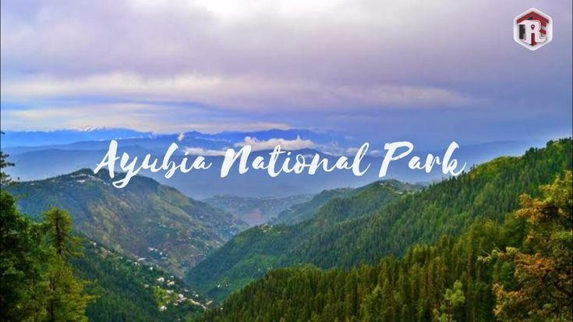

Wildlife

The park holds 104 species of plants. The main floral species are [*Cedrus deodara*](https://en.wikipedia.org/wiki/Cedrus_deodara), [blue](https://en.wikipedia.org/wiki/Blue_pine) [pine](https://en.wikipedia.org/wiki/Blue_pine), [yew](https://en.wikipedia.org/wiki/Taxus), [silver fir](https://en.wikipedia.org/wiki/Silver_fir), [horse chestnut](https://en.wikipedia.org/wiki/Horse_chestnut) and [oak](https://en.wikipedia.org/wiki/Oak). Around 21 plants belonging to 19 families are known for their medicinal properties. Many of these are used in treatment of [jaundice](https://en.wikipedia.org/wiki/Jaundice), [stomach ulcers](https://en.wikipedia.org/wiki/Stomach_ulcers), [snake bites](https://en.wikipedia.org/wiki/Snake_bites), internal infections, [diabetes](https://en.wikipedia.org/wiki/Diabetes), [psoriasis](https://en.wikipedia.org/wiki/Psoriasis) and more. Some plants are said to have [anti-carcinogenic](https://en.wikipedia.org/wiki/Anti-carcinogenic) effect as well. Also, some are used as biological [insecticides](https://en.wikipedia.org/wiki/Insecticides) and [pesticides](https://en.wikipedia.org/wiki/Pesticides), mostly due to their insect-repellent nature. The [World Wide](https://en.wikipedia.org/wiki/World_Wide_Fund_for_Nature) [Fund for Nature](https://en.wikipedia.org/wiki/World_Wide_Fund_for_Nature) has launched an [ethno-botanical](https://en.wikipedia.org/wiki/Ethnobotany) initiative here "to demonstrate the sustainable use of plant resources as a means for protecting [biodiversity](https://en.wikipedia.org/wiki/Biodiversity). There are 23 mammals, 203 birds and 13 herpto-fauna in the park.