BuildMyIdea: An Electronics Venture Planning and AI-Assisted Decision Support Platform
Aniket Raj^{a,*}, Ankit Rajª, Ansh Aryanª, Shola Usha Raniª
ª Vellore Institute of Technology (VIT), Vandalur–Kelambakkam Road, Keelakottiyur, Chennai, Tamil Nadu – 600127, India
* Corresponding author. E-mail: aniket.raj2023@vitstudent.ac.in

Abstract—Founders of electronics startups usually keep product specifications, component costs, manufacturing capacity, compliance, finance and launch milestones in separate documents, although each decision constrains the others. This paper presents BuildMyIdea, a venture-planning and decision-support platform that holds these modules in one structured workspace. Deterministic functions produce quantities, while LLM agents interpret retrieved evidence. Built with React, TypeScript and Firebase, the platform computes BOM cost, unit economics, break-even volume, manufacturing capacity and a nine-stage readiness score. An optional Node.js service uses Nomic Embed Text and exact cosine retrieval over an owner- and venture-scoped SQLite index, with a deterministic router, up to two Qwen3 8B specialists, and a reviewer. A reproducible evaluation used 24 frozen NovaEdge questions (12 development and 12 held-out), three randomized repeats per mode, and Qwen3 8B. Combined macro rule-check pass rates were 85.9% for direct prompting, 53.1% for RAG, and 46.5% for the full pipeline; mean latencies were 125.6 s, 15.7 s, and 116.7 s. Four full-pipeline development runs timed out and were retained as failures. The rule checks are not semantic or human-quality evaluation.
Keywords—Decision Support Systems, Retrieval-Augmented Generation, Large Language Models, Multi-Agent Systems, Electronics Product Development, Unit Economics, Human-in-the-Loop AI.

1. Introduction
To make an electronic product involves a whole series of interrelated decisions. The selection of components sets the cost per unit, while cost per unit dictates price and margins. The production capacity limits the launch volume; a new employee increases the operating expenses per month, and an unfulfilled compliance constraint may postpone the launch itself. These decisions are always recorded in separate spreadsheets and reports by the founders such that when one figure changes, the others do not change. Existing processes help the company know the decisions that it needs to make, from stage gates [1], validated learning [2], business model canvas [3], and structured product development [4]. However, no process guarantees that all the figures remain consistent for all the decisions. The decision support research has already pointed out years ago that a model, data and a user interface have to be designed around the decision[5].
LLMs [6] can respond to business inquiries conversationally, and artificial intelligence is revolutionizing how new ventures are started [7]. Two characteristics make them unreliable for planning. They hallucinate, generating fluent utterances not warranted by their input [8]. In addition, they lack the founder’s own numbers, meaning that their advice is typically generic, and the computations done in the generated text are neither necessarily correct nor replicable. RAG connects the answers to the retrieved text [9], [10], while the multi-agent approaches distribute the tasks to the agents with their different responsibilities [11]–[13]. Neither approach alone guarantees that the numbers relied upon by the founder are correctly computed. BuildMyIdea is a planning environment for electronics startups guided by one principle: deterministic code computes, language models interpret the retrieved information, and the founder decides. The paper makes four contributions:
- a structured workspace, scoped to its owner, that links thirteen editable planning modules from opportunity analysis to scaling and shares deterministic engines for unit economics, manufacturing capacity, readiness, risk and scaling gates;
- a bounded review workflow based on retrieval-augmented generation, which indexes the workspace incrementally into a user-scoped SQLite vector store, sends each question to no more than two of six specialists, adds a reviewer pass, and checks every output against a schema and against the identifiers of the retrieved evidence;
- a human approval boundary under which model output never writes planning data, and a proposed action enters the roadmap only when the founder adds it; and
- a working implementation on locally served open-weight models, examined through verification checks, an analytic reproduction of the demo venture indicators, a code audit, and a frozen 24-question evaluation with development and held-out sets.
Section 2 contains the literature review. Problem statement along with the design guidelines and the shift in scope of the project is presented in Section 3. Architecture, deterministic scheduling techniques, information retrieval, and the agent execution process are detailed in Sections 4, 5, 6 respectively. Implementation details and experiment description and results are provided in Sections 7 and 8 respectively. Comparison of the solution with other approaches along with limitations is described in Section 9. Section 10 concludes the paper.

2. Related Work

2.1 Venture Planning and Decision Support
Product Development is segmented by Stage-Gate into distinct stages and gate decisions [1]. The lean startup approach treats a venture as a collection of hypotheses to be tested [2], and the business model canvas lays out the value proposition, customers, channels, costs and revenue on a single page [3]. Product development texts contribute concept selection, design for manufacture and product economics [4]. Decision support systems bring together data, models and interfaces to help with semi-structured decisions [5], and AI is expected to change both how quickly ventures are created and the way they are created [7]. These texts outline what the founder needs to consider, but the underlying mathematics of each consideration is still up to the founder to do manually.

2.2 AI for Supply Chain, Cost and Compliance
However, according to a systematic analysis of artificial intelligence techniques applied in supply chain risk assessment, generalization of the methods into the real world environment, apart from the synthetic benchmarks, is an open challenge [14]. Link prediction across hierarchical supply chain networks enables digital surveillance of the supply chains, albeit with privacy and data completeness issues [15]. Machine learning has been used to estimate the cost of engineered-to-order products, with accuracy that depends on how closely the synthetically generated training data reflect real costs [16]. A third research paper implements an LLM pipeline with monitoring agents for continuous compliance checking and concludes that critical decision-making tasks need human intervention [17]. Each of these studies addresses a single function in isolation.

2.3 Language Models, Hallucination and Retrieval
Broad surveys describe the capabilities and limitations of LLMs [6], and hallucination has been divided into intrinsic and extrinsic types, each with its own mitigation methods [8]. RAG conditions generation on retrieved passages [9]. Dense retrievers map queries and passages into a shared vector space [18], and later methods let the model reflect on the evidence it retrieves [19]. Surveys of RAG list retrieval quality and evaluation as open issues [10], and models are known to make less reliable use of information placed in the middle of a long context than of information near its beginning or end [20].

2.4 Multi-Agent LLM Systems
Agents that combine reasoning and acting alternate between reasoning steps and tool calls [21]. Frameworks such as AutoGen [11] and MetaGPT [12] coordinate several agents with assigned roles, and surveys classify such systems by agent profile, communication pattern and the way agents acquire capabilities [13]. Debate among several instances of a model has been shown to improve factuality and reasoning [22]. When models are used to judge other models, they display position, verbosity and self-enhancement biases [23], which matters whenever a reviewer model checks the output of specialist models.

2.5 Human Oversight and Security
When the role given to automation is not matched to human judgment, people misuse, disuse or abuse it [24]. Guidelines for human-AI interaction recommend telling users clearly what a system can do, making correction quick and limiting the scope of a service when the system is uncertain [25]. Human-centered AI argues for combining a high level of automation with a high level of human control [26]. Validity, transparency, and human oversight of the use of AI are requirements of the NIST risk management framework for AI [27]. Documents retrieved by an LLM-integrated application can also carry indirect prompt injections that redirect the application’s behavior [28].

2.6 Research Gap
The surveyed method provides planning techniques which require no calculations, domain AI which is used only for one purpose at a time, and general agents which contain no business-specific information. None of the methods discussed here combines the use of integrated planning environment, determinism, evidence-based model analysis, and human confirmation of the results for electronics businesses. These types of methods are compared again in Section 9.2.
Table I makes the gap concrete by setting BuildMyIdea against four common alternatives: spreadsheet-based planning, general-purpose LLM planning, single-agent RAG, and multi-agent systems without a deterministic calculation engine. It extends the comparison in Section 9.2 in two aspects. Spreadsheets and single-agent RAG appear as separate categories, and venture-specific retrieval, evidence traceability and domain specialization are added as criteria. Rows one through four describe the architectural characteristics of each type of system, but do not quantify any particular product. The BuildMyIdea row describes the implementation documented in this paper. The only measured comparison against local direct-LLM and single-agent RAG baselines is provided in Section 8.5.
Table I
Comparison with Existing Planning Approaches
Approach | SP | VE | DC | ET | HA | DS
Spreadsheet-based planning | P | – | Y | P | n/a | P
General-purpose LLM planning [6] | – | – | – | – | P | –
Single-agent RAG [9], [10] | – | P | – | P | P | –
Multi-agent, no calculation engine [11]–[13] | – | P | – | P | P | –
BuildMyIdea (this work) | Y | Y | Y | Y | Y | Y
SP: structured planning environment that connects modules; VE: venture specific evidence acquisition; DC: deterministic computation; ET: evidence traceability; HA: human approval prior to AI result changes in the plan; DS: domain specialization (electronic engineering). Y: supplied; P: partial or implementation-dependent; –: not supplied by the approach itself; n/a: no AI output to be approved. Rows 1–4 describe categorization by the authors qualitatively; row 5 shows the results of implementation described in Sections 4–6. The traceability in the BuildMyIdea project is carried out at the level of identifiers, as described in Section 6.4. The system demonstrates that the source was accessed but it does not prove that the source supports the claim.

3. Problem Formulation and Design Principles
A founder u owns one or more ventures. Each startup s is represented by a workspace document W which consists of founder and scope attributes and thirteen modules: analysis, identity, product, BOM, manufacturing, logistics, distribution, compliance, finance, team, risks, scaling and roadmap. A deterministic function f(W) computes all the derived values, including costs, margins, capacity, readiness and gate status. For any question q, the AI service provides a report r = (σ, A, U, C), which consists of a summary σ, suggested actions A, uncertainties U and references to source evidence C. The workspace is updated only by the founder’s actions. If the founder adds a proposed action a ∈ A, the next state is
$W_{t+1}=W_{t}⊕milestone\left(a\right)$ (1)
and otherwise W_{t+1} = W_{t}. The operator ⊕ appends a roadmap milestone that records the action text, the report identifier and the evidence identifiers. Five design principles guide the system:
- P1 Consistency: the interface and the models take their quantities from the same function f(W). Models interpret calculations; they never originate them.
- P2 Grounding: model input is limited to retrieved evidence and f(W), and every cited identifier must belong to the retrieved evidence set.
- P3 Isolation: the retrieval scope is derived from the verified user identity, never from a value supplied by the caller.
- P4 Human authority: reports are recommendations, and the plan changes only through an explicit founder action.
- P5 Boundedness: each run makes a small, fixed number of model calls within resource limits, and there is no autonomous loop.
The scope of the project changed between its two reviews. At the first review, the team proposed a general multi-agent “AI operating system” for any kind of startup. The second review delivered a planning workspace specific to electronics ventures, with deterministic calculations at its core. Table II sets what was proposed beside what was implemented.

Table II
Proposed Versus Implemented Scope
Element | First review (proposed) | Implemented
Domain | Any startup | Electronics ventures
Agents | Legal, finance, marketing, market research, supplier, logistics | Planner, Product, Finance, Compliance, Team, Scaling, plus Reviewer
Frontend | React (Flutter in one module) | React 18, TypeScript
Data | PostgreSQL, Redis | Cloud Firestore; SQLite vectors
LLM and RAG | To be finalized | Ollama: Qwen 2.5 3B, Llama 3.2 3B, Nomic Embed Text
Calculation | Not specified | Deterministic TypeScript engines
Deployment | Docker, cloud | Static Firebase Hosting only; no backend deployment
Monitoring | Continuous monitoring | Not implemented
Sources: Project review presentation I & II; repository audit.

4. System Architecture
BuildMyIdea is structured into three levels (see Fig. 1). The browser level consists of a single-page React and TypeScript application with routes that are loaded asynchronously. It handles every planning edit and runs the deterministic engine locally, so charts and checks are recomputed as the founder types. Firebase service includes email and password-based authentication and Cloud Firestore database support. The AI tier is an optional Node.js service built on Node’s built-in HTTP server, with no web or agent framework, and bound to the loopback interface.
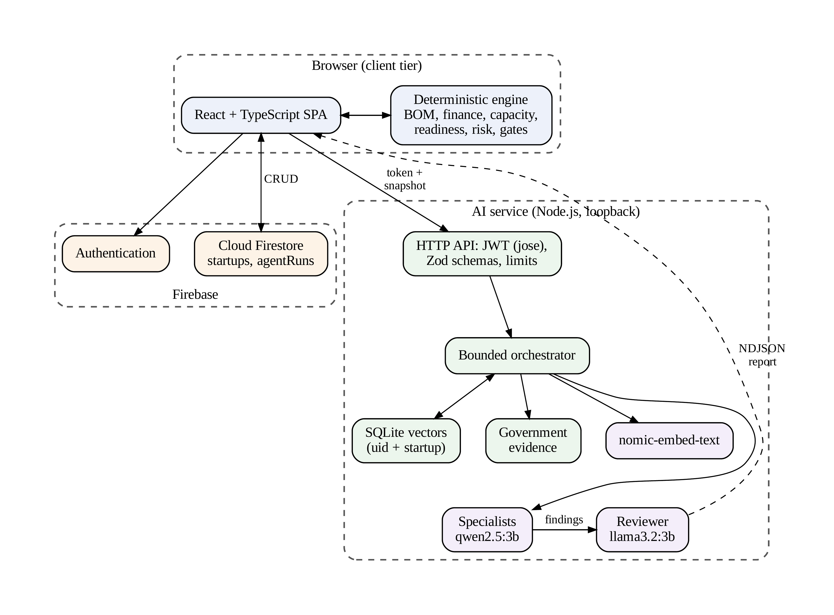
Fig. 1. Architecture of BuildMyIdea. Routine planning reads and writes go directly from the browser to Firestore. The AI service receives a token and a workspace snapshot and returns progress events and a report as NDJSON. The models are served by Ollama.
The system has two boundaries. First, ordinary create, read, update and delete operations travel directly from the browser to Firestore and are protected by owner-based security rules [29]; the Node service implements no planning endpoints. Second, the AI service works only on a snapshot that the browser submits. The service verifies the Firebase ID token, which is a JSON Web Token (JWT) [30], against Google’s public keys [31] and requires the owner recorded in the snapshot to equal the verified user identifier. It never reads Firestore itself. Ventures are stored under the path users/{uid}/startups/{startupId}, saved reports are kept in an agentRuns subcollection, and planning modules are held as maps and arrays inside the venture document.
The service exposes three routes. GET /api/health reports whether the models are available and the status of the source refresh. POST /api/agents/run executes one bounded run (Algorithm 1) and streams its events as newline-delimited JSON (NDJSON). DELETE /api/knowledge/{startupId} removes the caller’s private vector scope. Failures occurring prior to streaming result in status code 401 for invalid token, 403 for mismatching owner, 429 for busy or rate-limited service, and 400 for invalid body. Failures after streaming has begun are sent as an error event.
Algorithm 1: Bounded agent run (POST /api/agents/run)

Input: token τ, question q, optional role ρ, snapshot S, previous report p
Output: NDJSON progress events and a validated report r
1: u ← VerifyJWT(τ); on failure return 401
2: if a run is active or starts(u, 60 s) ≥ 6 then return 429
3: check body ≤ 350,000 B and Zod schema; on failure return 400
4: if S.ownerId ≠ u then return 403
5: Preflight(specialist, reviewer and embedding models)
6: Sync(scope(u, S.id), Chunks(S)) ▷ Algorithm 2
7: A ← SelectAgents(q, ρ) ▷ Eq. (22)
8: E ← Retrieve(q, A) ∪ {venture-scope, tool-calculations}
9: for each a ∈ A in sequence do
10: F_{a} ← Invoke(a, q, E, f(S), p); Validate(F_{a}, E); emit progress
11: r ← Invoke(Reviewer, q, E, Condense({F_{a}})); Validate(r, E)
12: emit result r ▷ abort on disconnect or after 6 min

Algorithm 1 has a static size: up to two calls to the specialist, and one to the reviewer, sequentially to avoid contention on computational resources. The result is displayed in the browser and saved to Firestore as soon as it is received, with a retry option if the save fails. A cancellation in the browser stops the request, and this cancellation propagates toward the model calls. Failure of execution is always reported as failure and never compensated with a synthetic success.
Table III lists each design decision of Section 3 together with the design alternative which it replaces and the principle which it satisfies. The design alternatives listed are not real competitors but just generic design choices. The direct-LLM and single-agent RAG baselines from Section 8.5 utilize rows 1 and 2 of Table III; rows 3 through 5 were not ablated. Each of these design decisions has its cost. Retrieval, review, and validation incur additional model calls and latency (Section 9.1). The identifier verification proves only that the record was found, not that it supports the citation.
Table III
System Architecture and Design Choices Compared
Design choice | Alternative | BuildMyIdea
Knowledge source (P2) | Direct LLM generation from the prompt or the whole serialized workspace | RAG over an owner-scoped vector index, plus mandatory scope and calculation records (Section 6.2)
Orchestration (P5) | Single agent, one model call | Bounded multi-agent run: at most two of six specialists, then a reviewer, in sequence (Algorithm 1)
Arithmetic (P1) | Arithmetic generated inside model text | Deterministic functions f(W) shared by the interface and the models (Section 5)
Output checking (P2) | Unvalidated free-text output | Zod schema validation and evidence-ID membership check, per Section 6.4
Plan changes (P4) | Automatic modification of the plan by the AI | Explicit founder approval; a roadmap write occurs only through Add to roadmap, per (1)
P1-P5 are the design principles from Section 3. Alternatives are general choices, not evaluations of specific products.

5. Planning Modules and Deterministic Methods
All calculations are performed via regular TypeScript functions employed by the interface and AI Service; therefore, the numbers seen by the specialist in his model are precisely those viewed by the founder. The formulas in this section are taken from the calculation module.

5.1 Unit Economics
For BOM line i with quantity n_{i} and unit cost c_{i}, the BOM cost per unit is
$B=\sum_{i}{max\left(0,n_{i}\right)⋅max\left(0,c_{i}\right)}$ (2)
where negative entries are clamped to zero. The total unit cost adds the manufacturing, packaging and logistics cost per unit:
$U=B+c_{mfg}+c_{pkg}+c_{log}$ (3)
For a selling price P, the contribution per unit and the gross margin in percent are
$π=P-U$ (4)
$g=100\frac{π}{P}$ (5)
With monthly unit sales Q and monthly operating expense X, the monthly revenue, cost of goods sold and operating profit are
$R=PQ$ (6)
$C_{COGS}=UQ$ (7)
$Π_{op}=R-C_{COGS}-X$ (8)
The break-even volume is the smallest whole number of units whose total contribution covers X:
$Q_{BE}=\left\{\begin{aligned}\left\lceil \frac{X}{π}\right\rceil \text{ if }π>0 \\ 0\text{ otherwise}\end{aligned}\right.$ (9)
The value 0 is a sentinel that the interface shows as “not achievable”. Similarly, the same value will also be obtained if π > 0 and X = 0, producing display defect D2 (see Section 8). The model ignores any effect due to taxes, financing, working capital, inventory management, depreciation, and cash run-way.

5.2 Manufacturing Capacity
For L production lines, a throughput of r units per hour, h hours per day and d working days per month, the theoretical monthly capacity and the realistic capacity at utilization υ (in percent) are
$C_{th}=Lrhd$ (10)
$C_{real}=\frac{C_{th}⋅min\left(100,max\left(0,υ\right)\right)}{100}$ (11)
Realistic capacity is compared against the sales objective per month to show if production can support the implementation of the plan.

5.3 Journey of Readiness
The readiness journey organizes the completeness assessment into nine stages: opportunity, product, sourcing, production, compliance, finance, team and risk, launch, and scale. Let K_{j} be the set of checks for stage j and $K_{j}^{p}$ the subset that passes. Stage readiness and overall readiness are
$ρ_{j}=100\frac{|K_{j}^{p}|}{|K_{j}|}$ (12)
$ρ_{all}=\frac{1}{9}\sum_{j=1}^{9}{ρ_{j}}$ (13)
Total value is shown in rounded form. Dependencies between steps are shown in the interface but have no effect on ρj. Readiness is a matter of filling out all fields consistently but cannot be an indicator of viability.

5.4 Risk Register
For each risk, there is a probability pk and an impact mk using the ordinal scale, and its weight is determined as
$σ_{k}=p_{k}m_{k}$ (14)
For the journey and the summary, σ_{k} ≥ 15 is considered to be critical, while for the risks pages, scores are critical when ≥16. This inconsistency is defect D4.

5.5 Team Structure and Scaling Gates
Team roles form a reporting structure through a manager link m(·). Role b may be assigned as the manager of role a only if b exists and the chain of manager links starting from b never returns to a:
$valid\left(a,b\right)⇔b∈R∧a∉\left\{b,m\left(b\right),m^{2}\left(b\right),…\right\}$ (15)
where R is the set of roles. This rule keeps the reporting graph acyclic. Deleting a manager clears the manager links of its direct reports. Scaling stages G₁, …, G_{n} are ordered gates, and gate G_{j} can be marked Ready only if
$Ready\left(G_{j}\right)⇒κ_{j}≠∅∧ϵ_{j}≠∅∧Γ_{j}$ (16)
where κj and ϵj denote the exit conditions and evidence of the gate Gj respectively, while the condition Γj is true if all previous gates Gi, i < j, are Ready. Editing a scaling phase erases the status of the phase and all subsequent Ready gates. Editing of other modules, such as manufacturing or finance, does not yet invalidate the gates.

5.6 Local Compliance Review
The compliance may also be evaluated deterministically without using any model. The founder validates the target market, whether there is wireless hardware in the product, and the role in the business and whether the products are packed. Then, the evaluation filters out seven summarized sources on BIS registration [32], WPC wireless approval, CPCB e-waste requirements [33], packaged commodities [34], incorporation, GST, and startup identification. It provides the details of the missing facts and suggests the checklists to be included, which will be incorporated in the current checklist without any duplicate source URL. Nothing is saved until the founder selects items and saves the page.

6. Retrieval-Augmented Multi-Agent Review

6.1 Chunking and Incremental Indexing
The orchestrator serializes selected factual fields of the snapshot (scope, founder, analysis, identity, product, BOM, manufacturing, supply, distribution, compliance, finance, team, risk, roadmap and scaling) as JSON text T. Conversation messages and saved reports are excluded. Chunk k covers
$c_{k}=T\left[1200k:min\left(1200k+1400,|T|\right)\right]$ (17)
for k = 0, 1, …, where T[a:b) denotes characters a to b − 1. Consecutive chunks therefore start 1,200 characters apart and share 200 characters of overlap, with at most 256 chunks per venture scope. In the implementation, chunking is applied to each selected field separately, so the text of one field plays the role of T. Each chunk is serialized and hashed with SHA-256 [35], and chunk c is embedded again only if
$H\left(c\right)≠h_{stored}\left(ω,μ,id\left(c\right)\right)$ (18)
where ω is the venture scope and μ the embedding model. Fig. 2 and Algorithm 2 show the procedure. All embeddings are computed before the database transaction begins, so a failed embedding call leaves the previous index intact.
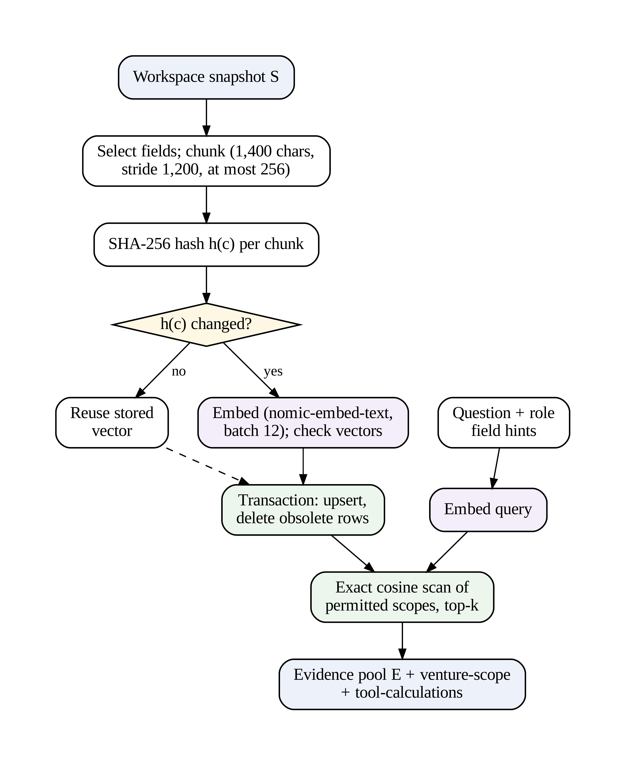
Fig. 2. Incremental indexing and retrieval. Only chunks whose SHA-256 hash has changed are embedded, the transaction starts after all embeddings have been checked, and the query is matched by exact cosine similarity within the permitted scopes.
Algorithm 2: Incremental index synchronization

Input: scope ω, chunks K, embedding model μ
1: for each c ∈ K: h_{c} ← SHA-256(serialize(c))
2: D ← {c ∈ K : stored(ω, μ, c.id).hash ≠ h_{c}}
3: V ← Embed(D) in batches of 12
4: if any v ∈ V has the wrong dimension, a non-finite entry or zero norm then fail
5: BEGIN; upsert (ω, μ, c.id, h_{c}, c, v) for c ∈ D
6: delete rows of ω whose id ∉ K or whose model ≠ μ; COMMIT

6.2 Retrieval
Before the question is embedded, field hints for each selected role are appended to it. For a query vector q and a stored vector v, the score is the cosine similarity
$sim\left(q,v\right)=\frac{q⋅v}{‖q‖‖v‖}$ (19)
computed by an exact scan over all rows of the permitted scopes for the selected model. Rows with positive similarity are sorted, and the top k are returned. With at most 256 chunks per venture, an approximate index such as hierarchical navigable small world (HNSW) graphs [36] or a GPU similarity search library [37] is unnecessary. Similarity measures how close two vectors are; it is not a confidence score. For agent set A, the evidence drawn from the user’s own scope is
$E_{u}=⋃_{a∈A}S_{k}\left(q_{a},Ω_{u}\right)$ (20)
and the complete evidence pool is
$E=dedup\left(E_{u}∪S_{3}\left(q,Ω_{gov}\right)\right)∪\left\{e_{scope},e_{calc}\right\}$ (21)
Here S_{k}(·, Ω) returns the top k records of scope Ω, q_{a} is the question extended with the hints of role a, Ω_{u} is the private scope of user u and the venture, and Ω_{gov} is the shared government corpus, which is searched only when Compliance takes part. The value of k is 3, or 2 when Compliance is selected. The mandatory records e_{scope} and e_{calc} hold the venture scope and the outputs of f(W).

6.3 Routing and Specialist Roles
Routing is deterministic and relies on regular expressions applied to the question. Given the priority order Π = (Compliance, Finance, Team, Scaling, Product) and the match predicate match_{a}(q), the selected set is
$A=first{}_{2}\left\{a∈Π:match{}_{a}\left(q\right)\right\}$ (22)
If no role matches, A = {Planner}. If the founder has selected the specialist role specifically, then it will be utilized, and Compliance will be utilized if the query uses legal language. Table IV shows the roles. Each specialist has individual prompts but shares model weights most of the time without communicating with each other. The reviewer gets the summary results along with the source documents.
Table IV
Specialist and Reviewer Roles
Agent | Responsibility
Planner | Cross-module next decisions and dependencies (default)
Product | Specifications, BOM, sourcing and manufacturing trade-offs
Finance | Interpretation of the deterministic financial facts
Compliance | Government evidence and applicability gaps
Team | Hiring sequence, payroll and ownership
Scaling | Capacity, capital and growth conditions
Reviewer | Consolidates findings; flags conflicts, unsupported claims and missing evidence

6.4 Model Invocation and Output Validation
Each call sends a role-specific system prompt and a JSON payload to the Ollama chat interface [38]. The prompt is assembled in four layers. The system role defines the agent’s responsibility and limits. A trust boundary instructs the model to treat retrieved documents and output from other models as untrusted data, which defends against indirect prompt injection [28]. The user payload carries the question, venture scope, calculations, evidence, provenance, jurisdiction and context from the previous report. Finally, an output contract fixes the form of the response. Table V lists the runtime parameters. Every output must contain a summary, actions, uncertainties and evidence identifiers, and it is parsed with Zod schemas [39]. For the cited set C_{r}, the validation rule is
$accept\left(r\right)⇔C_{r}⊆ID\left(E\right)$ (23)
A cited identifier that is not in the retrieved evidence causes the run to be rejected, whereas a finding that cites no evidence is accepted but flagged with an added uncertainty. Passing (23) therefore shows that every cited record was retrieved, not that the record supports the claim.
Table V
Runtime Parameters of the AI Service
Parameter | Value
Specialist / reviewer model | qwen2.5:3b [40] / llama3.2:3b [41]
Embedding model | nomic-embed-text [42]
Temperature; context window | 0.15; 8,192 tokens
Prediction limit; keep-alive | 1,800 tokens; 2 min
Output format | JSON, non-streamed
Chunk length; stride; cap | 1,400; 1,200 chars; 256 per venture
Private top-k; government top-k | 3 (2 with Compliance); 3
Government chunks indexed | At most 100 per source
Embedding batch size | 12
Question length; request body | 1–3,000 chars; 350,000 B
Concurrency; rate limit | 1 run per process; 6 starts/user/min
Run deadline; model call timeout | 6 min; 2 min

6.5 Isolation and Security Controls
Planner documents are grouped via Firestore path and secured by ownership rules. The AI service authenticates the JWT by verifying its signature, issuer, audience, and expiration date and computes the private SQLite scope based on the verified user ID and venture ID. Additional constraints are request limits, concurrency, inference limits, allowlist of governmental sources, trust boundaries at the prompt level, binding to the loopback interface, and an action by the founder before any roadmap write, according to published best practices on automation under human control [24]–[27]. There are two remaining issues. Firestore rules verify ownership but not field schemas or numeric ranges, and reports written by the browser are not tamper-evident audit logs.

7. Implementation
The technology stack is described in Table VI in conjunction with the resolved versions of the software from the lock file of the project. There are sixteen venture-focused web pages on the front end, such as the thirteen modules that can be edited, readiness journey, printable template containing 22 sections, and AI Copilot. Forms are controlled by the React state management, while charts are plotted with HTML, CSS, and SVG. The AgentWorkbench component handles runs, cancelling, progress, displaying evidence, report history, and adding to roadmap actions. The identifier for milestones that have been created using the action “add to roadmap” is agent-{runId}-{actionIndex}. The implementation is available in the project repository [43]. The system described in Sections 3–7 corresponds to commit 7231d3a (15 Sep. 2026). The repository head, commit 5f23d89 (13 Oct. 2026), is a later revision with different model defaults (Qwen3 8B) and additional features outside the scope of this paper.
Table VI
Technology Stack
Layer | Technology
Frontend | React 18.3.1, TypeScript 5.6.3, React Router 7.18.2, Tailwind CSS 3, Vite 6.4.3
Auth and database | Firebase Authentication, Cloud Firestore (SDK 11.10.0), security rules
AI backend | Node.js HTTP server, Zod 3.25.76, jose 6.2.12, NDJSON streaming
Retrieval and models | Node built-in SQLite (WAL), Ollama, nomic-embed-text, qwen2.5:3b, llama3.2:3b
Source ingestion | Cheerio 1.2.0 (HTML), pdf-parse 2.4.5 (PDF)
Testing | Vitest 2.1.9, Testing Library, jsdom, Node test runner, ESLint
Hosting | Firebase static Hosting (frontend only)

The vector table stores the scope, model, chunk identifier, hash, document and vector, with the primary key (scope, model, id). Vectors are stored as JSON arrays, and the database runs in write-ahead logging (WAL) mode. Government sources are ingested by an explicit command. The command fetches only allowlisted HTTPS hosts, checks redirect targets, applies a 25 s timeout and a 12 MB size limit, extracts text with Cheerio or pdf-parse, rejects challenge pages and replaces the parsed snapshot atomically. A failed refresh keeps the previous snapshot, and when no snapshot exists the bundled summaries are used instead. The audited checkout contained no downloaded snapshot, so compliance evidence came from the bundled summaries. The record date for the snapshots is 9 Sep. 2026 and is merely metadata about the repository and does not guarantee that the summaries contain the law as of now.
Firebase Hosting hosts the static frontend of the site and redirects all paths to the application. The development server is the only server that proxies /api to the Node service and there is no such configuration in the repository. At present, therefore, the AI features run only in local development.

8. Experimental Setup and Evaluation

8.1 Setup
The audited revision was evaluated in three ways: automated and static verification of the code base, an analytic reproduction of the demo venture’s reported indicators using (2)–(13), and a code audit. The audit was done on 8 Oct. 2026 using Node.js version 25.2.1 and npm version 11.6.2; the documentation of the project mandates that Node.js version 22.13 or higher be used. Live Firebase authentication, Firestore rules, and Ollama inference were not tested for during the audit. A separate benchmark test using live inference on a later version is provided in Section 8.5. The demo enterprise in question is the laptop enterprise called NovaEdge, made using the bundled demo data.

8.2 Verification Checks
Table VII is a comparison between the verification done by the team during the second review and the outcome of the independent audit. Both test suites cover the following aspects of the system: calculation, journeys, planning rules, drafts, compliance filtering and merging, and NDJSON stream parsing. The server-side tests additionally include testing of SQLite persistence, isolation, incremental indexing and deletion, routing, reviewer hand-off, and government filtering, URL allow-listing and stubbed Ollama API calls.

Table VII
Verification Status
Check | Team report | Audit (8 Oct. 2026)
Frontend tests (21 in 9 files) | Passed | Runner failed before tests*
Server tests (6) | Passed | Runner failed before tests*
TypeScript, frontend and server | Passed | Passed
ESLint | Passed | Passed
Production build | Passed | Not run
Live Ollama inference | Not verified | Not verified
Authenticated end-to-end run | Not verified | Not verified
*In the audit environment the test runner failed with the native error “SecItemCopyMatching failed -50” before any test ran; this is neither a pass nor a fail.

8.3 Demo Venture Indicators
Table VIII lists the indicators reported for the demo venture next to the values given by the documented formulas. Two of the values had to be inferred: monthly sales Q = 150, obtained by dividing revenue by price, and an operating expense X of INR 1,350,000, obtained from (8) and the reported operating profit. Contribution, margin and break-even volume, on the other hand, are independent checks, and (4), (5) and (9) reproduce INR 10,450, 23.22% and 130 units exactly. A realistic capacity of 1,659 units at 72% utilization implies, through (11), a theoretical capacity of about 2,304 units. The last column gives the values after correcting defect D1, which is described below.
Table VIII
Demo Venture: Reported and Recomputed Indicators
Indicator | Reported | Recomputed | D1 fixed
BOM cost (INR/unit) | 31,500 | input | 31,500
Unit cost U (INR) | 34,550 | input | 34,050
Contribution π (INR) | 10,450 | 10,450 | 10,950
Gross margin g | 23.22% | 23.22% | 24.33%
Revenue R (INR/month) | 6,750,000 | inferred Q | 6,750,000
Op. profit (INR/month) | 217,500 | inferred X | 292,500
Break-even (units/month) | 130 | 130 | 124
Realistic capacity | 1,659 | ≈ 2,304 theoretical | 1,659
Overall readiness | 78% | 77.8% | 78%
Computed with src/demo_check.py from the second-review figures. Inferred values are not independent checks.
Fig. 3 shows the stage readiness of the demo venture, taken from the second-review data. Five stages are complete, while compliance (20%), team and risk (50%), scaling (50%) and launch (80%) are not. By (13), the mean is 77.8%, which is displayed as 78%.
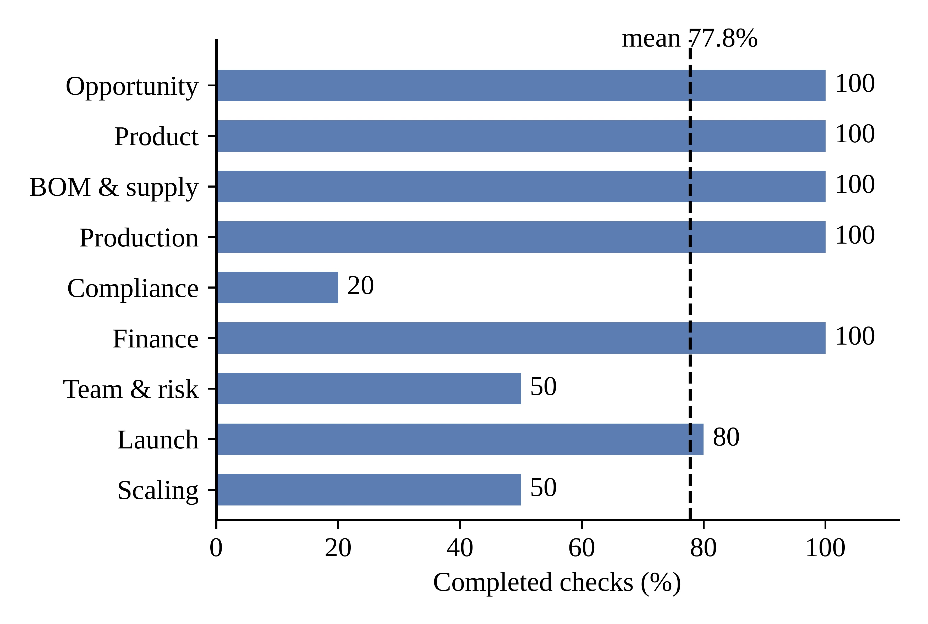
Fig. 3. Stage readiness of the illustrative demo venture, with the overall mean. Values are the percentage of completed checks in each stage and are not measures of feasibility.

8.4 Code Audit Findings
The audit combined inspection of the code with in-memory checks of the pure calculation and readiness functions. Table IX lists the defects that affect the correctness of what founders see. In-memory checks confirmed D1 to D3, D6 and D7, as well as an incomplete cleanup of legacy templates; the remaining defects were found by inspection. None of them had been fixed at the time of the audit.
Table IX
Defects Identified by the Code Audit
ID | Component | Defect and effect
D1 | Demo data | Packaging (INR 500) is counted in the BOM and again in the financial inputs, overstating unit cost
D2 | Finance, Blueprint | Zero operating expense gives break-even 0, displayed as “not achievable”
D3 | Journey | A stage marked Needs work counts as reviewed; the check passes vacuously when no stage is Ready
D4 | Risk | Critical threshold is 15 in the journey and 16 on the risk page
D5 | Journey | Checks on High-criticality BOM or compliance items cannot pass when none exist
D6 | Compliance | The radio filter substring “rf” matches “performance”
D7 | Progress | Stored milestone progress conflicts with computed readiness; Blueprint save sets 100%
D8 | Deletion | Deleting a venture leaves reports, legacy documents and vectors behind
D9 | Persistence | Whole arrays are saved without version checks, so concurrent edits can be lost

8.5 Baseline Pipeline Comparison
The original 14 Oct. 2026 evaluation files were lost. The evaluation was rebuilt with frozen questions and rerun at repository head using Qwen3 8B (Q4_K_M) for generation and Nomic Embed Text for embeddings. These results describe the later revision, not the Qwen2.5/Llama configuration described in Section 6.
Three configurations were compared on Qwen3 8B: direct prompting with the serialized workspace; RAG with question embedding, five highest-cosine records, and one generation call; and the complete application pipeline with routing, role-based retrieval, specialist(s), reviewer, and guardrails. The evaluation contains 24 frozen questions and three repeats per mode (216 records). Answers were scored after thinking-text separation. Pass rate is the question-level mean of predicate fractions; evidence recall is |R intersection G|/|G| and is undefined for direct prompting. RAG document-index construction is excluded once per evaluation, while query embedding and retrieval are timed; full-mode timing includes the complete pipeline.
Fig. 4 reports combined development and held-out results. Direct prompting has the highest macro rule-check pass rate (85.9%; 95% bootstrap CI 72.7%–97.0%), followed by RAG (53.1%; 35.4%–70.8%) and the full pipeline (46.5%; 28.9%–64.4%). Evidence recall is 53.8% for RAG and 47.7% for the full pipeline; it is undefined for direct prompting. Pooled predicate totals are 174/201, 106/201, and 89/201. Four full-pipeline records timed out and remain in the analysis as failed runs.
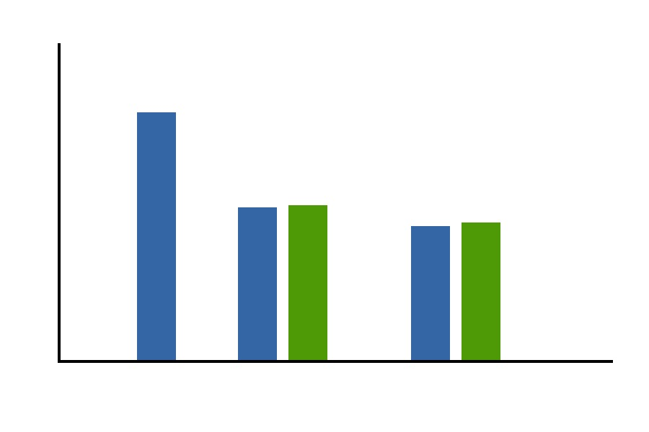
Fig. 4. Combined macro rule-check pass rate and evidence recall over 24 frozen questions with three repeats per mode. Error bars show 95% question-level bootstrap confidence intervals (10,000 fixed-seed resamples). Recall is undefined for direct prompting.
These values are descriptive rather than a claim of semantic correctness or general superiority. The predicates check specified terms and numeric facts, not factual entailment or usefulness. One illustrative venture and one local hardware/model setup were used; direct prompting has an advantage on this small fully serialized fixture. Development and held-out sets are reported separately in the released data. No answer retained thinking text, and the four full-pipeline timeouts were not rerun or discarded.

9. Results and Discussion

9.1 Findings
The results provide three main conclusions. First, the deterministic engine is internally consistent, as the listed formulas match every indicator of the demo venture that can be validated. Second, externalizing calculations ensures that an error will be identifiable. D1 is a data error that cascades from (3) to (9). As each value is calculated using a distinct function, its effect on the report can be specified precisely: the contribution is underestimated by INR 500 per unit, margin is overestimated by 1.11 percentage points, operating profit by INR 75,000 per month, and break-even point is overestimated by 6 units. It would be impossible to identify the impact of an error introduced into generated text. Third, the readiness and progress indicators require improvement in order to become reliable (D3-D5, D7). The results of the audit have not confirmed the accuracy, usefulness and robustness of the reports, which are evaluated via development set comparison in Section 8.5.
Fig. 5 plots combined macro pass rate against mean latency. Direct prompting is 125.6 s at 85.9%, RAG is 15.7 s at 53.1%, and the full pipeline is 116.7 s at 46.5%. This frozen rule-check evaluation therefore does not show a quality advantage for the full pipeline on this fixture, while it is substantially slower than RAG. Latency is wall-clock time on the reported Apple M4 environment and varies with local load; four full runs timed out.
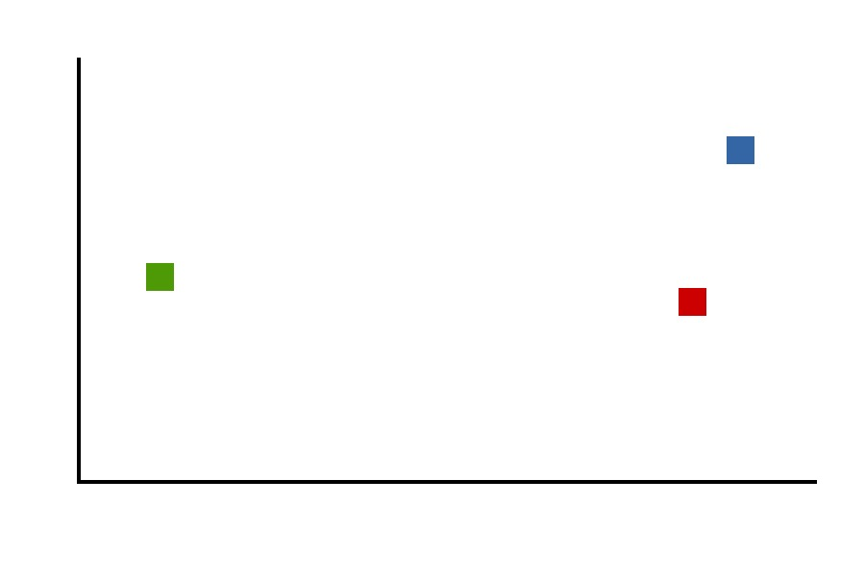
Fig. 5. Mean latency versus combined macro rule-check pass rate for three modes over 24 questions and three repeats. Pass-rate error bars are 95% question-level bootstrap intervals.

9.2 Comparison With Existing Approaches
There is no prior publication of a system that deals with the similar task using similar measures; thus, no quantitative comparison can be made. Table X shows the comparison in capabilities. Capability is considered Y if the proposed technique has it in its possession, P if it is partial to it or offers some form of guidance, and a dash if it lacks such a capability.
Table X
Capability Comparison of Approach Categories
Approach | IW | DC | EG | SR | HA | PS
Venture methods [1]–[3] | P | – | – | – | – | P
Domain AI studies [14]–[17] | – | P | P | – | P | –
General LLM assistants [6] | – | – | P | – | P | P
Multi-agent frameworks [11], [12] | – | P | P | Y | P | –
BuildMyIdea (this work) | Y | Y | Y | Y | Y | Y
IW: Integrated planning workspace; DC: Deterministic computation of quantities; EG: Evidence-based generation; SR: Specialist roles; HA: Human approval before any AI output alters the plan; PS: Persistent venture-state. Ratings are those of the authors. EG is rated Y for BuildMyIdea since citation and retrieval checking is included; its efficiency can be evaluated solely through the development-set test of Section 8.5.
BuildMyIdea is far more restricted than the generic systems and the agent architecture. It addresses only electronics-based businesses, its compliance data is highly restricted and primarily Indian in nature, and its agents do not have the ability to access the internet or manipulate data. This restriction is by design because all the calls and quantities are reproducible.

9.3 Limitations and Threats to Validity
Several limitations exist. The evaluation uses one illustrative venture, frozen term-based predicates rather than human ratings or semantic entailment, and one local hardware/model configuration. Four full-pipeline runs timed out. Direct prompting receives the entire serialized fixture, so it is not representative of larger or private workspace contexts. Readiness assesses field completeness, not venture viability; citation validation checks identifiers, not support; and government evidence is sparse and India-specific.

9.4 Remaining Evaluation
Table XI lists evaluation still required beyond the completed frozen rule-check, evidence-recall, and latency experiment. Human-rated quality, semantic faithfulness, reviewer ablations, broader ventures, and authenticated end-to-end tests remain necessary.
Table XI
Evaluation Still Required
Measure | Method
Retrieval relevance | Precision and recall at k on labeled question and chunk pairs from demo and blank ventures
Citation support | Share of cited records that support each claim, judged by humans or a separate judge model [23]
Quantity fidelity | Share of numbers in reports that match f(W)
Routing accuracy | Selected roles against labeled roles for a question set
Reviewer effect | Ablation with and without the reviewer pass
Latency | Median and 95th-percentile run time on target hardware
Usability | System Usability Scale [44] with founders
End-to-end and rules | Authenticated runs and Firestore rules tests in the Firebase emulator
STATUS: Frozen rule-check, evidence-recall, and latency evaluation completed; the remaining measures are not yet evaluated.

10. Conclusion and Future Work
The frozen evaluation reports rule-check, evidence-recall, and latency outcomes across development and held-out questions, but it does not establish semantic quality, generalization, or decision usefulness.
Limitations give way to the next areas: Zod schemas with versioning for Firestore and API data; versioning and saving with conflict detection; one consistent calculation and invalidation of readiness check; deletion of Firestore reports and SQLite vectors together; datasets for retrieving relevancy and hallucination tests; job queues and monitoring; replicable deployment into production; cash flow, tax, and inventory calculations; blueprint export with versioning; and jurisdiction control.

Declarations
Author contributions (CRediT). Aniket Raj: Conceptualization, Methodology, Software, Formal analysis, Visualization, Writing – original draft, Writing – review and editing. Ankit Raj: Conceptualization, Investigation, Software, Data curation, Validation, Writing – original draft, Writing – review and editing. Ansh Aryan: Methodology, Software, Investigation, Validation, Visualization, Writing – review and editing. Shola Usha Rani: Conceptualization, Supervision, Project administration, Writing – review and editing.
Funding. This research did not receive any specific grant from funding agencies in the public, commercial, or not-for-profit sectors.
Competing interests. The authors declare no competing interests.
Declaration of generative AI use. No generative AI or AI-assisted tools were used in the preparation of this manuscript.
Data and code availability. The source code of the platform is available in the project repository [43]; the system described in Sections 3–7 corresponds to commit 7231d3a. The NovaEdge demonstration data are in src/data/demoStartup.ts.

Acknowledgments
We are thankful to Dr. Shola Usha Rani, School of Computer Science and Engineering, for her invaluable help during the project.

References
[1] R. G. Cooper, “Stage-gate systems: A new tool for managing new products,” Bus. Horizons, vol. 33, no. 3, pp. 44–54, 1990.
[2] E. Ries, The Lean Startup. New York, NY, USA: Crown Business, 2011.
[3] A. Osterwalder and Y. Pigneur, Business Model Generation. Hoboken, NJ, USA: Wiley, 2010.
[4] K. T. Ulrich and S. D. Eppinger, Product Design and Development, 6th ed. New York, NY, USA: McGraw-Hill, 2016.
[5] J. P. Shim, M. Warkentin, J. F. Courtney, D. J. Power, R. Sharda, and C. Carlsson, “Past, present, and future of decision support technology,” Decis. Support Syst., vol. 33, no. 2, pp. 111–126, 2002.
[6] W. X. Zhao et al., “A survey of large language models,” arXiv:2303.18223, 2023.
[7] D. Chalmers, N. G. MacKenzie, and S. Carter, “Artificial intelligence and entrepreneurship: Implications for venture creation in the fourth industrial revolution,” Entrep. Theory Pract., vol. 45, no. 5, pp. 1028–1053, 2021.
[8] Z. Ji et al., “Survey of hallucination in natural language generation,” ACM Comput. Surv., vol. 55, no. 12, pp. 1–38, 2023, doi: 10.1145/3571730.
[9] P. Lewis et al., “Retrieval-augmented generation for knowledge-intensive NLP tasks,” in Proc. Adv. Neural Inf. Process. Syst. (NeurIPS), vol. 33, 2020, pp. 9459–9474.
[10] Y. Gao et al., “Retrieval-augmented generation for large language models: A survey,” arXiv:2312.10997, 2023.
[11] Q. Wu et al., “AutoGen: Enabling next-gen LLM applications via multi-agent conversation,” in Proc. Conf. Lang. Model. (COLM), 2024.
[12] S. Hong et al., “MetaGPT: Meta programming for a multi-agent collaborative framework,” in Proc. Int. Conf. Learn. Represent. (ICLR), 2024.
[13] T. Guo et al., “Large language model based multi-agents: A survey of progress and challenges,” arXiv:2402.01680, 2024.
[14] M. A. Jahin, S. A. Naife, A. K. Saha, and M. F. Mridha, “AI in supply chain risk assessment: A systematic literature review and bibliometric analysis,” arXiv:2401.10895, 2024.
[15] A. Brintrup, E. Kosasih, P. Schaffer, G. Zheng, G. Demirel, and B. L. MacCarthy, “Digital supply chain surveillance using artificial intelligence: Definitions, opportunities and risks,” Int. J. Prod. Res., vol. 62, no. 13, pp. 4674–4695, 2024, doi: 10.1080/00207543.2023.2270719.
[16] M. Mandolini, L. Manuguerra, M. Sartini, G. M. Lo Presti, and F. Pescatori, “A cost modelling methodology based on machine learning for engineered-to-order products,” Eng. Appl. Artif. Intell., vol. 136, Art. no. 108957, 2024, doi: 10.1016/j.engappai.2024.108957.
[17] J. Li and A. Maiti, “Applying large language model analysis and backend web services in regulatory technologies for continuous compliance checks,” Future Internet, vol. 17, no. 3, Art. no. 100, 2025, doi: 10.3390/fi17030100.
[18] V. Karpukhin et al., “Dense passage retrieval for open-domain question answering,” in Proc. Conf. Empirical Methods Natural Lang. Process. (EMNLP), 2020, pp. 6769–6781.
[19] A. Asai, Z. Wu, Y. Wang, A. Sil, and H. Hajishirzi, “Self-RAG: Learning to retrieve, generate, and critique through self-reflection,” in Proc. Int. Conf. Learn. Represent. (ICLR), 2024.
[20] N. F. Liu et al., “Lost in the middle: How language models use long contexts,” Trans. Assoc. Comput. Linguistics, vol. 12, pp. 157–173, 2024.
[21] S. Yao et al., “ReAct: Synergizing reasoning and acting in language models,” in Proc. Int. Conf. Learn. Represent. (ICLR), 2023.
[22] Y. Du, S. Li, A. Torralba, J. B. Tenenbaum, and I. Mordatch, “Improving factuality and reasoning in language models through multiagent debate,” in Proc. 41st Int. Conf. Mach. Learn. (ICML), PMLR vol. 235, 2024, pp. 11733–11763.
[23] L. Zheng et al., “Judging LLM-as-a-judge with MT-Bench and Chatbot Arena,” in Proc. Adv. Neural Inf. Process. Syst. (NeurIPS), vol. 36, Datasets and Benchmarks Track, 2023.
[24] R. Parasuraman and V. Riley, “Humans and automation: Use, misuse, disuse, abuse,” Human Factors, vol. 39, no. 2, pp. 230–253, 1997.
[25] S. Amershi et al., “Guidelines for human-AI interaction,” in Proc. CHI Conf. Human Factors Comput. Syst., 2019, pp. 1–13, doi: 10.1145/3290605.3300233.
[26] B. Shneiderman, “Human-centered artificial intelligence: Reliable, safe & trustworthy,” Int. J. Human–Comput. Interact., vol. 36, no. 6, pp. 495–504, 2020.
[27] National Institute of Standards and Technology, “Artificial intelligence risk management framework (AI RMF 1.0),” NIST AI 100-1, Gaithersburg, MD, USA, 2023.
[28] K. Greshake, S. Abdelnabi, S. Mishra, C. Endres, T. Holz, and M. Fritz, “Not what you’ve signed up for: Compromising real-world LLM-integrated applications with indirect prompt injection,” in Proc. ACM Workshop Artif. Intell. Secur. (AISec), 2023, arXiv:2302.12173.
[29] Google, “Firebase security rules,” Firebase documentation. [Online]. Available: https://firebase.google.com/docs/rules (accessed Oct. 19, 2026).
[30] M. Jones, J. Bradley, and N. Sakimura, “JSON web token (JWT),” IETF RFC 7519, May 2015.
[31] M. Jones, “JSON web key (JWK),” IETF RFC 7517, May 2015.
[32] Govt. of India, “Electronics and Information Technology Goods (Requirements for Compulsory Registration) Order, 2012,” 2012.
[33] Ministry of Environment, Forest and Climate Change, Govt. of India, “E-Waste (Management) Rules, 2022,” notified Nov. 2, 2022.
[34] Ministry of Consumer Affairs, Food and Public Distribution, Govt. of India, “Legal Metrology (Packaged Commodities) Rules, 2011,” 2011.
[35] National Institute of Standards and Technology, “Secure hash standard (SHS),” FIPS PUB 180-4, Aug. 2015.
[36] Y. A. Malkov and D. A. Yashunin, “Efficient and robust approximate nearest neighbor search using hierarchical navigable small world graphs,” IEEE Trans. Pattern Anal. Mach. Intell., vol. 42, no. 4, pp. 824–836, 2020.
[37] J. Johnson, M. Douze, and H. Jégou, “Billion-scale similarity search with GPUs,” IEEE Trans. Big Data, vol. 7, no. 3, pp. 535–547, 2021.
[38] Ollama, “Ollama,” GitHub repository. [Online]. Available: https://github.com/ollama/ollama (accessed Oct. 19, 2026).
[39] C. McDonnell, “Zod: TypeScript-first schema validation with static type inference.” [Online]. Available: https://zod.dev (accessed Oct. 19, 2026).
[40] Qwen Team, A. Yang et al., “Qwen2.5 technical report,” arXiv:2412.15115, 2024.
[41] A. Grattafiori et al., “The Llama 3 herd of models,” arXiv:2407.21783, 2024.
[42] Z. Nussbaum, J. X. Morris, A. Mulyar, and B. Duderstadt, “Nomic Embed: Training a reproducible long context text embedder,” Trans. Mach. Learn. Res., 2025, arXiv:2402.01613.
[43] BuildMyIdea source code (GitHub repository name: VenturePilot). [Online]. Available: https://github.com/ansharyan007/VenturePilot (accessed Oct. 19, 2026).
[44] J. Brooke, “SUS: A ‘quick and dirty’ usability scale,” in Usability Evaluation in Industry, P. W. Jordan, B. Thomas, B. A. Weerdmeester, and I. L. McClelland, Eds. London, U.K.: Taylor & Francis, 1996, pp. 189–194.

