***Problem***: Write a **JavaScript** program to get it to display the first n Fibonacci numbers.

***Solution*** :

var fibonacci= function(result,n)

{

var num1=result[0],

num2=result[1],

next,

count=2;

while(count<n){

next=num1+num2;

num1=num2;

num2=next;

result.push(next);

count++;

}

return result;

};

***Test your Code:***

* Open any javascript editor of your choice.
* Run the function as shown below

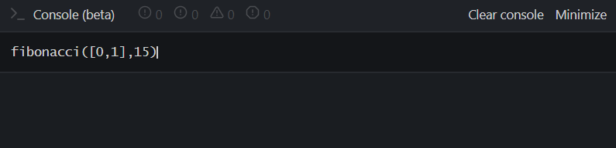

* Once the enter is pressed, it will show below result:

