DECODE Competition Intelligence Project
Complete analysis of Candidate Dataset 1 for Team 3470
Python-based, explainable analysis. No machine learning used.

Executive Summary
After cleaning 109 raw observations into 108 analysis-ready rows, the strongest overall robot is T08. Team 3470 ranks 6th overall in the balanced model and is strongest in cycle speed, reliability, and autonomous leave. Its clearest performance bottleneck is a late-event slowdown associated with the overflow/intake path, while its raw scoring-action volume is only mid-field despite fast cycles.
- Overall top five: T08, T14, T05, T17, T07.
- Best partners for 3470: T08, T14, T17, T02, T06.
- Most reliable: T02, T17, 3470, T08, T03.
- 3470: 100% autonomous leave, 0 recorded breakdowns, 15.03 s average cycle time, 10.5 average recorded scoring actions, 50% motif completion.
- Primary 3470 priority: fix late-match throughput before chasing more speed.

1. Data Cleaning and Method
The analysis starts with the supplied scouting export and preserves raw observations whenever the data does not justify a correction. One exact duplicate was removed. Missing values were not imputed. Suspicious values were flagged, and only one low-confidence extreme CL value was excluded from CL-based aggregates while its raw value remained in the cleaned dataset.
Check | Result | Interpretation
Raw observations | 109 | Before cleaning.
Analysis-ready observations | 108 | One exact duplicate removed.
Teams | 18 | 3470 plus 17 anonymized teams.
Missing cycle_time_sec | 2 | Both are T12; no imputation used.
Missing qualitative_note | 17 | Notes are optional qualitative evidence; numeric metrics retained.
Result/score conflicts | 0 | No W/L records conflict with final scores.
Extreme low-confidence CL rows excluded from CL aggregates | 1 | T05 M14-T05-3 only.
Ambiguous M## prefixes with conflicting same-alliance scores | 36/36 | Match-prefix semantics are uncertain; context-based overrated/underrated conclusions are provisional, not verified event results.
Prefixes with >2 observations on one color | 6 | Cannot safely treat M## as an official event match number; do not use for alliance joining.
Per-team sample size | 6 matches/team | Small sample size limits certainty and makes rank sensitivity important.

Ranking model
Because the supplied materials do not give official point values for CL, overflow, depot, motif, or leave actions, I did not invent point weights. Instead, each team metric is converted to a field percentile so different units can be combined transparently. Alliance score and win rate are excluded from robot strength because they describe the whole alliance.
Component | Weight | What it uses
Scoring volume | 45% | Mean field percentiles of CL, overflow, and depot actions
Objectives | 15% | Auto leave rate and motif completion rate
Cycle speed | 15% | Inverse percentile of average cycle time
Reliability | 15% | Breakdowns, driver consistency, penalties, action variability, cycle variability
Defense | 10% | Scout defense rating percentile

Ranking confidence is based on data completeness, average scout confidence, and rank stability under balanced, offense-heavy, and reliability-heavy weightings. This is a decision model, not an official FTC scoring model or a prediction of exact match points.

2. Data Quality Findings
- M23-T09-4 appeared twice as an identical row. One copy was removed.
- M14-T05-3 reports 28 CL actions while T05's other usable CL values are 6-7; the same row has the dataset's lowest scout confidence (2/5). Raw value retained; CL value excluded from the composite.
- T12 is missing two cycle times, and another T12 cycle time is 7.5 s, making any 'fastest robot' claim uncertain.
- Two very slow cycle-time outliers (T04 at 25.5 s and T07 at 25.6 s) were retained because they coincide with breakdown-prone robots and are plausible failure-performance observations.
- There are 17 missing qualitative notes, but no W/L records conflict with the listed alliance/opponent scores and team match numbers remain 1-6 for every team.
- Scout defense means range from 2.67 to 3.18, suggesting mild rater-calibration differences. Defense is therefore used as a supporting signal, not a precise standalone truth.
- All 36 reused M## prefixes have conflicting scorelines for observations with the same alliance color; 6 prefixes even have three observations labeled the same alliance. The prefix may be an arbitrary/reused label, not a global match ID. No rows were deleted for this ambiguity, but event scorelines need independent verification.
Scout | Obs. | Avg defense | Avg driver | Avg confidence
S1 | 25 | 2.67 | 3.61 | 4
S2 | 29 | 2.8 | 3.78 | 4.28
S3 | 24 | 3.13 | 3.62 | 3.96
S4 | 30 | 3.18 | 3.56 | 4.23

3. Overall Team Ranking
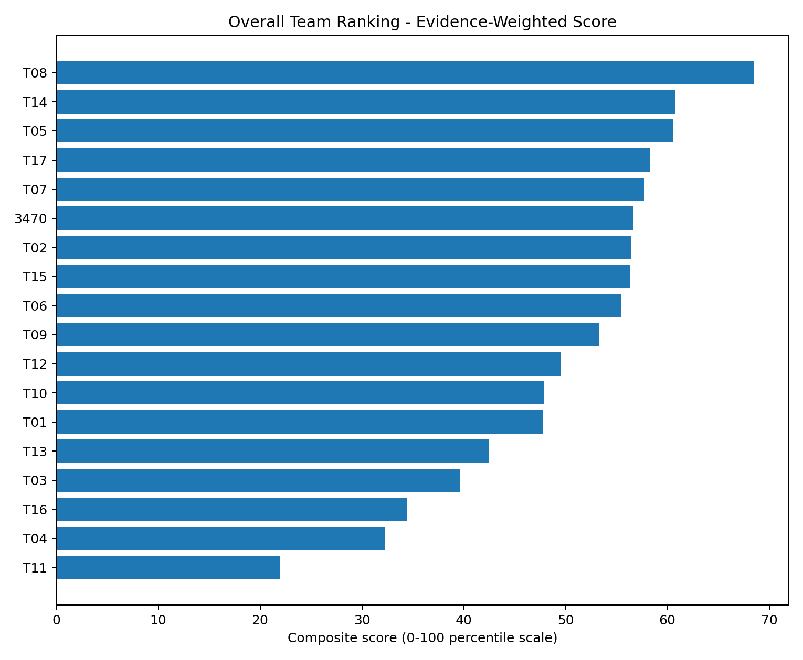
Figure 1. Overall evidence-weighted team ranking.
Rank | Team | Score | Avg actions | Cycle s | Reliability | Confidence
1 | T08 | 68.5 | 13.17 | 19.73 | Medium | High
2 | T14 | 60.81 | 11.5 | 15.53 | Medium | Medium
3 | T05 | 60.51 | 12.8 | 17.03 | Medium | Medium
4 | T17 | 58.29 | 12 | 17.38 | High | Medium
5 | T07 | 57.74 | 13.83 | 19.72 | Medium | Medium
6 | 3470 | 56.66 | 10.5 | 15.03 | Medium | Medium
7 | T02 | 56.49 | 10.67 | 18.35 | High | Medium
8 | T15 | 56.34 | 11.33 | 16.45 | Medium | High
9 | T06 | 55.49 | 13.5 | 19.82 | Medium | Medium
10 | T09 | 53.25 | 8.33 | 15.32 | Low | Medium
11 | T12 | 49.54 | 10.5 | 15.0 | Medium | Low
12 | T10 | 47.85 | 9 | 16.4 | Low | High
13 | T01 | 47.75 | 10.33 | 18.25 | Medium | Medium
14 | T13 | 42.46 | 6.5 | 14.4 | Low | High
15 | T03 | 39.66 | 11.67 | 20.0 | Medium | Low
16 | T16 | 34.43 | 6.5 | 20.27 | Low | Medium
17 | T04 | 32.31 | 7.83 | 20.17 | Low | High
18 | T11 | 21.93 | 7 | 19.52 | Low | High

Why the top teams rank where they do
- T08 (#1, High confidence): 13.17 average actions, 4.68/5 defense, 83% motif completion, no breakdowns. Main risks are 19.73 s average cycle time, 2.2/5 driver consistency, and 5.67 average penalty points. It stays #1 in all three weight-sensitivity models.
- T14 (#2, Medium confidence): fast 15.53 s cycles, 6.17 CL, 4.33 depot, low 2.83 average penalties, no breakdowns. Its rank moves from 2nd to 6th under different weight priorities, so placement is less stable than T08.
- T05 (#3, Medium confidence): high scoring volume and no breakdowns, but 6.5 average penalties, 2.25/5 driver consistency, and the low-confidence 28-CL outlier reduce trust and fit.
- T17 (#4, Medium confidence): strong driver consistency (4.85/5), 12.0 actions, 83% motif, no breakdowns. Weak defense (1.25/5) and 6.0 average penalties are the main drawbacks.
- T07 (#5, Medium confidence): the highest recorded action volume among the top group (13.83) and a 17-action ceiling, but a 50% breakdown rate makes it the clearest high-risk/high-ceiling option.

4. Reliability, Risk, and Floor/Ceiling
Rank | Team | Reliability | Floor | Ceiling | Breakdown | Avg penalty | Risk tags
1 | T02 | 71.18 | 10.0 | 13 | 0 | 4.67 | none
2 | T17 | 67.06 | 11.25 | 14 | 0 | 6 | high floor; penalty risk
3 | 3470 | 63.53 | 10.0 | 12 | 0 | 4 | none
4 | T08 | 57.65 | 13.0 | 15 | 0 | 5.67 | high floor
5 | T03 | 57.06 | 11.25 | 14 | 0 | 3.83 | high floor
6 | T15 | 56.47 | 11.25 | 13 | 0 | 6.17 | high floor; penalty risk
7 | T05 | 55.88 | 11 | 15 | 0 | 6.5 | high floor; ceiling risk; penalty risk
8 | T12 | 55.29 | 9.25 | 13 | 0.167 | 3.5 | none

- Most reliable: T02, T17, 3470. T02 has the best combined reliability index; T17 adds a high action floor; 3470 has zero breakdowns and the lowest action variability in the field.
- Best high-floor option: T08. Its 25th-percentile action floor is 13.0 with zero recorded breakdowns.
- High-ceiling/high-risk: T07 is the clearest case (17-action ceiling, 50% breakdown rate). T05 carries penalty/driver/data risk despite strong scoring. T06 has a 16-action ceiling but one breakdown and slower cycles.
- Major failure/penalty risk: T11 and T07 each have 50% breakdown rates; T04 combines a 33% breakdown rate with 8.5 average penalty points.

5. Overrated / Underrated Relative to Raw Match Results
This does not refer to external reputation. It compares the individual-robot composite to a separate result-context rank built from win rate and average alliance score. A robot can look better or worse in match results because alliance partners and opponents are not controlled in this dataset. Additionally, repeated M## match prefixes have conflicting scorelines within one alliance color; the meaning of the prefix must be verified before treating these as official event results. Consequently, result-context over/underrating labels are provisional.
Team | Robot rank | Result rank | Difference | Interpretation
T14 | 2 | 13 | 11 | Underrated by alliance results
T02 | 7 | 14 | 7 | Underrated by alliance results
T17 | 4 | 9 | 5 | Underrated by alliance results
T13 | 14 | 18 | 4 | Underrated by alliance results
T15 | 8 | 12 | 4 | Underrated by alliance results
T09 | 10 | 7 | -3 | Overrated by alliance results
T10 | 12 | 6 | -6 | Overrated by alliance results
T06 | 9 | 2 | -7 | Overrated by alliance results
T11 | 18 | 8 | -10 | Overrated by alliance results

The strongest underrated signal is T14 (#2 robot profile vs #13 result context). T02 and T17 also look better underneath than their match results suggest. T11 is the strongest overrated-by-results signal (#18 robot profile vs #8 result context), followed by T06 and T10.

6. Team Archetypes
Team | Archetype
T08 | Two-way primary scorer
T14 | Efficient primary scorer
T05 | Overflow scoring specialist
T17 | Driver-led primary scorer
T07 | High-risk / high-ceiling scorer
3470 | Fast, consistent balanced scorer
T02 | Consistent low-risk balanced robot
T15 | Consistent secondary scorer
T06 | Primary scorer
T09 | Defensive support specialist
T12 | Fast CL scoring specialist
T10 | Defensive support specialist
T01 | Support / defensive robot
T13 | Defensive support specialist
T03 | Overflow scoring specialist
T16 | Objective / motif specialist
T04 | High-risk low-output robot
T11 | High-risk low-output robot

7. Team 3470 Performance Analysis
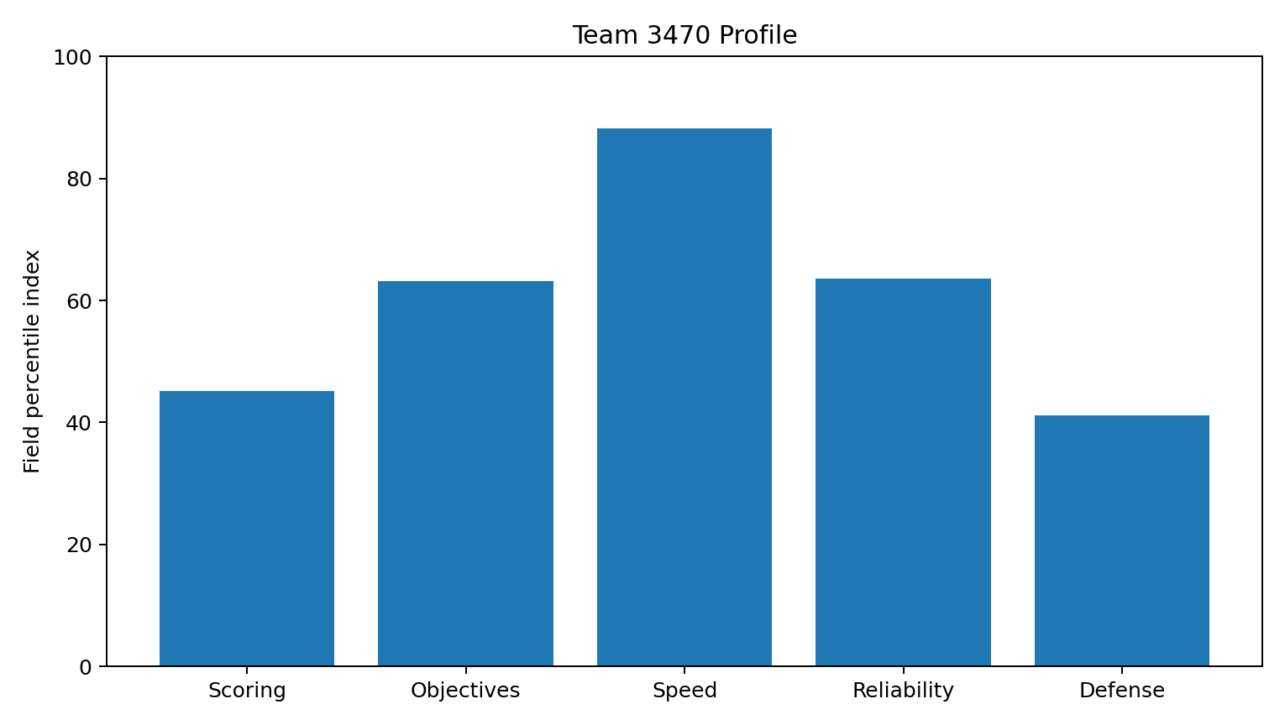
Figure 2. Team 3470's field-percentile profile.
Team 3470 ranks #6 overall. It averages 10.50 recorded scoring actions and 15.03 s cycle time, with 0% recorded breakdowns, 100% autonomous leave, 50% motif completion, and 4.15/5 driver consistency.
- Strongest areas: cycle speed (88th percentile), action consistency/reliability, 6/6 autonomous leave, and zero recorded breakdowns.
- Weakest areas: CL production (41st percentile), depot production (35th percentile), defense (41st percentile), and only 50% motif completion.
- Most important performance gap: 3470 is fast but only 45th percentile in scoring-volume index. The robot gets around the cycle quickly without converting that speed into top-tier action count.
- Late-event trend: cycle time rises and scoring actions drift down across the six matches; the same overflow-slowdown note appears in matches 4-6.
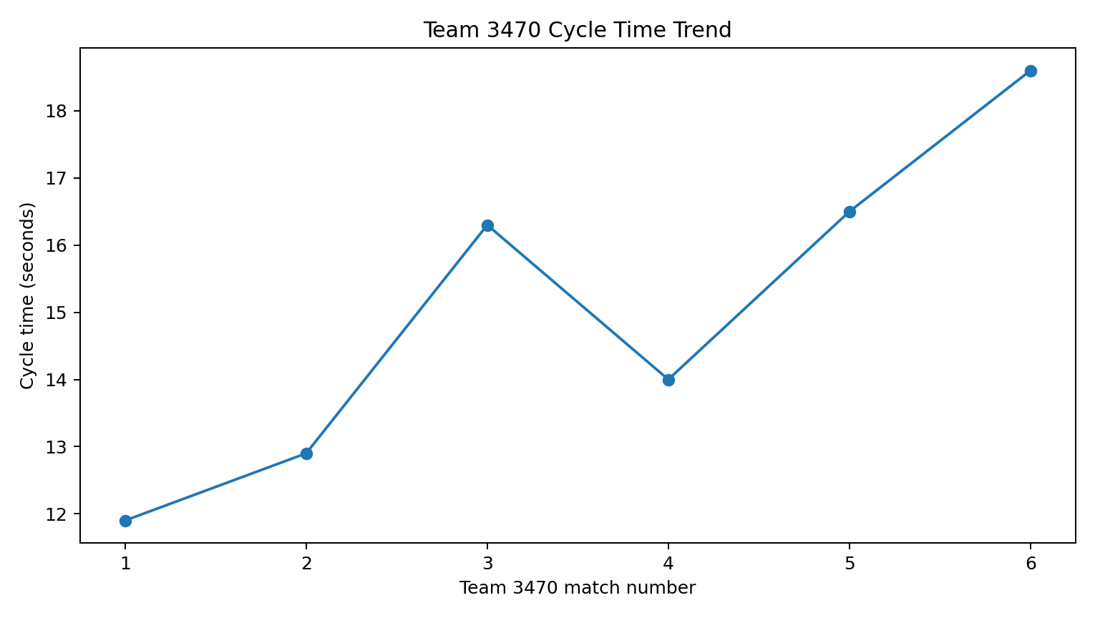
Figure 3. Team 3470 cycle time trends slower across the sample.
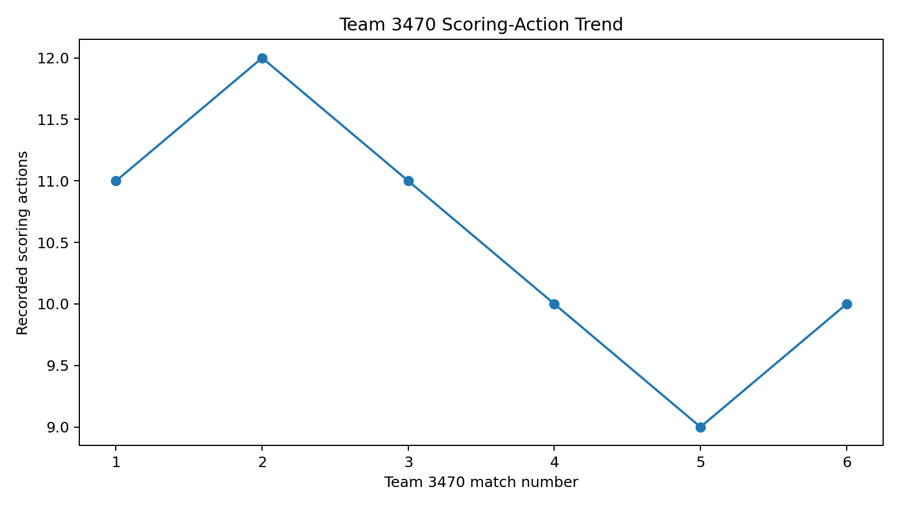
Figure 4. Team 3470 recorded scoring actions drift down late in the sample.

8. Prioritized Team 3470 Recommendations

Priority 1: Late-event cycle slowdown around the overflow mechanism/intake path
- Evidence: Cycle time rose from 12.40s over matches 1-2 to 17.55s over matches 5-6 (+41.5%); the note 'overflow mechanism slows late event' appears 3/6 times.
- Expected impact: Higher late-match throughput and less performance fade while preserving 3470's strong early speed.
- Action: Stress-test the overflow/intake/transfer path under full-match conditions; log jam/retry causes; simplify or reinforce the mechanism; add driver recovery practice.
- Confidence: High

Priority 2: Fast cycles are not translating into top-tier total scoring volume
- Evidence: 3470's cycle-speed index is 88th percentile, but scoring-volume index is only 45th percentile; CL is 41st percentile and depot is 35th percentile.
- Expected impact: More scoring actions per match without needing a faster drivetrain or riskier strategy.
- Action: Run timed intake-to-score conversion drills, standardize driver routes, reduce dead travel/aim time, and prioritize CL/depot throughput where 3470 trails the field.
- Confidence: Medium

Priority 3: Motif completion is only 50% despite perfect autonomous leave
- Evidence: Auto leave succeeded in 6/6 observations, while motif completion succeeded in 3/6.
- Expected impact: Raises objective reliability while keeping the already-stable autonomous foundation.
- Action: Add pre-match sensor/pose checks, deterministic autonomous state handling, and repeated motif-specific validation under different starting conditions.
- Confidence: High

Priority 4: Penalty spikes can erase gains in close matches
- Evidence: 3470 averaged 4.0 penalty points with a maximum of 9; two observations were 6+ points.
- Expected impact: Improves floor in close matches and reduces avoidable score swings.
- Action: Review the high-penalty matches with the drive team, identify repeatable causes, and add rule-boundary drills to practice sessions.
- Confidence: Medium

9. 3470 Alliance Compatibility Ranking and Picklist
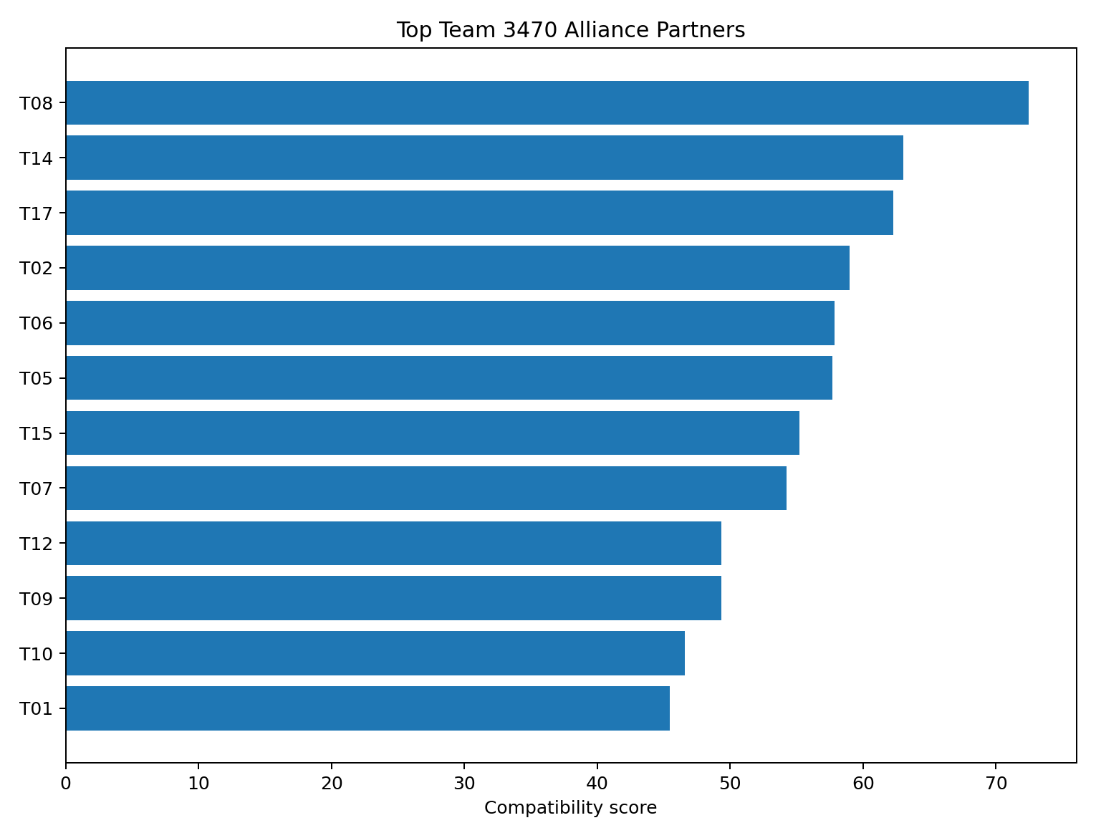
Figure 5. Highest-fit alliance partners for Team 3470.
Pick | Team | Fit score | Overall | Why it fits | Risk | Conf.
1 | T08 | 72.4 | 1 | Best fit areas: defense and CL scoring. | 2.2/5 driver consistency | High
2 | T14 | 63.0 | 2 | Best fit areas: depot scoring and CL scoring. | 2.9/5 driver consistency | Medium
3 | T17 | 62.3 | 4 | Best fit areas: depot scoring and motif completion. | 6.0 avg penalty points | Medium
4 | T02 | 59.0 | 7 | Best fit areas: reliability and defense. | no major measured risk | Medium
5 | T06 | 57.8 | 9 | Best fit areas: depot scoring and motif completion. | no major measured risk | Medium
6 | T05 | 57.7 | 3 | Best fit areas: CL scoring and reliability. | 6.5 avg penalty points; 2.2/5 driver consistency; data-quality uncertainty | Medium
7 | T15 | 55.2 | 8 | Best fit areas: depot scoring and reliability. | 6.2 avg penalty points; 2.9/5 driver consistency | High
8 | T07 | 54.3 | 5 | Best fit areas: depot scoring and motif completion. | 50% breakdown rate | Medium
9 | T12 | 49.4 | 11 | Best fit areas: CL scoring and reliability. | data-quality uncertainty | Low
10 | T09 | 49.4 | 10 | Best fit areas: defense and motif completion. | 33% breakdown rate | Medium
11 | T10 | 46.6 | 12 | Best fit areas: motif completion and defense. | 6.5 avg penalty points; 2.9/5 driver consistency | High
12 | T01 | 45.4 | 13 | Best fit areas: defense and CL scoring. | no major measured risk | Medium
13 | T03 | 43.4 | 15 | Best fit areas: reliability and defense. | no major measured risk | Low
14 | T16 | 41.8 | 16 | Best fit areas: motif completion and depot scoring. | 7.0 avg penalty points | Medium
15 | T13 | 35.1 | 14 | Best fit areas: defense and reliability. | no major measured risk | High
16 | T04 | 30.5 | 17 | Best fit areas: depot scoring and motif completion. | 33% breakdown rate; 8.5 avg penalty points; 2.8/5 driver consistency | High
17 | T11 | 23.8 | 18 | Best fit areas: reliability and CL scoring. | 50% breakdown rate | High

T08 is both the #1 overall robot and the #1 partner for 3470. That is not automatic: the partner model is separate and specifically rewards filling 3470's weaker CL/depot/defense areas. T08's high defense and scoring volume create the strongest complement, while T14 is a safer fast/low-penalty alternative and T17 brings elite driver consistency.
- Top tier: T08, T14, T17, T02.
- Strong second tier: T06, T05, T15, T07. T05 and T07 have more obvious risk; T06 is slower but high-volume; T15 is stable but penalty-prone.
- Avoid if better options remain: T13, T04, T11. T13 is useful defensively but low-volume; T04 combines low output, breakdowns, and penalties; T11 is last in overall strength and has a 50% breakdown rate.

10. Match Strategy Examples

Matchup 1: 3470 + T08 vs T07 + T06
Item | Drive-team brief
Primary win condition | Use 3470's speed/consistency plus T08's high-volume two-way play to match the opponents' scoring ceiling without giving away penalties.
Roles | 3470: fast repeatable scorer and stable objective execution. T08: primary volume scorer and defensive pressure when safe.
Biggest threat | T07/T06 combine very high scoring volume; T07 also has a 17-action ceiling.
Priority | Build an early clean lead, avoid traffic, and force the opponent's higher-risk robots to beat a stable score.
Major risk | T08's driver consistency/penalties and 3470's late-cycle slowdown.
Backup plan | If T08 execution drops, keep 3470 on offense and reduce risky defense; shift to reliable scoring rather than chase ceiling plays.
Confidence | Medium

Matchup 2: 3470 + T14 vs T17 + T02
Item | Drive-team brief
Primary win condition | Win on speed and complementary CL/depot production while keeping the match low-penalty.
Roles | 3470: fast cycling/overflow support. T14: efficient primary CL/depot scorer with secondary defense.
Biggest threat | T17's strong driver-led scoring paired with T02's top reliability.
Priority | Protect clean lanes and make T17/T02 spend time reacting rather than running their consistent plan.
Major risk | T14's rank is weight-sensitive and 3470 can fade late.
Backup plan | If scoring lanes clog, use T14's stronger defense while 3470 stays on the shortest repeatable scoring route.
Confidence | Medium

Matchup 3: 3470 + T02 vs T08 + T05
Item | Drive-team brief
Primary win condition | Turn the match into a reliability contest: clean execution, controlled defense, and no penalty spikes.
Roles | 3470: primary pace setter and scorer. T02: reliable balanced support/defense and motif coverage.
Biggest threat | T08 is the strongest overall robot and T05 adds high scoring volume.
Priority | Disrupt T08's two-way impact without sacrificing 3470's cycles; exploit T05's lower driver consistency and penalty risk.
Major risk | Our alliance has less raw scoring ceiling than T08 + T05.
Backup plan | Prioritize objectives and safe high-floor scoring; avoid a chaotic shootout if the early margin is close.
Confidence | Medium-Low

11. Ambiguity and Uncertainty

Uncertainty 1
Field | Assessment
Claim | The M## prefix is a unique official event match identifier, making alliance scorelines independently verifiable.
Confidence | Low
Competing explanation | All 36 repeated prefixes have conflicting scores for the same alliance color; prefixes could be reused labels rather than event match IDs, or match context may be misrecorded.
Missing information | An official match schedule, stable match ID definitions, and verified per-match alliance scores and partners.
Decision | Do not join rows by M## or make definitive claims from result-context rankings. Keep per-robot metrics and regard overrated/underrated as provisional.

Uncertainty 2
Field | Assessment
Claim | T05 is a top-3 robot in the balanced overall ranking.
Confidence | Medium
Competing explanation | One CL value of 28 may be a logging error rather than a true performance spike; scout confidence on that row is 2/5.
Missing information | Video or a second scout record for M14-T05-3; official per-match scoring breakdown.
Decision | Act on T05 as a strong option, but do not let the 28-CL row drive the picklist. The composite excludes that CL value.

Uncertainty 3
Field | Assessment
Claim | T12 is one of the fastest robots in the field.
Confidence | Low
Competing explanation | Two of six cycle times are missing and one recorded cycle is an extreme 7.5 s outlier.
Missing information | Complete cycle timestamps or video-based timing for all six matches.
Decision | Treat T12 speed as promising but unconfirmed; do not select them primarily for speed.

Uncertainty 4
Field | Assessment
Claim | Alliance win rate is a good proxy for individual robot strength.
Confidence | Low
Competing explanation | Alliance scores include partner performance and opponent strength; T11 has good result context but ranks last on underlying robot metrics.
Missing information | Alliance partner identities, opponent strength, individual contribution, and schedule strength.
Decision | Do not use wins/alliance score inside the robot-strength composite; use them only as context.

Uncertainty 5
Field | Assessment
Claim | Defense ratings are directly comparable across scouts.
Confidence | Medium
Competing explanation | Scout mean defense ratings vary by about half a rating point, which may reflect rater calibration rather than robot ability.
Missing information | Multiple scouts on the same matches or a calibrated defense-rating rubric.
Decision | Use defense as a supporting signal, not a precise standalone ranking metric.

Uncertainty 6
Field | Assessment
Claim | 3470's late slowdown is caused by the overflow mechanism.
Confidence | Medium
Competing explanation | The repeated note supports the hypothesis, but defense, battery state, traffic, or match strategy could also slow cycles.
Missing information | Subsystem telemetry, match video, battery voltage, and timestamps of retries/jams.
Decision | Prioritize testing the overflow path because it is the best-supported actionable hypothesis, but validate before redesigning.

12. Additional Data Needed
- Official point values or scoring-value mapping for each action type, if the goal is to estimate point contribution rather than action volume.
- Alliance partner identities and opponent strength for every match so alliance scores/wins can be adjusted for schedule context.
- Official global match IDs and score sheets to resolve the repeated M## prefix and same-alliance scoreline conflicts.
- Complete per-cycle timestamps and subsystem-failure timestamps, especially for T12 and Team 3470.
- Multiple scout observations of the same matches or a calibrated scoring rubric for defense and driver ratings.
- Match video for the T05 28-CL observation and Team 3470's repeated late-overflow slowdown.
- Phase-specific data (autonomous, teleop, endgame), defense faced, battery state, and jam/retry counts for stronger causal conclusions.

13. Final Decision Summary
- Strongest overall: T08 (High confidence within this dataset).
- Best alliance partner for 3470: T08; safest close alternatives are T14 and T02, while T17 adds high driver execution.
- 3470's competitive identity: fast and mechanically reliable, but not yet translating its speed into top-tier scoring volume.
- Highest-priority fix: late-event overflow/intake throughput. Then improve CL/depot conversion and motif reliability.
- Use the picklist as a living decision aid, not a fixed truth. Six matches per team and subjective scouting ratings mean pre-match verification still matters.

Appendix A. AI Use and Explainability
AI-assisted development was used for code scaffolding, analysis-method brainstorming, debugging, report drafting, and formatting. The final method is intentionally simple enough to audit: cleaning rules, percentile conversion, explicit weights, and rule-based confidence/archetype logic. Before submitting, the candidate should rerun the pipeline and complete the verification checklist in INTERVIEW_PREP.md so any first-person AI disclosure is accurate.
Where this system could be wrong: the supplied dataset does not include official point weights, alliance partner identities, schedule strength, full cycle timing, or duplicate independent scout observations. The analysis also finds conflicting scorelines among records sharing M## prefixes; their meaning requires official verification. The analysis therefore avoids precise point forecasts and labels uncertain conclusions instead of forcing them.

